KAON 4xx
NGAO Science Operations Requirements
D. Le Mignant, 04/13/2007

1. Science operations within the WBS: 2
2. Science Operations high-level requirements: 2
2.1. Top-level goals for the NGAO Science Operations 3
2.2. First priority requirements from the top-level goals 3
2.2.1. More than 80% of the time allocated is spent on collecting science-quality data. 3
2.2.2. The NGAO combined with its science instruments is facility-class instrument. 3
2.2.3. The Observatory is capable of supporting the equivalent of 240 nights/year for NGAO science operations: 4
3. Bibliography 4

Science operations within the WBS:

At this time, there are four studies tightly related to science operations undertaken:
- WBS 2.2.3 Observatory requirements:
  - Science Operations Requirements
- WBS 3.1.1 System Design Approach / System Engineering / Performance Budget
  - 3.1.1.11 Observing Efficiency
  - 3.1.1.12 Observing Uptime
- WBS 3.1.2.1.10 System Design Approach / System Engineering / Trade Studies
  - Observing Model TS
- WBS 3.4.2 System Design Approach / Science Operations
  - AO-Instrument operations

The slide below represents a schematic view of the active WBS related to science operations and their interactions.

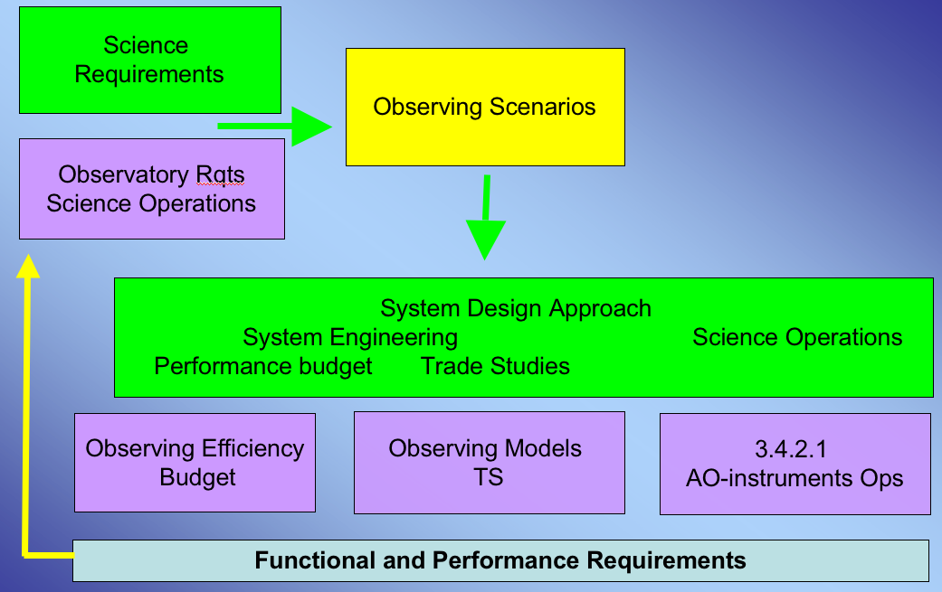

It is very important to develop the observing scenarios for each important science case in first place. The observing scenarios are critical to draft any flow-down requirements for the various areas of science operations: observing models, observing efficiency and uptime budgets, observatory requirements, etc

Science Operations high-level requirements:

The Science Operations Requirements for AO instruments on a large telescope have a very major impact:
- on the science impact:
The requirements for science operations will be one of the key-drivers for the science impact in terms of overall observing efficiency, instrument characterization and performance, observing models, data products and archive, etc
- on the design/cost of the AO/Laser and science instruments:
Requesting more reliability, more stability, more automated maintenance and calibration routine to drive down the Observatory Operation cost later on, requires a large work effort during the design, development and integration of the sub-systems.
- on the observatory budget 2010-2020+ and its future priorities
The recent NSF/AST Senior Review (http://www.nsf.gov/mps/ast/ast_senior_review.jsp) confirms that “the full costs of operating, maintaining, upgrading, exploiting [..] are many times the costs of construction. Realistic life cycle costing for the Observatories that are under construction or consideration is an essential part of strategic planning”

The mission for the science operations is to “Maximize the scientific impact of the TAC allocated observing time with the NGAO instruments from 2012 to 2020”.

The work taking place during the Systems Design phase proposes goals that will support this mission. We first propose a set of top-level goals for the science operations. Then, we anticipate a list of first priority requirements to support the goals.

Top-level goals for the NGAO Science Operations

We propose the following goals
- More than 80% of the time allocated is spent on collecting science-quality data.
- The NGAO combined with its science instruments is facility-class instrument.
- The Observatory is capable of supporting the equivalent of 240 nights/year for NGAO science operations.

First priority requirements from the top-level goals

More than 80% of the time allocated is spent on collecting science-quality data.
- Software should permit simultaneous commands to multiple sub-systems, as well as within a sub-system, in order to minimize time overhead during telescope dither, telescope slew, target acquisition, instrument setup, instrument data readout, etc.
- The time allocation method and the Keck science operations model should minimize the average impact due to lost time year-round (poor weather ~23% of the allocated time) and non-photometric conditions (~ 15 % of the time). Innovative observing scheduling may be able to take into account observed trends (i.e. more heavy cloud coverage in Apr-May and Oct-Nov – Kaufman and Vecchione, 1981).
- The acquisition and accurate centering (within the science case requirement) of a new science target should take less 120sec. The telescope pointing error should remain less than 2 arcsec and allow for direct acquisition. 180 degree telescope slews should take less than xx minutes.
- When the telescope dither, the time lag between the close shutter command and open shutter command for two consecutive frames on the NIR imager should be less than 10 seconds. If a chopping mode is used for the NIR thermal imager, it should be used for any dither of less than 5 arsec for all instrument.

The NGAO combined with its science instruments is facility-class instrument.
- Facility-class has many implications on safety, operability, reliability, maintainability, lifetime, documentation, configuration management, etc.
- The Mauna Kea laser projection requirements must be satisfied
- The NGAO installation, integration, testing and commissioning phases should follow the highest Observatory standards and be reviewed by the Keck community:
  - The time between decommissioning an AO capability on the telescope where the NGAO system is to be installed and making NGAO available for limited shared-risk science must not be longer than 6 months
  - The NGAO system must complete an operations transition review where operational responsibility is transferred from development to operations.
  - The telescope downtime required to implement NGAO must not be longer than 5 days
- The facility instrument should include a simulation module (telescope, natural and laser stars) for calibrating and troubleshooting the AO system, as well as a stable and accurate calibration module (wavelength, flat-field, field distortions, sensitivity) for the science instruments.
- Interferometer- & Ohana- related requirements:
  - NGAO should support IF and Ohana science operations
  - The interferometry modes should not require the NGAO light path for optical alignment in the basement.

The Observatory is capable of supporting the equivalent of 240 nights/year for NGAO science operations:

- NGAO include tools to auto-calibrate with the science instruments on a routine basis. The automated calibrations takes less than 30 minutes and is performed by non AO-experts.
- NGAO does require more than 30 minutes of daytime telescope restriction on a science night.
- The NGAO facility does not require more than 30min per observing night for maintenance and science instrument performance calibrations.
- The science instrument performance (image quality, sensitivity, observing efficiency and calibration stability) should be documented, simulated, checked and monitored by the observatory on a routine basis.
  - The simulation tools should provide key-parameters with a 10 % accuracy within a range of observing conditions and instrument setup.
  - The relative astrometry solution error over the field of view should be less than 2% of a pixel. The pointing and positioning accuracy error on the science field should be known with an error less than 20% of the measured FWHM.
  - The relative and absolute photometry should be monitored throughout the observations with a precision of xx % at the observed wavelength.
- Atmospheric parameters and system diagnostic data should be collected for image quality monitoring and PSF reconstruction.
- All observing sequences should be fully planned and saved prior to the observations, including calibrations. A software should be available for download, capable of simulating and self-checking more than 90% (?) of the observing scenarios. A library of observing sequence templates should be available to the observers.
- A support astronomer should review the observing sequences prior to the observations. The SA will be on-call and may be present during the observations.
- The science instrument should be operated remotely or on-site by one Observer or a Support Astronomer.
- The telescope, the AO & laser facility should be operated by two or less Observing Assistants (or equivalent skills).

Bibliography

- KAON 463
- KAON 476

