 Keck Adaptive Optics Note 494

Keck Next Generation Adaptive Optics
System Design Phase Project Report #3

P. Wizinowich, R. Dekany, D. Gavel & C. Max + NGAO team
June 19, 2007

Narrative

This report provides an update to Project Report #2 that was submitted to the Observatory Directors on Mar. 31, 2007. The next project report will be submitted in September.

Summary

The emphasis during this period has continued to be on developing the science and system requirements, and completing the performance budgets and trade studies. A major effort was also put into completing the scheduled replan activity. The system architecture phase has recently begun and this will be the highest priority activity over the summer.

The replan has brought the Mar/08 system design review back within reach. However, there are already some early indications of problems with staying on the new plan’s schedule that will need to be carefully monitored and corrected by the NGAO Executive Committee.

During this period the astrometric performance budget report was completed and the wavefront and companion sensitivity budgets have made good progress. Nine trade studies were also completed during this period. Good progress has been made on the system requirements document; although version 2 of the system requirements document has not been completed, it has acted as a stimulus for documenting the fundamental science requirements and the flow down to the derived requirements. Finally, a good start has been made on the system architecture phase.

Technical Status

The technical status reported below is organized according to the major WBS elements in the SEMP. Only the currently scheduled WBS elements are included.

System Design Phase Management (WBS 1)

The NGAO Twiki site (http://www.oir.caltech.edu/twiki_oir/bin/view.cgi/Keck/NGAO/WebHome) continues to be heavily utilized to manage and document the project.

Two team meetings have been held since the last report and our next team meeting will occur in July.

The scheduled mid-year replan has been completed. The replan is described in KAON 481 and the accompanying MS project plan and excel spreadsheet; these are labeled version 26. All of these documents can be found at http://www.oir.caltech.edu/twiki_oir/pub/Keck/NGAO/SystemDesignPhasePlanning/. The main purpose of the replan was to accomplish what we need for the system design phase within the remaining budget and schedule. The lessons learned in the first 6 months were utilized where practical. The replan partially addresses the concerns about being behind schedule in a number of areas. In addition we need to more carefully manage the project to ensure tasks are brought to closure within schedule and budget.

System Requirements (WBS 2)

Progress has been made on re-casting the science case requirements in terms of fundamental versus derived quantities. As a result the science requirements portion of the system requirements document (SRD) has been considerably reworked for most of the science cases, although considerable work remains. Progress has also been made on the Observatory operational requirements section of the SRD.

The science cases with initial requirements tables include:
- Asteroid companions survey and orbit determination (WBS 2.1.1.1)
- Moons of the giant planets (WBS 2.1.1.2)
- Shape and size of asteroids (WBS 2.1.1.3)
- Galactic Center astrometry and radial velocities (WBS 2.1.2.1 and 2.1.2.2)
- Planets around low mass stars (WBS 2.1.2.4)
- High redshift galaxies (WBS 2.1.3.2)
- Nearby AGNs (WBS 2.1.3.3)
- Gravitational lensing (WBS 2.1.3.4)
- QSO host galaxies (no WBS)

Note that WBS 2.1.2.3 Galactic Center Nature of Sgr A*: 3-5 µm color & 2 µm polarimetry was descoped as lower priority in the replan.

The science cases still requiring initial requirements tables include:
- Debris disks, protostellar envelopes and outflows: contrast and polarimetry (WBS 2.1.2.5 and 2.1.2.6)
- Resolved stellar populations in crowded fields (WBS 2.1.3.1)

Performance Budgets (WBS 3.1.1)

The progress and status of each of the performance budget elements is summarized below.

Model Assumptions (WBS 3.1.1.1). This category is complete except for ongoing releases of TMT site monitoring results and adoption of new model assumptions. The telescope dynamic and static wavefront error analysis was documented as KAON 482.

Model/Tool Validation (WBS 3.1.1.2). This category is complete except for ongoing work to anchor the Keck II LGS AO PSFs and LAO tomography experiments. The latter task has reached a significant milestone, the validation of the tomography error for one LGS constellation, and is pending a second experiment per recommendations from team meeting #6. Testing and documentation of the agreement between tomography codes is complete as KAON 475.

Transmission and Background Budgets (WBS 3.1.1.3 & 3.1.1.4). No progress.

Wavefront Error and Encircled Energy Budgets (WBS 3.1.1.5 & 3.1.1.6). Status: Version 1 nearly complete as KAON 471. Wavefront error budgets have been generated for five observational scenarios: Io, Kuiper Belt Objects, ExoJupiters, IFU spectroscopy of galaxies, and the Galactic Center. These budgets incorporate many error terms, and illustrate the NGAO system performance achieved in typical turbulence conditions for each of these observational scenarios.

Photometric Precision Error Budget (WBS 3.1.1.7). Complete as KAON 474, as reported in progress report #2.

Astrometric Accuracy Error Budget (WBS 3.1.1.8). Complete as KAON 480.

Polarimetric Accuracy (WBS 3.1.1.9). No progress. Still unable to find a scientist to assist in the development of a polarimetric accuracy technical report.

High-contrast Error Budget (WBS 3.1.1.10). This study is in the final stages of analysis, with recent input from the newly defined science requirements for the companion science cases (telecon 6/15/07). Detailed NGAO simulations with an apodized Lyot coronagraph have been carried out to produce AO PSFs for the contrast study and for producing simulated science cases.

Observing Efficiency Performance Budget (WBS 3.1.1.11). No work currently scheduled.

System Uptime Performance Budget (WBS 3.1.1.12). No work currently scheduled.

Trade Studies (WBS 3.1.2)

A series of trade studies were initiated at the start of the Keck NGAO System Design phase in order to help solidify system requirements and to give us a perspective on the feasible system architectures. The progress and status of these trade studies is described below.

MOAO versus MCAO (WBS 3.1.2.1.1). Status: Complete as KAON 452.

NGAO versus Keck AO Upgrades (WBS 3.1.2.1.2). Status: Complete as KAONs 461 and 462, as reported in Progress Report #2.

Adaptive Secondary Mirror Option (WBS 3.1.2.1.3). Status: Complete as KAON 485. The feasibility of implementing an adaptive secondary mirror and the pros and cons of such an approach were evaluated.

Keck Interferometer Support (WBS 3.1.2.1.5). Status: Complete as KAON 483.

GLAO for non-NGAO Instruments (WBS 3.1.2.1.7). Status: Complete as KAON 472, as reported in Progress Report #2.

Science Instrument Re-use (WBS 3.1.2.1.8). Status: Complete as KAON 493. The reuse of NIRC2 and OSIRIS are discussed.

Telescope Wavefront Error (WBS 3.1.2.1.9). Status: Complete as KAON 482.

Observing Model (WBS 3.1.2.1.10). Status: Complete as KAON 476. This study begins by identifying the top level goals and assumptions. A number of existing observing models are evaluated and three case study observing models are presented to assess a range of possibilities for NGAO. Working with the science community to develop a new flexible observing model for NGAO is recommended.

Optical Relay (WBS 3.1.2.2.2) & Field Rotation Strategy (WBS 3.1.2.2.2.3). Status: In process.

Rayleigh Rejection (WBS 3.1.2.2.5). Status: Complete as KAON 490.

LGS Wavefront Sensor Type (WBS 3.1.2.2.6) & LGS Wavefront Sensor Number of Subapertures (WBS 3.1.2.2.7). Status: Complete as KAON 465.

Low Order Wavefront Sensor Architecture (WBS 3.1.2.2.9). Status: Complete as KAON 487. Two main architectures were compared, Shack-Hartmann and Pyramid, for a range of observing parameters. A wide-field NIR option was introduced late in this study for comparison. The Pyramid sensor performed better than Shack-Hartmann under most conditions. The performance gain was marginal however for the tip-tilt only case. Both architectures showed a strong dependence on the degree of image sharpening.
Recommendation: Combining the results of this trade study with sky coverage calculations (KAON 470), a tentative recommendation for the LOWFS subsystem components are: Two NIR tip/tilt sensors (of e.g. STRAP type) and one NIR 2x2 Pyramid sensor for tip/tilt+focus+astigmatism, all capable of combining J+H band for sensing, and all capable of internal image sharpening.

Number and Type of Low Order Wavefront Sensors (WBS 3.1.2.2.10). Status: Complete as KAON 470, as reported in Progress Report #2.

d-IFU and LOWFS AO and Object Selection (WBS 3.1.2.2.16). Status: New study. Work scope planning sheet approved.

LGS Asterism and Geometry (WBS 3.1.2.3.3). Status: Complete as KAON 429, as reported in Progress Report #1. An additional analysis of tomography null and quadratic modes errors was performed during this period and documented as KAON 492. The main conclusion is that even for a narrow-field on-axis science case you will take an ~50 nm quadratic tomography error unless you measure focus/astigmatism (a single on-axis tip/tilt measurement is insufficient).

Variable versus Fixed Laser Asterism (WBS 3.1.2.3.4). Status: Complete as KAON 427, as reported in Progress Report #1.

Uplink Compensation (WBS 3.1.2.3.5). Status: New study. Currently ~ 50% complete.

System Architecture

A subset of the NGAO team has been tasked with determining the subsystem candidates for the NGAO system. Group attention directed to key subsystems that are seen as large drivers of system performance, cost and risk. Preliminary candidates have been identified and evaluated. System architecture will be built up from the evaluation of these subsystems. The core team will meet for one week of intensive work at UCSC in July. Goals of this workshop include:
- Propose candidate architectures as combinations of top ranked subsystems
- Develop architecture system-level cost estimation
- Assign and begin drafting initial subsystems functional requirements

Science Instrument (WBS 3.5)

This WBS was completely reworked in the replan. In order to make progress effort has been focused on completing initial sets of science requirements for the System Requirements Document so that a more complete flow down can be established.

A general framework for instruments has been established based on the assumption that we will continue to develop a concept for a deployable near-IR IFU, and will require single object imaging and spectroscopy, including spatially resolved spectroscopy for both near-IR and visible (to ~700 nm) wavelengths. For the deployable near-IR IFU a survey of the current architectures in development or proposed is nearing completion as a starting point for concept development. An initial version of a "summary description" of the science instruments is also in preparation; this will then be reviewed with the NGAO science team to consider an initial allocation of the required functions to specific instrument concepts.

Keck Adaptive Optics Notes

The following KAONs have been produced since the last report:
- 303 Mauna Kea Atmospheric Parameters
- 471 Wavefront Error Budget
- 474 Photometry for NGAO
- 475 Tomography Codes Comparison and Validation for NGAO
- 476 Observing Models Trade Study
- 480 Astrometry for NGAO
- 481 NGAO System Design Phase Mid-FY07 Replan
- 482 Keck Telescope Wavefront Error Trade Study
- 483 Keck Interferometer Support Trade Study
- 485 Adaptive Secondary Mirror Trade Study
- 487 NGAO LOWFS Architecture Trade Study
- 490 Rayleigh Rejection Trade Study
- 492 Null-mode & Quadratic Mode Tomography Error
- 493 Science Instrument Reuse Trade Study

All of the NGAO KAONs can be found at http://www.oir.caltech.edu/twiki_oir/bin/view.cgi/Keck/NGAO/NewKAONs

Schedule and Budget Status

Milestones

The SEMP milestones through September are shown in the table below along with their status. No milestones have been completed since the last report.

# | MILESTONE | DATE | DESCRIPTION | STATUS
1 | SD SEMP Approved | 10/9/06 | Approval of this plan by the Directors. Initial SEMP version released to Directors for comment on 9/12 & final version on 9/29/06. | Verbal approval received from individual Directors. Written approval requested.
2 | SD phase contracts in place | 10/27/06 | Contracts issued to Caltech & UCSC for the system design phase. | Complete
3 | Science Case Requirements Summary v1.0 Release | 10/27/06 | Initial Release of the Science Requirements as input to trade studies and performance budgeting | Complete
4 | System Requirements Document (SRD) v1.0 Release | 12/8/06 | Initial release of System Requirements with emphasis on the science requirements | Complete
5 | Performance Budgets Summary v1.0 Release | 6/15/07 | First round of all performance budgets complete & documented | 25% complete
6 | SRD v2.0 Release | 5/22/07 | Second release of System Requirements Document | Good progress
7 | Trade Studies Complete | 6/22/07 | All trade studies complete & documented (as a series of KAONs); with one new trade study excepted | 15 complete & 3 remaining
8 | SRD v3.0 Release | 9/7/07 | Third release of System Requirements
9 | System Design Manual v1.0 Release | 9/21/07 | First release of System Design Manual | Some work as part of system architecture
10 | Technical Risk Analysis v1.0 Release | 9/21/07 | First round of project risk analysis complete & documented | Some work as part of system architecture

Schedule

The following discussion focuses on the WBS elements for which major work should have occurred through mid-March. Overall we are behind schedule.

SD Phase Management (WBS 1). We are generally on track with the management items. The planning and contracting is complete to date and meetings are being held on schedule. The mid-year replan was completed in May.

System Requirements (WBS 2). The first versions of the science case and systems requirements documents (SRD) are complete, and good progress has been made on the second version of the SRD. This category is behind schedule. By not having these sufficiently defined we assume more risk that the performance budgets and the AO system and science instrument decisions may need to change.

Performance Budgets (WBS 3.1). The performance budgets are behind the replanned schedule. The switch from understanding the budgets to documenting the budgets should help in bringing these budgets to closure.

Trade Studies (WBS 3.2). Fifteen of the 18 trade studies planned for completion through the end of June are complete; and one additional study has begun.

Science Instruments (WBS 3.5). This effort is behind the replanned schedule; this is in part due to the need to complete the development of the science requirements in the SRD. Additional and more rapid progress is expected with the completion of the initial sets of science requirements.

Budget

As mentioned in Progress Report #2 the total FY07 budget is $818k.

The total budget spent through May, 2007 is $k. This represents % of the FY07 budget and % of the total System Design Phase budget.

Anticipated Accomplishments in Next Period

The next project report will be distributed prior to the September Keck Science Meeting. The priority during this period will be on the system architecture. We will also need to complete the science and system requirements, performance budgets and the trade studies (in that order of priority) and to make good progress on the science instruments WBS. We anticipate all project milestones through milestone 8 (see Milestone table in section 1.3.1) to be complete by the next report.

Schedule

A high level snapshot of the pre-replan tracked schedule is shown below through mid-April with a percent complete of 24%. The percent complete values refer to the percent complete of the task. The new and old tracked schedules in both MS Project and Excel format can be found at http://www.oir.caltech.edu/twiki_oir/bin/view.cgi/Keck/NGAO/SystemDesignPhasePlanning.

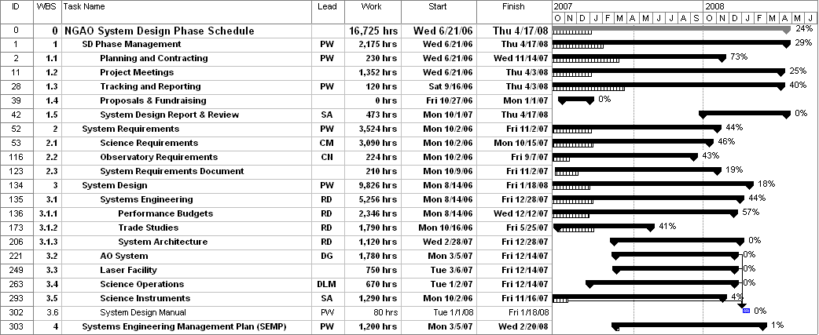

The replanned schedule is shown below through mid-April. The percent complete is shown as 34% due to the restructuring.
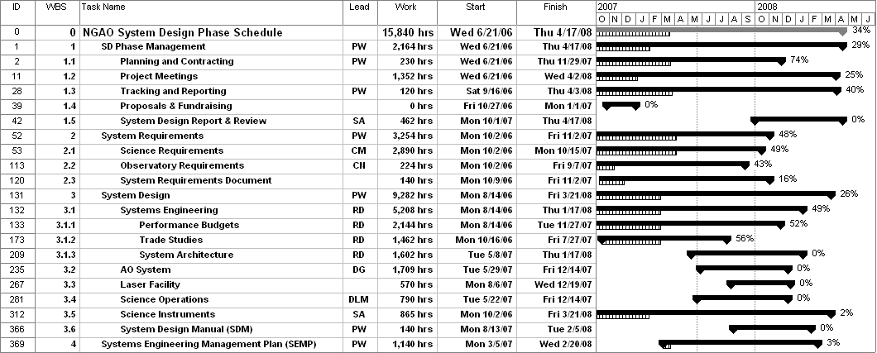

A high level snapshot of the tracked version of the replanned schedule through mid-June is shown below with 38% complete. Note that the % of work completed is only 36%.

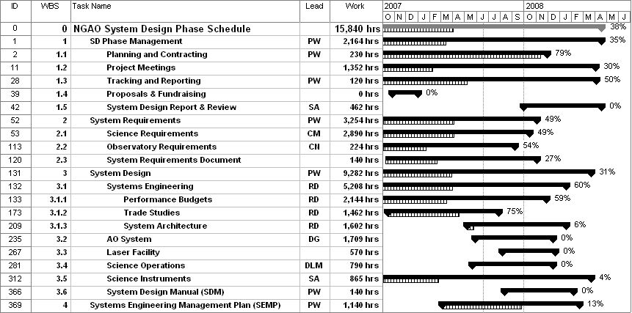

Financial Summary

The schedule shows 38% of the system design phase activities complete through mid-June. The budget shows 37% of the system design phase budget ($1142.8k including contingency) spent through May.

The average number of FTEs working on the NGAO system design tasks at our three institutions was 5.3 in the first eight months of FY07 versus the ~ 6 FTE level in the SEMP. The total expenditure through the end of May is $427.5k. This represents 52% of the $818k FY07 budget versus the ~ 67% level planned in the SEMP.

WMKO Report: The following table lists the WMKO FTEs and total costs through May, along with the year to date (YTD) total and the FY plan from the SEMP (not from the replan). WMKO is only slightly below the ~67% level expected in both FTEs and personnel costs.

Category | Oct | Nov | Dec | Jan | Feb | Mar | Apr | May | YTD | FY Plan | % Spent
Personnel (FTEs) | 2.1 | 2.5 | 1.4 | 3.2 | 3.7 | 2.5 | 3.2 | 2.6 | 1.8 | 2.8 | 64%
Personnel ($k) | 16.1 | 27.1 | 11.0 | 31.8 | 27.3 | 22.4 | 29.5 | 26.4 | 191.7 | 305.5 | 63%
Travel, phone ($k) | 0.1 | 2.5 | 0.1 | 0.6 | 0.1 | 0.1 | 2.7 | 1.7 | 7.7 | 13.3 | 58%
Total ($k) | 16.2 | 29.5 | 11.1 | 32.4 | 27.4 | 22.4 | 32.2 | 28.1 | 199.4 | 318.8 | 63%

COO Report: The following table lists the COO FTEs and total personnel costs through May. COO is significantly (~25%) below the expected number of FTEs however this has apparently been somewhat compensated with higher level FTEs as seen by the personnel dollars.

Category | Oct | Nov | Dec | Jan | Feb | Mar | Apr | May | YTD | FY Plan | % Spent
Personnel (FTEs) | 0.3 | 1.1 | 0.7 | 1.3 | 1.8 | 1.3 | 1.8 | 1.1 | 0.8 | 1.6 | 49%
Personnel ($k) | 6.9 | 15.1 | 11.4 | 22.2 | 26.5 | 16.0 | 33.5 | 15.7 | 147.3 | 232.5 | 63%
Travel, phone ($k) | 0.0 | 0.2 | 0.1 | 4.3 | 0.3 | 0.0 | 0.0 | 0.0 | 4.9 | 13.3 | 37%
Total ($k) | 6.9 | 15.3 | 11.5 | 26.5 | 26.8 | 16.0 | 33.5 | 15.7 | 152.3 | 245.8 | 62%

UCO/Lick Report: The following table lists the UCO/Lick FTEs and total personnel costs through May. UCO is low in both FTEs and personnel costs versus the plan. The FTEs are higher than the personnel costs because these extra no-cost LAO personnel were not in the MS project plan.

Category | Oct | Nov | Dec | Jan | Feb | Mar | Apr | May | YTD | FY Plan | % Spent
Personnel (FTEs) | 1.7 | 1.7 | 1.3 | 1.2 | 1.4 | 1.6 | 1.6 | 1.6 | 1.0 | 1.7 | 59%
Personnel ($k) | 6.8 | 7.8 | 7.0 | 8.1 | 8.6 | 10.6 | 10.6 | 10.6 | 70.2 | 162.6 | 43%
Travel, phone ($k) | 0.0 | 0.0 | 0.0 | 0.7 | 4.4 | 0.0 | 0.4 | 0.1 | 5.6 | 13.3 | 42%
Total ($k) | 6.8 | 7.8 | 7.0 | 8.9 | 13.0 | 10.6 | 11.0 | 10.7 | 75.8 | 175.9 | 43%

A postdoc is included in the UCO budget. The postdoc, Elizabeth McGrath, has started work at a 3 days/week level, but will not be charged to the project until late Aug. once she has completed her Ph.D. defense.

Science Case Requirements Report: The SEMP does include 620 hours ($19k) for graduate students to support the science case development. None of these funds have been spent or committed to date, although discussions are underway to fund a student of F. Marchis. Project scientist and science community participation, which is “free” to the project, is not tracked.

