 Keck Adaptive Optics Note 642

NGAO Design Changes
in Support of the Build-to-Cost Guidelines

P. Wizinowich, S. Adkins, R. Dekany, D. Gavel, C. Max
with input from the NGAO team
March 6, 2009

Introduction
The purpose of this note is to summarize the design changes that have been selected subsequent to the NGAO System Design Review (SDR). These changes have been driven by the need to satisfy the cost cap imposed by the Directors in August, 2008.

The SDR-level design is summarized in the system design manual (SDM; KAON 511). This KAON should be viewed as an addendum to the SDM. An updated SDM incorporated these changes and the preliminary design work will be produced for the preliminary design.

We first discuss the changes at a system level and follow this with a summary at the WBS level.

System Overview
The new NGAO architecture is shown schematically in the following figure.

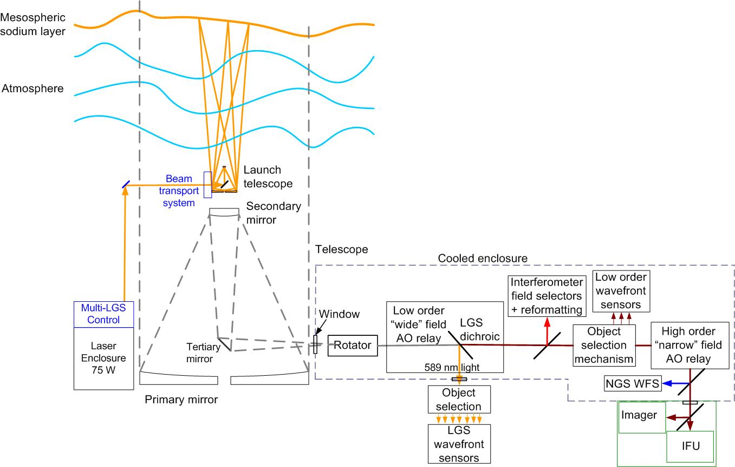

The design changes can be summarized into the following categories:
- Architectural changes allowed by no deployable multiple integral field spectrographs (IFS).
  - The LGS architecture now consists of a fixed “3+1” LGS asterism to perform tomography over a small on-axis science field and three deployable LGS to sharpen the three tip-tilt stars.
  - The high order narrow field relay is now located after the LOWFS pick-ups as opposed to in reflection off a dichroic placed in front of the LOWFS.
- New design choices that don’t impact the requirements.
  - The volume of the cooled AO enclosure is now minimized to just enclose primarily the science path optics and not the science instruments or LGS WFS.
  - The lasers are now located on the elevation moving part of the telescope.
- Design choices with minor science implications.
  - The field of view through the low order wide field relay has been reduced from 150” to 120” in diameter.
  - The LOWFS pick-offs move around the field as before, however there is no dichroic to split the light between the LOWFS and narrow field science instruments.
  - There is now no TWFS in the narrow field relay.
  - The TWFS in one of the LOWFS arms now uses a visible detector instead of an IR detector.
  - Only one lenslet array is available with the LGS WFS.
  - Only two lenslet arrays are available with the NGS WFS.
  - There is no ADC for the NGS WFS.
  - There is no ADC for the LOWFS.
- Science instruments.
  - The initially proposed instrument complement consisted of a deployable multiple IFS instrument, a NIR imager and a visible imager.
  - The new instrument complement consists of a single channel IFS and imager that operate from 0.8 to 2.4 μm.

No Multiple Deployable Integral Field Unit Instrument

Requirement Change
The primary requirement change driving the design changes is the decision not to support a multiple deployable integral field unit (d-IFU) instrument. The science field was reduced as a result from 120” diameter to a maximum of 40” diameter. This requirement change allowed us to select new architectures for the laser guide stars (LGS) and the optics bench that provided significant cost savings.

LGS Architecture Change
The LGS architecture at SDR included nine independently deployable LGS beacons, with a combined power of 100W, and a corresponding number of deployable LGS wavefront sensors (WFS). This number of beacons was required to perform tomography over a 120” diameter science field and a 150” diameter for guide stars.

The new baseline LGS architecture that we have arrived at based on the elimination of a deployable integral field unit instrument is the following:
- A fixed LGS asterism consisting of one on-axis LGS and three fixed LGS symmetrically located on a radius, R. The optimal value of R is to be determined from analysis. This “3+1” asterism is used for laser tomography over the science field. A total of 50W of laser power will be distributed uniformly between these four LGS.
- Three movable or point-and-shoot (PNS) LGS to be used to sharpen the three natural guide stars used to provide tip-tilt information (one will also be used for focus, astigmatism and high order low bandwidth information). These LGS are used as part of single LGS AO systems. A total of 25W of laser power will be distributed uniformly between these three LGS.

The new LGS asterism is shown schematically in the following figure.
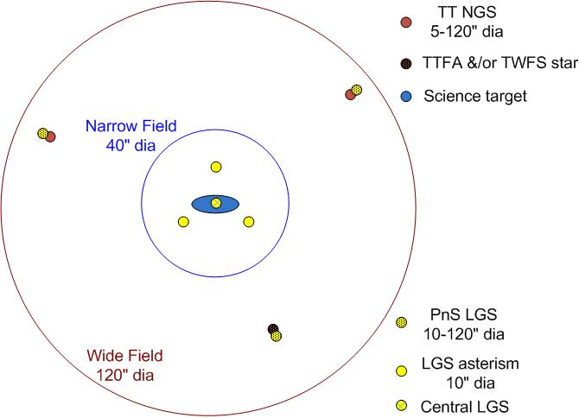

Note that this change has allowed reduced laser power (75W versus 100W). This change has impacts on the laser and laser launch facility, the LGS WFS, the real-time control (RTC) system and on the non-RTC system (primarily reduced motion control).

Optics Bench Architecture Change
The optical switchyard architecture at SDR included a six position dichroic changer after the 1st relay that transmitted the light to the d-IFU and to the three low order WFS (LOWFS), and reflected light to the 2nd relay.

The absence of the d-IFU means that there is no need to have a relatively expensive dichroic switcher after the 1st relay. The absence of a dichroic also has the advantage of higher throughput to the LOWFS, science instrument and NGS WFS The optics bench architecture has therefore changed such that the 2nd relay is in transmission (as opposed to reflection) after the 1st relay. The LOWFS are fed by pickoff arms that would vignette the science field if guide stars are selected which are within the science field. This approach therefore precludes using the science object as a guide star.

This approach also precludes an LGS fixed pupil mode since the on-axis science target cannot provide the tip-tilt information. This fixed pupil mode could be made available again if the NGS WFS had a mode with a few or a single subaperture.

Additional System Level Changes

Cooling of the Science Path
The SDR level design called for cooling of the entire AO enclosure. We reminded ourselves that it was only important to cool the science path optics. The new cooling approach is therefore to minimize the cooling volume. To the extent possible only the science path optics will be in a cooled environment.

The front face of the science instruments will interface to this cooled environment in such a way to form a seal for the cooled environment.

The LGS WFS unit should be outside the cooled enclosure, which does require a pair of windows, perhaps representing some of the LGS WFS optics, to provide a transmission path to the LGS WFS. This will allow access to the most complicated optics assembly while minimizing the volume of the cooled environment.

Science Instruments
One combined imager and IFU science instrument (in a single dewar) is currently planned to be built for NGAO. Both the imager and IFU extend from 0.818 to 2.4 μm (z to K-band). Both instruments will use Hawaii-4RG detectors with 15 μm pixels. The imager will have one plate scale (~8.5 mas) for a field size of 35”x35”, and a simple coronagraph. The IFU will have three spatial scales (~10, ~ 20 to 35, and ~50 to 75 mas) for a maximum field size of 4”x4”, and a spectral resolution of ~4000. Both instruments will be on-axis.

We are currently assuming that the IFU can provide better performance and capabilities than OSIRIS, so OSIRIS will not be implemented with NGAO (this may be revisited if we can find a lower cost solution by including OSIRIS).

Wavefront Sensors
A number of design changes have been selected for the various WFS for cost reasons:
- The LGS WFS will only have one lenslet array options (versus three in the SDR design).
- Overall we have reduced the priority on NGS wavefront sensing:
  - The NGS WFS will only have two lenslet array options (versus three in the SDR design).
  - The NGS WFS will not have an ADC.
  - The NGS WFS dichroic will only reflect 0.4 to 0.8 μm light to the NGS WFS.
  - The LGS dichroic shall be fixed.
- There will be no truth wavefront sensor (TWFS) after the 2nd relay.
- The TWFS that is in the same unit as one of the LOWFS will use a visible detector instead of an IR detector.
- The uplink tip-tilt (UTT) mirrors will be located in front of the LGS WFS instead of in the laser launch facility.
- No ADCs will be implemented for the LOWFS.

Laser Launch Facility
We have submitted a NSF MRI proposal to implement a center launch telescope for the Keck II LGS AO facility as a phase implementation step toward NGAO. We should therefore assume this launch telescope, which is a duplicate of the Keck I launch telescope produced by Galileo Avionica, in our design work. We should also maximize the benefit to NGAO in this implementation.

Lasers
ESO has funded two companies to produce laser preliminary designs. We have had some input to the ESO specifications and we will be participating in the preliminary design including funding some additional risk reduction activities. ESO intends to procure four ~ 25W lasers at the end of this preliminary design based on the designs and firm fixed price quotes from the vendors.

We will most likely procure the same lasers as ESO with some modifications for our facilities. Given this assumption then we can use the ESO specifications with minor modifications to define the NGAO lasers and laser facilities. In particular, these lasers can be mounted on the elevation moving part of the telescope which would remove the need for a tracking beam transport system.

Design Changes by WBS

AO Enclosure (WBS 4.1)
The cooled enclosure should cover the minimum volume consistent with enclosing the science path optics. The science instruments and LGS WFS should be located outside of the cooled volume. The front face of the science instruments should form a seal with the cooled enclosure.

Optical Relays (WBS 4.2.1)
The reduction of the wide field relay field diameter from 150 to 120" has allowed the wide field optical relay design to be re-evaluated. The baseline design is now to use a 100 mm diameter woofer DM and to have the entire first relay on a single level as opposed to the two-tier approach presented at the SDR.

Optical Switchyard (WBS 4.2.4)
Table 1 in the SDM includes a summary of the required dichroics and mirrors. This should be replaced with the table below. This table includes the following major changes:
- No LGS dichroic changer. The LGS dichroic is always in the beam.
- No LGS acquisition fold. It had already been identified at the SDR that a separation acquisition camera was not needed.
- No post relay 1 dichroics.
- No visible imager dichroic.
- No OSIRIS fold mirror.

LGS WFS Assembly (WBS 4.2.5)
The following design changes have been made:
- The UTT mirrors are to be incorporated in the LGS WFS assembly.
- The LGS WFS relay optics from the LGS dichroic should include two windows to separate the LGS WFS assembly from the science path cold enclosure.
- The LGS WFS assembly will be at dome ambient temperature, but will still be protected from dust.
- Two LGS WFS units have been removed.
- The central four LGS WFS units are nominally fixed with one on-axis and the other three uniformly spaced on a TBD radius (likely ~ 10”).
- The central four LGS WFS should have a common focus mechanism to stay conjugate to the sodium layer.
- Three LGS WFS should be deployable about a 120” diameter field.
- Only two LGS WFS plate scales will be provided (i.e., two lenslet arrays).

NGS WFS / TWFS Assembly (WBS 4.2.6)
The following design changes (in other WBS) may affect the NGS WFS design:
- The LGS dichroic will always be left in the beam.
- The NGS WFS dichroic will only reflect 0.4 to 0.8 μm light to the NGS WFS.
- The NGS WFS will not have an ADC.

The following design changes are specific to this WBS:
- The TWFS should be removed from this assembly.
- The NGS WFS will only have two lenslet array options (versus three in the SDR design).

LOWFS Assembly (WBS 4.2.7)
The TWFS detector should be changed from an IR detector to a visible detector to save costs.

Atmospheric Dispersion Correctors (WBS 4.2.10)
The following design or rather requirement changes have been made (the numbering corresponds to the numbers in section 3.3.1.10 of the SDM):
- The NIR ADC in the narrow field path to the NIR imager must now provide correction down to 0.8 μm. Somewhat reduced performance may be acceptable between 0.8 and 0.95 μm. This ADC will now provide correction for the imager and IFU, but not for OSIRIS.
- A separate visible ADC is no longer required unless this is required to achieve the wavelength range defined under item 1.
- A visible ADC is not required for the NGS WFS.
- A NIR ADC is not required for each LOWFS. It would be worthwhile to design the LOWFS pick-offs so that these could be added in future if they were desired as an upgrade.
- No d-IFS so no NIR ADCs are required for these.

Non-real-time Control (WBS 4.4)
The number of devices to be controlled has been reduced as follows: 2 less LGS WFS cameras, 2 less UTT mirrors and no d-IFS units (DM/TT).

All changes to the non-RTC motion control are highlighted in red in the following table. The total number of motion control degrees of freedom has been reduced by ~ 35% from 215 to 136.

A new functional requirement to be evaluated is whether we need feedback from the LOWFS to control the image rotator position or rotation rate.

We need to evaluate whether the tweeter DM should be mounted on a relatively slow tip-tilt stage to support dithering of the science object on the science instrument.

Real-time Control (WBS 4.5)
The changes that impact the RTC design include the following:
- Seven instead of nine LGS WFS and UTTs.
- Tomography only needs to be performed with the central “3+1” LGS asterism over a ~ 40” diameter science field for the imager and a ~ 5” diameter science field for the IFU.
- Three independent point-and-shoot AO control loops must be supported.
- Only one LGS WFS subaperture scales need to be supported. This should be assumed to be 64 subapertures across the pupil.
- Only two NGS WFS subaperture scales need to be supported.
- No multi-IFU science needs to be supported.
- A fast tip-tilt mechanism for the tweeter DM is no longer required.
- We need to evaluate whether the tweeter DM should be mounted on a relatively slow tip-tilt stage to support dithering of the science object on the science instrument.

Laser Enclosure (WBS 5.1)
The baseline is now that the lasers will be mounted on the elevation ring of the telescope in a similar location to the Keck II dye laser amplifier bench. If necessary one of the three lasers can be mounted on the bottom left face of the elevation ring (the Keck II laser bench is on the bottom right face of the elevation ring). No clean room will need to be provided around the vendor supplied laser enclosures.

Laser (WBS 5.2)
The laser specifications used should largely be the ESO specifications for their 4LGS facility. Some of these specifications will need to be modified to satisfy US or WMKO standards. Both laser preliminary designs being funded by ESO assume that the lasers will be mounted on the elevation moving part of the telescope. We should make the same assumption for Keck unless we see a significant advantage to putting the lasers on or under the Nasmyth platforms.

Laser Launch Facility (WBS 5.3)
A proposal was submitted to the NSF MRI program to implement a center launch telescope for NGAO that would be used with Keck II LGS AO in the meantime. The launch telescope that should be assumed is the Galileo Avionica launch telescope that has been procured for Keck I.

The LGS asterism generator should be significantly simpler. Two of the ~25W lasers will send their light to the four fixed LGS (2 LGS beacons per laser). One of the ~25W lasers will be used to feed the three point-and-shoot LGS. The central “3+1” LGS asterism will be centered on the on-axis science instruments and will not be required to move.

The beam transport system should be significantly simpler with the lasers mounted on the elevation ring. The tracking beam transport system between the Nasmyth platform and the elevation moving part of the telescope is no longer required. Pointing and centering mirrors are still needed to deal with slow changes (e.g., laser pointing, telescope flexures and temperature changes).

The UTT mirrors are no longer part of the launch facility; they are now part of the LGS WFS assembly.

Laser System Lab I&T (WBS 5.6)
A lab exists at Keck headquarters that includes the required infrastructure for the Keck I laser lab I&T. This lab and its infrastructure will be used for the NGAO laser lab I&T.

Infrastructure Modifications for AO (WBS 7.2)
The infrastructure modifications required for AO should be reduced by the new plan to minimize the volume to be cooled.

Infrastructure Modifications for Laser (WBS 7.3)
The infrastructure only needs to support three ~25W lasers. The infrastructure should be capable of being modified in the future to handle a 4th laser, but these modifications should not be implemented as part of the NGAO build-to-cost facility.

OSIRIS Modifications (WBS 7.4)
OSIRIS will not be used with NGAO. OSIRIS will remain with the Keck I LGS AO system.

Laser System Install + I&T (WBS 8.5)
The complexity of the system to be installed has been reduced. For example, no tracking beam transport system is now needed between the Nasmyth platform and the elevation moving part of the telescope.

