 Keck Adaptive Optics Note 516

Keck Next Generation Adaptive Optics
System Design Phase Early-FY08 Replan

P. Wizinowich, R. Dekany, D. Gavel, C. Max,
E. Johansson, D. Le Mignant, C. Neyman
November 29, 2007

Introduction

The NGAO System Design phase mid-year replan is summarized in KAON 481 dated May 22, 2007. Our status versus this plan has recently been summarized in Progress Report #5 (KAON 514). The purpose of this KAON is to support a replan that will allow us to complete the system design phase on schedule and within budget.

Pre-replan Status

Overall we are behind on the schedule and underperforming in terms of earned value.

2.1 MS Project Plan Status
The schedule status is shown below; the plan is tracked as 50% complete as of the end of October, 2007.

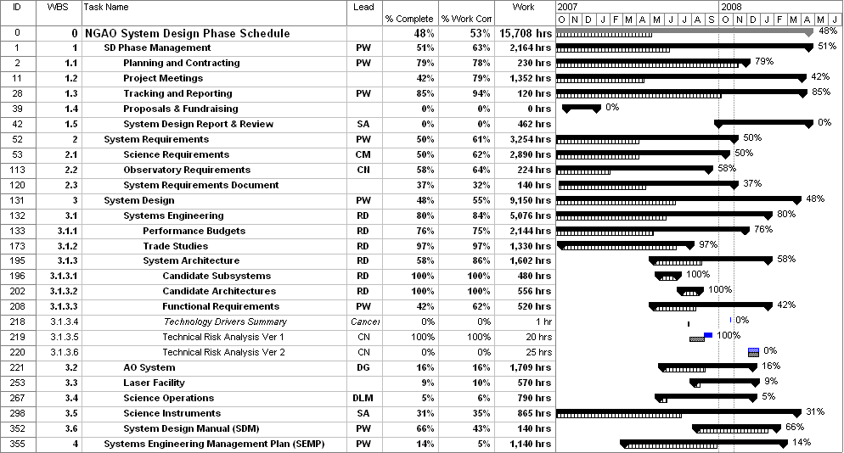

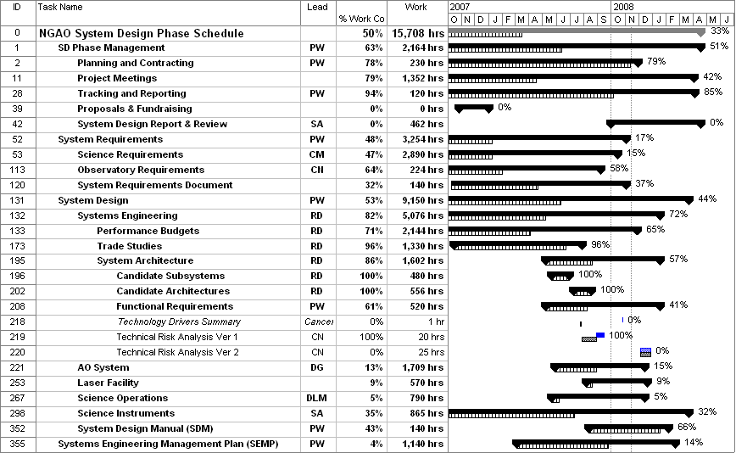

Note that in the above Figure that the % of work complete is shown in a column, whereas the % complete by duration is shown next to the schedule bars. For our purposes the % complete by work is the relevant number.

The MS Project Plan (as opposed to the actuals) indicates a total cost of $911.8k (these are just labor costs). The MS Project cost complete through October is $495.3k with $416.5k remaining. The percent of labor cost complete is therefore 54%. The remaining work totals 7899 hours.

2.2 Milestones Status
Milestones 1-5, 7, 9 and 10 have been completed through October. Two milestones are behind schedule (SRD versions 2 and 3) and five milestones are in the future. The percentage of complete milestones is 8/15 = 53%.

2.3 Priorities versus Time Status
The following list and schedule of key tasks was defined in the mid-year replan. The text in blue and green indicates our current status versus these tasks through October. There are 32 priority items in this list of which 25 represented completions. Of these 25 items a total of 15.5 have been completed for a completion rate of 62%.

- May/07
  - Complete Science Case Requirements Document (SCRD) v2. Not done.
  - Complete System Requirements Document (SRD) v2. Not done.
  - Complete performance budgets. Done for planned tasks, except for polarimetry by Aug.
  - Complete trade studies. Done for all but object selection by Sept.
  - Define candidate subsystems. Done.
  - Initial draft (v0) of Functional Requirements Document (FRD). Done.
  - Complete Science Instrument FRD v1. Not done.
- Jun/07
  - Progress Report #3 & SSC meeting. Done.
  - Complete performance budget summary v1. Done on July 8.
  - Evaluate candidate subsystems. Done.
  - Start Science Operations design work. Not started.
- Jul/07
  - Complete SCRD v3. Not started.
  - Complete candidate subsystems. Done.
  - Define candidate architectures. Done.
  - Science Operations design work. Started in Oct.
- Aug/07
  - Complete SRD v3. Not started.
  - Evaluate candidate architectures. Done.
  - Select candidate architecture(s). Done.
  - Complete FRD v1 for AO System, Laser Facility & Science Operations. Started, for all but science ops. FRD v1 for AO system and laser facility done in Oct.
  - Start Laser Facility design work. Started in Sept.
  - Science Operations design work. Not done.
- Sept/07
  - Progress Report #4 & Keck Science Meeting. Done.
  - Complete technical risk analysis v1. v0.5 done in Sept., completed in Oct.
  - Start AO System design work. Started.
  - Laser Facility and Science Operations design work. Some done.
  - Complete Deployable NIR IFU report v1. Done in Oct. with ATI proposal.
  - Complete System Design Manual (SDM) v1. Done in Oct.
- Oct/07
  - Complete SCRD v4. Not started.
  - Complete performance budgets summary v2. Not started.
  - AO System, Laser Facility and Science Operations design work. Yes.
  - Complete single object imagers/low resolution spectrographs report v1. Not done.
  - Start SEMP, including cost review. Not started.

2.4 Budget Status through FY07
The budget actuals by month are shown in the following table. Overall the budget is fairly well on track for FY07 versus the SEMP FY07 Plan with 92% of the FY07 planned budget having been spent. However, this also represents 64% of the total system design phase budget, including contingency, of $1142.8k.

Category | Oct | Nov | Dec | Jan | Feb | Mar | Apr | May | Jun | Jul | Aug | Sept | YTD | FY Plan | % Spent
Personnel (FTEs) | 4.1 | 5.2 | 3.4 | 5.7 | 6.9 | 5.4 | 6.5 | 5.2 | 5.0 | 5.3 | 5.6 | 7.2 | 5.4 | 6.1 | 90%
Personnel ($k) | 29.8 | 50.0 | 29.5 | 62.2 | 62.3 | 49.0 | 73.7 | 52.8 | 56.0 | 69.8 | 73.1 | 78.6 | 686.8 | 700.6 | 98%
Travel, phone ($k) | 0.1 | 2.7 | 0.2 | 5.6 | 4.8 | 0.1 | 3.1 | 1.7 | 2.4 | 7.3 | 7.2 | 2.1 | 37.2 | 39.9 | 93%
Students ($k) | 0.0 | 0.0 | 0.0 | 0.0 | 0.0 | 0.0 | 0.0 | 0.0 | 0.0 | 0.0 | 3.1 | 3.1 | 6.2 | 57.4 | 11%
Total ($k) | 29.9 | 52.6 | 29.6 | 67.8 | 67.2 | 49.1 | 76.8 | 54.5 | 58.4 | 77.1 | 83.4 | 83.9 | 730.2 | 797.9 | 92%

The following plot of the costs at each Institution by month. Overall WMKO and COO spent $8.3k and $10.5k, respectively, more than planned for FY07, while UCO under spent by $35.2k.

The cost of FTEs was the same as planned at WMKO. COO FTEs were 12% more expensive than planned representing an extra cost of $17k in FY07. UCO FTEs were 2.6% more expensive than planned representing an extra cost of $1.3k.

2.5 Budget and Schedule Comparison
The discrepancy between dollars spent and work completed is shown in the following plot. A potential discrepancy was noted in the preparation of Progress Report #4 in Sept. (note that only the July actuals were available for the Sept. report). The discrepancy has become very clear in the preparation of Progress Report #5. The actuals through Oct/07 are shown in the following plot. As of the end of October 70% of the budget has been spent, resulting in an ~ 17% or an ~$200k problem.

2.6 % Complete versus Budget – Explanation of Discrepancy
The magnitude of the discrepancy as of the end of Oct. is estimated to be ~ $200k. Potential explanations of the discrepancy include the following:
- The primary explanation is that our efficiency has not been as good as we had planned for. Either we underestimated tasks or we were less effective in completing them.
- As mentioned in section 2.4 FTE were slightly more expensive than planned resulting in a cost increase of $18k.
- Progress versus plan on the subsystem design phase. We have introduced a number of new people to NGAO (Chin, Johansson, Kupke, Lockwood, Reinig) as well as starting the new tasks that make up the subsystem design phase. These people have required time to get up to speed that was not planned for. The new personnel in Sept. accounted for 1.1 FTEs at Keck and 0.1 FTEs at UCO. This corresponds to ~ $10k.
- The work on the TSIP proposal was not in the plan. This represented 0.6 of Adkins in Aug. and perhaps another 0.2 of other FTEs that charged to NGAO. This corresponds to ~ $10k.
- The implementation of a requirements management tool was not in the plan. We decided to proceed with this task based on the longer term benefits to the project. This may have used ~ 0.5 FTEs that would have done other NGAO work. This corresponds to ~ $5k.
- The science requirements completeness was not updated in the last two project reports, and may therefore represent some additional % complete.
- Work on science requirements was originally planned to be largely free to the project. However, some senior personnel who charge to the project have had to work on this task.

System Design Phase Deliverables

The goals and deliverables of the System Design phase are discussed in section 3.1 and 8 of the NGAO System Design Phase Systems Engineering Management Plan (KAON 414). The following overall guideline is provided (Adkins, 2005):

“The principle objective of a system design is to establish a design approach that meets the scientific and user requirements established for the system. System design will establish a discipline integrated engineering plan for the proposed design, understand the technical risks, explore trade-offs, and determine estimates for performance and cost to completion.”

The major deliverables are the System Requirements Document (SRD), System Design Manual (SDM) and Systems Engineering Management Plan (SEMP). Each of these documents is a necessary precursor to the completion of the subsequent document. A System Design Report (SDR) provides a high level summary of the work done during the System Design phase.

The primary documents to be provided to the Reviewers are the following:
- SDR – provides an overview for all the work done during the system design and references the following documents as well as more detailed documents.
- SCRD & SRD – provide science and Observatory requirements
- SDM – provides design. Note that all the technical notes (not programmatic) will be referenced in this document. The technical risk analysis may be provided as a separate document.
- FRD – provides functional requirements (too large to include in the SDM)
- SEMP – provides the plan for moving forward, and likely an assessment of the system design phase programmatics as a basis for planning.

The remaining work in the NGAO SD phase is directly in support of completing the SRD, SDM and SEMP. WBS 2, 3 and 4 are directly in support of completing the SRD, SDM and SEMP, respectively. The SDR is produced as part of WBS 1.5. We should obviously keep these high level deliverables in mind as we replan.

Revised Milestones

The following table shows the status of the revised milestones produced in the mid-year replan. Eight of a total of fifteen milestones are complete (four have been completed since the mid-year replan) and the two SRD release milestones are behind schedule. Changes to these milestones are shown in italics. Milestones 6, 8 and 11 have all been delayed.

# | MILESTONE | DATE | DESCRIPTION | STATUS
1 | SD SEMP Approved | 10/9/06 | Approval of this plan by the Directors. Initial SEMP version released to Directors for comment on 9/12 & final version on 9/29/06. | Verbal approval received from individual Directors. Written approval requested.
2 | SD phase contracts in place | 10/27/06 | Contracts issued to Caltech & UCSC for the system design phase. | Complete
3 | Science Case Requirements Summary v1.0 Release | 10/27/06 | Initial Release of the Science Requirements as input to trade studies and performance budgeting | Complete
4 | System Requirements Document (SRD) v1.0 Release | 12/8/06 | Initial release of System Requirements with emphasis on the science requirements | Complete
5 | Performance Budgets Summary v1.0 Release | 6/15/07 | First round of all performance budgets complete & documented | Complete
6 | SRD v2.0 Release | 5/22/07  New: 12/20/07 | Second release of System Requirements Document | Nearing Completion
7 | Trade Studies Complete | 6/22/07 | All trade studies complete & documented (as a series of KAONs); with one new trade study excepted | Complete
8 | SRD v3.0 Release | 9/7/07 New:  2/12/08 | Third release of System Requirements | Not started
9 | System Design Manual v1.0 Release | 9/21/07 | First release of System Design Manual | Complete
10 | Technical Risk Analysis v1.0 Release | 9/21/07 | First round of project risk analysis complete & documented | Complete
11 | Cost Review Complete | 12/7/07  New:  1/30/08 | Project cost estimates complete, documented & internally reviewed | Some work done as part of system architecture activity
12 | SDM v2.0 Release | 2/12/08 | Final system design phase version
13 | System Design Review  Package Distributed | 3/4/08 | SDR documents sent to reviewers
14 | System Design Review | 3/31/08 | SDR meeting
15 | SDR Report & Project Planning Presentation at SSC meeting | 4/14/08 | Final SD phase report including results of SDR & project plans

Replan Changes

The replan details are tabulated in the “NGAO SD schedule v26.xls” spreadsheet under the “v26 Replan Changes” tab.

WBS 1 SD Phase Management. Total reduction = $5k + 56 hrs.
- WBS 1.2.2. Cancel the science advisory committee telecons since they have never happened. This is only 40h of Max which is free to the Project anyway. Deleted this item.
- WBS 1.2.3.12. Make the Dec. team meeting a videocon. ~ $5k savings on travel. This also saves travel time (which is not in the existing plan). Change the time assignments to the following: Add 8h each for McGrath and Johansson and 4h each to Le Mignant, Kupke. Lockwood, Reinig and Bell. Remove 8h each for Bauman and Flicker, and 4h each for Bouchez and Britton. Change the date to 12/1 from 12/12. This is a one-day meeting. Overall went from 80 to 92 hrs.
- WBS 1.2.3.13. Change the Jan. meeting from 1/9 to 1/23 and make this a cost review meeting. Change Bauman to Adkins and Bouchez to Johansson. Remove Flicker and Britton. Make this an all day meeting so remaining people are increased from 4 to 8h. Overall went from 40 to 72 hrs.
- WBS 1.3.9. Move the SSC meeting from 1/24 to 2/20 per their new schedule.
- WBS 1.3.10. Move the SSC meeting from 4/3 to 4/29 per their new schedule.
- WBS 1.5.2.4. Remove the following people from the SDR support: Bauman (12h), Bouchez (4h), Chin (8h), Flicker (16h), Moore (16h) for a total of 56 hours.

WBS 2.1 Science Requirements. Total reduction = 40 hrs.
- WBS 2.1. Make all the remaining student labor free. The only student charging is Marchis’ student and that contract is tracked separately. Subsequently all student labor removed.
- WBS 2.1.1.1. Changed title from “Companions & Multiplicity of Small Solar System Bodies” to “Mulitiplicity of Minor Planets”. Identified this as a “Key” science case.
  - WBS 2.1.1.1.1-4. Delete existing tasks. 2.1.1.1.1 had 100 hrs of student with 75% complete, 2 had 100 hrs of student with 85% complete, 3 had 25 hrs of student with 80% complete and 4 had 25 hrs of Le Mignant with 80% complete.
  - New WBS 2.1.1.1.1 is Minor Planets Survey Requirements.
  - New WBS 2.1.1.1.2 is Minor Planet Orbit Determination Requirements.
- Every science case has been given four sub-WBS: Science Requirements, AO Requirements, Observing Requirements & Instrument Requirements. The people assigned are some combination of Le Mignant, Max and McGrath. The percent completes were left at roughly the same as prior to the replan, so the hours that were entered were chosen so as to achieve the estimated amount of needed remaining work. The dates for all of these sub-WBS were put from 12/4/06 to 2/28/08.
- WBS 2.1.1.2. “Moons of the Giant Planets” was replaced by “Giant Planets & Their Moons”. 2.1.1.2.1 became “Giant Planet Requirements & 2.1.1.2.2 became “Giant Planet Moons Requirements”. Student1 totaling 125 hrs, with 105 hrs remaining was deleted as well as 25 hrs of Le Mignant with 12.5 hrs remaining. This was replaced by 12 hrs of Le Mignant (10.hrs remaining) on Giant Planets and 20 hrs of Le Mignant (10 hrs remaining) on the Moons.
- WBS 2.1.1.3. Deleted 250 hrs of Student1 (70 hrs remaining) and replaced with 16.6 hrs each of Le Mignant & McGrath (5 hrs each remaining).
- WBS 2.1.2.1. Changed name from “Galactic Center Proper Motions: Astrometry” to “General Relativity at the Galactic Center (Key)”. Inserted “GR Astrometry Requirements” as 2.1.2.1.1 and “GR Radial Velocity Requirements” as 2.1.2.1.2. Deleted the 200 hrs of Student2 (102.5 hrs remaining) for astrometry and under the old 2.1.2.2 the 200 hrs of Student2 (97.5 hrs remaining). Inserted 40 hrs of Max (20 hrs remaining) for astrometry and 20 hrs of Max (10 hrs) remaining for radial velocities.
- WBS 2.1.2.2. Changed name from “Galactic Center Radial Velocities & Stellar Populations: Integral Field Spectroscopy” to “Resolved Stellar Populations at the Galactic Center”. No work assigned. Labeled to be done during PDR.
- WBS 2.1.2.4. Deleted the 200 hrs of Student2 (85 hrs remaining) & replaced with 24 hrs of Max (9.6 hrs remaining).
- WBS 2.1.2.5. Changed name from “Debris Disks, Protostellar Envelopes & Outflows: Contrast” to “Debris & Protoplanetary Disks”. Removed the 200 hrs of Student2 (180 hrs remaining) & inserted 10 hrs each of Le Mignant and Max (9 hrs remaining for each).
- WBS 2.1.2.6. Changed name from “Debris Disks, Protostellar Envelopes & Outflows: Polarimetry” to “Young Stellar Objects”. Removed the 200 hrs of Student2 (200 hrs remaining) & inserted 20 hrs each of Max and McGrath (all remaining).
- WBS 2.1.3.1. Reduced the 300 hrs of McGrath (122.5 hrs remaining) to 40 hrs McGrath (16 hrs remaining) & added 12 hrs of Max (4.8 hrs remaining).
- WBS 2.1.3.2. Reduced the 300 hrs of McGrath (95 hrs remaining) to 28 hrs each of McGrath & Max (8.4 hrs remaining of each).
- WBS 2.1.3.3. Changed name from “Nearby Galaxies” to “Nearby Active Galactic Nuclei (Key)”. Reduced the 200 hrs of McGrath (120 hrs remaining) to 32 hrs of Max (19.2 hrs remaining).
- WBS 2.1.3.4. Reduced the 200 hrs of McGrath (132.5 hrs remaining) to 32 hrs McGrath (19.2 hrs remaining.
- WBS 2.1.3.5 is a new WBS for QSO host galaxies. Included 24 hrs of McGrath with 19.2 hrs remaining.
- WBS 2.1.4.2. Moved end date of SCRD v2 to 12/20 from 6/1/07.
- WBS 2.1.4.3. Moved version 3 of SCRD dates. Was 6/5/07 to 7/9/07. Now 1/7/08 to 2/15/08. Replaced Wizinowich with McGrath.
- WBS 2.1.4.4. Canceled SCRD version 4 (WBS 2.1.4.4) to regain 40 hrs. Deleted from schedule.

WBS 2.2 Observatory Requirements & 2.3 System Requirements. Total reduction = 110 hrs.
- WBS 2.2.4. Moved end date of Observatory requirements v2 from 2/9 to 12/20. Deleted 10h of Chin and replaced Meguro with Bell.
- WBS 2.2.5. Deleted Obs requirements v3. Was 20h.
- WBS 2.2.6. Deleted Obs requirements v4. Was 20h.
- WBS 2.3.1.2. Traceability matrix v2. Extended end date from 2/27/07 to 12/20/07.
- WBS 2.3.1.3. Deleted traceability matrix v3. Was 20h.
- WBS 2.3.1.4. Deleted traceability matrix v4. Was 20h.
- WBS 2.3.2.4. Delete SRD v4. Was 20h.

WBS 3.1.1 Performance Budgets. Total reduction = 405 hrs.
- WBS 3.1.1.1.5.2. New model assumptions v2. Remove all 4 hrs of Flicker.
- WBS 3.1.1.2.5. LAO experiments. Removed 40 hrs of Dekany & called this 100% done.
- WBS 3.1.1.4.1. Document background performance analysis had been cancelled but 1 hr remained. Removed this 1 hr.
- WBS 3.1.1.5.2. WFE budget v2. Reduced Britton from 30 to 20 hrs. Was 6/19-9/28. Moved to 11/5-2/5/08.
- WBS 3.1.1.11. Observing Efficiency. Remove 40 hrs of “Other”.
- WBS 3.1.1.12. Observing Uptime. Remove 40 hrs of Chin & 20 hrs of Johansson.
- WBS 3.1.1.14.1. Remove the 80 hrs of all-in science simulations.
- WBS 3.1.1.13.2. Reduce the performance budget summary v2 from 60 to 20 hrs by zeroing Britton. Was 9/28-10/19/07. Moved this to 1/7-1/25/08.
- WBS 3.1.1.14.2.1. Remove 10 of 30h of point source sensitivities. Was 11/1-11/27. Move to 1/21-1/30/08.
- WBS 3.1.1.14.2.2. Remove the 100h for PSF uniformity and stability. Deleted.
- WBS 3.1.1.14.2.3. Remove the 20 hrs of “Other” under science products. Deleted.

WBS 3.1.2 Trade Studies.
- All the cancelled trade studies had already been deleted.
- Moved end date of object selection TS to 12/14/07 from 7/27/07.

WBS 3.1.3 System Architecture. Total reduction = 46 hr.
- WBS 3.1.3.3.5. Laser system function requirements v2. Moved 16 hrs of Chin to 8 hrs of Velur and 8 hrs of Neyman. Changed lead from Chin to Neyman.
- WBS 3.1.3.3.6. Science ops functional requirements v1. Reduce Le Mignant from 40 to 20 hrs. Reduce Wizinowich to 4 hrs. Add 6 hrs of McGrath. Move dates from 8/6-8/31 to 12/1-12/14/07.
- WBS 3.1.3.3.7. Science ops functional requirements v2. Replace 10 hrs of Other with McGrath. Reduce Le Mignant from 40 to 20 hrs. Move dates from 10/29-11/30 to 2/4-2/15/08.
- WBS 3.1.3.4. Technology drivers summary had already been cancelled. Removed the remaining 1 hr.
- WBS 3.1.3.6. Technical risk analysis v2. Reduced from 25 to 20 hrs. Transferred 10 hrs from Neyman to Wizinowich. Moved dates out from 12/3-12/28 to 1/16-1/31/08.

WBS 3.2 AO System. Total reduction = 402 hrs.
- WBS 3.2.3.1. Field rotation. Changed 30 hours of Bauman to Kupke per an earlier decision & put Lockwood as lead.
- WBS 3.2.3.2. Optical relay. Changed 40 hrs of Bauman to Kupke per an earlier decision & put Kupke as lead.
- WBS 3.2.3.3. Optical switchyard. Changed 25 hrs of Bauman to Kupke per an earlier decision & put Kupke as lead.
- WBS 3.2.3.4. Optical support structure. Removed 15 hrs of Bauman. Changed lead to Lockwood.
- WBS 3.2.3.9. Alignment, calibration, etc. Replaced 15 hrs of Flicker with Neyman.
- WBS 3.2.3.5. Changed 50 hrs of Meguro to Bell on the sub-tasks.
- WBS 3.2.3.6.1. Replace 10 hrs of Flicker with Neyman. Replace Bauman lead with Neyman. Remove 10 hrs of Bauman.
- WBS 3.2.3.6.2. DM. Remove 10 hrs of Bauman.
- WBS 3.2.3.6.3. Tip/tilt vibration mitigation. Removed 20 hrs of Johansson.
- WBS 3.2.3.10. Atmospheric profiler. Reduce Britton from 50 to 4 hrs. Add 4 hrs each of Neyman and Gavel to document requirements.
- WBS 3.2.3.11. Object selection. Removed 8 hrs from Moore and added 8 hrs of Velur. Removed 60 hrs from Meguro, and 20 hrs from Gavel. Changed Meguro to Bell. Changed end date to 12/14 from 11/7. Changed lead from Moore to Gavel.
- WBS 3.2.3.12. PSF monitoring camera. Increase Britton from 10 to 20 hrs to record his thoughts on this topic. Reduce Neyman from 20 to 5 hrs.
- WBS 3.2.4.1. Non-RTC Software. Reduced Johansson and Stomski each from 80 to 50 hrs and reduced Johnson from 10 to 6 hrs.
- WBS 3.2.4.2. Non-RTC Electronics. Reduced Chin from 60 to 32 hrs and Reinig from 60 to 0 hrs.
- WBS 3.2.5.1. RTC architecture analysis. Removed all 40 hrs of Flicker and 30 hrs of Reinig.
- WBS 3.2.5.2. RTC Software module definition. Removed 10 hrs of Reinig.
- WBS 3.2.5.3. RTC Hardware module definition. Removed 30 hrs of Reinig.

WBS 3.3 Laser Facility. Total reduction = 105 hrs.
- WBS 3. Made CN overall lead.
- WBS 3.3.2. Remove 40 hrs of the 80 hrs on laser enclosure. Changed Meguro to Bell.
- WBS 3.3.4.1. Laser pointing & diagnostics. Removed all 4 hrs of Chin.
- WBS 3.3.4.2. Removed all 10 hrs of Chin & all 15 hrs of Bauman. Partially replaced with 10 hrs of Neyman.
- WBS 3.3.4.3. Launch telescope. Removed all 10 hrs of Chin.
- WBS 3.3.5.1. Safety system. Removed 20 hrs of Chin & added 6 hrs of Neyman. Changed lead to Neyman. Will utilize K1 LGS safety documents to get requirements.
- WBS 3.3.5.2. Aircraft, LTCS, etc. safety. Removed 20 hrs of Chin and added 6 hrs of Neyman and 2 hrs of Summers.
- WBS 3.3.6.2. Laser system electronics. Reduced Chin from 70 to 30 hrs, and added Neyman for 30 hrs. Changed lead from Chin to Neyman.

WBS 3.4 Science Operations. Total reduction = 400 hrs.
- WBS 3.4.1.2.3. Instrument, AO & telescope observer interfaces. Replace Johansson with Le Mignant & reduce by 10 hrs.
- WBS 3.4.1.2.4. Science data quality monitoring. Replace McGrath with Le Mignant & reduce by 10 hrs.
- WBS 3.4.1.3.1. Generic data products. Replace McGrath with Le Mignant & reduce by 10 hrs.
- WBS 3.4.1.3.2. Science data quality assessment. Replace McGrath with Le Mignant & reduce by 10 hrs.
- WBS 3.4.1.3.3. Science data archiving. Replace McGrath with Le Mignant & reduce by 30 hrs.
- WBS 3.4.1.3.4. PSF Reconstruction. Reduced Le Mignant from 80 to 40 hrs.
- WBS 3.4.2.1.1. Reduced observing modes from 80 to 50 hrs. 20 hrs off Le Mignant and 10 hrs off McGrath.
- WBS 3.4.2.1.2. Reduced operations support from 20 to 10 hrs.
- WBS 3.4.2.1.3. Configuration & setup. Reduced Le Mignant from 20 to 10 hrs.
- WBS 3.4.2.1.4. AO-Instrument calibrations. Exchange van Dam for Le Mignant. Reduce by 10 hrs.
- WBS 3.4.2.1.5. Nighttime operation modes. Reduced Le Mignant from 20 to 10 hrs.
- WBS 3.4.2.1.7. Reduced health monitoring and automation from 20 to 0 hrs.
- WBS 3.4.2.1.9. Reduced user interfaces from 40 to 20 hrs.
- WBS 3.4.2.1.10. Removed all 20 hrs from maintenance plan.
- WBS 3.4.2.2.1. Reduced performance prediction from 80 to 10 hrs. Removed van Dam 20h. Replaced Flicker 60h with 10h of Le Mignant. Changed lead to Le Mignant.
- WBS 3.4.2.2.2. Reduced real-time optimization from 80 to 10 hrs. Removed van Dam 20h. Replaced Flicker 60h with 10h of Le Mignant. Changed lead to Le Mignant.
- WBS 3.4.2.2.3. Reduced environmental monitoring from 20 to 0 hrs.

WBS 3.5 Science Instruments. Total reduction = 377 hrs.
- WBS 3.5.1.3.2. Revised summary descriptions of instruments. Reduce Adkins from 20 to 8 hrs.
- WBS 3.5.1.4.1. Hardware instrument interfaces. Reduce Adkins and Meguro each by 12 hrs.
- WBS 3.5.1.4.2. Software instrument interfaces. Reduce Adkins and Johansson each by 12 hrs.
- WBS 3.5.2.5. DNIRI Concept Review with AO team. Replaced 2 hrs of ME 1 with Bell. Replaced 2 hrs of OE 1 with Gavel.
- WBS 3.5.2.7. Delete DNIRI report v2 to save 20 hrs.
- WBS 3.5.3.1. Remove 10 hrs remaining on SOI/LRS coronagraph requirements & call this 100% done.
- WBS 3.5.3.3. SOI/LRS Concept development. Note that this is already marked 50% complete. Replaced ME2 with Bell. Replaced OE2 with Adkins.
- WBS 3.5.3.5.1. Reduce SOI/LRS NIR v1 report form 30 to 25 hrs. Changes % complete from 50 to 60%.
- WBS 3.5.3.5.2. Reduce SOI/LRS vis v1 report from 30 to 25 hrs. Changes % complete from 50 to 60%.
- WBS 3.5.3.5.3. Delete SOI/LRS NIR v2 to save 12 hrs.
- WBS 3.5.3.5.4. Delete SOI/LRS vis v2 to save 12 hrs.
- WBS 3.5.4.2. Reduce the vis IFU requirements review from 8 to 4 hrs.
- WBS 3.5.4.3. Remove the 45 hrs for a vis IFU concept.
- WBS 3.5.4.4. Remove the 6 hrs for concept reviews.
- WBS 3.5.4.5.1. Reduce from 12 to 6 hrs the SOIFU NIR v1.
- WBS 3.5.4.5.2. Reduce from 30 to 2 hrs the SOIFU vis v1.
- WBS 3.5.4.5.3. Delete 8 hrs form SOIFU NIR v2
- WBS 3.5.4.5.4. Delete 20 hrs for SOIFU vis v2.
- WBS 3.5.5. Delete the special purpose high contrast instrument effort to regain 61 hrs.
- WBS 3.5.6. Remove the 30h of “Other” on the Interferometer, 6 hrs of Wizinowich and 8 hrs of Neyman.
- WBS 3.5.6. Reduce the OHANA effort from 40 to 10 hrs. Reduce Woillez from 30 to 4 hrs and Neyman from 10 to 6 hrs.
- WBS 3.5.7. Had been 1 hr on the canceled Thermal NIR imager. Just deleted task.

WBS 4 System Engineering Management Plan. Total reduction = 154 hrs.
- WBS 4.1.1. WBS & task definition. Reduced Wizinowich, Dekany and Gavel by 20 hrs each.
- WBS 4.1.2. Cost estimation. Moved from 10/26-11/30 to 1/7-2/11 (also impacted dependencies). Changed Meguro to Bell. Moved 10h of Chin to Wizinowich.
- WBS 4.1.3. Major Project Milestones. Reduced Dekany from 20 to 10 hrs.
- WBS 4.3.3. PD phase plan final version. Reduced Wizinowich, Dekany, Gavel and Max each by 2 hrs.
- WBS 4.4.1.4. Science instrument test plan. Reduced Adkins from 20 to 4 hrs.
- WBS 4.4.2. System I&T plans. Reduced Neyman from 90 to 80 hrs.
- WBS 4.5. CM plan. Removed 10 hrs of Chin. Reduced Johansson from 50 to 20 hrs. Exchanged Randolph for Bell and reduced from 20 to 10 hrs.
- For the moment decided not to reduce the SEMP hours further. Could potentially reduce the time on I&T planning or configuration management, but we will likely need more time on cost estimation for example.

Budget & Personnel Changes.
- The above reductions total 2362 hrs (excluding 885 hrs of student reduction) + $5k in travel. Based on the MS Project Plan this corresponds to a remaining cost of $291k (was $416k) for a reduction of $125k.
- Flicker has moved onto a CfAO funded project as of Nov. 1.
- Stopped using % complete which is intended to be a representation of the % completion of the duration and started using % work complete which is intended to be a representation of the % of the work that has been completed. Had to move the % complete values to the % work complete column.

New MS Project Plan

The new MS Project Plan (NGAO SD schedule v30.mpp) shows the system design phase as 59% complete with 4652 hours of work remaining. The remaining cost of $291k does not include the remaining travel, procurements and student costs, nor does it take into account that we need to pay McGrath full salary (these items are covered in section 8).

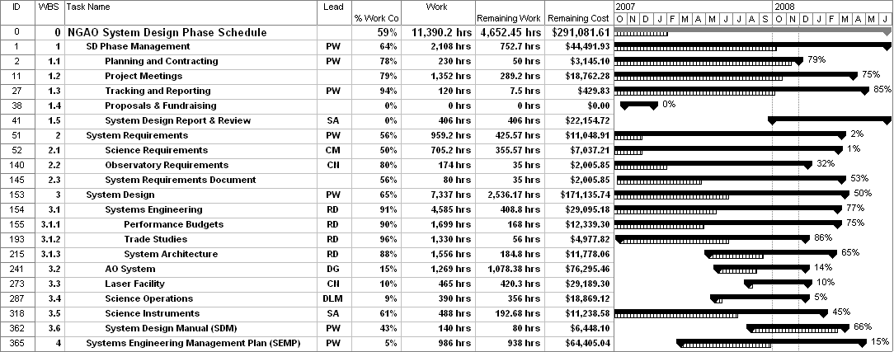

Note that not much effort went into rescheduling tasks in this replan activity. The focus was instead on budget. The schedule will be addressed by keeping the team focused on completing the subsystem design phase and the milestones.

Personnel Staffing

An alternate approach is to determine how much of each individual we will allow to charge over the remainder of the project. One way to do this is shown in the following table. The “Plan” column is directly from the MS Project Plan. The “Nov” to “Mar” hours are an estimate of how much time is needed from each individual balanced by how much time they might be available. These monthly hours are not yet consistent with the MS Project plan needs. The “Sum” used in the last column is the sum of the “Nov” to “Mar” hours. In general the “Plan-Sum” values should be zero; they are in general except for the case where we need to keep paying for an individual. Note that an effort has been made to switch to a more focused team after Dec.

Personnel Hours | Plan | Nov | Dec | Jan | Feb | Mar | Plan-Sum
Adkins | 185 | 40 | 70 | 55 | 10 | 10 | 0
Adkins(IPM) | 54 | 0 | 0 | 0 | 14 | 40 | 0
Bauman | 35 | 15 | 15 | 5 | 0 | 0 | 0
Bell | 139 | 40 | 60 | 35 | 0 | 4 | 0
Bouchez | 23 | 3 | 0 | 20 | 0 | 0 | 0
Britton | 90 | 5 | 70 | 10 | 0 | 5 | 0
Chin | 59 | 20 | 20 | 19 |  |  | 0
Dekany | 400 | 80 | 80 | 80 | 80 | 80 | 0
Flicker | 3 | 3 |  |  |  |  | 0
Gavel | 373 | 60 | 100 | 100 | 70 | 43 | 0
Ireland | 10 |  |  | 10 |  |  | 0
Johansson | 360 | 70 | 90 | 130 | 60 | 10 | 0
Johnson | 4 |  |  | 4 |  |  | 0
Kupke | 71 | 40 | 31 | 0 | 0 | 0 | 0
Le Mignant | 353 | 70 | 55 | 100 | 100 | 28 | 0
Lockwood | 71 | 40 | 31 | 0 | 0 | 0 | 0
Max | 394 | 80 | 80 | 90 | 90 | 54 | 0
McGrath | 245 | 160 | 160 | 160 | 160 | 160 | -555
Meguro | 47 | 5 | 40 | 2 | 0 | 0 | 0
Moore | 148 | 50 | 80 | 18 | 0 | 0 | 0
Neyman | 554 | 155 | 150 | 160 | 70 | 19 | 0
Reinig | 72 | 20 | 40 | 12 | 0 | 0 | 0
Stomski | 82 | 30 | 30 | 22 | 0 | 0 | 0
Summers | 12 | 0 | 10 | 2 | 0 | 0 | 0
Velur | 355 | 140 | 140 | 65 | 5 | 5 | 0
Wizinowich | 509 | 100 | 100 | 109 | 100 | 100 | 0
Woillez | 4 | 0 | 0 | 4 | 0 | 0 | 0
Total (hrs) = | 4652

- Budget Summary

The result of the replan is a total budget of $1147k by the end of Mar/08 as shown in the following table. This should be compared to our total budget of $1153k. This budget number needs confirmation. Note that in addition to the above personnel table a total of $6.2k was assumed for Marchis’ student in FY08, $6k for procurement of the Contour requirements management tool and $18k for travel.

Projected costs ($k) | Oct/06 to Oct/07 | Nov | Dec | Jan | Feb | Mar | Nov-Mar/07 | Total | SEMP
WMKO Personnel | 349.3 | 32.0 | 37.5 | 38.3 | 20.4 | 10.3 | 138.4 | 487.8 | 418.6
COO Personnel | 250.7 | 25.0 | 33.3 | 17.4 | 7.7 | 8.1 | 91.4 | 342.2 | 294.9
UCO Personnel | 147.4 | 19.7 | 24.4 | 18.3 | 13.7 | 10.5 | 86.5 | 233.9 | 218.1
SETI Contract | 9.3 | 3.1 | 3.1 |  |  |  | 6.2 | 15.5 | 57.4
Contour Procurement | 0.0 |  | 6 |  |  |  | 6.0 | 6.0 | 0
Travel | 43.9 | 4 |  |  | 2 | 12 | 18.0 | 61.9 | 60
Contingency |  |  |  |  |  |  |  |  | 103.9
Total | 800.6 | 83.8 | 104.3 | 73.9 | 43.7 | 40.9 | 346.6 | 1147.2 | 1152.9
 |  |  |  |  |  | Remaining = |  | 5.7

Conclusion

This replanning exercise has significantly reduced the budget problem by in general descoping tasks that are not critical to the SDR. The result of course is that work is pushed into the PDR phase. Unfortunately, we have no contingency remaining.

It will be important to keep the team on track for the SDR critical deliverables, to look for additional task reductions, and to carefully track both completion and actual costs in order to ensure we don’t go over budget.

