

Keck Adaptive Optics Note 511

Next Generation Adaptive Optics:
System Design Manual

Version 1.1
March 5, 2008

Author List
Name | Function
Peter Wizinowich | NGAO Executive Committee (EC) Chair
Richard Dekany | EC Member
Don Gavel | EC Member
Claire Max | EC Member & NGAO Science Team Chair
Sean Adkins | Instrument Program Manager

Contributors: Antonin Bouchez, Brian Bauman, Jim Bell, Matthew Britton, Jason Chin, Ralf Flicker, Erik Johansson, Renate Kupke, David Le Mignant, Chris Lockwood, Elizabeth McGrath, Anna Moore, Chris Neyman, Marco Reinig, Viswa Velur.

Approval Control
Control | Name | Function
Revised by:

Approved by:
Authorized by:

Document Change Record
Issue | Date | Change Description
Version 1.0 | October 31, 2007

1 Introduction 1
2 References 1
3 Design Overview 1
3.1 AO System Overview 1
3.2 Telescope and Facilities 3
3.2.1 Telescope Model 3
3.2.2 Facilities 5
3.2.3 Interfaces 5
3.3 AO System Description 5
3.3.1 AO Opto-Mechanical Design 5
3.3.1.1 Rotator and Wide Field Relay 8
3.3.1.2 LGS Wavefront Sensor Assembly and LGS Acquisition Camera Pickoff 10
3.3.1.3 Interferometer Pickoff 11
3.3.1.4 NGS Acquisition Camera Pickoff 12
3.3.1.5 Low Order Wavefront Sensor Assembly 12
3.3.1.6 Narrow Field Relay 12
3.3.1.7 Natural Guide Star and Truth Wavefront Sensors Pickoff 14
3.3.1.8 Narrow Field Science Instrument Pickoffs 14
3.3.1.9 Summary of Required Dichroics and Mirrors 15
3.3.1.10 Atmospheric Dispersion Correctors 16
3.3.1.11 Optics Bench Structure 16
3.3.2 Wavefront Sensor Opto-Mechanical Design 17
3.3.2.1 Low Order Wavefront Sensor Object Selection Mechanism 17
3.3.2.2 Tip-Tilt (Focus and Astigmatism) Sensors 17
3.3.2.3 Truth Wavefront Sensor 17
3.3.2.4 PSF Monitoring Camera 17
3.3.2.5 LGS Wavefront Sensor Object Selection Mechanism 17
3.3.2.6 LGS Wavefront Sensors 17
3.3.2.7 NGS Wavefront Sensors 18
3.3.3 AO Optical Performance 18
3.3.3.1 Wide Field Relay Optical Performance 18
3.3.3.2 Object Selection Mechanism Optical Performance 18
3.3.3.3 Narrow Field Relay Optical Performance 18
3.3.4 AO Enclosure 18
3.3.5 Alignment, Calibration and Diagnostics 18
3.3.5.1 Simulator 18
3.3.5.2 System Alignment Tools 18
Atmospheric Profiler 18
3.3.5.3 18
3.4 Laser Facility Description 18
3.4.1 Laser 18
3.4.2 Laser Enclosure 19
3.4.3 Laser Beam Transport 19
3.4.4 Beacon Projection System 19
3.5 Control Electronics and Software 19
3.5.1 Non-real-time Control 20
3.5.2 Real-Time Control 20
3.5.2.1 Massively Parallel Processing 21
3.5.2.2 Tomography 22
3.5.3 Laser Safety System 22
3.6 Science Operations 22
3.6.1 Science Operation Model 22
3.6.1.1 System Configuration 23
3.6.1.2 System Calibration 23
System Operation 23
3.6.1.3 23
3.6.2 System Control 23
3.6.2.1 Multi-System Command Sequencer 23
3.6.2.2 User Interfaces 23
3.6.2.3 AO-Instrument Interfaces 23
3.6.3 Data Server 23
Pre and 23
3.6.4 Post-Observing Tools 23
3.7 Science Instruments 23
3.7.1 Visible and NIR Imagers 24
3.7.2 Visible and NIR Spectrographs 24
3.7.3 NIR Deployable IFU 25
3.7.4 Interferometer 25
3.7.5 ‘OHANA 25
3.7.6 Thermal NIR Imager 25
4 Performance Budgets 25
4.1 Background and Transmission 25
4.2 Wavefront Error and Ensquared Energy 26
4.3 Photometric Precision 28
4.4 Astrometric Precision 29
4.5 Companion Sensitivity 29
4.6 Polarimetric Precision 29
4.7 Observing Efficiency and Uptime 30
5 Requirements Compliance 30
6 Alternate System Architectures 30
7 Glossary 30

Figure 1: NGAO Block Diagram 3
Figure 2 Telescope Solidworks model. 4
Figure 3 View from below of the telescope Nasmyth platform. 4
Figure 4: AO system optical layout perspective view (SolidWorks). 6
Figure 5 Elevation and plan views of the AO bench, including general dimensions (mm). 7
Figure 6 AO system optical layout (Zemax). 8
Figure 7. The image rotator and low order “wide” field relay. 10
Figure 8. Laser Guide Star Wavefront Sensor and Interferometer Pickoffs. 11
Figure 9. Narrow Field Relay. 13
Figure 10. Optics Bench Structure. 16
Figure 6: NGAO electronics and software subsystems 20
Figure 7: Multi-guidestar AO processing architecture 22
Figure 8: Tomography algorithm 22

Table 1. Summary of Required Dichroics and Mirrors. 15
Table 2: NGAO real time control requirements 21
Table 3: NGAO instrument priorities 24
Table 4: NGAO imager requirements 24
Table 5: Wavefront error budget summary 27
Table 6 Glossary of Terms 30

Introduction
This document describes the system design for the Next Generation Adaptive Optics (NGAO) system to be built for the W. M. Keck Observatory (WMKO). This document is one of the key system design phase deliverables as discussed in the System Design Report (KAON ). It is intended to provide an overview of the system design, while referencing the appropriate documents which contain the details. We begin with an overview of the system design. Next, a discussion of the flow down of the science and system requirements to the functional requirements in discussed. This is followed by summaries of the performance budgets.

References
A list of all Keck Adaptive Optics Notes for NGAO can be found in Section . These documents are available at http://www.oir.caltech.edu/twiki_oir/bin/view/Keck/NGAO/NewKAONs.

Design Overview

AO System Overview
All of the NGAO science cases require essentially diffraction limited performance (Strehl > 0.6) in the near-IR. A number of Solar System and Galactic science cases have requirements for at least modest Strehl in the visible wavelengths. All of the science cases also require high sensitivity with most of the targets of interest being too faint to use as references for wavefront sensing in the AO system. This high Strehl, faint object performance is required with reasonable (≥ 30%) sky coverage.

The requirements for sky coverage and high sensitivity are both met by using a laser of 589 nm wavelength to illuminate the mesospheric sodium layer, producing an artificial laser guide star (LGS) for AO wavefront sensing. Achieving the desired level of Strehl performance leads directly to a requirement for an AO system that can overcome the effect of focus anisoplanatism (the “cone effect”), a requirement that is met through use of multiple laser beacons producing a constellation of LGS’s. A high order wavefront sensor is required for each LGS, and the wavefront information from these sensors is combined to produce a three dimensional description of the atmospheric turbulence over the telescope aperture using tomographic reconstruction techniques. We have concluded that a variable diameter constellation of LGS with one in the center and five equally spaced around a circle provides the optimal sampling of the atmosphere above the telescope with respect to tomography error. The radius of the circle is set at 11" for the narrow field case, and optimized between this radius and 90" depending on the deployment of the Integral Field Spectrograph (IFS) heads (see section 4.8 for a description of the science instruments) within a 120" diameter field of regard and the specific availability of tip-tilt field stars on a target-by-target basis.

Tilt anisoplanatism is removed using three NGS tip-tilt sensors operating in the near-IR. Three tip-tilt sensors are sufficient for correction of the wavefront error modes associated with tilt anisoplanatism in multiple-LGS systems and to reduce the quadratic mode estimation errors in the LGS tomography. Three additional LGS beacons are used to provide image sharpening for each of the tip/tilt stars.

The Solar System and Galactic science cases all require single object observations over modest to narrow fields of view, ranging from 2" to 30". This single line of sight could be AO corrected using a single deformable mirror (DM). However, many of the extragalactic science cases require multi-object, spatially resolved spectroscopic observations; using a number of small (1" x 3") AO corrected fields selected within a larger “field of regard”. In addition, based on a combination of limiting magnitude and off axis distance for natural tip-tilt stars, an object selection mechanism is required for these stars, and such a mechanism could operate in a very similar way to the object selection mechanism (OSM) for the multi-object deployable IFS (d-IFS). A block diagram of the AO system architecture that we have selected to deliver both high Strehl and access to multiple objects over a wide field is shown in Figure 1. We refer to this design as the “cascaded relay” because it uses two AO relays in series.

Starting at the lower left hand side of the figure, an environmental enclosure is provided to house lasers generating a total of ~150 watts in a CW format (or a pulse format with comparable sodium layer return flux). The output from these lasers is transferred (via fibers or a free space beam transfer system) to a multiple beam pattern generator and controller located at the top end of the telescope. The output of this beam pattern generator is projected onto the mesospheric sodium layer by a laser launch telescope located behind the telescope secondary mirror as shown just to the left of center in Figure 1.

Light collected by the Keck telescope is directed to the AO system shown in the lower right in Figure 1. The AO system and instruments are located on the telescope’s leftNNasmyth platfors at the f/15 focus. The AO system is enclosed in an enclosure cooled to about -15C below ambient (~260 K) to reduce the thermal emissivity of the optical surfaces. A window is provided to isolate the enclosure from the dome environment.

Within the cooled enclosure, the light from the telescope passes through an image de-rotator. A “moderate” field low order AO relay incorporating a single DM provides low order AO correction (where low order refers to the order of AO correction provided by the existing Keck AO systems). This DM operates in a closed loop in conjunction with the LGS wavefront sensors. Just after the DM, a dichroic beamsplitter is used to send the 589 nm light from the constellation of LGS to the LGS wavefront sensor assembly, which includes an object selection mechanism. In the absence of a selectable dichroic the light from the low order relay is then transmitted directly to the object selection mechanism for the d-IFS and the low order wavefront sensors (i.e., the three NIR tip-tilt sensors and a NIR truth wavefront sensor (TWFS)). A fold mirror or dichroic can be inserted to feed light to the Keck interferometer.

To use the “narrow” field science instruments a selectable dichroic is inserted to send the light through a “narrow” field high order AO relay. High order refers to three times the DM actuator spacing of the low order DM. This relay provides AO corrected light to a visible light NGS wavefront sensor and TWFS assembly, and three science instruments.

For NGS AO observations only the NGS WFS is required. For LGS AO observations, the LGS wavefront sensors, three tip-tilt sensors and one of the TWFS are required.

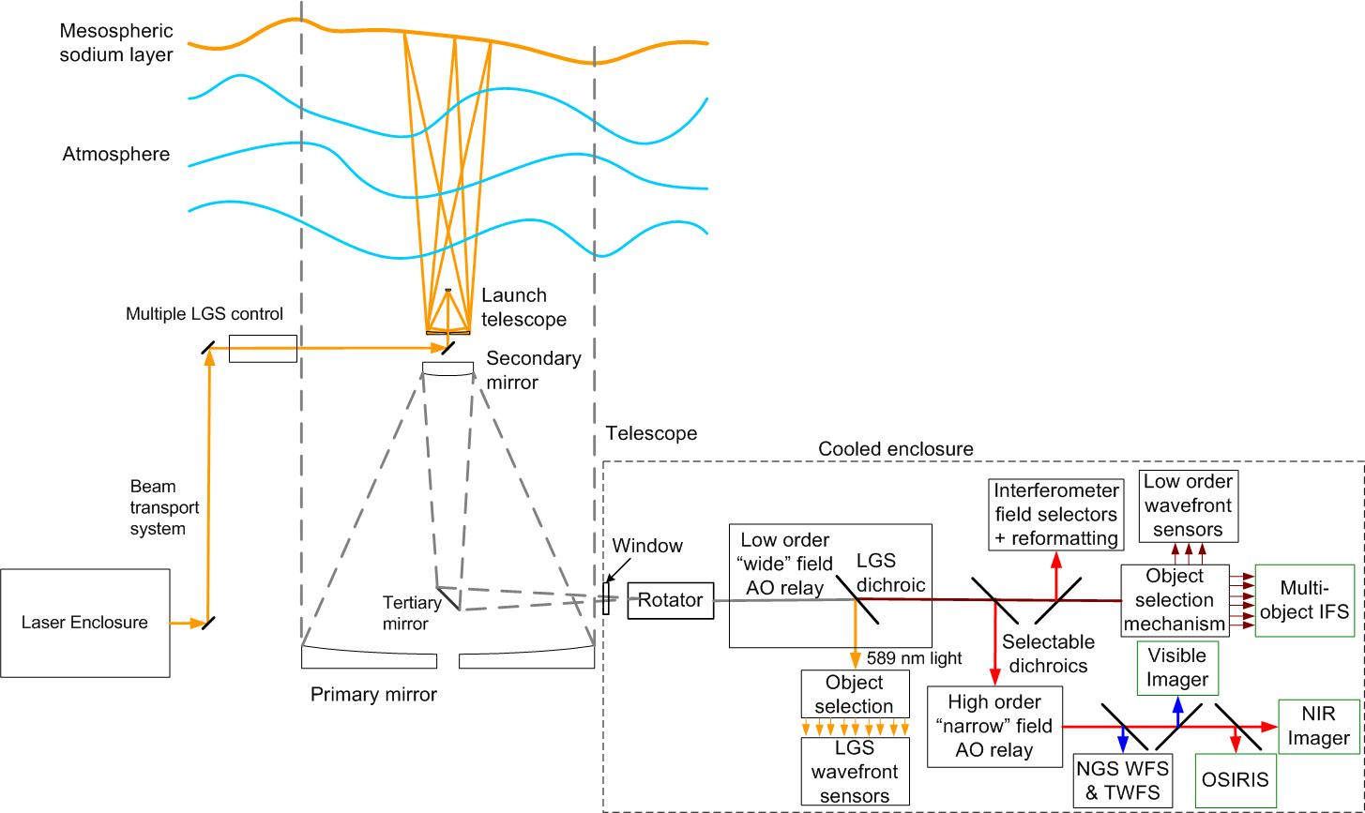

Figure 1: NGAO Block Diagram

Telescope and Facilities

The NGAO systems must utilize and interface to the existing Observatory infrastructure. This infrastructure includes the telescope and related control systems as well as mechanical and electrical services. In some cases this existing infrastructure may need to be modified.

The NGAO design and plan currently assumes implementation on the Keck II telescope, although it would be relatively straightforward to modify the design for implementation on Keck I. The design and plan also assume that the existing Keck II AO and laser systems will be removed from the summit facility to make room for the NGAO system. In addition to providing physical space for the system this will also free up power and cooling capacity, as well as cable wrap space.

Telescope Model
A Solidworks model of the Keck II telescope has been generated in order to clearly define the available space and interfaces for the NGAO system. A perspective view of this model is shown in Figure 2, with a possible AO enclosure on the left Nasmyth platform. This tool can be used to provide the details of areas like the Nasmyth platform or secondary mirror socket, as shown in Figure 3, which the NGAO system will need for interface purposes. The details of this model are suitable for preliminary design. Critical dimensions will need to be field verified before detailed design.

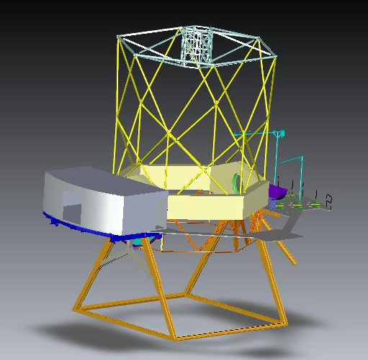
Figure 2 Telescope Solidworks model.

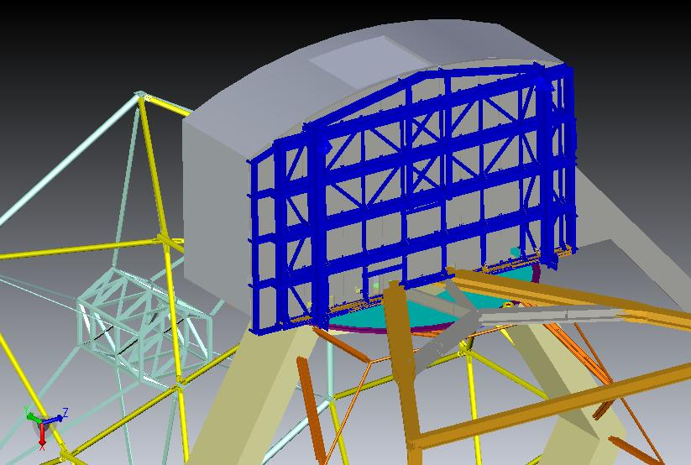
Figure 3 View from below of the telescope Nasmyth platform.

Facilities
The total required facility power and cooling is TBD, but several elements of these requirements have had some initial determination.

Interfaces
The AO system must interface to the existing telescope Drive and Control System (DCS); for example, to offload pointing and focus corrections or to request a telescope move.

AO System Description

AO Opto-Mechanical Design

The opto-mechanical design for the cascaded relay (see KAON 549) is summarized in this section.

The AO bench, as modeled in Solidworks, is shown in Figure 4 and Figure 5. These Figures include the d-IFS, visible imager and IR imager science instruments as well as a fold to OSIRIS (the interferometer feed cannot be seen in these views). They also include the wavefront sensors and acquisition cameras. For comparison the current Keck AO benches extend 2.4 m from the bulkhead shown in Figure 3. The final dimensions of the bench are TBD and may need to be extended to support the LGS WFS and visible imager.

The optical design, as modeled in Zemax, is shown in Figure 6. In order to follow this design it is easiest to step through the pieces beginning with the rotator and first relay. We discuss all the systems fed by the first relay before proceeding on to the second relay and the systems fed by it. The object selection mechanisms and wavefront sensors opto-mechanics are discussed in section 4.4.4.

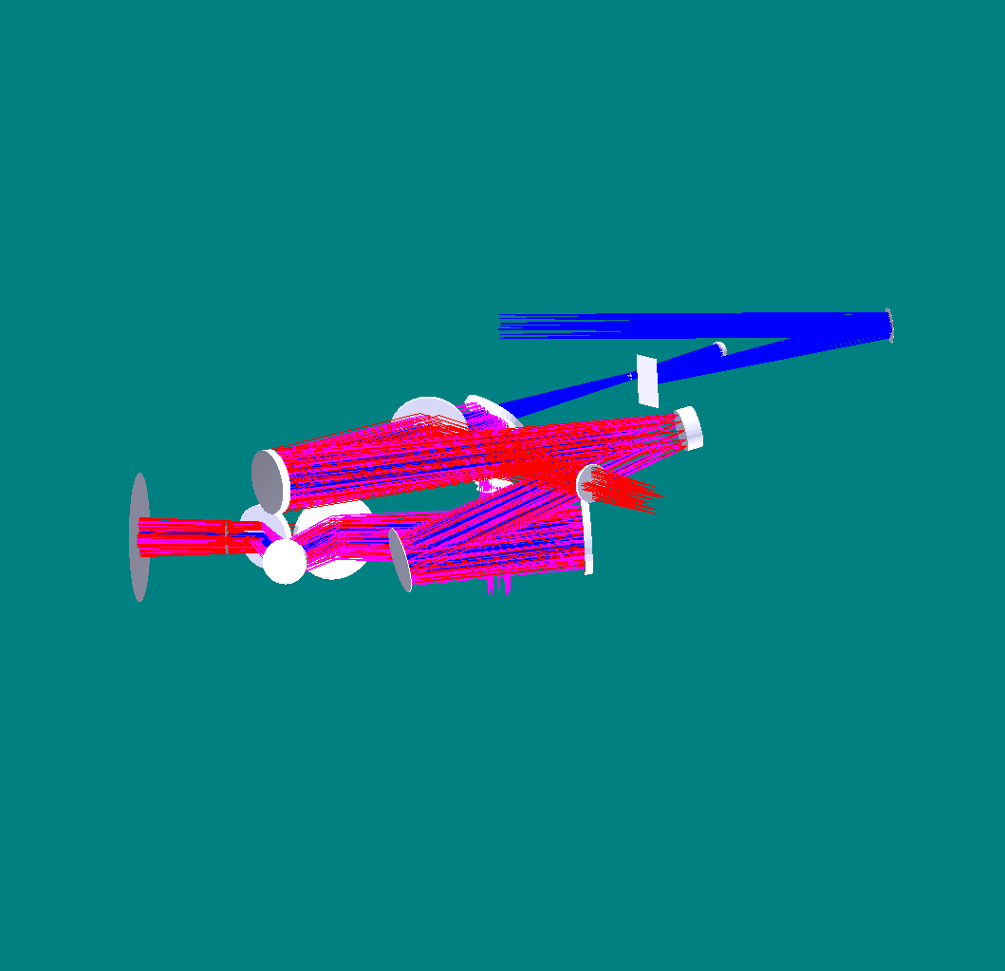
K-mirror
Fold mirror
OAP 1
Woofer DM
OAP 2
LGS dichroic
MEMS DM
f/45 output
LGS coma corrector plates
OAP 3
OSM dichroic
Nasmyth focus
Outside of telescope elevation bearing
To OSM (near-IR tip-tilt and multi-object instrument) input
LGS WFS input
OAP 4
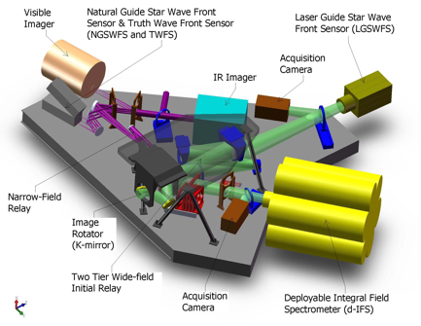

Figure 4: AO system optical layout perspective view (SolidWorks).
The optical path through the low order “wide” field relay and the high order “narrow” field relay are shown in green and purple, respectively. Light from the telescope enters through the image rotator.

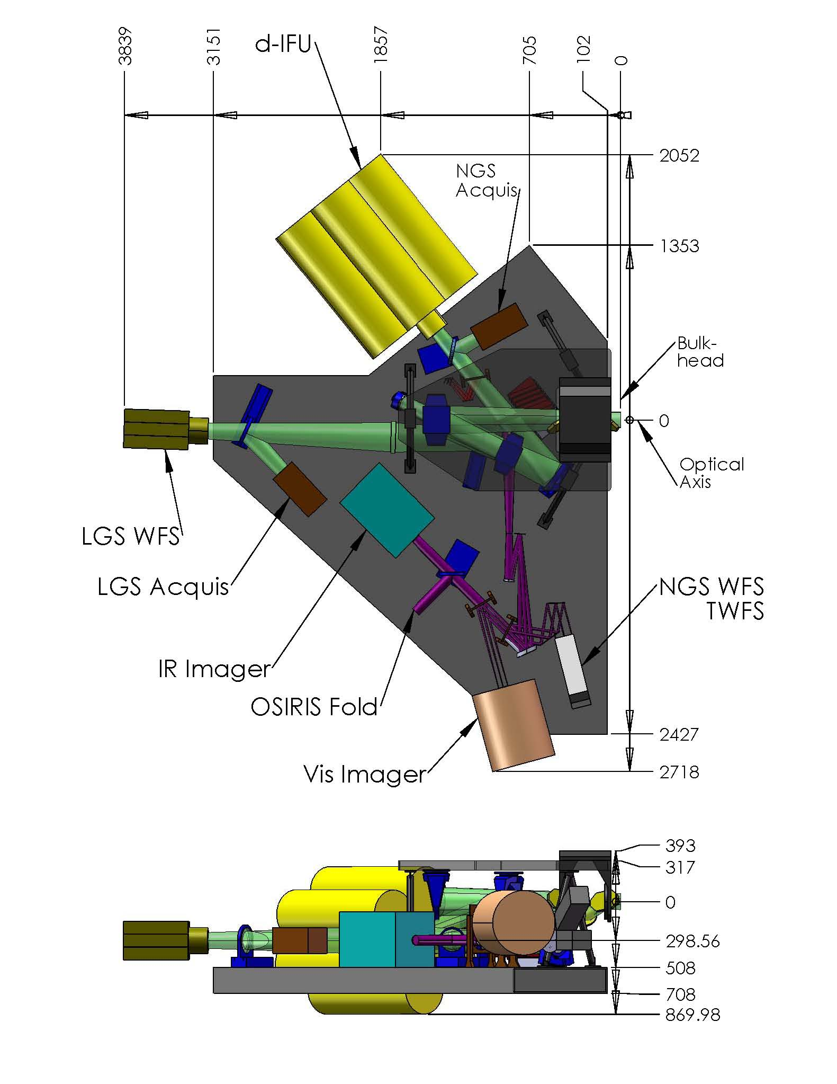
Figure 5 Elevation and plan views of the AO bench, including general dimensions (mm).
Light from the telescope enters from the right along the optical axis.

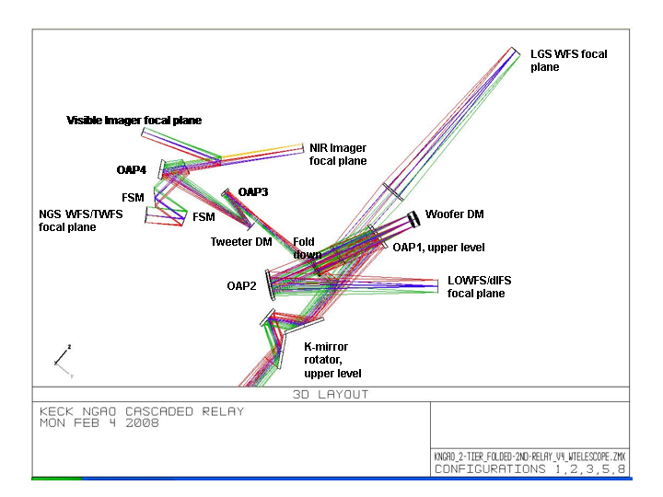
Figure 6 AO system optical layout (Zemax).
Light from the telescope enters from the bottom through the rotator.

Rotator and Wide Field Relay
The rotator and first relay are shown in shown in Figure 7. The rotator and first relay are intended to pass a wide field for the LGS and NGS and for the d-IFS science field. The relay includes a DM to provide low order wavefront correction.

The rotator is a K-mirror that can be used to either keep the field or pupil fixed. The Keck telescope’s f/15 Nasmyth focal plane is located ~270 mm past the telescope’s elevation bearing. The first and second rotator mirrors are located 150 mm before and after the focus, respectively. It is still to be determined whether having a focal plane close to these two mirrors will add thermal background effects or performance issues for high-contract science (for reference the first mirror of the existing Keck AO rotator is located 110 mm after the telescope focus). The 3-mirror rotator is sized to accommodate a 150" diameter NGS field of view (FOV) and a 175" diameter LGS FOV (for the case of an LGS at 80 km). The first and third mirrors are at 60º angles of incidence while the second mirror has a

The first relay is a one-to-one relay consisting of an off-axis parabola (OAP) to collimate the light and reimage the primary mirror onto the DM, a flat fold mirror, the DM and a second identical OAP to reconverge the light with the same focal ratio as the telescope and a telecentric pupil.

The third order optical aberrations can be minimized by two approaches using a collimated beam between two identical OAPs. Of these the off-centered pupil approach was chosen since it maintains a non-tilted focal plane (Korsch, Reflective Optics, p. 171, 1991).

The focal length of the OAP was selected to map the primary mirror to a 5 mm (d_{DM}) pitch DM with 20x20 actuators. The OAP off-axis angle of 25º was chosen as the minimum angle to provide adequate space for the subsequent optics.

The rotator, OAP1 and a flat, fold mirror are all mounted to an upper tier that sits above the AO bench. The fold mirror on the upper tier and the DM on the AO bench form a periscope that changes the beam height. In both cases the beam is parallel to the surface of the AO bench, with the beam on the upper tier ~ 300 mm above the beam on the AO bench. The two tier approach was chosen for packaging reasons. The angle of incidence on both the fold mirror and the DM is 9.125º. This fold mirror offers the possibility of a future multi-conjugate AO option since it is conjugate to an altitude of ~9 km.

The DM is placed at a conjugate to the primary mirror and is mounted on a fast tip-tilt mount. The second OAP is located its focal length from the DM in order to project the pupil to infinity and hence a telecentric output beam.

The output of the first relay goes directly to the object selection mechanism (OSM) that feeds the d-IFS and low order wavefront sensors (LOWFS). Dichroics and fold mirrors can be inserted into this beam to feed the NGS acquisition camera, the interferometer and the second “narrow” field relay.

Some key design numbers:
- Telescope parameters (from KOTN 163 or KAON 107).
  - Telescope focal length, f_{Tel} = 149.583 m.
  - Telescope entrance pupil diameter D_{Tel} = 10.949 m
  - Telescope exit pupil diameter, D_{EP} = 1460 mm.
  - Distance from telescope exit pupil to focus, t_{EP} = 19948 mm.
  - Telescope f/#_{Tel} = f_{Tel}/D_{Tel} = 13.66.
  - Telescope plate scale, PS = 0.727 mm/".
- Chosen design parameters.
  - NGS field of view diameter, Φ_{NGS} = 150".
  - Telescope primary mirror subaperture size, d_{PM} = 562.5 mm (the same as for the existing Keck AO system).
  - Rotator mirror angles of incidence are 60º for mirrors 1 and 3, and 30º for mirror 2.
  - OAP1 and OAP2 off-axis angle = 25º (corresponding to a decenter of 605 mm from the parent parabola) to provide adequate space for subsequent optics.
  - Fold mirror distance from OAP1, t_{fold} = 650 mm.
  - Fold mirror and DM angles of incidence are α_{DM} = α_{Fold} =9.125º.
  - DM conjugate to the telescope primary mirror.
  - DM subaperture size, d_{DM} = 5 mm.
  - Output pupil from 1st relay at infinity.
- 1st order calculated parameters.
  - LGS field of view diameter, Φ_{LGS} = 175" (for the case of an LGS at 80 km).
  - OAP focal length, f_{OAP} = (d_{DM}/d_{PM}) f_{Tel} = 1329.6 mm
  - Required OAP diameter to accept the pupil and field, d_{OAP} = (f_{OAP}/t_{EP})d_{EP} + (f_{OAP}+t_{EP})Φ_{NGS}*PS/t_{EP} = 214 mm.
  - Fold mirror conjugate height, h_{fold} = -1/{[f_{Tel}+f_{OAP}+(1/t_{fold}-1/f_{OAP})⁻¹]⁻¹ – 1/f_{Tel}} = 8.75 km.
  - Distance of DM from OAP1 in order to be conjugate to the primary, t_{DM} = [1/f_{OAP} – 1/(t_{EP}+f_{OAP})]⁻¹ = 1418 mm.
  - Pupil distortion on the DM due to the angle of incidence, % distortion = [1-cos(α_{DM})]*100% = 1.3%.
  - Distance of OAP2 from the DM in order to project the pupil to infinity, t_{OAP2} = f_{OAP} = 1329.6 mm.
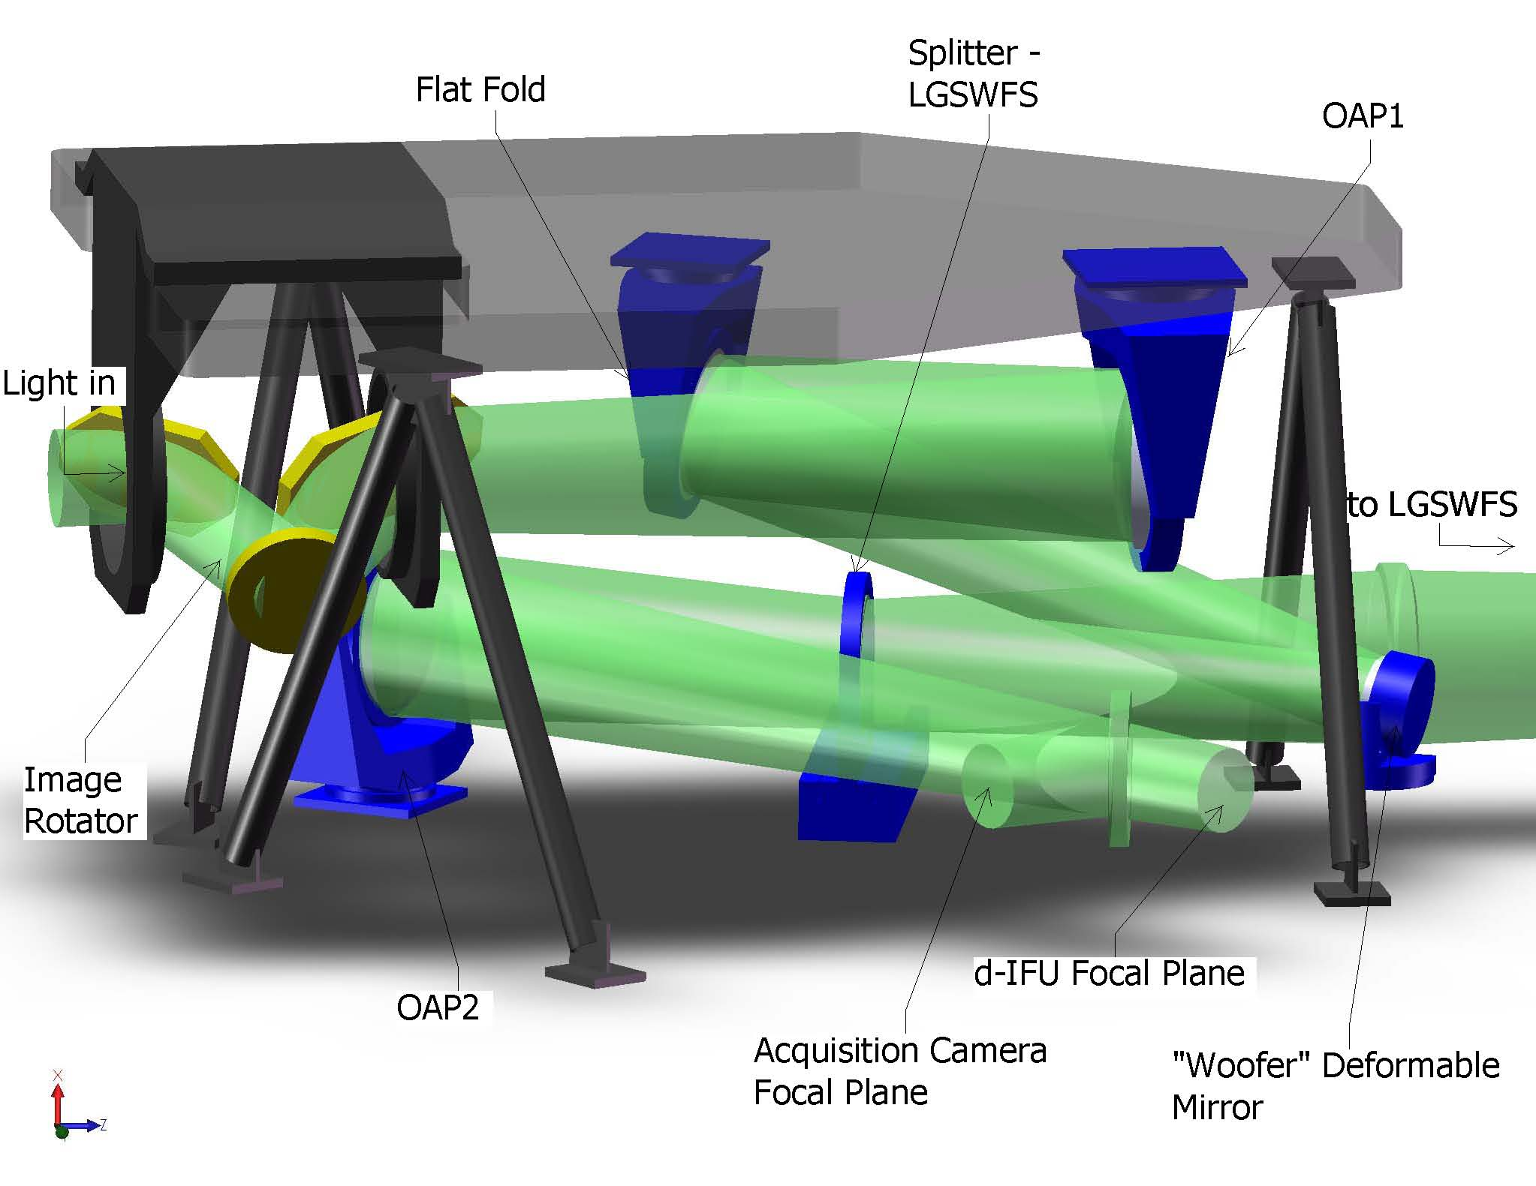
Figure 7. The image rotator and low order “wide” field relay.
Light from the telescope enters from the left and travels through the rotator to OAP1, the flat fold, the “woofer” DM. A dichroic splitter reflects the 589 nm light to the LGS WFS and transmits the remainder of the light to OAP2. A retractable mirror to feed the NGS acquisition camera is shown just before the focus.

LGS Wavefront Sensor Assembly and LGS Acquisition Camera Pickoff
A sodium reflective dichroic (i.e., retractable LGS WFS pickoff) is inserted in the collimated beam between the DM and OAP2 to send the sodium wavelength light to the LGS wavefront sensor as shown in Figure 6. A bi-convex lens is used to play the role of OAP2 and converge the light to the LGS WFS assembly. The lens’ focal length and distance from the DM are the same as those for OAP2 in order to minimize aberrations and project the pupil to infinity. A retractable mirror (i.e., retractable acquisition camera pickoff) can be inserted to send light to the LGS acquisition camera. Both the acquisition camera and LGS WFS must translate in focus to be conjugate to the sodium layer.

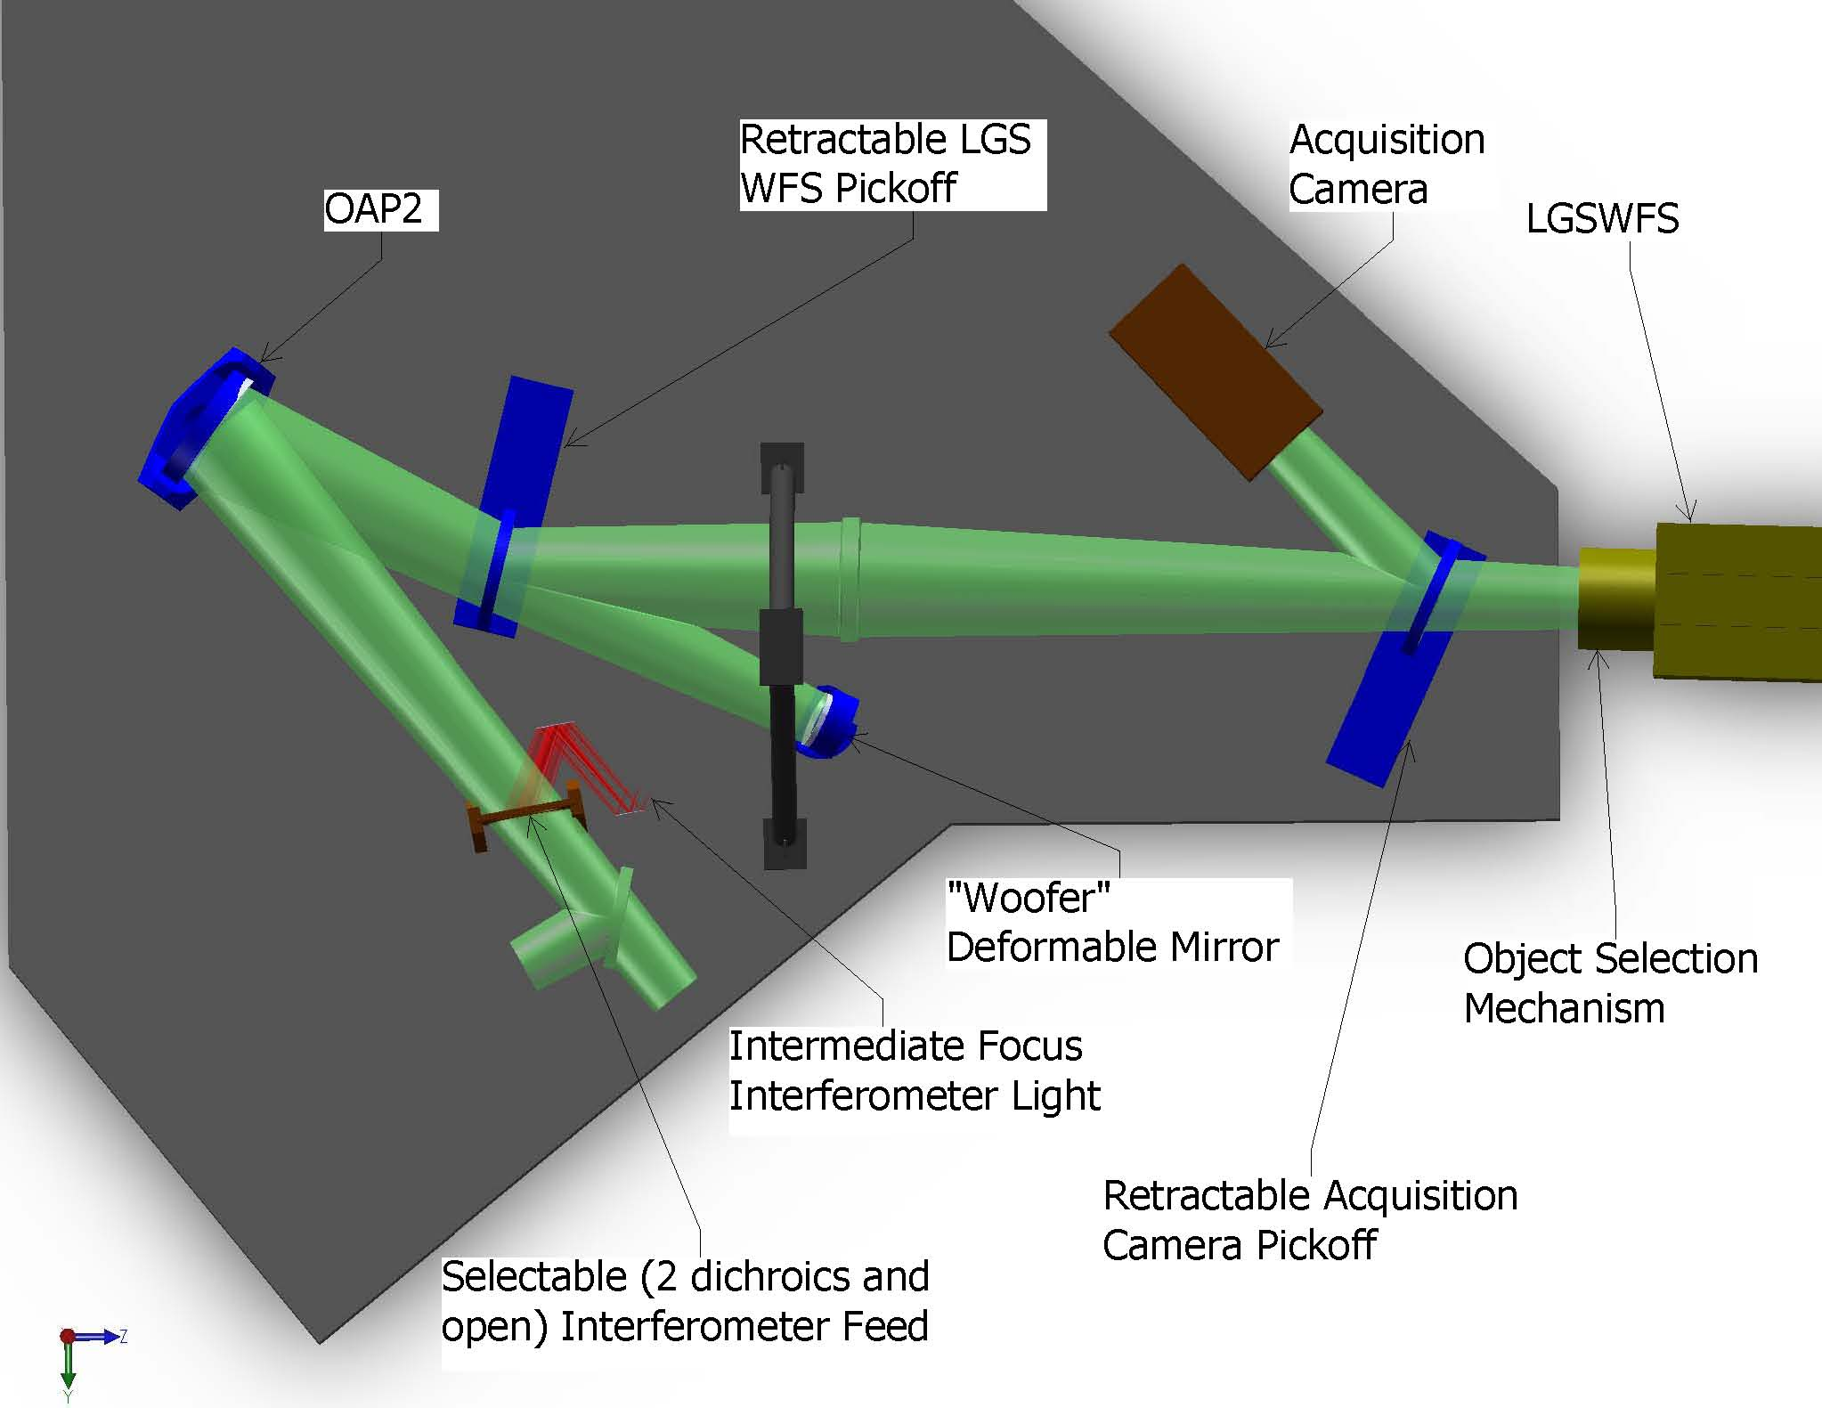
Figure 8. Laser Guide Star Wavefront Sensor and Interferometer Pickoffs.

The LGS WFS assembly consists of an Object Selection Mechanism (OSM) and nine LGS WFS. Each arm of the OSM picks up the light from a single LGS and transports this light to a single LGS WFS.

Interferometer Pickoff
Figure 6 also shows a dichroic pickoff to the Keck interferometer. This is located after the narrow field pick-off in order to most closely match the existing Keck AO system where the future interferometer pick-off is located after an IR transmissive dichroic.

The dichroic sends a 60" diameter field to a pair of field selector mirrors. The first of these mirrors is located near the focus and has a hole in it to transmit a small on-axis field. The first field selector steers the desired off-axis point to the center of the second field selector mirror, which in turn steers the off-axis field along the desired axis (parallel to the on-axis field). Similar field steering mirrors are used in the existing Keck AO system and this approach has been selected for the ASTRA upgrade to the Interferometer (ASTRA-0017).

Two options are being considered for transporting the interferometer beam to the basement. The first is to use a dual star module where OAPs are used to collimate the light and fold mirrors are used to steer the beam to the existing coude train. The second and preferred option is to insert both the on-axis and off-axis objects into single mode fibers for transport to the basement.

NGS Acquisition Camera Pickoff
A removable 45º incidence angle mirror folds the entire 150" diameter wide field relay output to the NGS acquisition camera.

Low Order Wavefront Sensor Assembly
The light reflected by OAP2 goes directly to the NIR imager (in the absence of any fold mirrors or dichroics between OAP2 and the d-IFS). The Low Order Wavefront Sensor (LOWFS) Assembly is located directly in front of the d-IFS and consists of an Object Selection Mechanism (OSM) and four LOWFS. Two arms of the OSM feed tip-tilt (TT) sensors. A third arm feeds a tip-tilt-focus-astigmatism (TTFA) sensor and truth wavefront sensor (TWFS). A beamsplitter splits the light between the TTFA and TWFS.

Narrow Field Relay
A choice of several dichroics can be inserted in the beam between OAP2 and the d-IFS in order to send light into the narrow field relay as shown in Figure 9. This relay is intended to provide a high order of correction for the narrow field science instruments. It also provides a magnification of ~3 in order to provide separation between the instruments and an optimal plate scale for the science instruments.

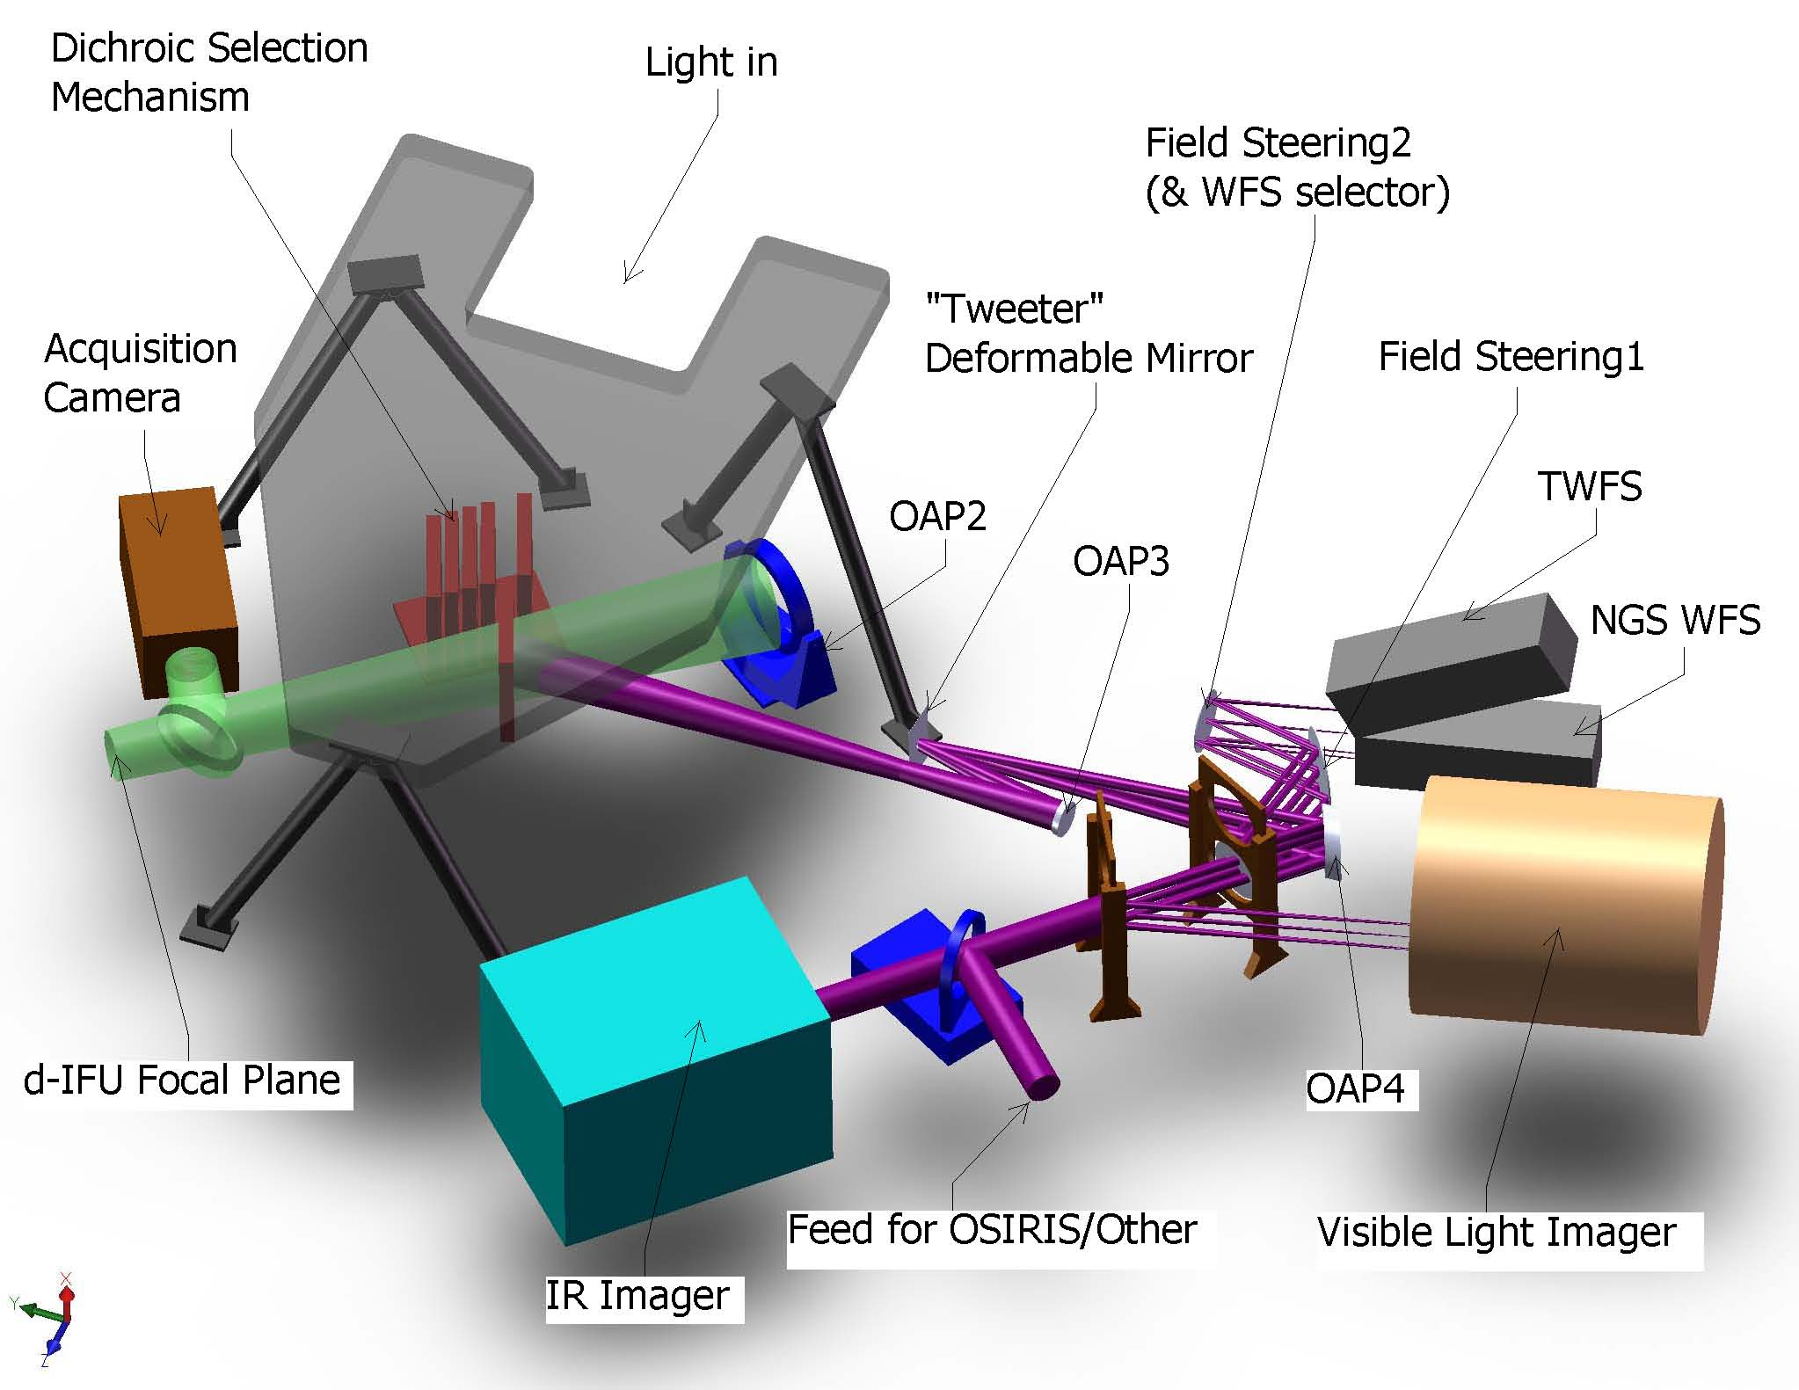
Figure 9. Narrow Field Relay.

The light reflected by the dichroic passes through focus to OAP3 which collimates the light and reimages the telescope primary mirror onto a 64x64 MEMS DM. The DM is mounted on a fast tip-tilt platform. OAP4 is chosen to provide a factor of three magnification and is located its focal length from the MEMS in order to project the pupil to infinity.

- Chosen design parameters.
  - NGS field of view diameter, Φ_{NGS,narrow} = 60" for NGS WFS and 30” for science instruments.
  - OAP3 off-axis angle = 13º.
  - Telescope primary mirror subaperture size, d_{PM2} = 176.0 mm.
  - MEMS angle of incidence, α_{MEMS} = 10º.
  - MEMS conjugate to the telescope primary mirror.
  - MEMS subaperture size, d_{MEMS} = 0.40 mm.
  - 3x magnification (f/15 input becomes f/45 out).
  - OAP4 off-axis angle = º.
  - Output pupil from 2nd relay at infinity.
- 1st order calculated parameters.
  - OAP focal length, f_{OAP3} = (d_{MEMS}/d_{PM2}) f_{Tel} = 340.0 mm
  - Required OAP3 diameter to accept the pupil and field, d_{OAP3} = f_{OAP3}/f/#_{Tel} + Φ_{NGS,narrow}*PS = 69 mm.
  - Distance of MEMS from OAP3 in order to be conjugate to the primary, t_{DM} = f_{OAP3}.
  - Pupil distortion on the DM due to the angle of incidence, % distortion = [1–cos(α_{MEMS})]*100% = 1.5%.
  - Focal length of OAP4 for a 3x magnification, f_{OAP4} = 3f_{OAP3} = 1020 mm.
  - Distance of OAP4 from the DM in order to project the pupil to infinity, t_{OAP4} = f_{OAP4}.
  - Required OAP4 diameter to accept the pupil and field, d_{OAP4} = f_{OAP3}/f/#_{Tel} + Φ_{NGS,narrow}*3PS = 134 mm.

Natural Guide Star and Truth Wavefront Sensors Pickoff
The dichroic pickoff immediately following OAP4 feeds both the NGS WFS and TWFS. The dichroic is at an angle of incidence of 17º. The nominal 30" diameter field required for the science instruments was deemed to be scientifically inadequate for the NGS WFS and TWFS. The current design has a slightly offset field that extends 57" perpendicular to the bench and 54" parallel to the bench due to vignetting by the tweeter and OAP4.

A pair of field selector mirrors, similar to those discussed in section will be used. In this case the first mirror will not have a hole in it and the second mirror is mounted on a two position rotation stage in order to provide light to one of either the NGS WFS or TWFS.

An alternate location for the NGS WFS and TWFS, in the visible imager path, will likely be implemented during the preliminary design. This location has the advantage of a shared ADC with the visible imager and only one dichroic in the beam to the IR imager when simultaneous NIR and visible observations are being performed in NGS mode.

Narrow Field Science Instrument Pickoffs
Three science instruments are fed by the narrow field relay as shown in Figure 9. The light reflected by OAP4 goes directly to the NIR imager (in the absence of any fold mirrors or dichroics between OAP4 and the NIR imager). A dichroic fold can be inserted in this path to feed the visible imager or a fold mirror can be inserted to feed the light toward OSIRIS.

In order to reuse the existing OSIRIS with NGAO, optics must be inserted in the path to convert the beam back to the initial telescope focal ratio with the pupil at the same position as provided by the telescope. This design is TBD, however similar reimaging optics were designed to use NIRSPEC with the existing AO system (KAON 201). This design consisted of two spherical mirrors and two flat mirrors and provided a magnification of 10.6 (versus only 3 in demagnification required in this case).

The interfaces to the instruments are defined in KAON 555.

Summary of Required Dichroics and Mirrors
The above sections only described the location of the required pickoffs. Table 1 provides a summary of the required dichroics and mirrors and their properties. The numbers in the NGS and LGS columns refer to the system configurations that will be discussed in a later section.

Table 1. Summary of Required Dichroics and Mirrors.
Dichroic or Fold | # | Options | NGS | LGS | Transmit | Reflect | R (extra) | Notes
LGS dichroic | 1 | Out | All |  | All | None |  | Notch filter ideal. ≥ 600nm an option
LGS dichroic | 2 | In |  | All | 0.4-L | 589 nm |  | Notch filter ideal. ≥ 600nm an option
LGS Acquis Fold | 1 | Out | n/a | 1-6 | All | None
LGS Acquis Fold | 2 | Mirror | n/a | 11 | None | 589 nm
Post Relay 1 Dichroic = Narrow Field Pickoff | 1 | IR transmit / vis reflect | 2,3 | 5 | JH | ≤ 1 µm | K
Post Relay 1 Dichroic = Narrow Field Pickoff | 2 | Mirror | 4-8 |  | None | All
Post Relay 1 Dichroic = Narrow Field Pickoff | 3 | Out |  | 1-3 | All | None
Post Relay 1 Dichroic = Narrow Field Pickoff | 4 | JH transmit / K reflect |  | 4ab, 6ab | JH | K | ≤ 1 µm | Address with #1 (if can do R (extra))
Post Relay 1 Dichroic = Narrow Field Pickoff | 5 | J transmit / H reflect |  | 4cd, 6cd | J | HK | ≤ 1 µm
Post Relay 1 Dichroic = Narrow Field Pickoff | 6 | H transmit / IJ reflect |  | 4ef, 6ef, 7ef | H | < H | K
Post Relay 1 Dichroic = Narrow Field Pickoff |  | JH transmit / IK reflect |  | 7ab |  |  |  | Address with #1 (if can do R (extra))
Post Relay 1 Dichroic = Narrow Field Pickoff |  | J transmit / IH reflect |  | 7cd |  |  |  | Address with #5 (if can do R (extra))
Interfer-ometer Fold | 1 | Mirror | 2,3 |  | None | All
Interfer-ometer Fold | 2 | Out | 10 | 1,4-6 | All | None
Interfer-ometer Fold | 3 | J transmit / HKL reflect |  | 2,3 | J | HKL
NGS Acquis Fold | 1 | Out | 2,3 | 1-6 | All | None |  | May need to replace mirror w/ a beamsplitter or to provide a 3rd position
NGS Acquis Fold | 2 | Mirror | 10 | 10 | None | All
NGS WFS Dichroic | 1 | IR transmit / vis reflect | All | 5 | Y-K | 0.4-0.95µm
NGS WFS Dichroic | 2 | I transmit / < I reflect |  |  | ≥ 0.7 µm | 0.4-0.7µm
NGS WFS Dichroic | 3 | Out |  | 4,6 | All | None
Visible Imager Dichroic | 1 | IR transmit / vis reflect |  |  | ≥ 1 µm | 0.7-1.0µm
Visible Imager Dichroic | 2 | Out |  |  | All | None
Visible Imager Dichroic | 3 | Mirror |  |  | None | 0.7-1.0µm |  | If #1 good then may not be needed.
OSIRIS Fold | 1 | Out | 4,7 | 4 | All | None
OSIRIS Fold | 2 | Mirror | 6 | 6 | None | z-K

Atmospheric Dispersion Correctors
The atmospheric dispersion corrector (ADC) design has only been taken far enough to demonstrate that suitable ADCs can be designed.

Optics Bench Structure
The optics bench structure is shown in Figure 10. The upper and lower tiers are both expected to be typical honeycomb core optical tables. The optimal thickness of both tiers will be determined in subsequent design phases. The separation of the two tiers is accomplished with three bipod struts. If necessary, there is clearance to make these tripod struts, allowing kinematic mount detail for the upper tier.

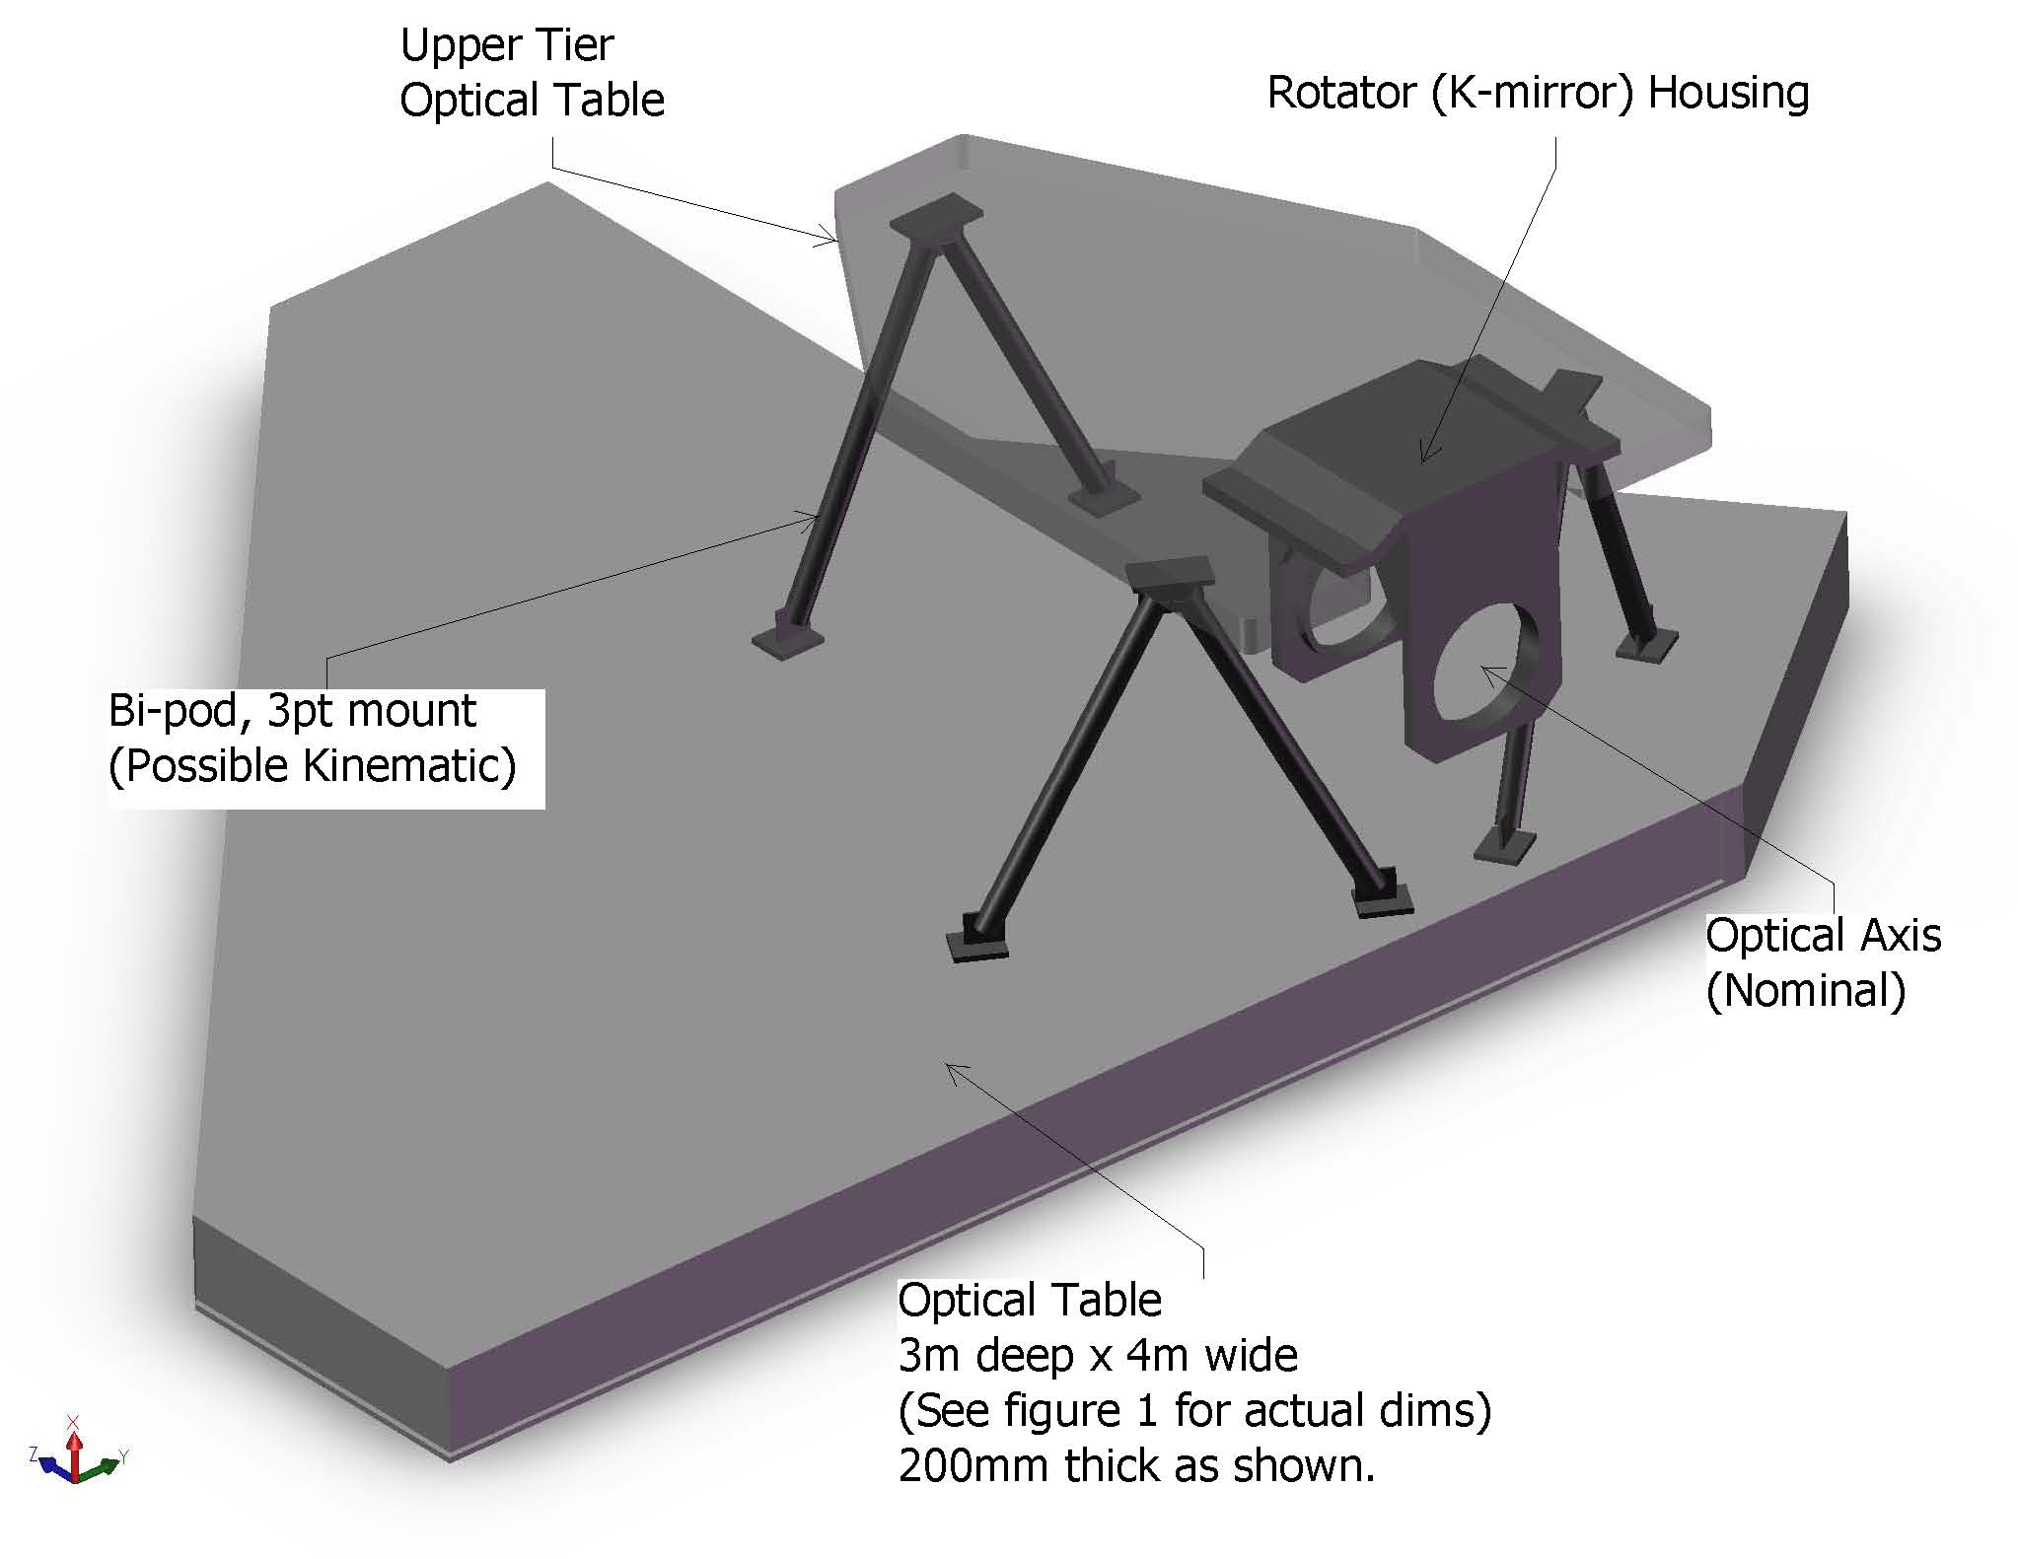
Figure 10. Optics Bench Structure.

Attachment of the optics bench to the Nasmyth platform is TBD, but will likely be similar to the mounting of the existing Keck AO benches. The clearance between the bottom of the bench and the Nasmyth platform is ~ 500 mm less than for the existing AO benches, which will make access under the bench more challenging (than for the existing benches).

Wavefront Sensor Opto-Mechanical Design
Two wavefront sensor assemblies are fed by the optical relay: the LGS wavefront sensor assembly and the low order wavefront sensor (LOWFS) assembly. The NGS and Truth wavefront sensor assembly is fed by the narrow field relay. Each of these assemblies includes an object selection mechanism that selects the appropriate NGS or LGS and feeds the light to the appropriate wavefront sensor(s). Two versions of the same multi-target mechanism have been chosen for the LGS and LOWFS object selection mechanisms, while a different single-object selection approach has been taken for the NGS/Truth wavefront sensor assembly as described in section 4.4.3.9. The LGS wavefront sensor assembly includes nine LGS wavefront sensors. The LOWFS assembly includes five NIR sensors: two tip-tilt sensors, a tip-tilt-focus-astigmatism sensor, a truth wavefront sensor and a PSF monitoring camera. The NGS/Truth wavefront sensor assembly includes an NGS wavefront sensor and a visible truth wavefront sensor. The conceptual design reports for the multi-target object selection mechanism and all of the wavefront sensors can be found in KAONs 562 and 551, respectively.

Low Order Wavefront Sensor Object Selection Mechanism

Tip-Tilt (Focus and Astigmatism) Sensors
The three Low Order Wavefront Sensors (LOWFS) operate at near-IR wavelengths to improve the availability of suitable stars of sufficient brightness. Optimal performance is obtained using combined J and H band light, but a selectable beam splitting dichroic will allow sending one or more near-IR bands in combination to the tip-tilt sensors with the remainder of the near-IR and the visible light passing to the narrow field instruments. At least one sensor will be of at least order 2 x 2 subapertures to provide sensing of focus and astigmatism. Each tip-tilt star will be AO corrected using a MEMS DM with a pointable LGS beacon positioned near each tip-tilt star to maximize this correction.

Truth Wavefront Sensor

PSF Monitoring Camera

LGS Wavefront Sensor Object Selection Mechanism

LGS Wavefront Sensors
The LGS wavefront sensors are Shack-Hartmann (SH) sensors with up to 64 x 64 subaperture sampling of the pupil. For the LGS wavefront sensor detectors we anticipate using a very low noise CCD based on the CCID-56b/d, developed for AO wavefront sensing through a project funded by the Adaptive Optics Development Program (AODP), to minimize the laser power required in each beacon in order to achieve the required SNR.

NGS Wavefront Sensors

AO Optical Performance

Wide Field Relay Optical Performance

Object Selection Mechanism Optical Performance

Narrow Field Relay Optical Performance

AO Enclosure
The AO enclosure conceptual design is documented in KAON 563.

Alignment, Calibration and Diagnostics

Simulator

System Alignment Tools

Atmospheric Profiler

The atmospheric profiler system design report is documented in KAON 552.

Laser Facility Description

Laser
A comparison of lasers currently in use at various facilities can be found at http://lao.ucolick.org/twiki/bin/view/CfAO/SodiumLaserGuidestars. A laser choice has not yet been made, however two types of solid state sum-frequency lasers are the most likely candidates for consideration:

- The Starfire Optical Range (SOR) laser in use at SOR. This laser has the highest measured return per Watt and the highest power of the existing lasers. A second generation, two frequency laser is currently under development for improved sodium efficiency.

- The LM/CTI laser. The first generation of this laser is in use at Gemini-North. In a combined Keck/Gemini experiment the Gemini-North laser was demonstrated to have twice the return of the Keck dye laser. The second generation of this laser is currently being fabricated for Gemini-South and Keck I. This is the only commercially available laser that could meet our needs.

We also intend to monitor the progress of fiber lasers. ESO is working with Volius to develop a Raman fiber laser and LLNL also continues to develop their fiber laser. Volius is currently building a low power sodium wavelength laser for Keck. The LLNL fiber laser will be demonstrated in the VILLAGES experiment at Lick.

Laser Enclosure
The laser enclosure conceptual design is documented in KAON 564.

Laser Beam Transport
Two options will be considered for transporting the laser light from the laser to the top end of the telescope. The favored approach because of its simplicity, especially if the laser cannot be on the elevation ring of the telescope, is to use single mode hollow core photonic crystal fibers. These are being used with the VLT, Subaru and Keck I lasers. Alternatively, a multiple mirror based beam transport system similar to what has been done for Gemini would be considered.

Beacon Projection System
The LGS beacon projection system consists of a beam pattern generation and pointing system and a launch telescope. The launch telescope will incorporate a tip-tilt mirror for correction of the laser uplink tip-tilt and the beam pattern generator may incorporate a beam splitting arrangement so that fewer laser beams will need to be transferred to the top end of the telescope. The beam pattern generator will provide one fixed on-axis LGS beacon, a variable diameter pattern of five LGS beacons from a radius of 11” to 90”, and three additional, pointable, LGS beacons over a range from some tbd minimum radius to a maximum radius of 101”.

An evaluation was performed of the benefits of uplink compensation in KAON 509. For the moment we have decided to proceed without uplink compensation.

Control Electronics and Software
Electronics and software subsystems are associated with each of the major components of the NGAO system. A block diagram of the NGAO electronics/software subsystems and related external subsystems is shown Figure 13.

Communications between the various subsystems are represented by four control and data paths shown in the figure. The real time data flow (magenta) between the wavefront sensors and the DMs is isolated from other communications flow to provide maximum performance. The “AO Configuration and Status” control path (light blue) is used by the AO sequencer to orchestrate the operation of the AO system. The sequencer establishes configurations for each observation and provides status and control for the non-real time subsystems to the AO host computer via the “Supervisory Control and User Interface” (green). This interface also provides the AO host computer with control and status for the various supervisory controls. The AO sequencer coordinates AO operations with the external subsystems, the instrumentation, telescope drive and control and the primary mirror control system via the “Auxiliary Configuration, Offloading and Status” interface (purple). This includes tip-tilt offloading to the telescope secondary and control of telescope tracking during an observation.

The majority of the AO electronics subsystems will be straightforward designs based on heritage systems, particularly for supervisory controls such as AO enclosure environmental and laser safety. Similarly, instrument electronics will be based on the most current heritage designs from the OSIRIS and MOSFIRE instruments at WMKO. The sensors for the tip-tilt stars will also be based on existing detector technology and readout systems. LGS wavefront sensing electronics will be based on the AO wavefront sensing systems being developed for the TMT through the AODP.

Figure 13: NGAO electronics and software subsystems

The main challenges in the design of the NGAO electronics and software are the demanding real time control requirements for AO in a multi-guidestar system employing tomographic wavefront reconstruction techniques and multiple DMs. Our investigation of the algorithms and data flow needed for AO real time processing and control has suggested that a massively parallel architecture using current state-of-the-art field-programmable gate arrays (FPGAs) can readily accomplish this task.

Non-real-time Control

Real-Time Control
The conceptual design of the real-time control system is documented in KAON 553. The real-time control requirements for NGAO are summarized in Table 2.

Massively Parallel Processing
The proposed massively parallel processing (MPP) system pipeline architecture depicted in Figure 14 implements a three step process: wavefront measurement, tomography, DM fitting. Multiple wavefront sensors, corresponding one to each LGS and tip-tilt star, feed data to a centralized tomography unit. These are inherently parallel operations. Calculation is further parallelized across the spatial dimensions (two dimensions x and y for wavefront sensor and deformable mirrors, and three dimensions x, y, and z for tomography, where z is the vertical direction). For algorithmic reasons, data in x, y planes parallel to the aperture are represented by their Fourier coefficients. Calculations are spread out among processors dedicated to pieces of the x-y Fourier space, slices in the z vertical space, individual wavefront sensors, and individual DMs.

The tomography unit determines an estimate of the differential optical path differences within volume elements of a model atmosphere. This information is then used in a process of determining the desired phase correction at each DM, given a tomographically determined estimate of differential phase aberrations over the atmospheric volume. For MOAO this is the line integral of the turbulence estimate through the volume in the direction of interest. Since the DMs commonly have inter-actuator influence functions, a deconvolution and/or lookup table access must be done for the actuator commands so that the resulting DM shape best fits the new wavefront estimate. Fitting involves deconvolving the DM’s unit response function so that a voltage command can be determined given the desired surface shape. In the case of MEMS in open loop operation, it is necessary to use an additional cascade of two non-linear lookup tables.

The MPP architecture described above has a distinct advantage over a traditional single CPU implementation in that it can scale with the number of guide stars, number of DMs, and number of subapertures by simply adding processor cards without affecting the data throughput rate or the software program significantly.

Control bandwidth | >90 Hz
Wavefront sensor frame rate | 1.5 to 2 kHz
Number of LGS wavefront sensors | 9
Number of tip-tilt sensors | 3
Number of deformable mirrors | Narrow field mode: 1 20 x 20 “woofer” DM, 1 64 x 64 “tweeter DM”, 3 32 x 32 DMs for MOAO correction of the tip-tilt stars.  Wide field mode: 1 20 x 20 “woofer” DM, 3 32 x 32 DMs for MOAO correction of the tip-tilt stars, 6 32 x 32 DMs for MOAO correction in the multi-object deployable IFU.
Reconfigurable for number of guide stars and DMs. Allows differing asynchronous data rates from various wavefront and tip-tilt sensors
Adapts and optimizes for changing seeing and signal-to-noise conditions and incorporates information from external measurements of the C_{n}² profile
Full telemetry and diagnostics streams
Table 2: NGAO real time control requirements

Figure 14: Multi-guidestar AO processing architecture

Tomography
Tomography is accomplished with an iterative back-propagation algorithm depicted in Figure 15 (Gavel 2004, Gavel et al. 2005). The method is analogous to the filtered-back-projection techniques used in modern medical tomography 3-d data analysis. These calculations can be mapped to the massively parallel computer architectures described earlier. During processing, each iterative correction is along a conjugate-gradient direction, resulting in convergence in only a few iterations. Overall, the MPP implementation combined with the fast converging algorithm enable the process to be repeated at the very demanding frame rates of real-time adaptive optics, about once per millisecond .

Figure 15: Tomography algorithm

Laser Safety System

Science Operations
This section discusses the hardware and software needed to control the overall NGAO facility for science operations at both the operator and astronomer levels and the pre- and post-observing support tools.

Science Operation Model
A trade study of possible observing models was performed in KAON 476.

Observing scenarios are documented in the SCRD.

System Configuration
Each science case defined in the Science Case Requirements Document (SCRD) has been mapped to an AO system configuration. This was done to ensure that the NGAO system had all the required functionality and to help map requirements to components. Describe …

System Calibration

System Operation

Several approaches to dithering and offsetting were proposed and discussed in KAON 558. The selected approach …

System Control

Multi-System Command Sequencer

User Interfaces

AO-Instrument Interfaces

Data Server
Pre and
Post-Observing Tools

Science Instruments
The philosophy for the NGAO instrument compliment is to address the large parameter space offered by NGAO with specialized instruments, while keeping them as simple as possible. By separating wavelength ranges along natural breakpoints based on optical and thermal design considerations and by providing spectroscopy with IFU’s we can meet the science needs without requiring multimode instruments. The major exception is a multi-object deployable near-IR IFU spectrograph that is of necessity a more complex instrument.

All of the proposed instruments are based either on currently available detector technology or on anticipated evolutionary developments of current technology that we believe will become available within the NGAO development timeframe. Instrument control software and data reduction requirements are expected to be evolutionary developments of current instruments and data reduction tools. It will be important to emphasize close integration with the AO system control software. Features that promote efficient AO observing will be an integral part of the software for every NGAO instrument.

Each of the major science areas has somewhat different instrument priorities. These must be reconciled in order to arrive at a useable priority list. Two important additional inputs to the setting of instrument priorities are the need for appropriate instrumentation for first light commissioning of the AO system, and the relative timescales required for development of the various instruments. Based on the science priorities and these other considerations we have identified the instrument priorities shown in Error: Reference source not found.

Single object Instruments |  | Multi-object Instruments
Name | Priority | Name | Priority
Near-IR imager | 1 | Deployable near-IR IFU | 1
Visible imager | 2
Near-IR IFU (OSIRIS?) | 3
Visible IFU | 4
Table 4: NGAO instrument priorities

The near-IR imager will be the first-light commissioning instrument for NGAO. The multi-object deployable near-IR IFU is a high priority instrument, but because of its complexity, it will also have the longest development timeline. Therefore, it is important that its development be started as soon as possible. In view of the development timeline for the deployable near-IR IFU, the single object near-IR IFU is ranked third because of the clear importance of near-IR spectroscopy.
Initial requirements for the imagers are summarized in Error: Reference source not found.

Visible and NIR Imagers

Instrument |  | Wavelength coverage (µm) |  | Field of view |  | Sampling
Visible Imager | 0.7 to 1.0 |  | 20” x 20” |  | Nyquist (6 mas)
Near-IR Imager | 1.0 to 2.45 |  | 20” x 20” |  | Nyquist (10 mas)
Table 6: NGAO imager requirements

Visible and NIR Spectrographs
The initial requirements for the single object near-IR IFU are as follows:

Wavelength coverage: 1.0 to 2.45 µm | Spectral resolution: R ~4,000
IFU Spatial sampling:  - 80 x 50 samples in a broad band mode  - 160 x 50 samples in a narrow band mode | Spectral sampling:  - ~2,000 pixels/spectra in broad band mode  - ~1,000 pixels/spectra in narrow band mode
Optional selection of sampling scales: 100, 50, 20 mas

With the exception of the field of view, OSIRIS meets many of the requirements for this instrument. See KAON 493 for a discussion of the possible reuse of OSIRIS with NGAO.

The initial requirements for the single object visible IFU are as follows:
Wavelength coverage: 0.7 to 1.00 µm | Spectral resolution: R ~3,000
IFU Spatial sampling:  - 60 x 68 samples in a broad band mode  - 120 x 68 samples in a narrow band mode | Spectral sampling:  - ~2,000 pixels/spectra in broad band mode  - ~1,000 pixels/spectra in narrow band mode
Optional selection of sampling scales: 50, 35, 20 mas

NIR Deployable IFU
The initial requirements for the multi-object deployable near-IR IFU are as follows:

Wavelength coverage: 1.0 to 2.45 µm | Sampling scale: 50 mas
Multiplex: minimum of 6 deployable IFU heads | Spectral resolution: R ~4,000
Spatial sampling per IFU head: 60x20 samples minimum | Spectral sampling: ~2,000 pixels/spectra

Interferometer
It is a requirement for the Interferometer to be supported by AO on both telescopes in the NGAO era. This could be a direct feed from NGAO, most likely after the first relay, or by a separate AO system, which imposes a requirement on being able to exchange AO systems. A trade study was performed on the issue of Keck Interferometer support which is documented in KAON 483. The primary requirements are to achieve at least the current level of performance while maintaining a common field orientation and polarization from both telescopes.

‘OHANA
Both existing Keck AO systems accommodate an ‘OHANA fiber injection module at the output of the AO systems. NGAO should provide an output port where this or a similar fiber injection module could be located, and whose output could be successfully interfered with the light from another telescope.

Thermal NIR Imager
A thermal NIR imager has not been given a high priority and therefore no significant evaluation has occurred for this instrument. An evaluation of the reuse of NIRC2, which extends out to L and M-bands, was performed as part of KAON 493.

Performance Budgets
Eight performance budgets have been addressed as part of the system design.

Background and Transmission
The background and transmission performance budget is developed in KAON 501.

Both AO relays must efficiently transmit the science wavelength light from 0.7 to 2.4 μm (with a goal of 0.656 to 2.4 μm, so as to include Hα). The first relay must also efficiently transmit sodium wavelength light (589 nm) and the additional L-band light (3.4 to 4.2 µm) for the interferometer. This wavelength range must be efficiently divided between the various sensors (LGS and tip-tilt) and the instruments.

Near-IR light will be shared between the tip-tilt sensors and the narrow field instruments. This will require the near-IR beamsplitter for the OSM to be a set of selectable dichroics. This will send some of the near-IR light (for example J and H bands) to the tip-tilt sensors while sending the balance to the narrow field instruments (visible and K band for example). Excellent coatings will be required for all surfaces

The design choice to achieve the K-band background requirement is to cool the AO optics to 260 K.

The sensitivity delivered by the NGAO system is significantly affected by the total background seen by the instruments. In the present Keck telescope AO systems background is recognized as a significantly limiting sensitivity, particularly for the K band.

Part of the solution to reducing background is the control of scattered light through careful design and implementation, and the use of hexagonal, rotating cold stops matched to the shape of the telescope pupil in the near-IR instruments. However, thermal emission is a significant factor for near-IR observations, particularly longward of 2 µm. Using data from the current Keck II telescope AO system we have developed a model of the background contributed by sky + telescope + AO system that indicates the AO system optics should be cooled to 260 K.

Wavefront Error and Ensquared Energy
The wavefront error budget is described in KAON 471. The primary tool is an excel spreadsheet (current version Wavefront Error Budget Tool v1.26.xls). This budget is supported and anchored by a number of KAONs. The atmospheric assumptions summarized in KAON 503 are based on previous seeing studies (KAON 303) and new TMT site monitoring data (KAON 415 and 496). The sodium return assumptions are based on sodium density from Keck LGS photometry (KAON 416), long term LIDAR measurements on Haleakala (KAON 417) and comparisons to measured returns from Gemini and Keck (KAON 419). The wavefront error budget tool has been anchored to the performance of the existing Keck AO system in KAON 461. The contribution of Keck telescope segment figure errors is determined in KAONs 468 and 469, and the overall contribution of the telescope to the wavefront errors is determined in KAON 482. Finally, several tomography codes were compared (KAON 475) in order to validate the tomography assumptions used in the wavefront error budget and the null and quadratic mode tomography errors were evaluated (KAON 492).

Related analyses include sky coverage modeling (KAON 470) and performance versus field of view for low order wavefront sensor guide stars (KAON 504).

The AO system architecture is driven by the required wavefront error to incorporate a number of innovative subsystems that work together to overcome specific effects that limit the quality of the AO correction provided by the system. These include multiple LGS beacons and a corresponding number of LGS wavefront sensors, multiple tip-tilt stars, a tomographic wavefront reconstructor and high order correction.

A minimum of 64 x 64 actuators is required over the telescope pupil to meet the most demanding narrow field residual wavefront error requirement of 140 nm. Such high actuator counts are only practical with MEMS DMs. The multiple LGS require a larger technical field of view than what can practically be accommodated with the very small actuator spacing of MEMS DMs. This would lead to operating the LGS wavefront sensors entirely in open loop, a risky design approach. To address the problem a two DM design is employed, with the first DM with 20 x 20 actuators providing low order correction for the LGS in a closed loop. The second DM is a MEMS DM operated in a feed forward or “go to” control mode. Multiple MEMS DMs are used, one for the narrow field relay, and one for each of the tip-tilt sensors, and for each head of the multi-object deployable near-IR IFU.

A wavefront error budget for NGAO has been developed using Excel spreadsheet tools developed over several years for the engineering evaluation of AO system performance. The primary purpose of the spreadsheet is to compute AO and instrumental wavefront error budgets for different architectures and science cases, along with Strehl ratios computed using the Marechal approximation. The spreadsheet also computes ensquared energy fractions using a core/halo model for the point spread function, and calculates sky coverage estimates for tip-tilt guide stars employed in LGS architectures from common star density models. The spreadsheet has been validated by comparing the spreadsheet predictions to the current performance of the Keck II LGS AO system with good agreement.

Our study of the performance of the selected AO system architecture shows that it is quite flexible, permitting optimization of the residual wavefront error for a wide range of observing conditions. The spreadsheet tool was configured to optimize the H band Strehl ratio, and certain parameters such as LGS constellation radius, high order update rate, and tip-tilt update rate were allowed to vary within appropriate constraints in order to optimize the Strehl ratio. Examples from this study of the wavefront error budget are shown in Error: Reference source not found. It should be noted that these examples are based on an earlier relay design using a single 64 x 64 actuator DM, a single tip-tilt star and an LGS constellation consisting of just the central LGS and the four equally spaced LGS in a variable radius. No additional LGS were deployed to sharpen the tip-tilt star.

Observation | Int. time | TT reference | LGS diameter, " | TT error, mas | Sky coverage | High order wavefront error, nm | Total wavefront error, nm | Strehl (1.65 μm)
Io | 10 s | Science target | N/A | 1.7 | N/A | 96 | 98 | 87%
Kuiper Belt | 300 s | Field star | 41 | 6.2 | 10% | 150 | 184 | 61%
Exo-Jupiter | 300 s | Science target | 12 | 3.3 | N/A | 124 | 137 | 76%
Extragalactic | 1800 s | Field star | 90 | 18.5 | 30% | 159 | 329 | 25%
Galactic Center | 30 s | IRS 7 | 11 | 2.0 | N/A | 170 | 174 | 64%
Table 8: Wavefront error budget summary

The first column of the table indicates the observing scenario. The second column indicates the integration time assumed for the science exposure. The third column indicates the tip-tilt reference used, and the fourth column gives the diameter of the LGS variable radius constellation. The fifth column indicates the tip-tilt error that results from the assumed angular offset of the tip-tilt star. The sixth column gives the sky coverage fraction over which the tip-tilt error will be less than or equal to the error given in column five. This estimate results from the use of common sky coverage models (Spagna and Bachall-Soneira). The last three columns give the high order wavefront error, the total wavefront error with tip-tilt errors, and the H band Strehl. For the extragalactic case, the figure of merit is ensquared energy rather than residual wavefront error, for the 50 mas spatial sampling of each head of the multi-object deployable IFU the ensquared energy is 37%.

These results show that the variable radius LGS constellation and the performance levels assumed for the tomographic wavefront reconstruction, LGS wavefront sensors and near-IR tip-tilt sensors are capable of providing performance that is generally at the level required by the science cases. Initial estimates of NGAO system performance based on laser tomography AO resulted in the adoption of three representative values of residual wavefront error for the science case simulations: 140 nm, 170 nm and 200 nm. This has led to further work to develop additional techniques for performance improvement including the additional three freely positionable LGS (see §4.4.4.14) and the additional tip-tilt sensors.

The sky coverage fractions required by the extragalactic and Galactic science cases requires optimizing the offset and brightness of the tip-tilt stars. This is accomplished by increasing the faint magnitude limit for tip-tilt stars through the use of tip-tilt sensors operating at near-IR wavelengths combined with MOAO correction using deployable LGS beacons specifically for tip-tilt reference sharpening, and by providing a 180" field of view for tip-tilt star selection.

Photometric Precision
Requirements for photometric measurements in the NGAO science cases range from 0.05 to 0.1 magnitudes in relative photometry, and ≤ 0.05 magnitudes for absolute photometry. The fundamental condition for high photometric accuracy is stability of the PSF. Because of the high Strehl delivered by the NGAO system, a more stable PSF is expected. Many of the science cases that require the highest photometric accuracy are observing a science target of sufficient brightness (H < 16) to permit use of the science target as an on-axis tip-tilt reference, further improving Strehl performance.

Analysis of NGAO photometric accuracy requirements also leads to a number of other technical requirements related to the PSF. These include obtaining precise knowledge of the AO system PSF through provisions for PSF calibration and monitoring. NGAO may need to provide a PSF monitoring imager deployable over the AO system technical field of view to allow simultaneous PSF imaging during observations. Recent work at Palomar (Britton 2006) has shown that real time turbulence monitoring giving C_{n}² data during the observation is also useful in improving the results of PSF post processing. This post processing will also be supported by facility PSF deconvolution software.

Astrometric Precision
Astrometry is important for a number of the Galactic and Solar System science cases. The most demanding requirements are for observations of the Galactic Center where precision of 100 μas is required. The current Keck II LGS AO system with the NIRC2 instrument is able to achieve best-case precision of 250 μas. The high Strehl of the NGAO system (~3 times that of the current LGS AO system under similar conditions) will make a significant contribution to the accuracy of astrometric measurements by reducing source confusion. In addition, studies of the astrometric precision of the current Keck II LGS AO system indicate that geometric distortion, differential tilt anisoplanatism between the science target and off axis tip-tilt stars (increasing with increasing distance between the two), and differential atmospheric refraction all contribute to the error in astrometric measurements.

The same features provided to monitor the PSF and monitor atmospheric turbulence for photometric accuracy would contribute to NGAO astrometric precision. Geometric distortion in the AO system and instruments will be minimized during design and facilities will be incorporated for mapping residual distortion during commissioning. Improved mechanical stability is also a fundamental part of the design of the NGAO system and instruments.

The NGAO system will incorporate an ADC to reduce the effects of atmospheric refraction, and differential tilt anisoplanatism will be reduced by the use of multiple, optimally located tip-tilt stars. Alignment tools for these multiple tip-tilt stars will minimize plate scale changes due to the AO correction.

Companion Sensitivity
Another important area for NGAO science is high contrast observations. The Strehl proposed for NGAO is lower than extreme AO systems such as the Gemini Planet Imager, but at the same time, NGAO will provide higher sensitivity and sky coverage that greatly exceeds that of an NGS-only extreme AO system. While our analysis of the contrast performance needed indicates that a conventional occulting spot coronagraph with an apodized (hexagonal, rotating) Lyot stop will meet the needs of the majority of the NGAO high contrast science cases, we are also investigating the use of more advanced techniques such as non-redundant aperture masking.

The level of contrast achieved with NGAO will also depend on the control of systematic errors such as non-static, non-common path aberrations, servo lag error and various sources of speckle. Speckle suppression techniques including spatially resolved spectroscopy will be available for NGAO observations.

Polarimetric Precision

Observing Efficiency and Uptime
KAON 463 discusses the observing efficiency and uptime of the existing Keck LGS AO system for reference.

Requirements Compliance

Alternate System Architectures
During the selection of the system architecture described in this document several alternate architectures were also evaluated including:

- Split relay. The LOWFS, NIR deployable IFU and LGS wavefront sensor are fed directly from the telescope (and therefore must rotate). The narrow field science instruments are fed by a refractive AO relay including a K-mirror and ADC. Some technical evaluation details for this architecture are discussed in KAON 506.
- Adaptive secondary mirror. All of the science instruments and wavefront sensors are fed directly by the telescope. An adaptive secondary trade study was performed in KAON 485. The existence of an adaptive secondary could potentially improve the performance on seeing limited instruments, and would offer the optimal approach to a ground layer AO system (see KAON 472).
- Large relay. A large rotator and AO relay feed all of the science instruments and wavefront sensors. This is the architecture that was described in the NGAO proposal (KAON 400).
- Keck I upgrade. Quite similar to the selected cascaded relay approach. The NIR deployable IFU and LGS WFS both follow the existing AO relay. A second, higher order relay feeds the narrow field science instruments. The difference is that this is an upgrade to the existing system, rather than a fresh start. KAONs 500 and 502 describe this upgrade in some detail.

Each of these architectures, along with the cascaded relay, are described and evaluated in KAON 499.

Glossary
Table 11 defines the acronyms and specialized terms used in this document.

Table 11 Glossary of Terms
Term | Definition
ACS | Active Control System
ADC | Atmospheric Dispersion Corrector
AO | Adaptive Optics
DCS | Drive and Control System
DM | Deformable Mirror
FAA | Federal Aviation Administration
FOV | Field Of View
FPGA | Field Programmable Gate Array
FRD | Functional Requirements Document
FWHM | Full Width at Half Maximum
HOWFS | High Order WaveFront Sensor
IBRD | Instrument Baseline Requirements Document
IFU | Integral Field Unit
KAON | Keck Adaptive Optics Note
KI | Keck Interferometer
KOTN | Keck Observatory Technical Note
LGS | Laser Guide Star
LOWFS | Low Order WaveFront Sensor
mas | milli-arcsecond
MEMS | Micro Electro-Mechanical System
MTBF | Mean Time Between Failures
NGAO | Next Generation Adaptive Optics
NGS | Natural Guide Star
NIR | Near InfraRed
NIRC2 | NIR Camera 2
NIRSPEC | NIR SPECtrometer
OAP | Off-Axis Parabola
‘OHANA | Optical Hawaiian Array for Nanoradian Astronomy
OMU | Opto-Mechanical Unit
OSIRIS | OH-Suppression InfraRed Integral field Spectrograph
OSM | Object Selection Mechanism
PSF | Point Spread Function
rms | root mean square
SCRD | Science Case Requirements Document
SRD | System Requirements Document
TBC | To Be Completed
TBD | To Be Determined
WFE | WaveFront Error
WFS | WaveFront Sensor
WMKO | W. M. Keck Observatory

