

Keck Adaptive Optics Note 511

Next Generation Adaptive Optics:
System Design Manual

Version 1.0
October 31, 2007

Author List
Name | Function
Peter Wizinowich | NGAO Executive Committee (EC) Chair
Richard Dekany | EC Member
Don Gavel | EC Member
Claire Max | EC Member & NGAO Science Team Chair
Sean Adkins | Instrument Program Manager

Contributors: Antonin Bouchez, Brian Bauman, Jim Bell, Matthew Britton, Jason Chin, Ralf Flicker, Erik Johansson, David Le Mignant, Elizabeth McGrath, Anna Moore, Chris Neyman, Viswa Velur.

Approval Control
Control | Name | Function
Revised by:

Approved by:
Authorized by:

Document Change Record
Issue | Date | Change Description
Version 1.0 | October 31, 2007

1 Introduction 1
2 References 1
3 Background 1
3.1 Motivation for the Development of NGAO 1
3.2 Design Phases and Management 2
4 Design Overview 2
4.1 AO System Overview 2
4.2 AO System Description 4
4.2.1 Optical Design 4
4.2.2 LGS Wavefront Sensors 7
4.2.3 Low Order Wavefront Sensors 7
4.2.4 Object Selection Mechanisms 8
4.2.5 Mechanical Design 8
4.2.6 AO Enclosure 10
4.2.7 Alignment, Calibration and Diagnostics 10
4.3 Laser Facility Description 10
4.3.1 Laser 10
4.3.2 Laser Enclosure 10
4.3.3 Laser Beam Transport 10
4.3.4 Beacon Projection System 10
4.4 Control Electronics and Software 11
4.4.1 Non-real-time Control 12
4.4.2 Real-Time Control 12
4.4.2.1 Massively Parallel Processing 12
4.4.2.2 Tomography 13
4.4.3 Laser Safety System 14
4.5 Science Operations 14
4.5.1 Observing Model 14
4.5.2 Observing Scenarios 14
4.5.3 Astronomical Observations Operation 14
4.5.4 AO-Instrument Interfaces 14
4.6 Science Instruments 14
4.6.1 Visible and NIR Imagers 15
4.6.2 Visible and NIR Spectrographs 15
4.6.3 NIR Deployable IFU 16
4.6.4 Interferometer 16
4.6.5 ‘OHANA 16
4.6.6 Thermal NIR Imager 16
5 Requirements 16
5.1 Requirements Documents 16
5.2 Science Case Requirements Summary 17
5.2.1 Physical Requirements 17
5.2.2 Performance Requirements 19
5.2.3 Operational Requirements 19
6 Performance Budgets 21
6.1 Background and Transmission 21
6.2 Wavefront Error and Ensquared Energy 21
6.3 Photometric Precision 24
6.4 Astrometric Precision 24
6.5 Companion Sensitivity 25
6.6 Polarimetric Precision 25
6.7 Observing Efficiency and Uptime 25
7 Technical Risk Analysis 25
8 Alternate System Architectures 28
9 Glossary 29
10 NGAO Keck Adaptive Optics Notes Sorted by Categories 1
11 Science Case Requirements Summary 3

Figure 1: NGAO Block Diagram 4
Figure 2: AO system optical configuration – 3D view. 5
Figure 3 AO system optical configuration – 2D view. 6
Figure 4: NGAO focal plane 8
Figure 5: NGAO Opto-mechanical Configuration 9
Figure 6: NGAO electronics and software subsystems 12
Figure 7: Multi-guidestar AO processing architecture 13
Figure 8: Tomography algorithm 14

Table 1: NGAO real time control requirements 13
Table 2: NGAO instrument priorities 15
Table 3: NGAO imager requirements 15
Table 4: Wavefront error budget summary 23
Table 5 Significant Technical Risks Matrix 25
Table 6 Glossary of Terms 29

Introduction
This document describes the system design for the Next Generation Adaptive Optics (NGAO) system to be built for the W. M. Keck Observatory (WMKO). It is intended to be used as an overview for the system design, while referencing the appropriate documents which contain the details. The background section contains some background material on the NGAO project. This is followed by a discussion of the design philosophy and an overview of the system design. Next, a discussion of the flow down of the science and system requirements to the functional requirements in discussed. This is followed by summaries of the performance budgets and prioritized technical risks,

References
A list of all Keck Adaptive Optics Notes for NGAO can be found in Section 10.

Background

Motivation for the Development of NGAO
The Keck telescopes are the world’s largest optical and infrared telescopes. Because of their large apertures they offer the highest potential sensitivity and angular resolution currently available. WMKO has already demonstrated scientific leadership in high angular resolution astronomy with the first natural guide star (NGS) and laser guide star (LGS) AO systems on 8-10 meter diameter telescopes. The importance of achieving the full potential of the Keck telescopes is recognized in the Observatory’s strategic plan which identifies continued leadership in high angular resolution astronomy as a key long-term goal.

In order to maintain our leadership in this field we must pursue new AO systems and the instrumentation to exploit them. We have examined, and are continuing to examine, a broad range of key science goals in order to identify the most compelling high angular resolution science priorities of our community and to determine what is needed to realize these goals. As a result we have identified that NGAO should provide the following suite of capabilities:

- Dramatically improved performance at near infrared wavelengths.
  - Both significantly higher Strehls (≥ 80% at K) and lower backgrounds will result in improved sensitivity.
  - Improved point spread function (PSF) stability and knowledge will result in improved photometry, astrometry and companion sensitivity.
- Increased sky coverage and a multiplexing capability, enabling a much broader range of science programs
  - Improved correction of tip/tilt stars will result in improved sky coverage.
  - Multiplexing will provide dramatic efficiency improvements
- AO correction in the red portion of the visible spectrum (0.6-1.0 µm)
  - Strehls of 15 to 25% at 750nm, will result in the highest angular resolution of any existing filled aperture telescope.
- Science instruments to facilitate the range of science programs envisioned for NGAO.

NGAO will be a broad and powerful facility with the potential to achieve major advances in astrophysics. It will provide dramatic gains in solar system and galactic science where AO has already demonstrated a strong scientific impact. NGAO will also allow for extraordinary advances in extragalactic astronomy, far beyond the initial gains being made with the Observatory’s current AO systems.

The NGAO proposal (KAON 400) and NGAO proposal executive summary (KAON 399) provide more background on the motivation for the development of NGAO. Further scientific motivation is provided in the NGAO science case requirements document (KAON 455).

Design Phases and Management
NGAO is currently in the System Design phase with the System Design Review (SDR) planned for mid-FY08. The Systems Engineering Management Plan (SEMP) for this phase of the NGAO project is documented as KAON 414; changes to this plan from a mid-year replan are documented as KAON 481. Project Reports have been regularly issued (see KAONs 459, 473, 494, 512).

As part of the System Design phase a SEMP will be prepared for the remainder of the NGAO project. Additional design phases include the preliminary and detailed design phases.

Design Overview
The objective of the system design phase is to establish a design approach that meets the scientific and user requirements established for the system. To do this we have initiated an iterative process that starts with the high level scientific and user requirements, proposes a design concept and then evaluates the ability of the concept to meet the requirements. Throughout this process we have performed trade studies in order to guide the system design process and select the best design concepts and later guide the allocation of function to subsystems and components. When the design approach emerges that appears best able to meet the science requirements an architecture is established that defines the required subsystems or components. The same iterative process is then applied to each subsystem until the design is understood well enough to allow writing the system’s requirements for performance, implementation and design. These system requirements are derived or “flowed down” from the scientific and user requirements.

AO System Overview
All of the NGAO science cases require essentially diffraction limited performance (Strehl > 0.6) in the near-IR. A number of Solar System and Galactic science cases have requirements for at least modest Strehl in the visible wavelengths. All of the science cases also require high sensitivity with most of the targets of interest being too faint to use as references for wavefront sensing in the AO system. This high Strehl, faint object performance is required with reasonable (≥ 30%) sky coverage.

The requirements for sky coverage and high sensitivity are both met by using a laser of 589 nm wavelength to illuminate the mesospheric sodium layer, producing an artificial laser guide star (LGS) for AO wavefront sensing. Achieving the desired level of Strehl performance leads directly to a requirement for an AO system that can overcome the effect of focus anisoplanatism (the “cone effect”), a requirement that is met through use of multiple laser beacons producing a constellation of LGS’s. A high order wavefront sensor is required for each LGS, and the wavefront information from these sensors is combined to produce a three dimensional description of the atmospheric turbulence over the telescope aperture using tomographic reconstruction techniques. We have concluded that a variable diameter constellation of LGS with one in the center and five equally spaced around a circle provides the optimal sampling of the atmosphere above the telescope with respect to tomography error. The radius of the circle is set at 11" for the narrow field case, and optimized between this radius and 90" depending on the deployment of the Integral Field Unit (IFU) heads (see section Error: Reference source not found for a description of the science instruments) within a 120" diameter field of regard and the specific availability of tip-tilt field stars on a target-by-target basis.

Tilt anisoplanatism is removed using three NGS tip-tilt sensors operating in the near-IR. Three tip-tilt sensors are sufficient for correction of the wavefront error modes associated with tilt anisoplanatism in multiple-LGS systems and to reduce the quadratic mode estimation errors in the LGS tomography. Three additional LGS beacons are used to provide image sharpening for each of the tip/tilt stars.

The Solar System and Galactic science cases all require single object observations over modest to narrow fields of view, ranging from 2" to 20". This single line of sight could be AO corrected using a single deformable mirror (DM). However, many of the extragalactic science cases require multi-object, spatially resolved spectroscopic observations; using a number of small (1" x 3") AO corrected fields selected within a larger “field of regard”. In addition, based on a combination of limiting magnitude and off axis distance for natural tip-tilt stars, an object selection mechanism is required for these stars, and such a mechanism could operate in a very similar way to the object selection mechanism (OSM) for the multi-object deployable IFU spectrograph. A block diagram of the AO system architecture that we have selected to deliver both high Strehl and access to multiple objects over a wide field is shown in Figure 1.

Starting at the lower left hand side of the figure, an environmental enclosure is provided to house lasers generating a total of ~150 watts in a CW format (or a pulse format with comparable sodium layer return flux). The output from these lasers is transferred (via fibers or a free space beam transfer system) to a multiple beam pattern generator and controller located at the top end of the telescope. The output of this beam pattern generator is projected onto the mesospheric sodium layer by a laser launch telescope located behind the telescope secondary mirror as shown just to the left of center in Figure 1.

Light collected by the Keck telescope is directed to the AO system shown in the lower right in Figure 1. The AO system and instruments are located on one of the telescope’s two Nasmyth platforms. The AO system is enclosed in an enclosure cooled to about -15C below ambient (~260 K) to reduce the thermal emissivity of the optical surfaces.

Within the cooled enclosure, the light from the telescope passes through an atmospheric dispersion corrector (ADC) and then through a “K-mirror” image de-rotator. A moderate field low order AO relay incorporating a single DM provides partial AO correction to the incoming wavefront. This DM operates in a closed loop in conjunction with the LGS wavefront sensors. At the output of the relay, a dichroic beamsplitter is used to send the 589 nm light from the constellation of LGS’s to the LGS wavefront sensors. A second dichroic beamsplitter is used to send near-IR light to the OSM for the tip-tilt stars and the multi-object deployable IFU spectrograph. Several dichroic beam splitters will be available for selection at this second location to determine which near-IR bands are sent to the OSM and which bands are passed on to the second AO relay. The second AO relay provides high order correction for the narrow field / single object visible and near-IR instruments.

Figure 1: NGAO Block Diagram

AO System Description

Optical Design
The optical configuration for the AO portion of the NGAO system is shown in Figure 2 and Figure 3. We refer to this design as the “cascaded relay” because it uses two AO relays in series. The partially corrected wavefront provided by the first low order AO relay improves the performance of the LGS wavefront sensors and the near-IR tip-tilt sensors. This relay also provides the low order correction for the multi-object adaptive optics (MOAO) mode used in the multi-object deployable IFU. After consideration of both MCAO and MOAO architectures for the wide field requirement NGAO has adopted the MOAO architecture. In this design, each head of the multi-object deployable IFU will use a 32 x 32 Micro Electro-Mechanical System (MEMS) (or equivalent) DM operating in open loop to provide high order AO correction. A MEMS DM will also be incorporated in each of the tip-tilt sensors in order to improve the sensitivity and accuracy of these sensors.
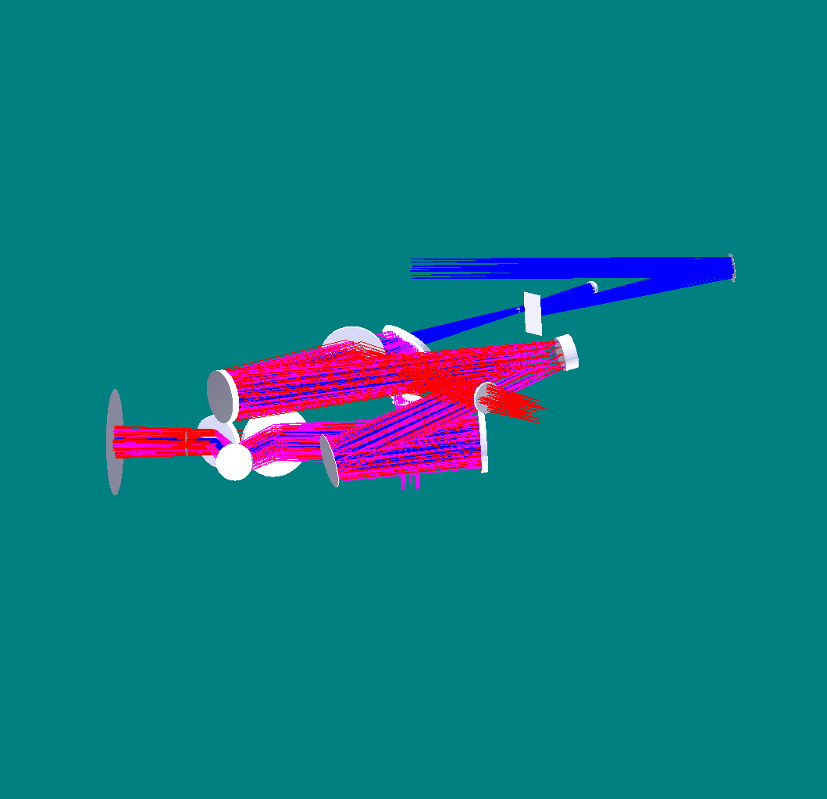
K-mirror
Fold mirror
OAP 1
Woofer DM
OAP 2
LGS dichroic
MEMS DM
f/45 output
LGS coma corrector plates
OAP 3
OSM dichroic
Nasmyth focus
Outside of telescope elevation bearing
To OSM (near-IR tip-tilt and multi-object instrument) input
LGS WFS input
OAP 4

Figure 2: AO system optical configuration – 3D view.
The path to the OSM is shown in magenta, the path to the LGS wavefront sensors in red and the path to the narrow field science instruments in blue.

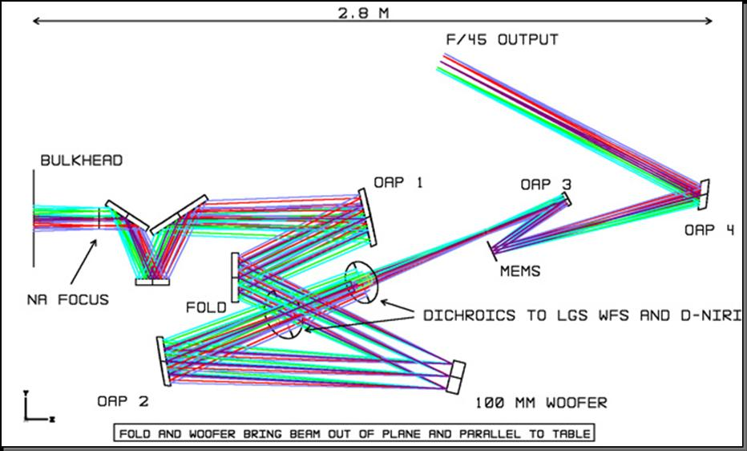
Figure 3 AO system optical configuration – 2D view.

The Keck telescope f/15 Nasmyth focal plane is located ~270 mm past the telescope’s elevation bearing. The AO system optics are enclosed in a cooled enclosure, and a window (not shown) is provided to isolate the enclosure from the dome environment. The light then passes through a “K-mirror” image de-rotator into the first AO relay. This is a one to one relay composed of off-axis parabola (OAP) 1, a fold mirror, the first DM with 20 x 20 actuators, and a second OAP. From the second OAP the light (now at f/15 again) travels to the first dichroic beam splitter located at a 45º angle of incidence. 589 nm light is reflected by this dichroic to the LGS wavefront sensors while the remaining light travels on to the second dichroic beam splitter. This dichroic is also located at a 45º angle of incidence but rotated 90º to fold the beam down to the OSM for the tip-tilt sensors and the multi-object deployable IFU. A benefit of this arrangement is that the astigmatism introduced into the transmitted beam path by the two dichroics is cancelled.

The first DM is conjugated to the telescope’s pupil. Between the two OAPs the collimated beam is ~100 mm diameter, resulting in a 5 mm actuator spacing for the first DM. The fold mirror is located conjugate to ~10 km altitude providing a location where a second DM could be retrofitted to implement a MCAO mode. This first AO relay provides a 120" science field, and a 180" technical field for acquiring the tip-tilt stars, to the OSM. The fold mirror and the first DM form a periscope that changes the beam height to allow a second layer in the opto-mechanical packaging of the system.

The second dichroic beam splitter will be realized as a set of selectable beam splitters in order to share the near-IR wavelengths between the tip-tilt sensors and the narrow field instruments. A second corrector plate is included in the beam path to the OSM to correct the astigmatism in this path introduced by transmission through the first dichroic.

The light that passes through the second dichroic continues on to a second AO relay. OAP3 collimates the f/15 beam to 25.6 mm diameter resulting in a 0.4 mm actuator spacing for the second DM. This is a MEMS DM with 64 x 64 actuators. OAP4 forms a one to three relay with OAP3 resulting in an f/45 output beam for the narrow field instruments.

The optical path to the LGS wavefront sensors results in a tilted image plane where the tilt changes as a function of zenith angle, requiring that each LGS wavefront sensor be independently focused. For the LGS images, the first AO relay is also not operating at the designed conjugates, resulting in aberrations that look like astigmatism but are field position dependent. These aberrations are cancelled by a pair of spherical aberration plates that are translated laterally with respect to each other as a function of zenith angle. This correction results in very small residual LGS image aberrations (~ 30 mas) that are largely independent of zenith angle. An OSM is also required for the LGS wavefront sensors covering a 202" technical field of view, which must also be passed by the first relay.

This configuration will be more compact than the current AO systems on the Keck telescopes. The pupil size is ~30% smaller, and results in a correspondingly smaller area for the first relay. For comparison the existing AO bench extends ~ 2.4 m from the elevation bearing, which is slightly less than the 2.8 m length of the combined relays.

None of the science instruments is required to rotate, and the location options and configurations for the instruments, including the multi-object deployable near-IR IFU, do not have particularly tight constraints.

LGS Wavefront Sensors
The LGS wavefront sensors are Shack-Hartmann (SH) sensors with up to 64 x 64 subaperture sampling of the pupil. For the LGS wavefront sensor detectors we anticipate using a very low noise CCD based on the CCID-56b/d, developed for AO wavefront sensing through a project funded by the Adaptive Optics Development Program (AODP), to minimize the laser power required in each beacon in order to achieve the required SNR.

Low Order Wavefront Sensors
The three Low Order Wavefront Sensors (LOWFS) operate at near-IR wavelengths to improve the availability of suitable stars of sufficient brightness. Optimal performance is obtained using combined J and H band light, but a selectable beam splitting dichroic will allow sending one or more near-IR bands in combination to the tip-tilt sensors with the remainder of the near-IR and the visible light passing to the narrow field instruments. At least one sensor will be of at least order 2 x 2 subapertures to provide sensing of focus and astigmatism. Each tip-tilt star will be AO corrected using a MEMS DM with a pointable LGS beacon positioned near each tip-tilt star to maximize this correction.

Object Selection Mechanisms
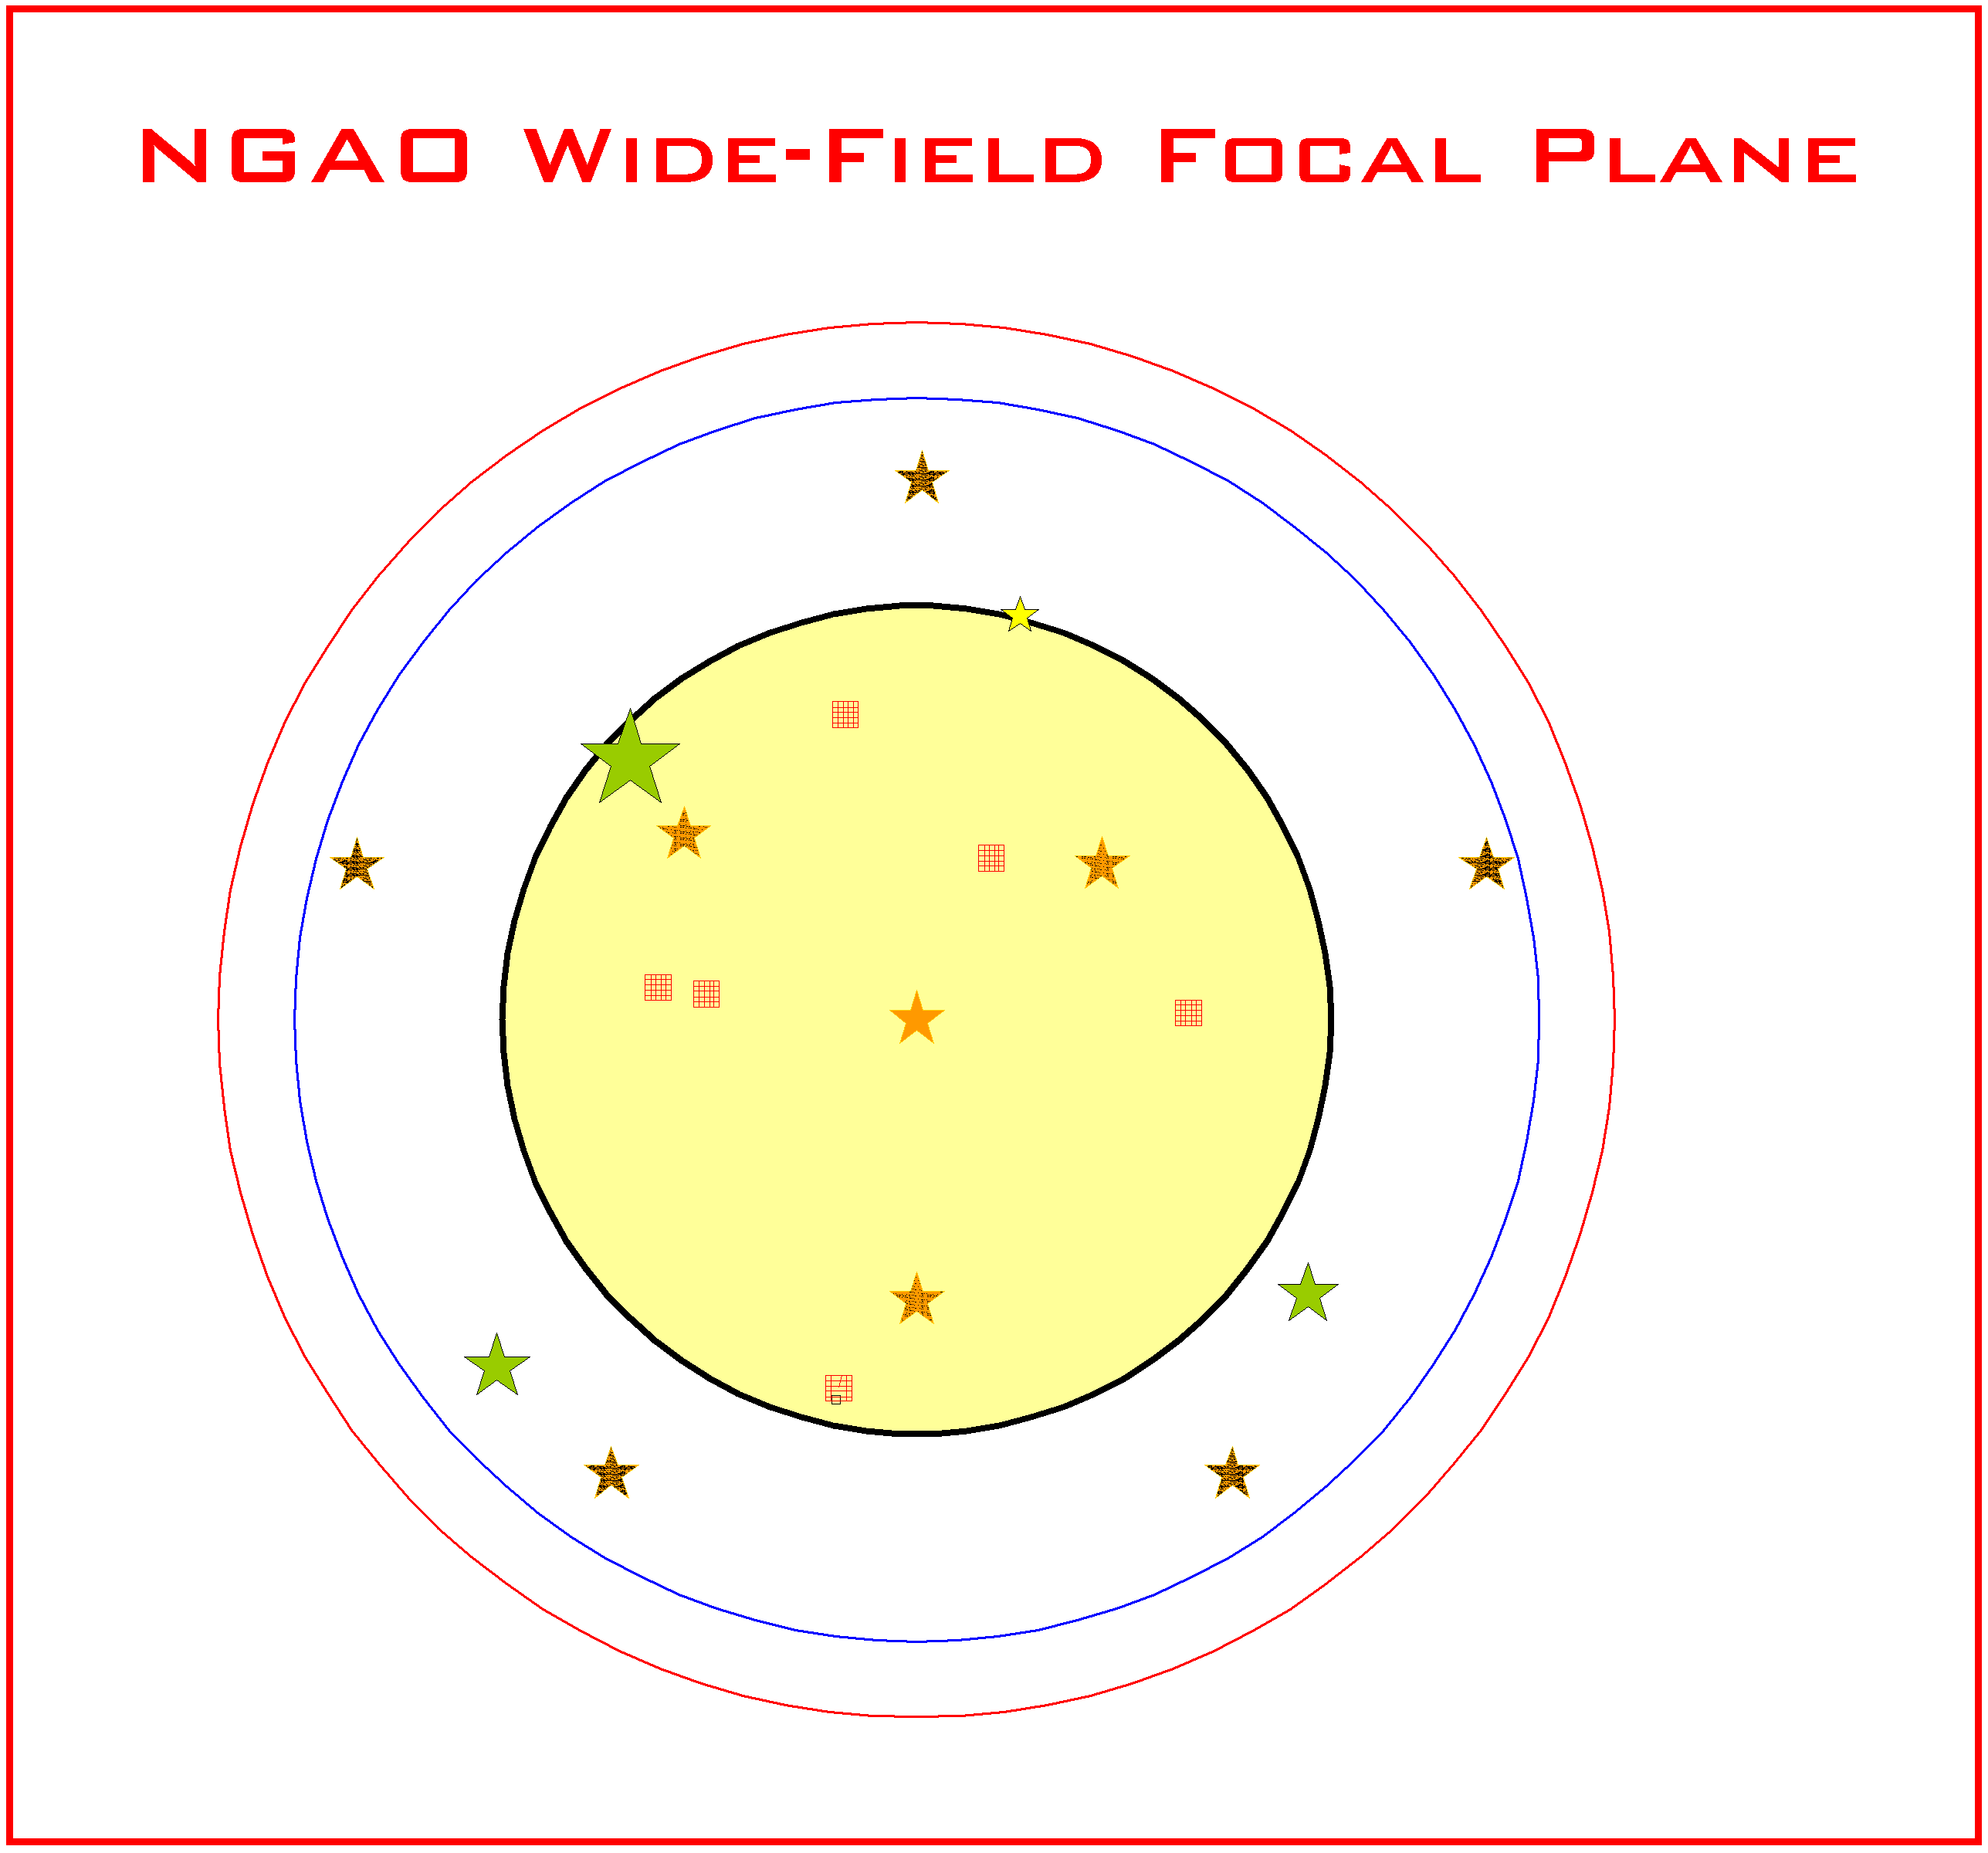
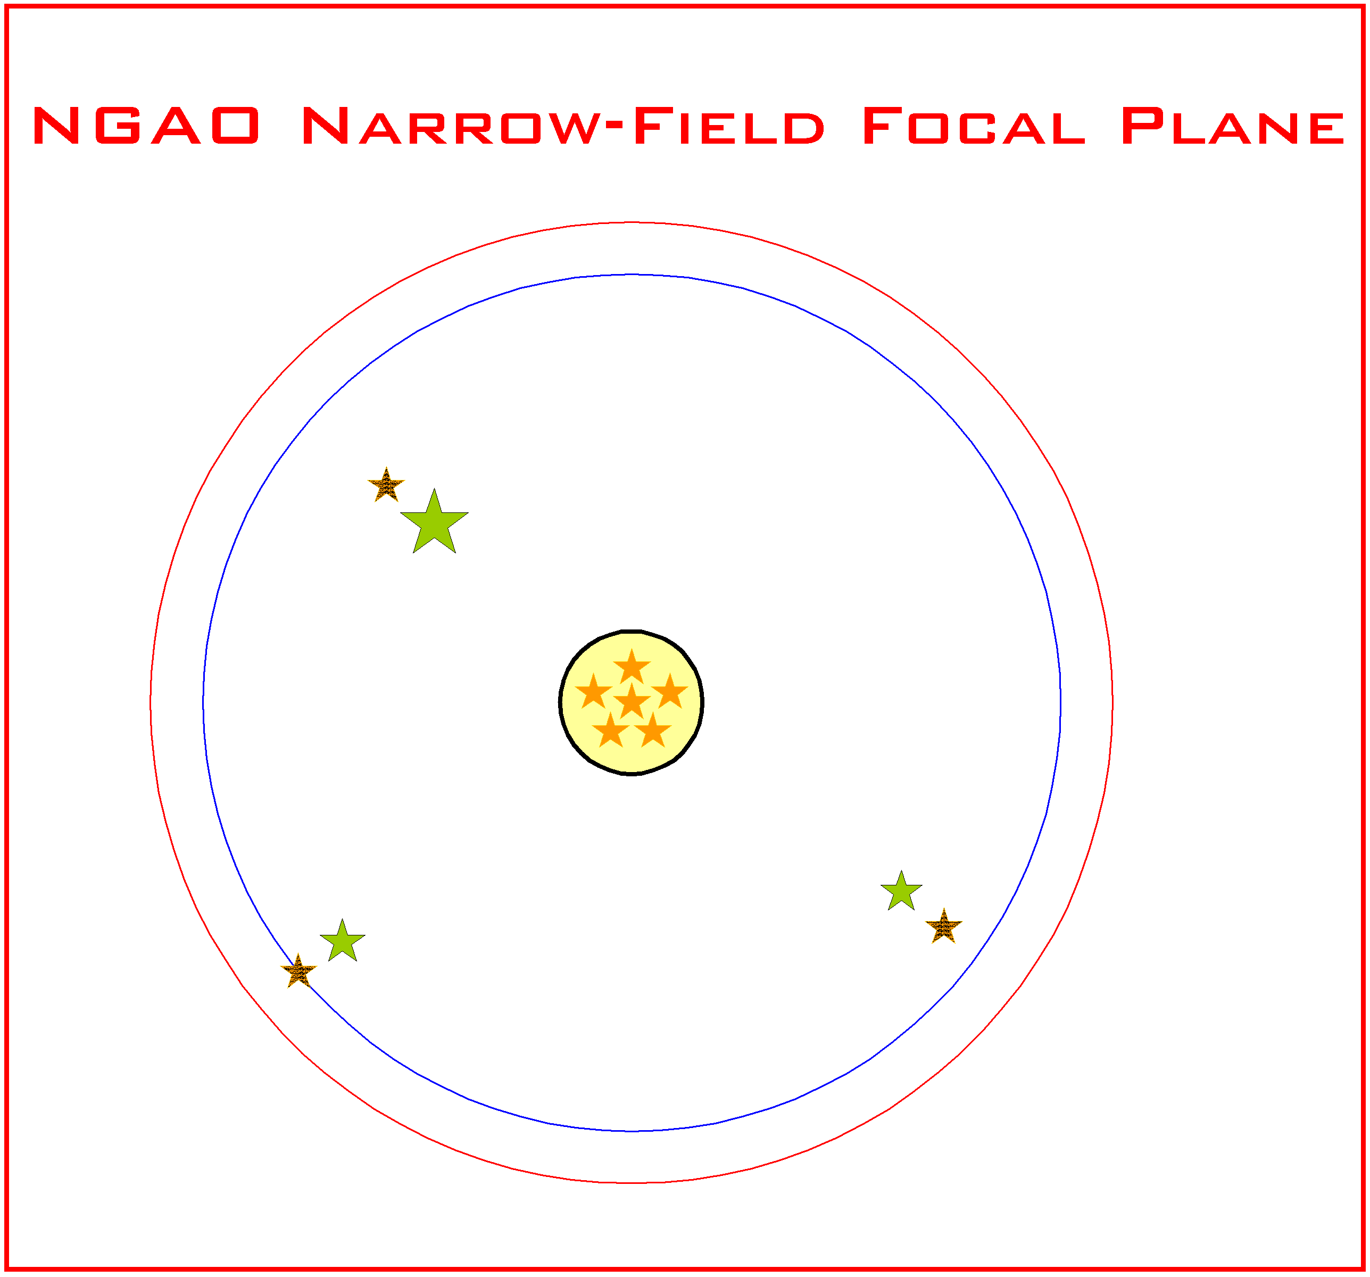
NGAO has two object selection mechanisms, one for the LGS and one for the tip-tilt stars and target selection for the multi-object deployable IFU. A cartoon of the NGAO focal plane for these two modes is shown in Figure 4.
5 LGS in variable radius constellation
1 of 3 tip-tilt stars
202" diameter LGS patrol range
180" diameter for tip-tilt star selection
120" FOR for multi-object target selection
Center LGS
1 of 3 freely positionable LGS to optimize wavefront quality
MOAO Multi-object deployable IFU head
30" diameter narrow field
5 LGS variable radius constellation at 22" diameter
1 of 3 tip-tilt stars
1 of 3 freely positionable LGS to sharpen tip-tilt star

Figure 4: NGAO focal plane
The wide field mode for multi-object observations is shown on the left and the narrow field mode for single object observations is shown on the right. Each mode uses a total of 9 LGS beacons.

In wide field mode the NGAO focal plane consists of a 120" diameter field of regard (FOR) for the selection of targets for the multi-object deployable IFU. This is surrounded by a 180" technical FOR used for selection of tip-tilt stars, and a slightly larger 202" field for LGS acquisition. In wide field mode the variable radius constellation of five LGS is deployed to a diameter selected to optimize the wavefront error across the 120" science FOR. A sixth LGS is located in the center of the FOR. Three freely positionable LGS are deployed in the FOR to optimize image quality, with respect to either the multi-object field of views or the tip-tilt stars.

In narrow field mode the NGAO science field is 30" in diameter. The variable radius constellation of 5 LGS is reduced to 22" diameter and the three freely positionable LGS are used to sharpen the selected tip-tilt stars.

Mechanical Design
The opto-mechanical configuration of the NGAO system on a Keck telescope left Nasmyth platform is shown in Figure 5. For reference the floor of the existing AO enclosure is indicated by the surface with the red outline. The AO system optical components will be further enclosed to allow cooling to 260 K, the exact configuration of this enclosure is to be determined. Starting just above the center of the figure on the left side the nine LGS wavefront sensor units are shown. Each wavefront sensor is mounted on an independently controlled focus stage. LGS field selection is performed by the OSM located just to the right of the LGS wavefront sensor assembly. At the center of the figure the two AO relays are shown mounted on the opto-mechanical unit (OMU) bench. The K-mirror and OAP 1are mounted below this bench, and the beam then passes up to the first and second AO relays mounted above the bench.
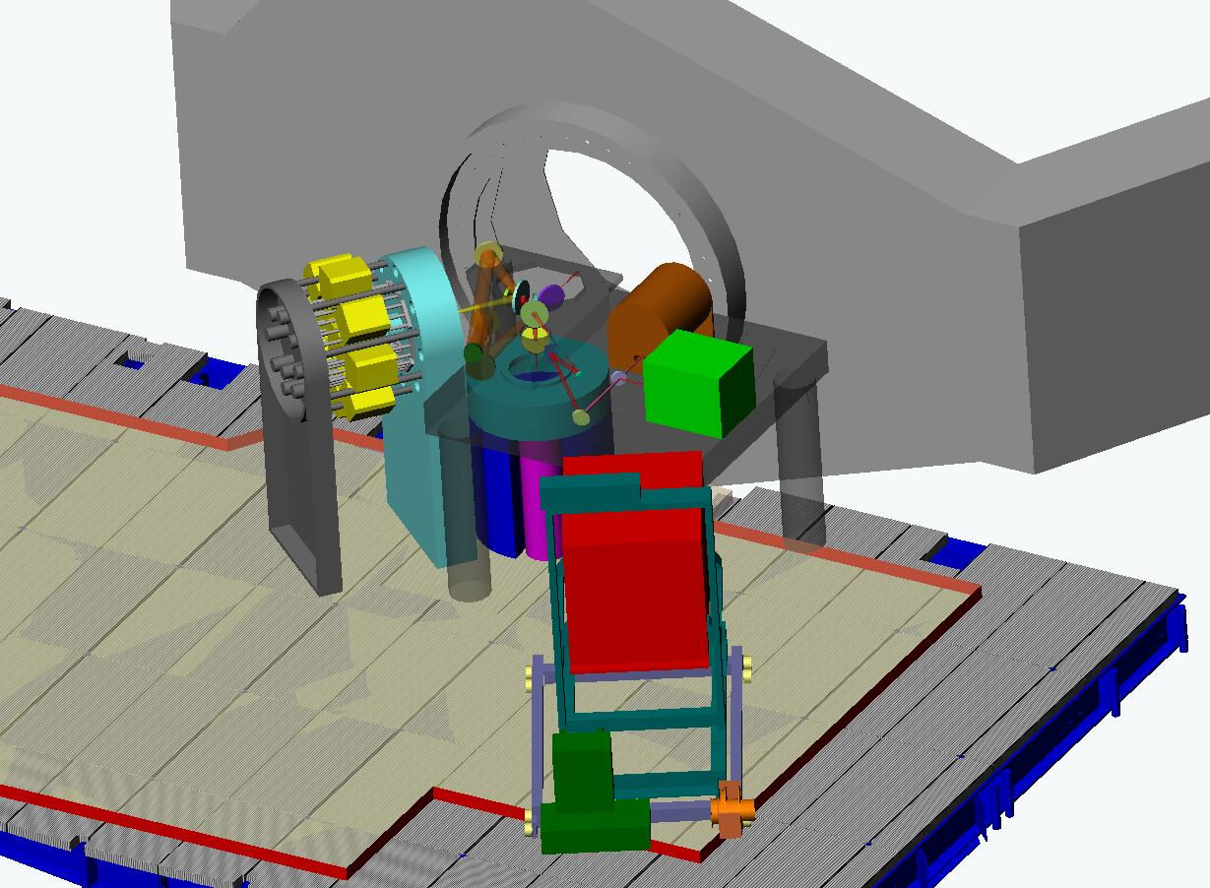
Visible imager
Near-IR imager
Near-IR IFU (OSIRIS)
Telescope elevation bearing
Keck I or II right Nasmyth platform
LGS OSM
LGS wavefront sensors on focus stages
Woofer DM
589 nm Light
f/45 narrow field AO relay
Narrow field selection mirror
IFU and tip-tilt OSM
2 channel IFU spectrograph (1 of 3)
Tip-tilt sensor (1 of 3)
K-mirror image
de-rotator
f/15 AO Relay
OMU Bench

Figure 5: NGAO Opto-mechanical Configuration

The OSM for the multi-object deployable IFU spectrograph is located beneath the bench and feeds the three tip-tilt sensors and the IFU. The IFU spectrographs are contained in three identical cryostats, each providing two IFU spectrographs. The tip-tilt sensors are also enclosed in cryostats.

Just to the right of center, above the OMU bench the f/45 narrow field relay output is directed to a selection mirror used to switch the beam between the single object near-IR IFU and the near-IR imager. The mirror is translated out of the beam for the visible imager. The two imagers are mounted on the OMU bench. The near-IR IFU is mounted on a separate service cart, in this illustration the OSIRIS instrument is shown for the near-IR IFU.

AO Enclosure

Alignment, Calibration and Diagnostics

Laser Facility Description

Laser
A comparison of lasers currently in use at various facilities can be found at http://lao.ucolick.org/twiki/bin/view/CfAO/SodiumLaserGuidestars. A laser choice has not yet been made, however two types of solid state sum-frequency lasers are the most likely candidates for consideration:
- The Starfire Optical Range (SOR) laser in use at SOR. This laser has the highest measured return per Watt and the highest power of the existing lasers. A second generation, two frequency laser is currently under development for improved sodium efficiency.
- The LM/CTI laser. The first generation of this laser is in use at Gemini-North. In a combined Keck/Gemini experiment the Gemini-North laser was demonstrated to have twice the return of the Keck dye laser. The second generation of this laser is currently being fabricated for Gemini-South and Keck I. This is the only commercially available laser that could meet our needs.

We also intend to monitor the progress of fiber lasers. ESO is working with Volius to develop a Raman fiber laser and LLNL also continues to develop their fiber laser. Volius is currently building a low power sodium wavelength laser for Keck. The LLNL fiber laser will be demonstrated in the VILLAGES experiment at Lick.

Laser Enclosure

Laser Beam Transport
Two options will be considered for transporting the laser light from the laser to the top end of the telescope. The favored approach because of its simplicity, especially if the laser cannot be on the elevation ring of the telescope, is to use single mode hollow core photonic crystal fibers. These are being used with the VLT, Subaru and Keck I lasers. Alternatively, a multiple mirror based beam transport system similar to what has been done for Gemini would be considered.

Beacon Projection System
The LGS beacon projection system consists of a beam pattern generation and pointing system and a launch telescope. The launch telescope will incorporate a tip-tilt mirror for correction of the laser uplink tip-tilt and the beam pattern generator may incorporate a beam splitting arrangement so that fewer laser beams will need to be transferred to the top end of the telescope. The beam pattern generator will provide one fixed on-axis LGS beacon, a variable diameter pattern of five LGS beacons from a radius of 11” to 90”, and three additional, pointable, LGS beacons over a range from some tbd minimum radius to a maximum radius of 101”.

An evaluation was performed of the benefits of uplink compensation in KAON 509. For the moment we have decided to proceed without uplink compensation.

Control Electronics and Software
Electronics and software subsystems are associated with each of the major components of the NGAO system. A block diagram of the NGAO electronics/software subsystems and related external subsystems is shown Figure 6.

Communications between the various subsystems are represented by four control and data paths shown in the figure. The real time data flow (magenta) between the wavefront sensors and the DMs is isolated from other communications flow to provide maximum performance. The “AO Configuration and Status” control path (light blue) is used by the AO sequencer to orchestrate the operation of the AO system. The sequencer establishes configurations for each observation and provides status and control for the non-real time subsystems to the AO host computer via the “Supervisory Control and User Interface” (green). This interface also provides the AO host computer with control and status for the various supervisory controls. The AO sequencer coordinates AO operations with the external subsystems, the instrumentation, telescope drive and control and the primary mirror control system via the “Auxiliary Configuration, Offloading and Status” interface (purple). This includes tip-tilt offloading to the telescope secondary and control of telescope tracking during an observation.

The majority of the AO electronics subsystems will be straightforward designs based on heritage systems, particularly for supervisory controls such as AO enclosure environmental and laser safety. Similarly, instrument electronics will be based on the most current heritage designs from the OSIRIS and MOSFIRE instruments at WMKO. The sensors for the tip-tilt stars will also be based on existing detector technology and readout systems. LGS wavefront sensing electronics will be based on the AO wavefront sensing systems being developed for the TMT through the AODP.

Figure 6: NGAO electronics and software subsystems

The main challenges in the design of the NGAO electronics and software are the demanding real time control requirements for AO in a multi-guidestar system employing tomographic wavefront reconstruction techniques and multiple DMs. Our investigation of the algorithms and data flow needed for AO real time processing and control has suggested that a massively parallel architecture using current state-of-the-art field-programmable gate arrays (FPGAs) can readily accomplish this task.

Non-real-time Control

Real-Time Control
The real-time control requirements for NGAO are summarized in Table 1.

Massively Parallel Processing
The proposed massively parallel processing (MPP) system pipeline architecture depicted in Figure 7 implements a three step process: wavefront measurement, tomography, DM fitting. Multiple wavefront sensors, corresponding one to each LGS and tip-tilt star, feed data to a centralized tomography unit. These are inherently parallel operations. Calculation is further parallelized across the spatial dimensions (two dimensions x and y for wavefront sensor and deformable mirrors, and three dimensions x, y, and z for tomography, where z is the vertical direction). For algorithmic reasons, data in x, y planes parallel to the aperture are represented by their Fourier coefficients. Calculations are spread out among processors dedicated to pieces of the x-y Fourier space, slices in the z vertical space, individual wavefront sensors, and individual DMs.

The tomography unit determines an estimate of the differential optical path differences within volume elements of a model atmosphere. This information is then used in a process of determining the desired phase correction at each DM, given a tomographically determined estimate of differential phase aberrations over the atmospheric volume. For MOAO this is the line integral of the turbulence estimate through the volume in the direction of interest. Since the DMs commonly have inter-actuator influence functions, a deconvolution and/or lookup table access must be done for the actuator commands so that the resulting DM shape best fits the new wavefront estimate. Fitting involves deconvolving the DM’s unit response function so that a voltage command can be determined given the desired surface shape. In the case of MEMS in open loop operation, it is necessary to use an additional cascade of two non-linear lookup tables.

The MPP architecture described above has a distinct advantage over a traditional single CPU implementation in that it can scale with the number of guide stars, number of DMs, and number of subapertures by simply adding processor cards without affecting the data throughput rate or the software program significantly.

Control bandwidth | >90 Hz
Wavefront sensor frame rate | 1.5 to 2 kHz
Number of LGS wavefront sensors | 9
Number of tip-tilt sensors | 3
Number of deformable mirrors | Narrow field mode: 1 20 x 20 “woofer” DM, 1 64 x 64 “tweeter DM”, 3 32 x 32 DMs for MOAO correction of the tip-tilt stars.  Wide field mode: 1 20 x 20 “woofer” DM, 3 32 x 32 DMs for MOAO correction of the tip-tilt stars, 6 32 x 32 DMs for MOAO correction in the multi-object deployable IFU.
Reconfigurable for number of guide stars and DMs. Allows differing asynchronous data rates from various wavefront and tip-tilt sensors
Adapts and optimizes for changing seeing and signal-to-noise conditions and incorporates information from external measurements of the C_{n}² profile
Full telemetry and diagnostics streams
Table 1: NGAO real time control requirements

Figure 7: Multi-guidestar AO processing architecture

Tomography
Tomography is accomplished with an iterative back-propagation algorithm depicted in Figure 8 (Gavel 2004, Gavel et al. 2005). The method is analogous to the filtered-back-projection techniques used in modern medical tomography 3-d data analysis. These calculations can be mapped to the massively parallel computer architectures described earlier. During processing, each iterative correction is along a conjugate-gradient direction, resulting in convergence in only a few iterations. Overall, the MPP implementation combined with the fast converging algorithm enable the process to be repeated at the very demanding frame rates of real-time adaptive optics, about once per millisecond .

Figure 8: Tomography algorithm

Laser Safety System

Science Operations

Observing Model
A trade study of possible observing models was performed in KAON 476.

Observing Scenarios

Astronomical Observations Operation

AO-Instrument Interfaces

Science Instruments
The philosophy for the NGAO instrument compliment is to address the large parameter space offered by NGAO with specialized instruments, while keeping them as simple as possible. By separating wavelength ranges along natural breakpoints based on optical and thermal design considerations and by providing spectroscopy with IFU’s we can meet the science needs without requiring multimode instruments. The major exception is a multi-object deployable near-IR IFU spectrograph that is of necessity a more complex instrument.

All of the proposed instruments are based either on currently available detector technology or on anticipated evolutionary developments of current technology that we believe will become available within the NGAO development timeframe. Instrument control software and data reduction requirements are expected to be evolutionary developments of current instruments and data reduction tools. It will be important to emphasize close integration with the AO system control software. Features that promote efficient AO observing will be an integral part of the software for every NGAO instrument.

Each of the major science areas has somewhat different instrument priorities. These must be reconciled in order to arrive at a useable priority list. Two important additional inputs to the setting of instrument priorities are the need for appropriate instrumentation for first light commissioning of the AO system, and the relative timescales required for development of the various instruments. Based on the science priorities and these other considerations we have identified the instrument priorities shown in Error: Reference source not found.

Single object Instruments |  | Multi-object Instruments
Name | Priority | Name | Priority
Near-IR imager | 1 | Deployable near-IR IFU | 1
Visible imager | 2
Near-IR IFU (OSIRIS?) | 3
Visible IFU | 4
Table 2: NGAO instrument priorities

The near-IR imager will be the first-light commissioning instrument for NGAO. The multi-object deployable near-IR IFU is a high priority instrument, but because of its complexity, it will also have the longest development timeline. Therefore, it is important that its development be started as soon as possible. In view of the development timeline for the deployable near-IR IFU, the single object near-IR IFU is ranked third because of the clear importance of near-IR spectroscopy.
Initial requirements for the imagers are summarized in Error: Reference source not found.

Visible and NIR Imagers

Instrument |  | Wavelength coverage (µm) |  | Field of view |  | Sampling
Visible Imager | 0.7 to 1.0 |  | 20” x 20” |  | Nyquist (6 mas)
Near-IR Imager | 1.0 to 2.45 |  | 20” x 20” |  | Nyquist (10 mas)
Table 3: NGAO imager requirements

Visible and NIR Spectrographs
The initial requirements for the single object near-IR IFU are as follows:

Wavelength coverage: 1.0 to 2.45 µm | Spectral resolution: R ~4,000
IFU Spatial sampling:  - 80 x 50 samples in a broad band mode  - 160 x 50 samples in a narrow band mode | Spectral sampling:  - ~2,000 pixels/spectra in broad band mode  - ~1,000 pixels/spectra in narrow band mode
Optional selection of sampling scales: 100, 50, 20 mas

With the exception of the field of view, OSIRIS meets many of the requirements for this instrument. See KAON 493 for a discussion of the possible reuse of OSIRIS with NGAO.

The initial requirements for the single object visible IFU are as follows:
Wavelength coverage: 0.7 to 1.00 µm | Spectral resolution: R ~3,000
IFU Spatial sampling:  - 60 x 68 samples in a broad band mode  - 120 x 68 samples in a narrow band mode | Spectral sampling:  - ~2,000 pixels/spectra in broad band mode  - ~1,000 pixels/spectra in narrow band mode
Optional selection of sampling scales: 50, 35, 20 mas

NIR Deployable IFU
The initial requirements for the multi-object deployable near-IR IFU are as follows:

Wavelength coverage: 1.0 to 2.45 µm | Sampling scale: 50 mas
Multiplex: minimum of 6 deployable IFU heads | Spectral resolution: R ~4,000
Spatial sampling per IFU head: 60x20 samples minimum | Spectral sampling: ~2,000 pixels/spectra

Interferometer
It is a requirement for the Interferometer to be supported by AO on both telescopes in the NGAO era. This could be a direct feed from NGAO, most likely after the first relay, or by a separate AO system, which imposes a requirement on being able to exchange AO systems. A trade study was performed on the issue of Keck Interferometer support which is documented in KAON 483. The primary requirements are to achieve at least the current level of performance while maintaining a common field orientation and polarization from both telescopes.

‘OHANA
Both existing Keck AO systems accommodate an ‘OHANA fiber injection module at the output of the AO systems. NGAO should provide an output port where this or a similar fiber injection module could be located, and whose output could be successfully interfered with the light from another telescope.

Thermal NIR Imager
A thermal NIR imager has not been given a high priority and therefore no significant evaluation has occurred for this instrument. An evaluation of the reuse of NIRC2, which extends out to L and M-bands, was performed as part of KAON 493.

Requirements

Requirements Documents
There are three main requirements documents:
- The Science Case Requirements Document (SCRD). KAON 455.
- The System Requirements Document (SRD). KAON 456.
- The Functional Requirements Document (FRD).

There is a fourth requirements document that is referenced by the SRD. This is the Instrument Baseline Requirements Document (IBRD) which contains Observatory standard requirements for any instrument.

The requirements process can be summarized as follows:

- The science requirements are developed in the SCRD.

- The science requirements from the SCRD, and additional requirements imposed by the Observatory, are tabulated in the Overall Requirements section of the SRD. These overall requirements are then flowed down to discipline based requirements in the SRD. The requirements are generally divided between performance, implementation and design requirements. The disciplines are Optical, Mechanical, Electronic/Electrical, Safety, Software, Interface, Reliability, Spares, Service and Maintenance, and Documentation. Note that the SRD avoids prescribing specific design or implementation solutions.

- The FRD flows down the requirements from the design-independent SRD to requirements on a few high level subsystems. The flow down of the SRD requirements to the FRD requirements is frequently a design choice that could be revisited. The subsystems are chosen to divide the NGAO system into functions that would be required independent of the selected architecture. At minimum these subsystems include the AO system, laser facility, science operations facility and science instruments with further subdivision as appropriate. For each subsystem there is a section describing the architectural assumptions, followed by a breakdown of the requirements by the same disciplines as used in the SRD.

The system design phase schedule allows for the development of four versions each of the SCRD and SRD. Two versions of the FRD are scheduled. The first was produced as part of the system architecture activity. The second is to be produced as a result of the subsystem design process.

The FRD provides the criteria against which the subsystems will be evaluated. The SRD provides the criteria against which the NGAO system will be evaluated.

Science Case Requirements Summary
A high level summary table of the science requirements can be found in Section 11. In this section a brief description of each of these requirements is provided. The summary table groups the requirements by three categories: physical, performance and operational. The requirements are then written down for each science instrument: visible imager, visible spectrograph, near-IR imager, near-IR spectrograph, near-IR deployable IFU and the interferometer. The science cases that drive these requirements are listed at the bottom of each column; and these science cases are defined in the table at the lower left. There is also a category of “Other” requirements and goals in the spreadsheet that is discussed at the end of each subsection.

Physical Requirements
- Wavelength range.
  - The visible instruments require a transmitted wavelength range of 0.7 to 1.0 µm, with a goal of a lower wavelength limit below Hα (0.6563 µm).
  - The near-IR instruments require a transmitted range from 1.0 to 2.4 µm, including the J, H and K spectral bands, but also as a goal the Y and z-bands (0.98-1.20 µm).
  - The interferometer requires coverage from J through L-band, with a goal to N-band.
- Field of view diameter
  - The field of view requirements for the narrow-field instruments is relatively modest. A decision was made, in consultation with the Keck AO Working Group, to provide a 30” diameter field to allow for science cases not considered as well as dithering and finding a point source.
  - The field of view requirement for the deployable IFU is 1”x3”. This allows adequate field to dither a < 1” diameter science object and to have a sky background in the field.
  - The interferometer’s field of view is quite small leading to a ≥ 1” diameter requirement.
- Field of regard diameter
  - This is applicable to the instruments where the field of view can be positioned over a larger field of regard.
  - The requirement for the deployable IFU heads is ≥ 120” diameter.
  - The requirement for the interferometer is ≥ 60” diameter to allow for simultaneous observation of an on-axis phase referencing star and an off-axis science target.
- Science detector pixel size
  - The visible and near-IR imager pixels should be sized to Nyquist sample the image at R-band (≤ 7 mas) and J-band (≤ 13 mas), respectively.
  - In the case of the deployable IFU there should be 2 pixels per spaxel (the spaxel is the spatial resolution element defined by for example a lenslet). This corresponds to ≤ 35 mas.
- Minimum number of IFUs
  - The goal is to have 6 or more IFUs, however the requirement is only 4.
- IFU separation
  - The > 1 IFU in a 10”x10” field is driven by the desire to observe two or more stars simultaneously at the Galactic Center.
- AO background
  - For all near-IR instruments the requirement is that the AO system contribute ≤ 30% of the total background, or emissivity, seen by the science instrument.
- Other
  - Goal is for AO to transmit to as short a wavelength as Hα (653 nm).
  - The NGS wavefront sensor field of regard should be ≥ 15” diameter. This was intended to allow the NGS to be anywhere in the science field.
  - Goal is to provide a full field (20” square for the visible and 40” square for the NIR) to a 2k Nyquist sampled detector. The requirement agreed to from a discussion with the AOWG was for a 30” diameter field to the narrow field science instruments.

Performance Requirements
The performance requirements must be met under median seeing conditions (as defined in KAON 503 and summarized in the bottom right corner of the spreadsheet): r₀ = 18 cm and θ₀ = 2.9”.

- Sky coverage
  - In all cases, with the exception of the interferometer, the following performance criteria are required to be met over ≥ 30% of the sky.
- High order wavefront error (WFE) for ≤ 5” field of view
  - The requirement on residual rms WFE after correction is ≤ 170 nm as delivered to the science focal plane of the narrow field imagers and spectrographs. High order refers to all terms higher than tip and tilt.
- Tip/tilt error
  - The requirement on residual rms tip/tilt error is ≤ 15 mas as delivered to the science focal plane of the narrow field imagers and spectrographs for the ≥ 30% sky coverage case. For the special case of the Galactic Center the requirement is ≤ 3 mas.
- 50% ensquared energy
  - Ensquared energy was determined to be a more relevant requirement for the NIR deployable IFU (the corresponding high order and tip/tilt errors can be derived from this requirement). The requirement is for 50% of the energy to be enclosed in an area of ≤ 70 x 70 mas.
- Companion sensitivity
  - This requirement is relevant only to the visible and NIR imagers. The requirement is written for different filters and different angular separations according to the relevant science case. For example, for planets around low mass stars ΔJ ≥ 8.5 at 0.1” from the primary star and ΔJ ≥ 11 at 0.2” separation.
- Photometry
  - The relative photometry requirement is ≤ 0.05 magnitudes for both imagers.
- Astrometry
  - The requirement is on relative astrometry for both imagers.
- Polarimetry
  - The polarimetry requirement is only relevant to the imagers and is currently TBD.

Operational Requirements
- Point Spread Function (PSF) estimation
  - An estimate of the PSF, for post-processing purposes, is required for both imagers and is a goal for both spectrographs. A spectrum of the PSF is required for the deployable NIR IFU. The accuracy of this estimate is TBD.
- Differential tracking
  - For solar system science there is a requirement to be able to use a sidereal rate object for tip/tilt correction of a solar system object.
- Acquisition accuracy
  - The acquisition system should be able to position the science object on the science field to the indicated accuracy without taking a science exposure. Generally, this is 10% of the field size, however for the case of placing an object on a slit the requirement is significantly more stringent (≤ 0.25λ/D).
- Dither distance, accuracy and time
  - Dithers are routinely used to move the science object on the science detector. This is done for purposes of mosaicing, sky subtraction and removal of detector non-uniformities. The dither distance is the maximum possible dither for a single dither. The dithers must be done accurately for later shift-and-adding of the images. Since dithers are done frequently they need to have small time overheads between ending one exposure and beginning the next.
- Micro dither distance, accuracy and time
  - Micro dithers are used to accurately position an object on a slit or coronagraph mask. This is a requirement on a relative move.
- Nod reacquisition time
  - A nod is performed to move the object off the science instrument in order to obtain a sky. This requirement is on the time from beginning the nod of the science object back onto the detector to the time when the science exposure can begin (with all AO loops properly locked).
- Positioning knowledge
  - Knowledge of the relative position of the science detector on the sky is important to allow co-adding of images.
- Science image drift
  - This defines the requirement on the stability of the science field with respect to the AO system. The requirement is to have this drift ≤ 5 mas per hour.
- NGS mode
  - Generally speaking it is a requirement to have an NGS mode. In the case of the NIR deployable IFU only one of the IFUs is required to do science in NGS mode.
- AO instrument switching
  - This requirement is driven by the desire to do both imaging and spectroscopy on the same night. The requirement is to be able to switch between the visible imager and spectrograph, and similarly be able to switch between the NIR imager and spectrograph.
- AO backup switching
  - The availability of an NGS mode and instrument switching already allows for backup in the case of laser problems, instrument problems or poor atmospheric conditions. In poor seeing conditions it is also a goal to be able to switch to the NIR instruments where some science may still be possible.
- Other
  - The interferometer requirements must be met by a NGAO mode including matched fields, polarization, etc. from both telescopes.
  - A non-AO backup is required for all cases.
  - Both fixed field and fixed pupil modes are required to be supported.
  - The acquisition system must provide a means of acquiring the tip/tilt stars and the LGS beacons.
  - Appropriate alignment, calibration and diagnostic tools must be provided.

Performance Budgets
Eight performance budgets have been addressed as part of the system design.

Background and Transmission
The background and transmission performance budget is developed in KAON 501.

Both AO relays must efficiently transmit the science wavelength light from 0.7 to 2.4 μm (with a goal of 0.656 to 2.4 μm, so as to include Hα). The first relay must also efficiently transmit sodium wavelength light (589 nm) and the additional L-band light (3.4 to 4.2 µm) for the interferometer. This wavelength range must be efficiently divided between the various sensors (LGS and tip-tilt) and the instruments.

Near-IR light will be shared between the tip-tilt sensors and the narrow field instruments. This will require the near-IR beamsplitter for the OSM to be a set of selectable dichroics. This will send some of the near-IR light (for example J and H bands) to the tip-tilt sensors while sending the balance to the narrow field instruments (visible and K band for example). Excellent coatings will be required for all surfaces

The design choice to achieve the K-band background requirement is to cool the AO optics to 260 K.

The sensitivity delivered by the NGAO system is significantly affected by the total background seen by the instruments. In the present Keck telescope AO systems background is recognized as a significantly limiting sensitivity, particularly for the K band.

Part of the solution to reducing background is the control of scattered light through careful design and implementation, and the use of hexagonal, rotating cold stops matched to the shape of the telescope pupil in the near-IR instruments. However, thermal emission is a significant factor for near-IR observations, particularly longward of 2 µm. Using data from the current Keck II telescope AO system we have developed a model of the background contributed by sky + telescope + AO system that indicates the AO system optics should be cooled to 260 K.

Wavefront Error and Ensquared Energy
The wavefront error budget is described in KAON 471. The primary tool is an excel spreadsheet (current version Wavefront Error Budget Tool v1.26.xls). This budget is supported and anchored by a number of KAONs. The atmospheric assumptions summarized in KAON 503 are based on previous seeing studies (KAON 303) and new TMT site monitoring data (KAON 415 and 496). The sodium return assumptions are based on sodium density from Keck LGS photometry (KAON 416), long term LIDAR measurements on Haleakala (KAON 417) and comparisons to measured returns from Gemini and Keck (KAON 419). The wavefront error budget tool has been anchored to the performance of the existing Keck AO system in KAON 461. The contribution of Keck telescope segment figure errors is determined in KAONs 468 and 469, and the overall contribution of the telescope to the wavefront errors is determined in KAON 482. Finally, several tomography codes were compared (KAON 475) in order to validate the tomography assumptions used in the wavefront error budget and the null and quadratic mode tomography errors were evaluated (KAON 492).

Related analyses include sky coverage modeling (KAON 470) and performance versus field of view for low order wavefront sensor guide stars (KAON 504).

The AO system architecture is driven by the required wavefront error to incorporate a number of innovative subsystems that work together to overcome specific effects that limit the quality of the AO correction provided by the system. These include multiple LGS beacons and a corresponding number of LGS wavefront sensors, multiple tip-tilt stars, a tomographic wavefront reconstructor and high order correction.

A minimum of 64 x 64 actuators is required over the telescope pupil to meet the most demanding narrow field residual wavefront error requirement of 140 nm. Such high actuator counts are only practical with MEMS DMs. The multiple LGS require a larger technical field of view than what can practically be accommodated with the very small actuator spacing of MEMS DMs. This would lead to operating the LGS wavefront sensors entirely in open loop, a risky design approach. To address the problem a two DM design is employed, with the first DM with 20 x 20 actuators providing low order correction for the LGS in a closed loop. The second DM is a MEMS DM operated in a feed forward or “go to” control mode. Multiple MEMS DMs are used, one for the narrow field relay, and one for each of the tip-tilt sensors, and for each head of the multi-object deployable near-IR IFU.

A wavefront error budget for NGAO has been developed using Excel spreadsheet tools developed over several years for the engineering evaluation of AO system performance. The primary purpose of the spreadsheet is to compute AO and instrumental wavefront error budgets for different architectures and science cases, along with Strehl ratios computed using the Marechal approximation. The spreadsheet also computes ensquared energy fractions using a core/halo model for the point spread function, and calculates sky coverage estimates for tip-tilt guide stars employed in LGS architectures from common star density models. The spreadsheet has been validated by comparing the spreadsheet predictions to the current performance of the Keck II LGS AO system with good agreement.

Our study of the performance of the selected AO system architecture shows that it is quite flexible, permitting optimization of the residual wavefront error for a wide range of observing conditions. The spreadsheet tool was configured to optimize the H band Strehl ratio, and certain parameters such as LGS constellation radius, high order update rate, and tip-tilt update rate were allowed to vary within appropriate constraints in order to optimize the Strehl ratio. Examples from this study of the wavefront error budget are shown in Error: Reference source not found. It should be noted that these examples are based on an earlier relay design using a single 64 x 64 actuator DM, a single tip-tilt star and an LGS constellation consisting of just the central LGS and the four equally spaced LGS in a variable radius. No additional LGS were deployed to sharpen the tip-tilt star.

Observation | Int. time | TT reference | LGS diameter, " | TT error, mas | Sky coverage | High order wavefront error, nm | Total wavefront error, nm | Strehl (1.65 μm)
Io | 10 s | Science target | N/A | 1.7 | N/A | 96 | 98 | 87%
Kuiper Belt | 300 s | Field star | 41 | 6.2 | 10% | 150 | 184 | 61%
Exo-Jupiter | 300 s | Science target | 12 | 3.3 | N/A | 124 | 137 | 76%
Extragalactic | 1800 s | Field star | 90 | 18.5 | 30% | 159 | 329 | 25%
Galactic Center | 30 s | IRS 7 | 11 | 2.0 | N/A | 170 | 174 | 64%
Table 4: Wavefront error budget summary

The first column of the table indicates the observing scenario. The second column indicates the integration time assumed for the science exposure. The third column indicates the tip-tilt reference used, and the fourth column gives the diameter of the LGS variable radius constellation. The fifth column indicates the tip-tilt error that results from the assumed angular offset of the tip-tilt star. The sixth column gives the sky coverage fraction over which the tip-tilt error will be less than or equal to the error given in column five. This estimate results from the use of common sky coverage models (Spagna and Bachall-Soneira). The last three columns give the high order wavefront error, the total wavefront error with tip-tilt errors, and the H band Strehl. For the extragalactic case, the figure of merit is ensquared energy rather than residual wavefront error, for the 50 mas spatial sampling of each head of the multi-object deployable IFU the ensquared energy is 37%.

These results show that the variable radius LGS constellation and the performance levels assumed for the tomographic wavefront reconstruction, LGS wavefront sensors and near-IR tip-tilt sensors are capable of providing performance that is generally at the level required by the science cases. Initial estimates of NGAO system performance based on laser tomography AO resulted in the adoption of three representative values of residual wavefront error for the science case simulations: 140 nm, 170 nm and 200 nm. This has led to further work to develop additional techniques for performance improvement including the additional three freely positionable LGS (see §4.2.4) and the additional tip-tilt sensors.

The sky coverage fractions required by the extragalactic and Galactic science cases requires optimizing the offset and brightness of the tip-tilt stars. This is accomplished by increasing the faint magnitude limit for tip-tilt stars through the use of tip-tilt sensors operating at near-IR wavelengths combined with MOAO correction using deployable LGS beacons specifically for tip-tilt reference sharpening, and by providing a 180" field of view for tip-tilt star selection.

Photometric Precision
Requirements for photometric measurements in the NGAO science cases range from 0.05 to 0.1 magnitudes in relative photometry, and ≤ 0.05 magnitudes for absolute photometry. The fundamental condition for high photometric accuracy is stability of the PSF. Because of the high Strehl delivered by the NGAO system, a more stable PSF is expected. Many of the science cases that require the highest photometric accuracy are observing a science target of sufficient brightness (H < 16) to permit use of the science target as an on-axis tip-tilt reference, further improving Strehl performance.

Analysis of NGAO photometric accuracy requirements also leads to a number of other technical requirements related to the PSF. These include obtaining precise knowledge of the AO system PSF through provisions for PSF calibration and monitoring. NGAO may need to provide a PSF monitoring imager deployable over the AO system technical field of view to allow simultaneous PSF imaging during observations. Recent work at Palomar (Britton 2006) has shown that real time turbulence monitoring giving C_{n}² data during the observation is also useful in improving the results of PSF post processing. This post processing will also be supported by facility PSF deconvolution software.

Astrometric Precision
Astrometry is important for a number of the Galactic and Solar System science cases. The most demanding requirements are for observations of the Galactic Center where precision of 100 μas is required. The current Keck II LGS AO system with the NIRC2 instrument is able to achieve best-case precision of 250 μas. The high Strehl of the NGAO system (~3 times that of the current LGS AO system under similar conditions) will make a significant contribution to the accuracy of astrometric measurements by reducing source confusion. In addition, studies of the astrometric precision of the current Keck II LGS AO system indicate that geometric distortion, differential tilt anisoplanatism between the science target and off axis tip-tilt stars (increasing with increasing distance between the two), and differential atmospheric refraction all contribute to the error in astrometric measurements.

The same features provided to monitor the PSF and monitor atmospheric turbulence for photometric accuracy would contribute to NGAO astrometric precision. Geometric distortion in the AO system and instruments will be minimized during design and facilities will be incorporated for mapping residual distortion during commissioning. Improved mechanical stability is also a fundamental part of the design of the NGAO system and instruments.

The NGAO system will incorporate an ADC to reduce the effects of atmospheric refraction, and differential tilt anisoplanatism will be reduced by the use of multiple, optimally located tip-tilt stars. Alignment tools for these multiple tip-tilt stars will minimize plate scale changes due to the AO correction.

Companion Sensitivity
Another important area for NGAO science is high contrast observations. The Strehl proposed for NGAO is lower than extreme AO systems such as the Gemini Planet Imager, but at the same time, NGAO will provide higher sensitivity and sky coverage that greatly exceeds that of an NGS-only extreme AO system. While our analysis of the contrast performance needed indicates that a conventional occulting spot coronagraph with an apodized (hexagonal, rotating) Lyot stop will meet the needs of the majority of the NGAO high contrast science cases, we are also investigating the use of more advanced techniques such as non-redundant aperture masking.

The level of contrast achieved with NGAO will also depend on the control of systematic errors such as non-static, non-common path aberrations, servo lag error and various sources of speckle. Speckle suppression techniques including spatially resolved spectroscopy will be available for NGAO observations.

Polarimetric Precision

Observing Efficiency and Uptime
KAON 463 discusses the observing efficiency and uptime of the existing Keck LGS AO system for reference.

Technical Risk Analysis
A preliminary technical risk analysis has been documented in KAON 510. The top 20 technical risks currently identified are tabulated in Table 5. Both the likelihood and consequence of a risk area are ranked from 1 to 5 with larger numbers representing increased risk. Each of these risks will be tracked and steps will be taken to lower the likelihood and consequence of each risk item.

Table 5 Significant Technical Risks Matrix

Risks in the red and yellow areas of the risk matrix represent high and medium level risks, respectively. These risk areas are defined below along with their status and proposed mitigation approach:

# | Trend | Conse-quence | Like-lihood | Description | Status | Mitigation
1 |  | 4 | 4 | Inadequate PSF calibration to support precision astrometry, photometry and companion sensitivity science. | The importance of PSF calibration and approaches to this calibration are documented in KAONs 474, 480 and 497. | 1) As a result of these recommendations NGAO team members wrote a two-year PSF reconstruction proposal to the CfAO that has been funded and which will begin in Nov/07. 2) NGAO resources will also be applied to this problem during the preliminary design phase. We will consider implementation of an atmospheric profiler and experiments with the existing Keck AO system in support of PSF reconstruction tests and demonstrations.
2 |  | 4 | 3 | Astrometry performance requirement not achieved | Error budget not adequately understood. Current understanding and recommendations summarized in KAON 480. | 1) We will continue to work with the UCLA Galactic Center team and CIT proper motions team to understand the limitations imposed by the existing Keck AO system and science instrument. 2) An error budget needs to be developed during the preliminary design phase.
3 |  | 4 | 3 | Inadequate tomographic reconstruction to support the wavefront error budget and hence science cases. | Laser tomography of the atmosphere has not yet been used for AO science. Preliminary on-sky experiments were performed at Palomar that provide an upper limit on the tomographic errors. Multiple tomography codes have been successfully compared as part of the system design phase (KAON 475) and tomography predictions have been made using one of these codes (KAON 429). | During the remainder of the system design phase and during the preliminary design phase we will closely monitor the tomography experiments being performed by other groups (MAD, MMT, Gemini). We will also continue to perform lab experiments at the LAO directly in support of NGAO.
4 |  | 3 | 3 | Inadequate sky coverage to support the wavefront error budget and hence science cases. | All of our evaluations have assumed AO corrected low order wavefront sensors using low noise near-IR detectors. These evaluations are documented in KAONs 470, 487, 492 and 504. | During the preliminary design phase 1) Prototype a near-IR tip/tilt sensor to demonstrate that adequate detectors are available and 2) Demonstrate the technique in the lab or on-sky.
5 |  | 4 | 2 | Required lasers unavailable | LM/CTI developing lasers for Gemini & Keck. SOR working on 2nd generation laser. Fiber lasers under development. | 1) Track laser progress. 2) Discussions with laser vendors.
6 |  | 2 | 3 | Photometry performance requirement not achieved | Error budget not adequately understood. Current understanding and recommendations summarized in KAON 474. | Develop a better understanding of this performance budget.
7 |  | 2 | 3 | Science requirements inadequately understood and defined. | Science cases requirements defined in KAONs 455 and 456. Science case development incomplete and ongoing. | 1) Complete the science cases requirements document & adequately review during system design phase. 2) Revisit during preliminary design.
8 |  | 2 | 3 | Inadequate tip/tilt performance for 1st relay DM on a tip/tilt stage | 1st stage DM is ~100 mm in diameter. Unclear whether required tip/tilt bandwidth can be achieved. | 1) Evaluate BW requirement given that tweeter MEMs may be on their own tip/tilt stages.  2) Determine achievable tip/tilt bandwidth performance during preliminary design.  3) Have a separate tip/tilt mirror (either use existing fold or redesign).
9 |  | 2 | 3 | Wavefront error budget not achieved due to inadequate assumptions and calculations | The largest issues are addressed as separate risks. In addition, attempts have been made to anchor the assumptions through site monitoring (KAONs 303, 415, 496, 503), sodium return measurements (KAONs 416, 417, 419), comparison to the Keck II performance (KAON 461), and understanding of the telescope contributions (KAONs 468, 469, 482) | 1) Anchor to Keck II NGWFC results.  2) Revisit all the assumptions and calculations during the preliminary design phase.

Alternate System Architectures
During the selection of the system architecture described in this document several alternate architectures were also evaluated including:

- Split relay. The LOWFS, NIR deployable IFU and LGS wavefront sensor are fed directly from the telescope (and therefore must rotate). The narrow field science instruments are fed by a refractive AO relay including a K-mirror and ADC. Some technical evaluation details for this architecture are discussed in KAON 506.
- Adaptive secondary mirror. All of the science instruments and wavefront sensors are fed directly by the telescope. An adaptive secondary trade study was performed in KAON 485. The existence of an adaptive secondary could potentially improve the performance on seeing limited instruments, and would offer the optimal approach to a ground layer AO system (see KAON 472).
- Large relay. A large rotator and AO relay feed all of the science instruments and wavefront sensors. This is the architecture that was described in the NGAO proposal (KAON 400).
- Keck I upgrade. Quite similar to the selected cascaded relay approach. The NIR deployable IFU and LGS WFS both follow the existing AO relay. A second, higher order relay feeds the narrow field science instruments. The difference is that this is an upgrade to the existing system, rather than a fresh start. KAONs 500 and 502 describe this upgrade in some detail.

Each of these architectures, along with the cascaded relay, are described and evaluated in KAON 499.

Glossary
Table 6 defines the acronyms and specialized terms used in this document.

Table 6 Glossary of Terms
Term | Definition
ACS | Active Control System
AO | Adaptive Optics
DCS | Drive and Control System
DM | Deformable Mirror
FAA | Federal Aviation Administration
FOV | Field Of View
FPGA | Field Programmable Gate Array
FRD | Functional Requirements Document
FWHM | Full Width at Half Maximum
HOWFS | High Order WaveFront Sensor
IBRD | Instrument Baseline Requirements Document
IFU | Integral Field Unit
KAON | Keck Adaptive Optics Note
KI | Keck Interferometer
LGS | Laser Guide Star
LOWFS | Low Order WaveFront Sensor
mas | milli-arcsecond
MEMS | Micro Electro-Mechanical System
MTBF | Mean Time Between Failures
NGAO | Next Generation Adaptive Optics
NGS | Natural Guide Star
NIR | Near InfraRed
NIRC2 | NIR Camera 2
NIRSPEC | NIR SPECtrometer
OAP | Off-Axis Parabola
‘OHANA | Optical Hawaiian Array for Nanoradian Astronomy
OMU | Opto-Mechanical Unit
OSIRIS | OH-Suppression InfraRed Integral field Spectrograph
OSM | Object Selection Mechanism
PSF | Point Spread Function
rms | root mean square
SCRD | Science Case Requirements Document
SRD | System Requirements Document
TBC | To Be Completed
TBD | To Be Determined
WFE | WaveFront Error
WMKO | W. M. Keck Observatory

NGAO Keck Adaptive Optics Notes Sorted by Categories

Science Case Requirements Summary

