 Keck Adaptive Optics Note 481

Keck Next Generation Adaptive Optics
System Design Phase Mid-FY07 Replan

P. Wizinowich, R. Dekany, D. Gavel, C. Max, S. Adkins, D. Le Mignant
May 22, 2007

Introduction

A mid-year replan was included as a task in the system design phase System Engineering Management Plan (SEMP) Work Breakdown Structure (WBS) as WBS 1.1.7. This document summarizes the major elements of the replan.

The replan documents are posted at http://www.oir.caltech.edu/twiki_oir/pub/Keck/NGAO/SystemDesignPhasePlanning/; these are all labeled version 26. In addition to this document the replan documents include a MS Project plan (in .mpp and .pdf format) and an excel spreadsheet which records the changes from the original SEMP version (all changes between versions 20 and 26).

The NGAO system design phase is behind schedule. The main purpose of the replan is to accomplish what we need for the system design phase within the remaining budget and schedule. We have endeavored to utilize our lessons learned from the first six months of this effort. This has allowed us to descope a number of trade studies that are not critical in driving the requirements or design choices; we have identified two new trade studies that were important to add. We have chosen to introduce a more encompassing system architecture phase prior to embarking on the subsystem designs. We have also selected a different management approach, using a small dedicated team with weekly telecons, for this three month system architecture phase. This phase is about to begin and will act as a test of this management approach.

Our concerns about completing the requirements, performance budgets and trade study tasks so that we can aggressively move into the system architecture phase, and concerns about making progress on the science instruments, are only indirectly addressed by the replan (i.e., by eliminating some tasks, transferring some tasks, more input into the replan, leveling, freeing up more time from key people, reducing the number of people with small amounts of time, etc.). In addition to this replan we therefore need to actively work with the team to bring these items to closure.

Pre-replan Status

Overall we are behind on the schedule and underperforming in terms of earned value.

The status of the milestones is unchanged since Project Report #2. The first four of a total of fifteen milestones are complete. Two additional milestones should have been completed by the end of March.

The schedule status is shown below; the plan is tracked as 24% complete as of mid-April/07.

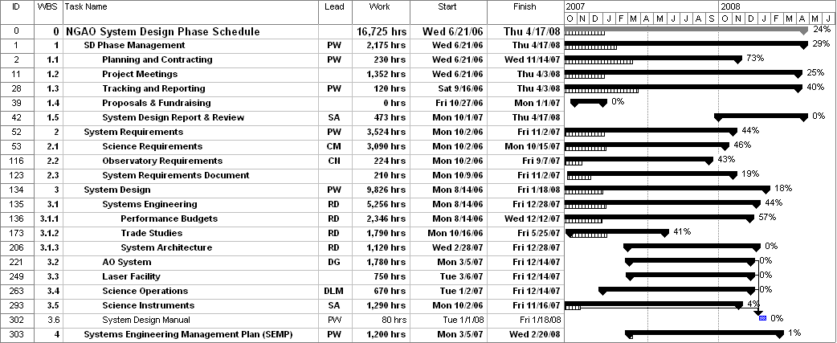

We are well behind on the schedule. In particular, all of the science cases were initially scheduled to be complete by the end of Apr/07 and none will be complete. Seven of the nine performance budgets were scheduled to be completed by the end of Apr/07 and only one has been completed. Twenty-five of the 29 trade studies were scheduled to be completed by the end of Apr/07; of these 9 have been completed and one cancelled.

A significant number of Keck Adaptive Optics Notes (KAONs) have been completed in support of the SEMP. Through mid-April these include:
415 TMT site monitoring data (restricted access)
416 Atmospheric sodium density from Keck LGS photometry
417 Sodium abundance data from MAUI Mesosphere
419 Simple models for the prediction of Na LGS brightness & comparison to measured returns
420 Accessing the MK TMT seeing & weather data
427 Variable vs fixed LGS asterism
428 Implications & requirements for interferometry with NGAO
429 LGS asterism geometry & size
452 MOAO vs MCAO trade study report
455 Science Case Requirements Document v1.0
456 System Requirements Document v1.1
459 NGAO System Design Phase Report #1
461 Wavefront error budget predictions & measured performance for current & upgraded Keck AO
462 Keck AO upgrade trade study
463 Lessons learned on LGS operations: weather impact, efficiency & science ops model
465 NGAO LGS wavefront sensor: Type & number of subapertures trade study
466 Computer simulations of AO PSFs for NGAO
468 An algorithm for reconstruction of Keck Telescope segment figure errors
470 Keck NGAO sky coverage modeling
472 GLAO for non-NGAO Instruments
473 NGAO System Design Phase Report #2
474 AO Photometry for NGAO
475 Tomography codes comparison & validation for NGAO
476 Observing Models trade study

Through Mar/07 a total of $281.1k has been spent, including $12.2k for non-personnel costs. This should be compared to the system design phase total proposed budget of $981.5k excluding contingency and students. The labor spent to date totals 2.5 ftes or 4850 hrs. The spent dollar amount represents 29% of the total dollars and the spent labor represents 29% of the plan. We have been underperforming in terms of earned value by roughly 20%.

Revised Milestones

We reviewed the milestones and determined that these are still the correct milestones. The completion dates for milestones 5 to 12 have been changed to be consistent with the overall replan (1 week has been added to the MS project plan dates); the changes are shown in italics. Note that the dates of the last three milestones have not changed and that the first four milestones are already complete.

# | MILESTONE | DATE | DESCRIPTION
1 | SD SEMP Approved | 10/9/06 | Approval of this plan by the Directors. Initial SEMP version released to Directors for comment on 9/12 & final version on 9/29/06.
2 | SD phase contracts in place | 10/27/06 | Contracts issued to Caltech & UCSC for the system design phase.
3 | Science Requirements Summary v1.0 Release | 10/27/06 | Initial Release of the Science Requirements as input to trade studies and performance budgeting
4 | System Requirements Document (SRD) v1.0 Release | 12/8/06 | Initial release of System Requirements with emphasis on the science requirements
5 | Performance Budgets Summary v1.0 Release | 6/15/07 | First round of all performance budgets complete & documented
6 | SRD v2.0 Release | 5/22/07 | Second release of System Requirements Document
7 | Trade Studies Complete | 6/22/07 | All trade studies complete & documented (as a series of Keck Adaptive Optics Notes); with one new trade study excepted
8 | SRD  v3.0 Release | 9/7/07 | Third release of System Requirements
9 | System Design Manual (SDM)  v1.0 Release | 9/21/07 | First release of System Design Manual
10 | Technical Risk Analysis  V1.0 Release | 9/21/07 | First round of project risk analysis complete & documented
11 | Cost Review Complete | 12/7/07 | Project cost estimates complete, documented & internally reviewed
12 | SDM  v2.0 Release | 2/12/08 | Second release of System Design Manual
13 | System Design Review  Package Distributed | 3/4/08 | SDR documents sent to reviewers
14 | System Design Review | 3/31/08 | SDR meeting
15 | SDR Report & Project Planning Presentation at SSC meeting | 4/14/08 | Final SD phase report including results of SDR & project plans

Replan Changes

The replan details are tabulated in the “NGAO SD schedule v26.xls” spreadsheet under the “v26 Replan Changes” tab.

WBS 1 SD Phase Management. Only minor changes.

WBS 2.1 Science Requirements. All of the science cases were initially scheduled to be completed by the end of April/07. The end dates were moved out by one to seven months. The “Galactic Center Nature of Sgr A*: 3-5 µm color & 2 µm polarimetry variability” science case was cancelled due to relatively low priority. The science cases are now intended to be completed by the end of Aug/07. Revisions 2 and 3 of the Science Case Requirements Document have been slipped by 3 months and 2 weeks, respectively. The final revision completion date has not been changed.

WBS 2.2 Observatory Requirements & 2.3 System Requirements. Wizinowich has assumed leadership for this WBS. The System Requirements Document revisions 2 and 3 have been slipped by 2 months and 2 weeks, respectively.

WBS 3.1.1 Performance Budgets. There are ten performance budgets. Only one of the eight budgets scheduled for completion by the end of Mar/07 has been completed. The completion dates for these seven budgets have been slipped by 2 to 8 months.

WBS 3.1.2 Trade Studies. There are a total of 29 trade studies. Only nine of the 21 trade studies scheduled for completion by the end of Mar/07 have been completed. Twelve trade studies have been cancelled in the replan and one new trade study, uplink compensation, has been added. The completion dates for three trade studies have been slipped by between 1 and 6 months.

The cancelled trade studies, along with the rationale for cancelling them, are listed below:
- K&L-band science. L-band low priority & K-band considerations covered in background performance budget.
- Instrument balance. More of an Observatory issue.
- AO enclosure temperature. Background versus number of optical surfaces and temperature is already covered in the background performance budget. Better to understand the AO system architecture and size before addressing this trade study. Will be covered under WBS3.2.2 AO Enclosure.
- Dichroics & beamsplitters. The cost and feasibility is largely associated with the size of these optics. Didn’t feel that the results of this study would contribute significantly to the architecture choices.
- Slow WFS. Adequate information from the Keck experience.
- Centroid anisoplanatism. Not a significant driver for the design.
- Deformable mirror stroke requirement. This does not appear to be a limitation.
- Stand-alone vs DM on TT stage. A preliminary evaluation was deemed adequate.
- Correcting fast TT with DM. Had earlier decided to cancel and assume that this will be part of our baseline.
- Focus compensation. Issues largely understood from the Keck (and other) experience.
- Laser pulse format. Options already largely covered on the LAO sodium laser web page.
- Free space vs fiber. This work is already being done for K1 LGS.

Two new trade studies were added:
- Deployable IFU and low order wavefront sensor AO and object selection. This was previously part of the D-IFU instrument study. This was called out as a separate trade study due to the need to get this part of the instrument to a system design level and the need to understand the object selection options.
- Uplink compensation. Uplink compensation could potentially significantly reduce the required laser power. This trade study was identified as a way to understand the pros and cons of this approach.

WBS 3.1.3 System Architecture. Significantly restructured and rescheduled with substantially more labor. This task will now be performed by a core team of six people. Other areas in the overall plan were reduced in labor where it was felt that there work would be addressed in this WBS.

WBS 3.2 AO System. Reshuffling of personnel and dates. Two new tasks: 1) atmospheric profiler and 2) d-IFU & LOWFS AO & Object Selection. The latter task was broken out from WBS 3.5.

WBS 3.3 Laser Facility. Reshuffling of personnel and dates.

WBS 3.4 Science Operations. One new task added for PSF reconstruction.

WBS 3.5 Science Instruments. Significantly restructured and rescheduled. A requirements and definition WBS was added. The visible and near-IR imagers were grouped under one WBS, as were the visible and near-IR IFUs. A new WBS was added for a potential high contrast imager. The thermal NIR imager was previously dropped since it was judged to be scientifically significantly lower priority.

WBS 4 System Engineering Management Plan. Only relatively minor changes.

Budget & Personnel Changes.
- Kellner has left Keck and his tasks have been transferred to others.
- Can increase Dekany to 50% availability from 33%.
- Can increase Wizinowich to 40% availability from 33%.
- Assume postdoc starts full-time on 8/20/07 in terms of funding (they will actually start 3 days/week in late May but will not be paid for this time). NGAO will pay their entire salary but they will only work 50% on NGAO. Note that previously the postdoc had been budgeted for 1260 hrs or 46% of their time during the SD phase; however we had only assumed that we would pay for this same fraction of their salary.
- No students have been used so far on the project. Agreed to drop the 1850 hrs of students by 2/3rds. This reduces the $57.4k set aside for students by the same amount.

Overall a considerable amount of personnel leveling and task redistribution was also performed.

New MS Project Plan

A top-level view of the revised MS Project Plan schedule (NGAO SD schedule v26) is shown below.

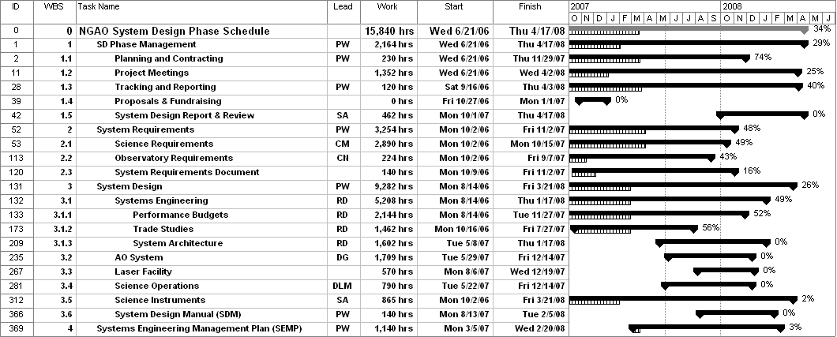

As discussed in section 2 we have already spent 29% of the $981.5k budget, excluding contingency and students; however we only accomplished 24% of the work. The remaining work in the re-plan is 11,048 hrs. The remaining labor cost is $683.3k or 70% of the initial plan. The percent complete now appears as 34% (essentially 6 out of 18 months).

Priorities versus Time:
The following is a list of key tasks that the NGAO team should be focused on by month during the remainder of the system design phase.

- May/07
  - Complete Science Case Requirements Document (SCRD) v2
  - Complete System Requirements Document (SRD) v2
  - Complete performance budgets
  - Complete trade studies
  - Define candidate subsystems
  - Initial draft (v0) of Functional Requirements Document (FRD)
  - Complete Science Instrument FRD v1
- Jun/07
  - Progress Report #3 & SSC meeting
  - Complete performance budget summary v1
  - Evaluate candidate subsystems
  - Start Science Operations design work
- Jul/07
  - Complete SCRD v3
  - Complete candidate subsystems
  - Define candidate architectures
  - Science Operations design work
- Aug/07
  - Complete SRD v3
  - Evaluate candidate architectures
  - Select candidate architecture(s)
  - Complete FRD v1 for AO System, Laser Facility & Science Operations
  - Start Laser Facility design work
  - Science Operations design work
- Sept/07
  - Progress Report #4 & Keck Science Meeting
  - Complete technical risk analysis v1
  - Start AO System design work
  - Laser Facility and Science Operations design work
  - Complete Deployable NIR IFU report v1
  - Complete System Design Manual (SDM) v1
- Oct/07
  - Complete SCRD v4
  - Complete performance budgets summary v2
  - AO System, Laser Facility and Science Operations design work
  - Complete single object imagers/low resolution spectrographs report v1
  - Start SEMP, including cost review
- Nov/07
  - Progress Report #5 & SSC meeting
  - Complete SRD v4
  - Complete FRD v2 for AO System, Laser Facility & Science Operations
  - AO System, Laser Facility and Science Operations design work
  - SEMP work; cost review completed
- Dec/07
  - Complete AO System and Laser Facility design work
  - Science Operations design work
  - SEMP work
- Jan/08
  - Progress Report #6 & SSC meeting
  - Complete FRD v2 for Science Instruments
  - Complete Science Operations design work
  - Complete single object IFU report v1
  - SEMP work
- Feb/08
  - Complete SDM v2
  - Complete single object IFU report v2
  - Complete SEMP document
- Mar/08
  - Complete deployable NIR IFU report and single object IFU v2
  - System Design Review (SDR) completed
- Apr/08
  - Project Report #7 & SSC meeting
  - SDR Reviewer Report response completed

The following table provides the above priorities in another format.

Month | System Design Phase Mgmt (WBS1) | Requirements (WBS2 & 3.1.3.3) | System Eng (WBS3.1) | Design (WBS3.2 to 3.6) | System Eng Mgmt Plan (WBS4)
May/07 |  | SCRD v2 | Perf budgets
May/07 |  | SRD v2 | Trade studies
May/07 |  | FRD v0 & Sci Instrum FRD v1 | Define candidate subsystems
Jun/07 | Prog Rep #3 |  | Perf budget summary v1 | Science Ops
Jun/07 |  |  | Eval & organize candidate subsystems
Jul/07 |  | SCRD v3 | Define candidate architectures | Science Ops
Aug/07 |  | SRD v3 | Eval & select candidate architectures | Laser Facility & Science Ops
Aug/07 |  | AO Sys, Laser Sys & Sci Ops FRD v1 |  | SDM v1
Sep/07 | Prog Rep #4 |  | Technical risk analysis v1 | AO System
Sep/07 | KSM |  |  | Laser Facility & Science Ops
Sep/07 |  |  |  | d-IFU report v1
Oct/07 |  | SCRD v4 | Perf budget summary v2 | AO System, Laser Facility & Science Ops | SEMP + Cost review
Oct/07 |  |  |  | Imager/Spect v1
Nov/07 | Prog Rep #5 | SRD v4 |  | AO System | SEMP
Nov/07 |  |  |  | Laser Facility & Science Ops | Cost review
Dec/07 |  |  |  | AO System | SEMP
 |  |  |  | Laser Facility
 |  |  |  | Science Ops
Jan/08 | Prog Rep #6 | FRD v2 |  | IFU Report v1 | SEMP
Feb/08 |  |  |  | SDM v2 | SEMP
 |  |  |  | IFU Report v2
Mar/08 | SDR |  |  | d-IFU report v2
Mar/08 |  |  |  | Imager/Spect v2
Apr/08 | Proj Rep #7
Apr/08 | SDR Report response
Key = | Complete | In progress

Budget Summary

The following summary table shows the original SEMP plan and the results of the replan (v26). The work-hours spent match quite well. The remaining work hours have been reduced by 827 hours, and this has been turned into contingency.

Budget Item | SEMP (thru Mar/07) | Replan
Work-hours Spent | 4850 | 4792
Work-hours Remaining | 11875 | 11048
Total work hours = | 16725 | 15840
Personnel $k Spent | 268.9 | 268.9
Personnel $k Remaining | 710 | 688.3
Travel $k Spent | 12.2 | 12.2
Travel $k Remaining | 47.8 | 47.8
Contingency $k Spent | 0 | 0
Contingency $k Remaining | 103.9 | 125.6
Total $k = | 1142.8 | 1142.8

Conclusion

The scheduled mid-year replan has been completed while maintaining the budget and date of the system design review. Not much effort has been put into updating the plan for the last six months of the system design phase since we plan to revisit the plan early in FY08.

Although we do have a new plan we have not yet demonstrated our ability to meet this plan. Tracking our progress and continuing to adapt (e.g., minimize the negative impacts and maximize the benefits) to working as a distributed, non-dedicated team will be important to maintain the overall system design phase schedule.

