 Keck Adaptive Optics Note 481

Keck Next Generation Adaptive Optics
System Design Phase Mid-FY07 Replan

P. Wizinowich, R. Dekany, D. Gavel, C. Max, S. Adkins, D. Le Mignant
April 23, 2007

Introduction

A mid-year replan was included as a task in the system design phase System Engineering Management Plan (SEMP) Work Breakdown Structure (WBS) as WBS 1.1.7. This document summarizes the major elements of the replan.

Pre-replan Status

Overall we are behind on the schedule and underperforming in terms of earned value.

The status of the milestones is unchanged since Project Report #2. The first four of a total of fifteen milestones are complete. Two additional milestones should have been completed by the end of March.

The schedule status is shown below; the plan is tracked as 24% complete.

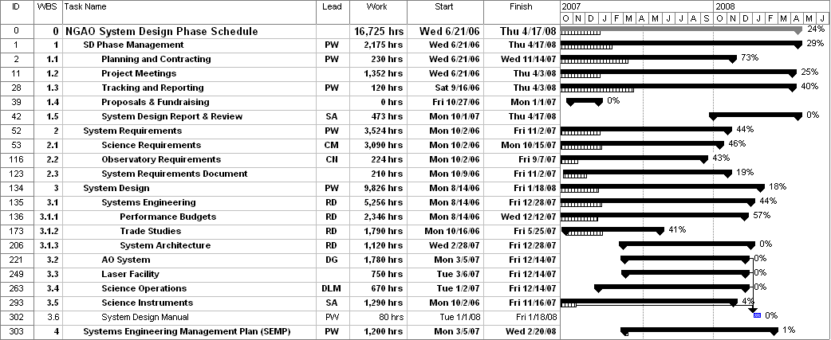

Through Mar/07 a total of $281.1k has been spent, including $12.2k for non-personnel costs. This should be compared to the system design phase total proposed budget of $981.5k excluding contingency and students. The labor spent to date totals 2.5 ftes or 4850 hrs. The spent dollar amount represents 29% of the total dollars and the spent labor represents 29% of the plan. We have been underperforming in terms of earned value by roughly 20%.

Revised Milestones

We reviewed the milestones and determined that these are still the correct milestones. The completion dates for milestones 5 to 12 have been changed to be consistent with the overall replan (1 week has been added to the MS project plan dates); the changes are shown in italics. Note that the dates of the last three milestones have not changed and that the first four milestones are already complete.

# | MILESTONE | DATE | DESCRIPTION
1 | SD SEMP Approved | 10/9/06 | Approval of this plan by the Directors. Initial SEMP version released to Directors for comment on 9/12 & final version on 9/29/06.
2 | SD phase contracts in place | 10/27/06 | Contracts issued to Caltech & UCSC for the system design phase.
3 | Science Requirements Summary v1.0 Release | 10/27/06 | Initial Release of the Science Requirements as input to trade studies and performance budgeting
4 | System Requirements Document (SRD) v1.0 Release | 12/8/06 | Initial release of System Requirements with emphasis on the science requirements
5 | Performance Budgets Summary v1.0 Release | 6/15/07 | First round of all performance budgets complete & documented
6 | SRD v2.0 Release | 5/22/07 | Second release of System Requirements Document
7 | Trade Studies Complete | 6/8/07 | All trade studies complete & documented (as a series of Keck Adaptive Optics Notes)
8 | SRD  v3.0 Release | 8/6/07 | Third release of System Requirements
9 | System Design Manual (SDM)  v1.0 Release | 9/6/07 | First release of System Design Manual
10 | Technical Risk Analysis  V1.0 Release | 9/21/07 | First round of project risk analysis complete & documented
11 | Cost Review Complete | 11/30/07 | Project cost estimates complete, documented & internally reviewed
12 | SDM  v2.0 Release | 2/21/08 | Second release of System Design Manual
13 | System Design Review  Package Distributed | 3/4/08 | SDR documents sent to reviewers
14 | System Design Review | 3/31/08 | SDR meeting
15 | SDR Report & Project Planning Presentation at SSC meeting | 4/14/08 | Final SD phase report including results of SDR & project plans

Replan Changes

The replan details are tabulated in the “NGAO SD schedule v20 tracked.xls” spreadsheet under the “Replan Changes” tab. This spreadsheet can be found at …

WBS 1 SD Phase Management. Only minor changes.

WBS 2.1 Science Requirements. All of the science cases were initially scheduled to be completed by the end of April/07. The end dates were moved out by one to seven months. The “Galactic Center Nature of Sgr A*: 3-5 µm color & 2 µm polarimetry variability” science case was cancelled due to relatively low priority. The science cases are now intended to be completed by the end of Aug/07. Revisions 2 and 3 of the Science Case Requirements Document have been slipped by 3 months and 2 weeks, respectively. The final revision completion date has not been changed.

WBS 2.2 Observatory Requirements & 2.3 System Requirements. Wizinowich has assumed leadership for this WBS. The System Requirements Document revisions 2 and 3 have been slipped by 2 months and 2 weeks, respectively.

WBS 3.1.1 Performance Budgets. There are ten performance budgets. Only one of the eight budgets scheduled for completion by the end of Mar/07 has been completed. The completion dates for these seven budgets have been slipped by 2 to 8 months.

WBS 3.1.2 Trade Studies. There are a total of 29 trade studies. Only nine of the 21 trade studies scheduled for completion by the end of Mar/07 have been completed. Twelve trade studies have been cancelled in the replan and one new trade study, uplink compensation, has been added. The completion dates for three trade studies have been slipped by between 1 and 6 months. The cancelled trade studies, along with the rationale for cancelling them, are listed below:
- K&L-band science. L-band low priority & K-band considerations covered in background performance budget.
- Instrument balance. More of an Observatory issue.
- AO enclosure temperature. Background versus number of optical surfaces and temperature is already covered in the background performance budget. Better to understand the AO system architecture and size before addressing this trade study. Will be covered under WBS3.2.2 AO Enclosure.
- Dichroics & beamsplitters.
- Slow WFS.
- Centroid anisoplanatism.
- Deformable mirror stroke requirement.
- Stand-alone vs DM on TT stage.
- Correcting fast TT with DM. Had earlier decided to cancel and assume that this will be part of our baseline.
- Focus compensation.
- Laser pulse format.
- Free space vs fiber. This work is already being done for K1 LGS.

WBS 3.1.3 System Architecture. Significantly restructured and rescheduled with significantly more labor. Other areas in the overall plan were reduced in labor where it was felt that there work would be addressed in this WBS.

WBS 3.2 AO System. Reshuffling of personnel on four tasks. Two new tasks: 1) atmospheric profiler and 2) d-IFU & LOWFS AO & Object Selection. The latter task was broken out from WBS 3.5.

WBS 3.3 Laser Facility. Reshuffling of personnel on three tasks.

WBS 3.4 Science Operations. One new task added for PSF reconstruction.

WBS 3.5 Science Instruments. Significantly restructured and rescheduled. A requirements and definition WBS was added. The visible and near-IR imagers were grouped under one WBS, as were the visible and near-IR IFUs. A new WBS was added for a potential high contrast imager. The thermal NIR imager was previously dropped since it was judged to be scientifically significantly lower priority.

WBS 4 System Engineering Management Plan. Only one minor change.

Budget & Personnel Changes.
- Kellner has left Keck and his tasks have been transferred to others.
- Can increase Dekany to 50% availability from 33%.
- Can increase Wizinowich to 40% availability from 33%.
- Assume postdoc starts full-time on 8/20/07 in terms of funding (they will actually start 3 days/week in late May but will not be paid for this time). NGAO will pay their entire salary but they will only work 50% on NGAO. Note that previously the postdoc had been budgeted for 1260 hrs or 46% of their time during the SD phase; however we had only assumed that we would pay for this same fraction of their salary.
- No students have been used so far on the project. Agreed to drop the 1850 hrs of students by 2/3rds. This reduces the $57.4k set aside for students by the same amount.

New MS Project Plan

A top-level view of the revised MS Project Plan schedule is shown below.

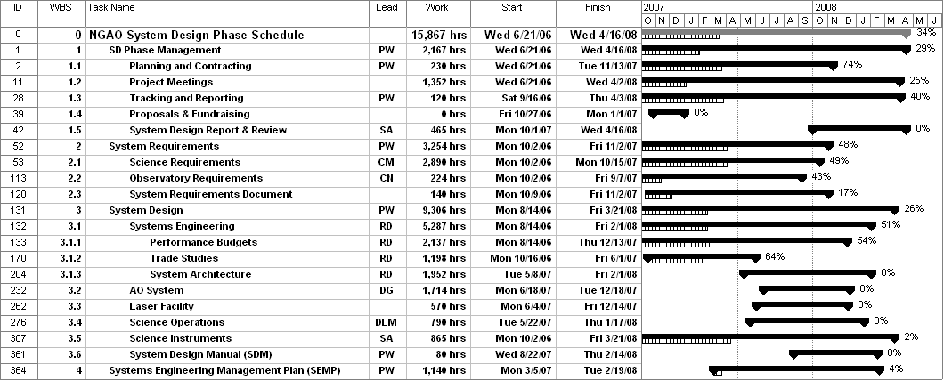

As discussed in section 2 we have already spent 29% of the $981.5k budget, excluding contingency and students; however we only accomplished 24% of the work. The remaining work in the re-plan is 11,009 hrs. The remaining labor cost is $688.4k or 70% of the initial plan. The percent complete now appears as 34% (essentially 6 out of 18 months).

Priorities versus Time:
The following is a list of key tasks that the NGAO team should be focused on by month during the remainder of the system design phase.

- May/07
  - Complete Science Case Requirements Document (SCRD) v2
  - Complete System Requirements Document (SRD) v2
  - Complete performance budgets
  - Complete trade studies
  - Define candidate subsystems
  - Initial draft (v0) of Functional Requirements Document (FRD)
  - Complete Science Instrument FRD v1
- Jun/07
  - Progress Report #3 & SSC meeting
  - Complete performance budget summary v1
  - Evaluate candidate subsystems
  - Start Science Operations design work
- Jul/07
  - Complete SCRD & SRD v3
  - Complete candidate subsystems
  - Define candidate architectures
  - Complete FRD v1 for Laser Facility
  - Start Laser Facility design work
  - Science Operations design work
- Aug/07
  - Evaluate candidate architectures
  - Complete FRD v1 for Science Operations
  - Laser Facility and Science Operations design work
  - Complete System Design Manual (SDM) v1
- Sept/07
  - Progress Report #4 & Keck Science Meeting
  - Select candidate architecture(s)
  - Complete FRD v1 for AO System
  - Complete technical risk analysis v1
  - Start AO System design work
  - Laser Facility and Science Operations design work
  - Complete Deployable NIR IFU report v1
- Oct/07
  - Complete performance budgets summary v2
  - AO System, Laser Facility and Science Operations design work
  - Complete single object imagers/low resolution spectrographs report v1
  - Start SEMP, including cost review
- Nov/07
  - Progress Report #5 & SSC meeting
  - AO System, Laser Facility and Science Operations design work
  - SEMP work; cost review completed
- Dec/07
  - Complete AO System and Laser Facility design work
  - Science Operations design work
  - SEMP work
- Jan/08
  - Progress Report #6 & SSC meeting
  - Complete FRD v2
  - Complete Science Operations design work
  - Complete single object IFU report v1
  - SEMP work
- Feb/08
  - Complete SDM v2
  - Complete single object IFU report v2
  - Complete SEMP document
- Mar/08
  - Complete deployable NIR IFU report and single object IFU v2
  - System Design Review (SDR) completed
- Apr/08
  - Project Report #7 & SSC meeting
  - SDR Reviewer Report response completed

The following table provides the above priorities in another format.

