

Keck Adaptive Optics Note 551
(DRAFT)
Keck Next Generation Adaptive Optics
WFS sub-system conceptual study report

V. Velur, A. Moore, R. Dekany C. Neyman, R. Flicker C. Lockwood, R. Kupke, D. Gavel and J. Bell
January 14, 2008

- Contents
3. Introduction 3
4. Work scope definition (as written before the NGAO system architecture meeting, the strikethroughs indicate changes due to decisions made during the architecture selection process): 3
5. Input parameters 5
6. The LGS wavefront sensor: 6
7. Tip-tilt (Focus and astigmatism) sensor: 10
8. Truth sensors: 13
9. NGS sensor: 14
10. Wavefront sensor conceptual design 19
11. Glossary: 19

- Figures

Figure 1 LGS guide star asterism showing fixed central guide star, 5 equi-angle LGS star with radiuses varying from 10-150” and 3 roaming guide stars with 174” FoV. 7
Figure 2 Schematic of a single LGS WFS channel on which 1st order design was based on. 7
Figure 3 Plan view of the pick-off scheme showing the theta-phi mechanism. The 8 sensors that are around the central star will need to have a rotation stage that ensures that the lenslet array, the DM and the corresponding sub-aperture pixels are all aligned to one-another at all times. Though this is not an active control, every time a new LGS star is picked off, we will need to reorient the WFS in rotation to maintain the one-to-one mapping of the DM actuators to lenslets. 8
Figure 4 A architect’s view of the LGS WFS unit showing 1 out of 9 channels with a single pick-off arm. 9
Figure 5 Schematic that unravels the theta-phi mechanism. 9
Figure 6 WF scenario – K mirror keeps the stars fixed on the AO focal plane(s) and hence on the WFS channels. 10
Figure 7 NF scenario in pupil fixed mode (for high contrast imaging) – K mirror keeps pupil fixed. The fact that the sky rotates, does not affect the observations. 10
Figure 8 Schematic of the TTFA showing the cold stop and cryogenic part and the front cold end ((there is a window between the cold and the cryogenic chamber). 11
Figure 9 Schematic of the TT sensor design (there is a window between the cold and the cryogenic chamber). 11
Figure 10 Sample simulation of a TT sensor with 200 mas size object and 30 mas/ pixel scale. 13
Figure 11 Shows the basic schematic for the lenslet switching scheme for the simplest mechanism to facilitate multiple pupil sampling scales. 15

Introduction
The Next Generation Keck Adaptive Optics system is a multiple guide star Adaptive Optics system with a two stage reflective OAP relay designed to work at wavefront errors as low as 90 nm. The system is envisioned to have four kinds of wavefront sensors, namely, one NGS WFS, 9 LGS WFS's, 3 TT(FA)s (2TTs and 1 TTFA), and two truth sensors. This is a report of a conceptual study of these wavefront sensors undertaken to provide input to the system design manual. Though throughout the study both the 1-tier and the 2-tier optical designs considered while developing concepts, this report deals with the down selected 1-tier optical design alone. The main work products of this WBS element is the volume envelope and the basic conceptual design parameters. These are documented in tables

Work scope definition (as written before the NGAO system architecture meeting, the strikethroughs indicate changes due to decisions made during the architecture selection process):
3.2.3.5 Overall WBS Dictionary definition: Develop a design concept for each of the required NGAO wavefront sensors

3.2.3.5.1 High Order LGS Wavefront Sensors: Given the functional and performance requirements, develop a design concept for the laser guide star high order wavefront sensors. Take into consideration the possible need for both open and closed loop wavefront sensing.

3.2.3.5.2 High Order NGS Wavefront Sensor: Given the functional and performance requirements, develop a design concept for the natural guide star high order wavefront sensor(s). Take into consideration the possible need for both open and closed loop wavefront sensing. Include consideration of ADC packaging (ADC design is covered in WBS 3.2.3.8).

3.2.3.5.3 Low Order NGS Wavefront Sensors: Given the functional and performance requirements, develop a design concept for the low order natural guide star wavefront sensors for the purpose of determining tip/tilt and other low order modes in laser guide star observing mode. Take into consideration the possible need for both open and closed loop wavefront sensing. Include consideration of ADC packaging (ADC design is covered in WBS 3.2.3.8).

3.2.3.5.4 Calibration Wavefront Sensor (Called truth sensor in this document): Given the functional and performance requirements, develop a design concept for the calibration wavefront sensor which will use natural guide star light as a truth wavefront. This sensor will be periodically used to reset the references of the high order wavefront sensors in laser guide star mode. Include consideration of ADC packaging (ADC design is covered in WBS 3.2.3.8).
Inputs to the study:
    - Optical design of the Cascaded relay.
    - FRD
      - Type of each WFS (SH/ PYR)
      - What order/ # of sub-apertures.
      - The position each sensor in the Optical Relay.
      - The FoR for each sensor
      - Positioning accuracy
      - Choice of detector(s) for each WFS (pixel size).
      - Pixel geometry specifics like guard bands, pixel geometry and spot size (for LGS with appropriate elongation) for each WFS
      - Centroiding accuracy, dynamic range, and linearity specifications from FRD for each WFS
      - The Field Stop/ Spatial filter specification
      - TT sensor specification (FoV, dynamic range, etc.)
    - SRD (specifically input of the type of sources on which tip-tilt sensor needs to work and performance margin for binaries, elongated/ asymmetric sources.
    - NGAO System Architecture Definition (KAON 499)
    - Mechanical drawing(s) w/ space constraints and packaging issues clearly stated for the of Cascaded relay.
    - Specification on pick-offs for the WFSs (including the ones shared by the TT(FA) sensors inside the d-NIRI) and rotation if necessary. (input must come from 3.2.3.11)
    - Wavefront sensor error budget spreadsheet.

3. Products:

- Conceptual optical design(s).
- Feed into relevant sections of FRD version 2.0 (in particular update TT sensor requirements and performance based on the type of source).
- LGS pick off mechanism concepts.
- Conceptual designs and first order optical design for the LGS WFSs, TT(FA) sensors.
- First order Mechanical packaging.
- Preliminary mechanical design and 3D model (at least a cartoon showing the envelopes occupied by the WFSs).
- Acceptance and completeness of concepts and conceptual design with information on what needs to be done during the preliminary design phase.
- Update the terms in the error budget spreadsheet based on conceptual design.
- Documentation for all the above.

4. Methodology:

- Liaise with opto-mechanical team to understand the optical and mechanical constraints.
- Based on the inputs from section 2, a first order optical design shall be worked out and shared with the rest of the WFS team for scrutiny. This will be documented and sent to the EC for further inputs.
- Conceptual designs for LGS pick offs will be worked out based on work done by the IWG, other projects like Gemini MCAO, and other MOS pick off options and Palomar Tomograph. Mechanism(s) for registering each LGS sensor to the DM will be conceptualized.
- One day meeting to understand risks and look at the acceptance of the work and design with the WFS design team. (this was subsumed by comprehensive NGAO team meeting, opto-mechanical teleconferences and ad-hoc phone conversations)
- Documentation of the designs with design risks stated.
- Update the FRD and Error Budget Spreadsheet as and when they need updating based on how the conceptual design evolves.

Input parameters
WFS type | Location | Sensing wavelength (nm) | Input PS (um/") | # of sub-apertures | Detector PS("/pixel) | Filters | Comments
NGS HOWFS | near NF sci. inst. | 400-900 | 2254 | 32x32, 64x64 | 1.5 | no filter | Steering mirrors for OSM
LGS HOWFS | after WF relay | 589 nm | 727 | 16x16, 32x32, 64x64 | 1.45 | no filter | Has to track Na layer, tilted focal plane, field dependent aberrations. Steering mirrors for OSM
TT | inside d-NIRI | 1.16 - 1.33 | 727 | 1x1 | 0.030 | J, H and J & H | will use d-NIRI OSM
TTFA | inside d-NIRI | 1.16 - 1.33 | 727 | 2x2 | 0.030 | J, H and J & H | will use d-NIRI OSM
Truth sensor | 1 sensor after the NF and 1 after the WF | 400-900(NF) 1000-2400 nm (WF) | 2254 and 727 | 5x5 | .65 and .200 | no filter | will use field steering and d-NIRI pick offs
Table 1: Baseline design parameters for the NGAO WFSs. The NGS HOWFS, the LGS HOWFS, the TTFA and the truth sensor are all SH sensors. The TT sensors work in a single quad-cell mode.

WFS type | FoR | Baseline detector choice | Pixels/sub-ap | Guard bands? | spot size delivered to the sensor | linearity | field stop | Comments
NGS HOWFS | 50" | Visible CCID56 | 4 | none at 64x64 | NF relay output @ 400-1000 nm | spot size ~ pixel size | specs TBD | Assumes Peltier package
LGS HOWFS | 174" | Visible CCID56 | 4 | none at 64x64 | WF relay output @ 589 nm | Based on an avg. spot size | specs TBD | Assumes Peltier package
TT | 150" | IR detector with selectable pixels and RG capability | 4-many | NA | MOAO corrected @ 1-1.7 um |  |  | many pixels for extended objects
TTFA | 150" | IR detector with selectable pixels and RG capability | 4-many | at least a few pix. | MOAO corrected @ 1-1.7 um |  | specs TBD | 2x2 lenslet
Truth sensor | 150" (50") | IR detector with selectable pixels and RG capability (visible detector with low dark current) | 4 | few pixels | MOAO corrected or high order corrected @ 1-1.7 um/ NF output @ 400-1000 nm |  | specs TBD
Table 2 Other wavefront sensor parameters of interest

The LGS wavefront sensor:
There are a total of 9 LGS wavefront sensors in the baseline NGAO design. The asterism is novel in the sense that there is a fixed central guide star with a 5 star asterism around it on the vertices of a regular pentagon and there are 3 additional point and shoot lasers that can be pointed anywhere in the FoR to MOAO sharpen the 3 TT(FA) stars (c.f. Figure 1). The quincunx asterism radius can be varied between 20 and 174”. A lenslet switching mechanism will be used to support multiple pupil sampling scales, a schematic of the same is shown in Figure 11. A single channel WFS is shown in Figure 2.

The motion control required for a single LGS channel is shown in Fig.2. The overall list of mechanisms is documented by Erik Johansson as part of the non-time real time supervisory control documentation based on our input. The list of motion control required by the LGS WFS sub-system is given in Table 3 with travel requirements and tolerances.

There are 8 pick-offs that facilitate the nine WFS to guide on stars and an OSM KAON written as part of the System Design phase elaborates on the pick-offs and their working detail. Figure 3, Figure 4and Figure 5 show the details of the pick-off concept based on a theta-phi mechanism. The LGSF team has come up with a scheme to keep the lasers fixed on the sky, Figures 6 and 7 show and explain how this is achieved. Please refer to LGSF conceptual design report for details on the concept for scheme to realize the flexible asterism.

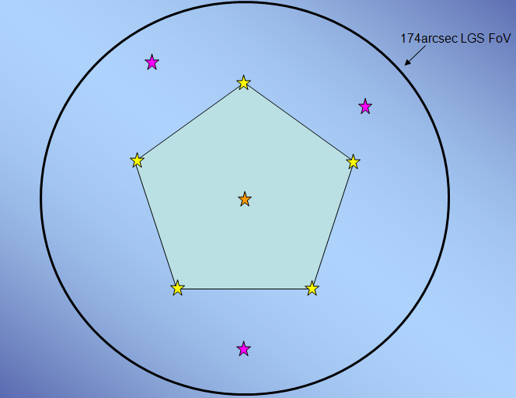

Figure 1 LGS guide star asterism showing fixed central guide star, 5 equi-angle LGS star with radii varying from 10-150” and 3 roaming guide stars with 174” FoV.

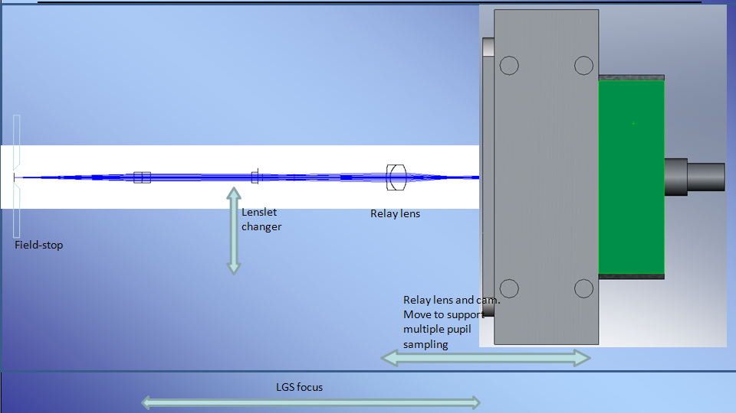
Figure 2 Schematic of a single LGS WFS channel on which 1st order design was based on.
Location | Type | Range of travel | Min. step size (est.)
LGS channel (individual unit focus) | delta Z | ~10 mm | 10 um
LGS lenslet changer | deltaX, Y | delta X = 20 mm, delta Y = 2 mm | 1 um
LGS channel relay and camera focus for pupil sampling change | delta Z | 5 mm | 1 um
Pick off (theta mech) | delta theta | 360 deg. | 0.2 (UP)/ 115" (LA)
Pick off (phi mech.) | delta phi | 360 deg. | 0.2" (UP)/ 300" (LA)
LGS WFS unit overall travel | delta Z | 130 mm | 1 mm
Rotation of the WFS (sans the central WFS) | delta (theta-phi) | 360 deg. | 100"
Table 3 Motion control parameters for the LGS WFS.

Pick-off mechanism:
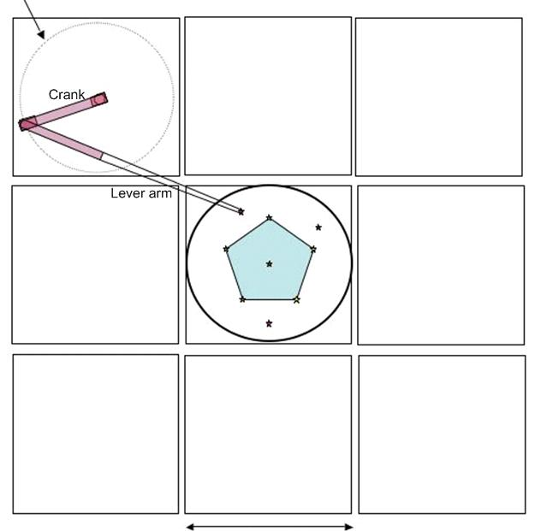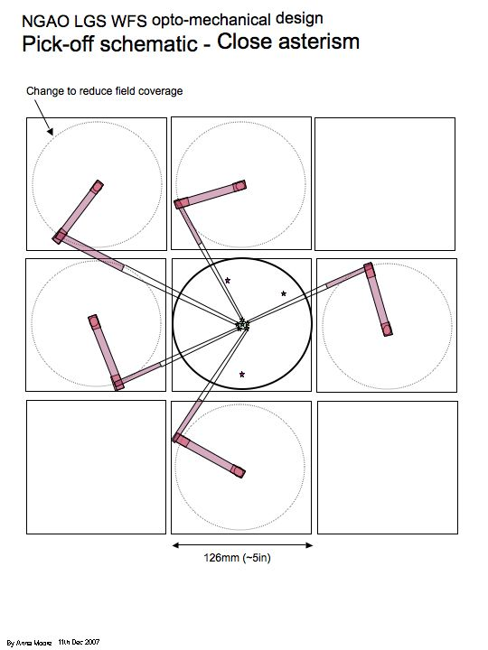
Figure 3 Plan view of the pick-off scheme showing the theta-phi mechanism. The 8 sensors that are around the central star will need to have a rotation stage that ensures that the lenslet array, the DM and the corresponding sub-aperture pixels are all aligned to one-another at all times. Though this is not an active control, every time a new LGS star is picked off, we will need to reorient the WFS in rotation to maintain the one-to-one mapping of the DM actuators to lenslets.

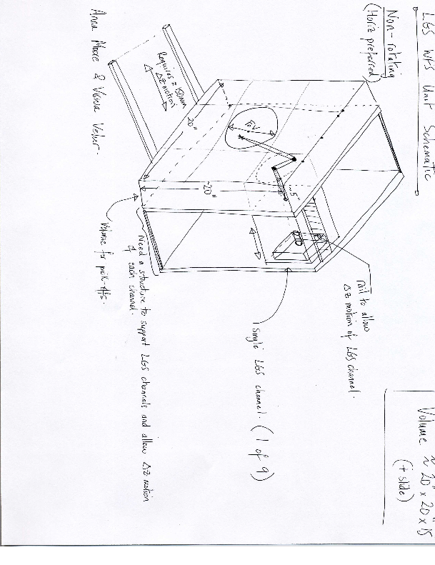
Figure 4 A architect’s view of the LGS WFS unit showing 1 out of 9 channels with a single pick-off arm.

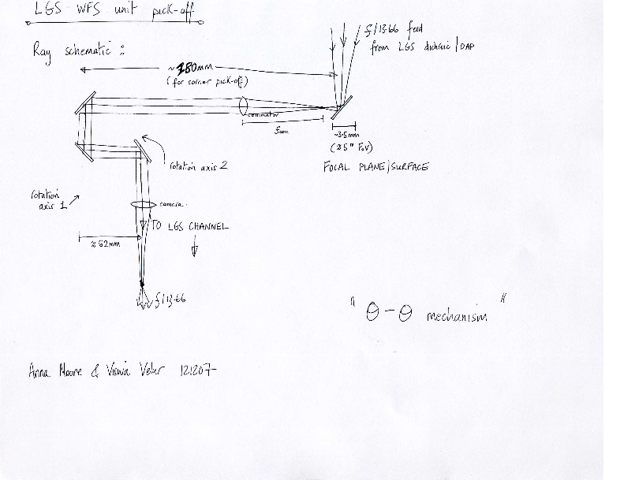
Figure 5 Schematic that unravels the theta-phi mechanism.

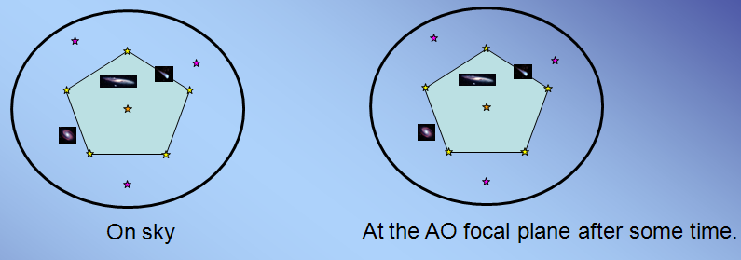Figure 6 Wide-field observing scenario – K mirror keeps the stars fixed on the AO focal plane(s) and hence on the WFS channels.
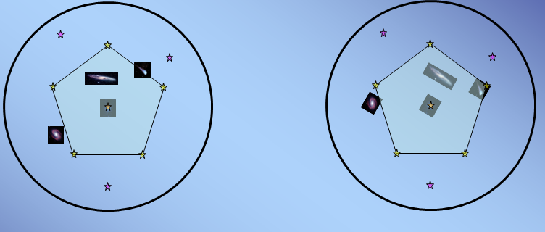Figure 7 Narrow-field observing scenario in pupil fixed mode (for high contrast imaging) – K mirror keeps pupil fixed. The fact that the sky rotates, does not affect the observations.

Tip-tilt (Focus and astigmatism) sensor:

Low Order Wavefront Sensors (LOWFS) use natural stars to sense low order modes of the wavefront that are poorly sensed by the multiple LGS. These modes include tip, tilt, focus and astigmatism when the goal is optimizing on axis science performance. When the goal is optimizing science performance averaged over a larger field of view the LOWFS is used to estimate tip, tilt and tilt anisoplanatism modes. A more complete discussion of this issue is included in KAON 492. In both cases these sensors account for the motion vertical motion of the sodium layer.

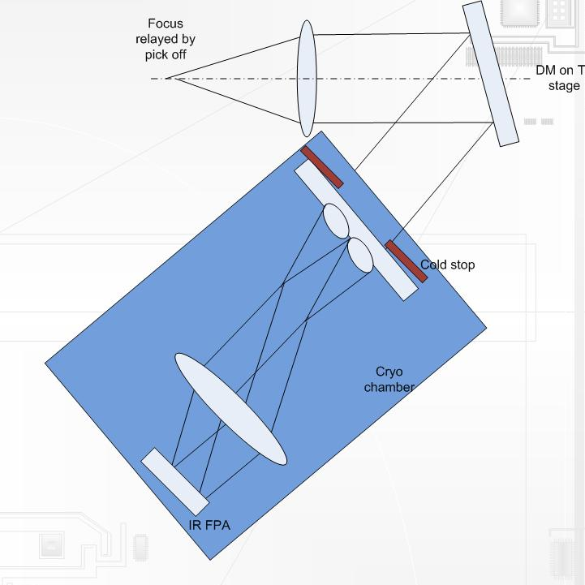
Figure 8 Schematic of the TTFA showing the cold stop and cryogenic part and the front cold end ((there is a window between the cold and the cryogenic chamber).

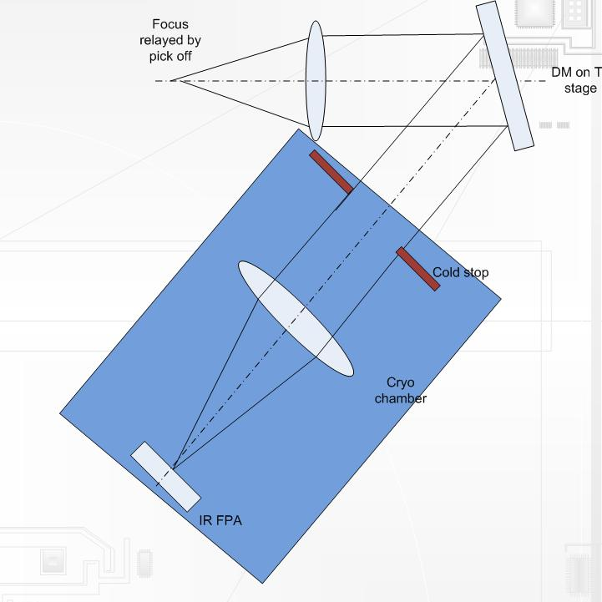
Figure 9 Schematic of the TT sensor design (there is a window between the cold and the cryogenic chamber).
Name | Number | Location | Mechanism type | Short arm length (mm) | Long arm length (mm) | Patrol field (arcsec/mm) | Arm FoV (arcsec) | Acquisition accuracy (mas/μm) | Stability*(mas/μm) | Dithering implementation
LGS 1 (corner) | 4 | LGS WFS unit | θ/φ | 65 | 180 | 170 | 5 | 100 | 1/0.72 | Non required
LGS 2 (center) | 4 | LGS WFS unit | θ/φ | 65 | 130 | 170 | 5 | 100 | 1/0.72 | Non required
TT star | 2 | Interim LOWFS unit | θ/φ | 50 | 100 | 120 | 5 | 100 | 1/0.72 | TT/DM
TTFA/TWFS | 1 | Interim LOWFS unit | θ/φ | 50 | 100 | 120 | 5 | 100 | 1/0.72 | TT/DM
PSF monitor | 1 | Interim LOWFS unit | θ/φ | 50 | 100 | 120 | 5 | 100 | 1/0.72 | TT/DM
Table 4 Pick off arm specification (subject to change)
"Stability" refers to the movement of a probe arm when the motors are switched off and/or are not moving

There are a total of 2 tip-tilt sensors and one TTFA sensor that are fed by the NGAO wide-field relay. The conceptual schematics of sensors are shown in Figure 8 and Figure 9. The LGS WFSs and the TT(FA) sensors use the same kind of object selection mechanism though their specification and requirements vary. The TT(FA) sensors will use a IR detector with selectable pixel pockets. This scheme allows us to deal with extended objects. Some preliminary simulations have been performed to test the validity of the scheme. The concept allows the AO system to guide on MOAO corrected point sources as well as corrected extended objects; both these scenarios are captured in the simulation effort shown in Figure 10.

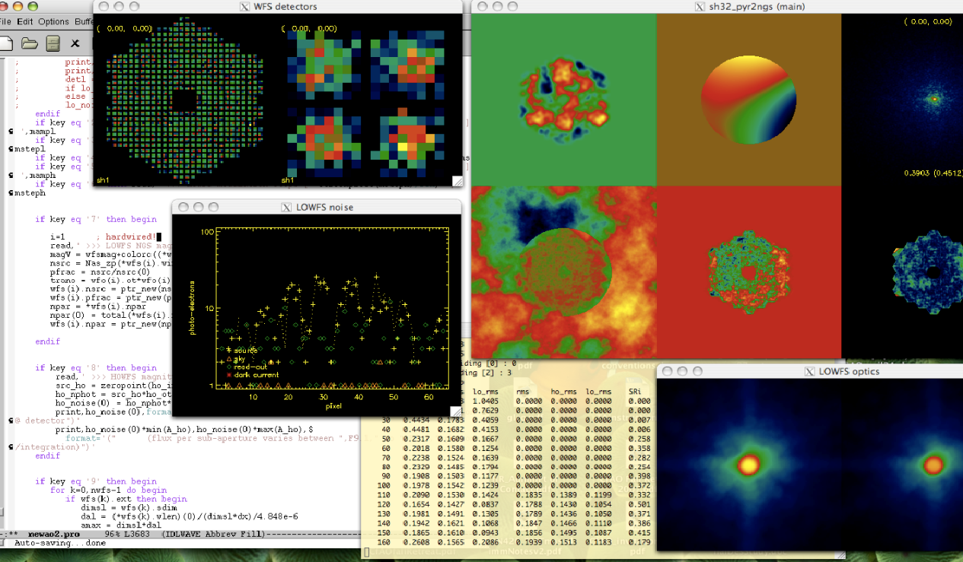Figure 10 Sample simulation of a TT sensor with 200 mas size object and 30 mas/ pixel scale.

Truth sensors:
Truth or Calibration Wavefront Sensor is used to calibrate biases that arise when using LGS in an adaptive optics system. The biases are principally caused by the elongated nature of the LGS when viewed by sub-apertures of the laser guide star wavefront sensor and the changing sodium layer density profile. The truth wavefront sensor measures these biases by sensing the wavefront from a point source (a natural star). These biases are slowly varying and are of a low spatial order. So, a natural guide stars WFS using long exposures and only measuring the lowest spatial wavefront error is sufficient.

The truth sensor has been estimated to be a 5x5 sensor with detailed error budgets for the same still in the works. The baseline design will have 2 truth sensors as these sensors are to be placed as close as possible to the science instrument. The WF truth sensor will be an IR sensor while the NF field truth sensor is conceptualized to be a visible sensor. The truth WFS plate scale is estimated to be 0.65”/pixel for the visible sensor and 200 mas /pixel for the IR TWFS. The visible plate scale was chosen based on the fact that the Strehls are 11% at 5” separation from the on-axis science target and 2% at an off-axis radius of 15”. The median seeing limited spot size is 0.65” (see NGAO Error budget spreadsheet).

Since the 20x20 woofer mirror won’t deliver a diffraction limited image over the 150” field, the IR TWFS can either be enabled with a separate MOAO relay to guide on a faint star or split (5%) light from the TTFA sensor. The later scheme is attractive since the TWFS is a slow sensor and needs only a fraction of the light feeding the TTFA sensor, at the same time it saves on the cost of the AO relay and the real-time computation hardware/ software to correct in yet another direction. The latter scheme also helps acquire stars faster and is so the preferred option for the NGAO system design. The plate scale for the IR TWFS is the same as the TT sensors. The Strehls are ~20% in H-band and 10% in J-band; well within the range to be able to sense TT on the core of the PSF. The baseline choice is to use feed the IR TWFS using light from the MOAO relay that feeds the IR TTFA sensor.

The EB tool is being revamped to include the TWFS in the control loop. Currently, a new spreadsheet to evaluate truth sensor SNR and centroiding error has been made. Current estimates suggest that the visible TWFS can go down to 21.5 mag with 10 sec. integration time and achieve 35 nm of total TWFS error.

NGS sensor:

The NGS sensor is to be positioned in the narrow field and will be equipped to pick off stars using a field steering mirrors/ dichroics over a 40” field of regard. The dichroic for splitting light the NGS sensor will be the same as that for splitting light for the TWFS. Since the TWFS and the NGS sensor are never to be used simultaneously, it is easiest to use the same articulated dichoric as the first field steering mirror. The NGS WFS and the TWFS are envisioned as separate cameras, instead of the TWFS being a role played by a 5x5 lenslet option of the NGS HOWFS, for the following reasons:

1. NGS sensors are built for speed (low RON but significant dark current). Even though they are at -20 deg. C ambient, this will be an issue. We don't have exact DC #s for the CCID56 detectors.
2. The current scimeasure control architecture implements the double correlated sampling method of reading out detectors using a clamp and filter based circuit. This circuit is optimized to work with a finite # of programs (gains, speed with optimized filter and clamp settings) for speeds between 25-2000+ Hz. The TWFS will typically need to run very slowly, 0.01-10 Hz and will need optimized circuitry for that particular application.
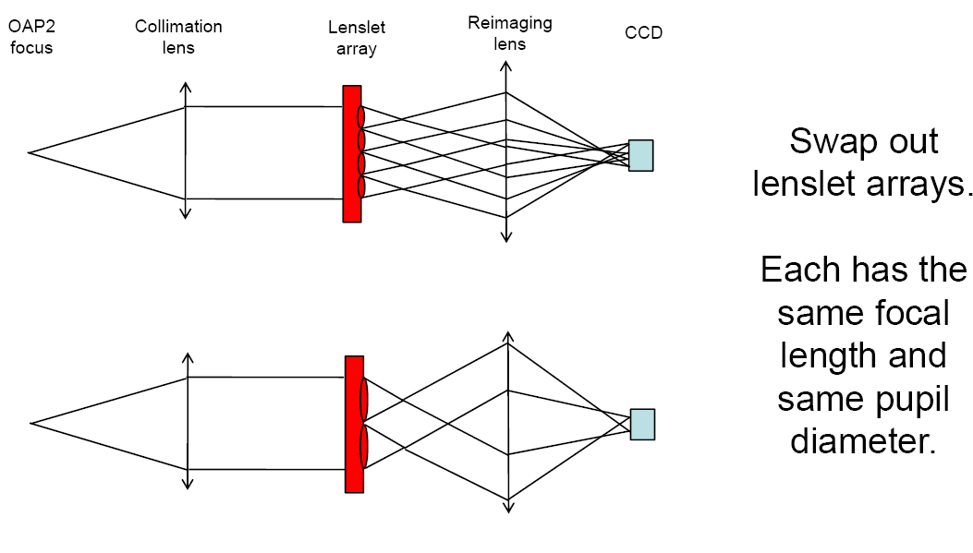Figure 11 Shows the basic schematic for the lenslet switching scheme for the simplest mechanism to facilitate multiple pupil sampling scales.

WFS type | Length in Z [mm] | Breadth X [mm] | Width Y [mm] | # of sensors | Pick off mech. | Cooling
LGS WFS | 200 | 150 | 150 | 9 | LGS theta-phi | 3 stage Peltier
NGS WFS | 450 | 100 | 150 | 1 | Chris and Reni's dichroic and steering mirror mech. | 3 stage Peltier
NF truth sensor | 450 | 100 | 150 | 1 | Chris and Reni's dichroic and steering mirror mech. | 3 stage Peltier
WF truth sensor | 200 | 150 | 150 | 1 | TT/ Truth theta-phi | Cryotiger
TT | 650 | 150 | 150 | 2 | TT/ Truth theta-phi | Cryotiger
TTFA | 650 | 150 | 150 | 1 | TT/ Truth theta-phi | Cryotiger
Table 5: WFS volume table (subject to change)

WFS/ parameter | # of subaps | Relay mag. | Pixel size | Detector Plate scale | design wavelength | pupil size at lenslet | lenslet pitch | lenslet FL | Fresnel # of lenslet spots | Collimator focal length
LGS | 64 | 1 | 0.013 | 1.45 | 0.000589 | 1.664 | 0.026 | 0.2811 | 1 | 22.73
LGS | 32 | 1 | 0.013 | 1.45 | 0.000589 | 1.664 | 0.052 | 0.2811 | 4 | 22.73
LGS | 16 | 1 | 0.013 | 1.45 | 0.000589 | 1.664 | 0.104 | 0.2811 | 16.33 | 22.73
TTFA | 2 | 1 | 0.018 | 0.05 | 0.0012 | 0.72 | 0.36 | 4.8831 | 5.53 | 9.8352
TT | 1 | 1 | 0.018 | 0.05 | 0.0012 | 0.36 | 1.8 | 24.58 | 12.2 | 55.29
NGS WFS | 64 | 1 | 0.013 | 1.5 | 0.0006 | 1.664 | 0.026 | 0.2717 | 1.03 | 74.88
NGS WFS | 32 | 1 | 0.013 | 1.5 | 0.0006 | 1.664 | 0.052 | 0.2717 | 4.1469 | 74.88
IR Truth WFS | 5 | 1 | 0.018 | 0.05 | 0.0012 | 1.35 | 0.27 | 9.1559 | 1.65 | 18.44
Visible truth WFS | 5 | 1 | 0.013 | 0.65 | 0.0006 | 0.325 | 0.065 | 0.1225 | 14.625 | 14.625

Table 6: Table of WFS optics

NGAO WFS parts | Charecteristics | # of units | Comments
CCD detectors | 128x128 pixels, read out @ 2000 Hz with 3 e- RON and <500 e-/pix/sec DN @ operating temp. | 10 | 9 LGS WFS + 1 NGS WFS
Truth sensor (visible) | 10x10 active pixels read out at 0.01-200 Hz with 0.001 e-/pix/sec DN and 3 e- RON | 1 | truth sensor NF
Truth sensor (IR) | 10x10 active pixels read out at 0.01-200 Hz with 0.001 e-/pix/sec DN and 5 e- RON | 1 | truth sensor WF
IR detectors | Must be able to read in PoI mode. RON < 7 e- with 16 Fowler samples, data rate = 500 Hz at this RON spec for the entire chip, DC = 0.001 e-/pix/sec @ 73K. # of active pixels = 128 x128? | 3 | 2 TT and 1 TTFA sensors
Stages | See table 3 | see table 3 | separate table
Pick off arms | See Anna's KAON | 4 + 4 LGS pick offs + 3 TT pick offs (+ 1 PSF camera OSM) | All LGS pick offs are not the same
Optics | See table 5
Table 7: List of the major components required for the WFS subsystem

WFS optics table (preliminary) | Optic | Quantity
NGS WFS | Collimator | 1
 | Lenslet array (64x64, 32 x 32) | 2
 | Relay lens | 1
 | Focusing lens | 1
 | Field stop (adjustable?) | 1
LGS WFS | Collimator | 9
 | Lenslet array (64x64, 32 x 32, 16x16) | 27
 | Relay lens | 9
 | Focusing lens | 9
 | Field stop (adjustable?) | 9
TTFA sensor | Collimator | 1
 | MEMS mirror | 1
 | TT stage (on which MEMS mirror is mounted) | 1
 | lenslet array (2x2) | 1
 | Relay lens | 1
 | Focusing lens | 1
 | Cryo chamber | 1
 | Cold pupil stop | 1
TT sensor | Collimator | 2
 | MEMS mirror | 2
 | TT stage (on which MEMS mirror is mounted) | 2
 | Relay lens | 2
 | Focusing lens | 2
 | Cryo chamber | 2
 | Cold pupil stop | 2
truth sensor (WF) | Collimator | 1
 | TT stage (on which MEMS mirror is mounted) | 1
 | lenslet array (5x5) | 1
 | Relay lens | 1
 | Focusing lens | 1
 | Cryo chamber | 1
 | Cold pupil stop | 1
truth sensor (NF) | Collimator | 1
 | Lenslet array (5x5) | 1
 | Relay lens | 1
 | Focusing lens | 1
Table 8: Table of optics required for the different WFS channels

Wavefront sensor conceptual design
All the wavefront sensors are Shack Hartmann in nature except the TT sensors that are just quad-cells.

The design concept for the NGS and LGS sensors are based on switching lenslets and keeping the plate scale constant regardless of the pupil sampling (changing sub-aperture size). One CAN change the detector plate scale by binning at lower pupil sampling scales. Based on Figures Figure 2, Figure 8, Figure 9, and 11 the following wavefront sensor parameters are arrived at:

Glossary:
Invisible modes Invisible modes: Some part of the modal content of atmospheric turbulence falls into a category called invisible modes, signifying that they are registered as zero measurements by all the WFSs, but in between the WFS beacons they are non-zero and contribute to the wavefront error seen by a science instrument. In the case of laser guide star (LGS) beacons, these modes also become non-zero for beams focused at infinity in the direction of the LGSs. These modes are by necessity three-dimensional, and are rendered invisible to the AO system by a conspiracy in which modes at different altitudes cancel out within the beam print to leave only piston in each beam, which is not sensed.

Null-modes (also Blind-modes) Null-modes (also Blind-modes): A special case of invisible modes are the so-called null-modes, which are particular to a LGS-based tomography system (as opposed to NGS-based). The null-modes arise from combinations of modes that only cancel out partially and leave, in addition to piston, also linear (i.e. tip/tilt) terms in the beam. When these terms are filtered in a LGS system, due to the tilt determination problem with LGSs, the result is a loss of information that renders the system blind to these modes as well. These differential tilt modes (sometimes called plate-scale modes because of their effect, or null-modes because they belong to the null space of the LGS interaction matrix) are produced by a combination of quadratic modes (e.g. focus, astigmatism) occurring at different altitudes. Hence, in the Kolmogorov model of atmospheric turbulence, these modes have relatively large weights in the turbulence power spectrum, and the impact of not correcting them can be severe

DM Tilt Anisoplanatism Modes The DM Tilt Anisoplanatism Modes are (typically) three modes of deformable mirror commands in an MCAO system that compensate for tilt anisoplanatism over an extended FoV without introducing higher-order wavefront errors. The real time control system controls these modes based upon tip, tilt, focus, and astigmatism measurements from natural guide star (NGS) wavefront sensors (WFS), and possible the focus and astigmatism modes of laser guide star (LGS) WFS measurements.

Object selection Mechanism is a contraption that helps the Multi-object Deployable Near-IR IFU and TT(FA) select field stars/ objects.

KAON 499 - NGAO Architecture definition, Aug. 2007.
KAON xxx - NGAO interim object selection mechanism conceptual design report
KAON xxx – NGAO laser guide star facility conceptual design report.
KAON 492 - Null-modes and quadratic mode tomography error in LGS-based multi-beacon tomography AO systems
KAON xxx - NGAO interim object selection mechanism conceptual design report

