Integration of Production Cobras to Testcube
December 9, 2015
Mitsuko Roberts (Caltech)

Abstract:
11 new Production Cobras were integrated into test cube in December 2015. This document describes the integration process that took place into Cobra Testcube in Caltech, Pasadena.

November 25, 2015
Five Cobras (serial numbers C1541, C1542, C1543, C1544, C1545) were inspected for the following: motor aliveness (frequency sweep and range of motion), mechanical dimensions / cleanliness. All 5 units passed, and they were painted. Station 1 Receiving Inspection procedure version 1 was used and Station 1 Receiving Inspection Report was generated for each Cobra. The data was entered into Cobra Receiving Inspection database in Microsoft Access.
Brief description of motor aliveness test:
Each Cobra was connected to New Scale electronics and frequency sweep test was performed for forward and reverse, for both 1st and 2nd stage motors. The resulting frequencies were recoded.
Brief description of range of motion test:
Each Cobra’s 1st stage motors were driven forward and reverse to the limit, and the approximate angular ranges were recorded. Each Cobra’s 2nd stage motors were driven forward and backward.
Brief description of mechanical dimensions / cleanliness test:
Cobra body length, shaft length, and body thickness diameter at flex cable were measured using a Caliper. The passing criteria was as shown in table 1. Cleanliness of exposed stage 2 motor core was examined using a microscope. No abnormality larger than approximately 300 micrometer was found in any of the five Cobras.

Description | Number in fig 1 | Nominal | Tolerance range
Body length | 3 | 80mm | +/- 0.2mm
Shaft length | 1 | 10mm | + 1 mm
Body diameter at flex | 4 | 8.2mm | Or less
Table 1: Passing criteria for Cobra dimension
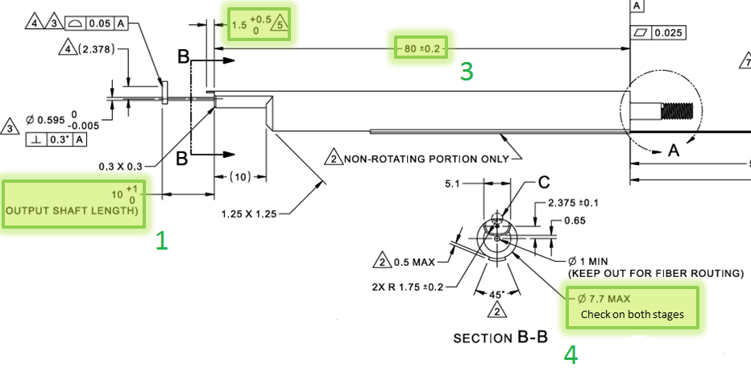
Fig 1: Measured dimensions of Cobra (#1, 3, and 4 as marked)
Painting process:
The U-mark W-20 Water Based Paint Marker pen’s chisel tip was used to paint the top surfaces of stage 2 housing. (fig 2)
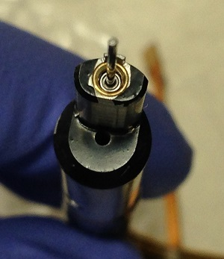
Fig 2: Painted stage 2 housing
November 30, 2015
Rail was removed from the test cube by lifting the beam support system for rail/fin assembly as well as fiducial fiber assembly. Beam support system was placed on a table. Then rail was uninstalled from bracket, and was installed into turn over fixture.
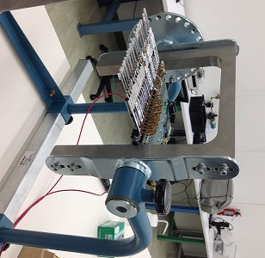
Fig 2: Rail is in turn over fixture
December 1, 2015
Seven more Cobras (serial numbers C1551, C1552, C1553, C1554, C1555, C1556, C1557) underwent the same procedure for receiving inspection as November 25. One Cobra (serial number C1557) measured 79.68mm for body length, and was rejected. All of the other 6 Cobras passed the inspection.
Cobra’s flex cables at the rail positions 1, 3, 5, 7, 11, 13, 15, 17, 19, 21, 23, 25, 27, 29, and 31 were disconnected from the board. Connectors on the red furcation tubes were cut off, and red furcation tubes were removed. Fibers were laid flat on the table with cable tie holders and cable ties to help keep fibers in place. Working with one Cobra at a time, removed 13 Cobras from rail by loosening the metal nuts at the rail, and pulling the Cobra off the rail as pulling the optical fiber through the fin and rail. Bundle of bare fibers were gently held down to the table to prevent them from tangling. Cobra at position 9 was production Cobra, and was not removed. Cobra at position 31 was also production Cobra, and was moved to position 11. Cobra at position 29 was moved to position 31. Removed Cobras were laid flat on the table. Furcation tube for the EM cobras were replaced. (Fig 3)
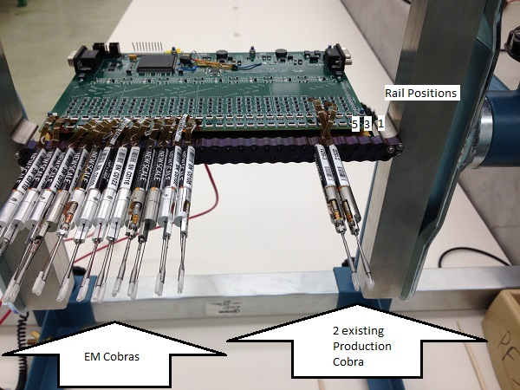
Fig 3: 13 Cobras were removed from the rail
Fiber arms were separated from the 13 removed Cobra’s shaft couplers: Cobra was held by the shaft coupler straight down, and fiber arm was pulled away from the shaft coupler (fig 4). Fiber and fiber arms were pulled through Cobra, and spooled safely.
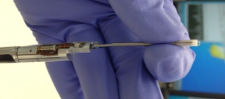
Separating fiber arms from shaft couplers:
Hold Cobra by the end of shaft coupler. Pull Fiber arm with the other hands straight up. Wiggle / rotate fiber arm carefully if necessary.
Fig 4: Separate fiber arms from shaft couplers

December 2, 2015
Installed new Cobras in rail: Turn over fixture was turned so that the Cobra’s shafts were facing down. Temporary fiber was taped onto fin to use as a guide for the nuts. Working on one Cobra at a time, temporary fiber was threaded through a metal nut, rail, then Cobra. Then the Cobra was inserted into rail, and nut was tightened using 4mm wrench. After all the Cobras were installed, temporary fiber was removed. Cobras’ serial numbers and the rail positions are as shown in table 2.
Rail Position | Cobra S/N
1 | EMPTY
3 | C1544
5 | C1551
7 | C1543
9 | C1522 (existing)
11 | C1521 (existing)
13 | C1541
15 | C142
17 | C1556
19 | C1552
21 | C1554
23 | C1545
25 | C1553
27 | C1555
29 | EMPTY
Table 2: Cobras’ serial numbers and rail positions
13 new shaft couplers were cleaned using following method: 3 minutes in ultra sonic cleaner at 80C in a glass jar, then rinsed in DI water. The parts were dried using Nigrogen blow, then rinsed in Aceton. Again the parts were dried using Nigrogen blow, then rinsed in Isopropyl Alcohol. Parts were dried using Nigrogen blow, and then parts were set out to air dry for 15 minutes.
Fiber arms that were separated from Cobras on December 2 were pressed into the clean shaft couplers. The angular alignment was set using fiber arm clocking fixture. Fiber arms were staked onto shaft couplers using 302-3M epoxy.
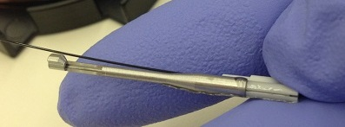
Fig 5: Fiber arms were staked onto Shaft couplers using 302-3M
December 3, 2015
Turn over fixture was turned so that the Cobras were horizontal. Working with one Cobra at a time, fibers were threaded through Cobras from shaft end then between fin and electronic board then shaft couplers were loosely placed onto shafts. Red protective furcation tubes were placed onto the production Cobra fibers and EM Cobra fibers separately. Furcation tubes were secured onto fin using Kapton tape.
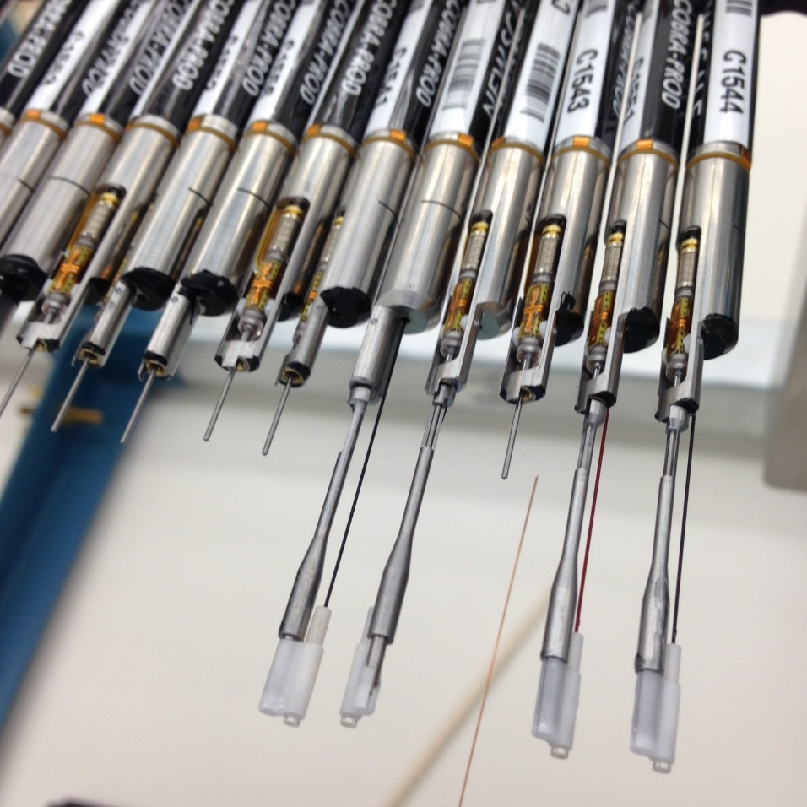
Fig 6: Fibers were threaded from shaft end through between fin and electronic board
Shaft couplers were aligned using a piece of Plexiglass on a heavy metal fixture. Cobras C1522 and C1521 were existing, therefore the shaft couplers were already staked. The Plexiglass was positioned to be touching one of the shaft couplers, and reasonably perpendicular to the shafts. The microlens of the other Cobras were pressed against the Plexiglass to set the focus. It was confirmed before bonding that shaft couplers’ hard stops were able to engage with the hard stop of the stage 2 housing. Epotec 302-3M was used to bond Shaft couplers onto shafts at the openings.
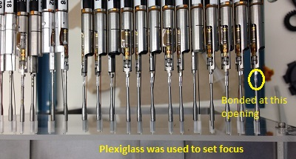
Fig 7: Production Cobras’ shaft couplers were aligned to C1522 and C1521
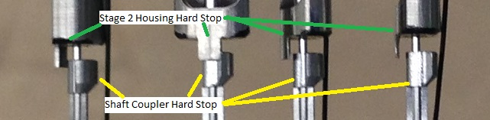
Fig 8: Shaft coupler’s hard stops were able to engage with hard stops of stage 2 housing
Connectors (Thorlab 11580A) were glued onto EM Cobra fibers and Production Cobra fibers using Epotek 302-3M. This connector turned out to have opening that is too large for this number of fibers. See December 4 notes for details.
December 4, 2015
Beam support structure with fiducial fibers was installed into test cube. Rail was uninstalled from turn over fixture, and then installed inside the test cube.
Starting up new rail:
Plug in power cable for the Cobra driving board. Make sure the ground is connected to a bolt within the test cube. Connect communication board to Cobra driving board. Connect fiducial and science fibers into LED light source. Turn on power onto communication board, Cobra driving board, Cobras, camera and LED light source. Make sure LED power is set to trigger, and trigger is connected to camera trigger.
Take fiducial images to set fiducial fibers.
Take dark image and bias image with camera trigger disconnected, and save the images in an appropriate folder.
Home all Cobras.
Take Cobra images to set home positions of all Cobras in mSIM.
Enter frequencies and on times from New Scale final inspection documents.
Lighting by LED was not uniform enough for measurement. Connector was replaced with one with 1040 micrometer opening (Thorlab 11040A) in Production Cobra side. Connector 11580A was used again in EM Cobra side because only one 11040A was available.

End of notes

