Inspection of Fin and Rail Assembly for PFS
Mitsuko Roberts
Caltech
July 29, 2016
- Abstract
Flat and bottom fins (p/n 10354804) and a rail (p/n 10354803) were assembled on July 18-20. This document describes the inspection of the assembly. Fin should be placed at the center of the rail and normal respect to the bottom surface of the rail. Amount of deflection of the top of the fin allowed is +/- 0.5mm. If top of the fin is deflected more than this amount, the instrument will have the risk of electronics board that are mounted to the fin touching each other even when instrument is not tilted.
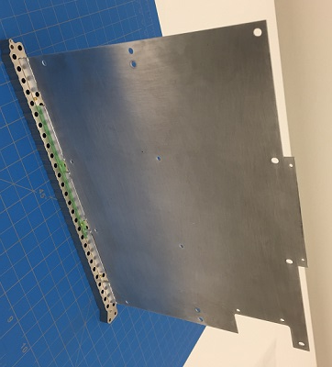
Finished Rail and Fin assembly

- Equipment
Granite counter,
Right angle bracket by Carr Lane (p/n CL-1537-ABK)
(Manufacturer’s published spec state the angle of the block is 90 +0.01/-0.03 degrees, and it is 6 inches tall. Reference:
http://www.carrlane.com/catalog/index.cfm/27225071F0B221118070C1C512A0A1F0900101B030010543C1C0C16190D172D252A5E47555A )
Variety of plastic shim stocks by Artus
Laser profilometer (Cahill Room 21)

- Method of inspection
  - Bottom and Flat Fin assembly
Using granite counter and right angle bracket, place fin assembly next to the bracket. Hold the bottom of the fin by another heavy metal block. Measure the gap between the right angle bracket and the top of the fin (near yellow x sign in the photo) by inserting variety of shim stock combination and find the thickness which does not move the top of the fin. (Side A)
Turn the fin 180 degrees to measure Side B.
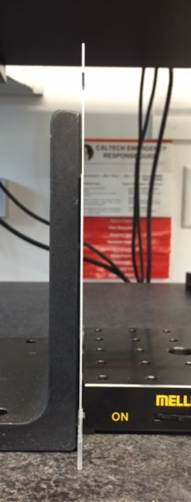
Measurement set up for Fin assembly

  - Fins and Rail assembly
Lay rail on its side and weight the rail sufficiently so that the rail is resting on its side flat on the granite surface. Set the laser profilometer’s reference point to the bottom of the flat fin on Side A (near yellow x sign on the photo below). Flip the rail and measure the relative distance of the similar position of flat fin on Side B.

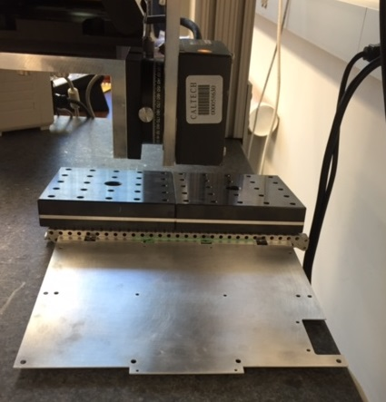
Top View of the measurement set up for fins and rail
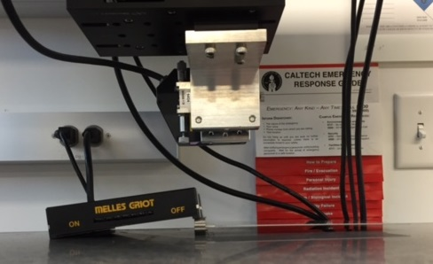
Side View of the measurement set up for fins and rail

- Results
  - Bottom and Fin assembly measurement
Side A | Side B | Side A or B theoretical
0.25mm | 0.65mm | 0.50mm
Flat Fin

Side A
Side B

Bottom Fin

  - Rail and Fin assembly measurement
Side A – Side B yielded measurement of 80 micrometer.
- Conclusion
Assembly process used for this article resulted in acceptable perpendicularity.

(End of document)

