Fin and Rail Assembly for PFS
Mitsuko Roberts
Caltech
July 20, 2016
- Abstract
Flat and bottom fins (p/n 10354804), made of aluminum were assembled using epoxy 2216 by 3M. Then the fin assembly was bolted onto a rail (p/n 10354803), made of Invar 36. The goal of this procedure is to have the top of the flat fin after assembly no more than +/- 0.5mm away from the center of the rail. This document describes the procedure used for this assembly on July 18-20, 2016.

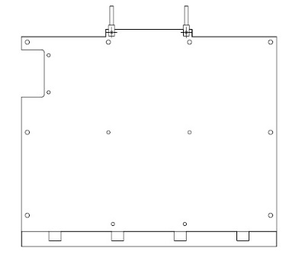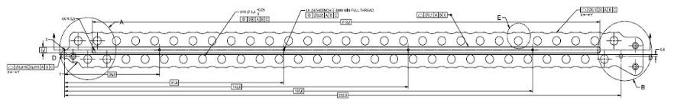
Bottom and Flat Fins (p/n 10354804) Rail (p/n 10354803)

- Preparation for assembly (performed on July 18)
Flat and bottom fins, as well as a rail were cleaned using following method
1) Wipe down with Isopropyl Alcohol and Kimwipe
2) Clean with ultrasonic cleaner (Branson Model 5510) and MC-3 solution with 60C temperature for 8 minutes
3) Wash cleaning solution off with tap water
4) Rinse under DI water, and blow dry
5) Rinse with Aceton, and blow dry
6) Bake dry with 100C for 15 minutes, shut off oven and wait over night for it to cool to room temperature
7) Surface on the bottom of the flat fin seemed sufficiently rough therefore no sand paper was used.
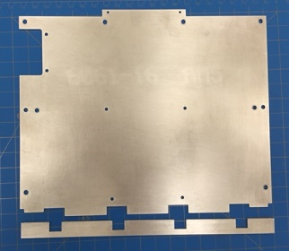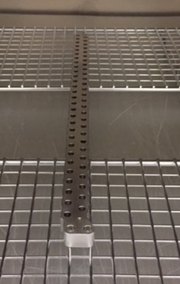
Fins Rail (inside oven)

- Work surface preparation (performed on July 19)
1) Wipe down the granite counter top with Alcohol, place Kapton sheet for surface protection, tape the Kapton sheet down for security, wipe the Kapton sheet with Alcohol.
2) Wipe down plastic shim stock (0.20 inch or 0.5mm thick, yellow) and place on Kapton sheet.
3) Have nearby 4 heavy, flat, and straight edged objects to be used as weights.

- Bonding
1) Mix epoxy 2216 according to the package directions. Weight scale with 0.1g denomination was used to measure the ration of the epoxy. Place mixed epoxy in syringe with 20 gauge needle. 20 was the largest gauge it would go inside the wells of bottom fin.

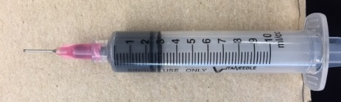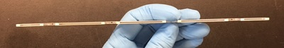
Syringe filled with 2216 Wells of bottom fin
2) Squeeze epoxy to the bottom of the wells of the bottom fins. Extra light and magnifier was used to make sure good coverage on the bottom surface of the wells.
3) Bottom and flat fins were pushed together. Extra epoxy came out along the edges of the bottom fins, and they were wiped clean with Acetone and Kimwipe.

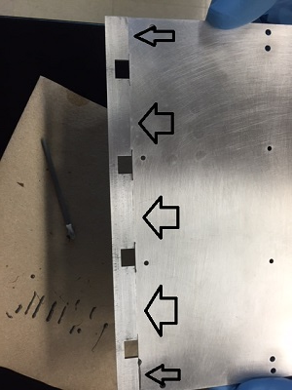
Excess epoxy came out at the edges and was wiped clean
4) Bottom and flat fin assembly were placed on Kapton sheet and weights were used to make sure that: edges of flat and bottom fins are aligned, and bottom fin was fully against flat fin, and flat fin was fully in contact with shim stock.

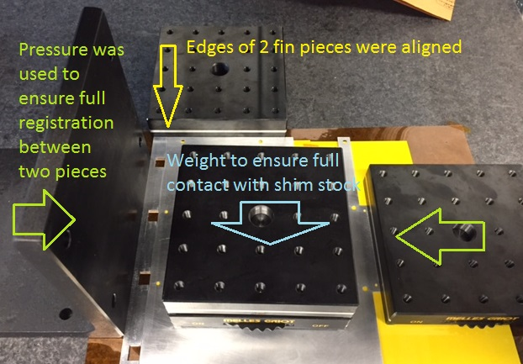
Assembly with epoxy was placed on prepared surface – top view

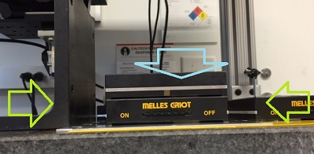
Assembly being cured – side view
5) Assembly was left undisturbed for overnight.
Note: Handling time for 2216 is 12 hours, full cure is 7 days

- Fin and Rail assembly (performed on July 20)
1) Two thin strip of shim stock of 0.003 inches (or 0.08mm, green) were cut out and placed on either side of the bottom fin in the rail.
2) Fin was bolted down using 00-90 brass screws and 5/64” open end wrench.

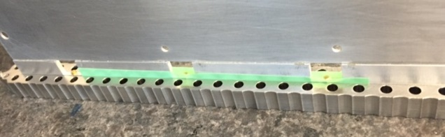
Fin is bolted onto Rail using shim stock as a guide for center
- Inspection of the final product
This section is covered by another document

(End of document)

