Fiducial assembly for PFS
Assembly process (studs to spine) and validation report
August 8, 2016
Mitsuko Roberts
(Updated: August 18, 2016)

Abstract
Fiducial studs and spine are assembled together and checked for alignment between the base of the assembly and the tip of the spine. This document describe the assembly process and the validation process used in August 2016.

Assembly
Tools:
Fiducial bonding fixture
Pneumatic epoxy dispenser
Custom open end wrench (2.6mm)
Materials:
Fiducial studs (10 ea)
Fiducial spines (10 ea)
Epotek 301

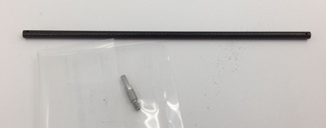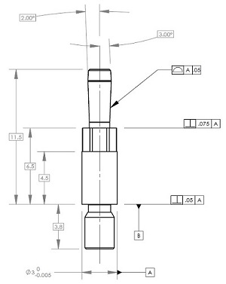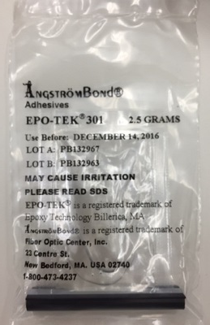
Fig 1: Spine and stud Fig 2: Stud drawing Fig 3: epoxy used

Preparation for assembly
- Fiducial studs were cleaned by rinsing in Isopropyl Alcohol, and then blew with pressured air to dry.
- Fiducial bonding fixture was wiped with Alcohol and Kimwipe.

Assembly Process
- Fiducial studs were installed into fixture using custom wrench of 2.6mm. (Fig 4 & 5) Torque used was approximately 4 in-lb.
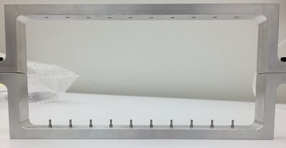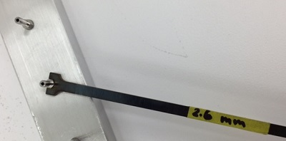
Fig4: Fiducial studs in fixture Fig 5: custom wrench
- Fiducial spines are inserted into the studs from the top holes gently.
- Spines are made sure to be holding studs securely, and the epotek 301 was injected through the small holes at the bottom of spines. A drop of epoxy placed on top of the small hole wicks in at the beginning of the process. After several dozen drops, coverage is visually confirmed when the drop of epoxy no longer wicks into the hole. (Fig 6 & 7)
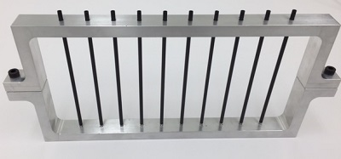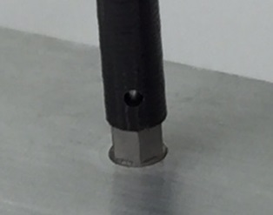
Fig 6: Spine installed onto studs Fig 7: Epoxy injection hole at the bottom
- Assembly was left undisturbed over night for cure. Full cure at room temperature is achieved after 24 hours.

Validation
Figures 8 through 11 are 360 degree view of the complete assembly. They show the epoxy squeezing out at bottom edge of the spine in all directions confirming the coverage at the bottom of the spine, while epoxy not running down past hex part of the stud.
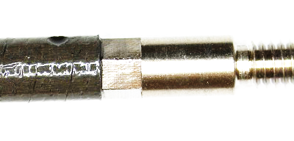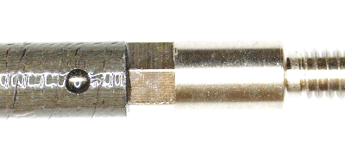
Fig 8: Complete assembly visual 1 Fig 9: Complete assembly visual 2
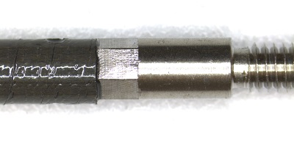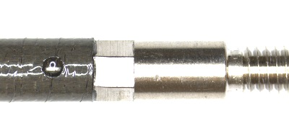
Fig 10: Complete assembly visual 3 Fig 11: Complete assembly visual 4

Fiducial studs were installed onto COB and checked for alignment. Figures 12 through 15 show that the tip of the fiducial spines line up in a straight line.

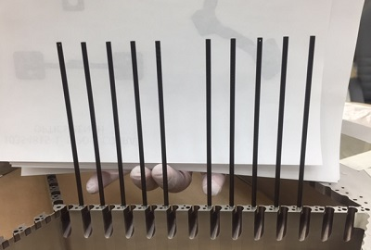
Figure 12: Fiducial studs and spines installed in COB, Side View

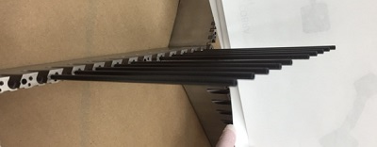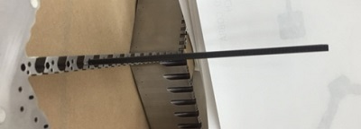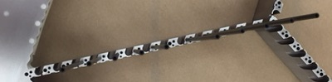
Figure 13: From an angle Figure 14: Fiducial tips line up Figure 15: Top view

Studs were disassembled to see how much coverage Epotek 301 made around the bond line. Figures 16 and 17 show that epoxy covered all areas intended for bonding. The studs and spines do not come apart without breaking. Figure 18 shows how the spine was broken to take the stud out for this inspection.

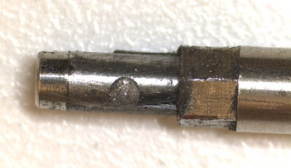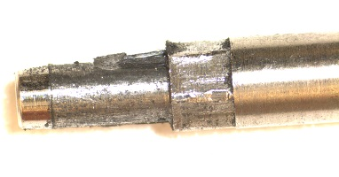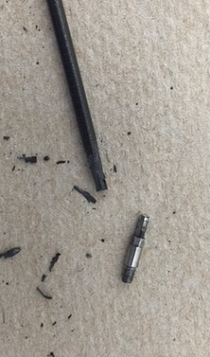
Fig 16: Epoxy Coverage (1) Fig 17: Epoxy Coverage (2) Fig 18: Broken spine and freed stud

Conclusion
The validation process confirms that the process used for this assembly achieves satisfactory results in alignment of the base and the top of the spine, and strength of the bond.

Update 8/16/2016
- Carbon fiber tubes shed black powder during handling. Therefore ultrasonic cleaner in alcohol (5 minutes, 60C), followed by water and IPA rinse, and 80C oven dry for 30 min will be used during preparation.
- Studs are found to develop burs at the leading edge of the shank after bonding. Torque used when studs are installed into the fixture will be reduced to 1 in-lb, and fixture to be cleaned by ultrasonic cleaner once every 2 bonding cycles to remove any debris. In addition, Lubricant (Dow Corning High Vacuum Grease) will be used at the shank when studs are installed into the fixture.

