Fiber Arm black coating (dry lube) rub off tests and results

- Rubbing with IPA – result: coating held up
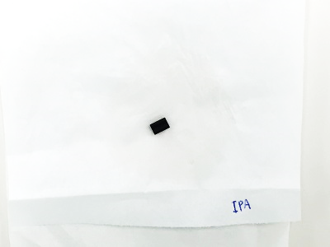

- Rubbing with Acetone – result: coating held up
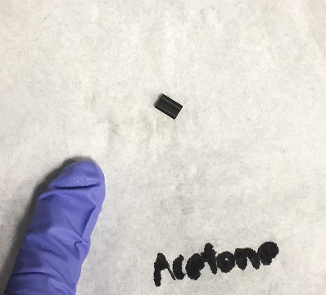

- Ultrasonic cleaning with Acetone (60C, 3 min) – result: coating held up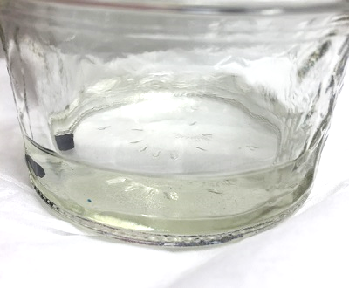 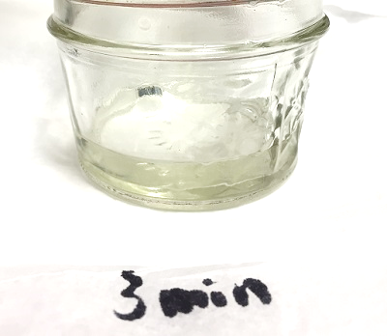
Before After

- Ultrasonic cleaning with Acetone (60C, 5 min) – result: coating held up 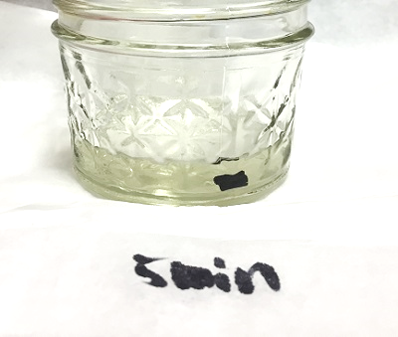
Before After

- Sand paper (1000 grid), light pressure – result: coating came off
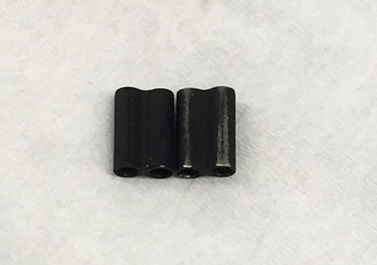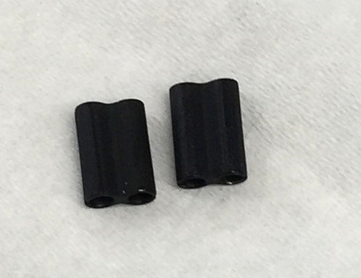
Other side of the piece that is sanded with 1000 grid
Sanded with 1000 grid, coating came off at the tops
Never been through any test
Never been through any test

