Epoxy Validation test report for PFS (v6)
Mitsuko Roberts (Caltech)
October 16, 2015

- Purpose
Cobra stage 2 output shaft and coupler are connected using adhesive. Previous test showed that Epotek 301 provided strong enough bond for the purpose, however because of its low viscosity, an alternative was suggested (Epotek 353ND). This test was performed to find out Epotek 302-3M gives enough strength in torque. The experiment was set up to reflect real manufacturing process as close as possible.
- Material
Meyer gauge pins, 0.6mm class Z, go (McMaster-Carr p/n 2281A1), cut to 2mm, 8 pieces
Stage 2 coupler (model), 8 pieces
Torque gauge (up to 1.2 ounce-inch)
Epo-tek 302-3M (Lot A: PB132111, Lot B: PB132113)
Syringe with applicator tip
A pair of pliers
Permanent marker

- Method
First, stage 2 coupler model was prepared using following method:
- Models’ surfaces were inspected under microscope for residual epoxy from previous experiment. The impurity discovered was scraped off using extra gauge pin. Previously coupler models were soaked in chloride solution for disassembly experiment that caused some corrosion. The corrosion was removed using steel wool cleaner.
- Models were cleaned under ultrasonic cleaner for 15 mintues.
- Models were rinsed in Acetone and then Ethyl Alcohol.
- Models were air dried.
Next, the flat surface and the groove on the coupler models were inspected by microscope. Each coupler model was marked by number, and the photos were taken to record the surface condition for each model.
Then the pins and the coupler models were assembled using following method:
- Gauge pins were inserted into coupler models, and the assembly was set standing on one end.
- Epoxy was mixed as provided by manufacturer, and applied using syringe with a thin tip on the opening of the coupler model. In order to simulate the manufacturing environment, the gauge pin and coupler model was carefully handled and not moved.
Epoxy was cured undisturbed for approximately 40 hours at room temperature (22-23C). The Technical Data Sheet states 24 hours under 23C.
Lastly, the strength of the bond was measured using following method.
- One side of gauge pin was colored, then grabbed by a pair of plier, and the coupler model was turned using torque gauge in both directions.
- The lower number where the bond was broken was recorded for each assembly.

- Results
Figures 1 through 8 shows the surface conditions of 8 coupler models just before bonding. Assembling and bonding happened within 10 minutes of taking these photographs. Although the effort was made to remove discoloration from chlorine damage to the surface, the microscope images show some of the discoloration remained after cleaning.

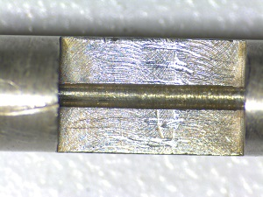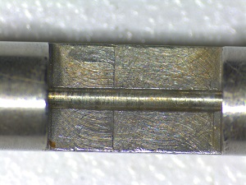
Fig 1: Coupler #1 Fig 2: Coupler #2

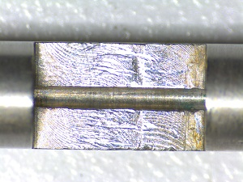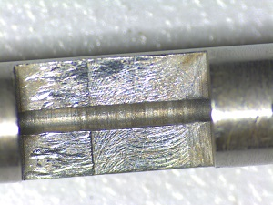
Fig 3: Coupler #3 Fig 4: Coupler #4

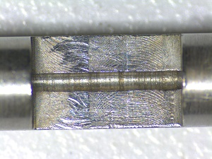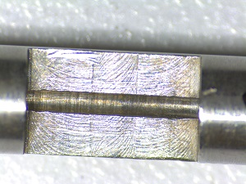
Fig 5: Coupler #5 Fig 6: Coupler #6

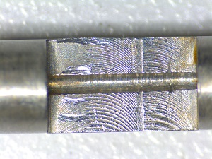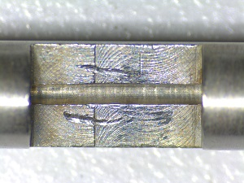
Fig 7: Coupler #7 Fig 8: Coupler #8

Figure 9 shows the assemblies just after applying epoxy, and being cured. Figure 10 shows the package of epoxy used.
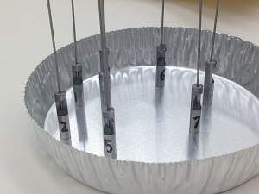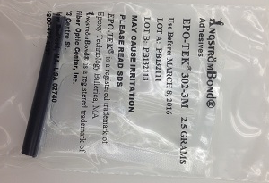
Fig 9: Assemblies being cured Fig 10: Epoxy package used
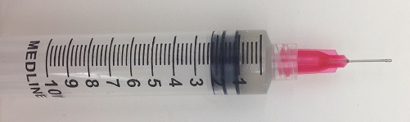
Fig 11: Syringe and the applicator tip used for this test

Table 1 shows the strength measurement, as well as cured time and condition. Since the number of samples are very small (eight), the actual pass rate percentage is not reliable.

Coupler # | Strength (unit: inch-ounce) | Curing time @22-23C | Condition | Pass/fail
1 | >1.2 | 24 hours | 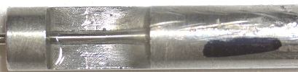 | Pass
2 | 0.95 | 24 hours | 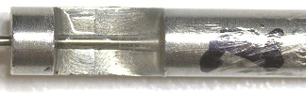 | Fail
3 | >1.2 | 24 hours | 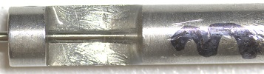 | Pass
4 | >1.2 | 24 hours | 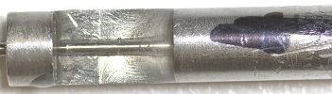 | Pass
5 | >1.2 | 24 hours | 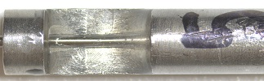 | Pass
6 | >1.2 | 24 hours | 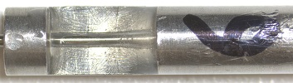 | Pass
7 | >1.2 | 24 hours | 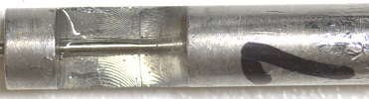 | Pass
8 | >1.2 | 24 hours | 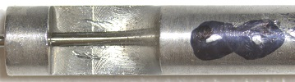 | Pass
Table 1: strength measurement results and condition
- Conclusion
Epotek 302-3M provided >1.2 inch-ounce strength for seven out of eight assemblies. One assembly provided 9.5 inch-ounce. Viscosity is not an issue with this product.

