Mechanical limits of 48"dome drive/bogie system

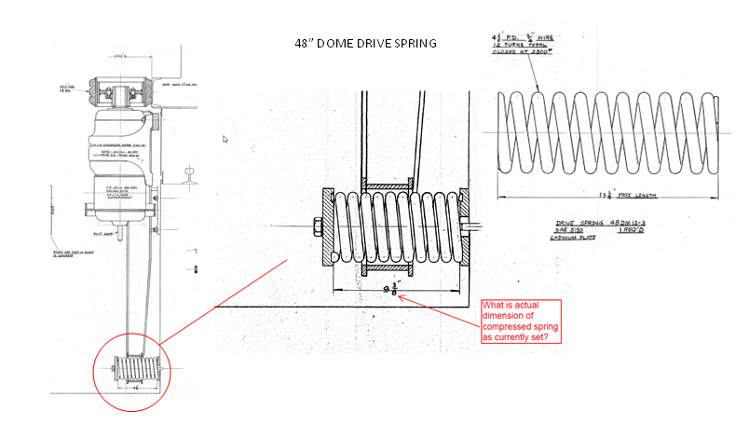

From dwg 102165 & 102166

Calculate Preload Spring rate:

Karl D reports that installed spring compressed length is 11.5". This is longer than shown in assembly dwg. (9.375")
Spring coil and wire diameter measure, # of coils counted. Confirmed spring is according to drawing.

Determine spring rate

Using calculator and assuming closed ground end………10 active coils.
http://www.acxesspring.com/spring-calculator.html
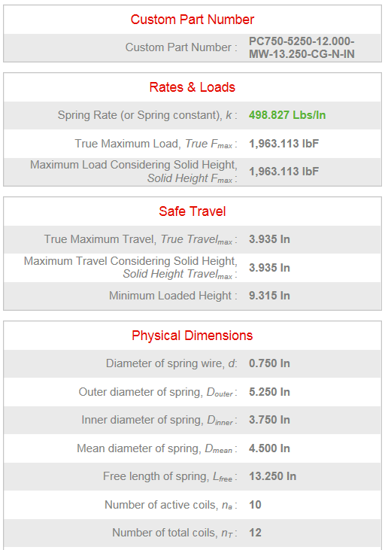

Currently installed preload on tire
Based on measured compressed length of 11.5" (from Karl D), and spring rate from above calculator: k= spring rate = 500 lbs/in
dL= compression from free length = 13.25 - 11.5=1.75"

Fs= Spring force= dL * k = 1.75" * 500lbs/in = 875 lbs

Ft = Load on tire from Spring force (current installed)
Spring arm Lever ratio: 38/28
Fs * 38" = Ft * 28"
Ft = 875 *38/28= 1187.5 lbs

Nominal design preload on tire maximum over-hung load on speed reducer:
Reducer manufacturers consider two factors: bearing life and shaft strength, and generally provide tables and/or formulas to calculate acceptable OHL from radial force and distance. Sumitomo quoted OHL for selected reducer configuration: 7550 lb at center of 3.54" shaft length; presumed de-rating to 4454 lb at 3" distance, or 2429 lb at 5.5".

As tire wears position of overhung load changes
Assuming conservative 5.5" overhung load rating of 2429 lbs

Ft (28/38)= spring load = 2429*(28/38) = 1789 lbs
This would correspond to 1790/500 = 3.58" spring compression
dL= compression from free length = 13.25 - 9.375 = 3.875 (nominal spring comp. from dwg)

Dome drive calculations

Friction drive wheel reference
http://www.schwingmetall.com/download/catalog/WT5556_Rotafrix_Catalog_en.pdf

Typical coefficient of friction for elastomeric/steel Friction Drive: 0.7

Friction load:
We measured 320 lb pull to move the dome (breakaway from static was the same, there is no indication of higher static friction). Assuming 10° pull misalignment in Y and Z, gives 310 lb tangential pull. With a 21 ft radius, dome rolling friction ≈ 6720 lb-ft.

Inertial Load:
From calculations using dome and motor properties: ~17500 lb-ft torque
(see 48in Dome Calculations doc)
This is worst case value based on theoretical motor output. A more realistic and lower value could be derived from actual dome acceleration measurements.

Max Total torque: Friction torque + Inertia torque: 6720 lb-ft + 17500 lb-ft = 24220 lb-ft

Tangential start-up force on dome drive band: 24220 lb-ft / 21ft = 1153 lbs

Theoretical traction drive force:
Current Installed condition:
Drive wheel pre-load: 1187.5 lbs
Traction force with CoF: 1187.5 * 0.7 = 831.25 lbs

Maximum design spring preload condition: (set by speed reducer overhung load)
Drive wheel pre-load: 2429 lbs
Traction force with CoF: 2429 * 0.7 = 1700 lbs

Based on this maximum required traction force, we should be able to drive at maximum acceleration of 1 deg/s/s.

Dome truck radial bearing capacity

Dome truck radial bearing: MRC 5208
Double row angular contact bearing

Assume worst case that 2 radial bearings are loaded:

Nominal spring preload design condition:
Drive wheel pre-load: 2429 lbs

Radial load per bearing: ~ 2429/2= 1214 lbs

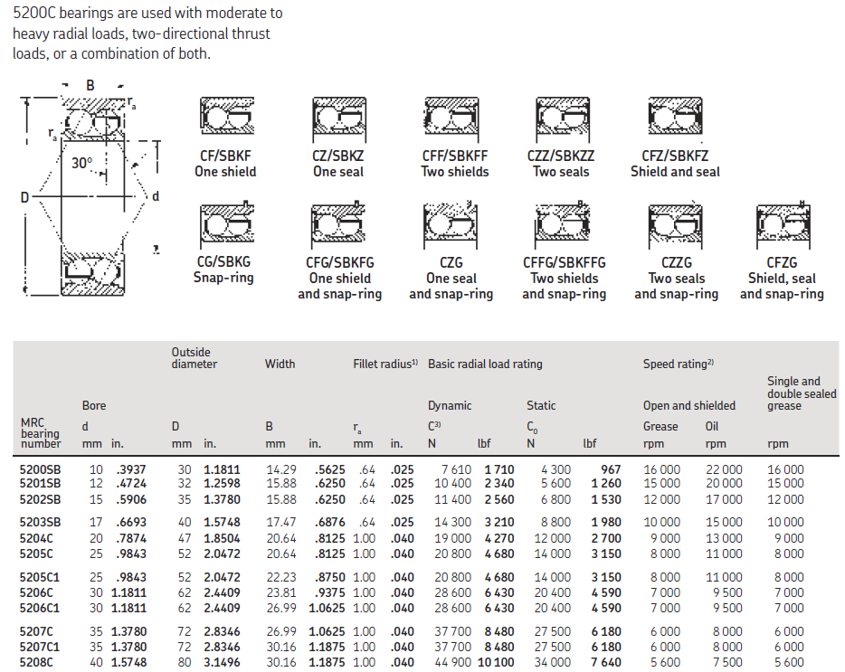

Per SKF Bearing literature:
Bearing 5208C 80mm OD
Dynamic Rating: 11,100 lbs
Static Rating: 7640 lbs

Assume no thrust load.
Equivalent radial load= P= 1314.75 lbs (from above)
C = Dynamic load rating = 11,100 lbs
L10 life = (C/P)^3 = (11,100 / 1314.75)^3 = 601 million revs
L10 life is 90% reliability of a single bearing life under defined loading.

Bearing dia" 80mm => 9.9" circumference
Rail circumference: 2*262*PI=1,646.19"
Bearing rev/dome rev = 1646/9.9= 166.2626 brg rev/dome rev
601E6/166 = 3.6205E6 ≈ 3.6 million dome revs for L10 bearing life

Assuming 20 year life on bearings, this give ~500 dome revs/day.

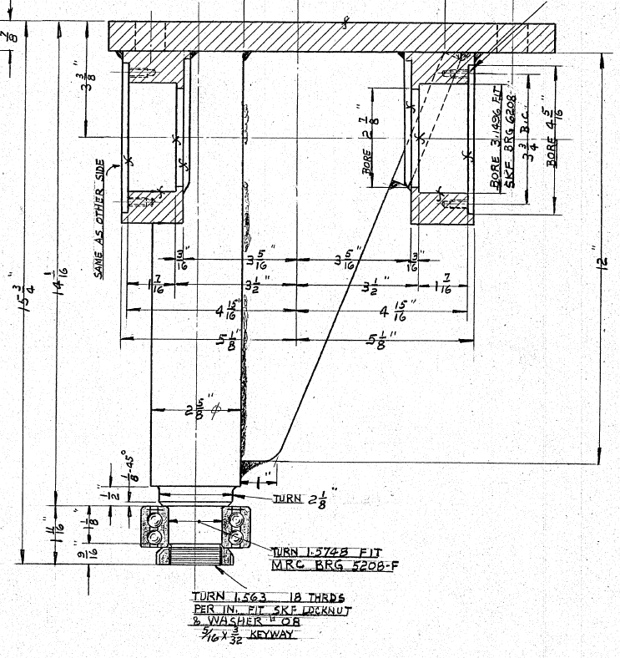

From drawing: 102160

_____________________________________

Dome operating parameter practical limitations:

All the Palomar domes, and especially the P60 & P48 domes, exhibit unique behaviors as a function of environmental conditions and actual construction tolerances which show themselves as increased driving torque, intermittent interference between moving and fixed parts, excessive noise especially at lower operating temperatures, and excessive wear of highly stressed components. (i.e. bearings, wheels, rails, over-travel restraints)

There are lateral and radial forces generated due to thermal variations in dome structure from differential expansion of moving steel structure as compared to fixed structure anchors to concrete. This can be caused by ambient temperature extremes, or differential heating of the dome by the sun. Experience shows that these variations cause signification changes in the dimensional interface between moving and fixed parts, which can cause wheel to rail misalignment.

Excess and varying lateral loads can also be caused by wind induced loads. These variable loads can induce skidding and "creep" forces in the wheel to rail contact. In addition to environmentally induced creep, the construction tolerance of wheel to rail misalignment can cause significant lateral forces. The subject of skidding and creep is analyzed for various cam follower bearing designs and has been given specific attention in the design of the TMT dome bogie design (see attached "TMT Enclosure - Azimuth Bogies PDR Report" ). This analysis was also used in defining the dome bogie system design for the CCAT telescope enclosure.

The lateral (creep) forces that arise come from having the wheels not perfectly aligned with the direction of travel. Figure 6 of the attached reference shows the "normalized creep forces" which are the lateral forces normalized to the sliding forces (i.e. 1.0 = pure sliding). You can see at 0.1 degrees misalignment (about 1.7mm per 1000mm) the lateral force is about 50% of the static sliding force.

The design of the P60 and P48 from the rail upwards are identical, but the construction methods and tolerances held are not. We have seen periodic failure and excessive wear of components of each of the systems, which theoretically should see very little load under the operating conditions, and should have a much longer operating life. Most of the failures appear to be the result of high lateral forces. It is presumed that these high lateral forces are a result of the environmental and construction induces misalignments between the bogie wheels and rail described above. Any assessment of the long term durability of the specific dome bogie system must consider these real world conditions when evaluating changes to the system's duty cycle or operating parameters, such as acceleration and maximum velocity, cycles per/year, and resulting time before failure of system components.

Given the operational experience with the P60 and P48 dome systems under previous increases in duty cycle, the result of operating under further increases in operating parameters will likely result in an accelerated failure rate of highly stressed components, and therefore lead to higher maintenance burden, increased operating costs and downtime.

