WaSP GUIDER CCD FASTENER TORQUE EVALUATION
Belleville Washers
Mc Master P/N: 9713K11
4 Series of 2 parallel
Detector Mounting Plate
JPL P/N: 10366091
Material: 6061-T6

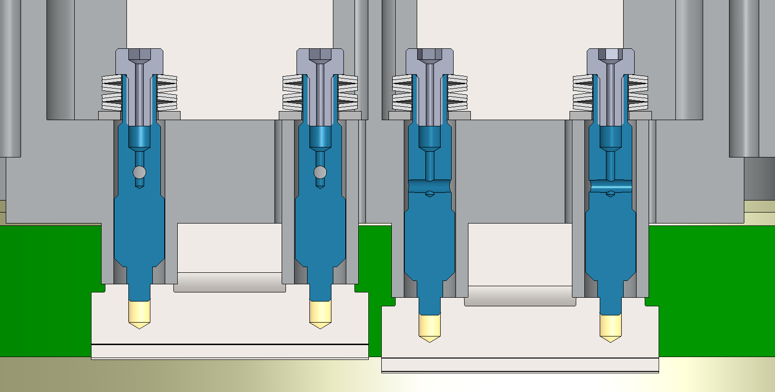
Guider CCD M3-0.5 Fastener
Caltech P/N: WASP-M00-1011
Material: 17-4PH Stainless Steel
Guider Package Base
JPL P/N: 10371432
Material: Invar 36

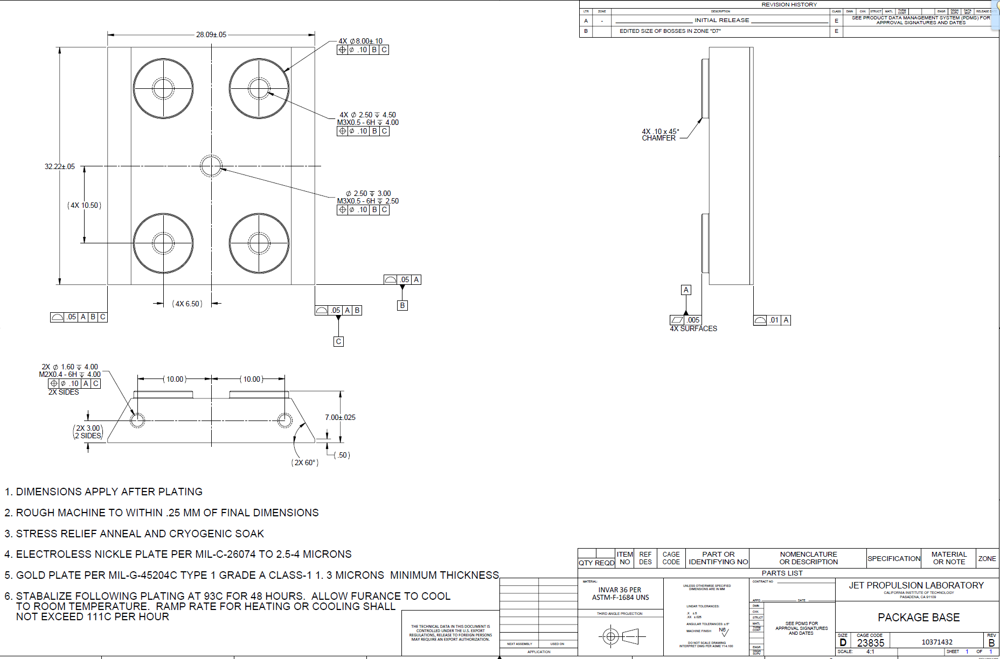
Guider CCD M3-0.5 Fastener Torque Evaluation based on Material Strength:

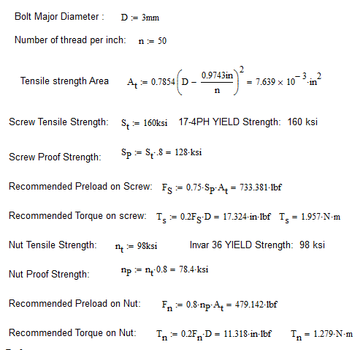

In this assembly, the Stainless Steel screw is 24% stronger than the Invar Nut.

The current Belleville washer design provides a Force of 98Lbf when torqued to 0.4 N.m with 1.5 turns.

This force should be sufficient and provides a comfortable margin of safety.

Force Generated by the Torque:

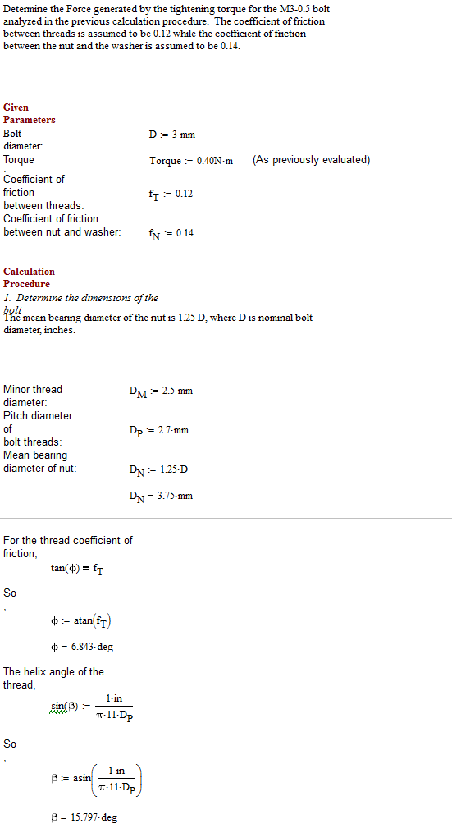

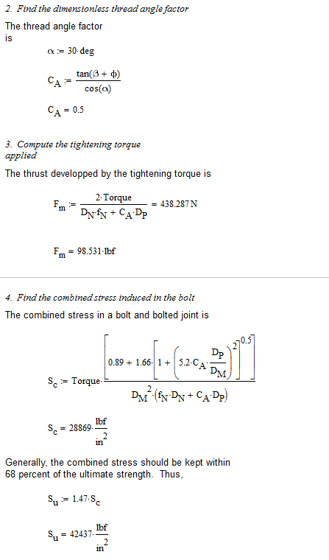
Conclusion:
Applying a 0.4N.m torque on the fastener will provide 98lbf on the CCD contact pads.
The 98ksi ultimate strength of the Invar CCD is safely well above the recommended 42ksi

Mechanical Assembly Verification:
The spring rate of 4 disc spring in series of 2 parallel disc, as specified, should be:
K= F/L = 2x36Lbs / (4 x .13mm) = 72Lbs / 0.52mm = 138Lbs/mm
Deflection for the calculated 98Lbf work load: L=F/K=98/138=0.71mm
Number of turns necessary to reach the load: 0.71/0.5= 1.42 turn
Deflection of each Disc: 0.68/4=0.17mm
Max total Deflection of each disc: .026”-.016”=.01”=0.25mm.
The Belleville will work at 68% of their capacity.

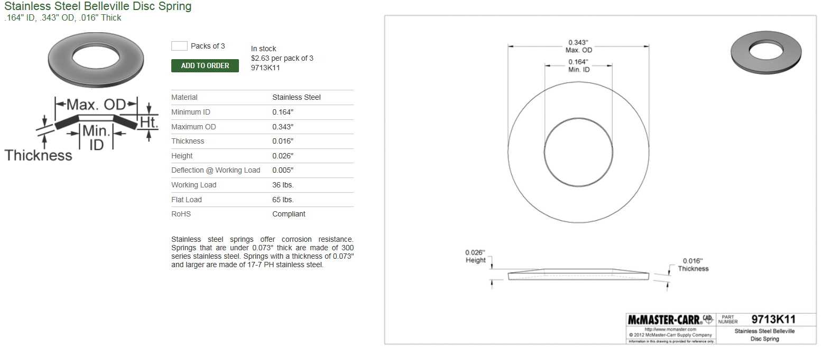

Belleville Washer experimental spring rate characterization:

The spring rate of each individual Belleville, as specified, should be: 36Lbs/0.13mm = 277Lbs/mm
The spring rate of 6 disc spring in series, as specified, should be:
K= F/L = 36Lbs / (6 x .13mm) = 36Lbs / 0.78mm = 46Lbs/mm
Max Stack deflection: 6 x 0.254mm = 1.5mm (3 Turns)
M3-0.5 |  |  | 6 Belleville in Series
# of turn | Displacement (mm) | Force (Lbs) | Stack Spring Cst (Lbs/mm) | Individual average Spring Cst (Lbs/mm)
0 | 0 | 0 | 0 | 0
1/4 | 0.125 | 5 | 40 | 240
1/2 | 0.25 | 10 | 40 | 240
3/4 | 0.375 | 15 | 40 | 240
1 | 0.5 | 21 | 42 | 252
1.25 | 0.625 | 28 | 45 | 269
1.5 | 0.75 | 35 | 47 | 280
1.75 | 0.875 | 42 | 48 | 288
2 | 1 | 48 | 48 | 288
2.25 | 1.125 | 54 | 48 | 288
 |  |  |  | 238

Experiment Conclusion: At specified 0.13mm Deflection this Belleville washers shows a spring rate of: 280 Lbs/mm or 36Lbs.

4 Belleville in series of 2 parallel:
M3-0.5 |  |  | 4 Belleville in series of 2 parallel
# of turn | Displacement (mm) | Force (Lbs) | Stack Spring Cst (Lbs/mm)
0 | 0 | 0 | 0
1/4 | 0.125 | 8 | 64
1/2 | 0.25 | 22 | 88
3/4 | 0.375 | 38 | 101
1 | 0.5 | 55 | 110
1.25 | 0.625 | 73 | 117
1.5 | 0.75 | 90 | 120
1.75 | 0.875 | 117 | 134
2 | 1 | 140 | 140
2.25 | 1.125 | 174 | 155
2.5 | 1.25 | 240 | 192
2.75 | 1.375 | 340 | 247
3 | 1.5 | 455 | 303
 |  |  | 136

Verification Conclusion: The 4 Belleville in series of 2 parallel requires 1.5 turns to achieve the desired 98Lbf.

Guider CCD M3-0.5 Socket Head Cap Screw Torque Evaluation based on Material Strength:
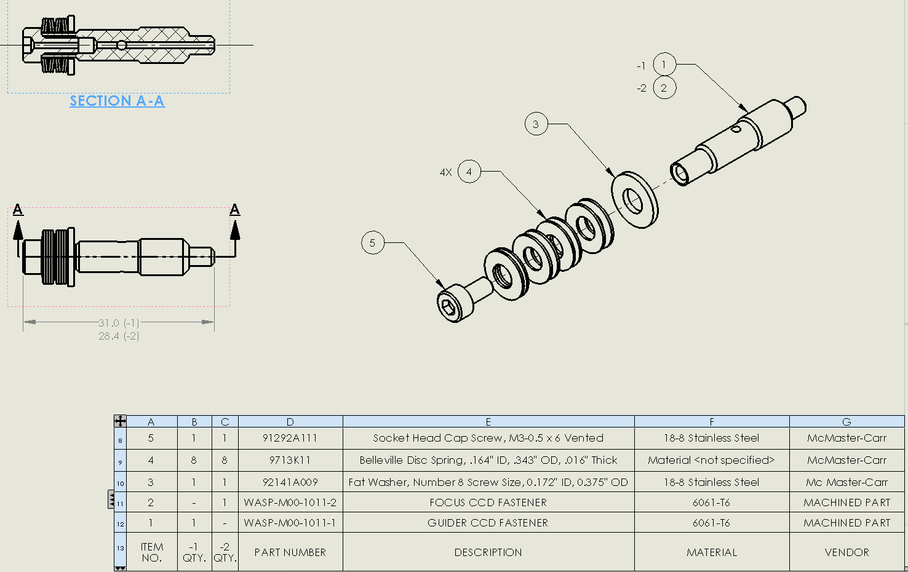

For Un-vented Screws:
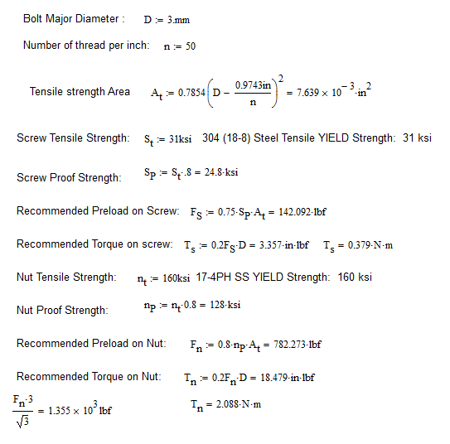

For Vented Screws:

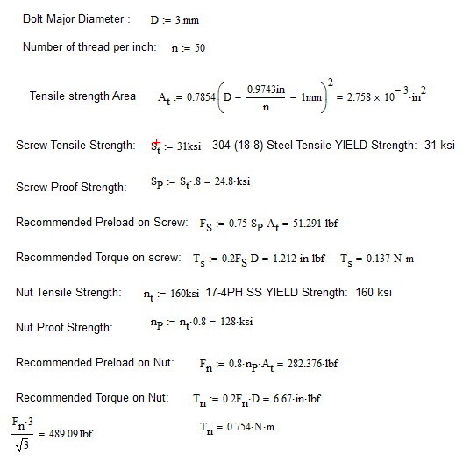

The recommended torque on the M3-0.5 Socket Head Cap Screw Item 5 is lower than the recommended torque of the Fastener to the CCD, the M3-0.5 Socket Head Cap Screw Item 5 have to be secured to the fastener with thread lock.

