SEDM Commissioning Report #01
01-oct-2015

By
Don Neill
neill@srl.caltech.edu
with
Nick Konidaris, Tom Barlow, Andrew Boden

Observer’s Summary

- The SEDM has been used to classify targets with successful classifications at g-mag 19.3, 19.3, and 19.6 (all Ia) and one tentative classification at 20.1 (Ic) and one unknown hostless object (possible CV) at 19.6 and another failed classification (missed Ia) at 20.1.
- Even with a new set of pointing model data and a fit giving an RMS of 7 arcsec, the actual observed pointing accuracy was closer to 25 arcsec RMS. This needs to be improved or a workaround implemented before fully robotic operation of the SEDM can be realized.
- Data for characterizing the throughput of the instrument were acquired.
- The pipeline was tested: it was run in real-time and produced classifiable spectra less than an hour after the final images were acquired.
- Flexure within the instrument was identified and reduced.

Introduction

As commissioning scientist my goal is to drive the deployment of the SED Machine (SEDM) such that it achieves its full scientific potential. To that end, I will be issuing these reports at intervals as significant milestones dictate. These reports will serve as status reports in the commissioning process, and will motivate further progress by including a list of items yet to be achieved. I will consider the SEDM fully commissioned when that list is empty.

I intend these reports to be a source of the technical details (along with the documentation website) specifying the capabilities of the SEDM. These include the on-sky throughput, the relationship between final signal-to-noise and transient object brightness and host galaxy involvement, as well as the range and accuracy of the spectral calibration in flux and wavelength. These details will be important inputs to the priority-scheduling engine that will generate on-the-fly observation queues during the operational phase.

I see our progress toward final commissioning proceeding along several distinct areas. The items yet to be achieved will be divided into categories based on these areas. They are:

- Mechanical stability and repeatability (flexure reduction)
- Mechanical optimization (best deployment)
- Mechanical automation (deployment of calib lamps, etc)
- Pipeline optimization (s/n, timing, flexure compensation)
- Pipeline automation (eliminate human interaction)
- Operational automation (scheduling based on object priorities)

There is a team of people who will be working on these fronts. Including myself there is the PI, Nick Konidaris, Tom Barlow, Andy Boden and Nadejda ("Nadia") Blagorodnova. In addition, there are a number of support personnel at Palomar, in particular Steve Kunsman.

This first report follows my first run using the SEDM (17-19 August 2015) and I can happily report that the instrument is fully capable of achieving its scientific goal of being a front-line, automated transient classification engine for objects brighter than 20.5 V magnitudes and imbedded in a host galaxy. I support this statement with many examples of spectra taken of a variety of objects in the sections below.

Commissioning Activities: August 2015 SEDM Run

Description and Goals

The recent SEDM run covered the nights of 17, 18, and 19 August 2015 and gave us a total on-sky time of roughly 24 hours. Our main goal for the run was to prove the concept of acquiring host-subtracted, flux calibrated spectra of transients within hours of discovery. We note that a failure of the P48-inch filter changer meant that the first night of our run was also the first night of the TILU g-band data acquisition after the Milky Way science program. As a result, there were no recent reference images for identifying very young transients.

In addition to the overall science goal, we had many engineering goals:

- Acquire a new TPOINT data set
- Test for sources of mechanical flexure
- Test for variation in the throughput of the IFU across the field of view
- Verify the wavelength solution
- Quantify atmospheric dispersion
- Test the blue-end throughput

We also acquired spectra for specific science projects not directly related to the SEDM primary mission.

Conditions

The first night of the run was plagued by cloudy periods lasting more than an hour. Our focus was on the TPOINT data and while we budgeted 3 hours for this task, it actually took most of the night. The seeing reported by the seeing monitor during the clear periods was typical at ~1.5”. The second night was much better with few clouds and good seeing and the third night was considered to be photometric and also had typical seeing.

Observing Outline

Night 1, Aug 17:

As previously stated, we intended to acquire new TPOINT data during the first three hours of the night. The TPOINT grid uses 118 grid points and consist of Rainbow Camera (RC) images with a 30s exposure time. At position number 51 (around 22:30) we were shut down by the P200 telescope operator because it became too cloudy to observe. We continued to check the sky at half-hour intervals and at 00:20 we were able to resume taking images for about 15 minutes. After position 60 (at 00:35) we stopped again due to clouds. The clouds finally dissipated for the remainder of the night around 02:25 and we resumed taking the rest of the TPOINT positions. We finished acquiring all the TPOINT images at around 03:40. I report these details because they may have an impact on the final quality of the TPOINT solution and subsequent model.

At this point we focused the IFU and took IFU images of PTF15bvl, a YSO, non-transient object. Then we acquired IFU data for two standard stars: HZ4 and G191B2B. We then acquired IFU images of a wavelength verification target, a planetary nebula NGC7662. This ended the night at 05:15 and a set of darks was acquired during late twilight.

Night 2, Aug 18:

During twilight we tested a script for acquiring a 5x5 grid of images on the IFU for the purpose of testing throughput variations across the IFU. We used the standard star G138-31 and tested the grid script first in the r-band quadrant of the RC. We then used the standard star to focus the IFU. We acquired A/B IFU image pairs for two EPIC targets during late 12-degree twilight. We then acquired IFU images for standards stars BD+33d2642, G24-9, and BD+28d4211. We then moved to SAO124437 and executed our 5x5 grid script. We adjusted the script to provide a rectangular grid and re-ran the script two more times. This completed at 21:37.

Work was done on the instrument when undue flexure was discovered during the data reduction process. When this was complete, a new set of calibration images was acquired, necessitated by adjustments to the instrument configuration. These completed at 22:30 and science observations resumed.

We took a 15 minute A/B IFU pair of Gaia14adr, a quiescent CV. After this we re-focused the IFU and acquired IFU images of two standard stars BD+33d2642, and G24-9. We then acquired a 30 minute A/B IFU pair of iPTF transient PTF15cam, which by this time had a FLOYDS spectrum and would thus be good for comparison and verification. In addition, we took a 60s exposure after the object was placed on the r-band quadrant of the RC in order to inter-compare the photometry and spectroscopy.

We then used SAO070260 as a target for another two sets of 5x5 throughput grid observations.

More transients were showing up on the marshal, so we concentrated on PTF15ccs with two 30 minute A/B IFU pairs. This was followed by a 20 minute A/B pair of a YSO PTF15bvl taken in early 18-degree twilight. We attempted a 10 minute A/B pair of new transient PTF15ccu in early to middle 12-degree twilight. This ended our night at 05:30.

Night 3, Aug 19:

Nick did more work on the instrument to reduce flexure prior to afternoon calibrations. Observations began in twilight of three standard stars BD+28d4211, BD+33d2642, and G24-9 on the IFU. We focused again after the standards and took a 20 minute A/B IFU pair of Gaia14adr. This was followed by two 30 minute A/B IFU pairs of PTF15cct and one 30 minute A/B IFU pair of PTF15ccv. We observed two more standards BD+28d4211 and G93-48 on the IFU. This was followed by two 20 minute A/B IFU pairs of both PTF15cde and PTF15cbf. These were followed by one 30 minute A/B IFU pair of PTF15cdf. When this completed we were very close to twilight so we shortened the next observation to one 20 minute A/B IFU pair of PTF15cdf. Our last observations were of the standard star HZ4 on the IFU.

General Results

Science Goal
The general goal of producing a calibrated, host-subtracted spectrum capable of being fitted and classified was achieved on the second night with the reduction of the data on PTF15ccs. This was performed at the telescope and it took less than one hour. The spectrum was transferred to Robert Quimby who was able to use superfit to type this object. Below is the output spectrum (in blue) with a fit to the SNIa 1998bu at +10 days overlaid (in black).

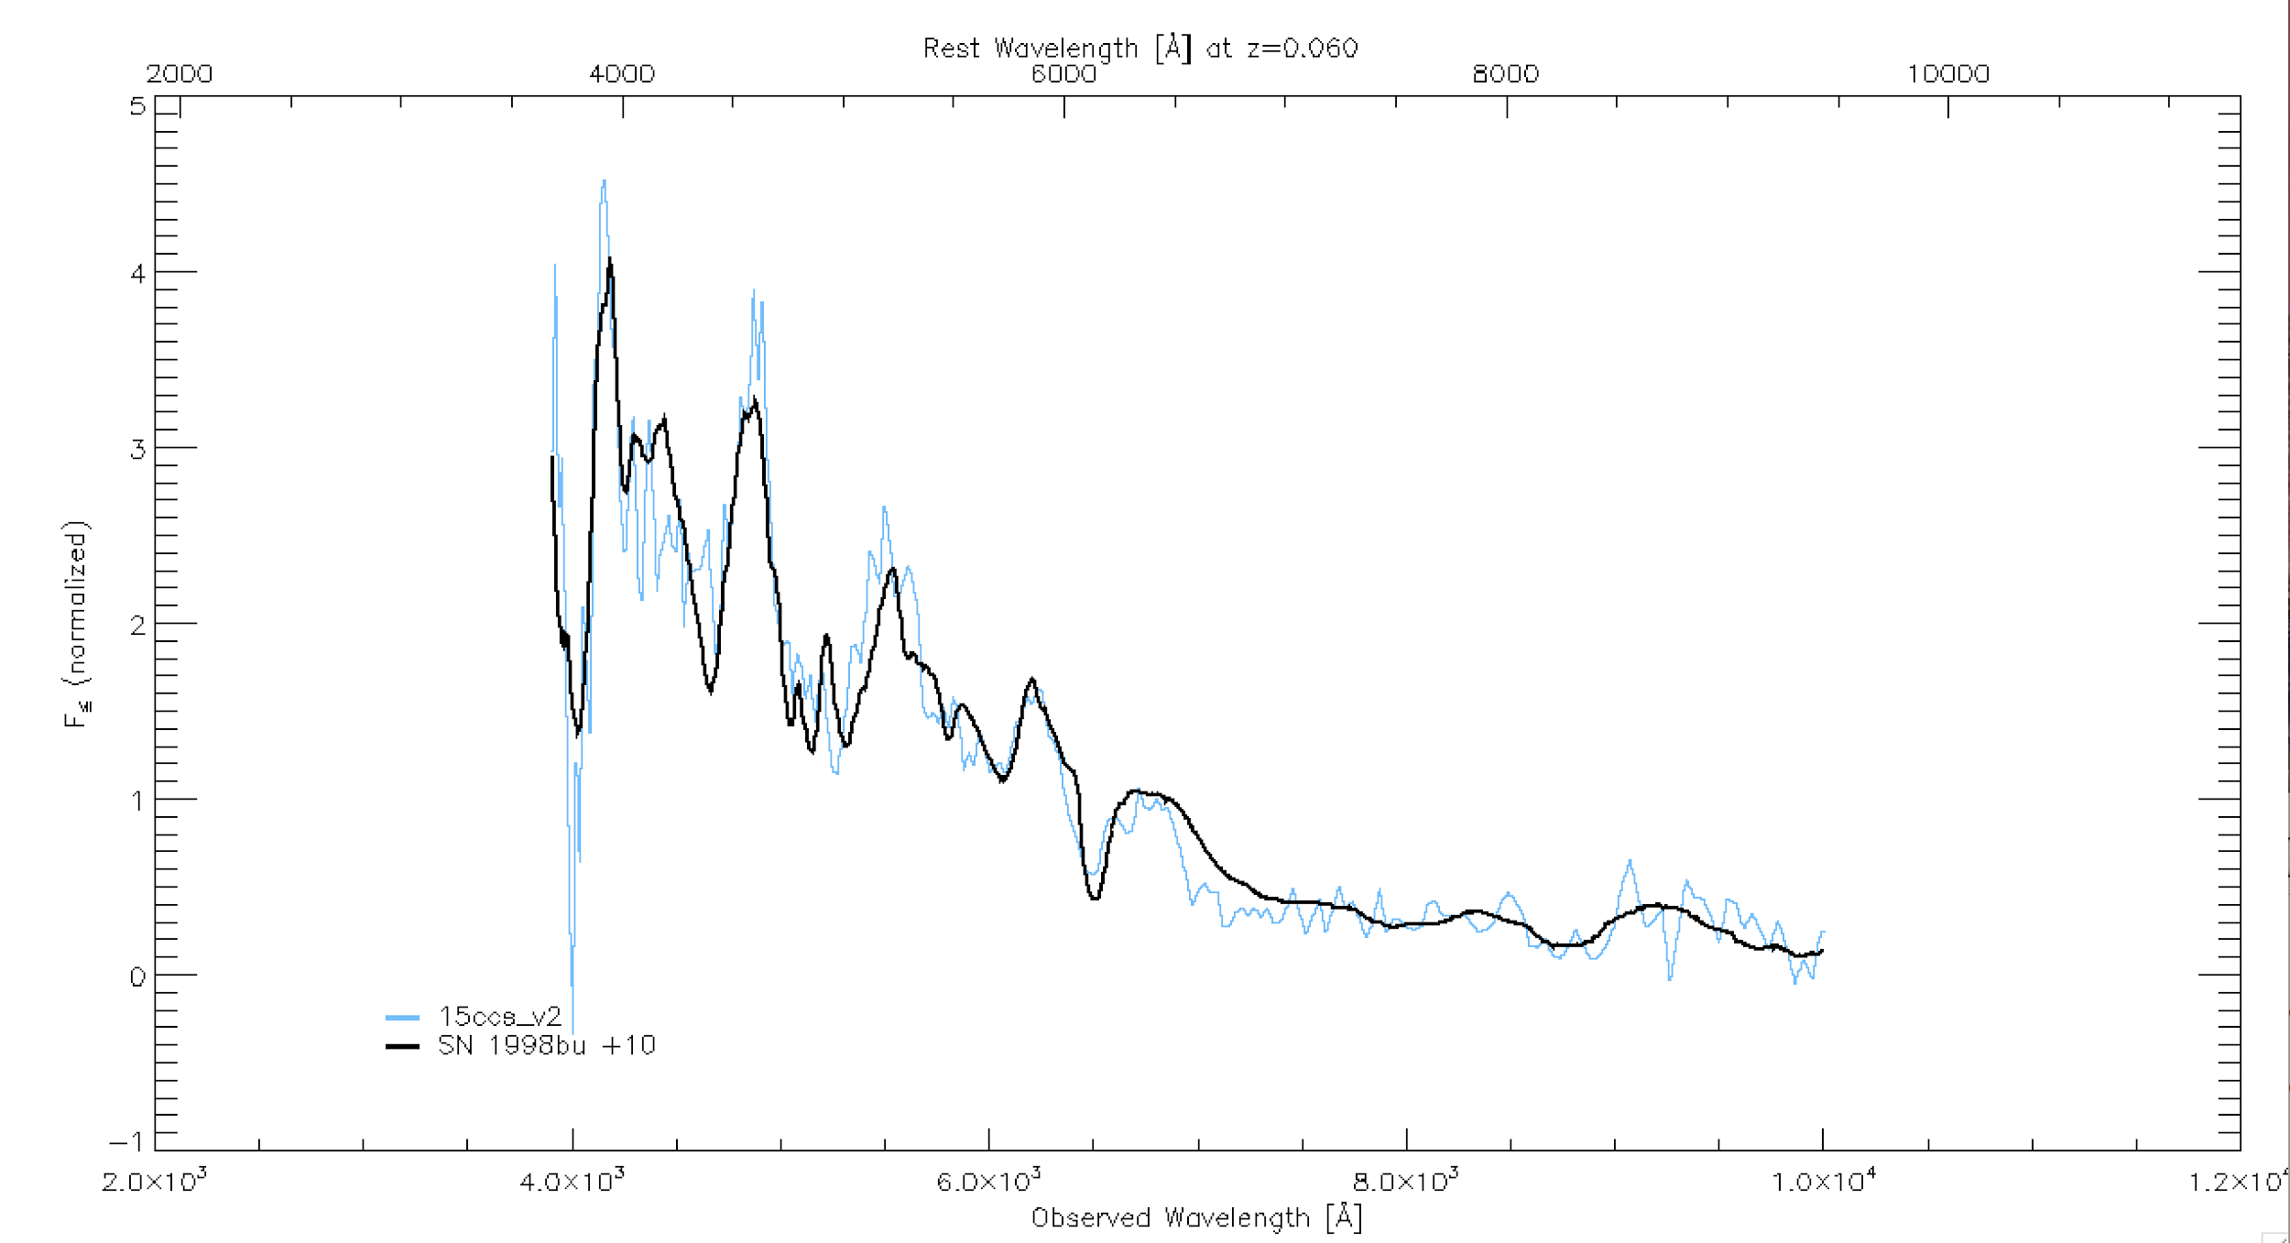
Once our typing was secure, the spectrum was uploaded to the PTF Marshal. This image is the result of coadding two 30 minute A/B IFU pairs having a total exposure time of 2hr. The object was listed as having a g-band magnitude of 19.3. It is reasonable to say that the signal-to-noise exhibited by this spectrum is overkill for identifying the transient type and 1hr would probably allow typing at the same level of accuracy.

During the run several other transients were typed as well. PTF15cct at g-mag 19.6 was identified as a SN Ia at +5 days, PTF15ccv at g-mag 20.1 was tentatively identified as a SN Ic, PTF15cde at g-mag 19.3 was identified as a SN Ia at -9 days. Two were not clearly identified. PTF15cbf at g-mag 19.6 has an unknown type, but is hostless and has a blue continuum and could thus be a CV, and lastly PTF15cdf at g-mag 20.1 also had an unknown type, but was later identified as an early Ia. All the above results (spectra and types) can be found on the PTF Marshal.

These results prove the basic capability of the SEDM in broad terms and fulfilled our science goal for this run.

Engineering Goals

TPOINT

We chose to use the regular TCS grid for out TPOINT observations. This yields a total of 118 separate pointings covering the sky in HA and Dec. The ‘rp’ TCS command selects the next grid position and the ‘go’ command moves thereto and once tracking logs the raw encoder values. The ‘wd’ command records the completion of each grid position. RC images of 30s (nominally) were taken at each position, although due to clouds and high airmass conditions, some exposures were lengthened. We attempted to repeat six fields when very few stars were detected and one field (TPOINT61) was inadvertently skipped which resulted in a total of 123 RC images being collected.

I ran the astrometry.net software on each image and then used the resulting WCS solution for each field to derive the coordinates of the reference pixel (1093, 1080). This coordinate was associated with the logged raw coordinates through the filename, which is a time-stamp accurate to the second of time.

Four of the 123 fields outright failed, due to cloud cover resulting in too few stars to fit. Six fields were duplicated in an effort to acquire enough stars for fitting. In most cases, the extra exposure time was not needed and the duplicate solutions were indistinguishable. This resulted in a total of 113 unique positions for the input to the TPOINT program.

John Henning ran the TPOINT data through the TPOINT fitting procedure and produced a new model (SEDM_AUG15) that had a formal positional RMS of ~7”. We installed this model in the menu for the P60 and used it for the following two nights. In addition, we zeroed out the RA and Dec offsets.

Results:

Our experience using the new model is that it is quite usable, but does not represent a significant improvement over the previous model. At the beginning of the night, we used an SAO star to define the coordinates by centering the star on the reference pixel and then issuing an ‘X’ TCS command. We found that this first ‘X’ still produced large errors in pointing (~120” in RA and ~50” in Dec). A second ‘X’ using a standard star seemed to improve things a bit, but still produced larger errors than desired (~25” in both RA and Dec).

In order for the SEDM to be fully automated, the target pointing accuracy is ~1”, although even a 5” RMS in pointing would be acceptable. The fact that the observed accuracy is at least a factor of three larger than the model RMS implies that there may be some problem with the input data. Given that our data taking was interrupted twice and that often we were exposing through clouds it can be said that the conditions were not ideal. Another factor that could come into play is the differential refraction through the different filters of the RC. I will endeavor to derive an astrometry.net solution just for the r-band section of each RC image (where the ref pixel resides) and see how different the input TPOINT coordinates would be. If they are significant, we can re-fit the data and see if that improves the pointing.

Mechanical Flexure

At the end of the first night (after taking the TPOINT RC images), Nick ran the pipeline on the science targets we acquired at the end of the night. These were using calibration images taken at the beginning of the night and he discovered a large amount of flexure. Our conclusion was that the TPOINT grid placed the telescope at very large hour angles (sometimes up to +- 6hr) and this could have introduced a flexure offset.

During the second night which focused on science observations, the pipeline was run much earlier and flexure was again discovered. Nick was able to find a source of flexure and eliminate it, but this required re-doing the calibrations. With these new calibrations, the pipeline was much easier to run and the flexure was drastically reduced.

Prior to the third night, Nick did some more work on isolating and eliminating sources of flexure. His impression was that the pipeline ran the easiest on the third night after eliminating more sources of flexure. He also expressed the idea that flexure could possibly be reduced even further by a dedicated effort that could take place with the instrument in the stored position (not installed on the telescope)

Throughput Variations

We acquired several sets of observations of a bright star placed on a 5 x 5 grid of positions with 3” separations on the IFU. We used the fast readout to attempt to minimize temporal transparency variations and we acquired two sets for each star in rapid succession to check for stability. These will be reduced and a graph of the throughput variation as a function of position will be shown in SEDM CR02. This will be important for locating the target on the best part of the IFU and for where to best offset the target for A/B observations.

Verify Wavelength Solution

We acquired images of NGC7662 on night one in order to verify the wavelength solution. Unfortunately, the flexure discovered on that night makes the reduction of those data problematic. However, we did acquire IFU images of PTF15cam on the second night after work was done to eliminate flexure. This object has a FLOYDS spectrum and this can be used to verify our wavelength solution. In addition, the ability to fit the other objects implies that at least our relative wavelength solution is approximately correct.

We will examine these images and see if we can quantify the wavelength solution accuracy and report the results in SEDM CR02. It may be desirable to acquire other wavelength standards on a subsequent run, if we cannot quantify the accuracy well enough.

Quantify Atmospheric Dispersion

We have acquired standard stars at many different airmasses and these data can be used to quantify the AD. Results will be reported in SEDM CR02.

Test the Blue-end Throughput

The P60 mirrors were recently re-surfaced and it was expected that the low throughput observed in the blue was due to old/dirty coatings. The reduced standard stars demonstrated that the throughput in the blue was significantly improved.

TODO:

Based on these activities, the list below represents the items required to be complete before the SEDM is fully commissioned.

Mechanical Stability

Procedures for testing for growing flexure as a function of time

Mechanical Optimization
  - Test final deployment and orientation of lenslet array and other optical elements to optimize:
    - spectral overlap
    - vignetting

Mechanical Automation
  - Install calibration lamps in a permanent mounting
  - Install remote switching capability (Eaton power controller, e.g.)

Pipeline Optimization
  - Test faster cosmic ray removal algorithms
    - Eran’s method (convert from matlab)
    - IDL la cosmic version
  - Optimize spectral extraction for maximum S/N
  - Optimize calibration of spatial/wavelength solutions accounting for flexure

Pipeline Automation
  - Eliminate human interaction currently required

Scheduling Automation
  - Improve pointing accuracy to < 5” RMS
    - Workaround: use astrometry.net on RCAM images
  - Script instrument focus
  - Script afternoon calibrations
  - Script twilight flat acquisition
  - Script pointing setup
  - Script telescope focus
  - Script standard star data acquisition
  - Use existing scheduling engines (GRBCAM) as starting point
  - Develop priority criteria:
    - Interest
    - Availability
    - Exposure time
  - Quantify exposure time and type (A or A/B) as a function of:
    - source brightness
    - background (host) brightness
    - desired signal-to-noise

