Telescope vibration mitigation for NGAO

Keck Adaptive Optics Note 680

Christopher Neyman
August 17, 2009

Abstract

This note considers the suitability of a “parametric oscillator” as a method to cancel vibration for the NGAO system. A continuous time Simulink model is used to estimate the performance of the natural guide star sensors to a combination of atmospheric and vibration tip tilt disturbances. The note concludes with recommendation on what method to use for vibration reduction in the final system.

Revision History

Revision | Date | Author (s) | Reason for revision / remarks
1.0 | August 17, 2009 |  | Initial release

Introduction

One goal of the NGAO project is to produce high Strehl observations over a significant fraction of the sky. The required sky coverage is 30%. This performance level implies the ability to track on several natural guide stars that are as faint as J~16 with exposure times as short at 5 msec. In addition to the tip tilt errors caused by atmospheric turbulence, the tracking system must be able to correct for errors in telescope guiding, wind shake, and mechanical vibrations.
High frequency mechanical vibrations have long been a limiting factor for high-resolution astronomy at W. M. Keck Observatory. The presence of vibration in the Keck telescope segments was noted as early as 1994 [1,2]. The effect was extensively studied by Dekens [3] in his PhD thesis using optical measurement with a high-speed CCD camera. Dekens reported both tip tilt motion of individual segments and full aperture tip tilt motion with the dominate frequency being located around 29 Hz. This frequency is typical of electrical motors that run at 1700-1800 revolutions per minute (28-30 Hz) used throughout the observatory.
More recently, an independent survey of vibrations at Keck was made by Tomas Erm [4,5] of the Thirty meter Telescope project. The measurements by Erm confirmed that the dominate vibration is centered around 29Hz. An attempt to determine if this is a resonant frequency of the telescope azimuth and elevation drive was inconclusive.
The current Keck adaptive optics systems [6] also observe 29 Hz vibrations in both full aperture tip tilt and higher order phase aberrations. The AO error budget for tracking bright stars is much higher [6] than would be expected from the simple scaling laws of Greenwood. All the above sources have reported that the 29 Hz vibration amplitude is highly variable with time although the frequency is very stable.
During the installation of the Keck interferometer, a large amount of effort was put forth by both the Keck staff and JPL team [7,8] to understand the vibration problem and reduce its effects. These efforts were successful and the interferometer was able to meet its fringe tracking requirements although it did not meet its goal specification of working at the atmospheric limit of the site. The interferometer success was due to two efforts:

- A reduction in vibrations by isolation of vibration sources such as pumps and air conditioners
- The use of a modified control system (parametric oscillator) for the interferometer tracking system

The use of accelerometers by the interferometer to sense and correct tip tilt vibrations did not prove successful although it has indicated that the worst offender is likely the secondary mirrors, with the tertiary also providing significant jitter. The interferometer has been able to suppress the residual beam wander that is not corrected by the AO systems with its own tracking systems. The jitter is removed by the Keck Angel Tracker (KAT), which is composed of a tracking mirror and position sensitive detector for each telescope. These components are in the interferometer beam combiner located in the Keck basement. Although the sampling frequency of this servo is as low as 100Hz, the controller is able to reject a significant amount of 29 Hz by the use of a specialized control technique. This method makes use of the fact that the vibration is located at a precise frequency of 29 Hz. Mark Colavita [9] has named this technique the “parametric oscillator” and it is similar to the standard method of “higher harmonic control” used in other dynamic systems such as helicopter rotors. This method appears to be promising for our application. This report evaluates it in subsequent sections of this memo.
The organization of the remainder of this memo is as follows: The next section discusses the expected values for the tip tilt sources and levels to be expected for NGAO. Subsequently, a control system model for the tracker and parametric oscillator is developed. Next, the performance in the presence of vibration is compared to the NGAO error budget. The final sections discus the relative advantages and disadvantages for the parametric oscillator when compared to other means of vibration mitigation.
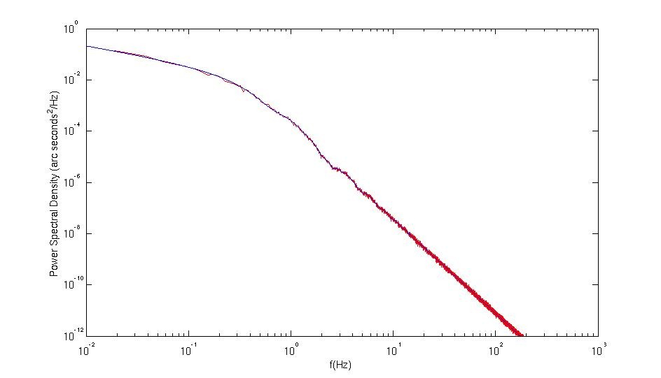
Figure 1: Comparison of analytical power spectral density (blue line) and the average of 100 random samples (red line).

Tip Tilt Sources and Levels

Atmospheric Tip Tilt

Atmospheric turbulence produces random motion of astronomical targets as well as higher order distortions. We use the standard gradient or G-tilt formalism devolved by Tyler [10]. The expressions in reference 10 were evaluated for the standard median profile of the Mauna Kea Ridge atmospheric model [11] (KAON 503) that is used in the NGAO error budget and other performance estimates. The formalism of Tyler assumes an infinite outer scale. The result of this assumption is excess tip tilt power at very low frequencies, of order ~0.1 Hz or less. Since any tracking system will be very efficient at removing these frequencies, the author feels that little performance penalty is associated with the unphysical assumption of an infinite outer scale. With these assumptions, the atmosphere used in this study has a fundamental tip-tilt tracking frequency, f_{T}, of 2.8 Hz and uncorrected RMS tilt error of 1.31 arc seconds. The reader is reminded that the G-tilt power spectral density (PSD) is proportional to f^{--2/3} at low frequencies and behaves as f ^{-11/3} at high frequencies. A bend in the PSD is expected at intersection of these two asymptotes, for MKR model this is at a frequency of approximately 2.8 Hz.
Our tip tilt compensation techniques were tested with random time series of one axis tilt. These random samples were generated to have an ensemble average consistent with the PSD in reference 10. The samples were generated from the inverse Fourier transform of filtering white noise. This technique is the one dimensional analog of the standard atmospheric phase screen generation technique commonly used in AO simulations. A comparison of the ensemble average PSD from 100 random time samples and the analytical PSD from reference 10 is shown in Figure 1.

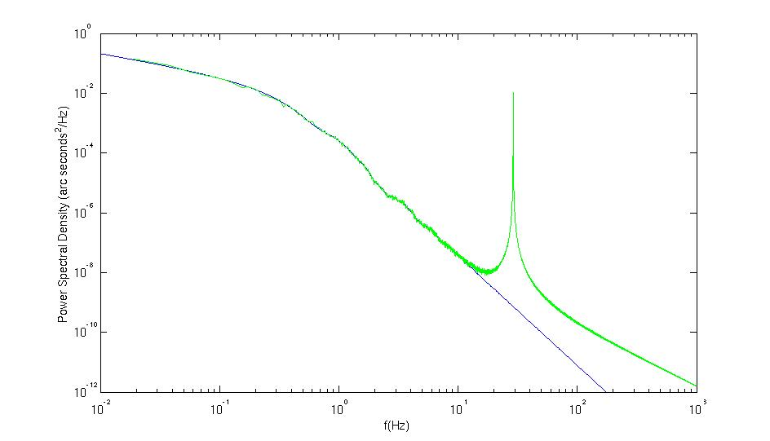
Figure 2: Atmospheric PSD power with additional power at 29 Hz from mechanical vibrations. The excess power above 29 Hz is the result of spectral leakage from the large peak at 29 Hz when the power spectrum is estimated from the FFT of the time series.

Mechanical Vibration

The mechanical vibration at Keck is known be located close to 29.0 Hz. The amplitude of the resulting disturbance is variable in amplitude but its frequency is typically stable over many seconds. The resulting rms jitter has been measured by several groups and found to be between 0.010-0.020 arc seconds. We assume a value of 0.020 arc seconds as a worse case value. Vibrations were modeled as a pure sine function with a frequency at precisely 29.0 Hz. The phase of the sine wave was a uniform random variable in the range 0-2π. This variability is an attempt to simulate the slowly variable nature of the 29 Hz disturbance. In the simulation, a sine function with random phase is produced for each atmospheric time series generated with the technique described in section 2.1 above.

Others Sources of Tip Tilt Error

Currently NGAO has not specified a standard wind shake spectrum. If suitable wind shack measurements could be made then it would be straightforward to add their PSD to the atmospheric disturbance and generate random time series that are consistence with the composite spectrum of both disturbances. Another source of tip tilt errors is drifts in the telescope guiding. However, telescope tracking and guiding error are of a slow enough frequency to be removed by the AO systems tracker.

NGAO Tracker Design

A continuous time model of the AO system was developed using the standard Laplace transform techniques for AO, given by Madec in reference 12. The Laplace transform techniques were also used to model the parametric oscillator for compensation of the 29 Hz vibrations. A real AO system is actually a combination of discrete and continuous time (CT) components. However, the continuous approximation is often acceptable. Starting from these basic control functions a
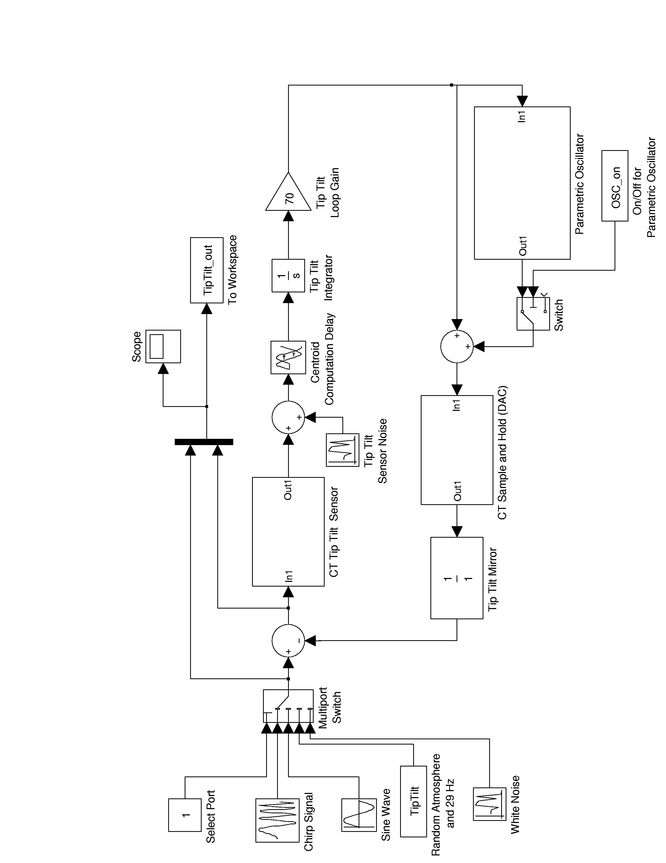
Figure 3: Simulink model of single channel AO control loop with a parametric oscillator for vibration cancelation. See details in text.
model of a single channel of the tip tilt tracker was developed using the MATLAB add-on package Simulink. Simulink is a time domain differential equation solver that has a graphical interface that resembles a control system block diagram. This technique was chosen for the flexibility and the expansion capabilities it provides for future design of AO control models.

The overall Simulink block diagram for an AO tip tilt loop with a parametric oscillator is shown in Figure 3. A few features of the overall model should be noted. At the left of Figure 3, several different types of input signals can be used in the simulation by selecting the desired input with the multiple port switch. The chirp signal and sine wave inputs proved useful in setting up the control loop and verifying the operation of the model. The white noise input was used to measure the error transfer function of the overall system. The “TipTilt” input block reads an input variable from the MATLAB workspace. This function links the Simulink model to MATLAB code that generates random tip tilt time series as described in section 2. The MATLAB code is flexible enough to generate atmospheric tip tilt disturbances or disturbances that are a combination of vibrations and atmospheric sources. These inputs were described in section 2 above.
The input signal and the error in the control correction are both output to the MATLAB workspace for further analysis via the block labeled “TipTilt_out”. The Scope block allows monitoring of these signals as the simulation runs. Complicated control functions are combined into subsystem blocks that make the top-level control diagram of Figure 3 appear simpler. Examples of such blocks are the “CT Tip Tilt Sensor”, the “Parametric Oscillator”, and the “CT Sample and Hold”. The parametric oscillator can be switched on or off from the MATLAB workspace using the variable “OSC_on”. The “Tip Tilt Sensor Noise” block allows the simulation to have white noise added to the output of the tip tilt sensor measurement. The next sections consider the Simulink models for these subsystem blocks.
The input tip tilt disturbance photons are integrated by the tip tilt sensor for a sample period, T, the resulting continuous transfer functions is
$H_{\text{integration}}(s)=\frac{1−e^{−\text{Ts}}}{\text{Ts}}$. (1)
The transfer function, 1/Ts, is an integrator and the exponential is pure delay. The transfer function is realized in the Simulink “CT Tip Tilt Sensor” block as shown in Figure 4
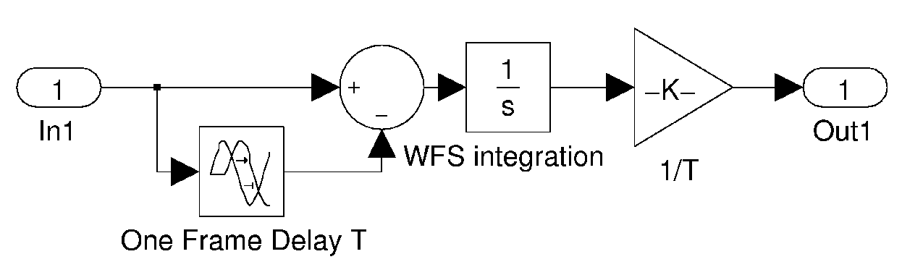
Figure 4: The Simulink subsystem model for the “CT Tip Tilt Sensor”. Its transfer function is equivalent to equation (1).
The readout time, image processing, and centroid computation represent a pure time delay, τ. The transfer function is represented by the delay block labeled “Centroid Computation Delay” in the Simulink model of Figure 3. The transfer function of a centroid computation is:
$H_{\text{comp}\text{.}}(s)=e^{−τs}$. (2)

The tracker control system compensator is modeled, as simple continuous time integrator where, K_{gain}, is the equivalent analog gain of the tracking control loop. Its transfer function is:
$H_{\text{control}}(s)=\frac{K_{\text{Gain}}}{s}$. (3)
The Simulink model is a standard integrator followed by a multiplicative gain, see Figure 3. The signal from the tip tilt compensator will be sampled and held until the next update of the tracking loop. This corresponds to the conversion from a digital to an analog signal for driving the tip tilt mirror. The transfer function is:
$H_{\text{DAC}}(s)=\frac{1−e^{−\text{Ts}}}{\text{Ts}}$. (4)
Note that this transfer function is identical to the sensor integration. It has an identical Simulink subsystem block as well.
The tip tilt mirror is assumed to have no significant resonances in the frequency range of interest and for simplicity, we model its transfer function as a constant value of unity at all frequencies. With the parametric oscillator switched off, the tip tilt tracking loop can be used to model the temporal behavior of the standard tracking loop. In order to simulate tracking on faint stars the integration time, T, was set to 10 ms (100 Hz updates). It was assumed that the readout and centroid computation would happen at a rate consistent with the fastest possible operation of the tracker, a value for τ of 0.7 ms was chosen as being consistent with operation at 1 kHz maximum update rate. The gain of the tip tilt compensator, K_{gain}, was set to value of 70 to ensure more than a 45 degree phase margin for control loop stability. The gain was set by examining the bode plot of the analytical transfer functions of the tracking control loop. The selected gain value was verified by examine the Simulink model output. The next section considers the Simulink block for the parametric oscillator.

Parametric Oscillator Design

The interferometer has demonstrated significant reduction in 29 Hz vibration using a parametric oscillator in combination with its tracking system. This technique is especially attractive because it is shown to reduce 29 Hz vibration using a detector sampling frequency as low as 100 Hz. Exact details for the implementation for the parametric oscillator are scarce. In fact, reference 9 contains some errors in describing its function, which were discovered in the course of this study. The author contacted Mark Colavita directly [11] and obtained the block diagram in Figure 5. This diagram was used to develop the Simulink model, shown in Figure 6.
Figure 5: A block diagram of the interferometer parametric oscillator.

The parametric oscillator has three parameters: the rejection frequency, ω, which was set to 29.0 Hz, the delayed oscillator phase shift, φ, and the gain, k. The phase shift was set equal to phase shift of a 29.0 Hz sine wave through the tracker model. The phase shift was estimated from the frequency response of the AO model and the choice was verified with the Simulink model using pure sine waves and chirped sine waves swept across 29 Hz. The phase delay would need to be modified if the tracking exposure time is shortened or increased.
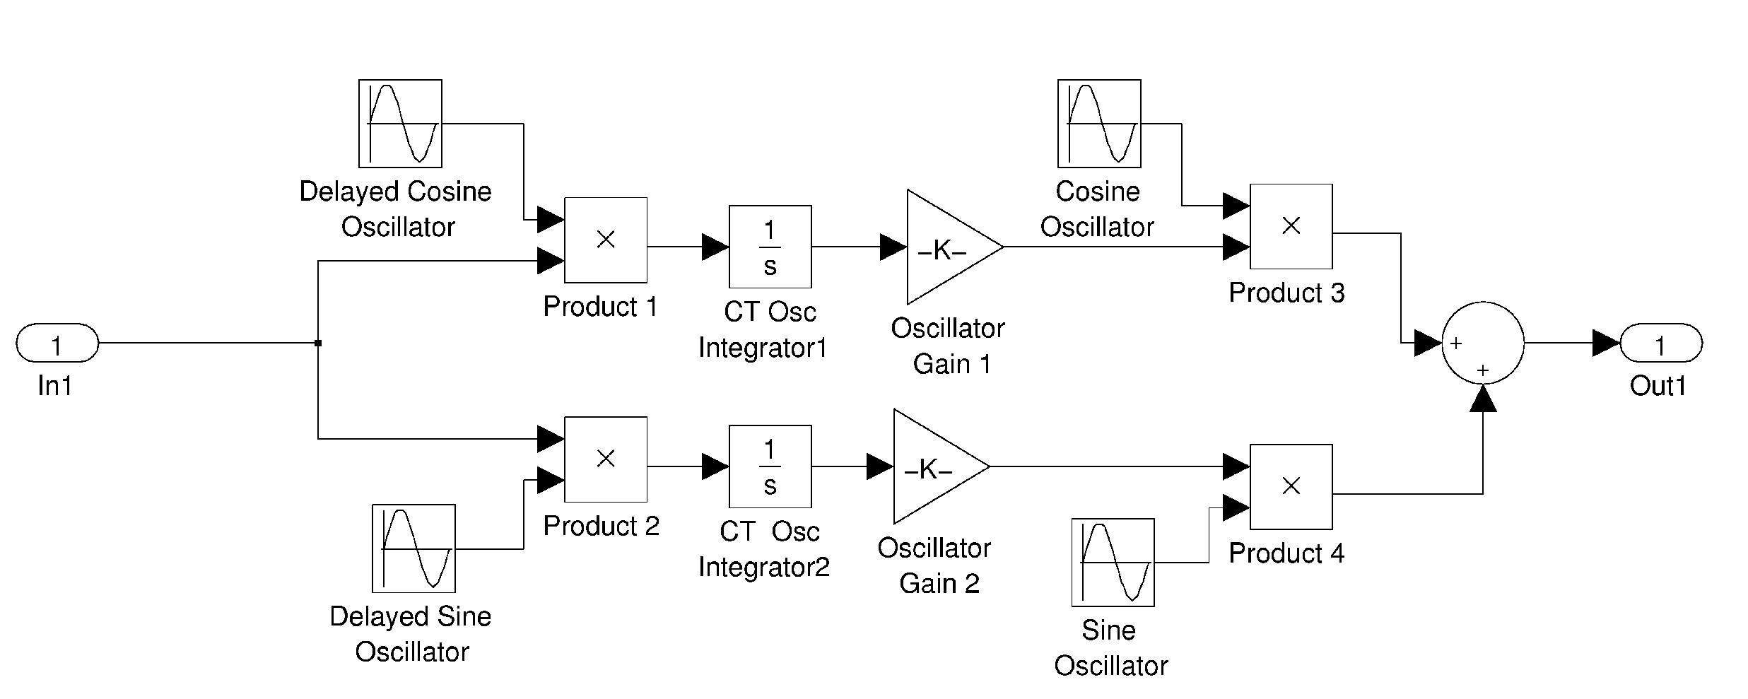
Figure 6: Simulink model of the parametric oscillator.
Since we have not developed an analytical transfer function model of the parametric oscillator, its internal gain was set in the following manner. A comparison of the Simulink model output for a chirped sine wave input with the oscillator on and off shows two distinct behaviors, error rejection at 29 Hz and amplification around ~18 Hz. The gain was set iteratively to balance these two effects. It should be noted that when used alone the tracker controller also amplifies signals around ~18 Hz. This peaking is a feature of the tracking controller latency.

Tracker Error Transfer Function

A more complete comparison of the performance of the tracking system can be obtained by estimating the error transfer function directly from the Simulink model. Using the standard set of parameters the Simulink model was driven from the white noise input with the tracking sensor noise disconnected; see Figure 3, the input signal and the error signal were sent to the MATLAB workspace for further analysis (variable TipTilt_out). The Simulink model is run with a time sample of 50 microseconds (20 kHz update). This sample rate is chosen to be much faster than the update associated with the tracking controller. The PSD of the input and output signal were estimated using the Welch method. The square of the transfer function is given as:
${\left|H_{\text{error}}(f)\right|}^{2}=\frac{\overset{}{\text{PSD}}(\text{error})}{\overset{}{\text{PSD}}(\text{input})}$. (5)

The transfer functions estimated in this manner with the oscillator on and off is shown in Figure 7. The error rejection at 29 Hz is significant while the out of band peaking is not objectionable. Tracking system update was 100 Hz, corresponding to an integration time of, T=10 ms. The readout and centroid delays were, τ=0.7 ms. The tracker gain was set to ensure stability (phase margin ~45 degrees). The parametric Oscillator gain was set to trade peaking above the zero db frequency and depth of 29 Hz rejection.
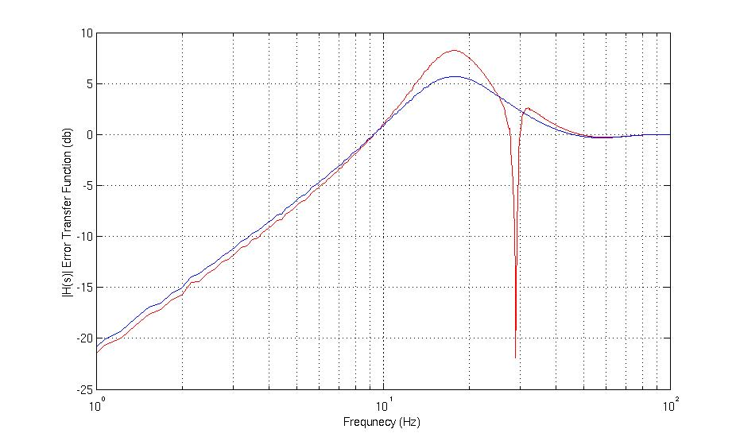
Figure 7: The error rejection transfer functions from the Simulink model for the tracker plus parametric oscillator. The parametric oscillator on is shown in red and with the oscillator off in blue.

Tracker Performance with Vibration and Atmospheric Tip Tilt

Tracker performance was estimated directly from the Simulink model see Figure 8. The input signal was a random atmospheric time series with or without 29 Hz vibration. The atmospheric signal was generated from the inverse FFT of filtered white noise as described in section 2.1. The 29 Hz vibration had an rms disturbance of 0.020 arc seconds see section 2.2.

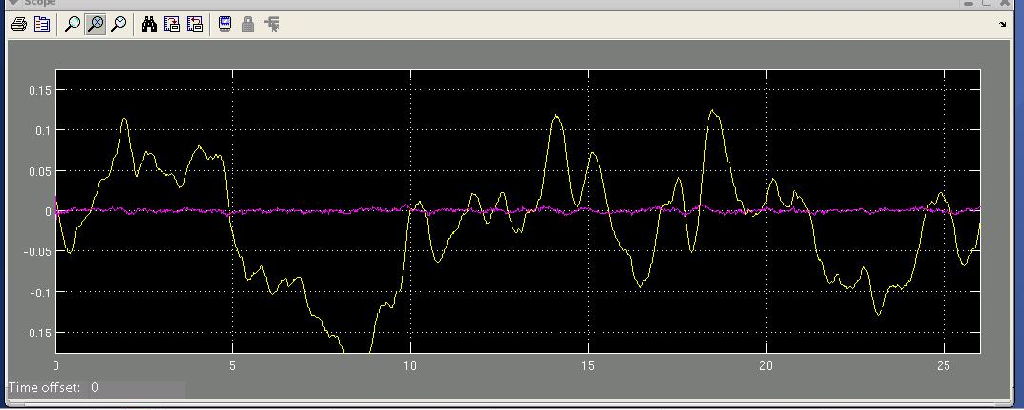

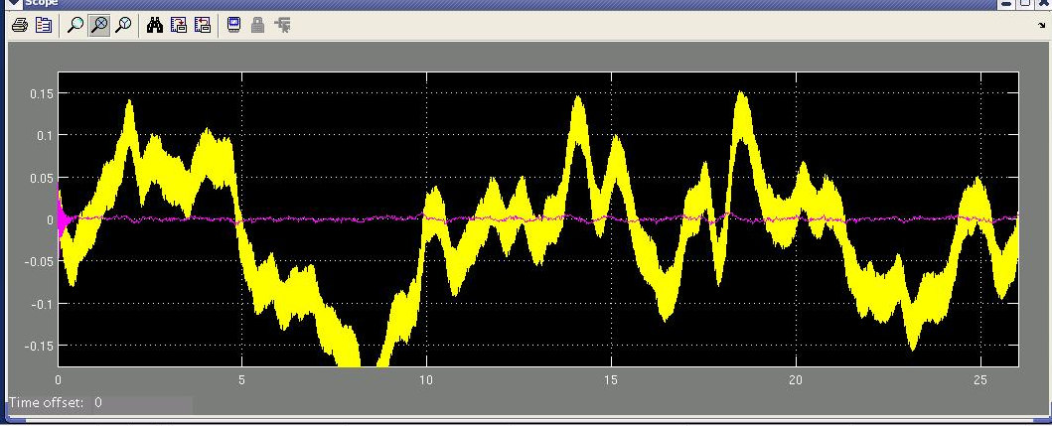
Figure 8: Two sample screen shots of the Simulink Scope block display. The input signal is shown in yellow and the correction provided by the tracker and parametric oscillator is shown in pink. The top graph is with only a random atmospheric disturbance. The bottom graph has the same atmospheric signal but with 29 Hz vibration added. The left hand scale is tilt in units of arc seconds and the bottom scale is time in units of seconds.
The rms tip tilt error was estimated directly from the output time series. The results were averaged over 100 random time simulation each of duration 26 seconds for a total sample time of 2600 seconds. The time step of the simulation was set to 50 microseconds (20 kHz update rate). Tip tilt sensor noise equivalent angle was set to 0.002 arc seconds a value consistence with the error budget. The performance of the tip tilt tracker and parametric oscillator for atmospheric and vibration in combination was:

- RMS one-axis uncorrected = 0.132 arc seconds
- RMS one-axis Par. Osc. Off = 0.0273 arc seconds
- RMS one axis Par. Osc. On = 0.0037 arc seconds

The parametric oscillator has provided almost a factor of 10 reduction in the rms tracking error: from 27 mas to 3.7 mas. These results are a combination of following NGAO error budget terms:

- Bandwidth
- Measurement noise
- Telescope tracking residual (vibration)

The NGAO Error budget total for these terms is an error of ~0.002 arc seconds rms. However, the simulation results are for worse conditions. The differences are shown in the table below. The simulation is producing a 10 times reduction in the residual error in more challenging conditions than the error budget.

Parameter | Simulink | Error Budget | Comments
Frame rate (Hz) | 100 | 200 | Simulation has less error rejection at slower update rate
Outer scale (m) | Infinite | 75 | Finite outer scale removes mostly low frequency power < 1Hz
F_Tyler (Hz) | 2.7 | 1.3 | Outer scale reduction assumed in error budget should not change the fundamental tilt frequency. Error budget should probably be revised.

At present, the author has not had time to revise the tilt power spectrum to include a finite outer scale. The author of this note believes that the arbitrary reduction in tilt power with a finite outer scale used in the error budget is overly optimistic in predicting the tilt error.

Conclusion and Recommendations

Several methods for vibration mitigation have been suggested for NGAO including the parametric oscillator featured in this report. Additional methods include using accelerometers [12] to measure the vibration directly and then feeding this information into the tracking sensor control loop. Another proposal is using a Kalman filter in combination with the final tracking control loop to reduce vibrations [13]. This method has been tested on a laboratory AO system in reference 13. Using a dedicated wide field star tracker camera has also been suggested. The error signal from the wide field camera would be processed to select only 29 Hz vibrations. Assuming the vibration is common to the entire telescope this camera could sense stars over a much larger field of view than the LOWFS and therefore could use brighter stars with no impact to the overall sky coverage.

The parametric oscillator technique is noted to have the following advantages over these other techniques:

Accelerometers: The parametric oscillator works on the error signal from the final track sensor. Accelerometers do not directly measure optical errors. In some cases, it is impractical to mount them on optical surfaces. The accelerometers on the secondary at Keck are not used by the interferometer for vibration reduction although this method was originally tested against the parametric oscillator and found to be inferior.

Wide field camera: A dedicated vibration camera would require additional optics and sensors. The dedicated vibration camera would require a large FOV and impose additional acquisition overheads to center one or more stars.

Kalman filter with track sensor: The Kalman filter has been demonstrated to be able to cancel vibrations, see reference 13. However, it is a complicated control method and is computationally intensive. Both of these obstacles could be overcome but the simpler parametric oscillator appears to provide sufficient vibration reduction.

We also note the parametric oscillator has been proven in interferometers Keck Angle Tracker (KAT). The parametric oscillator technique is noted to have the following disadvantages:

The error rejection is narrow and centered on a fixed frequency: Examination of Figure 7 shows that the parametric oscillator must be tuned to the correct frequency. Kalman filters could be made adaptable to new or fluctuating vibration frequencies.

Parametric oscillator phase shift must be tuned for each frame rate: The parametric oscillator phase shift must be matched to the delay in the tracker control loop. Typically, the control system would be well characterized and the delay could be fine-tuned when the system is first delivered.

Vibration must be coherent on scale of ~0.1 second: The parametric oscillator has an intrinsic rise time of about 0.1 s. If the vibration phase is changing faster than this, the oscillator will not be able to cancel the vibration completely. Performance with the interferometer has indicated that this is not an issue at Keck.

The author feels that the parametric oscillator in combination with the already planned natural guide star tracker (the LOWFS) is sufficient to meet the NGAO error budget. Methods that can be made adaptable to changing frequencies such as a Kalman filter are the only other method that should be considered with the priority given to the parametric oscillator because of its simplicity.

References

1. P. Wizinowich, T. Mast, J. Nelson, M. DiVittorio, “The Optical Quality of the W. M. Keck Telescope”, in Advanced Technology Optical Telescopes V, Vol. 2199, Proc. SPIE, 1994.
2. F. Dekens, et al., “High speed seeing measurements at the Keck Telescope”, in Adaptive Optics in Astronomy, Vol. 2201, Proc. SPIE, 1994.
3. F. Dekens, “Atmospheric characterization for adaptive optics at the W. M. Keck and Hale telescopes,” PhD thesis, UC Irvine, 1999.
4. T. Erm, “Report of the Keck mission March 10-19, Part 1. Vibrations,” Thirty Meter Telescope technical report SEN.TEC.04.001.DRF0, Pasadena, CA, March 3, 2004.
5. T. Erm, “Analysis of Keck vibration data from 4/16/04, 4/29/04, 5/1/04,” Thirty Meter Telescope technical report SEN.TEC.05.001.DRF01, Pasadena, CA, May 10, 2004.
6. van Dam, et al., “Performance of the Keck Observatory adaptive-optics system”, Applied Optics, 2004.
7. M. Hess, et al., “Strategy for identifying and mitigating facility vibrations to improve optical performance at the W.M. Keck Observatory”, in Large Ground-based Telescopes.. Vol. 4837, Proc. SPIE, 2003.
8. M. Colavita, “Keck Interferometer Vibration Review Number 3”, Keck Interferometer document library, January 16, 2004.
9. M. Colavita, “Parametric oscillator for canceling 29 Hz vibration”, Keck Interferometer memo, March 2, 2003.
10. G. Tyler, “Bandwidth consideration for tracking through turbulence”, JOSA A., 1994.
11. R. Dekany, “Mauna Kea Ridge (MKR) Turbulence Models”, Keck Adaptive Optics Notes 503, November 15, 2007.
12. P. Y. Madec, “Control techniques”, in Adaptive Optics in Astronomy, F. Roddier, ed., 1999.
11. M. Colavita, personal communications, June 2009.
12. D. Wiburg, personal communication, April 2009.
13. Petit, et al., “First laboratory demonstration of closed-loop Kalman based optimal control for vibration filtering and simplified MCAO”, in Advances in Adaptive Optics II, Vol 6272, Proc. SPIE, 2006.

