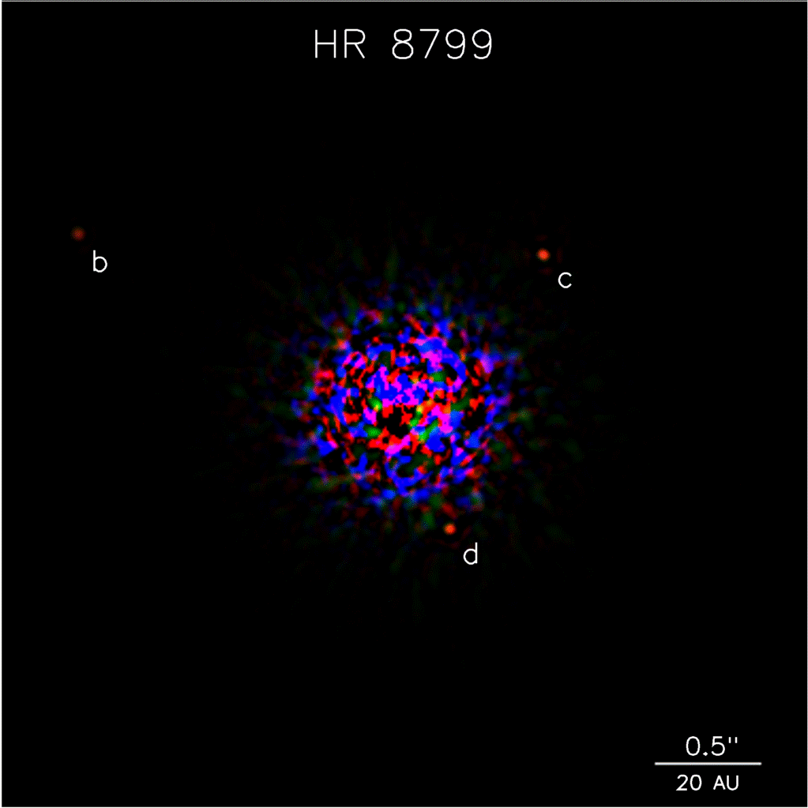
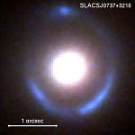

W. M. Keck Observatory’s
Next Generation
Adaptive Optics Facility

Primary Author:
Peter Wizinowich, W.M. Keck Observatory
peterw@keck.hawaii.edu; (808) 881-3512

Co-authors:
Elizabeth McGrath⁶, Sean Adkins¹, Taft Armandroff¹, Aaron Barth⁵,
Mike Bolte⁶, Richard Dekany², Donald Gavel⁶, Shri Kulkarni²,
Hilton Lewis¹, Michael Liu⁷, Jessica Lu², Bruce Macintosh³, Franck Marchis⁴

¹W. M. Keck Observatory
²California Institute of Technology
³Lawrence Livermore National Laboratory
⁴University of California Berkeley
⁵University of California Irvine
⁶University of California Santa Cruz
⁷University of Hawaii

Activity Submission in Response to the
Astro2010 Programs Subcommittee Request for Information
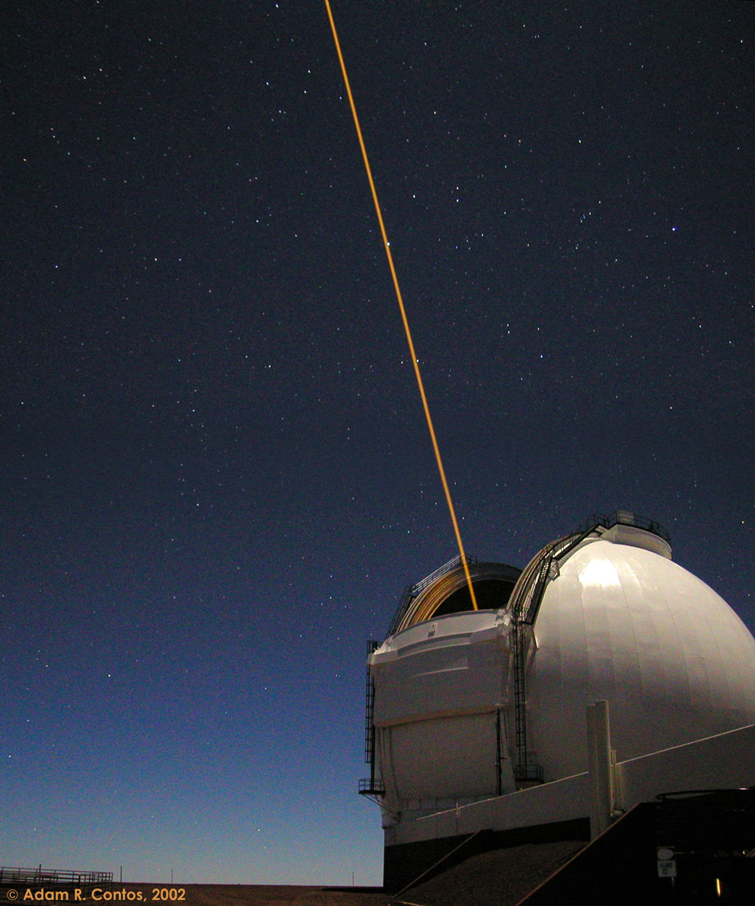
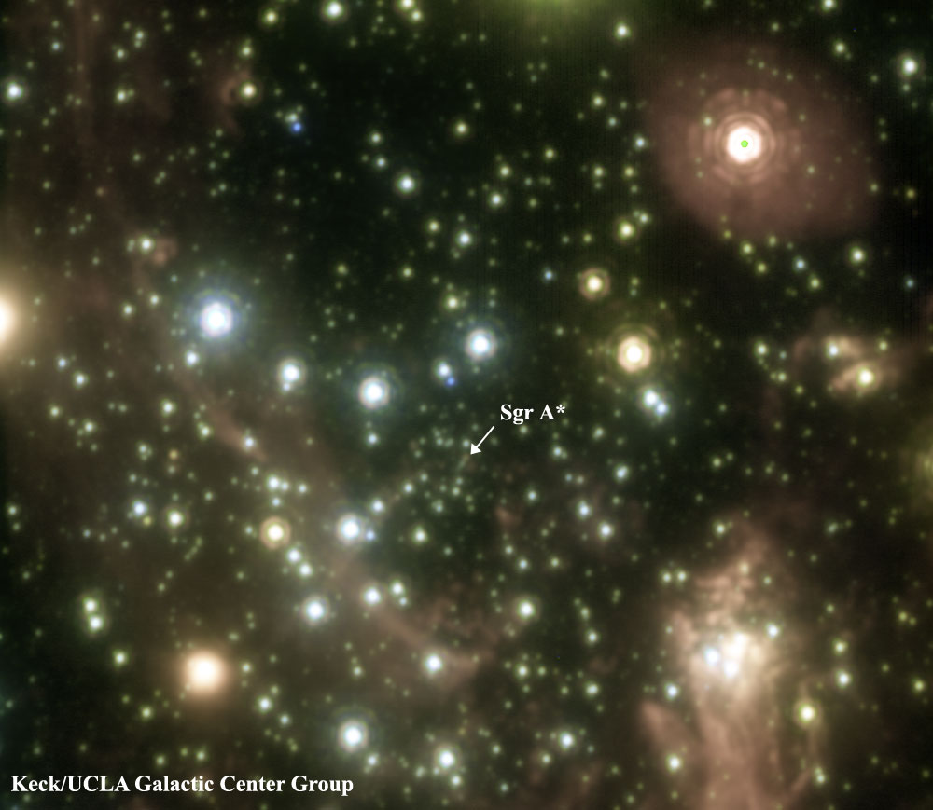
Based on the scientific success of its existing adaptive optics (AO) facilities the W.M. Keck Observatory (WMKO) science community has identified the development of a Next Generation AO (NGAO) facility as the highest priority in the Observatory’s 2008 scientific strategic plan. NGAO will serve the U.S. community through NASA’s partnership in Keck and through the NSF/TSIP program, in addition to serving astronomers at the University of California, Caltech and University of Hawaii. The NGAO facility is being designed to satisfy a number of key science cases that require diffraction-limited performance at near-IR wavelengths, or modest Strehl ratios at red wavelengths, over narrow fields with high sky coverage and high sensitivity.

Key Science Goals
Key Science Goals
Understanding the Formation and Evolution of Today’s Galaxies since z=3
Measuring Dark Matter in our Galaxy and Beyond
Testing the Theory of General Relativity in the Galactic Center
Understanding the Formation of Planetary Systems around Nearby Stars
Exploring the Origins of Our Solar System

NGAO–based capabilities will be very powerful for addressing many of the top-priority science cases that are likely to be identified by the Decadal Survey’s Science Frontier Panels. Topics where NGAO will make important contributions include galaxy formation and evolution across cosmic time⁵¹; the co-evolution of galaxies and black holes^{6, 10, 33, 38}; precise mass measurements of black holes in nearby AGNs^{2, 25}; star formation rates and resolved kinematics of distant galaxies^{22, 29}; measurements of dark matter through gravitationally lensed galaxies^{4, 26, 34, 36, 39}; resolved stellar populations in nearby galaxies and star clusters^{41, 50}; measuring the effects of general relativity and dark matter in the Galactic center^{21, 35}; determining the origins of compact stellar objects⁴⁴; follow-up of Galactic and extragalactic transients¹⁶; direct imaging and characterization of extrasolar planets around low-mass stars^{3, 7, 31, 32}; protoplanetary and debris disk morphology^{24, 28, 37, 46}; asteroid and comet characterization²³; imaging and spectroscopy of new dwarf planets as well as the gas and ice giant planets in our solar system. We discuss NGAO’s role for a few of these science topics in greater detail below.

Background
The two existing Keck AO systems, with⁴⁹ and without⁴⁸ the laser guide star (LGS), have been extremely fruitful. Through mid-March 2009 a total of 216 refereed science papers based on Keck AO data have been accepted for publication (see Figure 1). Community demand for LGS observing time is high with 105 science nights allocated in the past year.
The NGAO facility at Keck will expand on the success that the first generation AO systems have enjoyed in a number of ways. First, NGAO will provide a much higher Strehl over narrow fields, allowing observations of extremely crowded fields, such as the Galactic center, to much fainter detection limits, and enabling diffraction-limited performance from near-IR to optical wavelengths (0.8 to 2.4 μm). Second, NGAO will make a leap in sky coverage capability with AO-sharpened tip-tilt stars over a 120" field of regard, allowing the use of much fainter reference stars farther off-axis, thereby greatly expanding the number of potential science targets in all subfields. Lastly, NGAO will provide stable and well-characterized point spread functions (PSFs) which will enable improved photometric and astrometric accuracy.
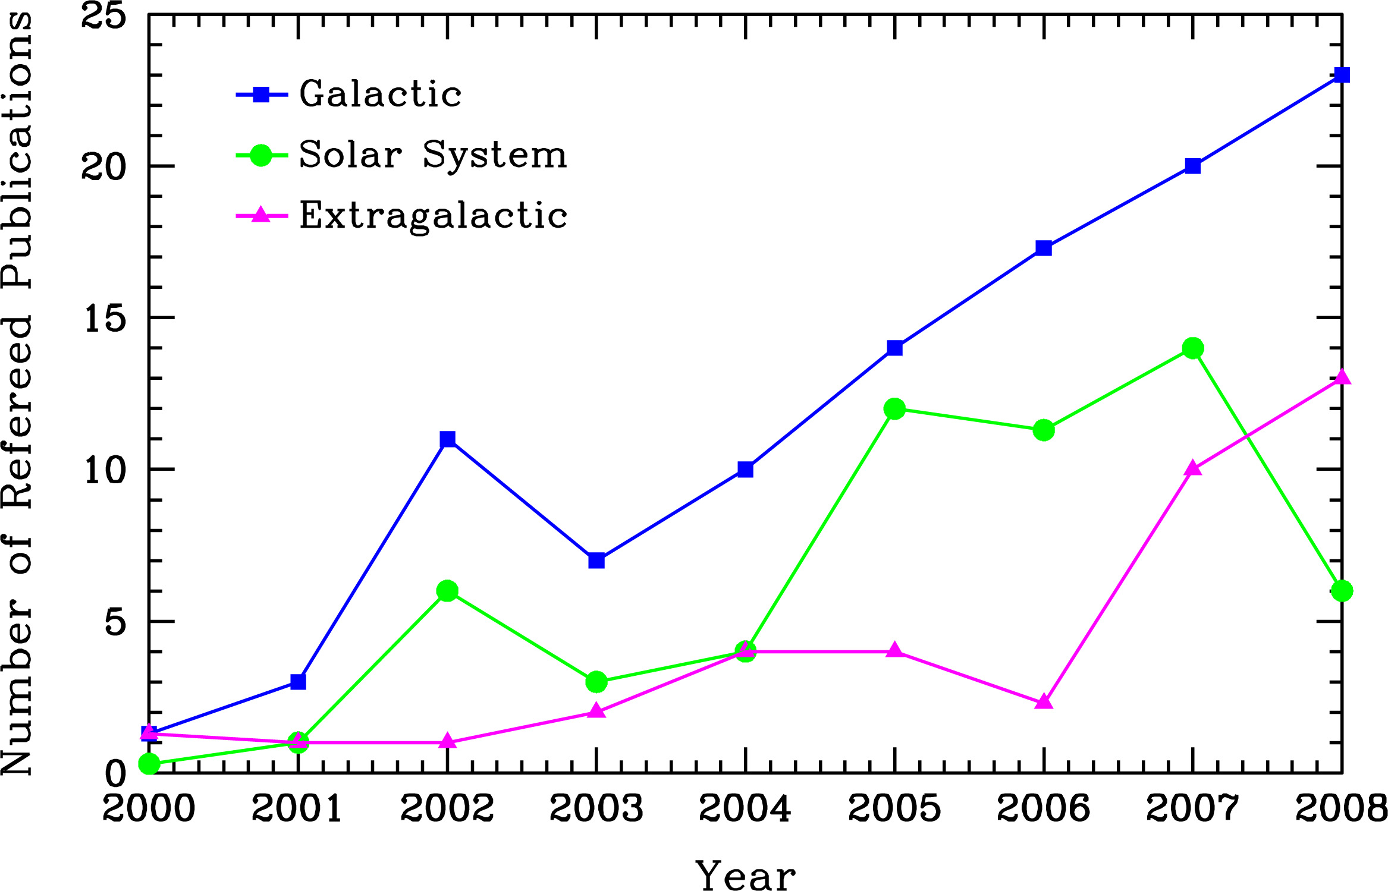
Figure 1 Refereed publications based on AO data obtained at Keck by year and type. The distribution with respect to subfield is as follows: 28% solar system, 54% galactic and 18% extragalactic; this total includes 21 papers from the Keck Interferometer (which requires AO on both telescopes). A total of 59 LGS science papers have been published beginning in 2005 (7% solar system, 55% galactic and 38% extragalactic).

A Selection of NGAO’s Contribution to Astronomy in the Next Decade

Galaxy Assembly and Star Formation History
At redshifts of z ~ 1 – 3 galaxies are thought to have accumulated the majority of their stellar mass⁸, the rate of major galaxy mergers appears to peak⁵, and instantaneous star formation rates are consistent with those of local starburst galaxies¹². Given the high level of activity at these redshifts transforming irregular galaxies into the familiar Hubble sequence of the local universe, it is of strong interest to study these galaxies in an attempt to understand the overall processes of galaxy formation and the buildup of structure in the universe.
The global properties of these galaxies have been studied in detail, however little is known about their internal kinematics or small-scale structure, particularly with regard to their mode of dynamical support or distribution of star formation. AO and seeing-limited observations^{11, 14, 30, 47} suggest that the kinematics are frequently inconsistent with simple equilibrium disk models. However, spatially resolved information for a larger sample is needed to conclusively determine whether the majority of star formation during this epoch is due to rapid nuclear starbursts driven by large-scale merging of gas-rich protogalactic fragments, circumnuclear starbursts caused by bar-mode or other gravitational instabilities, or piecemeal consumption of gas reservoirs by sub-kpc-scale star forming regions in stable, rotationally-supported structures. NGAO’s increased sky coverage will vastly expand the number of available targets for this study.
Figure 2 shows simulated IFU-derived images and velocity fields for a galaxy merger observed with current Keck LGS AO (left) and NGAO (right). With NGAO, images similar to the kinematic map in the lower right panel will also be derived for star formation rates, metallicity distributions, velocity dispersion, and age, thus allowing us to address the issue of whether the observed peak in star formation at z ~ 2.5 is stimulated by galaxy mergers. While JWST will be more sensitive for extremely high redshift galaxies (due to larger IFU spaxels and lower IR backgrounds), NGAO’s higher spatial resolution will provide more detailed information regarding the structure and kinematics of galaxies on sub-kpc scales.

Supermassive Black Holes and Active Galactic Nuclei
During the past several years it has become increasingly clear that black holes (BH) play a key role in galaxy formation and evolution. The most important evidence for a close connection between BH growth and galaxy evolution comes from the observed correlations between BH mass and the bulge velocity dispersion of the host galaxy (the “M_{BH}-σ∗ relation”^{13, 17, 27}). Despite the fact that BHs contain only about 0.1% of the mass of their host bulge, their growth is evidently constrained very tightly by the kiloparsec-scale properties of their environment.
Figure 2 Improvements in SNR and velocity measurements with NGAO. Top: Hα emission line SNR for a galaxy merger at z=2.2. Using current Keck LGS AO (left) there are only a few pixels with SNR≥10 (yellow), but with NGAO (right) there are an order of magnitude more such pixels. Bottom: Kinematic maps for the same cases as the upper panels, showing velocities for those pixels with SNR>5. Note the difficulty with current LGS AO of determining whether the lower left panel is kinematically differentiated from a typical ordered rotation map with smooth transition across the galaxy from red (positive velocities) to violet (negative velocities). The NGAO panel brings out the spatially complex velocity field which characterizes a major merger. (Simulations courtesy D. Law, UCLA)
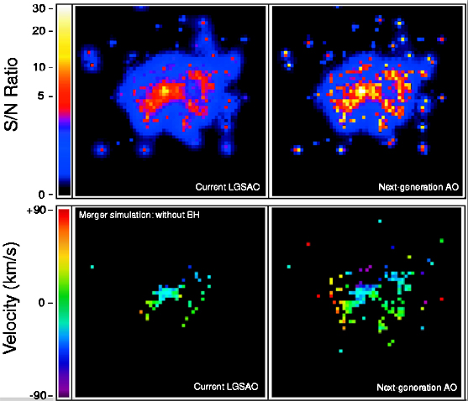
Key observational goals in this field that Keck NGAO will address include:
- demographics of BHs in nearby galaxies over a wide range in BH mass
- investigations of the redshift evolution of the M_{BH}-σ∗ relation
- studies of the host galaxies of AGNs out to high redshifts
Several Astro2010 white papers list these goals as priorities for the next decade^{2, 6, 10, 25, 33, 38}.
Since the minimum detectable BH mass scales as ~ distance * (angular resolution)², NGAO will be able to detect lower mass BHs to farther distances than JWST. NGAO will place important constraints on the slope of the M_{BH}-σ∗ relation and will likely double the number of galaxies with kinematics-based detections of massive BHs before TMT first light. In the era of TMT, NGAO-based observations will remain crucial for screening the best low-mass candidates and improving the statistics for understanding the amount of intrinsic scatter in the M_{BH}-σ∗ relation.
The expected performance of NGAO at the Ca II triplet (850 nm) will enable the detection of a 10⁷ M_{Sun} BH at the distance of the Virgo Cluster (17.6 Mpc). To date, only a handful of similar mass BHs have been detected kinematically, and all of them at distances of only a few Mpc. According to Koekemoer et al.²⁵, a few thousand new supermassive BH targets will be within reach of 10m-class telescopes that are diffraction limited to visible wavelengths.
In addition, AO observations in the near-IR will be used to study quasar host galaxies at high redshifts. With the much higher Strehl NGAO system, improved contrast levels between the bright QSO and the faint host galaxy will enable spatially resolved studies of stellar populations and emission-line kinematics. These results will shed light on the interplay between AGNs and their hosts, including the role of AGN feedback in shaping galaxy formation and evolution.

Testing General Relativity in the Galactic Center
The proximity of our Galaxy's center (GC) presents a unique opportunity to study a massive BH and its environs at extremely high spatial resolution. In the last decade, orbital motions for several stars near the GC have revealed a central dark mass of 3.7 x 10⁶ M_{Sun}^{18, 19, 42, 43}, and constrained the GC distance, R₀, to within a few percent⁹. Since R₀ sets the scale within which is contained the observed mass of the Galaxy, measuring it to high precision enables one to determine to equally high precision the size and shape of the Milky Way's dark matter halo⁴⁰. The halo shape contrains the extent to which dark matter self-interacts and illuminates the process of galaxy formation (how the dark matter halo relaxes following mergers).
Though the current orbital reconstructions in the central 1"x1" are consistent with pure Keplerian motion, with improved astrometric and radial velocity precision, deviations from pure Keplerian motion are expected^{20, 45, 52}. With NGAO we will be able to detect these deviations due to a variety of effects, providing a unique laboratory for probing the extended dark matter distribution of the GC, and testing general relativity for the first time in the high-mass, strong gravity, regime. NGAO will measure these non-Keplerian motions to precisions that will not be greatly surpassed even in the era of extremely large (~30m) telescopes, and will be able to continue long-term monitoring campaigns that may be too costly to perform on larger telescopes.
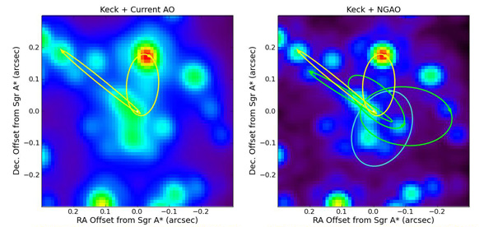
Figure 3 Comparison of orbital measurements at the Galactic Center with current Keck + LGS AO (left) and NGAO (right).
(credit: http:// www.astro.ucla.edu/∼ghezgroup/
gc/pictures/Future/GCorbits.shtml)
According to Ghez et al.²¹, “The use of [AO] with large ground-based telescopes should allow many of these precision measurements of the central potential of our Galaxy for the first time within the next decade. (…) the accuracy of the astrometric measurements are [currently] degraded to ~0.5 mas (…) or more due to source confusion in this high density region (…). Future AO systems that deliver higher Strehl ratios on existing ground-based telescopes, such as NGAO on Keck, will be able to overcome this source of confusion (…).”
In addition to reduced source confusion, NGAO will improve measurements at the GC through:
- Detection of new stars whose orbits will improve the precision of measurable GR effects.
- Decreased field dependence of the PSF, increasing photometric and astrometric accuracy.
- Increased SNR will improve the radial velocity contribution to orbit determinations.

Imaging and Characterization of Extrasolar Planets Around Nearby Stars
The unique combination of high-contrast near-IR imaging and large sky coverage delivered by NGAO will enable direct imaging searches for Jovian-mass planets around nearby young low-mass stars and brown dwarfs. The “extreme AO” systems being designed at Gemini and ESO are very powerful planet-finding instruments, but their design restricts them to searches around bright, solar-type stars (I<9). NGAO provides an important complementary approach. Establishing the mass and separation distribution of planets around a wide range of stellar host masses and ages is a key avenue to understanding the planet formation process.
By number, low-mass stars (M ≤ 0.5M_{Sun}) and brown dwarfs dominate any volume-limited sample, and thus these objects may represent the most common hosts of planetary systems. While such cool, optically faint targets will be unobservable with extreme AO systems, thousands of low-mass stars in the solar neighborhood can be targeted by NGAO because of its LGS. Direct imaging of extrasolar planets is substantially easier around these lower mass primaries, since the required contrast ratios are smaller for a given companion mass.
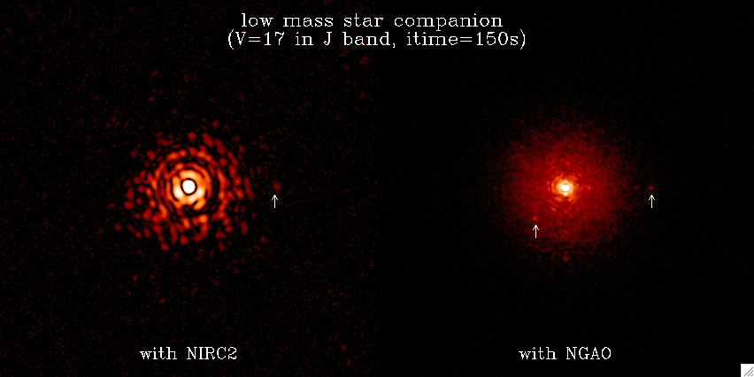
Figure 4 NGAO’s direct imaging ability (right image) to detect faint companions around nearby stars versus the current Keck LGS AO performance (left). The images are 150 sec J-band integrations. The first companion with Δm = 7.1 is located at 0.6" (at 3 o’clock) from the primary (G2 star with V=17 and J=15.8). The second companion with Δm = 6.0 is located at 0.3" (at 7 o’clock). The first companion is detected with both AO systems while the closer one is only visible with NGAO’s improved sensitivity and angular resolution. NGAO’s planned coronagraph coupled with detection techniques will further improve the companion sensitivity by ~ 3 magnitudes.
Direct imaging and spectroscopy of extrasolar planets with NGAO will allow us to:
- Measure physical properties (color, temperature, luminosity, surface gravity) and test theoretical models of planetary evolution.
- Characterize their atmospheres (water and methane absorption lines).
- Expand the sample of resolved systems and push to cooler, lower-mass systems.
Burgasser et al.³ identify NGAO as a project that will address this science.

Debris Disk Demographics and Substructure
Debris disk systems represent the extrasolar analogs of the asteroid belt and Kuiper Belt in our own solar system. Spatially resolved high-contrast, multi-wavelength imaging offers a unique opportunity to study their circumstellar material and their embedded low-mass planets. Key questions that NGAO will address include: (1) How do primordial planet-forming disks transition into debris disks? (2) What is the role of planets in this transition? (3) How do planets interact with the disks in which they are embedded?
NGAO’s unprecedented angular resolution and stable PSF will extend direct imaging surveys to distances >100 pc yielding a much larger sample of resolved debris disks. This will allow for comparative studies of debris disk properties (sizes, substructures, grain properties) as a function of stellar host mass, age, environment, etc., thereby offering a comprehensive external view of what the young solar system may have looked like.
In addition, high resolution NGAO optical imaging will enable scattered light imaging studies off the sub-micron sized dust grains. This new, powerful capability is particularly important in the post-HST era, as it can reveal dynamical signatures (rings, gaps) in disks due to embedded planets out to three times greater distances than previous studies and over smaller physical scales around nearby systems. Kraus et al.²⁸ note that “Visible-light AO systems on large aperture telescopes (…) will be crucial in extending our studies into the optical regime; initiatives like (…) NGAO at Keck will lead the field.”

Technical Overview
Key New Science Capabilities
Near Diffraction-Limited in Near-IR (K-Strehl ~80%)
AO correction at Red Wavelengths (0.65-1.0 μm)
Increased Sky Coverage
Improved Angular Resolution, Sensitivity and Contrast
Improved Photometric and Astrometric Accuracy
Imaging and Integral Field Spectroscopy

Design Overview
The NGAO technical approach is shown schematically in Figure 5. The requirement of high Strehl over a narrow field is achieved using laser tomography (to correct for focal anisoplanatism; i.e., the “cone” effect) with an on-axis LGS and three uniformly spaced LGS on a 10" radius (as illustrated in Figure 6), a narrow field relay with a deformable mirror having 64 actuators across the telescope pupil and careful control of all wavefront errors especially tilt errors. High sky coverage is achieved by sharpening the three stars used to provide tip-tilt information with their own LGS AO systems including a movable LGS (shown in Figure 6) and a MEMS DM with 32 actuators across the telescope pupil (i.e., the low order wavefront sensors shown in Figure 5). High sensitivity at thermal wavelengths requires low emissivity which is achieved by cooling the science path optics (e.g., the cooled enclosure in Figure 5).
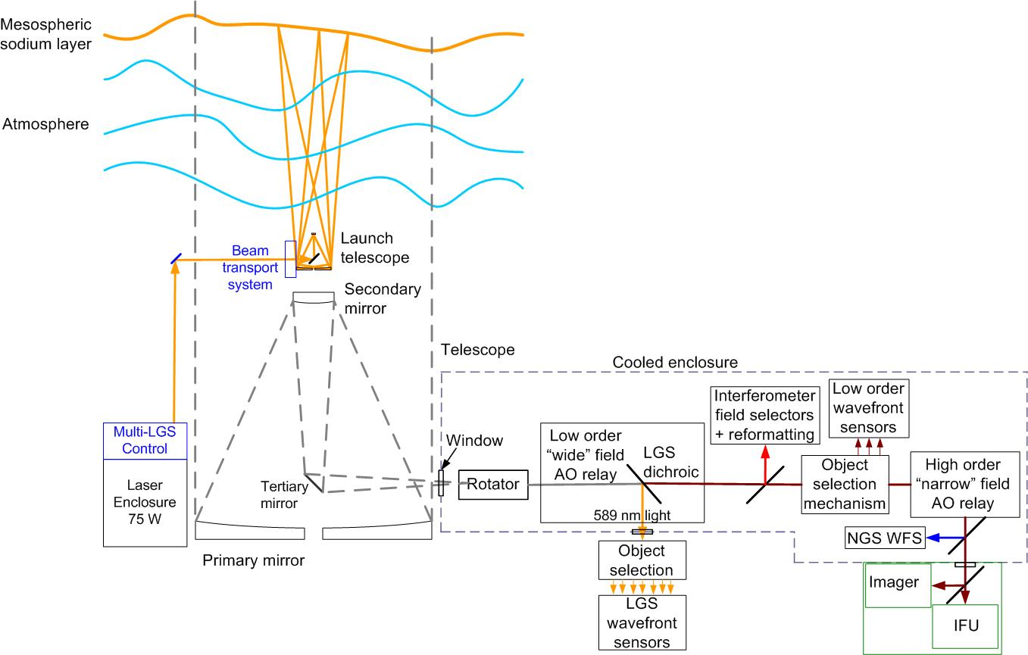
Figure 5 Schematic of the NGAO concept
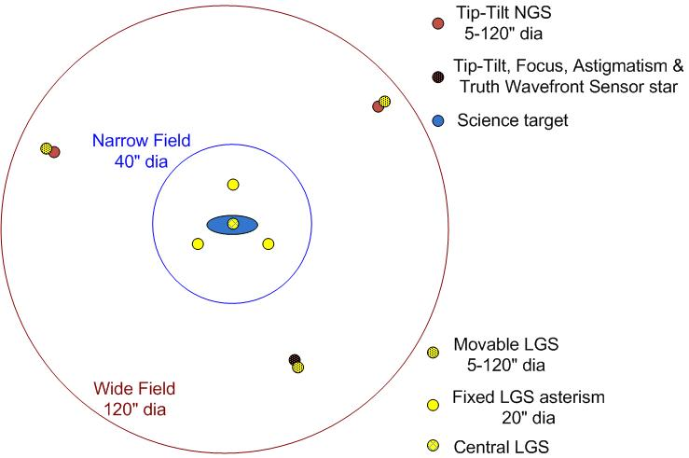
Figure 6 Schematic of the NGAO LGS asterism
The initial NGAO science instrument will provide both imaging and integral field spectroscopy from 0.65 or 0.8 to 2.4 µm. At the short wavelength cut-off the instrument will allow observation of the Ca II triplet (~850 nm) with a goal of reaching Hα (~656 nm). The imager will have a 35" x 35" field of view and will provide at least 2 pixel sampling of diffraction limited z-band images (8.5 milli-arcsec/pixel) with low internal wavefront error, and a coronagraph.
An integral field spectrograph (IFS) is ideally suited to take advantage of the image quality offered by AO because of its ability to provide spatially resolved spectroscopy of diffraction limited images. IFS data can provide information essential for deconvolution of the PSF and offers a comprehensive tool for determining kinematics, mass distributions and velocity dispersions.
The NGAO IFS will be an advanced design based on lessons learned in the development of the first generation of AO-corrected near-IR IFS instruments for large telescopes and an improved understanding of the science requirements gained through observations with the currently available instruments. The IFS will be optimized to take advantage of the lower backgrounds, higher throughput, higher Strehl, and extended wavelength coverage possible with NGAO. The IFS will have higher sensitivity than current near-IR IFS instruments and will provide a 4" x 4" FOV with 0.050 to 0.075" spatial sampling optimized to match the ensquared energy in the NGAO science field. The IFS will also provide spatial sampling matched to the diffraction limit in the K-band with a 2" x 2" FOV, and a fine sampling scale (~0.010") for the short wavelengths.
The real-time control system architecture for NGAO uses the massively parallel processing approach shown in Figure 7 along with an iterative Fourier domain preconditioned back projection tomography algorithm.
Figure 7 NGAO’s real-time control parallel processing architecture

Performance Overview
A detailed wavefront error budget has been developed for NGAO based on a combination of simulations, anchors to the existing Keck AO system performance and measured atmospheric and sodium conditions. The performance of the NGAO design has been evaluated for each of the key science cases at the wavelengths of most interest to each science case. Figure 8 (bottom left) shows the predicted Strehl ratio for the exoplanet science case at H-band and 10º galactic latitude, as a function of sky coverage. Figure 8 (top right) is a similar plot for the AGN science case at z-band and a galactic latitude of 30º. For this science case the energy in a particular IFS diameter is the performance parameter of interest. The tip-tilt error is shown separately in both of these figures since the impact of increasing tip-tilt error is to increase the diameter of the core of the PSF without decreasing the amount of energy in this core. Overall NGAO is predicted to have excellent sky coverage due to the use of multiple AO-corrected tip-tilt stars.
The performance versus off-axis distance for the Galactic Center science case is shown in Figure 9. The Strehl is the important parameter for reducing source confusion and thereby improving the accuracy of astrometric imaging observations. The ensquared energy is important for the corresponding IFS radial velocity measurements. In this application the IFS will have a maximum size of 2" radius while the science imaging requirement is a radius of 5". If more uniform Strehl performance was required this could be accomplished by optimizing the performance for a different radius at the expense of the on-axis performance.

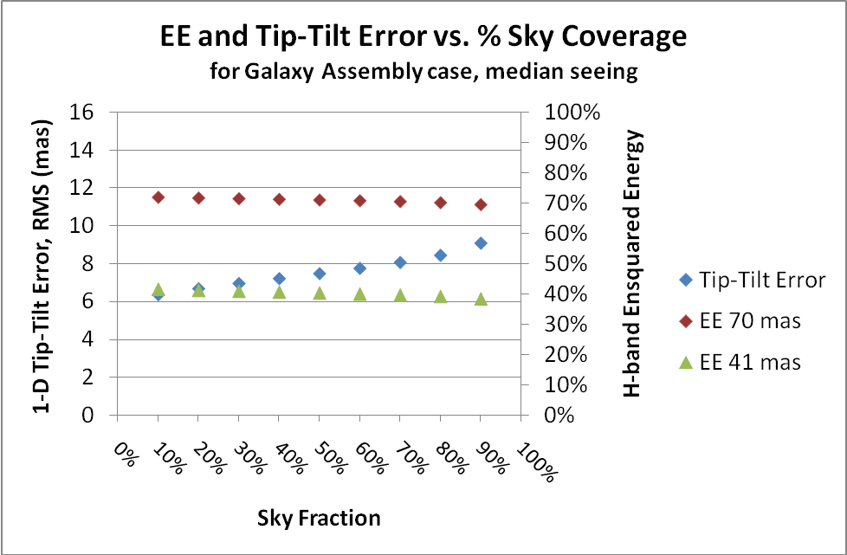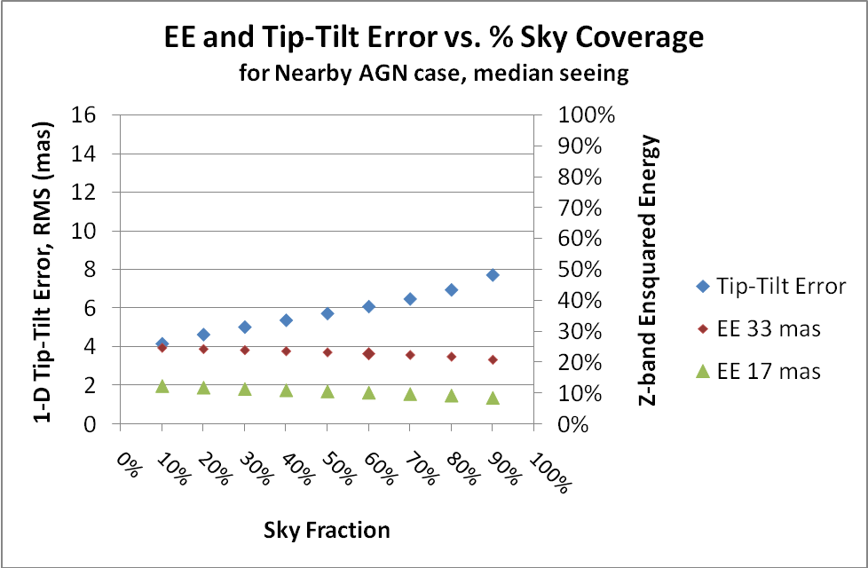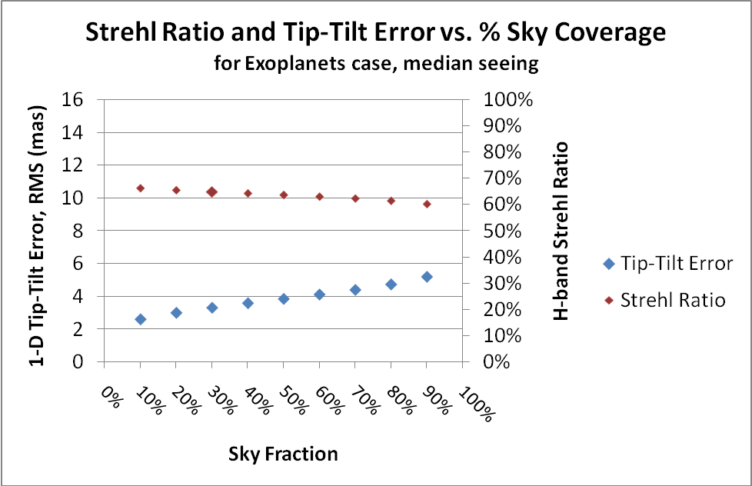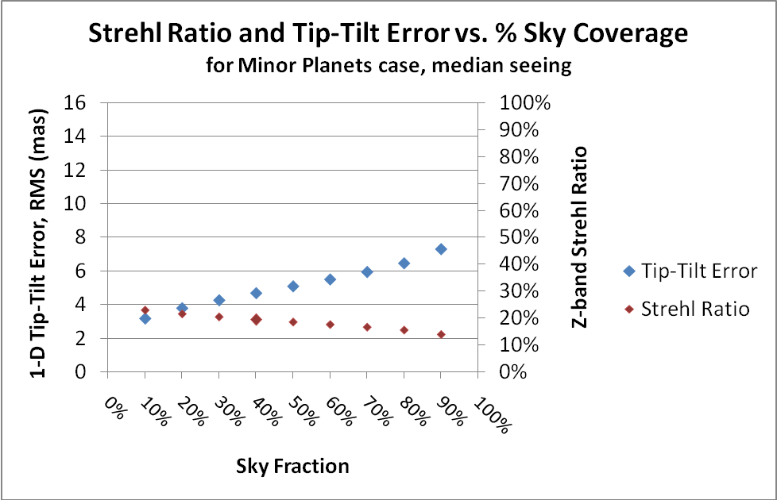
Figure 8 Key performance parameter plots versus sky coverage for four key science cases. The top two plots show ensquared energy (right axis), within the dimension specified in each plot’s legend, for the galaxy assembly in H-band and nearby AGN in z-band science cases. The lower two plots show Strehl ratio (right axis) for the exoplanet in H-band and minor planets in z-band science cases. The rms tip-tilt error is shown versus the left axis in all four plots; the tip-tilt errors are relatively small in comparison to the ensquared energy areas.

Figure 9 NGAO Strehl ratio and ensquared energy (in a 70x70 mas area) for the Galactic Center science. The maximum off-axis distance is 2" for integral field spectroscopy and 5" for imaging of the Galactic Center.
A summary of the predicted NGAO performance for the key science cases is shown in Table 1. The rough comparison between current Keck AO performance and NGAO shown in Figure 10 illustrates the dramatic science improvement that will be provided by NGAO.

Table 1 Predicted performance for the NGAO key science cases

Figure 10 NGAO versus current Keck II NGS and LGS AO performance (for the case when a bright natural guide star is available for NGS AO or for tip-tilt correction with LGS AO).

NGAO’s Capabilities versus JWST and GSMT
A comparison of the NGAO capabilities to those of JWST and TMT has been performed. JWST’s sensitivity is ~200 times higher than NGAO at K-band, but NGAO offers higher sensitivity than JWST for imaging at or bluer than J-band (by ~6 times at J) and for spectroscopy between the OH-lines at H-band or bluer. NGAO offers higher spatial resolution for both imaging and spectroscopy (from 0.65 to 2.4 μm) due to a larger telescope and higher spatial sampling (0.009"/pixel versus 0.032"/pixel for JWST).
NGAO will have already made a significant scientific contribution prior to the start of science operations with TMT or GMT. NGAO will offer similar Strehls as TMT’s first light AO system but with lower spatial resolution (at the same wavelength) and similar spatial resolution for IFS science but with lower sensitivity. As TMT arrives on the scene NGAO could move to new areas such as shorter wavelengths or multiple object spectroscopy. Even in the GSMT era NGAO will remain an ideal platform for long term precision synoptic science from astrometric and radial velocity measurements of the Galactic Center to weather monitoring of solar system planets and moons.

Technology Drivers

Key Technology Drivers
Sodium Wavelength Lasers
Laser Guide Star Tomography
Low Order Wavefront Sensing with LGS AO-Corrected Guide Stars
Open Loop AO Correction with MEMS Deformable Mirrors
Improved Science Measurement Accuracy and PSF Knowledge

In order to achieve the required science performance NGAO must offer improved performance in a number of areas that have not yet been demonstrated. The NGAO design process has therefore been one of finding solutions to the reduction of numerous error terms while simultaneously finding ways to minimize risk and cost.

Laser Guide Star Tomography
NGAO will use four LGS beacons (Figure 6) to perform tomography of the atmosphere in a narrow volume around the science field. The primary purpose of tomography is to reduce focal anisoplanatism (i.e., the cone effect); the single largest wavefront error term for the current Keck II LGS AO system. Laser tomography has not yet been demonstrated on the sky despite the fact that it is planned as a key part of future AO systems on existing telescopes as well as future extremely large telescopes. We have compared multiple tomography simulation codes, followed the results of NGS tomography demonstrations and performed experiments at the UCSC Laboratory for AO to better quantify the tomography error.
The data from multiple wavefront sensors are combined to determine the wavefront error as a function of altitude and direction. In the NGAO system this information will be used to provide the optimal on-axis correction. This information could alternatively be used to optimize the performance at any given field point within the tomographic volume. We also intend to use the tomographic information in support of providing PSF calibration data versus field position (see section 1.3).
Laser tomography requires the availability of high return sodium wavelength lasers. Toward this end WMKO was a participant in a consortium also consisting of Gemini Observatory, the Air Force Phillips Lab and the Center for Adaptive Optics that resulted in the Starfire Optical Range (SOR) laser and the lasers that Lockheed Martin Coherent Technologies has or is producing for Gemini and WMKO. Despite these successes the availability of affordable and reliable commercial sodium wavelength lasers continues to be a major issue for the astronomical community. We are now collaborating with ESO, GMT, TMT and AURA to fund two companies to develop preliminary designs for commercial lasers that have been specified to meet our joint needs. The two companies are FASORtronics who are commercializing the SOR laser approach and TOPTICA who are developing a fiber Raman amplifier based laser system similar to the approach recently demonstrated by ESO in the lab. Based on the preliminary design results, due by the end of 2009, ESO intends to select one of these vendors to provide four 25W lasers for their planned 4LGS facility. WMKO would need three of these lasers for NGAO and TMT and GMT would each need ~6 of these lasers. These preliminary designs will also be exploring some new approaches including back-pumping of the sodium atoms which could potentially significantly improve the coupling efficiency to the sodium atoms and hence the return per Watt.

Near-IR Low Order Wavefront Sensing
The NGAO low order wavefront sensors (LOWFS) are a key element in achieving high Strehl with high sky coverage. Two of these LOWFS just provide tip and tilt based on measurements from natural guide stars in the 120" diameter field. A third LOWFS also measures focus and astigmatism. Three tip-tilt measurements are necessary to determine low order modes which the LGS wavefront sensors cannot measure. The use of AO-sharpened tip-tilt stars has not been demonstrated on the sky to date. A number of challenging technologies need to be incorporated into these LOWFS to achieve the required performance. These include:
- Pickoff arms to accurately acquire and track the tip-tilt stars with respect to the science field.
- MEMS deformable mirrors to sharpen the image of the tip-tilt star based on the wavefront sensor data from the LGS pointed at the tip-tilt star.
- Near-infrared low order wavefront sensor cameras.

Science Measurement Accuracy
Astronomers are interested in such key performance issues as sensitivity, spatial resolution, spectral sensitivity, contrast, astrometric accuracy and photometric accuracy. AO developers have traditionally designed and assessed their system performance versus wavefront error (or encircled energy) and transmission/emissivity budgets. In order to move to another realm of science performance the AO developers now need to develop error budgets for, and improved understanding of, the other relevant performance parameters impacting science with AO.
One key parameter is the point spread function (PSF) of the images delivered by the AO system; this needs to be determined in the absence of a PSF star in the science data. The structure of this PSF and its dependence on time and field position strongly impacts the accuracy of astrometric or photometric measurements, the ability to detect faint sources next to bright sources and the ability to characterize the structure of astronomical objects. Improving the stability of the PSF and knowledge of the PSF versus time and field position will directly improve the science achievable with AO.
In the process of developing NGAO we have begun to develop additional error budgets, for such areas as companion sensitivity, astrometry and photometry, in order to determine their impact on the NGAO design. We have also begun the process of implementing PSF characterization tools with the existing Keck AO system, based on existing wavefront sensor data supplemented by atmospheric turbulence monitoring data, as a stepping stone to developing the more complex tools that will need to be implemented with NGAO’s laser tomography system. PSF characterization tools have not yet been implemented anywhere for LGS AO science or for NGS AO with Shack-Hartmann wavefront sensors.

Activity Organization, Partnerships, and Current Status
The organization chart for the NGAO project is shown in Figure 11. The project personnel are distributed between Caltech, UCO and WMKO. Key personnel include the project manager, P. Wizinowich (WMKO), who reports to the WMKO directorate, the project scientist, C. Max (UCSC), and the senior management team, R. Dekany (Caltech), D. Gavel (UCSC) and S. Adkins (WMKO), who manage major elements of the NGAO project.
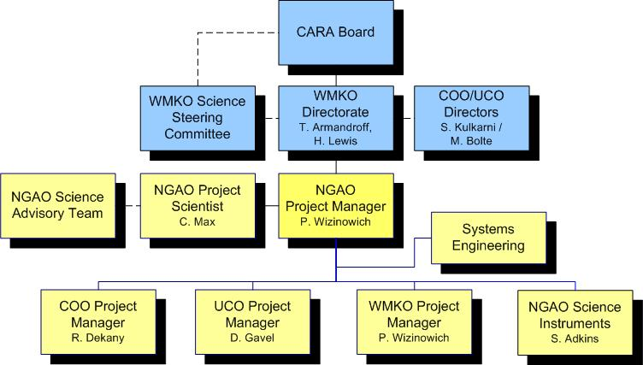
Figure 11 NGAO organization chart
The project (excluding science instruments) successfully completed the System Design Review phase in April 2008 and is currently in the Preliminary Design Phase which is planned to be completed by April 2010. The System Design Reviewers reported that: “The review panel believes that Keck Observatory has assembled an NGAO team with the necessary past experience … needed to develop the Next Generation Adaptive Optics facility for Keck. It is a sound, though aggressive strategy to be among the first observatories to develop and depend on advanced laser guide star AO systems as a means to maintain Keck’s leadership in ground-based observational astronomy for the immediate future. The panel also believes that NGAO is an important pathfinder for the 2nd generation of AO based instruments for future Extremely Large Telescopes …” The WMKO 2008 Strategic Plan identifies the importance of AO to the Observatory’s future with the highest priority given to NGAO: “NGAO will reinvent Keck”.
NGAO will serve the broad community of scientists already served by WMKO. WMKO observing time is allocated as follows: Caltech (36.5%), University of California (36.5%), NASA (14.5%) and University of Hawaii (12.5%). Yale University and the Swinburne University of Technology participate in Keck observing via a partnership with Caltech. The broad U.S. community gains peer-reviewed Keck access via the NASA partnership and through the NSF/NOAO Telescope System Instrumentation program (~24 nights/year). NOAO’s recent ALTAIR committee noted in the context of 6.5-10 meter telescopes that “of the open access time available to the entire US community, Gemini represents ~57%, the NASA Keck time represents ~25%, and NSF TSIP represents ~18%.” Thus, Keck Observatory represents a significant fraction of U.S. peer-reviewed public access to large telescopes.¹

Activity Schedule

Table 2 Major NGAO Project Milestones

The major NGAO milestones are shown in Table 2. The NGAO design phase began in October 2006 and is planned to be completed in April 2012. The design phase schedule has been primarily driven by the need to complete other WMKO priorities while simultaneously obtaining the major funding required for NGAO. This extended design phase allows us (i.e., WMKO, Caltech and UCSC) to build up a strong NGAO development team during the design phase and to produce a fabrication-ready design. The NGAO design phase includes the design of the combined imager and IFS instrument.
Note that we will have continued to improve the capabilities of the existing Keck AO facilities during the NGAO design phase in order to maintain the scientific competitiveness of these facilities. This has the additional advantage of further developing and maintaining the expertise of our AO team. The primary improvements to the existing AO facilities during the NGAO design phase include:
- A Keck Foundation funded project to implement new wavefront controllers and wavefront sensor cameras on both Keck I and Keck II was completed in 2007. These new systems have improved the NGS limiting magnitude for both systems by 1.5 magnitudes and the Keck II LGS AO Strehl ratios by more than 10%, and have provided us with a flexible real-time control system for system optimization.
- We are currently implementing a LGS AO system capability with the Keck I AO system including a 20W NSF-funded solid state mode-locked CW laser from LMCT. The major improvements of this system over the existing Keck II system will be the center launch (as opposed to side launch) of this laser and the better sodium coupling efficiency and higher power of this laser versus the Keck II dye laser. This system is planned to be in science use by the second half of 2010.
- A MASS/DIMM atmospheric profiler will be implemented on Mauna Kea in 2009. We will use the turbulence profile data in combination with real-time wavefront controller data to understand how to produce scientifically useful off-axis PSF calibration data.
- We submitted a NSF MRI proposal in January 2009 to implement the NGAO center laser launch telescope on Keck II by September 2011. In the interim, prior to NGAO, we would replace the existing side launch telescope in order to reduce the LGS perspective elongation by a factor of two and hence to significantly reduce the measurement and bandwidth errors of the existing LGS AO system.
Also in parallel with the NGAO design phase we have been working on the laser development collaboration with ESO, GMT, TMT and AURA mentioned in section 1.1. This collaboration will provide us with laser system preliminary designs from two commercial laser vendors in December 2009 and a final design from the down-selected company by April 2011. The NGAO laser requirements are by design very similar to the ESO requirements so we should be in a position to coordinate orders with ESO and/or TMT and GMT. The expected delivery time for the first ESO laser is a little over a year after the contract is placed.
The fabrication, delivery and commissioning milestones are quite ambitious. As mentioned before by the end of the Detailed Design phase we will be in a position where orders can be placed immediately. In a few cases (e.g., lasers or long lead optics) we expect to have had to place the order prior to the completion of the detailed design and these items will be identified for approval at the Preliminary Design Review.
All sub-assemblies will be completed including full unit testing by the end of the 18 month fabrication phase. The delivered sub-assemblies will be at a high level of integration by the end of the fabrication phase (e.g., the optical system will have been completed aligned on the optical bench). Work to prepare the telescope facilities for the NGAO facility will also occur during this period. Careful attention to the requirement and interface definitions during the design phase will result in compliance matrices for these sub-assemblies to be tested against. A pre-Lab I&T readiness review will be held to insure compliance.
There will be separate ~ 6 month laboratory integration and test phases for the AO system and the laser system. A task schedule including optimizations and compliance testing will be carefully developed during the design phase to ensure that the I&T activities are well defined and can be completed in a timely fashion. It is important that we do not take problems to the telescope and that we have a good baseline for reference during telescope I&T. A pre-ship readiness review will be held to insure we are ready for the telescope.
The laser system I&T will commence first and precede the AO system to the telescope. We have already developed a laser testing lab at WMKO headquarters for the Keck I LMCT laser which will be used for the NGAO laser acceptance testing (much of which will already have been performed at the vendor’s facility) and integration with the controls and safety systems.
A clean-room facility, used for the existing Keck AO systems, is also available at WMKO headquarters and will be re-assessed to ensure its suitability and readiness for I&T. A very important part of this lab I&T will be the integration with the science instrument and the use of the science instrument to optimize the AO system. This phase will include the operation of the system at cold temperatures.
The telescope I&T phase will first reproduce the lab I&T testing to ensure the system is operational at the same level of performance before turning to sky testing. We have experience in fielding multiple AO systems and science instruments at this point and will have careful test plans to optimize and characterize the system’s on-sky performance. The first six months will be quite intensive and this will be followed by up to a year of gathering additional characterization data while further optimizing the system for science operations. Operational personnel will participate during both the lab and telescope I&T phases for training purposes.

Cost Estimates
The cost estimate for NGAO by fiscal year (FY) and design phase is shown in Table 3. The total of $54M (in FY09 dollars, with actual dollars used in FY07 and FY08) includes $42M for the NGAO system and $12M for the imager and integral field spectrograph capabilities. WMKO’s current five-year plan assumes a combination of private and Federal sources for the funding of NGAO. The majority of the preliminary design phase is being funded by the NSF/NOAO Telescope System Instrumentation Program.
Table 3 The NGAO cost estimate in actual and FY09 $k
A rigorous approach was taken to costing for the NGAO system in preparation for the NGAO April 2008 system design review. Cost estimation spreadsheets were prepared by the technical experts for each phase (preliminary design, detailed design, full scale development and delivery and commissioning) of ~85 WBS elements. The 24% overall contingency resulted from the use of standard risk factors based on the type of estimate (from vendor quote to engineering judgment). More recently a careful assessment was performed of the NGAO costs versus the TMT AO first light system which further built confidence in the estimate.
The science instrument(s) are only at a proposal level and hence a higher contingency (30%) for full scale development and delivery and commissioning has been adopted (10% contingency is assumed for the design phase). These estimates have been anchored versus several comparable instruments that have been or are being fabricated for WMKO, as well as against a similar instrument being designed for TMT.
The NGAO project successfully completed a build-to-cost review in March, 2009 based on a $60M then-year dollars cost cap; the Table 3 cost estimate amounts to $60M in then-year dollars assuming 3.5% inflation. The review panel (Brent Ellerbroek (TMT), Michael Liu (UH) and Jerry Nelson (UCSC)) found that “Build-to-cost study has been an extremely efficient, cooperative, and productive response to the … request.” They found that the science cases remained very compelling and that credible technical approaches and budget contingency had been presented; a view supported by the Directors of Keck, Caltech and UC Observatories.
Table 4 provides the NGAO system cost estimate by project phase broken down by labor, non-labor, travel and contingency. Table 5 shows the same cost estimate versus top-level WBS element and phase. The next level of cost breakdown for one of the top-level WBS elements (the AO system itself) is shown in Table 6. All of these tables are in FY08 dollars and 2% inflation was assumed between FY08 and FY09 to produce Table 3.
Table 4 NGAO system cost estimate by phase in FY08 $

Table 5 NGAO system cost estimate by top-level WBS in FY08 $.

Table 6 Cost estimate for WBS 4, the AO system, in FY08 $

Summary
WMKO’s Scientific Strategic Planning process has been closely coupled to the community-wide conversation enabled by the Astro2010 survey because Keck is a national resource for astronomical leadership. To this end we have reviewed all of the 334 white papers submitted to the Science Frontier Panels to determine the role of future Keck capabilities in advancing the field of astrophysics over the next decade. Nearly 10% of these papers discuss science that could take advantage of capabilities made available by NGAO.
NGAO is being designed to address a number of key science questions including:
- Understanding the Formation and Evolution of Today’s Galaxies since z = 3
- Measuring Dark Matter in our Galaxy and Beyond
- Testing the Theory of General Relativity in the Galactic Center
- Understanding the Formation of Planetary Systems around Nearby Stars
- Exploring the Origins of Our Solar System
The requirements derived from these science questions have resulted in NGAO being designed to have the following key capabilities:
- Near Diffraction-Limited in Near-IR (K-Strehl ~80%)
- AO correction at Red Wavelengths (0.65-1.0 μm)
- Increased Sky Coverage
- Improved Angular Resolution, Sensitivity and Contrast
- Improved Photometric and Astrometric Accuracy
- Imaging and Integral Field Spectroscopy
The resultant key design features for NGAO include the following:
- Laser tomography to measure wavefronts and overcome the cone effect.
- Open loop AO-corrected near-IR tip-tilt sensors, with MEMS deformable mirrors, to maximize sky coverage.
- A high actuator count MEMS deformable mirror for atmospheric and telescope static error correction for high Strehls and good companion sensitivity.
- PSF calibration for improved photometry, astrometry and companion sensitivity.
- A cooled science path to reduce thermal background and maximize sensitivity.
- Science instrumentation including an imager and integral field spectrograph with sampling designed to achieve the science requirements.
NGAO is planned to be performing routine science observations in 2015 for a total cost of $54M in FY09 dollars.
The WMKO AO facilities have proven to be a powerful science research facility for the broad U.S. astronomical community. The development of a next generation AO facility (NGAO) has been identified by the WMKO community as being of high strategic importance to maintaining unique observing capabilities on the Keck telescopes that will lead to continued high impact science. NGAO also offers the next breakthrough in AO capability for the U.S. community and the opportunity to retain U.S. leadership in high angular resolution science. This is especially important given the high level of AO investment and innovation planned by ESO.¹⁵

References

- Armandroff, T. 2009, “The Role of the W. M. Keck Observatory in U.S. Astronomy”, Astro2010 State of the Profession white paper
- Barth, A., et al. 2009, “The Nuclei of Low-Mass Galaxies and the Search for the Smallest Massive Black Holes”, Astro2010 Science white paper
- Burgasser, A., et al. 2009, “Toward the End of Stars: Discovering the Galaxy’s Coldest Brown Dwarfs”, Astro2010 Science white paper
- Coe, D. 2009, “Detailed Dark Matter Maps of Galaxy Cluster Substructure and Direct Comparison to Simulations”, Astro2010 Science white paper
- Conselice. C., et al. 2003, AJ, 126, 1183
- Coppi, P., et al. 2009, “Lifting the Veil on the Black Hole-Galaxy Connection: Opportunities for 2010-2020”, Astro2010 Science white paper
- Cruz, K., et al. 2009, “Low-mass Stars and Brown Dwarfs Beyond the Solar Neighborhood”, Astro2010 Science white paper
- Dickinson, M. et al. 2003, ApJ, 587, 25
- Eisenhauer, F., et al. 2003, ApJ, 597, L121
- Elvis, M., et al. 2009, “Active Galaxies and Quasars, 2010-2020”, Astro2010 Science white paper
- Erb, D. K. et al. 2004, ApJ, 612, 122
- Erb, D. K. et al. 2006, ApJ, 647, 128
- Ferrarese, L., & Merritt, D. 2000, ApJ, 539, L9
- Flores, H. et al. 2006, A&A, 455, 107
- Frogel, J. et al. 2009, “Frontier Science and Adaptive Optics on Existing and Next Generation Telescopes”, Astro2010 State of the Profession Position Paper
- Gaudi, B. S., et al. 2009, “The Demographics of Extrasolar Planets Beyond the Snow Line with Ground-based Microlensing Surveys”, Astro2010 Science white paper
- Gebhardt, K., et al. 2000, ApJ, 539, L13
- Ghez, A. M., et al. 2003, ApJL, 586, L127
- Ghez, A. M., et al. 2005, ApJ, 620, 744
- Ghez, A. M., et al. 2008, ApJ, 689, 1044
- Ghez, A. M., et al. 2009, “The Galactic Center: A Laboratory for Fundamental Astrophysics and Galactic Nuclei”, Astro2010 Science white paper
- Guzman, R., et al. 2009, “Reference Science Case for a MOAO-fed Deployable-IFU IR Spectrograph (MDIRS) on Extremely Large Telescopes (ELT): Surveys of Star Formation Over Cosmological Timescales”, Astro2010 Science white paper
- Haghighipour, N., et al. 2009, “Main Belt Comets”, Astro2010 Science white paper
- Holland, W., et al. 2009, “Debris Disks: Signposts to Planetary Systems”, Astro2010 Science white paper
- Koekemoer, A., et al. 2009, “Tracing the Mass Buildup of Supermassive Black Holes and their Host Galaxies”, Astro2010 Science white paper
- Koopmans, L. V. E., et al. 2009, “Strong Gravitational Lensing as a Probe of Gravity, Dark-Matter, and Super-Massive Black Holes”, Astro2010 Science white paper
- Kormendy, J., & Richstone, D. 1995, ARAA, 33, 581
- Kraus, A., et al. 2009, “The Formation and Architecture of Young Planetary Systems”, Astro2010 white paper
- Law, D. R., et al. 2009, “Kinematics and Formation Mechanisms of High-Redshift Galaxies”, Astro2010 Science white paper
- Law, D. R., et al. 2009, ApJ, in press (arXiv:0901.2930)
- Law, N. M., et al. 2009, “Planets Around M-dwarfs – Astrometric Detection and Orbit Characterization”, Astro2010 Science white paper
- Macintosh, B., et al. 2009, “Direct Detection and Spectroscopic Characterization of Giant Extrasolar Planets”, Astro2010 Science white paper
- Madau, P., et al. 2009, “Massive Black Holes Across Cosmic Time”, Astro2010 Science white paper
- Marshall, P. J., et al. 2009, “Dark Matter Structures in the Universe: Prospects for Optical Astronomy in the Next Decade”, Astro2010 Science white paper
- Miller, M.C., et al. 2009, “Probing Stellar Dynamics in Galactic Nuclei”, Astro2010 Science white paper
- Moustakas, L. A., et al. 2009, “Strong Gravitational Lensing Probes of the Particle Nature of Dark Matter”, Astro2010 Science white paper
- Mundy, L. G., et al. 2009, “Dust Enshrouded Star and Planet Formation”, Astro2010 Science white paper
- Nandra, K., et al. 2009, “The Growth of Supermassive Black Holes Across Cosmic Time”, Astro2010 Science white paper
- Ofek, E. O., et al. 2009, “Mass Makeup of Galaxies”, Astro2010 Science white paper
- Olling, R. P., & Merrifield, M. R. 2000, MNRAS, 311, 361
- Sahai, R., et al. 2009, “Understanding Mass-Loss and the Late Evolution of Intermediate Mass Stars: Jets, Disks, Binarity, Dust, and Magnetic Fields”, Astro2010 Science white paper
- Schodel, R., et al. 2002, Nature, 419, 694
- Schodel, R., et al. 2003, ApJ, 596, 1015
- Shaya, E., et al. 2009, “Properties of Dark Matter Revealed by Astrometric Measurements of the Milky Way and Local Galaxies”, Astro2010 Science white paper
- Weinberg, N. N., et al. 2005, ApJ, 622, 878
- Weinberger, A., et al. 2009, “Problems in Circumstellar Disks and Planet Formation”, Astro2010 Science white paper
- Weiner, B. J. et al. 2006, ApJ, 653, 1027
- Wizinowich, P. et al. 2000, PASP, 112, 315
- Wizinowich, P. et al. 2006, PASP, 118, 297
- Worthey, G. 2009, “Extragalactic Stellar Populations”, Astro2010 Science white paper
- Wright, S. A., et al. 2009, “Tracing the Evolution and Distribution of Metallicity in the Early Universe”, Astro2010 Science white paper
- Zucker, S., et al. 2006, ApJ 639, L21

Cover Page Keck AO Images:
Top left: Gravitational lens. Marshall, P.J., et al., 2007, ApJ, 671, 1196
Top right: Direct imaging of multiple planets. Marois, C., et al., 2008, Science 322, 1348
Bottom left: Galactic Center. http://www.astro.ucla.edu/~ghezgroup/gc/pictures/lgs05.shtml

