NGAO System Integration and Test Plans

Keck Adaptive Optics Note 581

Christopher Neyman, David Le Mignant and Peter Wizinowich
March 25, 2008

Introduction

This document describes the plan for integration and testing (I&T) of the NGAO facility. The NGAO facility is composed of the following major components:
- AO system
- Laser system
- Science operations tools
- Keck Telescope and associated observatory facilities
- Science instruments

All of these elements are covered by this integration and test plan with the exception of the science instruments which are covered under each individual instrument’s integration and test plan. The major components correspond to major elements of the work breakdown structure (WBS) as shown in Figure 1. The WBS shown in Figure 1 uses a new numbering scheme that will be used for the next phases of the NGAO project that follow the system design phase. The reader should be warned that the number scheme of Figure 1 is different than the one used previously during the system design phase, for example KAON 414 [1].

Construction of NGAO follows the structure outlined in Figure 1. Each of the major systems is built from underlying subsystems. For example, the AO system (WBS 4) includes:
- AO enclosure (WBS 4.1)
- Opto-mechanical (WBS 4.2)
- Alignment, calibration and diagnostics (WBS 4.3)
- Non-real-time control (WBS 4.4)
- Real-time control (WBS 4.5)

These subsystems can be broken further into the next level of sub-elements as shown in Figure 2 for WBS elements 4.1, 4.2, and 4.3.

NGAO integration and test overview

The sequencing of the major elements of the NGAO overall integration and test activities is shown in Figure 3. The activities in Figure 3 are approximately ordered in time from earliest to latest as you move from left to right in the diagram. The “Subsystem Development and Testing” is the first part of the overall I&T activity. The NGAO integration plan proceeds from the assumption that the lowest levels of the work break down structure will be tested to verify that the components function as stand-alone units before they are combined into higher level systems. The verification of each subsystem means that it complies with specifications developed in the functional requirements document. In some cases; a single functional requirement will be allocated across many components of the subsystem. To avoid problems later during integration, the subsystems must also be shown to comply with the standards of the NGAO internal interface control documents. Throughout the remainder of the document will the term “verify” or “measure” will be used to mean a comparison of the particular system to the relevant requirements and interfaces.

The integration of NGAO will proceed to the one-sublevel structure of the WBS (i.e. 4.x, 5.x, and 6.x). The next step of the overall I&T is the “Laboratory Integration and Test” of the laser system and AO systems. These systems will be integrated in separate laboratories for each, as part of WBS 4.6 and 5.6 respectively. The Science Operations Tools will also be delivered to the integration laboratories so the command sequencer, user interfaces, and the data server can be tested with the AO and laser systems. During this integration the AO and laser systems will be tested against the functional requirements. These two systems must also demonstrate compliance with interface control documents. While the implementation of a full system test at the integration laboratory will initially add cost to the system, such a test is likely to eventually save cost and avoid schedule delays over implementing an untried system on Mauna Kea. This is an important consideration, given the experiences of other AO facilities and the need to integrate and commission the system as efficiently as possible.

While the laboratory integration and testing is occurring, the observatory will be preparing the needed infrastructure as part of the “Summit Preparation” phase as shown in Figure 3. The final step of summit preparation will be the installation and integration of the AO and laser enclosures (see WBS 8.2 and 8.3 in Figure 3). Once the enclosures are ready, the “Telescope Integration and Test” phase will start with installation of the AO and laser systems as part of WBS 8.5 and 8.6 respectively. The next step of the “Telescope Integration and Test” phase will be repeating the system verification tests performed in the lab to verify that the AO and laser systems are functioning correctly after installation on the summit. In addition, during this phase (WBS 8.5) the AO system will be tested on the sky in its NGS mode. The laser system will be tested on the sky independently of the AO system to verify laser system alignment to the telescope.

In the next step, WBS 8.6, the laser and AO system will be tested as integrated units at the observatory during the daytime and subsequently tested on the sky. The system will be tested and compared against the system requirements document specifications. Next the NGAO overall performance will be characterized by extensive on-sky testing, see WBS 8.7 in Figure 3. This will be followed by testing with at least the “first light” science instruments and verification of the science requirements, see WBS 8.8 in Figure 3.

Science operations tools integration and test

The science operation tools include:
- Multi-system command sequencer
- User interfaces
- Pre- & post-observing support
- Data server

It is planned to start integration of all these tools as the AO and laser systems undergo their laboratory integration and test phases. These tools should be completed as the other parts of the NGAO are being finished at the end of the pre-lab I&T full-scale development phase. These tools can be checked with the overall control software for the AO and laser systems. The NGAO team prefers a closely linked integration of these tools with the laboratory integration of the laser and AO systems. During lab integration, the data server will be used to get diagnostic data from the AO and laser systems when testing in the lab. All AO and laser sequences can be tested. Some testing can be done with simulator functions for the other subsystem sequencers that will not be available in the lab. Tests would include the sequences for setup, calibrations, monitoring, etc. Of course, many of the observing sequences cannot be tested fully at this time, but we will try to have (simple) simulation tools in place for the parts that cannot be tested.

The laboratory integration and testing are important for the science operations tools to support the later phases of the project and not delay them. When the AO and laser systems are integrated at the telescope, operation of these systems will not be done manually. The integration team will need to have software tools in place. Even the current Keck AO system cannot be run effectively in a manual mode without software tools as there are too many parameters and devices to set. The early integration of the software tools will also make for a smoother transition to science verification at the telescope. The science verification observing proposals are to be prepared about 1 year before observing occurs. NGAO is a new instrument that is likely to attract a more general user so planning tools, as well as the pre- and post- observing support tools, need to be ready during the laboratory integration phase for observers to learn how to use them and provide feedback before the full system is sent to the telescope.

AO system laboratory integration and test

It is assumed that each lower level subsystem of the full AO system will be tested where it undergoes assembly either at a contractor or one of the NGAO partner institutions (CIT, UC, WMKO). At this point in the design process, it would be premature to detail the testing of each of these lower level subsystems. The AO subsystems, including the cooled AO enclosure, will be integrated at a designated laboratory. At present, this laboratory is likely to be at the Keck Observatory headquarters.

The AO subsystems and the relevant science operations tools (WBS 6.0) will be shipped to this laboratory. Each subsystem will be retested at the integration laboratory to determine that it meets the NGAO functional requirements and satisfies all interface control documents (ICD) that pertain to it. The AO enclosure will be assembled and tested. The AO bench will be installed inside the enclosure. Optical and mechanical components will be installed with the AO bench and aligned into final position. Electronics not located inside the AO enclosure as well as computers would be located in an area adjacent to the AO enclosure. At least one science instrument will be shipped to the integration lab to support testing of the AO system. If this is not feasible, a surrogate “scoring” camera or high resolution wavefront sensor could be substituted.

With the system at room temperature (~ 20º C) the following tests would be performed including:
- Perform all subsystem acceptance tests again, as the first step in checking integrated system performance
- End to end wavefront error: this is likely the last step of the optical alignment
- Motion control: K-mirror, ADC, dichroic changer, etc.
- LGS and NGS pickoff motion control
- LGS wavefront sensor focus tracking
- Detector readouts and interface to real-time control system
- Real-time control performance with wavefront sensor detectors
- Check AO sensors performance: throughput, read noise, dark noise, flat fields, light leaks
- System transmission
- Test high level software with AO: including the AO sequencer, data server and multi-system command sequencer
- Test acquisition, dithering, offsetting to the extent possible with both the source simulator and the telescope software simulator
- Data server functionalities
- User interface software
- Calibrate and verify registration for pickoff arms (LOWFS, LGSWFS) against acquisition camera (using simulator source)
- Calibration of the DM influence functions, DM-to-lenslet registration
- Calibration of the non-common path wave-front aberrations in the adaptive optics instrument package using phase diversity, on-instrument wavefront sensors, or other methods
- AO performance using simulation source “clean beam”: closed loop bandwidth, wavefront measurement errors
- Test AO system closed loop with turbulence simulator: validate AO control modes (NGS, tomography, etc),
- Tracking functions and devices: non-sidereal, true focus, DAR, field curvature compensation, LOWFS/TWFS control

The system would then be brought to its operating cold temperature and the tests above repeated. Thermal background levels with the science camera will also be estimated at this point. Assuming that performance is satisfactory, the system would then be disassembled and packed for shipment to the Keck Observatory.

Laser system laboratory integration and test

It is assumed that each lower level subsystem of the laser system will be tested where it undergoes assembly either at a contractor or one of the NGAO partner institutions (CIT, UC, WMKO). At this point in the design process, it would be premature to detail the testing of each of these lower level subsystems. The laser subsystems will be integrated at a designated laboratory. At present, this laboratory is likely to be the Keck Observatory headquarters using the same lab space where the Keck I laser system will be tested before installation on Mauna Kea. A schematic of the laser laboratory is shown in Figure 4. The laser enclosure is likely to be constructed on site at the telescope and the laser system installed into the enclosure after passing its laboratory integration and test phase. The lasers and associated systems are complex instruments which should be tested at a dedicated facility as a complete system prior to shipping to Mauna Kea for integration into the telescope. While it may be impossible to project the 50W lasers into the sky at the integration laboratory, the laser beams can be projected through the optics train and dumped prior to entering or just after the laser launch telescope. Every feature and component of the LGSF system should be aligned, calibrated, and/or tested prior to being shipped to the telescope, at operational conditions and with a variable gravity vector when appropriate.

The laser subsystems and part of the relevant observer tools (WBS 6.0) will be shipped to the Keck headquarters laboratory. Electronics and computer terminals would be located in an area adjacent to the laser laboratory to support testing. A low power laser could also be used for some of these tests and should be included in the system plan for use during subsystems tests, laser laboratory integration, and on site during initial phases of the laser telescope I&T. The following are some tests that would be performed including:
- Perform all subsystem acceptance tests again, as the first step in checking integrated system performance
- Test laser launch telescope at operational temperature and orientation
- Operation of each laser head: power, beam quality, M², stability
- Working of motion control for beam transport optics
- Laser pointing and centering control
- Laser diagnostics: far field cameras, polarization meters, power meters
- System transmission
- Test high level software: including the laser sequencer and multi-system command sequencer
- Test user interface software
- Test laser safety system with laser and beam transport systems
- LGS asterism generator functionality
- Laser to beam transport optics interface
- Beam transport to launch telescope interface
- Laser safety system
- If appropriate, test the changing gravity vector on the laser, launch telescope, or other systems

If performance were satisfactory, the system would then be disassembled and packed for shipment to the Keck Observatory.

Telescope integration and test plan for NGAO

After shipping the AO system and laser system to Mauna Kea, each will be installed at the observatory. During the telescope system integration period, each of the subsystems, and the system as a whole, will undergo testing prior to being tested with the telescope on the sky. In addition, some system tests not previously done because they were impractical to perform in a lab setting will be done on the telescope with the integrated system. Some examples are: verifying the on-sky ADC performance, verifying that the wavefront sensor probe arms will track NGS, and testing the full laser transport system. Any modifications to the telescope and other facilities at WMKO made to support NGAO, that require NGAO for testing, will be regression tested at this time.

Several atmospheric turbulence monitors would be useful for the on-sky testing. At least one is expected to be part of the NGAO project. Additional turbulence monitors would also be useful.

To monitor the return from the sodium laser guide stars, an independent sodium column density monitor would also be needed during testing. Perhaps an existing sodium profiler could be brought to Mauna Kea for the NGAO on-sky testing. The University of Illinois has previously transported Na LIDAR systems to Hawaii for measurement campaigns. The return from the NGAO laser could be compared to the return from the laser on the other Keck Telescope; this will provide at least relative return measurements. Keck Observatory is unique in that it will have a single LGS AO system on the other telescope for comparison with NGSO in identical atmospheric conditions. Some effort should be made to schedule comparable testing on the legacy AO system as a baseline for evacuating of NGAO.

AO telescope integration and test

The AO system and its enclosure will be shipped to Mauna Kea and installed at the telescope. Unit and system level testing will be repeated at a level similar to what was done at the integration laboratory. The same science instrument (likely a NIR imager) that was used for laboratory integration will be installed with NGAO. The existing OSIRIS instrument can also be installed at this time. The visible camera and the d-IFS will be installed as these instruments are completed, likely later in the project. After verification of all laboratory testing results on the telescope, any remaining non sky testing on the AO system will be performed. This will be followed by on-sky testing with only natural guide stars. Functionality that was previously impractical to test in a laboratory setting will be tested at this time. This includes testing the AO system under control of the higher order NGS wavefront sensor. The low order natural guide star system will be tested for functionality that does not require the LGS system.

The NGS functionality of the AO system will be tested first, including the following:
- ADC atmospheric correction based on telescope pointing
- NGS pickoff and probe arm control for the LOWFS, HOWFS, and TWFS on-sky
- Acquisition of guide stars in the fields-of-view of the LOWFS
- Testing algorithms for automatically optimizing AO control algorithm parameters, such as control loop gain, in real time, NGS HOWFS, NGS TWFS, and NGS LOWFS
- Testing to validate the performance in operations of the integrated system: accuracy and efficiency for dither sequences, tracking and guiding
- Test observing efficiency budget for key NGS observing modes
- Test acquisition efficiency budget for acquisition camera and LOWFS

Laser system telescope integration and test

The laser system will be shipped to Mauna Kea and installed at the telescope. Likely the laser enclosure will be installed and tested in place. Unit level testing of the other laser systems will be repeated at a level similar to what was done at the integration laboratory.

Laser system functionality that is independent of AO will be tested at this time including:
- Interface between laser safety software and the laser safety shutters
- Test laser safety software with the LTCS
- Test laser safety software with avoidance systems for both aircraft and satellites
- Operation of the beam transport pointing and centering loops with a single laser beam
- Diagnostic beam quality measurements with a single laser beam
- Aligning the beam transport and launch telescope optical axis to the Keck telescope
- Proper operation of the pointing and centering loops with multiple laser beams
- Diagnostic beam quality measurements with multiple laser beams
- Controlling the orientation of the LGS pattern on the sky
- LLT blind pointing accuracy as a function of elevation angle
- Measure the motion versus elevation, so that this can be compensated in the laser pointing versus elevation code

AO and LGS telescope integration and test

The full LGS and AO system on-sky integration and test is the next phase of NGAO I and T.
These tests will be used to validate the AO system performance predictions in the LGS-AO mode. It also includes validation of the science operations tools and characterization of the observational efficiency performance. A list of the key tests is as follows:

- Closed-loop control of the uplink laser fast steering mirrors using tip/tilt measurements from the LGS WFS (location of these mirrors inside LGS WFS or before laser launch telescope is TBD)
- Adjusting focus for the LGS wavefront sensor based upon telescope zenith angle
- Testing algorithms for estimating the variations in LGS WFS gains and biases in real time
- LGS AO control loop optimization, measurement of the system loop transfer function, and testing to optimize the LGS AO tomography control algorithm
- Check accuracy and efficiency for dither sequences, tracking and guiding in LGS AO mode
- Na layer tracking, etc.
- Check sodium return versus laser polarization and focus
- Check impact of Rayleigh backscatter on LGS WFS
- Check impact of Rayleigh and LGS backgrounds on LOWFS
- Verification of AO system monitoring of atmospheric parameters (e.g. r0, τ0, θ0, Cn2)
- Verification of wavefront error budget terms (e.g. tomographic error, calibration errors)
- Test the PSF extraction/recovery algorithm
- Test observing sequences
- Test observing efficiency budget for key observing modes

Performance characterization and science verification

Performance characterization

This testing of the NGAO system is for the purpose of producing information for observers to assist them in planning for future observations. Previous performance verification at Keck observatory is documented in references 2, 3 and 4. We use the term AO performance as a catch all for Strehl, FWHM, and ensquared energy. Testing will include AO performance as a function of:

- Seeing profile, r₀, θ₀, and f_{G}
- NGS brightness for higher order wavefront sensing
- Off-axis NGS distance for higher order wavefront sensing
- Laser guide star return and sodium column density and profile
- Laser asterism
- Sky coverage at several galactic latitudes
- LOWFS guide star brightness
- LOWFS guide star configuration
- LOWFS guide star size
- Sky background

Tests will also be performed to quantify polarization and measure astrometric and photometric performance under various conditions. Strehl stability will also be measured as well as high contrast performance. The system performance will be measured for both on-axis and off-axis image quality. PSF uniformity will be characterized. As atmospheric conditions will be variable, results will be compared with detailed computer simulations in order to verify that performance satisfies the system and science requirements.

Science verification

The scientific verification phase takes place during the commissioning of the NGAO instruments. Previous science verification efforts at Keck observatory are documented in references 5, 6, and, 7. Full end-to-end system verification will be done with a variety of observational programs to confirm the capabilities of the system. The system performance will be checked in the following modes: NIR imaging and spectroscopy, visible imaging and spectroscopy, and NIR d-IFS observations. Metrics will be determined for the science efficiency and observing uptime of the NGAO + instruments.

References
1. P. Wizinowich, et al., “Keck Next Generation Adaptive Optics: System Design Phase Systems Engineering Management Plan”, Keck Adaptive Optics Note 414 (W. M. Keck Observatory, Kamuela, Hawaii, 2006).
2. M. van Dam, et al., “Performance of the Keck Observatory Adaptive-Optics System”, Applied Optics, 43, pp. 5458-5467, 2004.
3. M. van Dam, et al., “The W. M. Keck Observatory Laser Guide Star Adaptive Optics System: Performance Characterization.”, PASP, 118, pp. 310-318, 2006.
4. E. Johansson, P. Stomski, M. van Dam, “NGWFS Performance Verification Report”, Keck Adaptive Optics Note 505 (W. M. Keck Observatory, Kamuela, Hawaii, 2006).
5. O. Lai, “Engineering Science with Keck AO”, Keck Adaptive Optics Note 156 (W. M. Keck Observatory, Kamuela, Hawaii, 1998).
6. P. Wizinowich, et al., “Performance of the W.M. Keck Observatory Natural Guide Star Adaptive Optic Facility: the first year at the telescope”, Proc. SPIE Vol. 4007, p. 2-13, 2000.
7. A. Bouchez, et al., “Keck Laser Guide Star Adaptive Optics: Science Verification Results”, Proc. SPIE, Vol. 5490, pp. 321-330 (2004).

Figure 1: NGAO project work breakdown structure
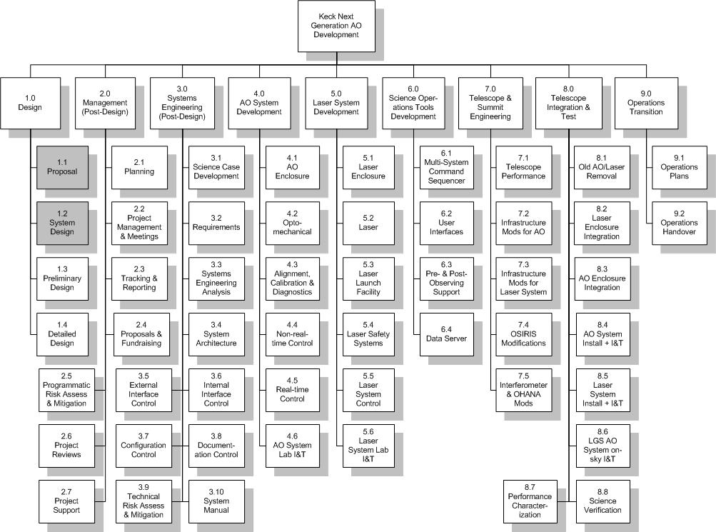
Figure 2: NGAO WBS 4.0
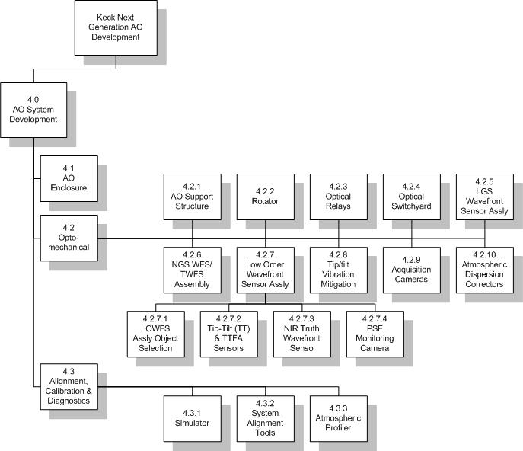

Figure 3:
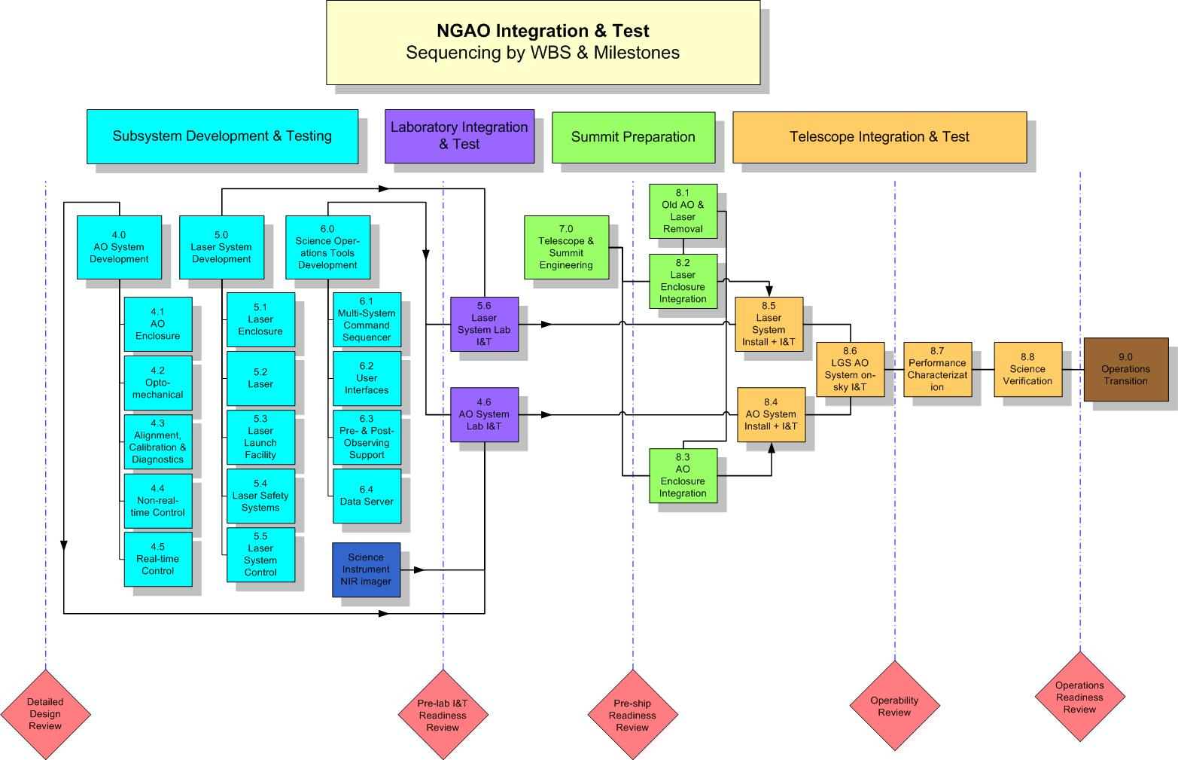
Figure 4: Schematic of Keck I LGS integration laboratory, Waimea Hawaii. The facility includes clean room, benches and other infrastructure to support testing of a 20 W LMCTI laser

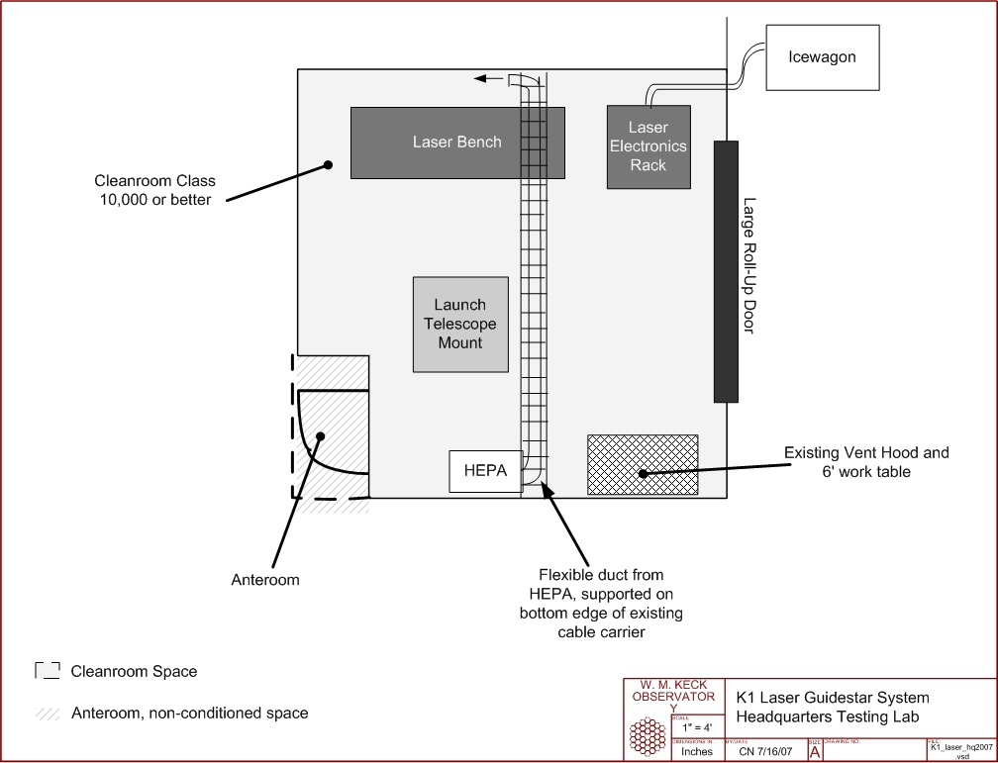

The NGAO product breakdown structure may be more appropriate when it is complete.
The Laboratory for Adaptive Optics at UCSC or the Caltech Synchrotron high bay where MOSFIRE is being assembled could also be used.

