

Keck Adaptive Optics Note 574

Next Generation Adaptive Optics:
Systems Engineering Management Plan

Version 1.0
April 8, 2008

Author List
Name | Function
Peter Wizinowich | NGAO Executive Committee (EC) Chair
Richard Dekany | EC Member
Don Gavel | EC Member
Claire Max | EC Member & NGAO Science Team Chair

Contributors: .Sean Adkins, Erik Johansson, Elizabeth McGrath, David Le Mignant, Chris Neyman, Viswa Velur

Approval Control
Control | Name | Function
Revised by:

Approved by:
Authorized by:

Document Change Record
Issue | Date | Change Description
Version 0.9 | April 3, 2008
Version 1.0 | April 8, 2008 | Added section 2.1 & added material to section 5.

1 Introduction 1
2 Project Plan 1
2.1 Organization Structure 1
2.2 WMKO Design Phase and Deliverables 3
2.3 Work Breakdown Structure 5
2.3.1 Design WBS 6
2.3.2 Management WBS 6
2.3.3 Systems Engineering WBS 7
2.3.4 AO System WBS 8
2.3.5 Laser System WBS 8
2.3.6 Science Operations Tools WBS 9
2.3.7 Telescope and Summit Engineering WBS 9
2.3.8 Telescope Integration and Test WBS 9
2.3.9 Operations Transition WBS 9
2.4 Product Structure 9
2.5 Project Milestones and Schedule 10
2.6 Cost Estimate 12
2.6.1 Introduction 12
2.6.2 Project Scope 12
2.6.3 Cost Estimation Process 13
2.6.3.1 Objectives 13
2.6.3.2 Project Phases 13
2.6.3.3 Costing Methodology 15
2.6.3.4 Resource Pricing 15
2.6.3.5 Labor Resources 16
2.6.3.6 Non-Labor Expenses 17
2.6.3.7 Travel 17
2.6.3.8 Shipping 18
2.6.3.9 Sales Tax 18
2.6.4 Cost Estimates 18
2.6.4.1 Estimate to Completion 18
2.6.4.2 Cost Comparison 19
2.6.4.3 Preliminary Design Phase Cost Estimate 22
2.6.4.4 Key Cost Risks 25
2.6.4.5 Potential Cost Savings 25
2.6.4.6 Estimate Refinement 26
2.7 Risk Assessment and Management 26
2.8 Configuration and Documentation Management 26
2.9 Interface Definition 27
2.10 Requirements Management and Compliance 27
2.11 Integration and Test 28
2.12 Component Failure and Spares Approach 31
3 Preliminary Design Phase Plan 32
3.1 PD Phase Management 32
3.2 PD Phase Overview and Deliverables 32
3.3 PD Phase Work Breakdown Structure 32
3.4 PD Phase Planning Assumptions 32
3.5 PD Phase Schedule 33
3.6 PD Phase Milestones 37
3.7 PD Phase Personnel and Core Team 38
3.8 PD Phase Budget and Contingency 39
3.9 PD Phase Risk Assessment and Risk Management 40
3.10 PD Phase Management 41
4 Phased Implementation and Descope Options 42
5 System Design Phase Summary 44
6 Appendix: Cost Estimation Worksheet Example (WBS 3.3.3 DD Phase) 48
7 Appendix: Cost Estimation Worksheet Example (WBS 4.2.4 FSD Phase) 50
8 Appendix: NGAO Cost Estimate Summary (in FY08 $K) 52
9 Appendix: NGAO Detailed Design Cost Estimate Summary (in FY08 $K) 54
10 Appendix: NGAO Full Scale Development Cost Estimate Summary (in FY08 $K) 56
11 Appendix: NGAO Delivery and Commissioning Cost Estimate Summary (in FY08 $K) 58
12 Appendix: Full NGAO Preliminary Design Phase Schedule 60
13 Appendix: Management Approach to Real-Time Controller Design 73

Figure 1. NGAO Preliminary Design Phase Management Structure. 2
Figure 2. The WMKO Development Process. 4
Figure 3. NGAO Work Breakdown Structure. 5
Figure 4. NGAO AO System Opto-Mechanical Work Breakdown Structure. 8
Figure 5. Partial view of the NGAO Product Structure. 10
Figure 6. Modified V-diagram shown the requirements flowdown and relationship to testing. 28
Figure 7. NGAO Integration and Test Approach. 30
Figure 8. PD phase Management schedule (WBS2). 33
Figure 9. PD phase Systems Engineering schedule (WBS3). 34
Figure 10. PD phase AO System schedule (WBS4). 35
Figure 11. PD phase Laser System schedule (WBS5). 35
Figure 12. PD phase Science Operations Tools schedule (WBS6). 36
Figure 13. PD phase Telescope and Summit Engineering schedule (WBS7). 36
Figure 14. PD phase Telescope Integration and Test schedule (WBS8). 37
Figure 15. PD phase Operations Transition schedule (WBS9). 37
Figure 16. System Design cumulative percent complete for budget and work. 46
Figure 17. System Design work completed versus plan. 46
Figure 18. System Design actual labor costs by Institution and month. 47

Table 1. WMKO Development Process Deliverables. 4
Table 2. NGAO Project milestones. 11
Table 3. TAC notifications associated with NGAO milestones. 11
Table 4. NGAO Project phases and durations. 14
Table 5. Estimating Methodology 15
Table 6. Labor categories. 16
Table 7. Non-labor categories. 17
Table 8. Travel destination categories. 17
Table 9. Travel duration categories. 17
Table 10. NGAO cost estimate (in FY08 $k) by WBS 19
Table 11. NGAO cost estimate (in FY08 $k) by project phase. 19
Table 12. NGAO cost comparison to similarly complex AO systems. 20
Table 13. NGAO cost comparison notes. 21
Table 14. Preliminary Design phase cost estimate (FY08 $). 24
Table 15: Milestones 37
Table 16. PD phase personnel assignments versus Fiscal Year (FY). 38
Table 17. Core PD phase team members. 39
Table 18. PD phase work distributed by Institution. 40
Table 19. System Design phase actual $k versus plan. 44
Table 20. System Design phase actual hours versus plan. 44

Introduction
A Systems Engineering Management Plan (SEMP) is a standard part of the project documentation for W.M. Keck Observatory (WMKO) development efforts. This SEMP represents a key deliverable from the system design phase for the WMKO Next Generation Adaptive Optics (NGAO) project. This document will be updated as a product of the NGAO preliminary and detailed design phases.

The following sections document the proposed management process, schedules and budgets for the remainder of the NGAO project.

Project Plan

Organization Structure
The System Design phase management structure setup by the Observatory Directors (i.e., Armandroff, Bolte, Kulkarni and Lewis) consisted of a four member Executive Committee (EC) with one person identified as EC Chair and another as Project Scientist. The participants represented the three institutions collaborating on the NGAO System Design. The members of the EC worked well together and the structure also supported good involvement of the three institutions.

For the Preliminary Design phase we propose a revised management structure. The Chair of the EC, Peter Wizinowich, will become the overall Project Manager. The two other EC technical leads, Rich Dekany and Don Gavel, will become Project Managers responsible for the work at their respective institution. This will allow us to have a leaner and less complex project structure, so that we can focus on management and technical leadership of specific parts of the Preliminary Design.

The proposed organization structure including other senior leadership roles is shown in Figure 1. All items highlighted in yellow represent part of the NGAO preliminary design phase project for which this SEMP is written. The NGAO project continues to be led by the EC members but now in more defined roles. The NGAO Project Scientist will be assisted by an NGAO Science Advisory Team. The NGAO senior management group (Wizinowich, Dekany, Gavel and Max) will provide project management with the cleaner lines of authority necessary for successful completion of the Preliminary Design.

NGAO science instruments are separately managed under the direction of the WMKO Instrument Program Manager (IPM), Sean Adkins. The dashed links between the science instruments and the Project Manager, Project Scientist and Systems Engineering reflect the need for close collaboration in the design and development of these systems. The requirements for both the AO facility and science instruments flow down from the NGAO science case requirements. These requirements and the interface definitions between systems are maintained by the NGAO Systems Engineering team.

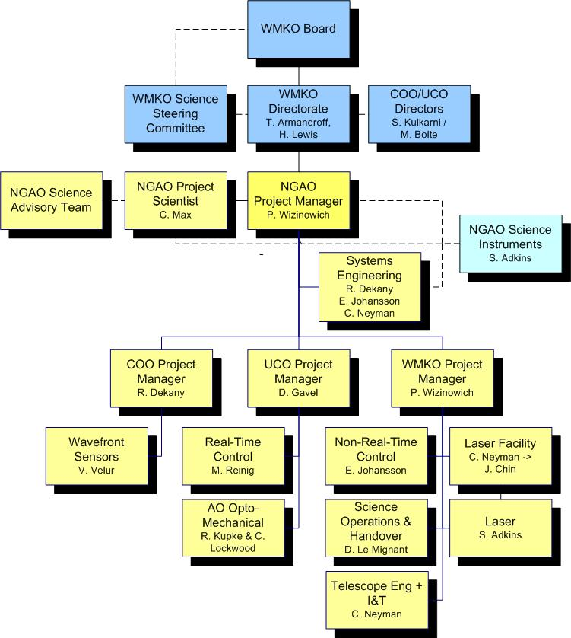
Figure 1. NGAO Preliminary Design Phase Management Structure.
Solid lines are direct reports. Dashed lines are advisory or collaborative.

WMKO’s top-level management structure is highlighted in blue in Figure 1. The NGAO Project Manager reports directly to the WMKO Director, Taft Armandroff, and Deputy Director, Hilton Lewis. They in turn report to the WMKO Board. There is a close collaboration between the WMKO Directorate and the Director of the University of California Observatories (UCO), Mike Bolte, and the Director of the Caltech Optical Observatories (COO), Shri Kulkarni. A similar collaboration exists with the WMKO Science Steering Committee co-chaired by Jean Brodie and Tom Soifer.

Due to the collaborative inter-Observatory nature of the NGAO project and the EC System Design phase mandate, the EC provided regular reports to the Observatory Directors during the System Design phase and looked to them for guidance. In order to ensure clear direction during the Preliminary Design the NGAO Project Manager will meet regularly with the WMKO Directorate (at least bi-weekly) and the NGAO senior management (Dekany, Gavel, Max and Wizinowich) will have four scheduled telecoms with the Directors.

The NGAO EC provided updates at each of the SSC meetings during the NGAO System Design. The Project Manager and Project Scientist will plan to provide updates at each SSC meeting during the Preliminary Design. The NGAO project looks for the community science input primarily through the NGAO Project Scientist. The Project Scientist seeks guidance from the NGAO Science Advisory Team and the SSC.

The NGAO Preliminary Design is partially funded by the NSF’s Telescope Systems and Instrumentation Program (TSIP). The WMKO IPM has been responsible for interactions with and reporting to this program for other TSIP funded projects. The NGAO Project Manager will collaborate with the WMKO IPM to provide monthly updates to the TSIP.

This organization structure will need to be modified as we move from Preliminary to Detailed Design phase. The amount of activity will increase dramatically and we will need additional dedicated project management and systems engineering resources. Personnel will be identified or hired for these roles.

As noted in Figure 1 the laser facility management will be transitioning from Chris Neyman to Jason Chin during the preliminary design as Jason frees up from the Keck I LGS AO implementation project management role.

WMKO Design Phase and Deliverables
WMKO’s standard development process is shown in Figure 2. This document is being written as a product of the NGAO System Design and presents the SEMP for the remaining development phases starting with the Preliminary Design and ending with the transition of NGAO into Facility Class Operation. Table 1 lists the standard deliverables for each of the development phases.
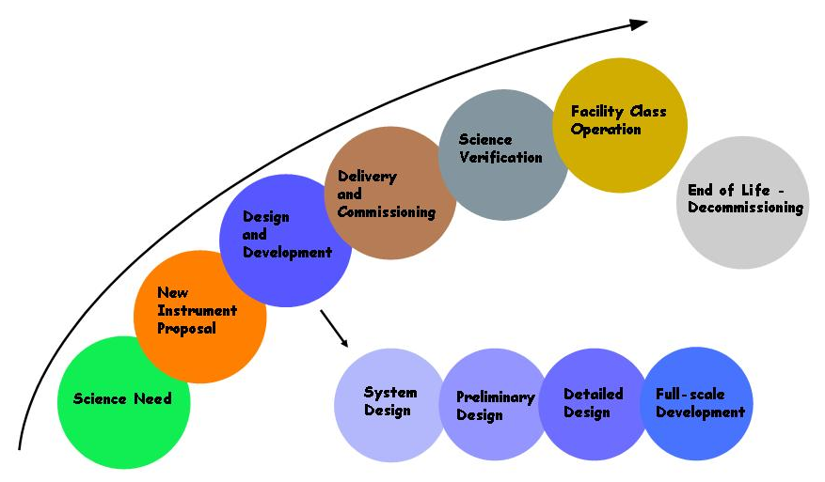
Figure 2. The WMKO Development Process.

The deliverables for the AO portion of the NGAO project consist of documentation and the actual AO Facility, Laser Facility and related interfaces. Major documentation items include:

Table 1. WMKO Development Process Deliverables.
System Design: | Preliminary Design:
Science Case Requirements Document | Requirements Documents for Key Subsystems
System Requirements Document | Operations Concept Document
System Design Manual | Preliminary Technical Specifications
Systems Engineering Management Plan | Interface Control Documents
System Design Report | Preliminary Design Report
Detailed Design:
Detailed Design Drawings and Bills of Material
Final Technical Specifications
Acceptance Test Plans
Detailed Design Report
Full Scale Development:
Hardware and Software Manuals and Maintenance Documentation
Pre-ship Review Reports
Installation/Commissioning:
Acceptance, Operational Readiness and Science Verification Review Reports

Work Breakdown Structure
The NGAO Project Work Breakdown Structure (WBS) is shown schematically in Figure 3. The top level structure reflects the transition from Design (1.0) through Full Scale Development (4.0 to 7.0) to Delivery and Commissioning (8.0 and 9.0). WBS 8.0 includes Science Verification and WBS 9.0 covers the handover to Facility Class Operation. Management (2.0) and Systems Engineering (3.0) are ongoing items through both Full Scale Development (FSD) and Delivery and Commissioning (DC).

Each of the top level WBS elements is briefly described in the following section. A full WBS dictionary can be found in KAON 583.

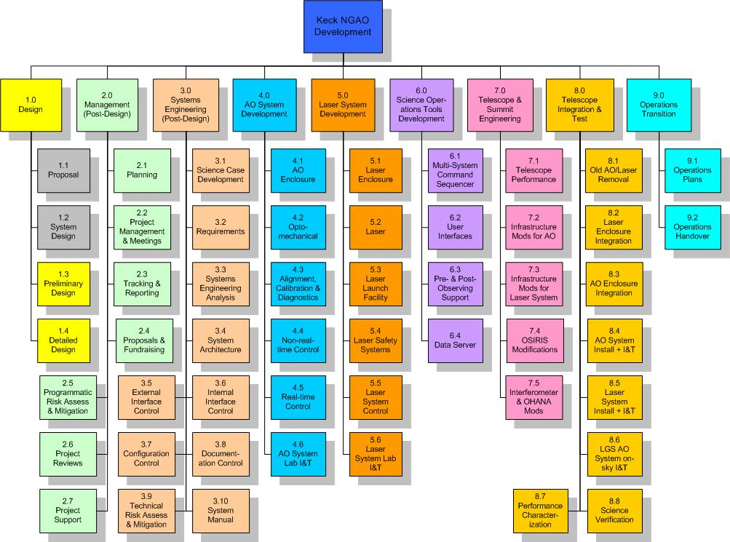
Figure 3. NGAO Work Breakdown Structure.

Design WBS
The two gray highlighted boxes in Figure 2 represent the project phases completed prior to the start of the Preliminary Design. There are two remaining design phases, Preliminary Design and Detailed Design. In order to simplify the creation of separate project plans and budgets for each design phase a WBS numbering plan is used within each design phase WBS (1.3 and 1.4) that reflects the overall WBS numbering for each of the major elements shown in Figure 3. For example, the overall WBS contains an element number 4.0, named “AO System Development”. An identically named WBS element appears in each of the Preliminary Design and Detailed Design WBS outlines, but these elements are numbered 1.3.4 and 1.4.4 respectively.

Management WBS
The management WBS has seven major elements:

- Planning. This WBS includes the normal adjustments to the plan during a development phase, supporting the Observatory’s fiscal year planning process and preparing the Systems Engineering Management Plan (SEMP). The SEMP, the document you are currently reading, will be updated during the Preliminary and Detailed Design phases.
- Project Management and Meetings. This category includes management telecoms and team meetings and telecoms. During the preliminary design phase for example management teleconferences will occur weekly and team teleconferences monthly with four face-to-face team meetings.
- Tracking and Reporting. Monthly status reports will be provided throughout the project and regular reporting will be made quarterly at WMKO SSC meetings. During the Preliminary Design phase the monthly reports will be provided to the TSIP and the Observatory Directors and monthly telecoms will be held with the TSIP representatives.
- Proposals. The NGAO team will need to write proposals and support fundraising. This is primarily a schedule item here since the WMKO labor for these activities is covered outside the NGAO budget. Some COO and UCO labor is covered here.
- Programmatic Risk Assessment and Mitigation. This WBS covers analysis of the programmatic risks and some mitigation activities. Some mitigation activities are covered under the appropriate development WBS.
- Project Reviews. Project reviews corresponding to major milestones are covered under this WBS. These include:
  - Preliminary Design Review.
  - Detailed Design Reviews.
  - An intermediate Full Scale Development Review as a checkpoint during development (we may revisit the need for this review).
  - A Pre-lab I&T Review to determine that the subsystems are ready for lab I&T.
  - A Pre-ship Review to determine that the system and telescope infrastructure are ready for telescope I&T.
  - An Operability Review to determine that NGAO is ready for shared-risk science.
  - An Operations Readiness Review to determine that NGAO and the operations team are ready for Facility Class Operation.
- Project Support. This category includes administrative and contract support, the procurement of shared infrastructure for development and/or testing purposes, and research time for postdocs and scientists working on the NGAO project.

Systems Engineering WBS
The Systems Engineering WBS has ten major elements:
- Science Case Development. This WBS is the primary home for the Project Scientist and Science Advisory Team activities. These include science case and requirements development, science observing planning, science performance input to the performance budgets, science operations tools and Operations Concept Document, understanding and updating the case for NGAO’s science competitiveness and liaising with the science community. This will continue to be an active area during the Preliminary Design and should move to more of a supporting role until we reach the telescope I&T and science verification phase.
- Requirements. This category includes the development and maintenance of the Operations Concept Document, System Requirements Document, Functional Requirements database, and the software and component standards that we select for NGAO. The System and Functional Requirements were developed during the System Design phase and will require updating during the remaining design phases. The initial Operations Concept and Standards Documents will be developed during the Preliminary Design.
- Systems Engineering Analysis. This is where all the performance budgets and the modeling and analysis tools are developed and maintained. There is a close connection with the Science Case Development WBS activities.
- System Architecture. Four high level architectural views are developed and maintained in this WBS: system hardware, software, control systems and operations sequences. These architectures are the high level views that reach across the various subsystem (i.e., they reach across WBS 4.0 to 7.0). The system hardware architecture is the cascaded relay architecture developed during the System Design.
- External Interface Control. This WBS covers the development and maintenance of the interface definitions to the Observatory and to the NGAO science instruments. One or more Interface Control Documents will be produced.
- Internal Interface Control. This WBS covers the development and maintenance of the interface definitions between NGAO subsystems. One or more Interface Control Documents will be produced.
- Configuration Control. Initially this will cover the definition of the configuration control process and subsequently the configuration control activity.
- Documentation Control. Initially this will cover the definition of the document control process and subsequently the document control activity.
- Technical Risk Assessment and Mitigation. This WBS covers analysis of the technical risks and some mitigation activities. Most mitigation activities are covered under the appropriate development WBS.
- Design Manual. A System Design Manual was produced during the System Design phase. This Manual will be updated during the Preliminary and Detailed Design phases. It will ultimately be further updated to reflect the as-built system in order to provide the operations team with a complete design reference.

AO System WBS
WBS 4.0 includes all of the elements related to the AO system itself. One of the larger WBS elements, WBS 4.2 is shown at another level of detail in Figure 4, and one of its component elements, WBS 4.2.7 Low Order Wavefront Sensor Assembly, is shown at a further level of detail.

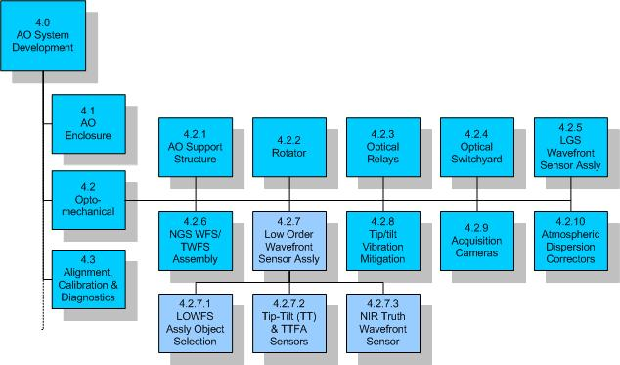
Figure 4. NGAO AO System Opto-Mechanical Work Breakdown Structure.

All of the subsystems are expected to be completed, including testing and demonstration of compliance at the subsystem level, within their WBS element. These subsystems, as well as the subsystems from WBS 6.0, are then delivered to WBS 4.6 AO system lab I&T. The output of WBS 4.6 is an AO system demonstrated to be ready for telescope I&T.

Laser System WBS
WBS 5.0 includes all of the elements related to the laser facility itself. All of the subsystems are expected to be completed, including testing and demonstration of compliance at the subsystem level, within their WBS element. These subsystems, as well as appropriate elements of WBS 6.0, are then delivered to WBS 5.6 laser system lab I&T. The output of WBS 5.6 is a laser system demonstrated to be ready for telescope I&T.

Science Operations Tools WBS
The science operations tools provide the high level coordination between the AO system, laser system, telescope and science instruments. These are the tools used to operate the NGAO system for science. The user interfaces provide the operator and astronomer interfaces to NGAO and the multi-system command sequencer provides the high level coordination. The pre- and post-observing tools are intended to support optimal observation planning and the generation of the data needed by the astronomer to make their observations scientifically useful. The data server collects and temporarily stores the required data.

Telescope and Summit Engineering WBS
This WBS covers the modifications needed to the telescope and summit facilities, and some existing science instruments, needed to integrate with NGAO. Currently there is no effort in the area of telescope performance, but we have left WBS 7.1 as a placeholder in case we find that it would be more cost effective to implement some changes to the telescopes performance than to achieve some performance aspect with NGAO.

Telescope Integration and Test WBS
This WBS covers all NGAO activities at the summit, from installation through performance characterization and science verification.

Operations Transition WBS
This WBS covers the development of operations plans and training of operations personnel. These activities will overlap in time with elements of other WBS elements, especially integration and test. The cost of operations personnel to be trained is covered by the Observatory.

Product Structure
A partial view of the Product Structure is provided in Figure 5. MS Project was chosen as the tool to maintain the product structure since it allows easy roll-up of the structure. The view shown in Figure 5 allows you to see the lowest product structure level for the rotator. This product structure was developed in parallel with the WBS.

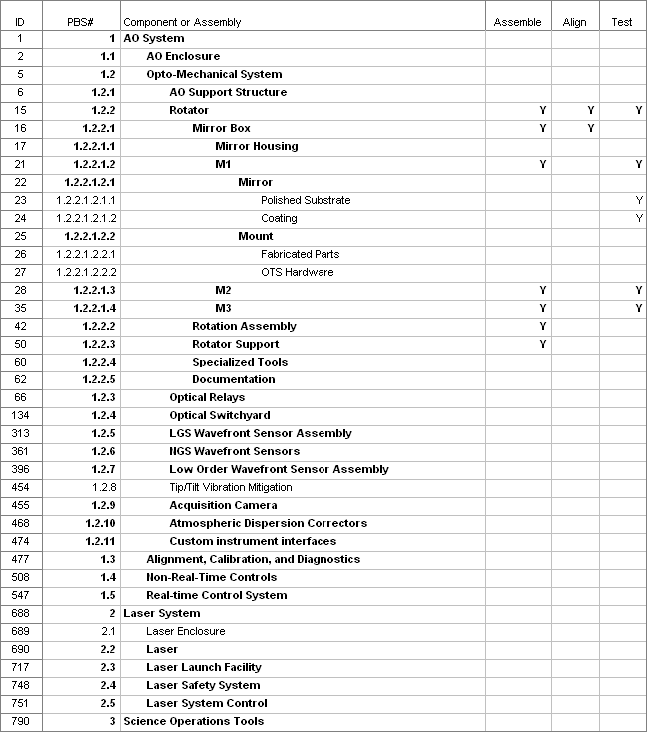
Figure 5. Partial view of the NGAO Product Structure.

Project Milestones and Schedule
The major project milestones are shown in Table 2. Our ability to meet these milestones will strongly depend on the availability and consistency of funding. It will also depend on advance knowledge of when funding will become available since it takes time to ramp up personnel and to set up contracts.

The 22 month Preliminary Design, as discussed in section 3.4, is driven by the availability of funding. The 24 month Detailed Design phase is driven by the need to allow time to significantly increase the number of personnel at the start of the Detailed Design phase. The 18 months between the end of the Detailed Design and the start of lab I&T will only be adequate if long lead procurements can be placed during the Detailed Design. The laser procurement in particular will likely need to be placed during the Preliminary Design.

Table 2. NGAO Project milestones.
Year | Month | NGAO Project Milestone
2008 | April | System Design Review
2010 | February | Preliminary Design Review
2012 | February | Detailed Design Review
2013 | February | Full Scale Development Intermediate Review
2013 | August | Pre-Lab I&T Readiness Review
2014 | February | Pre-Ship Readiness Review
2014 | May | NGS First Light
2014 | July | LGS First Light
2014 | August | 15A Shared-Risk Science Availability Review
2014 | December | Operational Readiness Review

Although a single date is shown for the pre-lab I&T and pre-ship readiness reviews there will likely be good reasons to have a separate earlier review for the laser system. In order to meet the aggressive summit installation schedule it would be ideal to be able to have the laser in place and tested on the sky prior to shipping the AO system to the summit.

WMKO’s observing time is scheduled in six month increments beginning in February and August. Generally speaking WMKO notifies the Time Allocation Committees (TACs) of instrument availability at least five months prior to the next observing semester. The NGAO summit integration effort needs to be coordinated with this process. The successful completion of the later NGAO project milestones would therefore result in notifications of AO science availability, shown in Table 3, being sent to the TACs. For example, the project milestone of a pre-lab I&T readiness review in August, 2013 would be the milestone at which we would notify the TACs that the Keck II AO system would not be available for science in semester 14A. We would be performing science verification science in semester 14B, but no AO system would be available on Keck II for TAC-allocated science for a full year in this scenario. The Keck I AO system would be available for science during this period but the Keck Interferometer would not be able to be used for a year, except for some limited science verification in semester 14B.

Table 3. TAC notifications associated with NGAO milestones.
Date | Milestone | TAC Notification for Semester
Aug, 2013 | Pre-lab I&T Readiness Review | AO system unavailable for 14A
Feb, 2014 | Pre-Ship Readiness Review | AO system unavailable for 14B
Aug, 2014 | Shared-Risk Science Availability Review | NGAO available for shared-risk for 15A
Dec, 2014 | Operational Readiness Review | NGAO available for science for 15B

Cost Estimate

Introduction
The NGAO SD Phase Cost Estimate was developed through a controlled process over a period of 10 weeks following, but somewhat overlapping the AO System Design work package element. Approximately 36 work-weeks of effort went into the generation of the SD phase cost estimate, including generation of the full project WBS Dictionary, labor, non-labor, and travel estimation, science/technical performance iterations, and consistency verification. The estimate was conducted by a dozen estimators who are all technical experts and in most cases are expected to be involved in the execution of the NGAO project plan. Approximately half of the estimators have had extensive prior cost estimation experience on complex opto-electro-mechanical instrumentation projects. A full description of both the estimation process and estimator guidelines for our System Design phase cost estimate is provided in KAON 546.

Project Scope
The NGAO project includes a new Nasmyth-based adaptive optics instrument, comprised of a K-mirror-fed, wide-field optical relay followed by a laser guide star wavefront sensor assembly, a narrow-field science optical relay and high order NGS wavefront sensor, and a low-order natural guide star wavefront sensor assembly for use on an interim basis until the delivery of the dIFS instrument (not included within NGAO scope). NGAO also includes a a thermally-controlled AO instrument enclosure, an AO instrument diagnostics and calibration unit, and two “truth” wavefront sensors necessary to maintain precision wavefront control.

NGAO includes a new laser guide star launch facility, consisting of a baseline 100W of CW sodium D₂-line laser power providing an assumed total of ~10 photons/cm²/millisecond returning to the telescope aperture from a median abundance sodium layer, divided into six laser guide stars. This laser asterism and power are sufficient for all NGAO narrow-field science goals. In addition, the NGAO system includes a laser projection and wavefront sensing system that supports expansion to 150W total laser power and nine laser guide star beacons and wavefront sensors, sufficient to support wide-field d-IFS science. The cost estimate presented here includes the entire projection capability and wavefront sensing for all nine laser beacons, but does not include the purchase of the incremental 50W of laser power required only by the d-IFS instrument.

Regarding instrumentation, the NGAO SD phase cost estimate does not include delivery of any new back-end science instruments per se, as these will be developed as separate WMKO projects. However, we do include all modifications to OSIRIS and the Keck Interferometer (KI) necessary to enable their use with NGAO.

Cost Estimation Process

Objectives
The primary objective of the SD phase cost estimation effort was set out to develop a comprehensive estimate of the total NGAO project cost, excluding science instruments. This includes the costs for engineering, design, analysis, procurement, fabrication, assembly, inspection, administration, installation, and commissioning of the telescope, instrumentation, and support facilities.

The cost estimates were prepared by responsible technical experts who are experienced in the various fields required to design, build, and commission the NGAO system. Vendor quotations, engineering calculations, analogies based on prior telescope programs, and parametric cost estimates were collected according the lowest level of full-project Work Breakdown Structure and by project phase. Approximately 300 BOE’s were generated by ~12 estimators and organized into the NGAO SD Phase Cost Book. This documentation will include the basic configuration information and list all critical assumptions used during the estimating process. Two sample cost estimation sheets can be found in the Appendices in Sections 6 and 7.

Large, complex, and challenging projects entail uncertainty and cost risk. A contingency to cover anticipated costs resulting from this uncertainty has been developed using standardized risk analyses as established in the cost estimating plan. Contingencies have been developed at the same level of the WBS used to prepare the cost estimates.

NGAO costs will be monitored and controlled over the life of the project. The cost estimate has been integrated with the project schedule to establish a time phased budget baseline. This time-phased budget has been developed in detail for the Preliminary Design phase and at an annual cost level for the full NGAO project. A more formal project management control system will be established in the PD phase to compare actual costs with the project’s budget baseline and the work accomplished.

The NGAO SD phase cost estimate is a detailed bottom-up estimate performed at the lowest reasonable level within available time. The estimate is based on the project Work Breakdown Structure (WBS), a product-oriented hierarchy that identifies all the elements of the NGAO project and their parent/child relationships. The scope of work for each WBS element will be described thoroughly in the NGAO WBS Dictionary. Each lowest-level WBS element has been estimated independently for each program phase including Preliminary Design, Detailed Design, Construction, and Commissioning. The cost estimate for each activity shall be based on the scope of work defined for the WBS element for each defined program phase. Where strong parametric relationships have been established for specific portions of the estimate, a Cost Estimating Relationship (CER) has been utilized and referenced in the BOE. All estimates are given in Base Year (2008) dollars.

Project Phases
For each BOE, the full cost-to-completion will be subdivided into four project phases as shown in Table 4.

NGAO Project Phase | Phase Code | Duration
Preliminary Design | PD | 22 months
Detailed Design | DD | 24 months
Full Scale Development | FSD | 24 months
Delivery and Commissioning | DC | 18 months
Table 4. NGAO Project phases and durations.

The durations are tentative for the purpose of the System Design phase cost estimation task and will be updated for future revisions of the project cost estimate. The majority of the work in the DC phase will be expended in the first 12 months, but the DC phase allows for an 18-month phase to fully complete transition to routine science operations.

For guidance on the level of maturity of design, we adopt for this costing exercise the WMKO Instrument Development Program Definitions of project phases (Adkins, S., “An Overview of the WMKO Development Phases”, December 8, 2005). This is, in part, as follows:

Preliminary Design

The preliminary design phase has two primary objectives. The first objective is to deliver documented designs for each system, sub-system and component, hardware or software, of sufficient detail to establish through inspection and analysis the feasibility of the proposed design, and the likelihood that the design will meet the requirements. The second objective is to present the project plan to completion, including a detailed schedule and budget.

Detailed Design

The detailed design phase has two primary objectives. The first objective is to complete the design, fabrication and assembly documentation for the system and all components, hardware or software, and show that the final design complies with all specifications and applicable standards. The second objective is to present the project plan to completion, including a schedule and budget.

Full Scale Development

The full-scale development phase builds the hardware, codes the software and integrates the complete system and performs laboratory testing culminating in the completion of an acceptance test plan followed by a pre-ship review.

Delivery and Commissioning

The objective of the delivery and commissioning phase is to install the AO instrument on one of the Keck telescopes, verify the correct operation of all hardware and software, perform first light observations and gather the data needed to complete the Acceptance Test Plan.

Costing Methodology
Each WBS Estimator provided data for each activity within the WBS, categorized by specific labor category, non-labor category, or travel. Each item in the cost estimate was tagged with a descriptor that characterizes the method used to derive the estimate. The categories established for this project in decreasing order of general confidence, and the associated code for entry in the Cost Estimating Input Form, are shown in Table 5.

Estimating Methodology | Input Code
Direct Historical Data (“done before”) | DH
Catalog Prices | CP
Vendor Quotes | VQ
Cost Estimating Relationship | CER
Engineering Estimate | EE
Table 5. Estimating Methodology

Each methodology is defined in the following fashion:
- Direct Historical Data - The use of costs demonstrated in immediate, applicable history for the same product or service.
- Catalog Prices - A known, advertised price from a potential supplier for a specific product or service.
- Vendor Quote - A quote from a potential supplier within the program estimate. Note: although useful to refining our current cost estimates, a balance must be found that satisfies project needs while not alienating vendors who often commit considerable resources for the generation of detailed price quotes.
- Cost Estimating Relationship – An estimate based on parametric relationships, analogy to another program, or by “Rule of Thumb.”
  - Parametric Estimate – A statistical model based on characteristics and costs of multiple previous observations.
  - Estimate by Analogy - Scaling of costs demonstrated in previous observations using subjective or objective factors.
  - Rule of Thumb - General cost relationships demonstrated by informal studies of past programs.
- Engineering Estimate – An estimate based on the judgment of a recognized authority.

Resource Pricing
Labor, Non-Labor, and Travel costs have been based directly on information provided by the cost estimator. All Labor Resource estimates were provided in hours of direct effort required to complete the work package and/or perform the task; the cost of labor resource estimates was calculated within the cost estimating system utilizing the hours estimated. Non-Labor expenses such as materials, subcontracts, and non-travel direct costs were estimated based on the unit cost and number of units required. Travel costs were based on the number of trips, general trip location, and duration of the trip. A narrative rationale for each resource estimate was developed and included in the estimate BOE.

Labor Resources
Average NGAO labor rates for each labor category will be used when available for pricing direct labor. The labor categories used in the estimating process, the associated code for entry in the Cost Estimating Input Form, and comparable Salary Grade are provided in Table 6.

Resource | Input Code | Salary Grade
Technical Functions:
Post Doc | PostDoc | A
Technician | Tech | A
Junior Scientist / Engineer | JunSci | B
Associate Scientist / Engineer | AssoSci | C
Information Tech. Specialist | IT | C
Senior Scientist / Engineer | SrSci | D
Lead Scientist / Engineer | LdSci | E
Free Labor | FL | $0 / hr
Business Functions:
Administrative I | AsstAdmin | A
Administrative II | AssoAdmin | B
Management Functions:
Subsystem Manager | SubMgr | E
Project Manager | ProjMgr | E
Table 6. Labor categories.

All estimates were provided in hours of productive effort required to accomplish the task. The rates used to price labor hours have been adjusted to include paid leave such as sick leave, vacations, holidays, etc. For estimating purposes, the typical 2,080 hour working year has been reduced to 1,800 hours to account for the expected annual productive hours. The hourly labor rates have been adjusted such that 1,800 productive hours is priced at a full year of salary. In addition, all fringe benefits and other indirect costs have been included and applied by the cost estimating system utilizing demonstrated burdening factors.

NGAO salary grades A-E were converted into quantitative labor rates using a blending of known WMKO, COO, and UCO/Lick salary rates, corresponding to specific individuals classified in these categories, and in approximately equal contribution among the NGAO partner institutions. Detailed salary figures are not included here in order to protect privileged personnel information however, we can report this summary labor rate information:

- The weighted-average salary of all labor on the NGAO project equals FY08 $92,700 per annum without benefits burden or FY08 $116,800 per annum including a 26% burden.

This corresponds to an equivalent rate of $116,800 / 1,800 = $65 / productive work hour. Excluding free labor the equivalent rate becomes $75 / productive work hour.

Non-Labor Expenses
All non-labor and non-travel expenses that will be directly charged to NGAO have been included as a non-labor expense estimate. This includes, but is not limited to, all subcontracts, materials and equipment, and shipping costs. All non-labor estimates have been placed into the appropriate category to identify the type of activity that will take place. The categories, and the associated code for entry in the Cost Estimating Input Form, are provided in Table 7.

Category | Input Code
Equipment | EQP
Material | MAT
Subcontract | SUB
Shipping | SHIP
Other Direct Cost | ODC
Table 7. Non-labor categories.

Travel
All travel in support of an activity has been included as part of the input sheet submitted for that item. Travel estimates were performed by determining the number of trips that will be required based on the general location and duration. Travel destinations and durations, and the associated codes for entry in the Cost Estimating Input Form, are shown in Table 8 and Table 9, respectively.

Destination | Input Code
Intra - California | CALIF
Hawaii - California | HAWAII
International (Origination/Destination unspecific) | INTER
Other locations not included in above list | OTHER
Table 8. Travel destination categories.

Duration | Input Code
Extended: More than three weeks. | EXT
Long: Greater than one week but less than 3 weeks. | LONG
Mid: Greater than 3 days but less than 1 week. | MID
Short: Three days or under | SHORT
Table 9. Travel duration categories.

Travel applicable to conferences, project-wide reviews, outreach, and funding source meetings has been included as costs in the NGAO Project Management WBS 2 element and not as part of the input sheets submitted for a particular item.

Estimators assumed that entire Level 3 WBS elements (e.g. WBS 4.4) will be executed entirely within a single partnership organization. (I&T elements, of course, will require multiple institution participation and are expected to require considerable travel.)

We have included the labor costs for travel itself (e.g. time ‘sitting on a plane’) in the travel section of our cost summarizes, depending on the duration of each flight. Estimators therefore included in their WBS element labor resource estimates only the actual work hours spent at the destination site, and not labor hours while traveling.

Shipping
Shipping for each element to its integration point, assumed to be WMKO headquarters facility in Kamuela, HI, has been included with the estimate for that cost element. The cost of shipping integrated elements from WMKO to the summit has been estimated as a cost for the Integration and Test element of the WBS. Insurance costs for all shipments between California and Hawaii have not been specifically included, as each of WMKO, COO, and UCO/Lick typically self-insures.

Sales Tax
We assume the NGAO project will incur sales / use taxes on some but not all purchases, depending on the organization making the purchase, the location of the vendor, and other factors. Out-of-state procurements are charged sales tax in California but not in Hawaii. Based on a cursory assessment of a plausible procurement division between the NGAO partners, we have currently adopted an ‘effective’ sales tax rate of 3.00% which we apply to all non-labor EQP and MAT cost categories.

Cost Estimates

Estimate to Completion
Our System Design phase full project Estimate to Completion (ETC) based upon the above described methodology is summarized as a function of WBS in Table 10 and by NGAO project phase in Table 11.

We note that labor and non-labor costs (which includes some labor costs as subcontracts) are comparable to one another. Compared with previously built AO systems, this ratio overweights project labor, reflecting our belief that NGAO will require significant systems engineering, software development, I&T, and telescope commissioning to ensure satisfaction of all flow-down requirements to ultimately meet performance goals.

WBS | WBS Title | Prelim. Design | Detailed Design | Full Scale Develop-ment | Delivery & Commiss. | Base Cost  ($K, FY08) | Contin-gency | Total
2 | Management | 874 | 1,232 | 1,594 | 657 | 4,356 | 318 | 4,674
3 | Systems Engineering | 811 | 1,004 | 478 | 193 | 2,485 | 401 | 2,886
4 | AO System Development | 730 | 2,208 | 9,742 | 3 | 12,683 | 3,849 | 16,533
5 | Laser System Development | 285 | 1,947 | 6,619 | 128 | 8,980 | 1,935 | 10,915
6 | Science Operations | 166 | 756 | 646 |  | 1,568 | 233 | 1,801
7 | Telescope & Summit Eng. | 95 | 424 | 1,049 | 19 | 1,587 | 344 | 1,932
8 | Telescope Integr. & Test | 46 | 106 | 114 | 1,944 | 2,211 | 525 | 2,735
9 | Operations Transition | 14 | 20 | 555 | 70 | 660 | 91 | 750
 | Sub-Totals ($K, FY08) | 3,021 | 7,697 | 20,797 | 3,015 | 34,530 | 7,697 | 42,227
Table 10. NGAO cost estimate (in FY08 $k) by WBS

Phase | Labor (PY) | Cost Estimate (FY08 $k) |  |  |  |  |  | % of NGAO Budget
Phase | Labor (PY) | Labor | Non-Labor | Travel | Sub-Total | Contin-gency | Total | % of NGAO Budget
Preliminary Design | 21.0 | 2,582 | 216 | 224 | 3,022 | 458 | 3,479 | 8%
Detailed Design | 43.6 | 5,516 | 1,827 | 354 | 7,697 | 1,403 | 9,100 | 22%
Full Scale Develop | 50.5 | 5,661 | 14,510 | 626 | 20,797 | 5,234 | 26,031 | 62%
Delivery/ Commission | 22.4 | 2,287 | 250 | 478 | 3,015 | 602 | 3,617 | 9%
Total = | 138 | 16,045 | 16,804 | 1,681 | 34,531 | 7,697 | 42,227 | 100%
% = |  | 38% | 40% | 4% | 82% | 18% | 100%
Table 11. NGAO cost estimate (in FY08 $k) by project phase.

Cost Comparison
In order to provide ourselves with an external check of our ‘bottom-up’ cost estimation methodology, we have tabulated the known, expected, or budgeted costs of several comparable AO systems, which we present in Table 12. The notes associated with this Table can be found in Table 13.

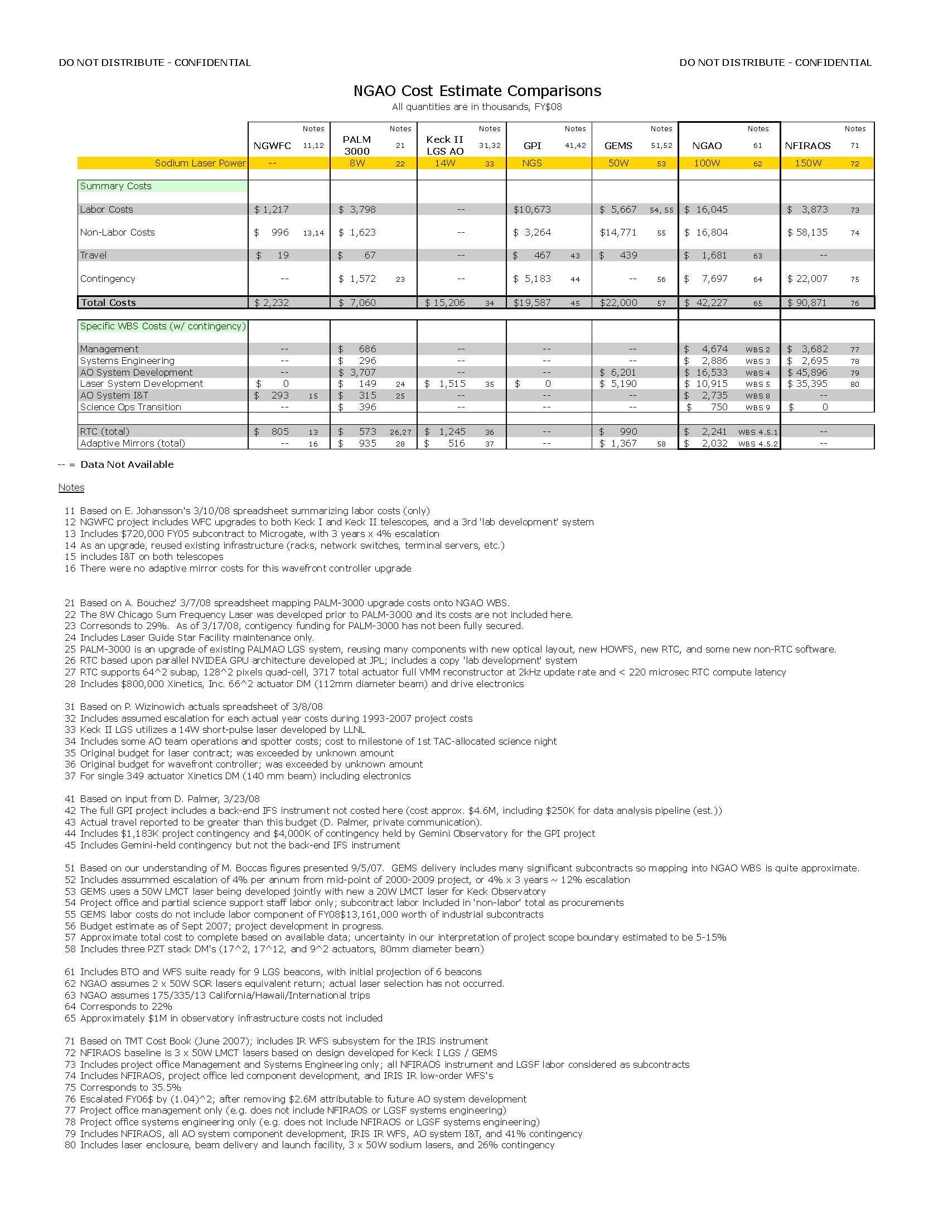
Table 12. NGAO cost comparison to similarly complex AO systems.
Table 13. NGAO cost comparison notes.

Although we believe our bottoms-up estimate to be solid, we gain additional confidence in our cost estimates by comparison with independent costing of similar recent and proposed AO systems, as shown in Table 12. Compared to the original Keck II LGS system, for example, our NGAO estimate has significantly increased, as expected, reflecting the greater technical challenge of achieving better wavefront control. Much of the additional cost for NGAO arises from the need for ~ 10 photons/cm²/millisecond returning from the sodium layer to the telescope aperture at zenith, more than 10 times that from the current Keck II LGS system. The approximately $27M greater cost for NGAO is roughly attributable to ~$9M more for lasers, ~$6M more for wavefront sensors, ~$3M more for the 2nd stage AO relay, approximately ~$5M more for increased labor due to greater systems engineering and I&T complexity, and ~$4M greater contingency.

Compared with Gemini GPI, which uses a similar MEMS DM to our baselined NGAO 2nd relay DM, our bottom-up NGAO cost estimate, excluding the laser system (WBS 5) for a fairer comparison with the NGS GPI system, is somewhat higher, reflecting the multi-instrument and multi-functional nature of NGAO. The approximately $23M greater NGAO cost, relative to GPI, can be attributed as ~$13M to the 100W laser system (including contingency), ~$5M to wavefront sensors, and ~$6M to greater system complexity.

Compared to the Gemini South MCAO system, GEMS, the incremental cost of NGAO is also attributable in a self-consistent way. The approximately $20M additional cost for NGAO is attributable to approximately ~$4M for greater laser costs (100W v. 50W), ~$4M for wavefront sensors, ~$1M for real-time-computer, ~$3M for the 2nd stage AO relay, $4M for greater system complexity, and $4M for increased contingency (all relative to the GEMS baseline budget.)

Compared with the TMT NFIRAOS budget, our NGAO cost estimate is significantly less, reflecting we believe an overall lower technical and cost risk, incorporating our understanding of costs incurred on the original Keck II LGS AO system. From a component perspective, NGAO saves cost on the laser guide star facility, less expensive piezostack DM(s) (requiring less stroke), less expensive LGS WFS detectors (offset by our need for nine vs. six sensor channels), less expensive LGS WFS optics and mechanics, and less expensive instrument structure and enclosure. We also project lower RTC costs relative to NFIRAOS, in part due to improved computing components and architecture, and in part due to a different development model. Moreover, the use of existing components in nearly all NGAO subsystems eliminates the need for component development. Finally, we have elected an approach to laser procurement that carries some risk, namely a collaborative laser development, as opposed to TMT’s commercial procurement strategy. Resolving this major project risk is a key goal for the preliminary design phase.

Preliminary Design Phase Cost Estimate
A more detailed breakdown of costs during the preliminary design phase is shown in Table 14. This table shows the WBS level at which the cost estimate was prepared. Similar tables for the other three project phases, and the overall total cost, are provided in the Appendices in Sections 8 to 11.

Our division of effort in the Preliminary Design phase emphasizes systems engineering (including further refinement of the science case and flow down requirements, such as astrometric requirements), AO system development, and laser system development. WBS 2, Management, includes project-wide support, including items such as software licenses that are shared resources not directly attributable to specific NGAO subsystems.
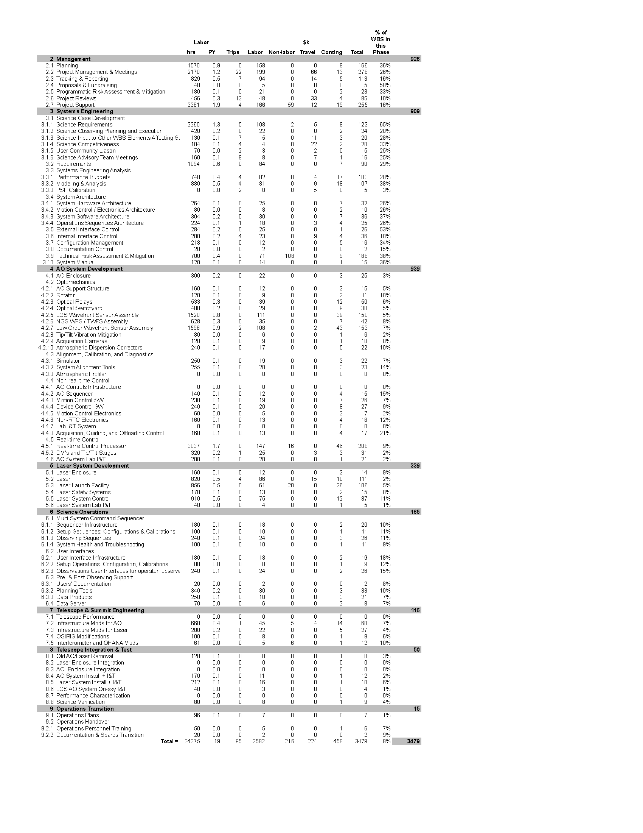
Table 14. Preliminary Design phase cost estimate (FY08 $).

Key Cost Risks
The single largest known component cost uncertainty is associated with the NGAO sodium guide star lasers. Our strategy for procurement of appropriate guide star lasers relies on early negotiation and establishment of the principle of technology transfer from the StarFire Optical Range (SOR) in Albuquerque, New Mexico. In the event that access to SOR technology is precluded for whatever reason, increased costs for sodium guide star laser procurement may be incurred. Depending on commercial vs. academic options, this outcome could increase NGAO laser costs by several million dollars.

NGAO programmatic risk also causes us to incur financial risk. The NGAO project is structured to rely on successful raising of private instrument funding, as it is not expected to be feasible within the envelope of Keck Observatory operations and TSIP-generated instrumentation funds alone. In particular, the proposed $3.4 million preliminary design phase expenditure represents a significant outlay risk to the Observatory. If private funding is not successful and the NGAO project suspended at or before PDR, a significant fraction of this investment will be lost. Offsetting this, the NGAO management team has identified the following durable benefits to WMKO to be achieved by NGAO PDR:

- Installation of a MASS/DIMM atmospheric profilometer at Keck Observatory, enabling improved on- and off-axis PSF calibration with the existing Keck AO systems.
- Demonstration of ‘single laser’ tomography algorithms that are expected to reduce focal anisoplanatism error, the dominant wavefront error source for the center-projected Keck I LGS AO system.
- Prototyping work of infrared LOWFS subsystems in the NGAO PD phase will result in hardware that could be used as part of a single-channel near-IR tip/tilt sensor for Keck I or Keck II AO. Implementation of such a sensor would require a separately funded WMKO project, but the NGAO investment is estimated to be > 50% reallocatable.
- Improved designs for atmospheric dispersion correctors could benefit the Keck LGS AO systems, even if NGAO did not proceed beyond PDR.

Potential Cost Savings
During the Preliminary Design phase, we intend to explore a number of specific issues that we believe have the potential for significant cost savings. Each of the following questions will be answered within the first six months of the PD phase:

- Is the cost/benefit ratio of ‘Point and Shoot’ TT and TTFA star sharpening justified by a detailed analysis?
- Is LGS HOWFS barrel rotation, selected in the SD Phase on the basis of wanting one-to-one subaperture to DM actuator registration, necessary, or can sufficient performance be achieved by developing reconstructors that encode the variable (but known) pupil rotation geometry. We will engage with ESO and/or TMT to seek mutual benefit from such investigations.
- Can uplink AO sharpening of our sodium beacon be cost-effectively implemented to reduce the total NGAO sodium laser power requirement?
- Can one or more Rayleigh beacons be cost-effectively implemented to either 1) reduce the number of NGS IR LOWFS stars from three to one (potentially saving ~$1M) and/or 2) reduce the total sodium laser power requirement (by augmenting expensive sodium photons with low-cost Rayleigh photons)?

In addition, we will actively monitor other activities underway around the world that may lead to component cost savings, such as better understanding of sodium return as a function of laser spectral content and pulse format, and advances in fast frame rate, low noise CCD development.

Estimate Refinement
In developing the next iteration of the cost estimate during PD phase, we will refine the estimate to include a more fulsome development of the lowest level WBS available. We will increase our direct communications with vendors and move a larger fraction of cost estimates into the Vendor Quote (VQ) category. We will also refine our labor rates to reflect actual rates of specific individuals identified as assigned to each WBS element and/or cost account. Finally, we expect to refine the bases of estimate to replace a substantial fraction of estimates classified as Engineering Estimate (EE) to our increasingly higher fidelity bases: Cost Estimating Relationship (CER), Direct Historical (DH), and Vendor Quote (VQ) respectively.

Risk Assessment and Management
A programmatic risk assessment was performed and documented in KAON 566 along with proposed mitigation efforts. A technical risk assessment and mitigation plan was similarly documented in KAON 510. Both KAONs use the JPL risk management approach of ranking risks by likelihood and consequences.

Configuration and Documentation Management
There are a number of configuration items that will need to be managed. These include requirements, interface definitions, designs, plans, spares inventory, etc.

Documentation management is expected to be performed with the following tools:
- All technical and programmatic notes to continue to be given a Keck Adaptive Optics Note (KAON) number. These documents will be maintained on the NGAO Twiki site and also on the more protected Keck Docushare site.
- Requirements to continue to be maintained in the Contour database (see section 2.9).
- Interface definitions to be input and maintained in the Contour database.
- SolidWorks mechanical models to be maintained in a shared repository. Mechanical drawings to ultimately be maintained within the Keck Mechanical group database using assigned numbers.
- Electronics drawings to be maintained within the Keck Electronics group database using assigned numbers.
- Spares inventory to be integrated within the Keck Electronics group spares inventory.
- Preventative maintenance tasks to be integrated within the Keck Facilities group preventative maintenance program database.

An NGAO Configuration Control Board (CCB) will be formed to review and approve changes to the requirements, interfaces, designs and drawings. The CCB will use similar tools and procedures as used by existing Keck CCBs (for example the AO CCB and the Interferometer CCB). Keck’s existing Engineering Change Request (ECR) and Field Change Notices (FCN) will be used to request approval for changes.

The requirements and interface definitions will fall under CCB responsibility during the Preliminary Design phase. Design changes will fall under CCB responsibility during the Detailed Design.

CCB responsibilities will be handed over to a Keck operation’s CCB at the time of the Operability Review.

Interface Definition
Both external and internal interfaces will be defined during the Preliminary Design phase. An N-squared diagram will be developed for interfaces between NGAO subsystems.

Requirements Management and Compliance
KAON 573 describes our approach to requirements development and management. All requirements from the Science Case Requirements (KAON 455) and System Requirements (KAON 456) Documents, as well as the Functional Requirements, are maintained in a requirements management software database (e.g., the Contour tool by JAMA software). This database is web accessible from each of our three institutions.

Compliance testing versus requirements will be performed at the subsystem, system and science levels, corresponding to the functional, systems and science requirements, respectively as shown in Figure 6.
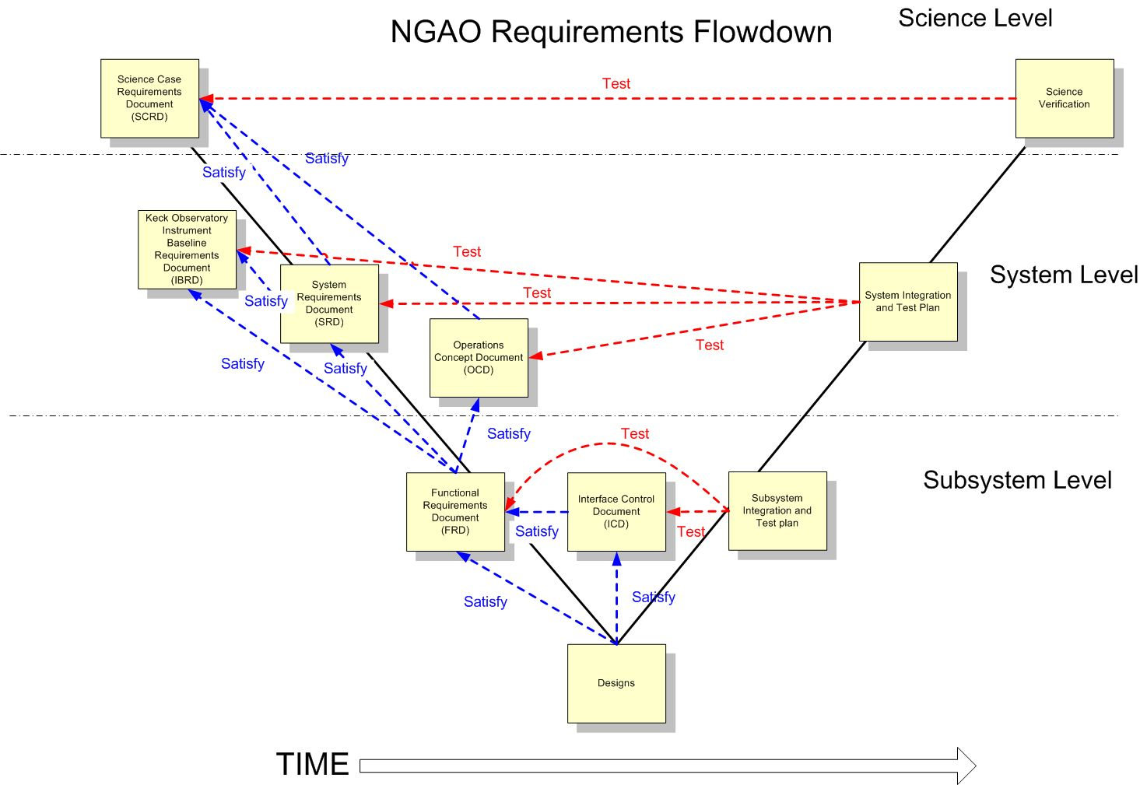
Figure 6. Modified V-diagram shown the requirements flowdown and relationship to testing.

Integration and Test
Our approach to integration and test is documented in KAON 581 and is shown schematically in Figure 7, along with the WBS numbers for each activity. This Figure is divided into subsystem development, lab I&T, summit preparation and telescope I&T sections. A philosophy that will be followed throughout this process is for subsystems and systems to be complete, including testing versus requirements, prior to transitioning to the next phase. This will be ensured by appropriate Reviews.

The subsystem development (WBS 4.0 to 6.0) and summit preparation (WBS 7.0) phase begins with the successful completion of the Detailed Design Review. These subsystems are intended to be complete and fully tested at the subsystem level prior to system lab I&T. Their readiness, as well as the readiness of the lab facilities, will be evaluated at a pre-lab I&T Readiness Review. The AO and laser systems undergo separate lab I&T efforts since they can largely be treated independently.

Readiness of the AO and laser systems, as well as the summit infrastructure to proceed to telescope I&T will be evaluated at a pre-ship review. Successful completion of this review will result in installation at the telescope followed by a sequence of I&T activities.

The pre-lab and pre-ship I&T Readiness Reviews will likely be separate events for the laser and AO system. Ideally the laser would have been implemented on the telescope prior to the AO system pre-ship review in order to minimize the time between decommissioning the existing AO system and implementing NGAO.

The Operability Review is a milestone intended to mark the point where the system and operations are ready to support shared-risk science observations. The system will continue to be characterized and optimized prior to the final handover to operations and regular science operations which will be marked by the Operations Readiness Review.

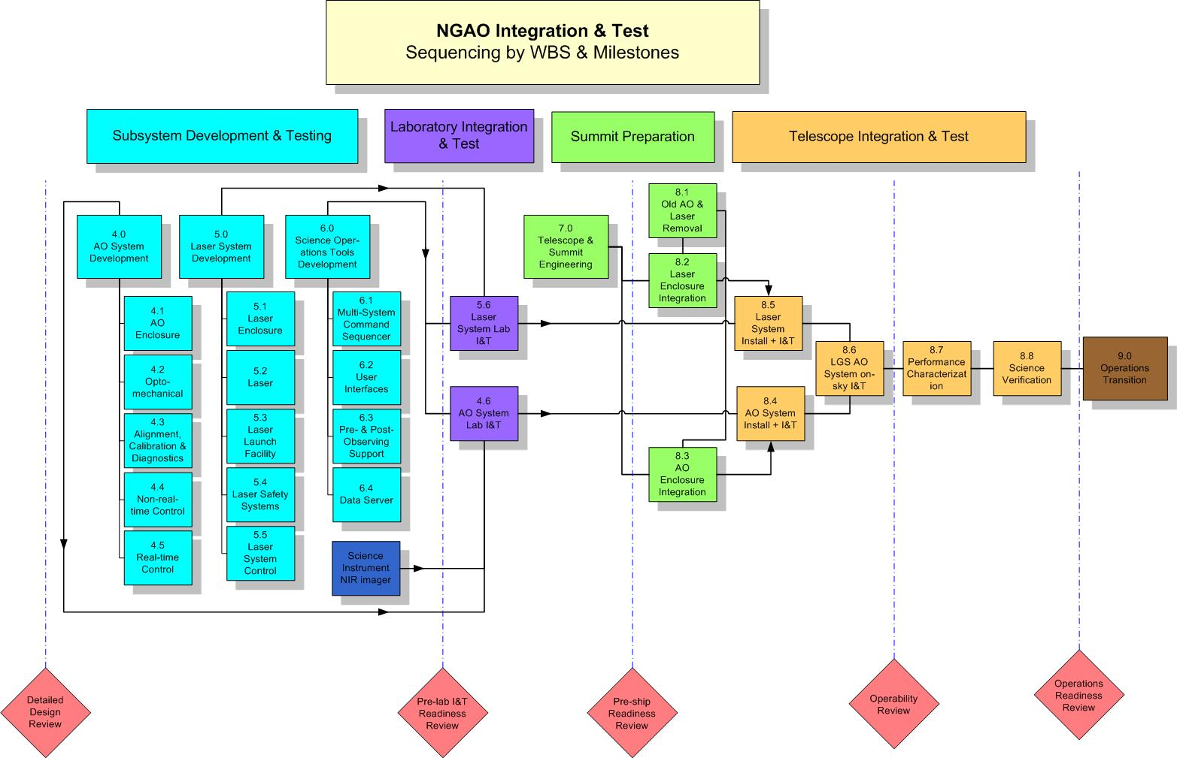
Figure 7. NGAO Integration and Test Approach.

Component Failure and Spares Approach
Two component failure issues need to be addressed: failures during development and failures during operations. The impact of failures during development and operations are different. Spares are one way to address failures and need to be considered in this context. Highly reliable components should be the standard.

The impact of a component failure depends on the development phase, its criticality to the subsystem and overall system, and the required time to troubleshoot, repair or replace the component. The failure of a key component during subsystem development could potentially result in the late delivery of a subsystem and the delay of system integration and test. The failure of a key component during lab or telescope integration and test could result in significant cost and schedule impacts.

A component failure during a science night must be addressed immediately, preferably by having a back-up mode of the instrument that does not require this component. It is important to have good tools and procedures for quickly identifying and repairing or replacing the failed component. The failed component should be able to be replaced or repaired prior to the next night or in the worst case before the next observing run.

A preventative maintenance program is required during operations to minimize the chance of component failures and to ensure the early detection of components that are starting to fail.

Failures can be addressed by a combination of troubleshooting and repair procedures, good component documentation, proper sparing, team expertise and vendor support (potentially including maintenance contracts).

Some component failures are more likely to happen during development than operations. Infant mortality is most likely during subsystem development, where more time is potentially available to replace it. An optic is more likely to be broken as it is being shipped or integrated during subsystem, lab or telescope integration.

For cost reasons not everything can be spared. We must therefore focus on the most critical components and the limited lifetime components. The likelihood and impact of a failure needs to be considered.

A partial list of key components and their recommended sparing was developed during the SD phase and was incorporated in the cost estimate. This list will be further defined during the remaining design phases. The sparing recommendation needs to include the number of units in the system, and some analysis of the consequence and likelihood of failure during both development and operations. This list could be integrated into the Product Structure MS Project tool.

Preliminary Design Phase Plan

PD Phase Management
The Preliminary Design (PD) Phase management structure was shown in Figure 1.

Leadership responsibilities for specific parts of the preliminary design are indicated in the MS Project Plan in section 3.5.

PD Phase Overview and Deliverables
The PD phase is the second design phase for WMKO development projects. This phase follows the system design and precedes the detailed design phase.

In the Observatory’s development program, the preliminary design phase has two primary objectives. The first objective is to deliver documented designs for each system, subsystem and component, hardware or software, of sufficient detail to establish through inspection and analysis the feasibility of the proposed design, and the likelihood that the design will meet the requirements. The second objective is to present the project plan to completion, including a detailed schedule and budget.
The principal activities of the preliminary design phase are design, prototyping, simulation and analysis. The key deliverables are preliminary technical specifications, requirements for subsystems, a preliminary Operations Concept Document, Interface Design document(s), and a Preliminary Design report.

PD Phase Work Breakdown Structure
The WBS structure for the Preliminary Design is identical to this WBS numbering in Figure 3 except that each WBS element number is preceded by “1.3” and there is no WBS 1.3.1. For example, WBS 1.3.2 is the Preliminary Design Phase Management and WBS 1.3.4.1 is the preliminary design of the AO enclosure. This approach to the design phase WBS numbering was chosen to allow a separate budget and plan for the design phases.

PD Phase Planning Assumptions
The following assumptions were used in producing the preliminary design phase plan:

- The collaboration between WMKO, COO and UCO would continue in the PD phase.
- The NGAO Preliminary Design is funded by the NSF TSIP at $2M.
- The remainder of the NGAO Preliminary Design is funded by WMKO.
- The available funding profile is $455k in FY08 (starting May 1) and $2000k in FY09.
- Since the PD phase cost estimate is $3479k the remaining $1024k is required in FY10.

The estimated PD phase cost when combined with the above funding profile resulted in a 22 month PD schedule, with a Preliminary Design Review date of February 22, 2010, as shown in the next section. This assumes that we can ramp up from an average spending rate of $167k/month in FY09 to a rate of $205k/month in FY10.

PD Phase Schedule
The level three version of the PD schedule (ignoring the initial “1.3”) is shown in Figure 8 through Figure 15. The complete PD schedule can be found in section 12. The schedule includes WBS numbers, task names, initials of the task lead, number of work hours and start and end dates.

The approach to developing this schedule was to: 1) develop the WBS and product structure, 2) incorporate this structure into an MS project plan, 3) apply the work hours from the cost estimation work sheets, 4) apply resources to the MS project plan, 5) iterate to produce a realistic schedule and 6) iterate to produce a realistic budget. Links have only been used sparingly so far in this schedule due to their tendency to move tasks in unusual ways. Some non-PD phase tasks are included with zero hours in order to maintain WBS numbering for future phases.

We will track performance versus this baseline schedule. We will also update this schedule, with the original baseline maintained, as needed during the PD phase to ensure we achieve the PD goals within schedule and budget. Three potential replanning windows are included in the plan to address new information about the design or such issues as changing personnel availability or external constraints. Replanning activities not required will be returned to the contingency pool.

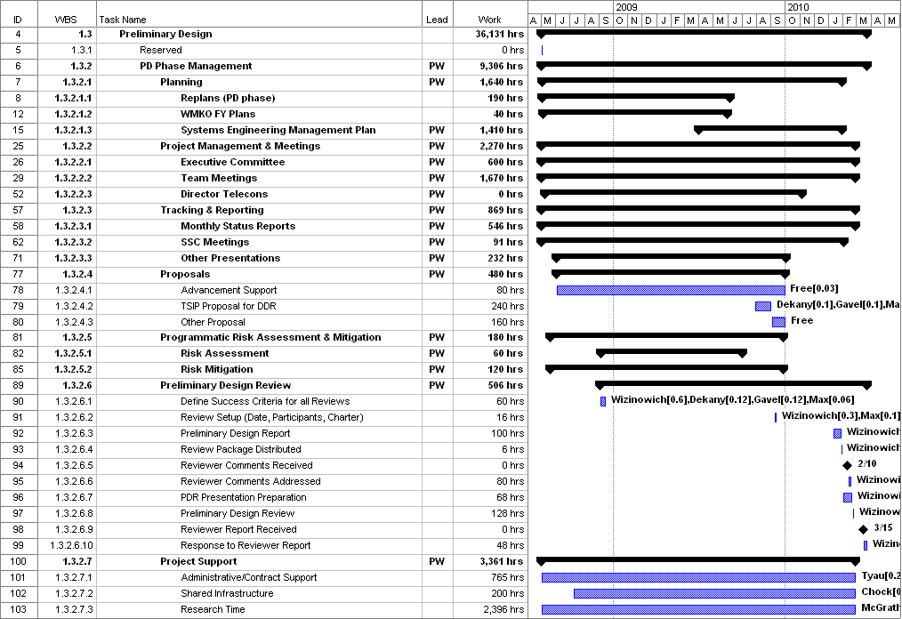
Figure 8. PD phase Management schedule (WBS2).

The WBS dictionary definitions and deliverables for the PD phase elements can be found in KAON 583. The design approach for the real-time controller (WBS 1.3.4.5.1) is somewhat atypical and therefore is described in more detail in section 13.

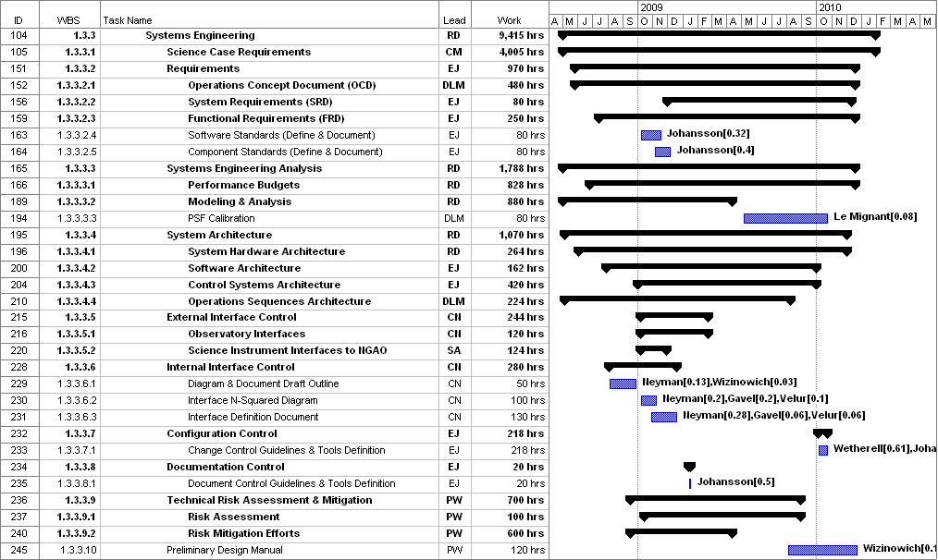
Figure 9. PD phase Systems Engineering schedule (WBS3).

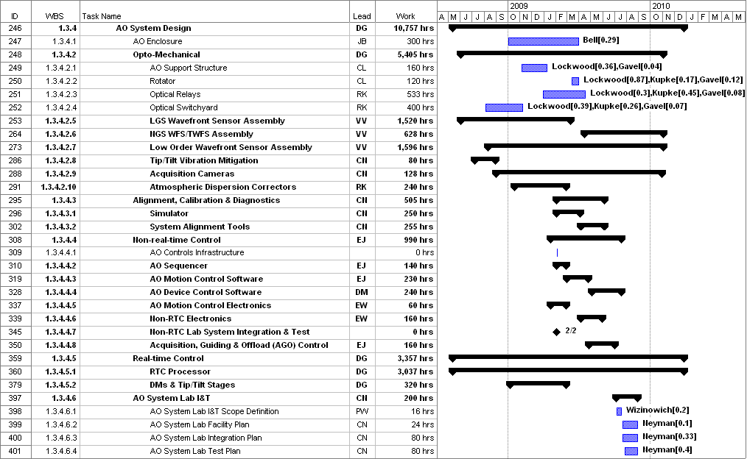
Figure 10. PD phase AO System schedule (WBS4).

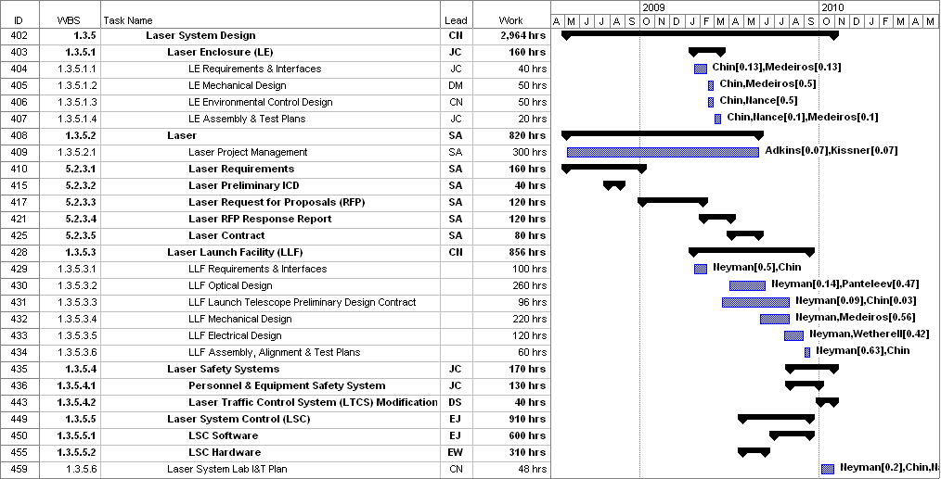
Figure 11. PD phase Laser System schedule (WBS5).

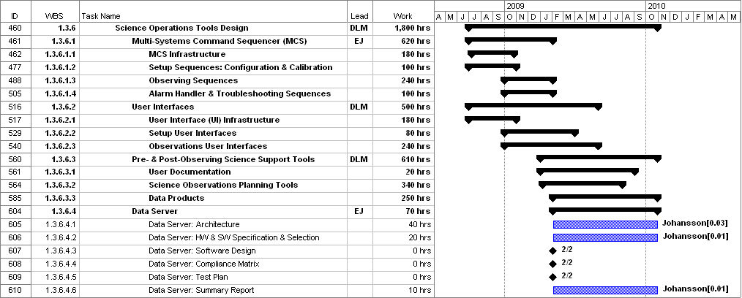
Figure 12. PD phase Science Operations Tools schedule (WBS6).

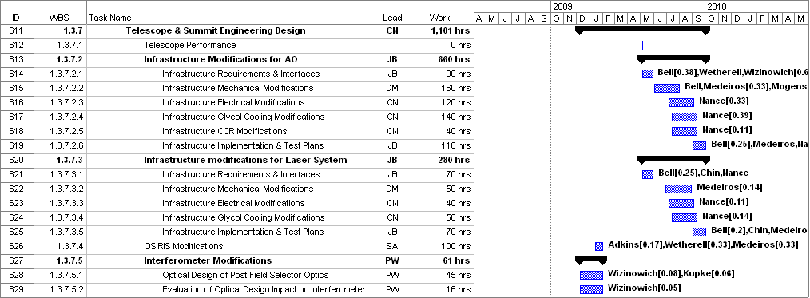
Figure 13. PD phase Telescope and Summit Engineering schedule (WBS7).

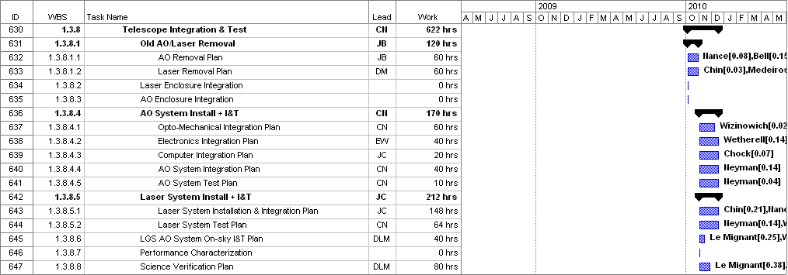
Figure 14. PD phase Telescope Integration and Test schedule (WBS8).

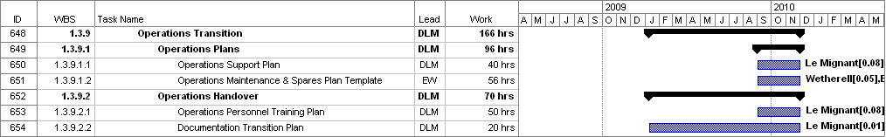
Figure 15. PD phase Operations Transition schedule (WBS9).

PD Phase Milestones
Major milestones for the NGAO PD phase are shown below in Table 15. These milestones are consistent with the PD phase schedule discussed in section 3.5.

Table 15: Milestones
Year | Month | NGAO Project Milestone
2008 | May | Preliminary Design phase begins
2008 | October | Functional Requirements PD Release 1
2009 | March | Operations Concept Document Release 1
2009 | April | External Interface Document Release 1
2009 | February | Internal Interface Document Release 1
2009 | May | Software & Controls Architectures PD complete
2009 | May | LGS WFS Assembly PD complete
2009 | June | Laser vendor identified & contract ready
2009 | June | Optical relay/switchyard PD complete
2009 | September | RTC Processing Requirements complete
2009 | November | Laser Launch Facility PD complete
2009 | December | LOWFS Assembly PD complete
2010 | February | Preliminary Design Review

PD Phase Personnel and Core Team
Table 16 was used as a modified output of the MS Project Plan to help balance individuals and the hours per fiscal year. This table lists the names of all of the PD phase personnel. The work hours do not include any contingency time. Some cases of over assigning work to an individual are in italics. These will be addressed by a combination of transferring work to others and/or moving work into another FY.

Table 16. PD phase personnel assignments versus Fiscal Year (FY).
Name | Work (hrs) by FY |  |  | Work | Work %
Name | FY08 | FY09 | FY10 | PY | FY08 | FY09 | FY10 | Total
Adkins | 292 | 524 | 45 | 0.48 | 39% | 29% | 6% | 26%
Bell |  | 608 | 143 | 0.42 | 0% | 34% | 19% | 23%
Bouchez |  | 80 |  | 0.04 | 0% | 4% | 0% | 2%
Britton | 230 | 525 | 23 | 0.43 | 31% | 29% | 3% | 24%
Brown |  |  | 40 | 0.02 | 0% | 0% | 5% | 1%
Chin |  | 238 | 80 | 0.18 | 0% | 13% | 11% | 10%
Chock | 29 | 121 | 70 | 0.12 | 4% | 7% | 9% | 7%
Contract Administrator | 18 | 44 | 18 | 0.04 | 2% | 2% | 2% | 2%
Dekany | 392 | 841 | 467 | 0.94 | 52% | 47% | 62% | 52%
Doyle |  |  | 16 | 0.01 | 0% | 0% | 2% | 0%
EE / Programmer | 407 | 1820 | 347 | 1.43 | 54% | 101% | 46% | 78%
Free (WMKO) | 20 | 400 |  | 0.23 | 3% | 22% | 0% | 13%
Gavel | 250 | 613 | 364 | 0.68 | 33% | 34% | 49% | 37%
Grace |  |  | 16 | 0.01 | 0% | 0% | 2% | 0%
Hale | 47 | 525 | 55 | 0.35 | 6% | 29% | 7% | 19%
Johansson | 432 | 2070 | 422 | 1.63 | 58% | 115% | 56% | 89%
Kissner | 57 | 141 |  | 0.11 | 8% | 8% | 0% | 6%
Kupke | 95 | 675 | 56 | 0.46 | 13% | 37% | 7% | 25%
Le Mignant | 603 | 1841 | 638 | 1.71 | 80% | 102% | 85% | 93%
Lockwood | 139 | 924 | 118 | 0.66 | 18% | 51% | 16% | 36%
Macintosh |  | 160 |  | 0.09 | 0% | 9% | 0% | 5%
Max (free) | 272 | 668 | 203 | 0.63 | 36% | 37% | 27% | 35%
McGrath | 728 | 1950 | 622 | 1.83 | 97% | 108% | 83% | 100%
Medeiros |  | 508 | 40 | 0.30 | 0% | 28% | 5% | 17%
Mogensen |  | 30 |  | 0.02 | 0% | 2% | 0% | 1%
Morrison | 55 | 760 |  | 0.45 | 7% | 42% | 0% | 25%
Nance |  | 488 | 77 | 0.31 | 0% | 27% | 10% | 17%
Neyman | 609 | 1763 | 403 | 1.54 | 81% | 98% | 54% | 84%
Panteleev |  | 200 | 16 | 0.12 | 0% | 11% | 2% | 7%
Reinig | 100 | 265 | 168 | 0.30 | 13% | 15% | 22% | 16%
Student/Postdoc | 227 | 933 |  | 0.64 | 30% | 52% | 0% | 35%
Summers |  |  | 40 | 0.02 | 0% | 0% | 5% | 1%
Tyau | 69 | 430 | 176 | 0.38 | 9% | 24% | 23% | 20%
Velur | 217 | 1426 | 269 | 1.06 | 29% | 79% | 36% | 58%
Wetherell |  | 935 | 196 | 0.63 | 0% | 52% | 26% | 34%
Wizinowich | 376 | 933 | 633 | 1.08 | 50% | 52% | 84% | 59%
Zolkower | 229 | 963 | 73 | 0.70 | 31% | 53% | 10% | 38%
Total (hrs) = | 5895 | 24401 | 5835
Total (PY) = | 3.3 | 13.6 | 3.2 | 20.1

Table lists the 18 core team members and their roles during the PD phase. These include all individuals assigned to the plan at a level ≥ 20%. In most cases the percentages for these core personnel are significantly higher in FY09. These core team members bring a great deal of relevant experience to the project. Overall they represent 83% of the PD phase labor. We consider the UCO EE / Programmer, Johansson, Le Mignant, McGrath and Neyman to be full-time on this project, and will look at transferring some COO work to allow Velur to become full-time as well.

Table 17. Core PD phase team members.
Name | Inst | Role | %
Adkins, Sean | WMKO | Laser procurement, instrument interfaces | 26
Bell, Jim | WMKO | AO enclosure & infrastructure | 23
Britton, Matthew | COO | Wavefront sensor design, performance budgets | 24
Dekany, Rich | COO | COO project management, systems engineering | 52
EE / Programmer (tbd) | UCO | Real-time control | 78
Gavel, Don | UCO | UCO project management, technical overview | 37
Johansson, Erik | WMKO | Non-real time controls & software, systems engineering | 89
Kupke, Renate | UCO | AO optical design | 25
Le Mignant, David | WMKO | Science operations tools, operations concept | 93
Lockwood, Chris | UCO | AO mechanical design | 36
Max, Claire | UCO | Project Scientist, science requirements development | 35
McGrath, Elizabeth | UCO | Postdoc for Project Scientist, science development | 100
Morrison, Doug | WMKO | Non-real time control software | 25
Neyman, Chris | WMKO | Systems engineering, laser & AO facility design | 84
Velur, Viswa | COO | Wavefront sensor design | 58
Wetherell, Ed | WMKO | Non-real time control electronics | 34
Wizinowich, Peter | WMKO | Project manager, technical overview | 59
Zolkower, Jeff | COO | Wavefront sensor design | 28

PD Phase Budget and Contingency
The PD phase budget estimate is $3479k in FY08 dollars as previously shown in Table 14. The dollars by fiscal year are summarized in Table 18. This Table also shows the breakdown of work (hours) and personnel costs by Institution. The hours are from the MS Project Plan shown in Section 3.5. The last row compares the cost estimate to the available budget. The costs and available budget have been made to just match in FY08. We will have to adjust the schedule to shift some hours from FY09 to FY10 to stay within the available FY09 budget.

Institution | Work (hours) |  |  |  | Cost ($k)
Institution | FY08 | FY09 | FY10 | Total | FY08 | FY09 | FY10 | Total
COO | 1116 | 4360 | 927 | 6403 | 107 | 419 | 88 | 614
UCO | 1719 | 6407 | 1675 | 9801 | 113 | 444 | 118 | 675
WMKO | 2542 | 11633 | 3030 | 17204 | 196 | 841 | 228 | 1264
Free (Max + WMKO) | 292 | 1068 | 203 | 1563 | 0 | 0 | 0 | 0
Student/Postdoc | 227 | 933 | 0 | 1160 | 9 | 37 | 0 | 46
Labor Total = | 5895 | 24401 | 5835 | 36131 | 425 | 1741 | 434 | 2600
Procurements ($k) |  |  |  |  | 2 | 164 | 50 | 216
Travel ($k) |  |  |  |  | 28 | 125 | 61 | 214
Labor & Non-Labor Total ($k) = |  |  |  |  | 30 | 289 | 111 | 430
Contingency ($k) |  |  |  |  | 0 | 0 | 449 | 449
Total ($k) = |  |  |  |  | 455 | 2030 | 994 | 3479
Available ($k) = |  |  |  |  | 455 | 2000 | 1024 | 3479
Available - Total ($k) = |  |  |  |  | 0 | -30 | 30 | 0
Table 18. PD phase work distributed by Institution.

As can be seen from Table 18 all of the contingency dollars are in FY10 and as can be seen from the FY10 column of Table 16 we also have people available to use these contingency dollars on in FY10. To the extent that contingency is not needed we may therefore be able to complete the Preliminary Design ahead of the current schedule. To the extent that contingency is required we have the people to perform the work. In FY08 and 09 are only available contingency is to reprioritize tasks in order to provide additional resources and to allow some items to slip in schedule (eventually into FY10).

PD Phase Risk Assessment and Risk Management
A PD phase risk is that work will be shifted into the Detailed Design (DD) phase. Although some of the PD phase deliverables are clearly defined, the state of the design acceptable for a preliminary design can be open to interpretation thereby potentially leaving more work for the DD phase. The definition of the Detailed Design on the other hand is clear cut. We will attempt to mitigate this risk and to keep the tasks well focused by using the work planning sheets we used during the SD phase. The required information includes the WBS dictionary definition, the required inputs, the products, the methodology that will be taken to obtain the products and an effort estimate. Much of the information required to fill in these sheets is already in the cost estimation work sheets. These sheets will require approval from the appropriate Institutional Project Manager and the NGAO Project Manager. The advantage of using these sheets is that the team starts a task with all the relevant information compiled and with a consensus between the team and project management.

The cost risks for the PD phase were tabulated in the PD phase cost worksheets. Overall we have identified 15% contingency for the PD phase. The estimated work is scheduled toward the beginning of the PD phase leaving contingency dollars at the end of the phase to cover work slippage. Problems will be handled as they arise but we will have funded schedule contingency at the end of the phase to ensure that the work is completed. We have also made sure that key personnel have some available time in the last few months of the project to be able to use these contingency dollars. To the extent that we can leave the contingency untouched we can also pull in the Preliminary Design Review date.

PD Phase Management
NGAO management will be responsible for maintaining the PD phase budget and schedule for the PD phase.

Cost accounting and other financial and administrative matters will be done by WMKO. WMKO will be issuing contracts to CIT and UC to fund personnel at these institutions to participate in the PD phase, as was done for the SD phase. COO and UCO will provide monthly financial reports to WMKO by the 15th of the following month. The PD phase actual expenditures will be tracked at the 1.3.X level of the WBS (i.e., 1.3.2 Management through 1.3.9 Operations Transition).

A monthly written project report will be provided to the Observatory Directors and the TSIP. The same or similar format to the MOSFIRE monthly reports to TSIP will be used. The project leads will be expected to provide monthly status reports for inclusion in the monthly report. This input will also be used to give quarterly updates at the WMKO SSC meetings. The management team will meet with the Observatory Directors four times during the PD phase to ensure

In order to ensure clear direction during the Preliminary Design the NGAO PI will meet regularly with the WMKO Directorate (at least bi-weekly) and the NGAO senior management (Dekany, Gavel, Max and Wizinowich) will have four scheduled teleconferences with the Directors.

The team will have monthly teleconferences throughout the PD phase and four face-to-face multi-day meetings. The NGAO senior management will alternate between weekly and bi-weekly telecoms depending on the issues that need to be addressed.

Email will be used as a primary means of intra-project communications. Working documents will continue to be posted on the NGAO Twiki site:

http://www.oir.caltech.edu/twiki_oir/bin/view/Keck/NGAO/WebHome,

which proved to be a very productive shared work environment during the SD phase. Documents will continue to be archived as Keck Adaptive Optics Notes on the KeckShare site at:

http://keckshare.keck.hawaii.edu/dsweb/View/Collection-218.

A Preliminary Design Review (PDR) will be held as the culmination of this design phase. This review will be conducted in accordance with WMKO standards. To the extent practical we are expecting the same reviewers as for the System Design Review.

Phased Implementation and Descope Options
This section was not identified as a System Design phase deliverable. Although the Directors and SSC have expressed interest in these topics we all agreed that this issue would have to wait until after the System Design Review. That being said we have had some initial thoughts on this subject especially during the development of the system architecture. These initial thoughts are provided below.

The following notes are the result of an NGAO Executive Committee discussion on program structure during the July, 2007 system architecture meeting. The purpose of this discussion was to determine whether particular architectures were favored (or not favored) because they allowed the implementation to be structured in an advantageous (or non-advantageous) way. For example, an architecture could have a significant advantage if it allowed for incremental funding and/or a useful system even in the absence of full funding.

In the event of having to descope, the approach to system design can take one of the following paths:

Preferred: Complete the DDR to fully implement the AO system.

Option: Complete the PDR to fully implement the AO system and the selected option, & the DDR for the initial phases.

Preferred Design Option and Approach

The preferred approach is to have full funding for the preferred system architecture and five science instruments. The science instruments include d-IFS, NIR & visible imagers, and NIR & visible spectrographs. d-IFS would have five or more patrolling IFU heads feeding a moderate resolution cyrogenic spectrograph(s) and an imager scoring capability.

- Complete NGAO design
- Development sequence (in parallel)
  - Component development
  - Subsystem development & lab I&T
  - Entire AO system + imager science camera demonstrated in lab
  - Lasers demonstrated in lab with fibers & projector telescope
- Telescope implementation sequence (in series)
  - Lasers with fibers & projector telescope implemented on telescope & test/demo with old AO system & use for science
  - Remove old AO system
  - Take AO system & imager science camera to telescope & implement as science facility
  - Add on science instruments at telescope
- Risk mitigations
  - Some initial risk mitigations to occur during design phase and potentially others during development phase. Potential examples, include tomography experiments, vibration reduction, PSF reconstruction, CCID-56 testing and a LOWFS demonstration.
  - Keck AO upgrades. It may be desirable to implement some upgrades to the existing AO systems in support of risk mitigation and also to maintain mid-term scientific competitiveness (which might also help with schedule risk).

Descope Options

If insufficient funds are available for the above preferred option then a number of descopes could be taken. The following list of potential descopes starts with first item to be descoped and then the second, etc. The idea would be to add these items back as additional funds became available. We would need to move down this descope list until we fit into the available funds.

Descope options (in order of preferred descope):
- Visible spectrograph
- NIR spectrograph
- Visible imager
- AO system partially meets requirements initially, but designed for full requirements. There are a series of potential options here. To list just a couple likely candidates:
  - Less laser power (probably in 50W increments)
  - Fewer LGS wavefront sensors
- Reduce number of d-IFS heads to two or three, but upgradeable to more.
- d-IFS.
- NIR imager.

Keck AO Upgrade Option

This option could be followed in the event of very limited initial funding for NGAO.

A base approach would be to continue to upgrade Keck I AO to keep Keck AO scientifically competitive in the mid-term. In parallel with this development we would either amass adequate funding to start on NGAO or use this money as it becomes available to start building up NGAO subsystems. These subsystems could either be used as part of the Keck AO upgrade path or as part of a new NGAO system should more funding become available.

A more decisive approach, in the limited funds scenario, would be to adopt the Keck AO upgrade approach earlier and proceed along this path to NGAO capabilities. This would have the advantage of directly designing and planning for the upgrade approach as opposed to designing and planning to maintain two options (both the new NGAO and upgrade options).

System Design Phase Summary
A SEMP was produced for the system design phase (KAON 414). The purpose of this section is to provide a brief overview of the schedule and budget actuals versus the plan in KAON 414.

The original schedule had the System Design Review on March 31, 2008. This review will actually be held three weeks later on April 21, 2008.

Table 19 lists the System Design phase actual dollars spent versus the plan presented in KAON 414. The original plan was in FY07 dollars. The numbers reported in Table 19 are in actual year dollars. The bottom line is that by the end of April, 2008, which is expected to represent the end of the System Design phase, we anticipate spending $50k more than the $1170k plan. The plan numbers are $26.8k higher than those listed in KAON 414 due to two factors: the first occurred prior to the start of the System Design phase and was due to an increase of $10k in WMKO labor rates as part of the normal cost adjustment that occurs in the annual WMKO budgeting process. The second was a $16.7k adjustment to the FY08 numbers for inflation. The $50k overrun was anticipated several months ago and the WMKO Directorate has agreed to cover this from Observatory contingency.

Institution | FY07 | FY08  (to 2/29) | FY08 Remain | Total | Plan | Plan - Total
COO | 261.6 | 72.1 | 20.9 | 354.6 | 314.9 | -39.7
UCO | 144.0 | 92.6 | 11.9 | 248.5 | 238.1 | -10.4
WMKO | 327.1 | 195.3 | 80.9 | 603.3 | 438.6 | -164.7
Students | 6.2 | 7.0 | 0.0 | 13.2 | 57.4 | 44.2
Contingency |  |  |  |  | 103.9
Inflation |  |  |  |  | 16.7
Total ($k) = | 738.9 | 367.0 | 113.7 | 1219.6 | 1169.6 | -50.0
Plan ($k) = | 818 | 351.6 |  | 1169.6
Plan - Total = | 79.1 | -129.2 |  | -50.0
Table 19. System Design phase actual $k versus plan.

Table 20 lists the System Design phase actual hours used versus the plan presented in KAON 414 (free hours such as those provided by the Project Scientist and some LAO personnel are not included). Personnel billing was provided in fractions of an FTE for each month and these were converted to actual worked hours assuming 1800 hrs/year. There is good agreement between the actual and plan hours at each Institution through February, 2008.

Institution | Plan  (hours) | Actuals  (to 2/29/08) | Actual - Plan | Actual Avg. Rate ($/hr) | Plan Rate ($/hr)
COO | 3369 | 3581 | 212 | 85.29 | 87.56
UCO | 3154 | 2651 | -503 | 88.10 | 69.11
WMKO | 7276 | 7539 | 263 | 65.80 | 56.21
Total (hrs) = | 13799 | 13771 | -28
Table 20. System Design phase actual hours versus plan.

From the calculated hours and the associated billed personnel dollars we can calculate the average dollar rate per hour shown in the second last column of Table 20 and compare it to the planned rate in the last column. The difference in the actual versus planned rate when multiplied by the planned hours at each Institution results in a $122k increase. This factor is responsible for using up our $104k contingency.

The actual travel used through February, 2008, was $44.2k versus the budget of $60k. The remainder of this budget, and a little more, will be used for the System Design Review. Utilities and computing services which we had not budgeted for totaled $5k through February, 2008. The procurement of two Contour database licenses at a cost of $6k was unplanned but will easily save more than this in personnel time to maintain the NGAO requirements.

The System Design phase plan was broken into the following major phases that represented a sequential flow but necessarily overlapped at some level:
- Requirements development.
- Performance budget development and trade studies.
- System architecture development.
- Subsystem design.
- Costing and planning.

Since the initial plan had been very much top-down and because we were entering a new collaboration we recognized that we would likely need to replan during the System Design phase. Two replans were therefore scheduled for the SD phase. These replans proved to be necessary and were documented in KAONs 481 and 516. The first replan addressed slow ramp-up of project personnel, an effect that also caused the need to overlap the first three phases (shown in the previous paragraph) more than initially intended. The second replan was motivated by an identified variance between planned and realized earned value. This was primarily because people were taking longer to perform tasks than originally planned due partly to our initial top-down plan, partly to part-time personnel inefficiency, and occasionally to people who had difficulty documenting their work. We have addressed these in the Preliminary Design plan by producing bottoms-up estimates, switching to more full-time personnel and making sure that we utilize people who can document the work.

We ultimately completed less work than we had planned as shown in Figure 16 and Figure 17. By the end of March, 2008, 88% of the work we planned to complete had been completed; we estimate 91% by the time of the System Design Review. Several areas were not completed to the initially intended level including: the science cases and requirements; the science operations functional requirements, conceptual design and test plans; the science instruments functional requirements, feasibility design and test plans; the overall project schedule; and a configuration management plan. The incomplete portions of these items, with the exception of the science instruments, have been included in the Preliminary Design phase plan. In addition, several originally planned trade studies were cancelled during the System Design since they would no longer provide timely input to the architectural or design decisions, and some more relevant trade studies were performed instead.

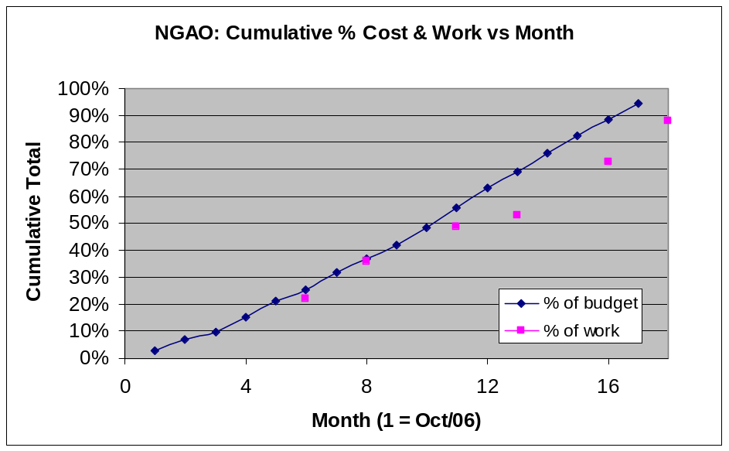
Figure 16. System Design cumulative percent complete for budget and work.

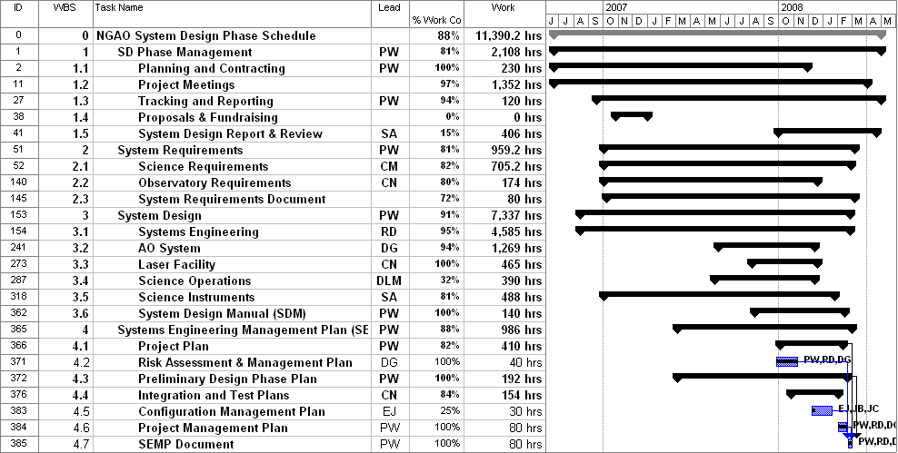
Figure 17. System Design work completed versus plan.

Dedicated personnel in the Preliminary Design phase will be very important. We found that the personnel working on the System Design phase fluctuated significantly as shown in Figure 18 (note that the number of pay periods in a month can also introduce fluctuations). This was partly due to people cycling on to perform a specific task and partly due to conflicts for their time.

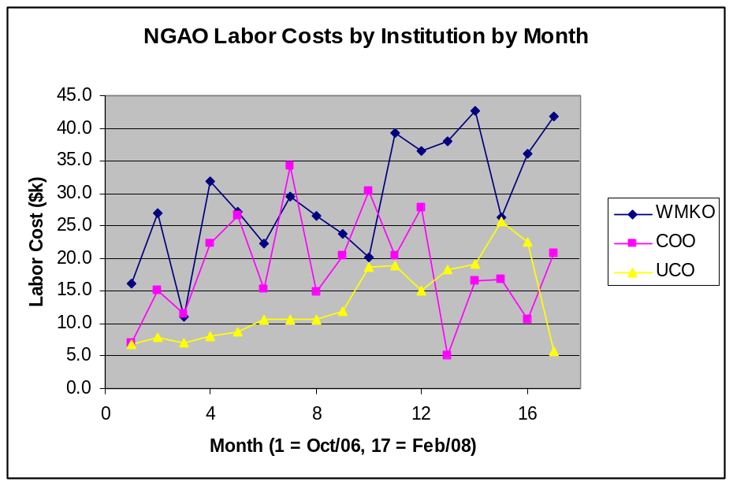
Figure 18. System Design actual labor costs by Institution and month.

We also encountered inefficiencies during the System Design phase due to our new multi-institution collaboration. As pointed out earlier we did benefit from the Executive Committee structure however it also added to the management overhead. There were also inefficiencies due to work being spread across multiple institutions during the System Design phase, which was required to come to joint conclusions on systems engineering issues. We have produced a Preliminary Design plan that has work packages primarily assigned to individual institutions in order to reduce the inter-institution inefficiencies.

Quarterly project reports were provided to the Directors prior to each Keck Science Steering Committee meeting throughout the System Design Phase (KAONs 459, 473, 494, 512, 514 and 557). These reports provide additional information on the progress and issues over the course of the System Design phase.

Appendix: Cost Estimation Worksheet Example (WBS 3.3.3 DD Phase)
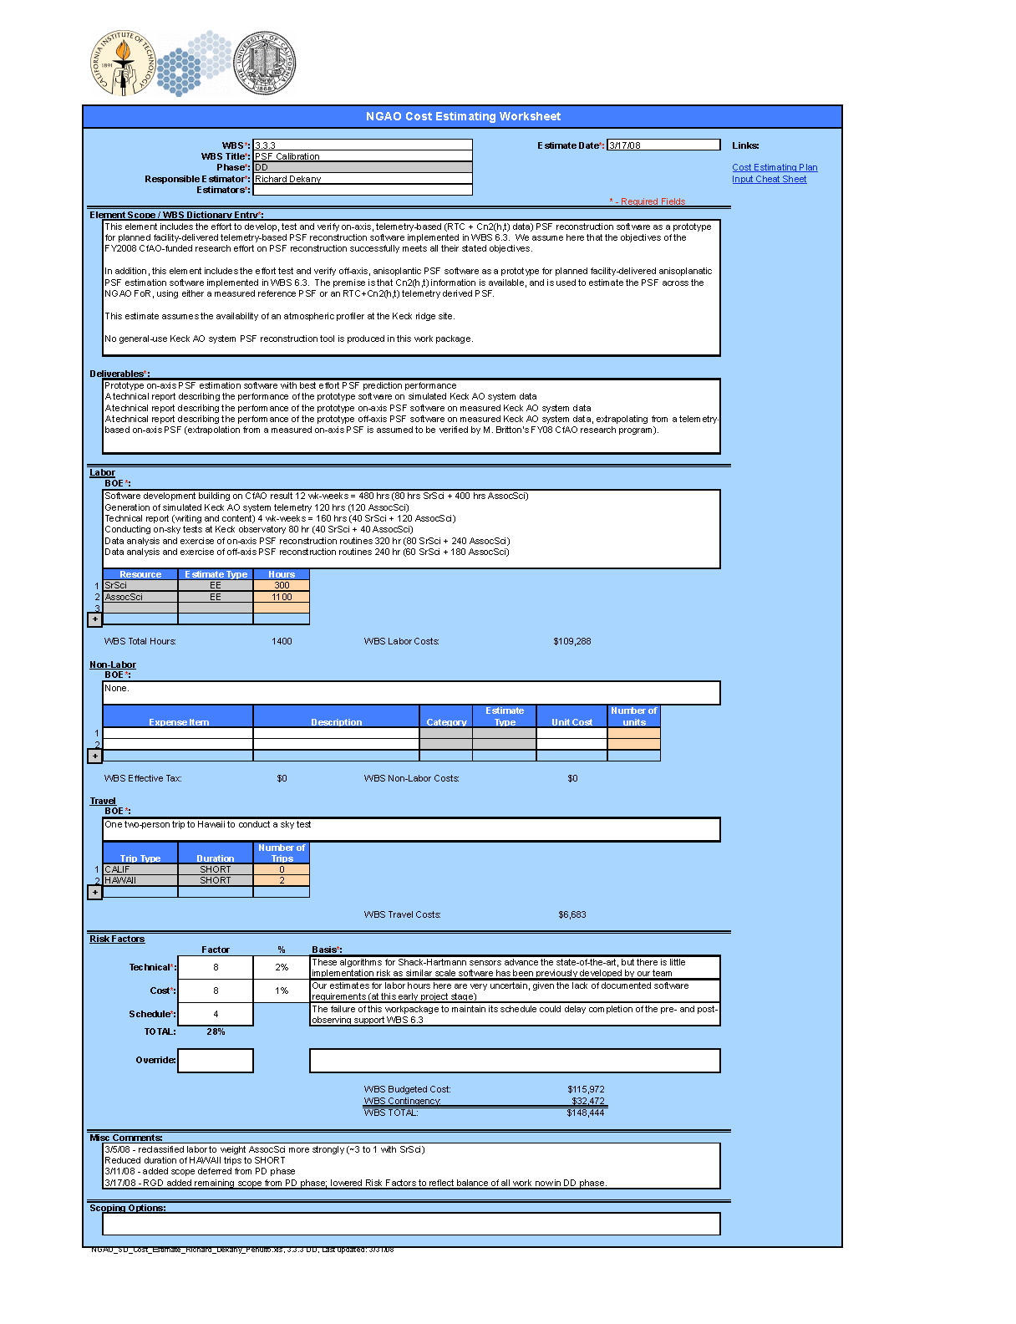

Appendix: Cost Estimation Worksheet Example (WBS 4.2.4 FSD Phase)
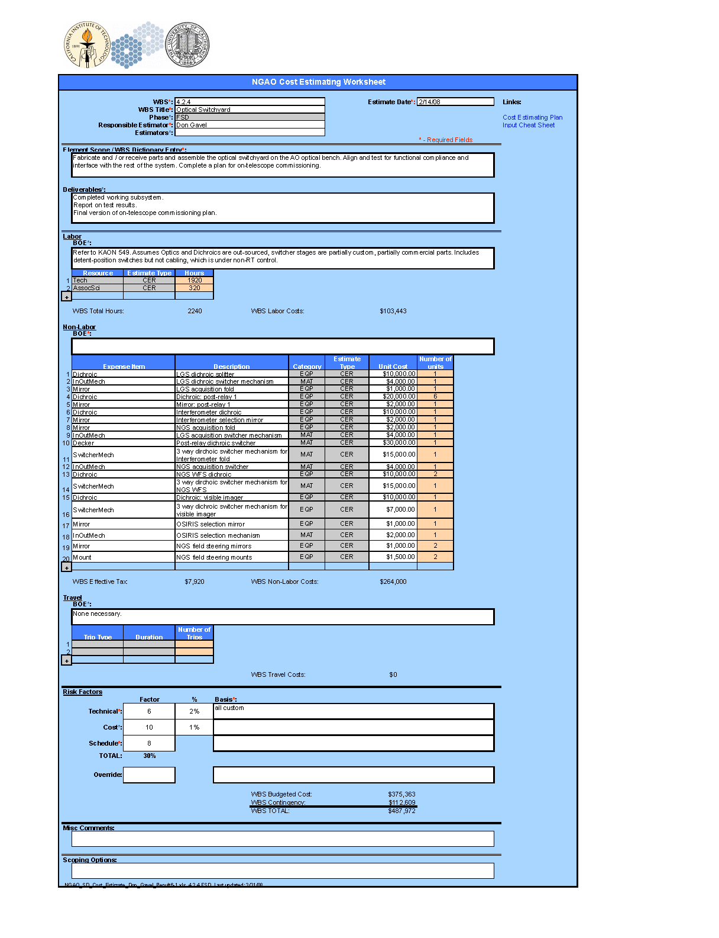

Appendix: NGAO Cost Estimate Summary (in FY08 $K)
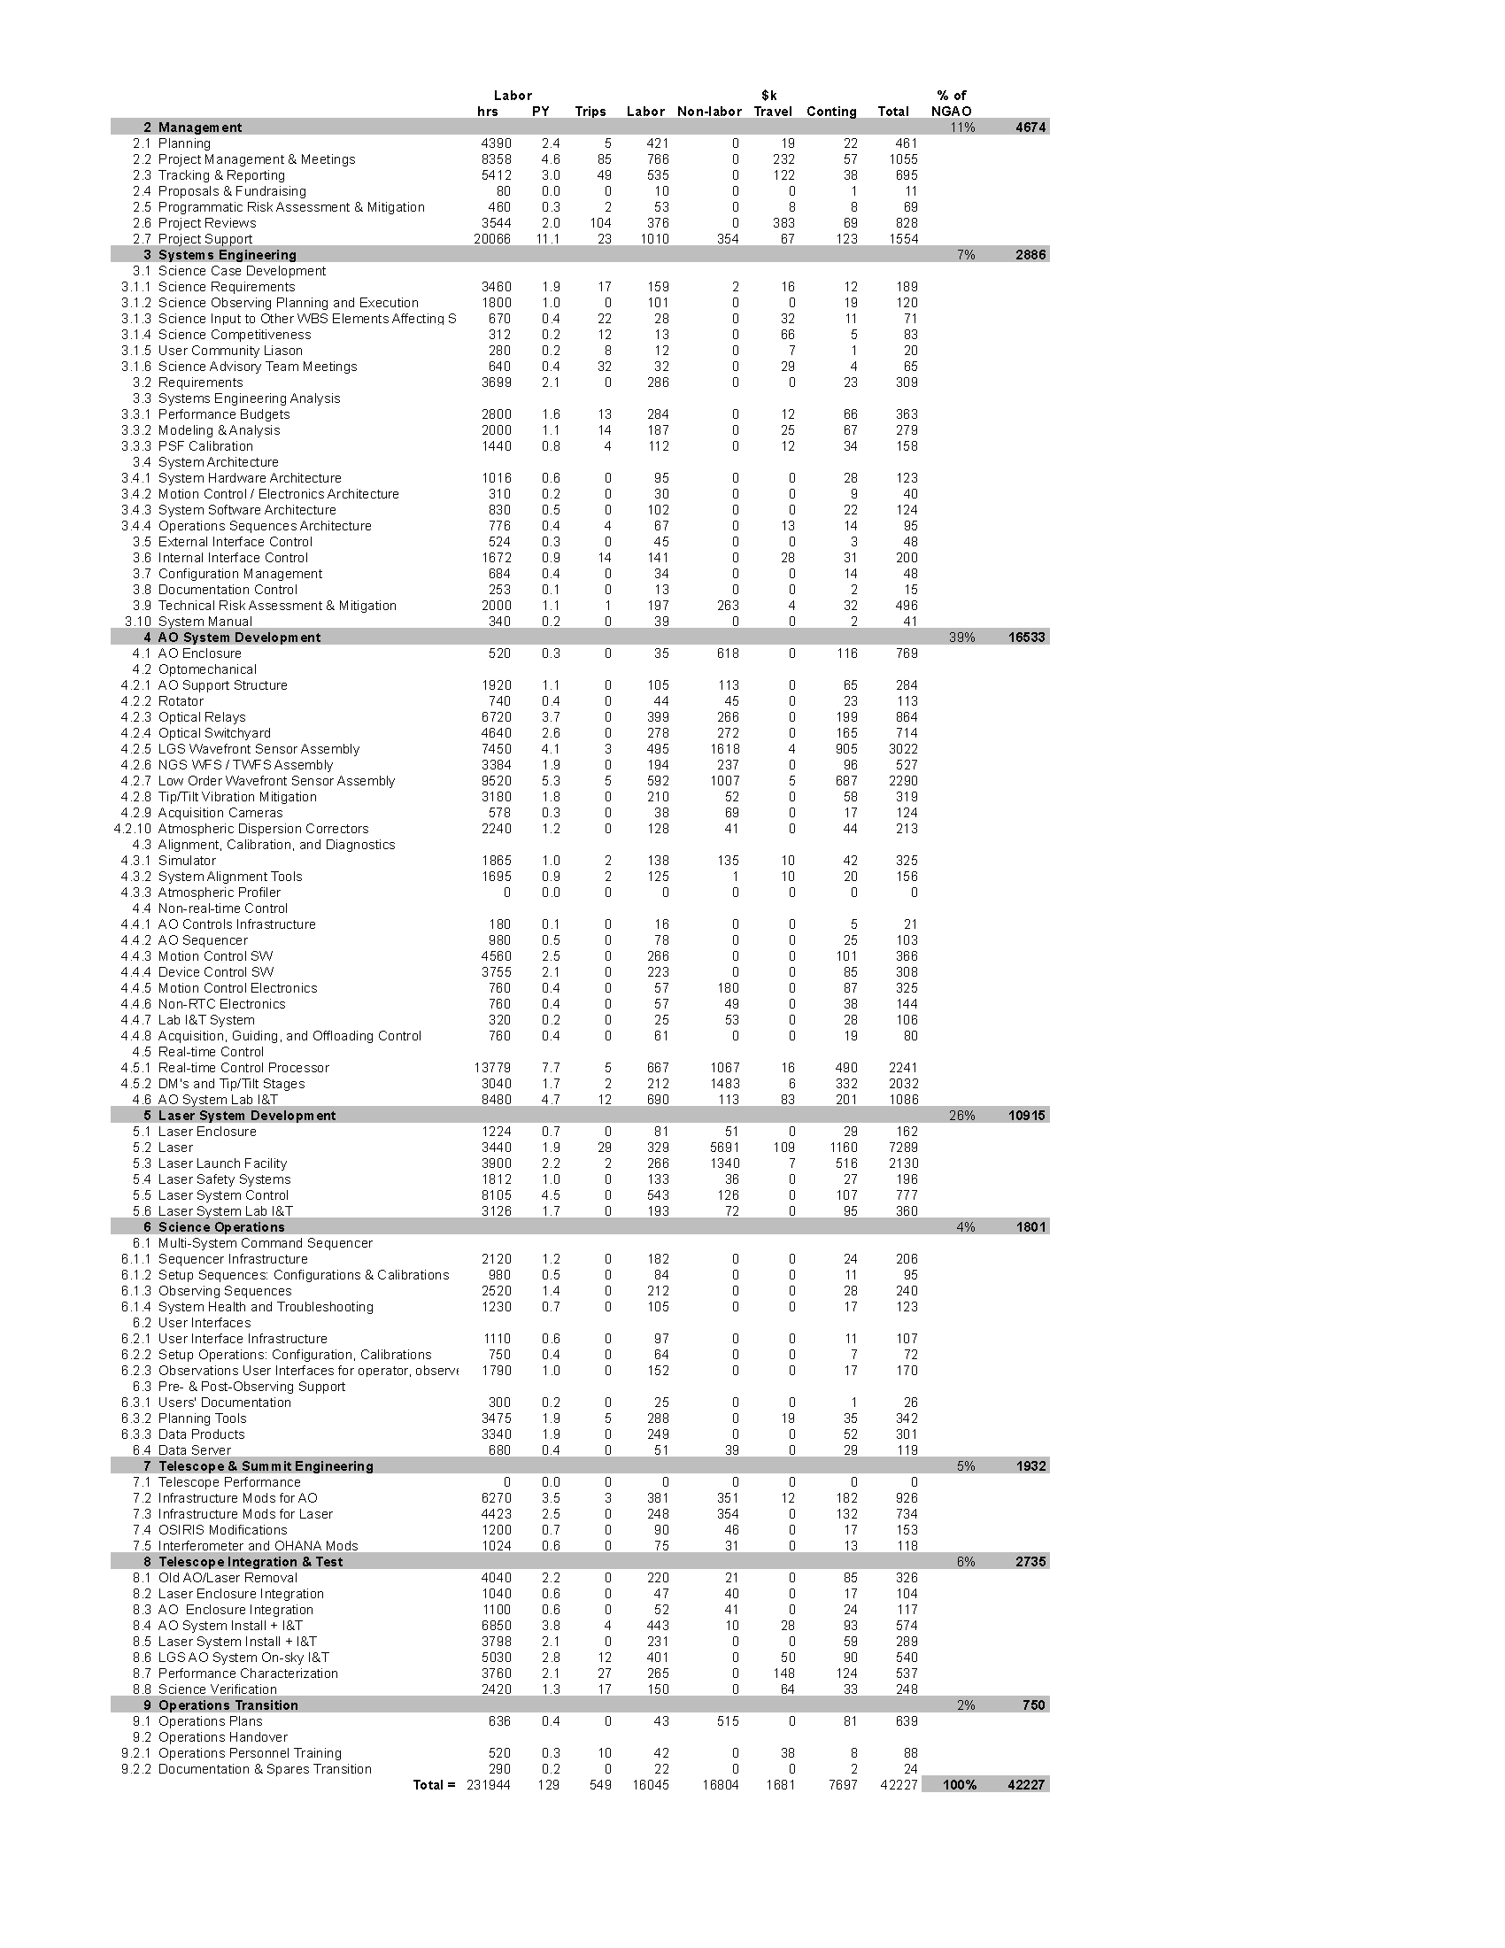

Appendix: NGAO Detailed Design Cost Estimate Summary (in FY08 $K)

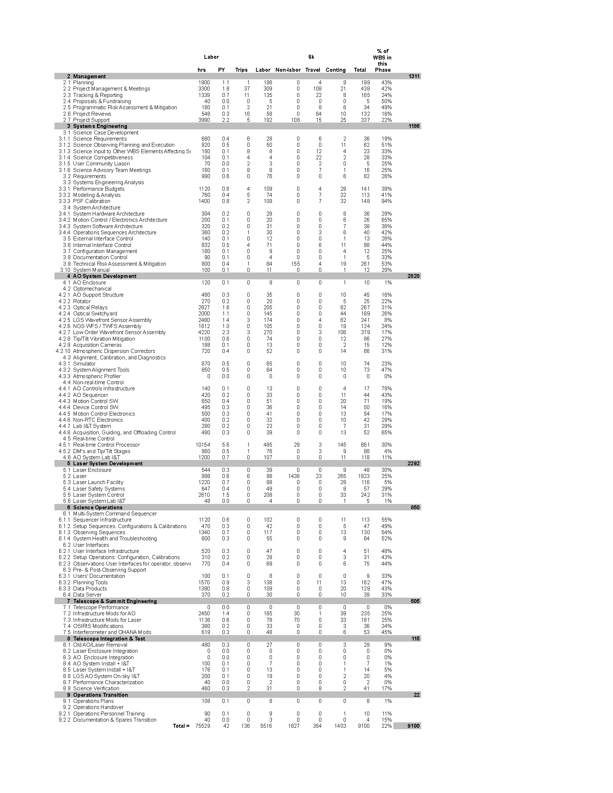

Appendix: NGAO Full Scale Development Cost Estimate Summary (in FY08 $K)

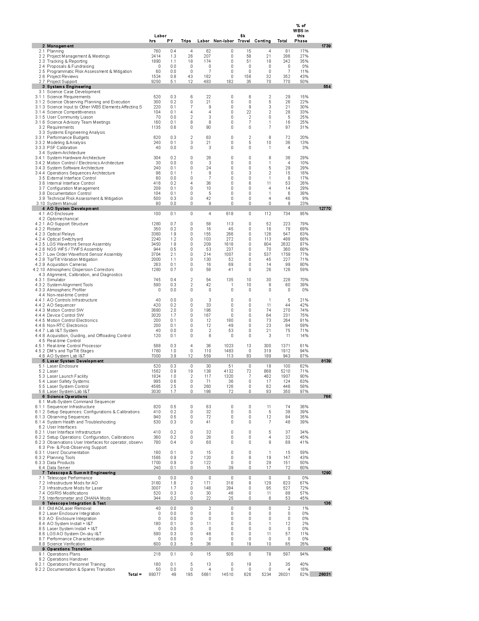

Appendix: NGAO Delivery and Commissioning Cost Estimate Summary (in FY08 $K)

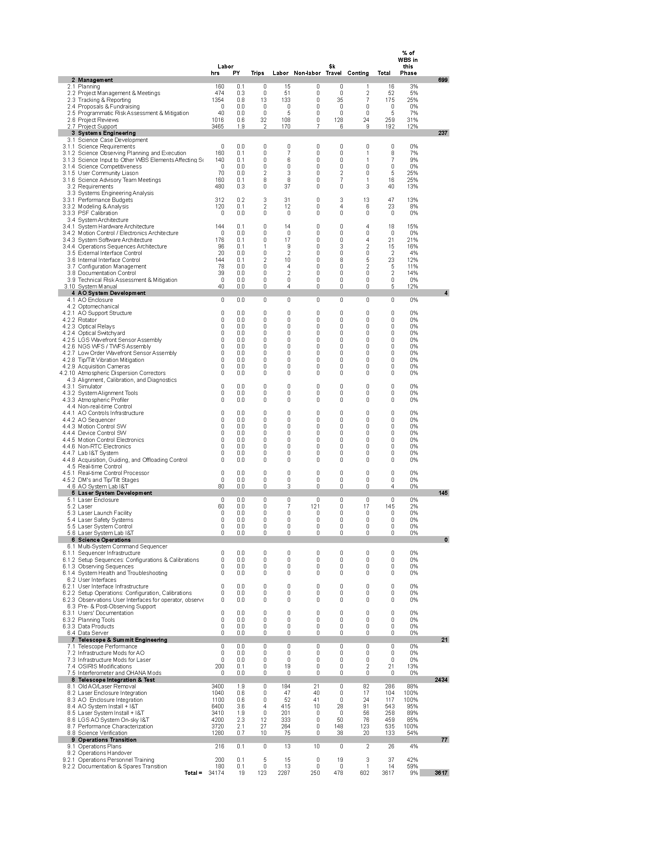

Appendix: Full NGAO Preliminary Design Phase Schedule
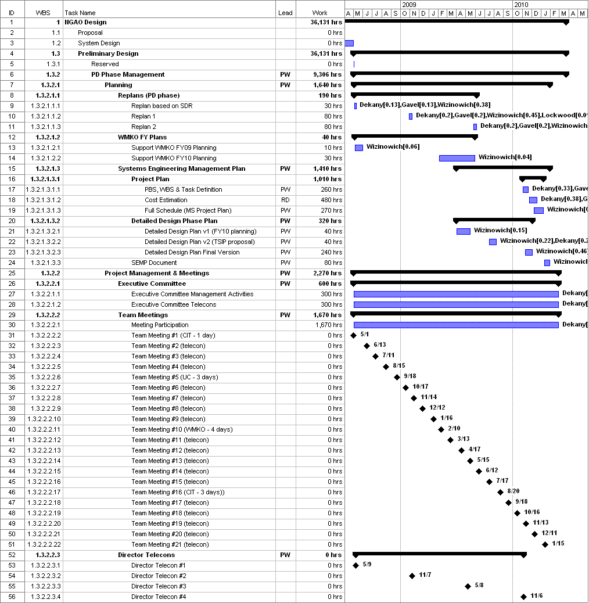

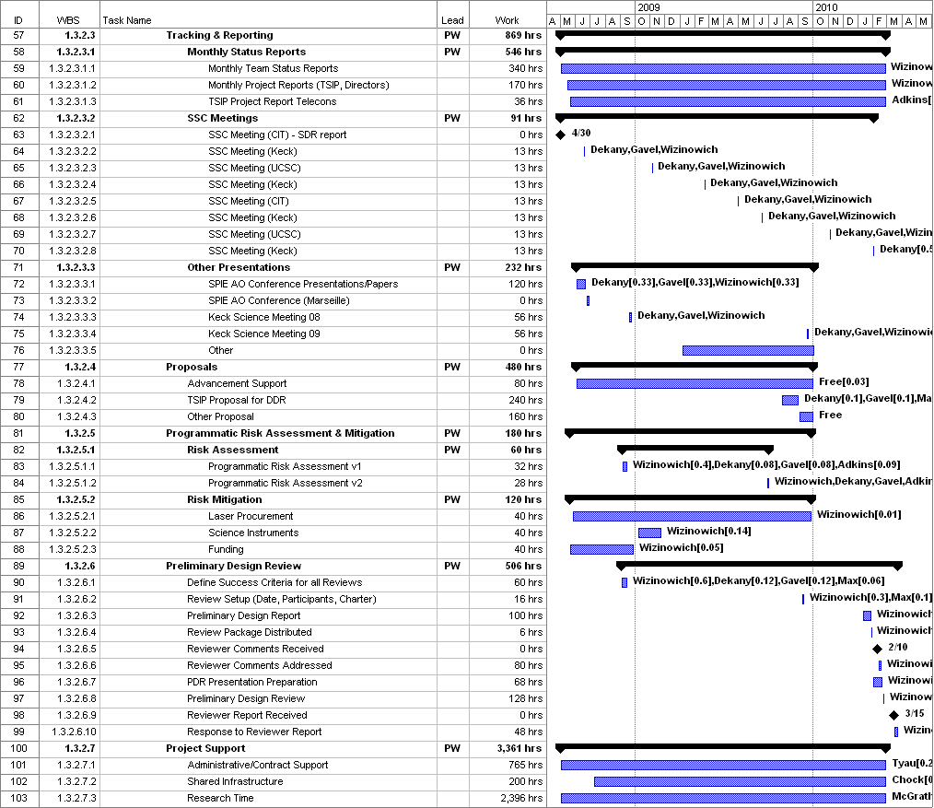

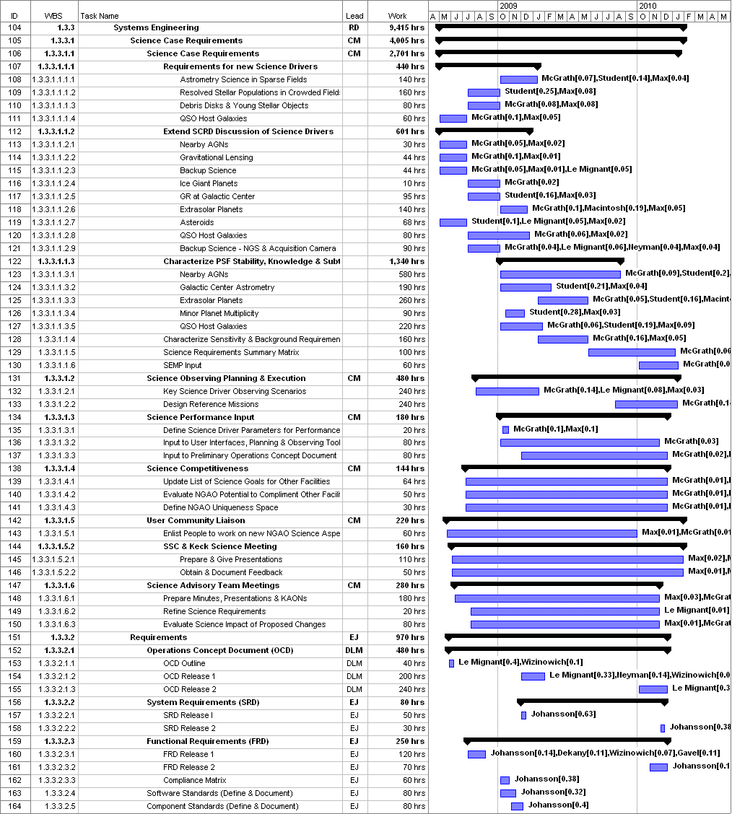

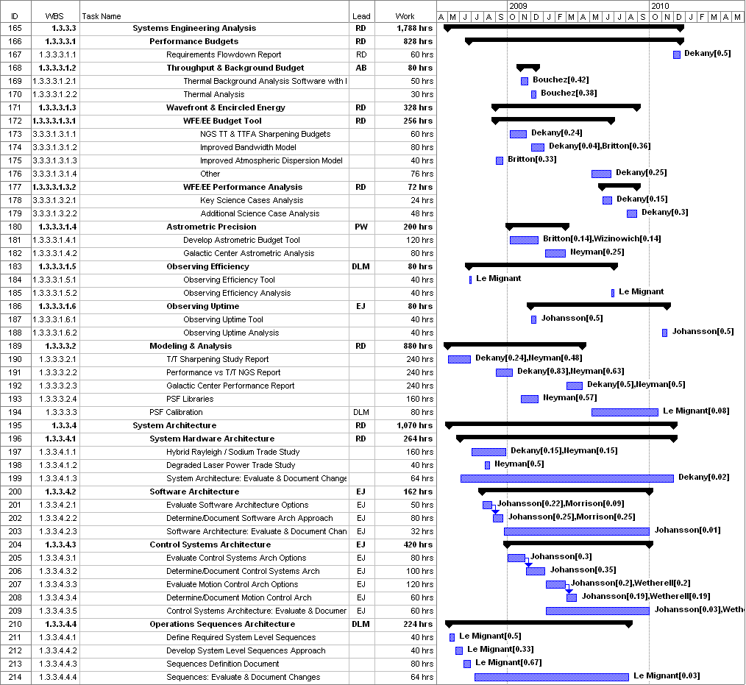

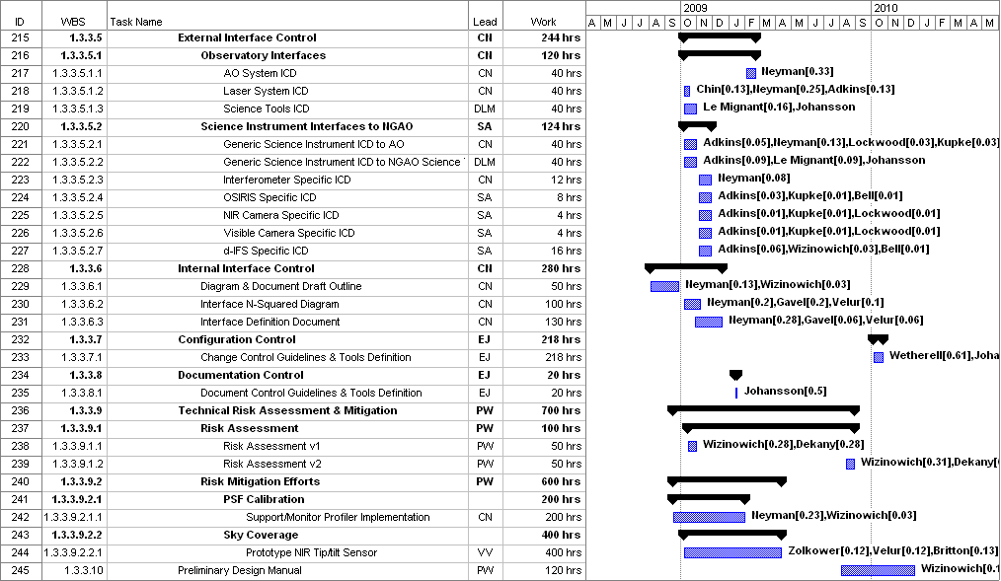

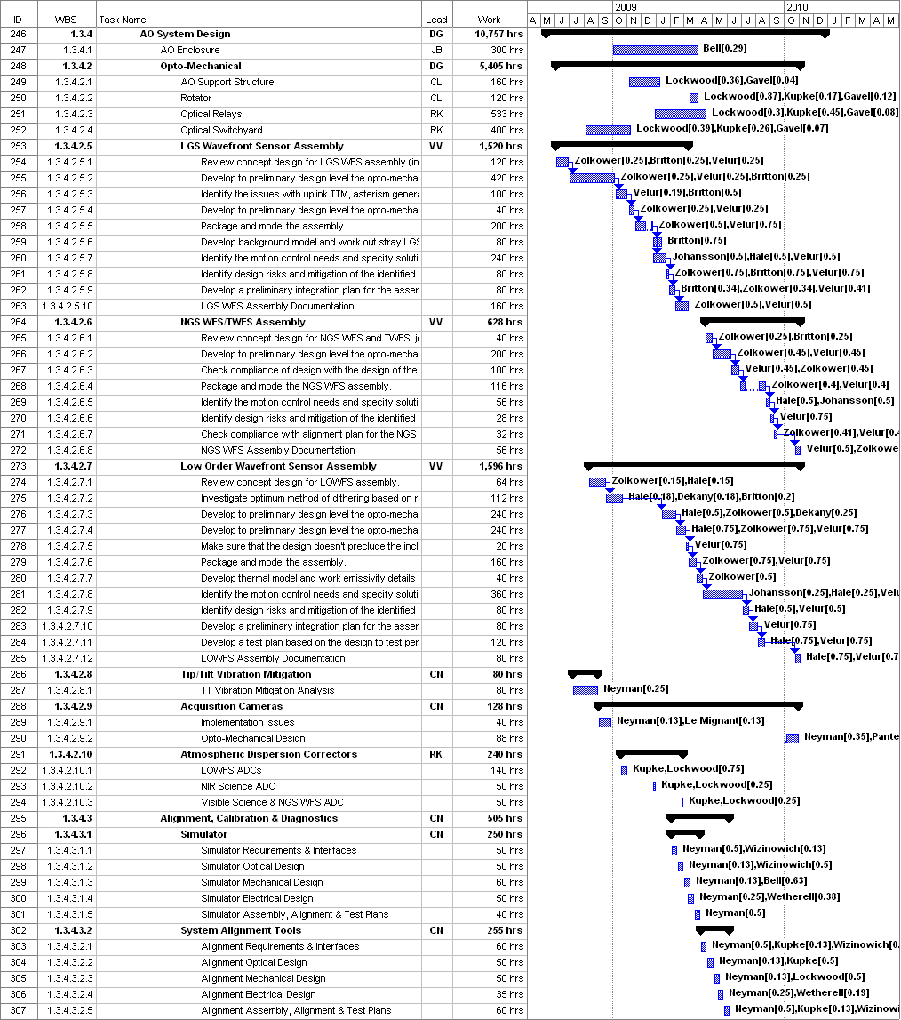

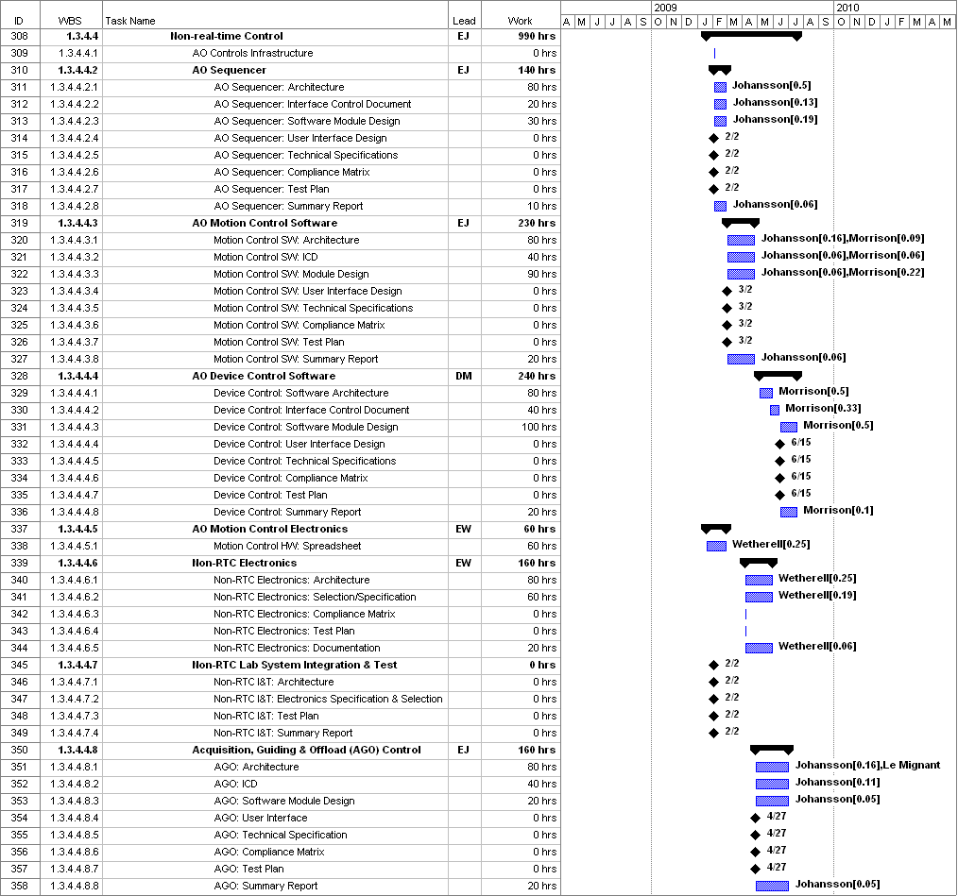

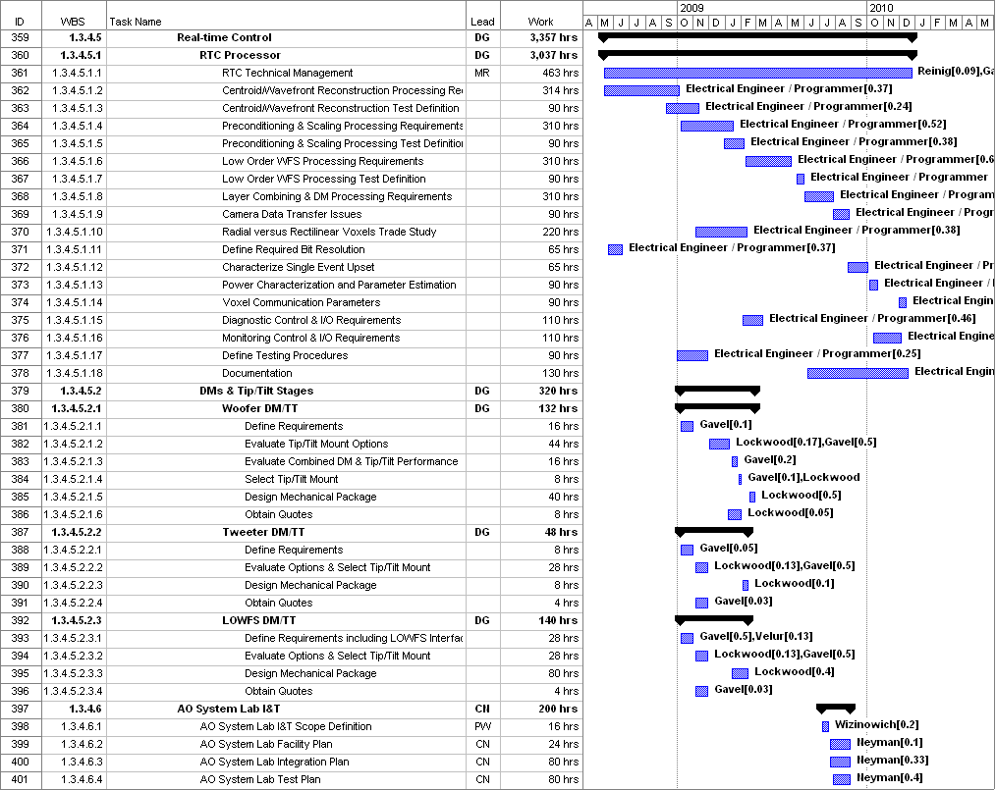

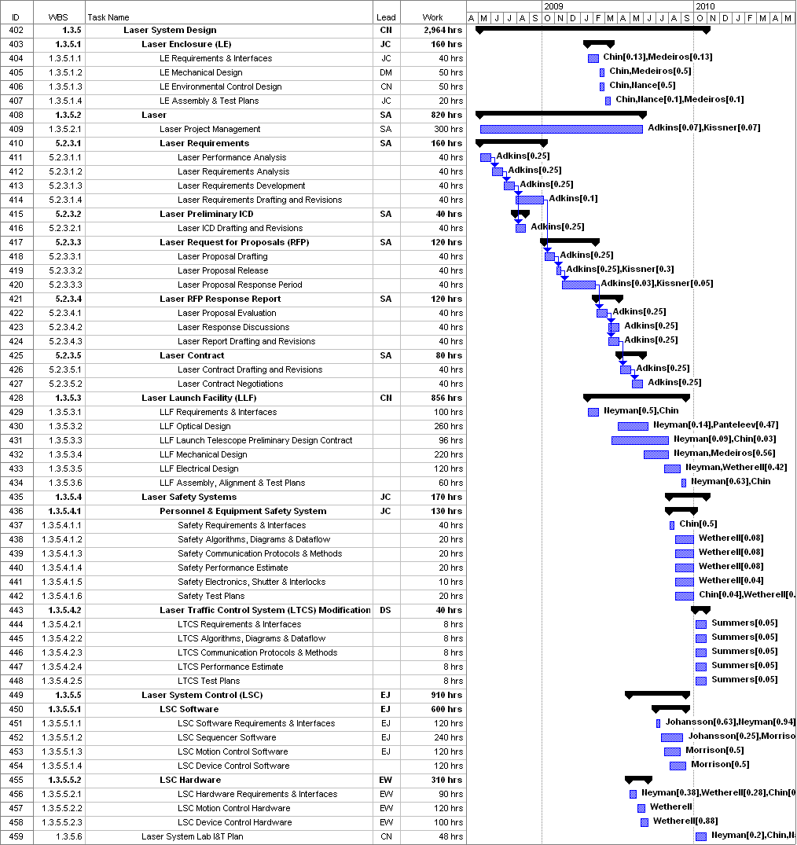

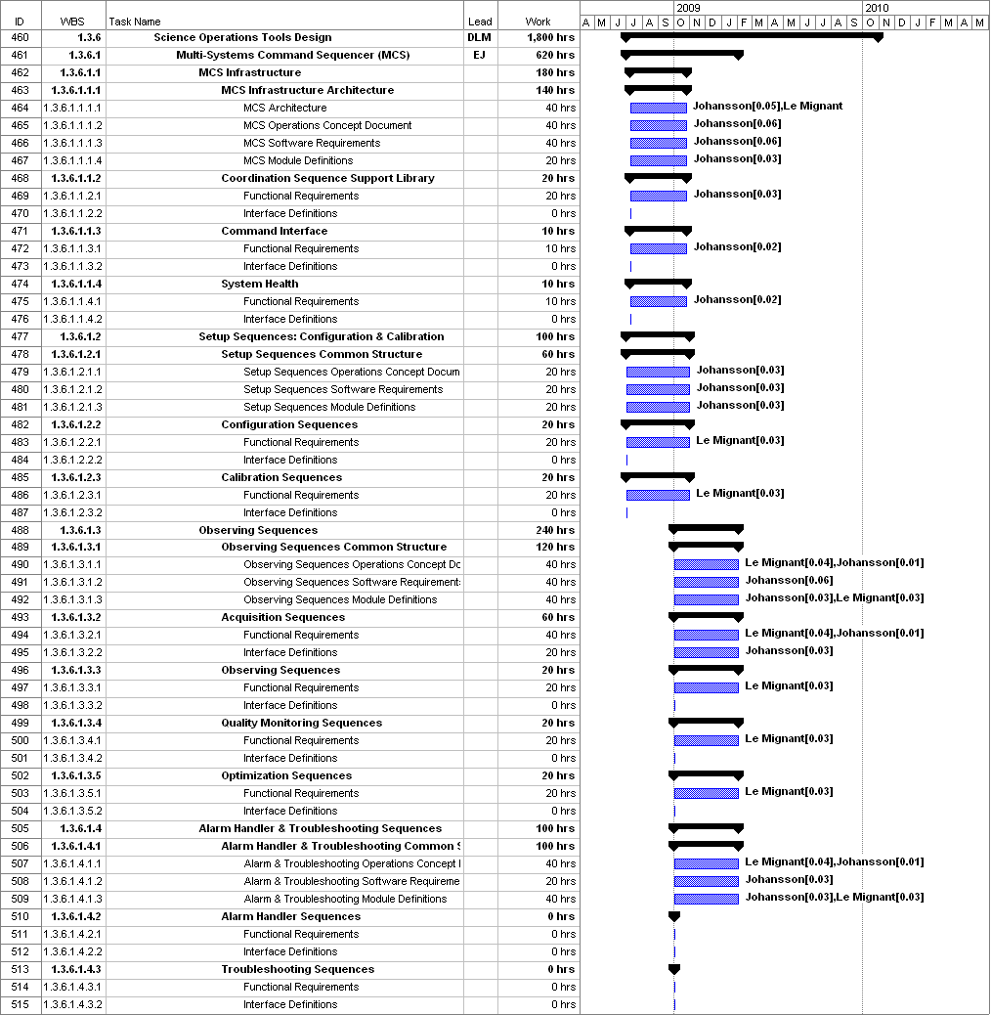

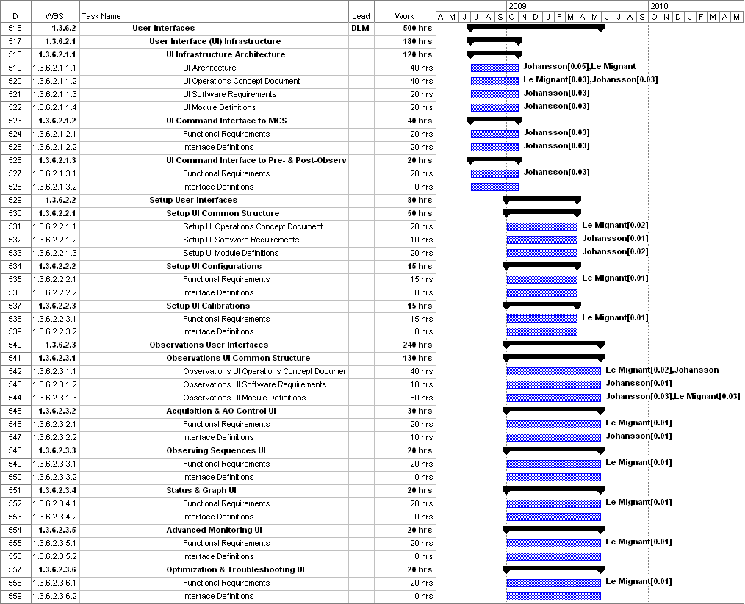

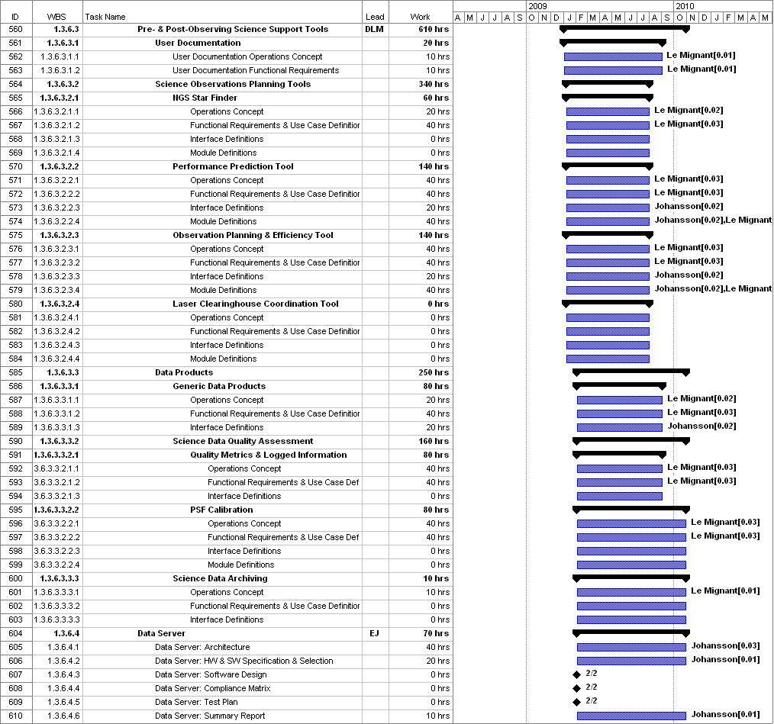

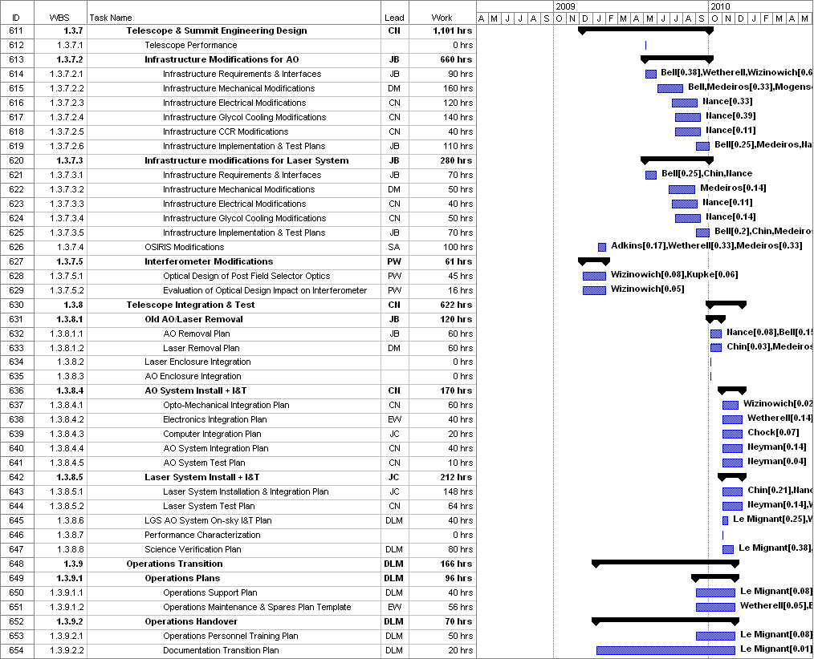

Appendix: Management Approach to Real-Time Controller Design
Don Gavel and Marc Reinig, March, 2008

The proposed real-time controller (RTC) for Keck NGAO is an atypical design compared to AO real-time controllers built in the past. Because of the extremely demanding compute speed and data communication requirements for real-time tomography, we have proposed a massively parallel processing architecture. “Programming” these systems is not like programming a standard (Von Neuman architecture) computer, but is instead one of simultaneously designing the processors themselves along with specifying the data handling and communication tasks each of the processors will do.

From an engineering management perspective, we adopt an approach that more closely resembles that of managing the AO system’s mechanical or electrical subsystems design, rather than managing a software project. In Preliminary Design (PD) and Detailed Design (DD) phases, the mechanical engineers, for example, specify and design the mechanical components and systems, ending up with full set of specifications and full set of drawings ready to hand off to fabrication. On the other hand, a typical software system is “designed” in time for the Detailed Design Review (DDR), but is not yet “coded.” The software coding is traditionally done in the Full Scale Development (FSD) phase. However, for the proposed Keck NGAO RTC architecture, we will be treating the system and its units as items to be fully designed by the end of DD phase and ready to be handed off for fabrication in FSD phase, just as a mechanical design would be. In FSD phase, actual construction and populating of circuit boards, and burning in of the RTC processing tasks (the “code”) into the chips on those boards, will occur.

The elemental subsystems within the RTC product structure are reflected to some extent in the RTC’s work breakdown structure (WBS) for PD phase. Each of the identified subsystems of the architecture can be viewed as a piece of electronic hardware to be designed to meet a specific set of requirements. During PD phase, these requirements are themselves being fully developed, but some progress will be made, to the PDR level, on specifying the subsystem elements themselves, just as they would in a mechanical hardware system design. A few of the RTC WBS tasks are design trade studies intended to support a design decision prior to PDR.

Finally, since there are a number of RTC subsystems that must work together as a whole, there is an element of system engineering that needs to take place. This is reflected in a number of compliance “testing” tasks affiliated with each subsystem and the overall system engineering tasks to be performed by the senior engineer responsible for the RTC.

A preliminary dictionary for the tasks in PD phase is given below. These are in the WBS for PD phase at level 1.3.4.5.1.x

- Technical Management. Coordinate the overall design and systems engineering for the RTC. Develop a simulator that will prove the system design prior to build (Full Scale Development) phase. Coordinate the requirements specification process and development of compliance matrices and use these to assure the RTC design will meet performance requirements in conjunction with the overall NGAO system engineering effort.
- Centroider/Wavefront Reconstructor Requirements Specification and Design. Design a subsystem that takes digital inputs coming from the wavefront sensor camera controllers and produces reconstructed wavefronts (phase in nanometers) and transmits these to the tomography engine in real time, conforming to an overall error and timing budget. This system will also provide telemetry and monitoring (diagnostic) data streams to the supervisory (non-RTC) system.
- Centroider/Wavefront Reconstructor Testing Plan and Compliance Plan Development. Develop a compliance matrix and testing plan for the Centroider/Wavefront Reconstructor, including a plan to prove the system design in an overall RTC system simulator prior to build (Full Scale Development) phase.
- Preconditioning and Scaling Requirements Specification and Design. Specify and design the real-time tomography engine. This unit accepts wavefront phase data from the centroider/wavefront reconstructors and low order wavefront sensors and produces estimates of the delta-index variations in the atmosphere volume above the telescope. The process must adhere to an overall error and timing budget. This system will also provide telemetry and monitoring (diagnostic) data streams to the supervisory system.
- Preconditioning and Scaling Testing Plan and Compliance Plan Development. Develop a compliance matrix and testing plan for the tomography engine, including a plan to prove the system design in an overall RTC system simulator prior to Full Scale Development phase.
- Low Order WFS Processor Requirements Specification and Design. Specify and design a subsystem that takes digital inputs coming from the low order wavefront sensor controllers and produces an estimate of the low-order invisible modes in the atmosphere volume above the telescope, and sends this information into the tomography engine. This subsystem must conform to overall error and timing budgets. This system will also provide telemetry and monitoring (diagnostic) data streams to the supervisory (non-RTC) system.
- Low Order WFS Testing Plan and Compliance Plan Development. Develop a compliance matrix ant testing plan for the low order WFS processor, including a plan to prove the system design in an overall RTC system simulator prior to Full Scale Development phase.
- Layer Combining and DM Processor Requirements Specification and Design. Specify and design a set of subsystems that will 1) accept volume delta-index information from the tomography engine and produce projected estimates for wavefronts in directions of on-axis science, IFU science, low order WFS, and PSF monitors (i.e., every DM field position in the system), and 2) calculate the required mirror voltage commands needed to bring each DM to the indicated wavefront. This subsystem must conform to overall error and timing budgets. This system will also provide telemetry and monitoring (diagnostic) data streams to the supervisory (non-RTC) system.
- Assess Data Communications Issues: Centroider Distance from Camera Head. Perform an engineering trade study to determine whether bit rate x distance will drive the centroider units to be located physically close to the wavefront sensor camera heads. Consider options and costs therein, given any solution will need to conform to overall error budget and timing budgets.
- Assess Tomography Engine Size Issue: Voxel Sample Size vs Altitude. Perform an engineering trade study to decide whether to adopt an altitude scaling of voxel sample size in order to reduce number of voxels / processor boards at the cost of a more complex algorithm. Consider options and costs therein, given any solution will need to conform to overall error budget and timing budgets.
- Determine Required Data Resolution. Perform an engineering study to determine the minimum data representation size (“bit width”) required of data within the various stages of processing, assuming bit width will drive complexity and cost but that a minimum is required to meet the overall error and timing budgets.
- Characterize the Effects of Single Event Upsets (SEUs). Predict, given the processor system design, the rate of “single event upsets” – cosmic ray or other events that corrupt data in processing elements, and determine the requirements for redundancy and error correction coding, in light of the need to meet overall error and timing budgets.
- Determine Parameters for Optimization of Power Consumption. Perform a design trade study that addresses methods of minimizing total RTC power consumption, and assures that the overall power required will be within limits imposed by the telescope and Naysmyth platform infrastructure while still conforming to overall RTC error and timing budgets.
- Voxel, Chip, and Board Communications Infrastructure Requirements and Design. Develop options for the layout, communication paths, and data communication protocols for on-chip, chip-to-chip, and board-to-board communications within the centroider, tomography engine, and DM processing subsystems. Perform engineering design trade studies to determine a parametric model for characterizing cost and complexity vs communication approaches while adhering to overall RTC system error and timing budgets. Provide an initial specifications for a selected communications model.
- Telemetry Control and I/O Requirements and Design. Specify and design the RTC-side I/O support for the high speed gathering, transport, and recording of telemetry data.
- Monitoring Control and I/O Requirements and Design. Specify and design the RTC-side I/O support for the low speed gathering, transport, and display of system monitoring information.
- Define Testing Procedures. Develop a compliance matrix and testing plan for the overall RTC. Develop a system engineering test plan to prove the RTC system design with a simulator prior to the full scale development phase.
- Documentation. Write a set of documents for the RTC. These include the requirements documents, the preliminary design documents and related materials, and trade study reports from PD phase.

The notable exception is the 64x64 MEMS DM, but this is a critical development for GPI and expected by 2009.

