 Keck Adaptive Optics Note 529

Next Generation Adaptive Optics:
Optimum Pixel Sampling for Asteroid Companion Studies

M. Baek and F. Marchis
(UC Berkeley & SETI Institute)

Eds. E. McGrath and D. LeMignant

November 27, 2007

Simulation software
The simulation software, simul_NIRC.pro, is made to simulate observations of small solar system bodies taken with NGAO instrument on Keck II in narrow-field mode with MCDS 16 reads. We used the zero-point equation for the magnitude-to-DN conversion, and the instrument properties such as readnoise, gain, linearity limit, and zero-point values are taken from those of NIRC2 (for near-IR) and LRIS-R (for visible). The input parameters for simulation include apparent magnitude, total integration time, band, number of secondaries, number of coadds, pixel scale (λ/xD), and more. In case of resolved primary, there are optimal inputs like fwhm, a/b ratio and orientation available for simulation.

Near-IR
The NIRC2 detector characteristics we used for simulation, obtained from http://www2.keck.hawaii.edu/observing/kecktelgde/ktelinstupdate.pdf, are the following:
  - readnoise = 15 e-/pixel/read
  - gain = 4 e-/DN
  - linearity limit = 14000 DN
  - zero-point = 25.35 in J, 25.44 in H, 24.63 in K

The sky brightnesses used for the near-IR simulation are 15.88, 13.70, and 13.18 in JHK, respectively, which are taken from KAON 501 Bouchez v1.1 (at 259.0K).

The PSF frames used for simulation were done with the TMT Monte Carlo code by C. Lidman & R. Flicker, and have a pixel scale of 0.00257831 arcseconds per pixel (file name: nfaoJ_dm32lgs5rms170.fits). These PSF frames demonstrate the quality of NGAO obtained for a narrow field AO with 32 actuators, 5 lgs, and 170 nm wavefront error.

Visible
The LRIS-R detector characteristics we used for simulation, obtained from http://www2.keck.hawaii.edu/inst/lris/photometric_zero_points.html and
http://www2.keck.hawaii.edu/inst/lris/detectors.html, are the following:
- readnoise = 6.2 e-/pixel/read
- gain = 2.075 e-/DN
- linearity limit = 60000 DN
- zero-point = 27.52 in R and 27.40 in I

The sky brightness used for the visible simulations are 20.8 and 19.6 in R and I band, respectively, which are taken from the CFHT website (http://www.cfht.hawaii.edu/Instruments/Imaging/CFH12K/Summary/CFH12K-Optics.html).

Just like for the JHK simulations, the PSF frames used for simulation were done with the TMT Monte Carlo code, LAOSA, and have a pixel scale of 0.00257831 arcseconds per pixel. These PSF frames demonstrate a narrow field AO with 32 actuators, 5 lgs, and 170 wavefront error.

Simulation of a triple asteroid system
The simulation images represent a pseudo (45) Eugenia system, but with an unresolved primary of mv=16, which corresponds to D=12.21 km at 2.7 AU when its phase angle is 0 deg and assuming an albedo ~0.15. Two visible moonlets with diameters of 0.61km and 0.38km are located at 0.6" (~1178km or .45 R_{Hill}) and 0.3" (~589 km or .23 R_{Hill}), with the apparent magnitudes of 22.5 (Δm=-6.5) and 23.5 (Δm=-7.5), respectively.

The Hill sphere radius of the primary (R_{Hill} = 2600 km) and its mass (m=1.59 x 1015), are estimated with the assumption of the asteroid being the most common C-type, which corresponds to the bulk density of 1680 kg/cm3.

For each band, simulation images are created in five different pixel scales (λ / D, λ /2D, λ /3D, λ/4D, λ /6D (or λ /5D for R)) in order to determine the most appropriate pixel scale for the purpose of photometry as well as astrometry. For R band, we created a simulation image with a pixel scale of λ/5D instead of λ/6D, because a pixel scale of λ/6D in R band is smaller than the pixel scale of the PSF frame. All simulated observations have total integration time of 900 seconds.

Results (Near-IR)
This simulation test was done in order to determine the most appropriate pixel scale for the purpose of both photometry and astrometry, and the images with such pixel scales must present the flux ratio between the primary and secondary and the secondary positions that are very close to those in the initial frame prior to the convolution and rebinning. For all JHK simulations, images with the pixel scale of λ/3D present the peak flux ratio between the primary and the larger secondary (Fp/Fs1) that is the most similar to the flux ratio in the initial frame. Although the simulation image in H band with the pixel scale of λ/2D show Fp/Fs1 that is slightly closer to the initial flux ratio than the image with λ/3D, it was ruled out because the smaller secondary is hardly detectable.

The images with the pixel scale of λ/3D are also well suited for the purpose of astrometry, and the both secondaries are easily detected in these. However, in K band images, the closer secondary appears elongated due to the nearby artifacts from the PSF frames. The longer wavelength of K band (corresponding to larger pixel scales) and the bright artifacts from its PSF frame that spread out to ~3.3 arcsecs make K band images not very apt for astrometrical observations of secondaries close to the primary.

In conclusion, the simulation images with the pixel scale of λ/3D are the most appropriate for both photometry and astrometry, but, indeed, more simulations using other PSF frames that are accurately constructed may be necessary to finally decide the best pixel scale for the NGAO instrument.

Results (Visible)
For both R and I band simulations, images with the pixel scale of λ/2D present the peak flux ratio between the primary and the larger secondary (Fp/Fs1) that is the most similar to the flux ratio in the initial frame.

The position of the larger secondary is well defined in all simulations for both bands. Among the I band simulations, images in λ/2D and λ/3D display the better positioned smaller secondary, while the smaller secondary is not detectable in any of R band simulation images. Even the larger secondary appears faint in R band simulations, which makes R band not so appealing choice for astrometry.

In conclustion, the simulation images with the pixel scale of λ/2D are the most appropriate for both photometry and astrometry in R and I bands, but, indeed, more simulations using other PSF frames that are accurately constructed may be necessary to finally decide the best pixel scale for the NGAO instrument.

Table 1. Photometric measurement of the generated images in J, H, and K bands with various sampling. A sampling of λ/3D provides the best measurements in J and H bands.

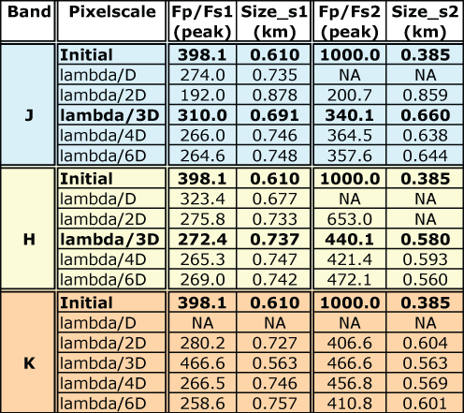

Table 2. Astrometric measurements performed on the generated images in J, H,and K bands with various sampling.
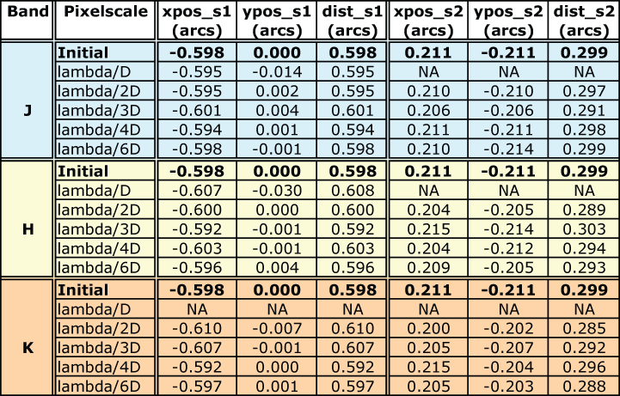
Table 3. Photometric measurement of the generated images in R and I bands with various sampling. A sampling of λ/2D provides the best measurements in R and I bands.
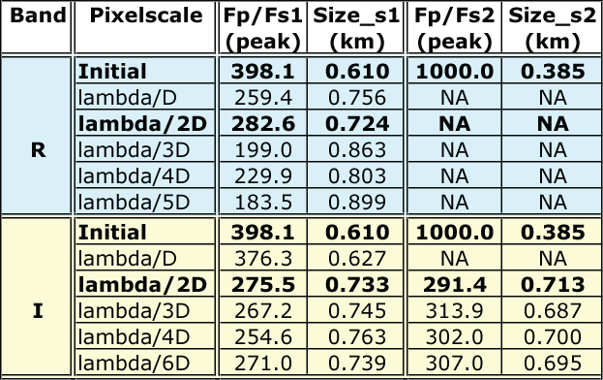

Table 4. Astrometric measurements performed on the generated images in R and I bands with various sampling.
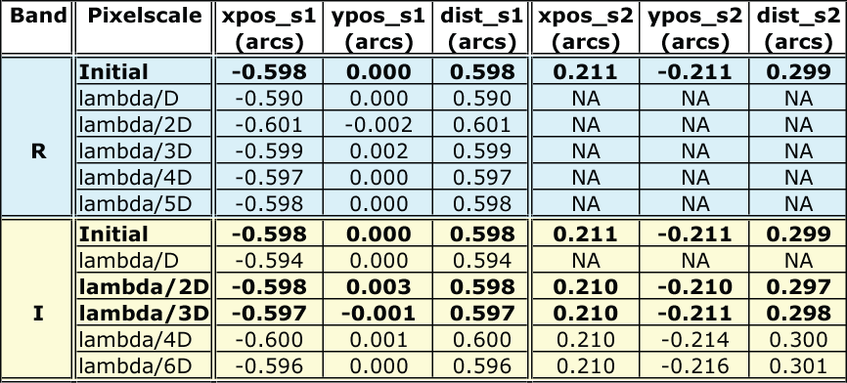
Figure 1. Generated images in J band for various pixel scales. The arrows show the position of the moonlets.
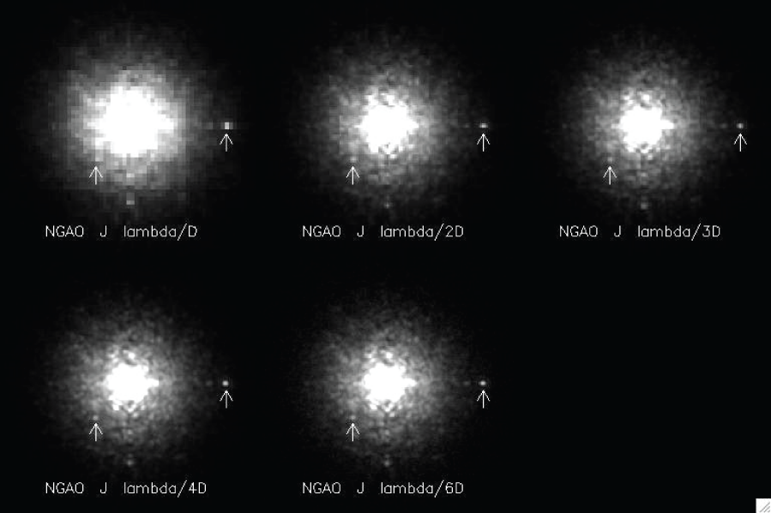

Figure 2. Generated images in H band
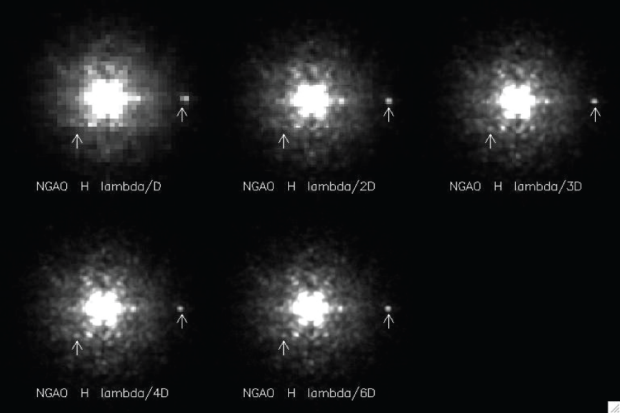

Figure 3. Generated images in K band
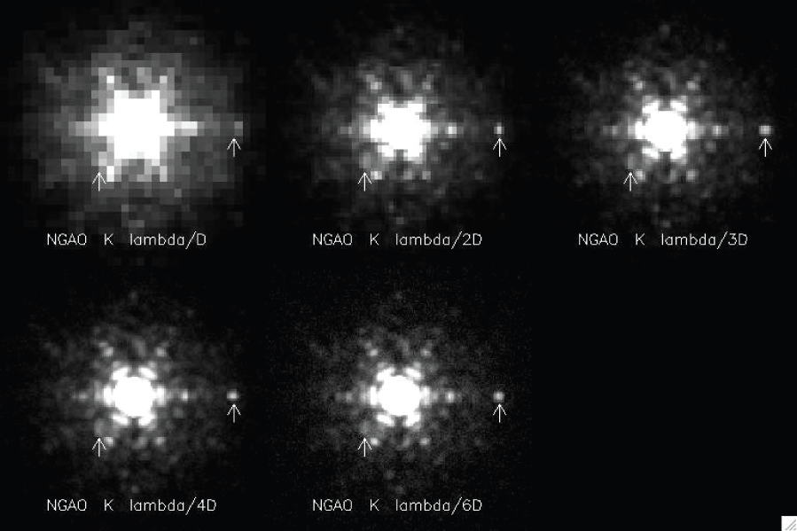

Figure 4. Generated images in R band
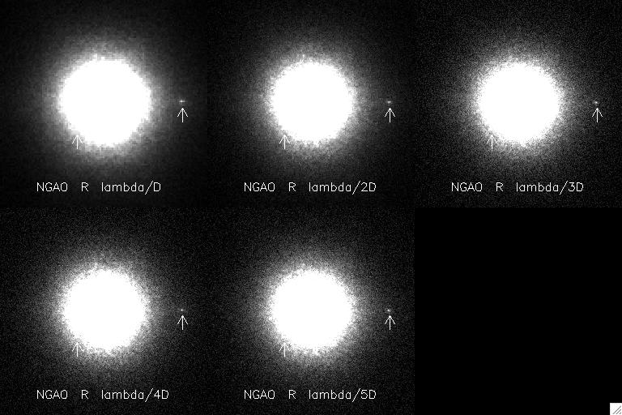
Figure 5. Generated images in I band
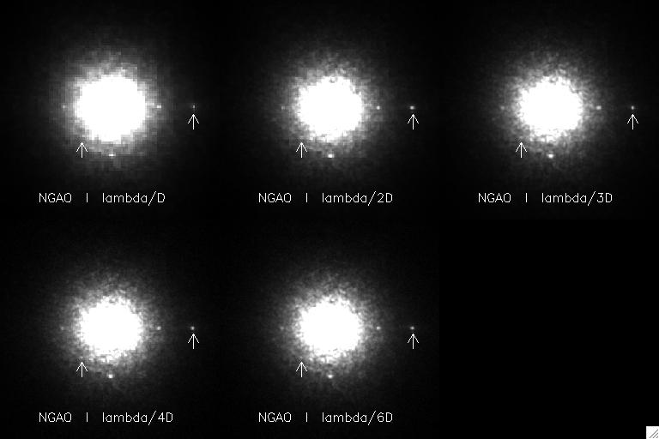
Figure 6. Detection profiles in H band with various pixel scales.
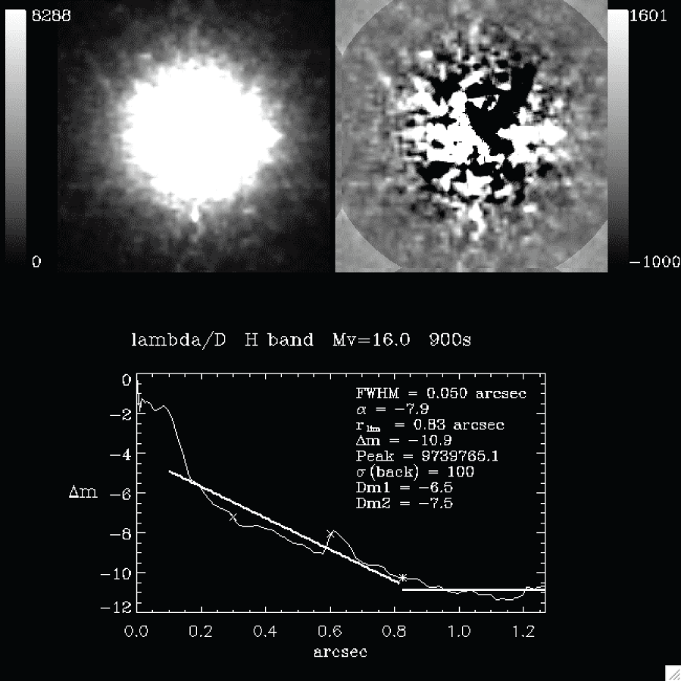

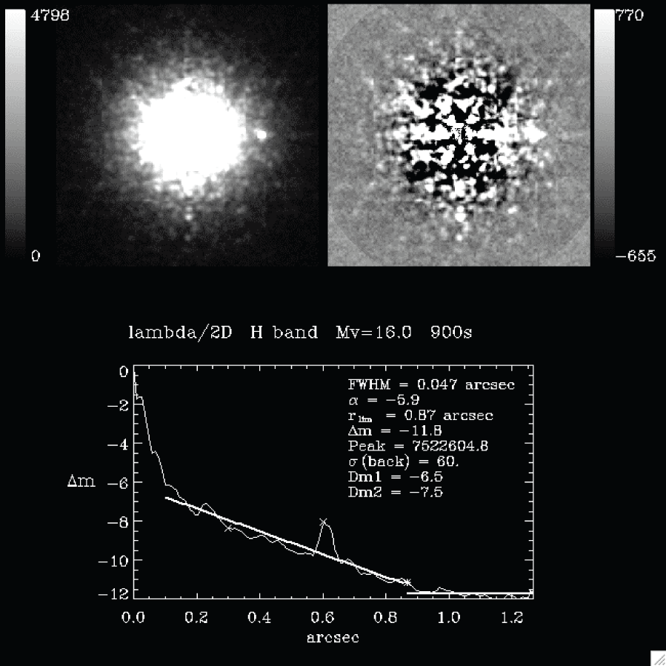

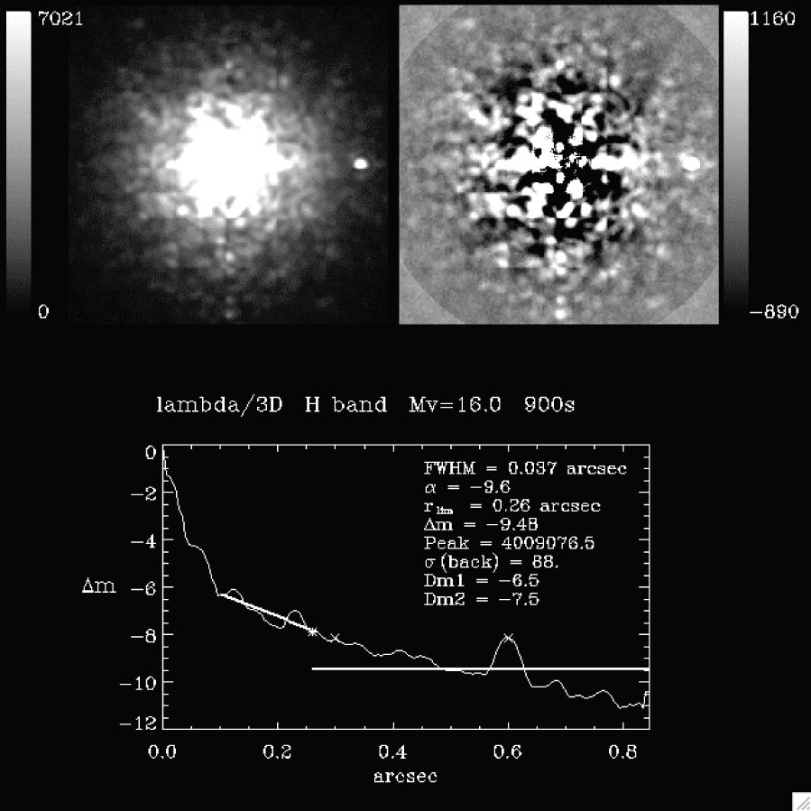

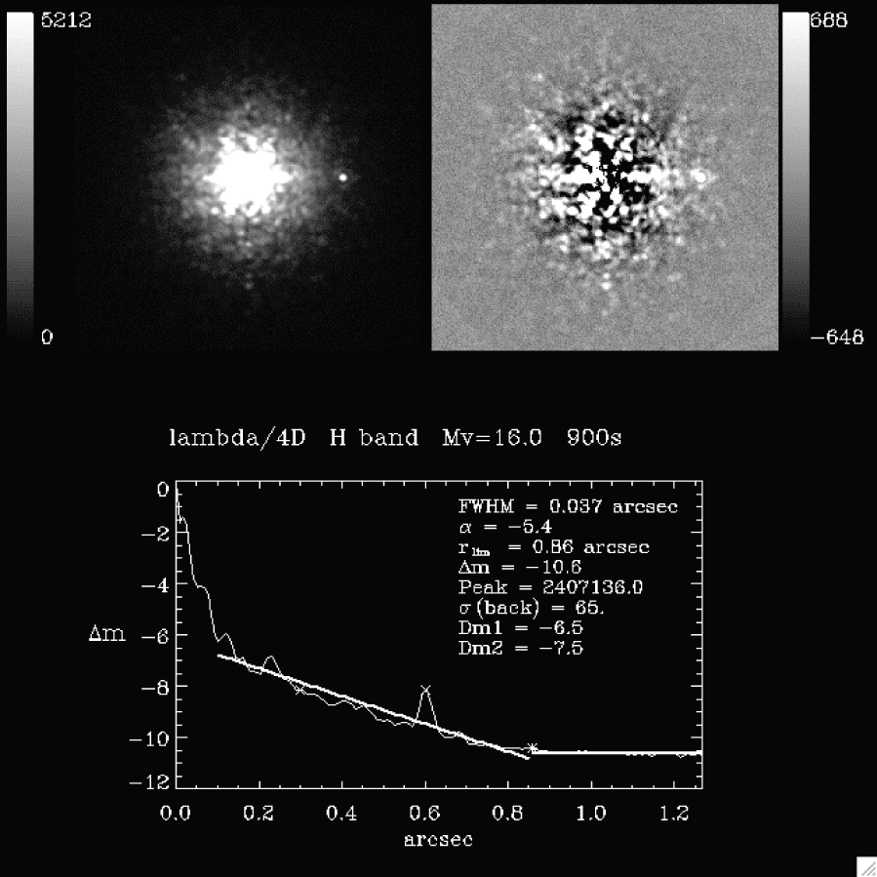

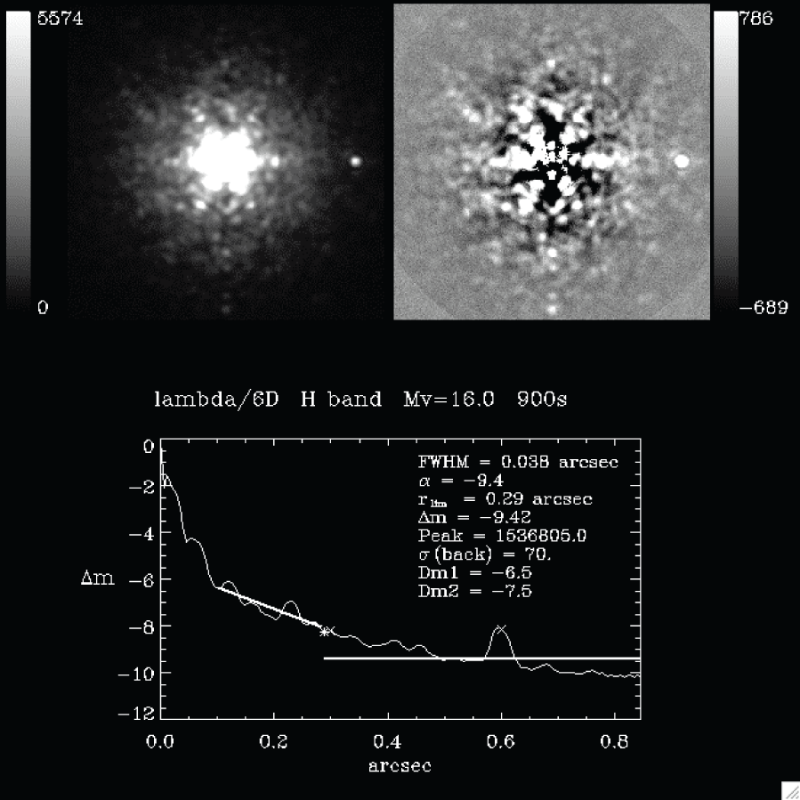
Figure 7. Detection profiles in I band with various pixel scales.
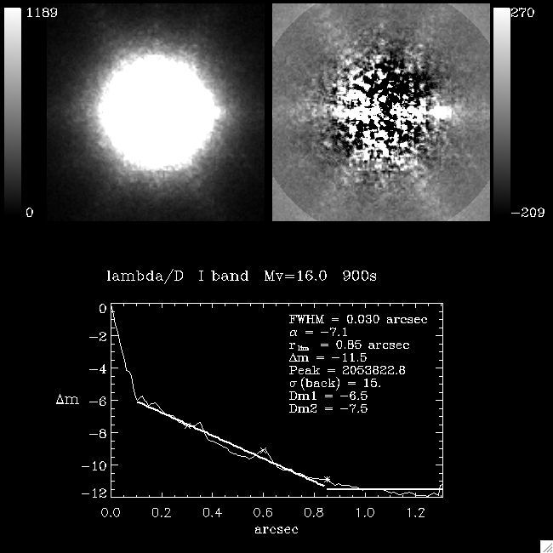

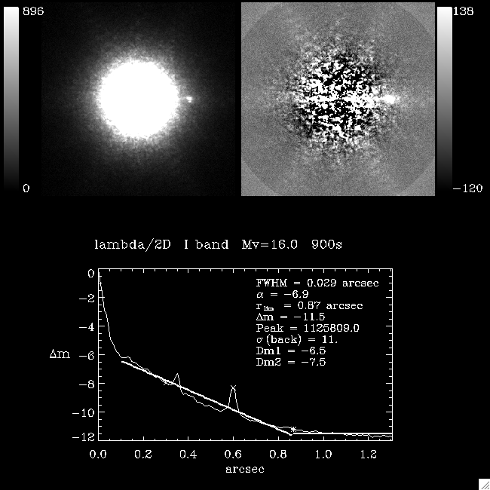

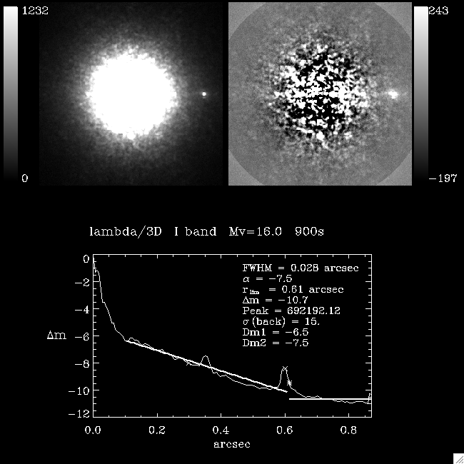

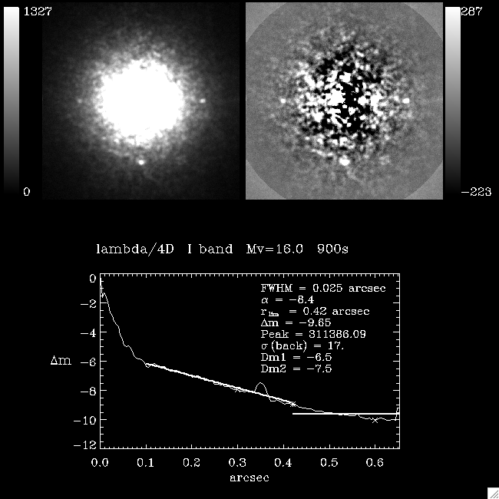

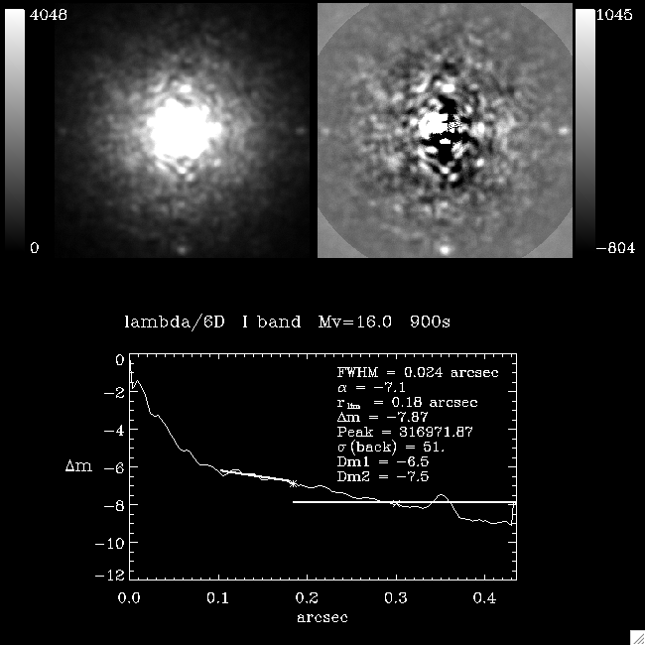
Figure 8. Detection profiles in R band with various pixel scales.


