Keck Adaptive Optics Note XXX
Near-Infrared Tip-Tilt Sensor System
Remove/Install Cryo-Cooler Review Report
H. Rodriguez, R. Dekany, R. Smith, D. Hale, J. Fucik, J. Cromer
August 16, 2013

Draft Version 0.1

Document Revision History
Revision Number | Revision Date | Summary of Changes | Author
0.1 | 08/07/2016 | first draft | H. Rodriguez

Overview

The purpose of this procedure is to describe in detail the steps required to safely remove and install the cold head assembly from the Near-Infrared Tip-Tilt Sensor System (NIRTTS).

Overall Components

Ion Pump
Indexing Pin Access Port

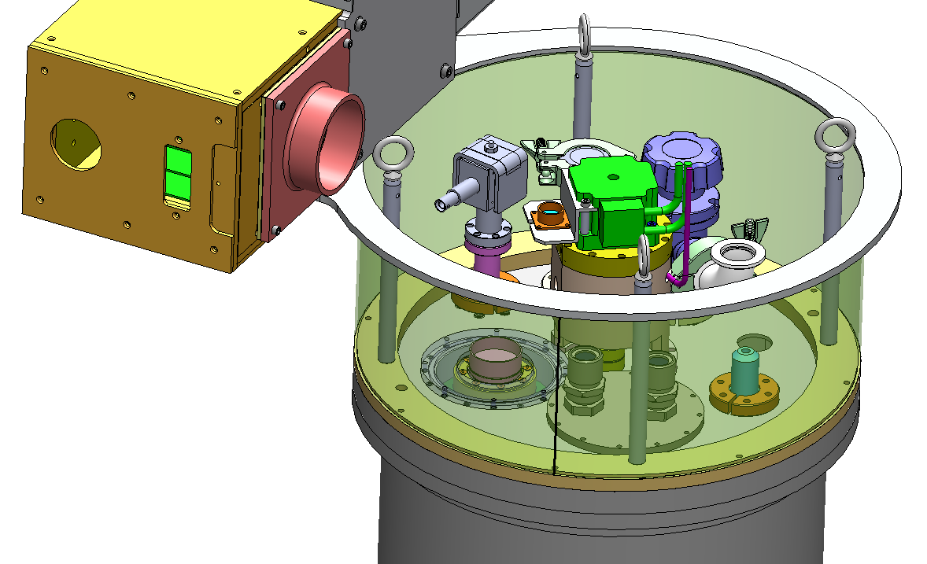
Filter Wheel Motor Assembly
Extension Tube (Shroud)
Cold Head Assembly
Pressure Relief Valve
Cryo-Cooler Assembly Access Port
ARC Electronics
Figure 1: Components that will be affected in this procedure.

Pre-requisite:
- Dewar must be at ambient pressure.
- Replacing or maintenance of any components inside the dewar are required to be done inside a clean room environment and follow clean room protocol.
Tools Required:
- 5/32” Extra-long T-handle hex key (23”) index pin
- 9/64” Extra-long T-handle Hex Key (18”) cold head
- 3mm Extra-long T-handle hex key (12”) coupler #3
- 3/32” Extra-long T-handle hex key (18”) filter wheel pedestal
- 3/32” allen wrench
- 5/32” allen wrench
- CCR open end wrenches (1”, 1-1/8”, 1-3/16”)
- Grounding strap

Procedures:

Remove Cryo-Cooler Assembly
- Send filter wheel to the home position.
- Disconnect cables.
- Disconnect the detector cable and install shorting plug.
  - Use a grounding strap during the removal of the detector cable.
- Disconnect the filter wheel motor cable.
  - Power off the filter wheel controller before disconnecting the cable.
- Disconnect the thermal control cable.
- Remove electronics.
- The ARC detector controller is installed onto the shroud using (4) 10-32 socket head captive screws. Remove electronics from shroud.
- Insert index pin through access port.
- Remove the ion pump by releasing the KF16 bulkhead clamp kit. Use 5/32” allen wrench. Ion pump is susceptible to contaminates when exposed to the environment. Place ion pump in an evacuated chamber after removing from the dewar.
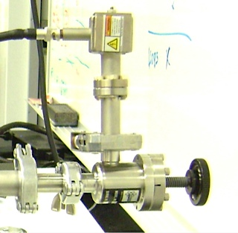
Figure 2: Ion pump connected to a KF16 valve and vacuum pump.

- Use index pin hex key to engage the index pin to the filter wheel.
  - The index pin is spring loaded, and will require a 90° turn to engage.
- Remove the shroud to get access to coupler #3.
- Remove (8) 8-32 socket head cap screws that fastens the shroud to the rear dewar cover. Remove shroud to get access to coupler #3.
- Unclamp the bottom socket head cap screw from coupler #3 using the 3mm hex key.
- Loosen the pedestal from the rear dewar cover.
- Loosen (6) 4-40 x ½” socket head cap screws that secures the pedestal to the rear dewar cover.
- Remove filter wheel motor assembly.
- Rotate ferrofluidic feed through nut.

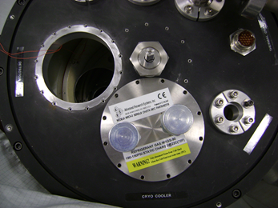
Figure 3: Position of nut before removing or installing cold head.
- Remove the pressure relief valve.
- Remove the KF16 bulkhead clamp kit for the pressure relief valve to get access to the cold head clamp fastener.
- Unclamp cold head from cryo cooler interface.
- Loosen the 8-32 x 1 ¼” socket head cap screw on the clamping linkage 4 ½ turns. Use a 9/64” T-handle hex key wrench.
- Remove cold head assembly.
- Remove (12) 6-32 x ½” socket head cap screws on the cold head flange, and carefully pull up the cold head assembly.
- Disconnect K14 sensor connector.
- Disconnect the K14 temperature sensor that is mounted to the cold head tip at the quick disconnect connector.

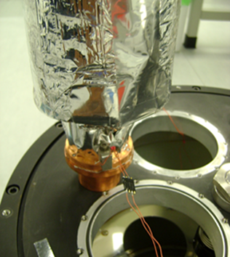
Quick disconnect connector
Carbon Getter
K14 Temperature Sensor
Figure 4: K14 temperature sensor quick disconnect. Constantan wire connections are very fragile, and can easily break.

- Remove carbon getter and indium seal.
- Replace indium seal if the carbon getter is removed or if the seal is damaged.
- Cover the cold head port.
- Use 6-32 x ½” socket head cap screws to cover the hole with the cold head blank plate.
- Cold head removal complete.

Install Cryo-Cooler Assembly
- Install carbon getter to cold head if applicable.
- Cut out indium seal to fit between the carbon getter and cold head tip.
- Fasten (5) 4-40 x ½” socket head cap screws to mount the carbon getter to the cold head tip.
- Connect K14 temp sensor connector
- Fasten the K14 temperature sensor to the cold head tip with a 4-40 x ¾” socket head cap screw and disc belleville washer.
- Connect the sensor quick disconnect connector.
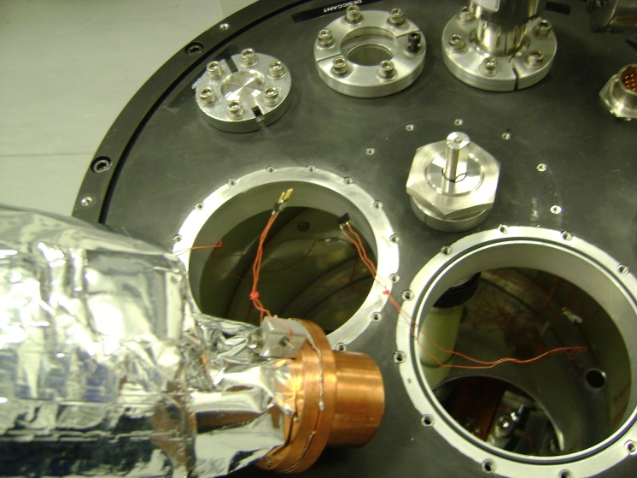
Figure 5: K14 temperature sensor mounted on cold head tip.

- Lower cold head assembly into the cryo-cooler interface assembly.
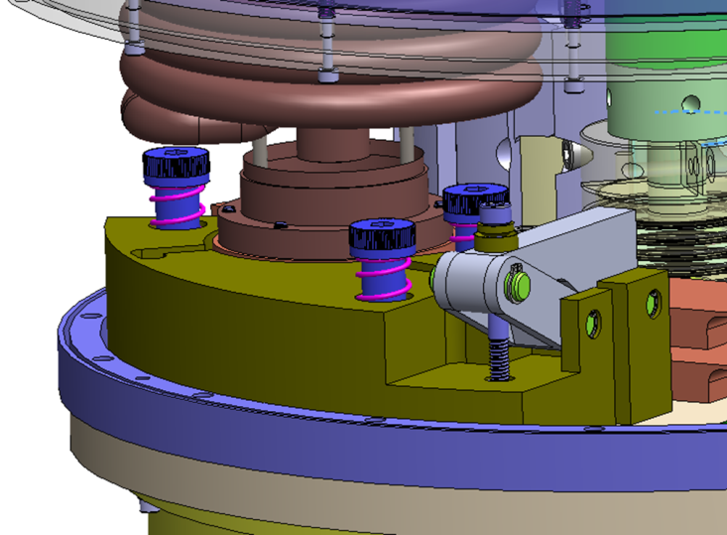
Cold Head Tip/Carbon Getter
8-32 x 1 ¼ shcs
Clamping Linkage
Figure 6: Cryo-Cooler Interface Assembly
- Fasten the (12) 6-32 x ½” socket head cap screws on the cold head to the rear dewar cover.
- Clamp the cold head to the cryo cooler interface.
- After inserting the carbon getter into the cryo-cooler interface, access the cryo-cooler clamp assembly through the pressure relief valve port.
- Clamp the 8-32 x 1 ¼” socket head cap screw. Using the 9/64” T-handle hex key turn the screw 4 ½ complete turns.
- Install pressure relief valve
- Use the KF16 bulkhead clamp kit to fasten the pressure relief valve to the rear dewar cover. Fasten the #10 socket head cap screws with a 5/32” allen wrench.
- Use the 1” open end ccr wrench to tighten the ferrofluidic feed through nut.
- Install filter wheel motor assembly.
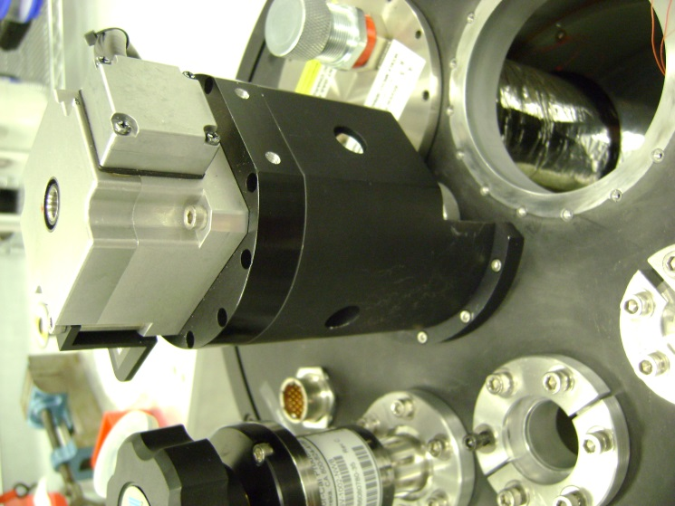
Figure 7: Filter Wheel Motor Assembly

- Lower coupler #3 mounted on the filter wheel motor assy. onto the ferrofluidic shaft.
- Home filter wheel motor encoder.
- Clamp coupler #3.
- Use the 3mm T-handle hex key to clamp coupler #3 to the ferrofluidic feed through shaft.

- Release index pin.
- Access the filter wheel index pin through the ion pump port. See Figure 1.
- Use a 5/32” T-handle hex key to release the pin from the filter wheel.
- Test filter wheel for rotation.
- Install ion pump.
- The ion pump is susceptible to contaminants. If the pump is in an evacuated environment, use nitrogen gas to pressurize pump.
- Fasten the ion pump to the rear dewar cover.
- Use KF16 bulkhead clamp kit to secure the pump to the rear dewar cover.
- Fasten the 10-32 screws with a 5/32 allen wrench.
- Installation of the cold head is complete.

