Keck Adaptive Optics Note 861

Near-Infrared Tip-Tilt Sensor
Systems Engineering Management Plan
at the Preliminary Design Review

P. Wizinowich
with contributions from R. Bartos, A. Cooper, J. Cromer, R. Dekany, D. Hale,
M. Hess, S. LaVen, C. Neyman, M. Pollard. R. Smith, C. Tyau
April 12, 2011

Table of Contents
1. Introduction 1
2. Organization Structure and Lead Personnel 1
3. Product Breakdown Structure 2
4. Project Plan and Schedule 5
4.1 Work Breakdown Structure 5
4.2 Milestones 5
4.3 MS Project Plans 6
5. Budget 7
5.1 Revised Proposal Budget 7
5.2 Remaining Budget at PDR 7
5.3 Budget Actuals 8
5.3.1 Actuals through SDR 8
5.3.2 PDR Actuals versus Plan 8
5.4 Budget Estimate at PDR 9
5.5 Labor Estimate at PDR 11
5.6 Procurement Estimate at PDR 13
6. Configuration Control 14
7. Risk Assessment 14
8. Project Plan Details 17
9. Proposal Plan (for reference) 27

Introduction
This document is written in support of the NSF ATI-funded near-infrared (NIR) tip-tilt sensor (TTS) project. The purpose of this document is to define the systems engineering management plan (SEMP) for the completion of the NIR TTS system and its implementation with the Keck I LGS AO system. This document represents an update to the project plan in the original ATI proposal and the SEMP presented at the system design review (SDR; KAON 839).

Organization Structure and Lead Personnel
The organization chart for the project, provided in the NSF proposal, is shown in Figure 1. Table 4 provides descriptions of the project staff. Wizinowich will act as project manager through the preliminary design phase of this project in order to allow Stalcup to focus on the K1 LGS free space transport project. Chris Neyman will be added to the project team for at least the preliminary design phase to provide systems engineering support and to help define the operations software tools. Andrew Cooper will replace Ed Wetherell during the preliminary design phase.
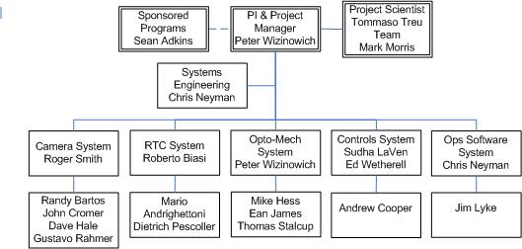
Figure 1: Project Organization

Table 1: Project Staff
Position | Name | Notes
P.I., Project Manager & Opto-Mechanical Lead | Peter Wizinowich | As PI & AO project manager Wizinowich is responsible for the overall project success in coordination with other WMKO activities. Responsible for managing the engineering team & project to meet the budget and schedule. Responsible for the design & implementation of the opto-mechanical system, plus the optical design of the camera system.
Project Scientist | Tommaso Treu | Leads the management of the science requirements for the upgrade and oversees the performance characterization phase of the project.
Camera System Lead | Roger Smith | Responsible for the design and delivery of the NIR sensor, including readout mode validation and lab performance testing.
Systems Engineer + Operations Software Lead | Chris Neyman | Manages the design process to ensure proper design choices and maintains the performance budgets. Responsible for the overall integration of the system from sub-system acceptance through lab, telescope I&T & handover.  Responsible for the design and implementation of the operations software tools.
RTC System Lead | Roberto Biasi | Responsible for the design and implementation of the RTC system per the SOW (KAON 824).
Controls Software Lead | Sudha LaVen | Responsible for the design & implementation of the controls software. Also oversight responsibility for all software & the software interfaces.
Controls Hardware Lead | Ed Wetherell  A. Cooper | Responsible for the design & implementation of the controls hardware. Also oversight responsibility for all electronics & the electrical interfaces. Responsibility will switch from Andrew Cooper during the design to Ed Wetherell during the implementation.
WMKO’s normal management process will provide oversight for this project. This includes regular status reports to WMKO’s management and Science Steering Committee. WMKO’s Office of Sponsored Programs will monitor project compliance with NSF terms and conditions, including timely reporting. Regular project meetings will be held to manage activities, discuss progress and address problems.

Product Breakdown Structure
The Product Breakdown Structure (PBS) is shown in Table 2. The five major subsystems are shown at level 1 and their major components at level 2. A quick summary of the 5 major subsystems of the PBS and their key components is provided in Figure 2. There is one change since the SDR: the field lens and fold mirror and the interface plate between the camera and the focus stage have been transferred from the opto-mechanical system to the camera system.
Table 2: Product breakdown structure
PBS Level 1 | Level 2 | Level 3
Camera System | External opto-mechanics | Kinematic interface plate
Camera System | External opto-mechanics | External optics cylinder
Camera System | External opto-mechanics | Field Lens & Mount
Camera System | External opto-mechanics | Fold Mirror & Mount
Camera System | Camera | Camera Opto-mechanics
Camera System | Camera | Filter Change Mechanism
Camera System | Camera | Filter Stage Motor, Limit Switches & Cable
Camera System | Camera | Dewar Cryostat
Camera System | Camera | Detector
Camera System | Camera | Heaters/Thermistors
Camera System | Readout Electronics | ARC Timing Board
Camera System | Readout Electronics | Video Card
Camera System | Readout Electronics | Interface to Dewar
Camera System | Readout Electronics | Interface to Host Computer
Camera System | Readout Electronics | Interface to RTC
Camera System | Housekeeping Electronics | Housekeeping Interface Board
Camera System | Housekeeping Electronics | Temperature Controller/Sensor
Camera System | Housekeeping Electronics | Interface to Host Computer
Camera System | External Motion Control | Stepper Motor Driver
Camera System | External Motion Control | Interface to Host Computer
Camera System | External Cryo System | CryoTiger
Camera System | External Cryo System | Interface to Dewar
Camera System | External Vacuum System | Ion Pump
Camera System | External Vacuum System | Interface to Dewar
Camera System | Host Computer | Computer
Camera System | Host Computer | Readout Control Software
Camera System | Host Computer | Housekeeping Control Software
Camera System | Host Computer | Motion Control Software
Camera System | Host Computer | Keyword Interface
Real-Time Control System | Microgate HW Mods | Camera Interface
Real-Time Control System | Microgate Software Modifications | Camera Interface & Readout
Real-Time Control System | Microgate Software Modifications | Wavefront Controller Interface Mods
Real-Time Control System | Microgate Software Modifications | Wavefront Processor Mods
Real-Time Control System | Microgate Software Modifications | Telemetry Recorder/Server Mods
Real-Time Control System | Microgate Software Modifications | Downlink TTM Controller Mods
Opto-mechanical System | Pickoff Exchange Mechanism | AO Bench Extension
Opto-mechanical System | Pickoff Exchange Mechanism | AO Bench Modified Cover
Opto-mechanical System | Pickoff Exchange Mechanism | Pickoff Stage Mount
Opto-mechanical System | Pickoff Exchange Mechanism | Pickoff Stage
Opto-mechanical System | Pickoff Exchange Mechanism | Pickoff Stage Motor, Encoder & Cable
Opto-mechanical System | Pickoff Exchange Mechanism | Pickoff Mount
Opto-mechanical System | Pickoff Exchange Mechanism | K'-Band Dichroic
Opto-mechanical System | Pickoff Exchange Mechanism | H-Band Dichroic
Opto-mechanical System | Pickoff Exchange Mechanism | Annular Mirror (option)
Opto-mechanical System | Focus Mechanism | Riser for Focus Stage
Opto-mechanical System | Focus Mechanism | Focus Stage
Opto-mechanical System | Focus Mechanism | Focus Stage Motor, Encoder & Cable
Opto-mechanical System | Focus Mechanism | Mounting Plate to Camera Interface Plate
Opto-mechanical System | AO Modifications | Modifications to Support Camera System
Controls System | OBS Modifications | Pickoff Stage Motion Control Hardware
Controls System | OBS Modifications | Pickoff Stage Motion Control Software
Controls System | OBS Modifications | Camera System Hardware Implementation
Controls System | OBS Modifications | Camera System Control Software
Controls System | SC Modifications | Modifications to RTC Interface
Controls System | SC Modifications | DAR Compensation Modifications
Controls System | SC Modifications | Focus Compensation Modifications
Controls System | SC Modifications | Non-Sidereal Tracking Modifications (goal)
Controls System | SC Modifications | Rotator Control Modifications (long term)
Controls System | RTC Modifications | Wavefront Controller Command Processor Mods
Operations Software System | Pre-Observing Tools | Acquisition Planning Tool Software
Operations Software System | Pre-Observing Tools | Acquisition Planning Documentation
Operations Software System | Pre-Observing Tools | Performance Estimation Tool Software
Operations Software System | Pre-Observing Tools | Performance Estimation Documentation
Operations Software System | Observation Setup Software | OBS Setup Software
Operations Software System | Observation Setup Software | SC Setup Software
Operations Software System | Observation Setup Software | Camera System Setup Software
Operations Software System | Observation Setup Software | RTC Setup Software
Operations Software System | Calibration Software | Camera Calibration Software
Operations Software System | Calibration Software | Focus Calibration Software
Operations Software System | Calibration Software | Distortion Mapping Software
Operations Software System | User Interfaces | Engineering GUI Additions/Modifications
Operations Software System | User Interfaces | Observing UI Additions/Modifications
Operations Software System | Observing Tools & Sequences | Acquisition Software
Operations Software System | Observing Tools & Sequences | MAGIQ Software Modifications
Operations Software System | Observing Tools & Sequences | Nodding Script Modifications
Operations Software System | Observing Tools & Sequences | Dithering Script Modifications
Operations Software System | Observing Tools & Sequences | Repositioning Script Modifications
Operations Software System | Observing Tools & Sequences | Background Measurement Script Mods
Operations Software System | Observing Tools & Sequences | FITS Header Modifications
Operations Software System | Observing Tools & Sequences | Telemetry Data Recording Modifications
Operations Software System | Observing Tools & Sequences | TT Control Loop Parameter Optimization
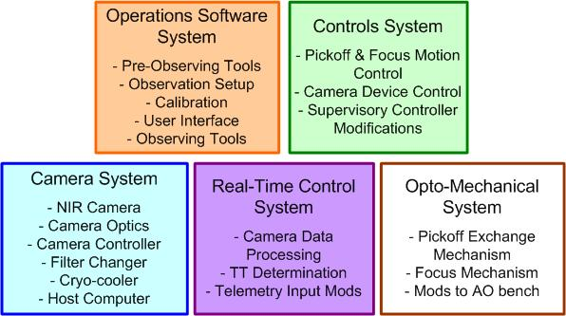
Figure 2: Block diagram summary of major NIR TTS subsystems and their key components

Project Plan and Schedule

Work Breakdown Structure
The top-level work breakdown structure is shown in Figure 3. WBS 1.3 to 1.7 correspond to the level 1 items in the PBS; i.e., the five NIR TTS subsystems shown in Figure 2. WBS 1.1, 1.2, 1.8 and 1.9 are system-wide activities.
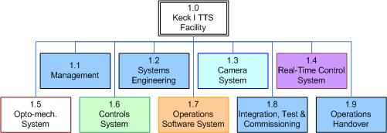
Figure 3: Top-level work breakdown structure

Milestones
Table shows the milestone dates in the original proposal and the plan presented in this SEMP. The handover review essentially marks the end of the project, except for some modest additional performance characterization and science verification that could run through an additional ~ 2 months.

The PDR is being held 3 months later than planned in the proposal, and 1 month late with respect to the PDR date proposed at the SDR (about 2 weeks of this delay are due to reviewer availability). The DDR date is a 2.5 month slip versus the proposal.

The TAC-allocation milestones indicate when both shared-risk and regular science with the NIR TTS should begin; the readiness for these milestones will be reviewed by the indicated dates. Overall the new schedule represents a 1 semester slip in the start of regular TAC-allocated science.

Table 3: Project Milestones
Milestone | Date in Proposal | Date in Current Plan
Project Start | 8/1/10 | 8/1/10
System Design Review | 11/8/10 | 12/7/10
Preliminary Design Review | 1/31/11 | 4/25/11
Detailed Design Review | 7/11/11 | 8/30/11
RTC Pre-Ship Review |  | 1/30/12
Camera Pre-Ship Review | 7/9/12 | 9/28/12
Pre-Summit Review | 11/9/12 | 1/30/13
Handover Review | 7/3/13 | 12/15/13
TAC-Allocation Milestones
Readiness for 13B Shared-Risk |  | 2/1/13
Start of TAC-allocated Shared-Risk |  | 10/1/13
Readiness for 14A Science |  | 8/1/13
Start of TAC-allocated Science | 8/1/13 | 2/1/14

A rolled up version of the project plans, as submitted in the NSF ATI proposal, showing key milestones and work estimates is provided in section 9.

MS Project Plans
A total of four project plans have been prepared for the remainder of the project. Figure 4 is the project plan for the camera prepared by Caltech covering the detailed design through the completion of the project. Figure 5, Figure 6 and Figure 7 are the WMKO plans for the remaining three phases of the project, namely detailed design, full scale development, and delivery and commissioning, respectively. The project plans shown in this section are rolled up to high level tasks, the versions showing all subtasks can be found in section .

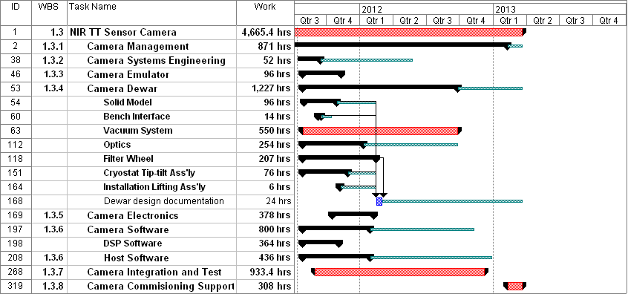
Figure 4: Caltech plan from start of detailed design through delivery

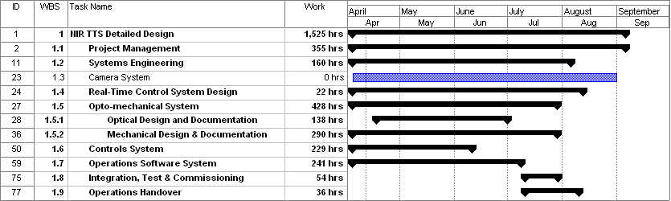
Figure 5: WMKO detailed design phase plan

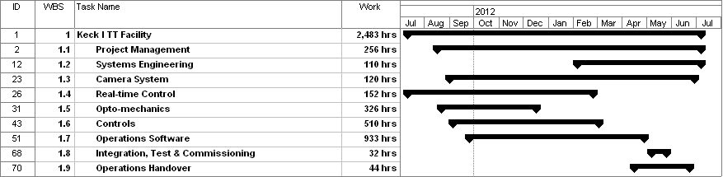
Figure 6: WMKO full scale development phase plan

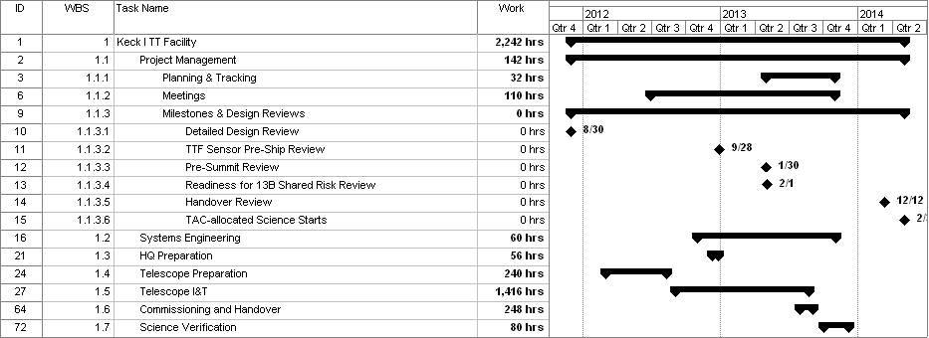
Figure 7: WMKO Delivery and Commissioning Plan

Budget

Revised Proposal Budget
The original proposal amount was $1966k. At NSF’s request this budget was revised downward to $1716k; a total reduction of $250k. The WMKO Director agreed to a cost share of $15k in year 3 and $28k in year 4, and to cover the 483h of support astronomer time ($47k with indirect). The remainder was achieved with a $62k reduction in WMKO labor (an 8.5% reduction) and a $98k reduction in COO labor (a 12.5% reduction). These reductions essentially used the total contingency in the original proposal (10% at WMKO and ~$100k at COO).
The lack of contingency was identified as a critical issue at the SDR. In response, Hilton Lewis identified additional WMKO resources that could be applied to the project. These additional resources include $140k of flexible dollars and $100k of Keck labor in FY13.
In summary the resources for this project include:
- $1716k from NSF ATI
- $15k in FY11, $28k in FY12 and $240k in FY13 from WMKO
- 483h of support astronomer (SA) time from WMKO

Remaining Budget at PDR
The remaining budget is summarized as follows:
- $1716k - $325k - $329k = $1062k from NSF ATI
  - The spent dollars include $280k of planned procurements
- $15k in FY11, $28k in FY12 and $240k in FY13 from WMKO
- 483h – 8h – 61h = 414h of support astronomer time from WMKO

The subtractions above are from the SDR and PDR actuals discussed in sections 5.3.1 and 5.3.2, respectively. We have spent 33% of the NSF plus WMKO budget (22% of the budget excluding the $280k of procurements), and 14% of the SA hours. We have $1345k remaining.

Budget Actuals

Actuals through SDR
The total budget spent through SDR was $324,858 including $41,727 for labor, $256,000 for equipment, $375 for materials and $26,756 for indirect costs.

Only WMKO charged to this account in FY10 since a purchase order was not yet in place at Caltech. Caltech personnel (18h of Dekany and 33h of Smith) charged to the NGAO technical risk reduction budget. The FY10 actuals included 153 hours of labor (57h James, 1h Johansson, 14h LaVen, 12h Stalcup, 10h Wetherell and 60h Wizinowich). The total FY10 labor dollars was $11,916 or 78% of the budgeted $15,298 for WMKO labor. In addition there was $100 for supplies, $231 for phone calls and $6,865 for indirect costs.

The FY11 actuals through November 2010 included 388 hours of WMKO labor (97h James, 23h Neyman, 17h LaVen, 95h Stalcup, 2h Tsubota, 5h Wetherell, 141h Wizinowich and 8h of SA). The total labor dollars through November were $29,576 or 16% of the total dollars budgeted for WMKO labor in FY11. In addition there was $250,000 to Teledyne for the H2RG detector and $19,891 for indirect costs. In October and November Caltech personnel worked 25.5 hours on this project (38h Dekany and 45h Smith), again charged to the NGAO technical risk reduction budget. The December Caltech labor (25h Dekany, 19h Hale and 47h Smith) most of which was for the SDR was also charged to the NGAO technical risk reduction budget.

One additional procurement was placed and the parts were received: $6000 to ARC for a dual transmit ARC-22 timing board and an ARC-64 PCI interface board. The ARC procurement represents a $500 cost increase since the timing board had to be modified for dual channel output.

PDR Actuals versus Plan
The overall PDR actuals estimate is $329k including $124k of WMKO labor, $112k of Caltech labor, $24k of equipment, $1k of materials and $67k of indirect costs.

Although the PDR did not start until after the SDR on Dec. 7 the actuals listed here include all labor in December through February for WMKO and through March for Caltech. An estimate has been made for the remaining PDR labor through April 10 since these numbers are not yet available.

The PDR plan presented at SDR included 1227h of WMKO labor and 786h of Caltech labor.

The PDR actuals estimate is for 1573h of WMKO labor for a 28% increase (346h) over the plan. This corresponds to a $48k increase including indirect. The differences by individual can be seen in Table 4. The two large discrepancies are for Neyman and Wizinowich. In Neyman’s case the AO software tools took much longer than planned mostly due to the learning curve of not using or creating the current tools; he also needed to spend extra time supporting software folks on the interactions between the NIR TTS and the AO supervisory controller. In Wizinowich’s case, he ended up taking on some new responsibilities including the requirements, interfaces (including keywords) and calibrations, and addressing the cryocooler selection safety issues; the mechanical design support task also grew considerably. The next largest discrepancy is a transfer of the mechanical design work from James to Hess. Note that we utilized 53h of SA during the PD.

Table 4: WMKO preliminary design phase labor hours versus the plan

The PDR actuals estimate is for 1227h of Caltech labor for a 56% increase (441h) over the plan. The additional hours correspond to a $33k cost increase (this includes a higher rate for mechanical engineering than in the SDR plan). The differences by individual can be seen in Table 5. The largest discrepancy is for Hale. Originally unplanned work for Hale including validating the video link communications, evaluating the self heating effects and work on developing the camera emulator to be sent to Microgate. Smith ended up needing to spend unplanned time on the cryocooler selection (because of Keck safety issues) and ITAR issues imposed by the Teledyne detector and the Federal requirements flowdown in the subcontract from WMKO.

Table 5: Caltech preliminary design phase labor hours versus the plan

The equipment cost includes $17k to Microgate to cover the system and preliminary design phases.

A procurement was placed in March for additional ARC components to allow for an interface emulator for Microgate in addition to the development system at Caltech: $7000 including an ARC-22 timing board (with dual channel output), a controller housing and power supply. The second timing board represents a $3000 cost increase since only one timing board was originally budgeted.

Budget Estimate at PDR
The overall project budget at PDR is presented in The dollars by year for personnel are shown in sections A to C of The dollars by year for personnel are shown in sections A to C of The dollars by year for personnel are shown in sections A to C of and . The equipment purchases over $5k are listed in section D of and by year. Travel and other direct costs are shown in sections E and G, respectively. The indirect costs are calculated in section I. and Table 7. The equipment purchases over $5k are listed in section D of The dollars by year for personnel are shown in sections A to C of and . The equipment purchases over $5k are listed in section D of and by year. Travel and other direct costs are shown in sections E and G, respectively. The indirect costs are calculated in section I. and Table 7 by year. Travel and other direct costs are shown in sections E and G, respectively. The indirect costs are calculated in section I. and Table 7. The equipment purchases over $5k are listed in section D of The dollars by year for personnel are shown in sections A to C of The dollars by year for personnel are shown in sections A to C of and . The equipment purchases over $5k are listed in section D of and by year. Travel and other direct costs are shown in sections E and G, respectively. The indirect costs are calculated in section I. and Table 7. The equipment purchases over $5k are listed in section D of The dollars by year for personnel are shown in sections A to C of and . The equipment purchases over $5k are listed in section D of and by year. Travel and other direct costs are shown in sections E and G, respectively. The indirect costs are calculated in section I. and Table 7 by year. Travel and other direct costs are shown in sections E and G, respectively. The indirect costs are calculated in section I. and Table 7 by year. Travel and other direct costs are shown in sections E and G, respectively. The indirect costs are calculated in section I. by year. The total cost estimate (row J) is $1890k. After combining the $1716k of NSF funding (2nd last row of The dollars by year for personnel are shown in sections A to C of The dollars by year for personnel are shown in sections A to C of The dollars by year for personnel are shown in sections A to C of and . The equipment purchases over $5k are listed in section D of and by year. Travel and other direct costs are shown in sections E and G, respectively. The indirect costs are calculated in section I. and Table 7. The equipment purchases over $5k are listed in section D of The dollars by year for personnel are shown in sections A to C of and . The equipment purchases over $5k are listed in section D of and by year. Travel and other direct costs are shown in sections E and G, respectively. The indirect costs are calculated in section I. and Table 7 by year. Travel and other direct costs are shown in sections E and G, respectively. The indirect costs are calculated in section I. and Table 7. The equipment purchases over $5k are listed in section D of The dollars by year for personnel are shown in sections A to C of The dollars by year for personnel are shown in sections A to C of and . The equipment purchases over $5k are listed in section D of and by year. Travel and other direct costs are shown in sections E and G, respectively. The indirect costs are calculated in section I. and Table 7. The equipment purchases over $5k are listed in section D of The dollars by year for personnel are shown in sections A to C of and . The equipment purchases over $5k are listed in section D of and by year. Travel and other direct costs are shown in sections E and G, respectively. The indirect costs are calculated in section I. and Table 7 by year. Travel and other direct costs are shown in sections E and G, respectively. The indirect costs are calculated in section I. and Table 7 by year. Travel and other direct costs are shown in sections E and G, respectively. The indirect costs are calculated in section I.) with the $283k of WMKO funding (4th last row) the remaining contingency is $109k of WMKO funds (bottom right cell). Note that no indirect cost is charged to the WMKO funds.
Table 7 is the COO project budget which is listed as a subaward in the overall project budget.
The dollars by year for personnel are shown in sections A to C of The dollars by year for personnel are shown in sections A to C of The dollars by year for personnel are shown in sections A to C of The dollars by year for personnel are shown in sections A to C of and . The equipment purchases over $5k are listed in section D of and by year. Travel and other direct costs are shown in sections E and G, respectively. The indirect costs are calculated in section I. and Table 7. The equipment purchases over $5k are listed in section D of The dollars by year for personnel are shown in sections A to C of and . The equipment purchases over $5k are listed in section D of and by year. Travel and other direct costs are shown in sections E and G, respectively. The indirect costs are calculated in section I. and Table 7 by year. Travel and other direct costs are shown in sections E and G, respectively. The indirect costs are calculated in section I. and Table 7. The equipment purchases over $5k are listed in section D of The dollars by year for personnel are shown in sections A to C of The dollars by year for personnel are shown in sections A to C of and . The equipment purchases over $5k are listed in section D of and by year. Travel and other direct costs are shown in sections E and G, respectively. The indirect costs are calculated in section I. and Table 7. The equipment purchases over $5k are listed in section D of The dollars by year for personnel are shown in sections A to C of and . The equipment purchases over $5k are listed in section D of and by year. Travel and other direct costs are shown in sections E and G, respectively. The indirect costs are calculated in section I. and Table 7 by year. Travel and other direct costs are shown in sections E and G, respectively. The indirect costs are calculated in section I. and Table 7 by year. Travel and other direct costs are shown in sections E and G, respectively. The indirect costs are calculated in section I. and Table 7. The equipment purchases over $5k are listed in section D of The dollars by year for personnel are shown in sections A to C of The dollars by year for personnel are shown in sections A to C of The dollars by year for personnel are shown in sections A to C of and . The equipment purchases over $5k are listed in section D of and by year. Travel and other direct costs are shown in sections E and G, respectively. The indirect costs are calculated in section I. and Table 7. The equipment purchases over $5k are listed in section D of The dollars by year for personnel are shown in sections A to C of and . The equipment purchases over $5k are listed in section D of and by year. Travel and other direct costs are shown in sections E and G, respectively. The indirect costs are calculated in section I. and Table 7 by year. Travel and other direct costs are shown in sections E and G, respectively. The indirect costs are calculated in section I. and Table 7. The equipment purchases over $5k are listed in section D of The dollars by year for personnel are shown in sections A to C of The dollars by year for personnel are shown in sections A to C of and . The equipment purchases over $5k are listed in section D of and by year. Travel and other direct costs are shown in sections E and G, respectively. The indirect costs are calculated in section I. and Table 7. The equipment purchases over $5k are listed in section D of The dollars by year for personnel are shown in sections A to C of and . The equipment purchases over $5k are listed in section D of and by year. Travel and other direct costs are shown in sections E and G, respectively. The indirect costs are calculated in section I. and Table 7 by year. Travel and other direct costs are shown in sections E and G, respectively. The indirect costs are calculated in section I. and Table 7 by year. Travel and other direct costs are shown in sections E and G, respectively. The indirect costs are calculated in section I. and Table 7 by year. Travel and other direct costs are shown in sections E and G, respectively. The indirect costs are calculated in section I.
The overall project cost estimate of $1890k, excluding contingency, is 4% less than the original proposal budget of $1966k. The cost increases and decreases with respect to the original proposal budget are shown in Table 8.

Table 6: Overall project budget

Table 7: Detailed CIT Project Budget (incorporated on line G.5 of The dollars by year for personnel are shown in sections A to C of The dollars by year for personnel are shown in sections A to C of The dollars by year for personnel are shown in sections A to C of and . The equipment purchases over $5k are listed in section D of and by year. Travel and other direct costs are shown in sections E and G, respectively. The indirect costs are calculated in section I. and Table 7. The equipment purchases over $5k are listed in section D of The dollars by year for personnel are shown in sections A to C of and . The equipment purchases over $5k are listed in section D of and by year. Travel and other direct costs are shown in sections E and G, respectively. The indirect costs are calculated in section I. and Table 7 by year. Travel and other direct costs are shown in sections E and G, respectively. The indirect costs are calculated in section I. and Table 7. The equipment purchases over $5k are listed in section D of The dollars by year for personnel are shown in sections A to C of The dollars by year for personnel are shown in sections A to C of and . The equipment purchases over $5k are listed in section D of and by year. Travel and other direct costs are shown in sections E and G, respectively. The indirect costs are calculated in section I. and Table 7. The equipment purchases over $5k are listed in section D of The dollars by year for personnel are shown in sections A to C of and . The equipment purchases over $5k are listed in section D of and by year. Travel and other direct costs are shown in sections E and G, respectively. The indirect costs are calculated in section I. and Table 7 by year. Travel and other direct costs are shown in sections E and G, respectively. The indirect costs are calculated in section I. and Table 7 by year. Travel and other direct costs are shown in sections E and G, respectively. The indirect costs are calculated in section I.)
Table 8: Comparison of budget at PDR to budget in original proposal
Category | Proposal | PDR Plan | Increase
WMKO Labor | $549,644 | $614,319 | $64,675
Caltech Labor | $581,905 | $454,131 | -$127,774
Camera Procurements | $371,960 | $396,717 | $24,757
Microgate Contract | $23,100 | $67,800 | $44,700
Other Procurements | $58,850 | $50,810 | -$8,078
Travel | $13,920 | $9,508 | -$4,412
Indirect | $366,536 | $296,760 | -$69,776
Total | $1,965,915 | $1,890,044 | -$75,871

Labor Estimate at PDR
The required WMKO personnel to complete the NIR TTS project are listed in Table 9. Overall the SD phase used 541h of WMKO labor (section 5.3.1) and the PD phase used 1573h (Table 4). Table 9 shows that another 6250h are required for an overall total of 8364h. This represents a 16% increase over the 7210h in the original proposal (Figure 13).
Table 9: WMKO Staffing by Phase
The WMKO FY11 plan has the personnel hours shown in Table 10 assigned to this project. The actuals through PDR and the remaining required hours to complete the detailed design phase (from Table 9) are also listed. The last column shows the difference between the FY11 plan and the revised expected actuals (negative means that more hours were required than planned).
Table 10: Remaining FY11 WMKO hours versus Observatory plan
Category | Name | FY11 Plan (hours) | Actuals  (thru PDR) | Required hours | Plan – Actuals – Required
Support Astronomer | Campbell | 83 | 21 | 0 | 62
Support Astronomer | Conrad | 77 | 0 | 0 | 77
Support Astronomer | Lyke | 0 | 48 | 60 | -108
Mechanical | Hess | 0 | 110 | 260 | -370
Mechanical | James | 572 | 134 | 0 | 438
Mechanical | Pollard | 62 | 16 | 66 | -20
Mechanical | Randolph | 0 | 9 | 0 | -9
Electronics | Cooper | 0 | 28 | 137 | -165
Electronics | Wetherell | 232 | 9 | 0 | 223
Software | Honey | 40 | 0 | 0 | 40
Software | Kwok | 0 | 6 | 0 | -6
Software | LaVen | 667 | 285 | 287 | 95
Software | Stomski | 0 | 42 | 0 | -42
Software | Tsubota | 100 | 12 | 0 | 88
Optical Systems | Chin | 0 | 3 | 0 | -3
Optical Systems | Neyman | 0 | 495 | 337 | -832
Optical Systems | Stalcup | 873 | 210 | 102 | 561
Optical Systems | Tyau | 0 | 36 | 36 | -72
Optical Systems | Wizinowich | 83 | 495 | 240 | -652
Total |  | 2789 | 1959 | 1525 | -695

All engineering disciplines except for optical systems are roughly equal between the plan and the actuals. Neyman and Wizinowich are now planned to spend 940h more in FY11 than originally planned from Stalcup and Wizinowich.

The required Caltech personnel to complete the NIR TTS project are listed in Table 11. Overall the SD phase used 225h of Caltech labor (section 5.3.1) and the PD phase used 1227h (Table 5). Table 11 shows that another 4585h are required for an overall total of 6037h. This represents a 21% decrease over the 7296h in the original proposal (after subtracting 276h of Stalcup from Figure 13).

Table 11: Caltech staffing by year

Procurement Estimate at PDR
The procurement budget in the original proposal included $373,700 for equipment and $80,210k for materials, supplies and shop fees. The current budget (The dollars by year for personnel are shown in sections A to C of The dollars by year for personnel are shown in sections A to C of The dollars by year for personnel are shown in sections A to C of and . The equipment purchases over $5k are listed in section D of and by year. Travel and other direct costs are shown in sections E and G, respectively. The indirect costs are calculated in section I. and Table 7. The equipment purchases over $5k are listed in section D of The dollars by year for personnel are shown in sections A to C of and . The equipment purchases over $5k are listed in section D of and by year. Travel and other direct costs are shown in sections E and G, respectively. The indirect costs are calculated in section I. and Table 7 by year. Travel and other direct costs are shown in sections E and G, respectively. The indirect costs are calculated in section I. and Table 7. The equipment purchases over $5k are listed in section D of The dollars by year for personnel are shown in sections A to C of The dollars by year for personnel are shown in sections A to C of and . The equipment purchases over $5k are listed in section D of and by year. Travel and other direct costs are shown in sections E and G, respectively. The indirect costs are calculated in section I. and Table 7. The equipment purchases over $5k are listed in section D of The dollars by year for personnel are shown in sections A to C of and . The equipment purchases over $5k are listed in section D of and by year. Travel and other direct costs are shown in sections E and G, respectively. The indirect costs are calculated in section I. and Table 7 by year. Travel and other direct costs are shown in sections E and G, respectively. The indirect costs are calculated in section I. and Table 7 by year. Travel and other direct costs are shown in sections E and G, respectively. The indirect costs are calculated in section I. and Table 7) includes $416,994 for equipment and $98,333 for materials, supplies and shop fees. Overall the procurements have grown by 14% from $453,910 to $515,327.

To date $330,800 of the procurement orders have already been placed, including the $67,800 fixed price contract to Microgate. Detailed procurement spreadsheets were prepared by Caltech and WMKO. Approximately $64k of the remaining $184k is from catalog prices or quotes.

Contingency at PDR
The remaining cost estimate for the detailed design phase through completion is $1236k. What part of this budget needs contingency? We assume that contingency is not needed on the remaining indirect costs, $203k, since the indirect cost recovery will be limited by the remaining NSF ATI funds. We only need to maintain a modest contingency, ~5%, on fixed price contracts ($51k remaining) and catalog prices or quotes ($64k remaining). At minimum we should have a 10% contingency on the rest of the remaining cost estimate. The desired contingency would therefore be ≥ ($1236k - $203k - $51k - $64k) * 10% + ($51k + $64k) * 5% = $98k. A more reasonable contingency would be to increase the 10% contingency number to 20% which would require $189k of contingency overall. Currently we have $109k or 10.6% contingency on the remaining costs excluding indirect costs.

The $81k or 33% cost overrun on the preliminary design phase versus the plan presented at SDR (see section 5.3.2) warrants a significant contingency and/or much improved project management. Some time was used during the preliminary design to ramp up team members on this project and to bring them up to speed. Now that the team is ramped up efficiency should be higher. The plans and cost estimates also have improved fidelity over those in the original proposal (we only updated the preliminary design phase plan for the SDR).

In preparing the current cost estimate we excluded goals including the use of three stars for tip-tilt, the use of a star for focus and an interactive performance prediction tool. We have however kept the infrastructure to allow these to be implemented in the future. Our remaining descope options appear to be relatively limited. We could still for example only order one instead of two dichroics to save ~$5k.

Configuration Control
Documents are maintained as Keck Adaptive Optics Notes (KAONs) in the KeckShare database. Drawings will be maintained in the mechanical and electronics databases, which are also available through KeckShare.

Four documents, representing all of the requirements and interfaces, are under configuration control as of the PDR:
- KAON 824: Microgate Statement of Work
- KAON 835: System and Functional Requirements Spreadsheet
- KAON 836: Camera to AO Interface Control Document
- KAON 857: Keyword Interface Spreadsheet

Changes to these documents must be tracked and approved by the project manager.
Engineering change requests (ECRs) are used to protect the operational systems. The ECRs indicate which change control boards (CCBs) are affected. The primary CCB review will be the AO CCB but there will be minor items for the telescope and instrument CCBs to review. The following draft ECRs have already been submitted through the SEED database, and will have initial reviews prior to the DDR:
- EC91418 for the OBS motion control modifications and motion stages
- EC91425 for the camera and opto-mechanics
- EC91433 for the camera support electronics
- EC91432 for the cryocooler

Several software ECRs have been posted and will also be submitted for review through the MANTIS database, again making sure to note the affected CCBs:
- Optics Bench software modifications
- Supervisory Controller software modifications
- Wavefront Controller software modifications
- Top-level software modifications

Risk Assessment
The JPL risk evaluation matrix approach used for the Keck Interferometer and NGAO was selected to track the significant programmatic and technical risks. This matrix ranks each risk by the consequences and likelihood of the risk occurring. A scale of 1 to 5 is used with higher numbers representing higher risk.

The JPL-format risk matrix is shown in Figure 8. In this risk matrix red represents high risks that require implementation of new processes or a change in the baseline plan, yellow represents medium risks that need to be aggressively managed including considering alternative approaches, and green represents relatively low risks that should at least be monitored.
Likelihood of Occurrence:
Level | Definition
5 | Very High > 70%, almost certain
4 | High >50%, more likely than not
3 | Moderate >30%, significant likelihood
2 | Low > 1%, unlikely
1 | Very Low <1%, very unlikely

Consequence of Occurrence – Programmatic Risks
(JPL’s usage of “launch” replaced with “schedule”)
Level | Implementation Risk Definition
5 | Overrun budget & contingency. Cannot deliver.
4 | Consume all contingency, budget or schedule
3 | Significant reduction in contingency or schedule slack
2 | Small reduction in budget or schedule slack
1 | Minimal reduction in budget or schedule slack
Consequence of Occurrence – Technical Risks
(JPL’s usage of “mission return” replaced with “science return”):
Level | Performance Risk Definition
5 | Project Failure
4 | Significant reduction in science return
3 | Moderate reduction in science return
2 | Small reduction in science return
1 | Minimal or no impact to science return

Table 12 lists the significant technical and programmatic risks. Two risks (items 7 and 8) were added subsequent to the SDR. Actions taken during the preliminary design lowered the likelihood on four risks.

Figure 8: Programmatic and technical risk matrix

Table 12: Significant risk areas
# | Conse-quence | Like-lihood | Description | PDR | DD Proposed Mitigation
1 | 3 | 2 | Tip-Tilt measurement accuracy requirement not achieved working off null | The selected approach (to allow the use of 3 stars, & to compensate for differential atmospheric refraction & to allow small positional adjustments) requires good tip-tilt performance even when the tip-tilt star is located up to 25 mas in x & y from the intersection of 4 pixels. The proposed correlation algorithm achieves the required performance. A tip-tilt mirror was incorporated in the PDR SolidWorks model but will not be initially implemented for cost reasons. | a) Will continue to implement both the correlation & centroiding approaches.  b) Will ensure that the fold mirror can be replaced with a tip-tilt tracking mirror as part of the final SolidWorks model (as a future upgrade).
2 | 4 | 2 | Advantages of NIR tip-tilt sensing not achieved | Many groups have predicted improvements with this technique but this is an unproven concept on the sky. Additional simulations were performed by van Dam during the PD which still show the advantage of NIR TT vs STRAP for a single star and limited off-axis distances; the performance is significantly improved when at least 2 NIR TT stars are used. | No work planned for DD.
3 | 2 | 3 | Schedule delays due to personnel non-availability | The PDR is 1 month later than the date proposed at the SDR. Personnel availability continued to be a challenge in the early part of the PD. We do however largely have the staff currently to proceed at a good pace with the project. There is still a chance of being impacted by delays in the FST project & Stalcup's unavailability (which has been filled with Neyman & Wizinowich) | a) Wizinowich, Neyman & LaVen continuing in lead roles  b) At WMKO project priority will increase as K1 free space transport & center launch system are completed in FY11.  c) Collaborate with GMT for further analysis
4 | 3 | 3 | Inadequate contingency (project requires more resources than budgeted) | Project already had effectively a $160k reduction.  Microgate fixed price quote assumes modification of an existing interface (desired interface protocol tested during PD).  Subsequent to SDR WMKO committed an additional $240k in FY12 & 13 to help with contingency.  More detailed cost estimate prepared for PDR with better COO software estimates. PD costs higher than planned. | a) Perform a more careful cost evaluation for DDR.  b) Only accept goals after sufficient budget clearly identified.  c) Ensure DD phase stays in budget.  d) Provide Microgate with camera emulator during DD.
5 | 3 | 2 | Detector failure | We rely on 1 key & expensive ($250k) component. | a) Smith has a spare detector that could be used as a backup
6 | 2 | 3 | Conflicts with observing schedule impact delivery schedule | The observing schedule is defined in 6 month increments with some TBD engineering. | Not an issue to be addressed in DD phase. Longer term we will request adequate implementation gaps & engineering nights. A quick switch back to the operational system is practical.
7 | 3 | 2 | Proposed camera data interface to RTC doesn't work | Interface proposed in Microgate SOW was untested at SDR. A modified camera timing board was procured & debugged during PD & the interface was successfully demonstrated on the camera side. | Will test on the Microgate side during DD
8 | 3 | 2 | Self-heating of the detector doesn't allow for shifting regions of interest | Performed a self-heating test for shifting ROI during the PD. This does not impact the centroid. | Need to complete writing up the test results to be certain that the test was adequate.

Project Plan Details
The project plans shown in section 4.3 have been expanded in the following figures.

Figure 9: Detailed Caltech plan for detailed design phase to completion
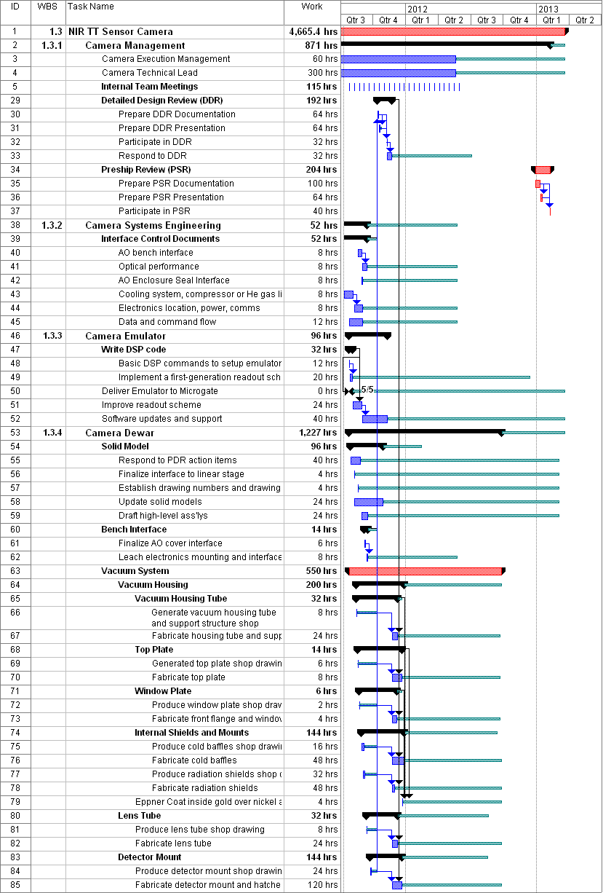
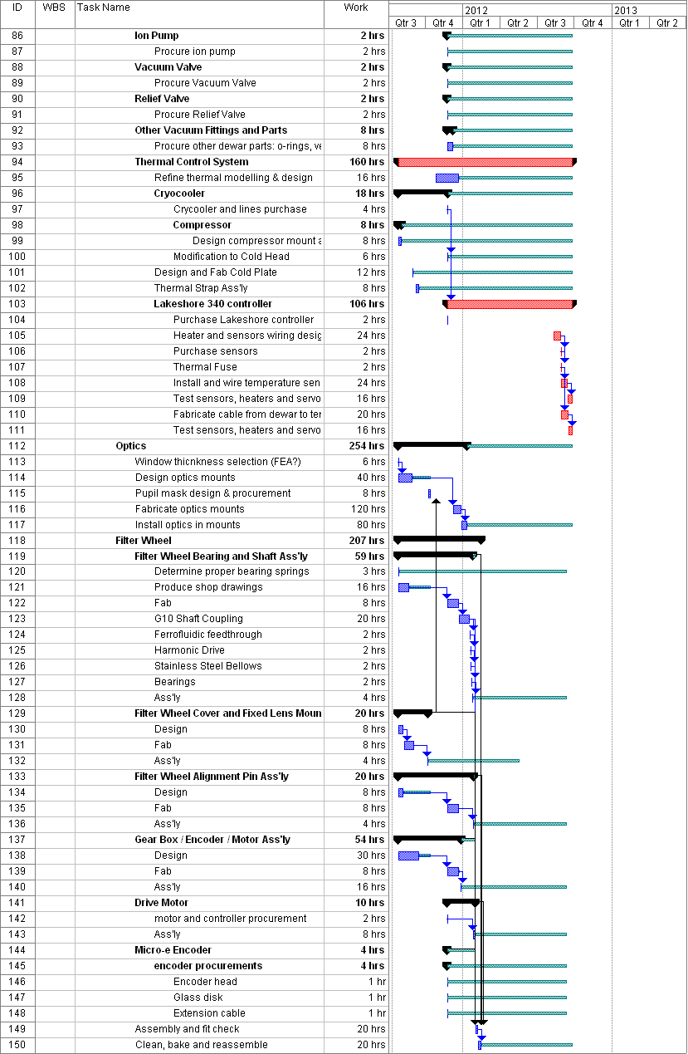
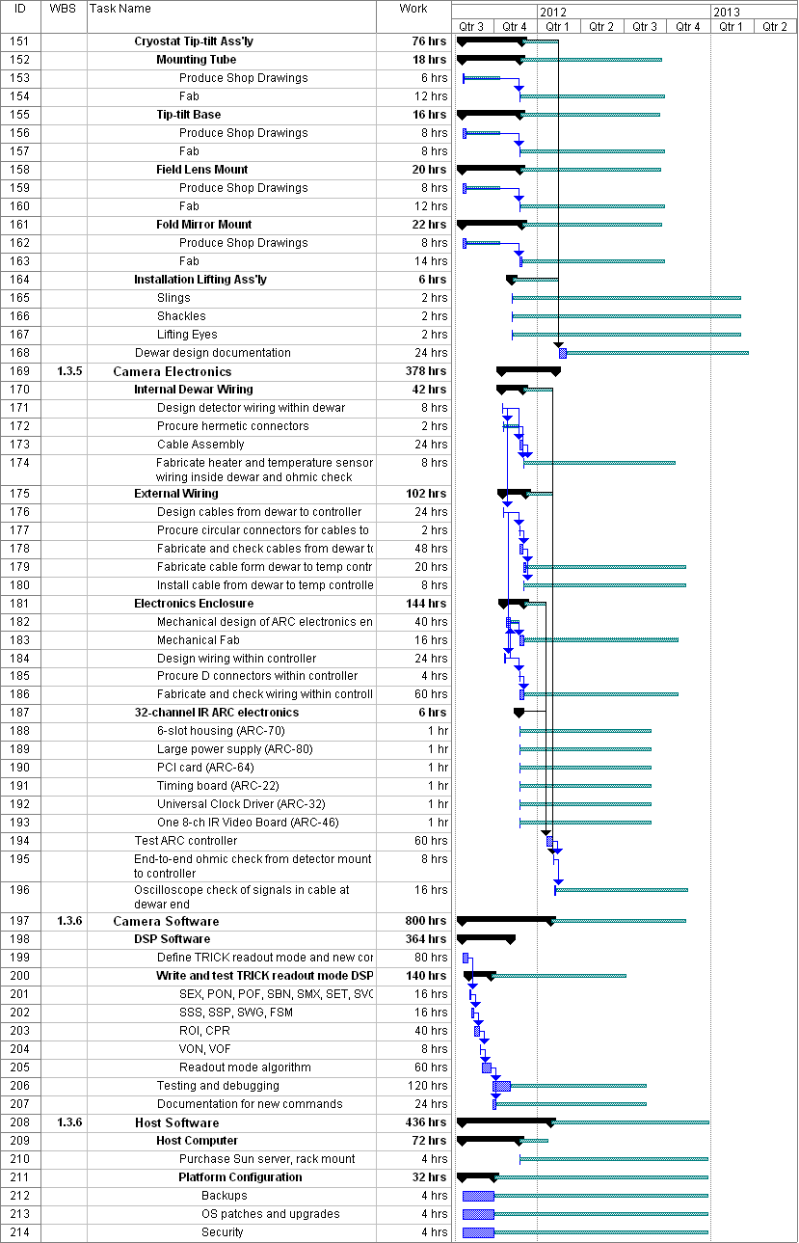
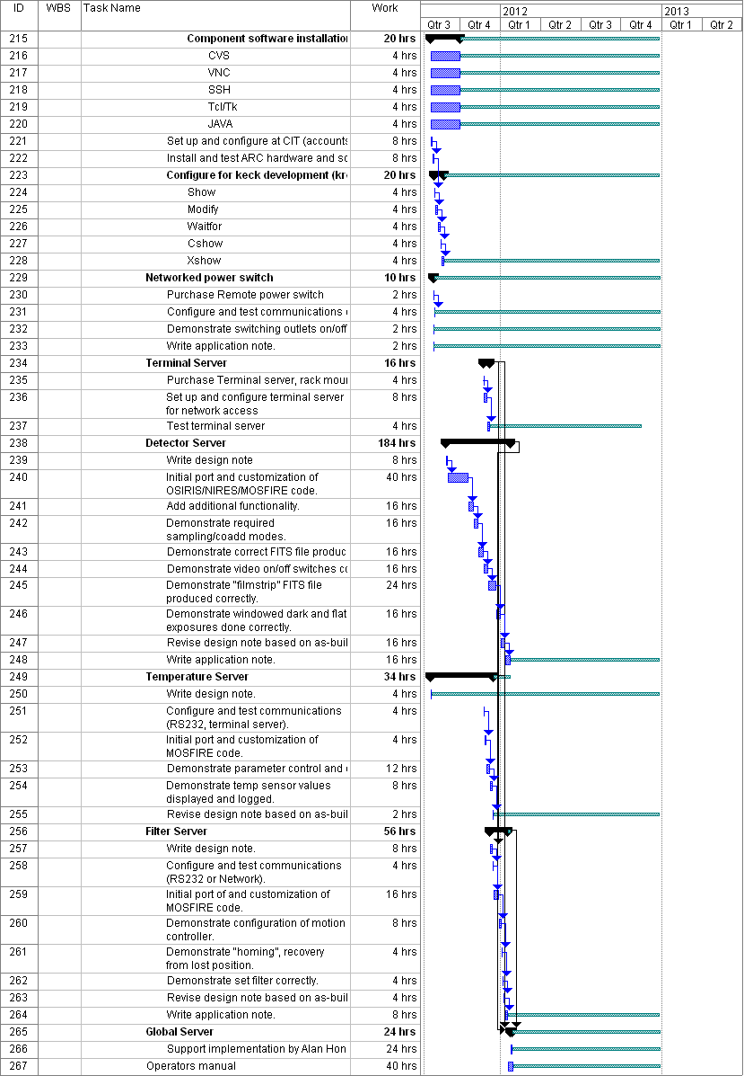

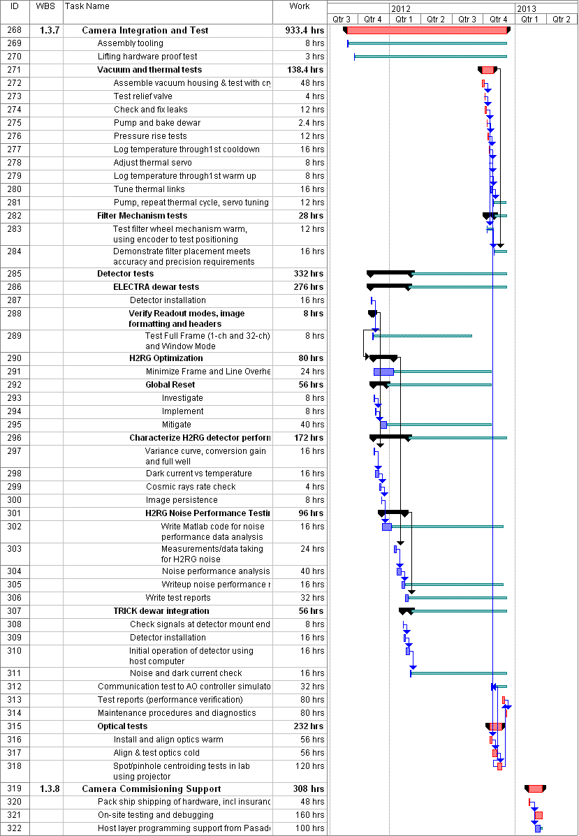

Figure 10: WMKO detailed design phase plan
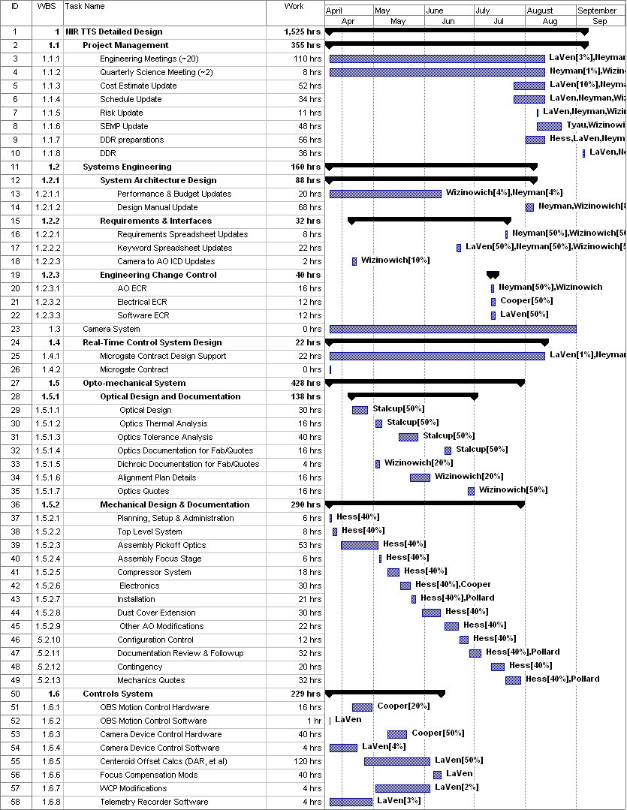
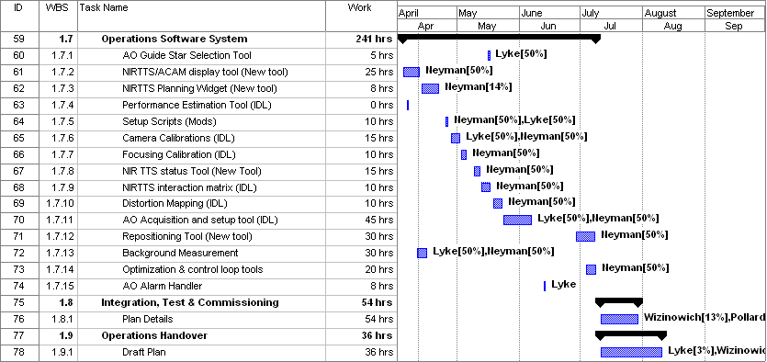

Figure 11: WMKO full scale development phase plan
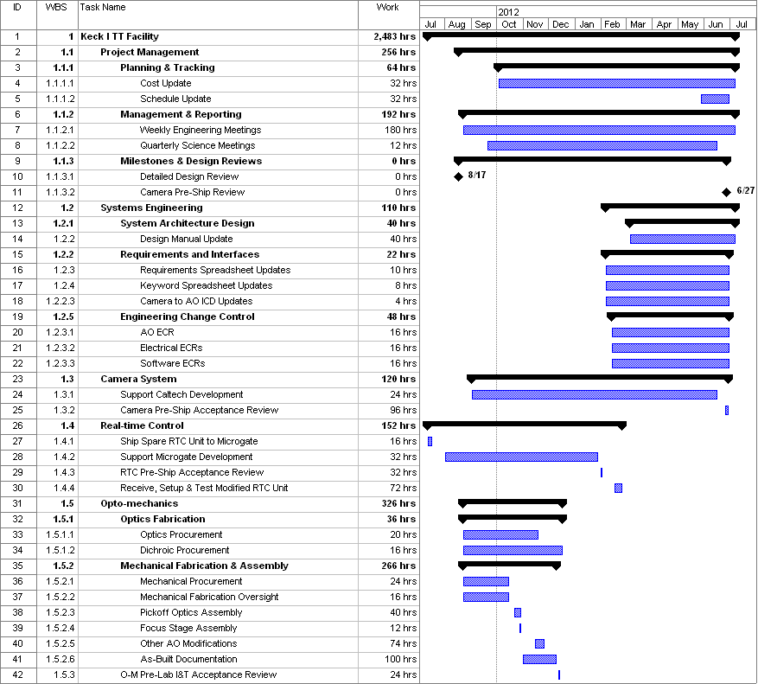
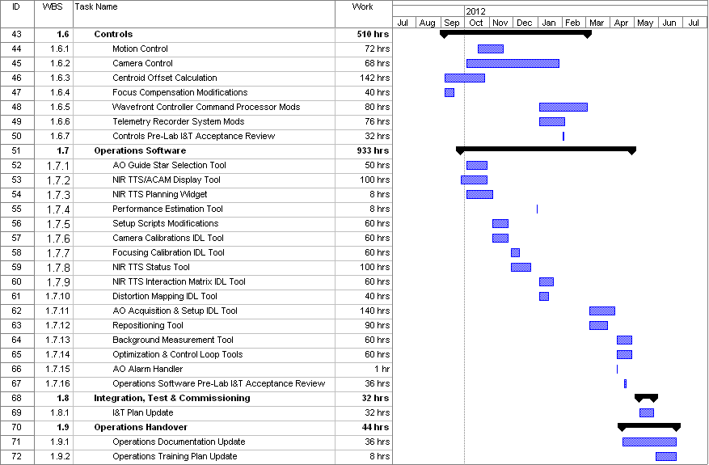

Figure 12: WMKO delivery and commissioning phase plan
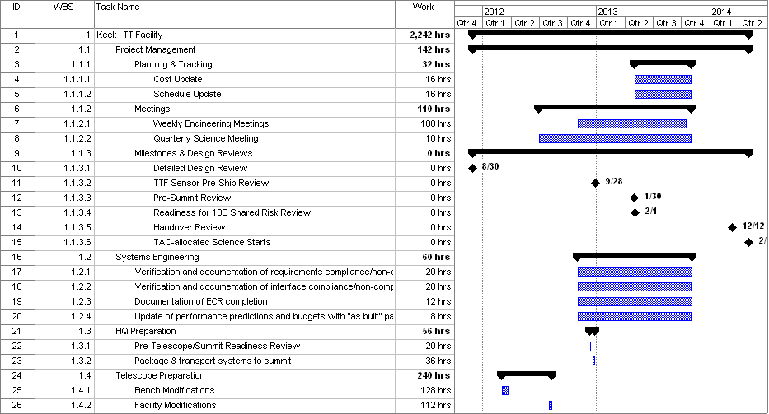
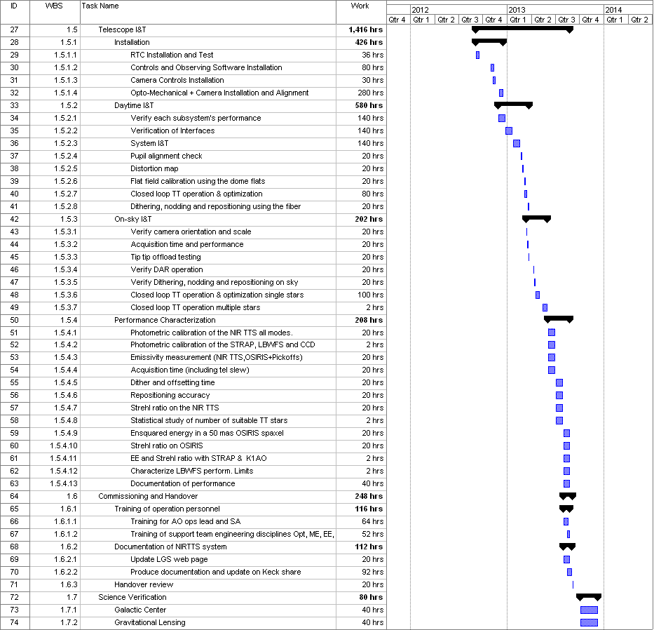

Proposal Plan (for reference)
A rolled up version of the project plans, as submitted in the NSF ATI proposal, showing key milestones and work estimates is provided in Figure 13. The rolled up proposal project plan for the camera system to be built at COO is also shown at the bottom of Figure 13 (note that this includes 276h of Stalcup which is already accounted for in the overall project plan).

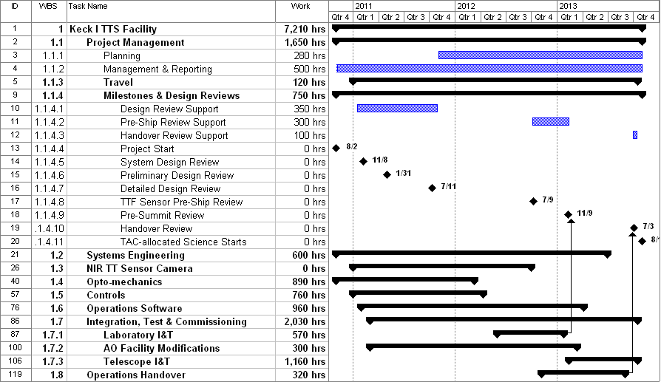

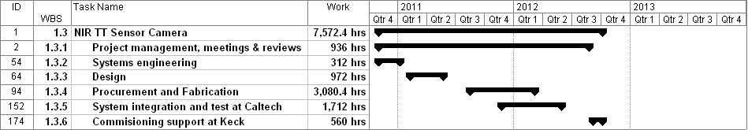
Figure 13: Full project plan, proposal version, excluding the TTS camera (top). TTS camera plan (bottom)
The COO labor estimates in WBS 1.3 were updated to reflect the contingency reduction required to meet the revised NSF budget, some work transferred to WMKO and Microgate, the work already completed during the system design which was charged to NGAO and the addition of a filter mechanism. The WMKO labor estimate were not updated since the dollars removed to meet the revised NSF budget were taken from labor dollar contingency, not labor hours.

