Opto-Mechanical Design for the Keck NGAO Cascaded Relay
By Renate Kupke, Chris Lockwood, Brian Bauman, Don Gavel, Peter Wizinowich, Chris Neyman, Anna Moore, Viswa Velur, Jim Bell

We present here conceptual optical and mechanical designs for the Keck Next Generation Adaptive Optics Relay. This design expands on the concept of the Cascaded Relay, the architecture chosen as the baseline design for the optical relay during the July, 2007 Architectural Retreat.

Requirements

The design of the NGAO relay was driven by requirements derived from the science objectives of the NGAO. The requirements are described in the Science Requirements and the Functional Requirements documents.These include, but are not limited to:
- Location
  - The AO system will reside on the Nasmyth platform.
- Field and Pupil Rotation
  - The optical relay will have a K-mirror upstream of the science instruments, wavefront sensors and tip/tilt sensors.
- Field of View
  - A 30”, high Strehl science relay.
  - A 150” FOV interfacing to a deployable IFU device.
  - A 175” FOV at the laser guide star (LGS) focus, feeding LGS high-order wavefront sensors (HOWFS).
  - A 150” FOV at the natural guide star (NGS) focus, providing NGS for tip, tilt, focus, and astigmatism (TTFA) low order wavefront sensing (LOWFS).
- Pupil Diameter
  - The first relay provides a 100mm pupil, assuming a telescope diameter of 10.949m at the primary mirror.
  - The second relay provides a 25mm pupil, assuming a 10.949m primary mirror.
- Output pupil location
  - The output pupil location for the entire relay will match the Keck telescope when used with the f/15 secondary.
- Deformable Mirrors
  - The first relay contains a 20x20 actuator mirror at the 100mm pupil.
  - The second relay contains a 64x64 actuator mirror at the 25mm pupil.

Some of the functional requirements will be driven, in part by the design of the optical relay. These include:
- Static Optical Quality of the first and second relays, given by RMS wavefront error and geometric spot radii.
- Lateral color.
- Chromatic focal shift.
- Focal plane curvature of the first and second relays.
- Pupil distortion on DMs of first (woofer) and second (tweeter) relay.
- Transmission of the first relay in science, NGS and LGS wavelength ranges.
- Transmission of the second relay in science and NGS wavelength ranges.

Design
The complete optical layout of the relay can be seen in Figure 1. Appendices 1 and 2 contain a list of the optics required for the relay. The K-mirror, providing field or pupil rotation to the downstream instruments and wavefront sensors, lies 150mm before the Nasmyth focus. The science focus thus lies between K1 and K2. It is still to be determined whether having a focal plane in the vicinity of two reflecting surface will add undesirable thermal background effects for infrared observations. The existing Keck AO system has the K-mirror positioned after focus. The K-mirror consists of three mirrors, sized to accommodate a 150 arcsec natural guide star (NGS) field and a 175 arcsecond laser guide star (LGS) field at a height of 80km. The K-mirror has been designed, mechanically, to achieve a complete 360 degrees of rotation (described more in mechanical design section).
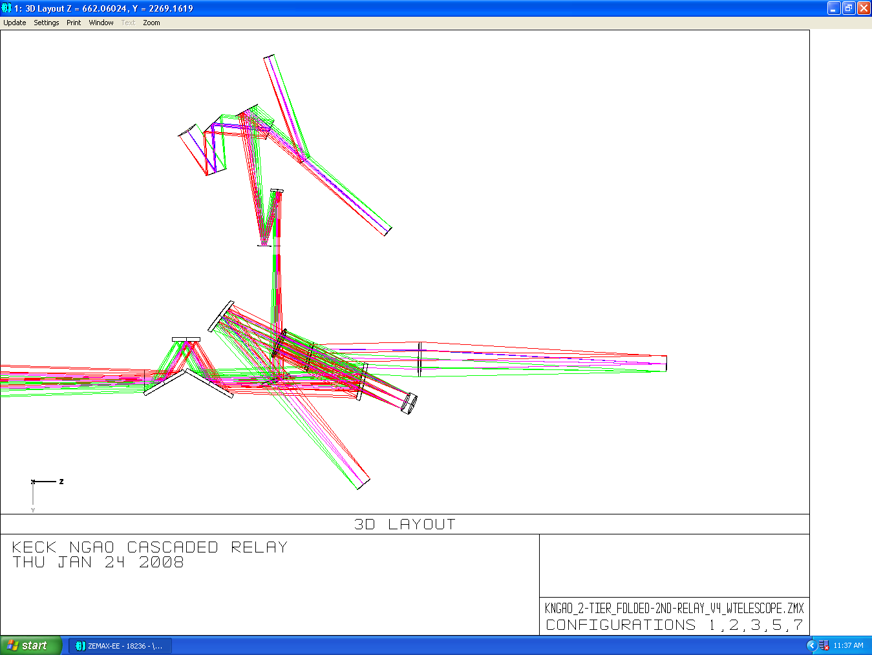
Layout of KNGAO Cascaded Relay 1

Figure 1 Complete optical layout of the AO Relay.

Following the K-mirror is the first Off Axis Parabola (OAP1). OAP1 has a focal length of 2732mm, an off-axis tilt angle of 25 degrees, and a decenter of approximately 605mm. It’s focal length was chosen to achieve the pupil size of 100mm on a woofer mirror conjugate to the exit pupil of the telescope. Before reaching the 100mm woofer mirror, the beam is folded downward, in a periscope fashion, at an angle of 9.125 degrees, to a lower tier which resides on an optical bench. This fold mirror is at a conjugate height of approximately 10 km, and can be considered for use as a possible MCAO DM. At the bottom of the periscope leg resides the woofer DM. This nominally 20x20, 5mm pitch DM has an incident angle of 9.125 degrees, causing a pupil elongation of 1.7% over the 20 subapertures. Continuing on from the Woofer DM is the second Off Axis Parabola (OAP2). Its parameters exactly match those of OAP1, to reduce aberrations at the infinite conjugate. It lies one focal length away from the Woofer DM, projecting the pupil to infinity and providing a telecentric beam for the second relay, deployable Infrared Field Spectrograph (dIFS), and Tip/Tilt/Low Order Wavefront Sensor (LOWFS) relays.

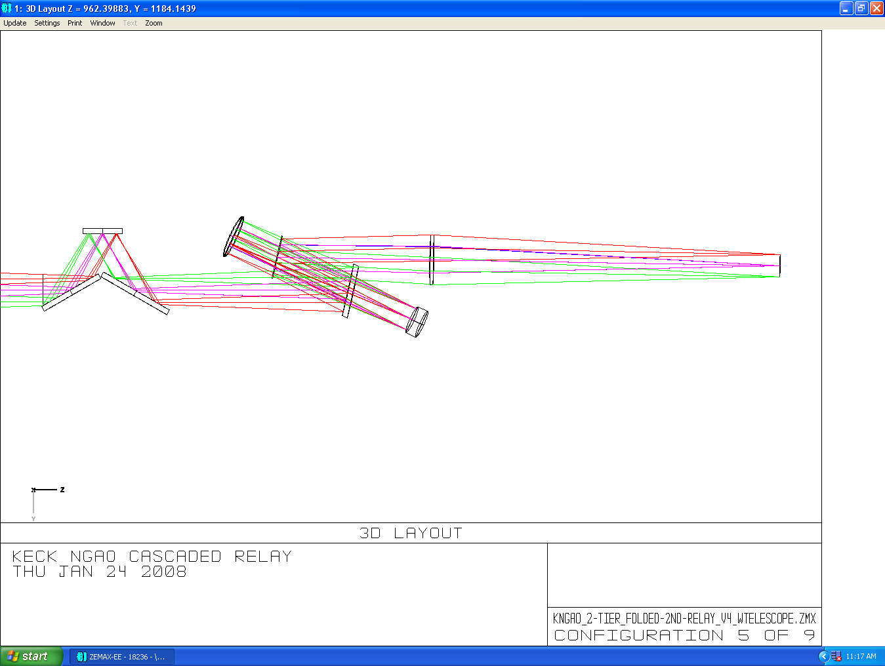
Figure 2 Optical path for the LGS WFS.

Laser Guide Star WFS
Shown in Figure 2, between the woofer DM and OAP2 is a dichroic pick-off for the LGS wavefront sensors, in collimated space. This dichroic pick-off will ideally be a notch filter, reflecting only the sodium (Na) laser guide star wavelength of 589nm. A notch filter was chosen to allow visible light, below 600nm, to be available to the visible truth wavefront sensor (TWFS) located in the second relay. The dichroic has an incident angle of 12 degrees.

The object selection for the LGS (LGS OSM) requires an image plane, thus the collimated light after the dichroic pick-off is focused using a simple, relatively high index (to minimize aberrations) bi-convex lens. The lens is located one focal length away from the woofer DM, to provide a telecentric beam for the LGS relays. The lens has been optimized to 90km conjugate.

In the converging beam following the lens, there will be located a removable mirror at 45 degrees to feed an acquisition camera for the LGS WFS.

Interferometer feed
The Keck interferometer, working in Dual Star Mode, will require a pick-off in the converging f/15 beam to acquire a 60 arcsecond field. Following the pick-off will be two field steering mirrors (FSMs), the first of which will be near the focal plane of the f/15 beam, and have a hole in its center to pass the light of one star to an OAP, which will collimate the light. The remaining field will be steered onto a second steering mirror, and will be sent by this mirror, parallel to the beam emanating from the hole in the first FSM, to a second OAP which will collimate its light. This collimated light will then be steered to holes in the floor of the Nasmyth platform. The beam must be at least 100mm in diameter to avoid diffraction effects along its path.

The pick-off, ideally, will be located after the dichroic feed to the narrow field relay, to most closely match the existing Keck AO system where the interferometer pick-off is located after an infrared dichroic.

Wide-Field Relay to Acquisition Camera, LOWFS, and dIFS
In the f/15 converging beam following OAP2 lies the dichroic bank which will either reflect light into the 30 arcsecond narrow field relay, transmit to the 150 arcsecond LOWFS/Tip-tilt sensors and dIFS instrument, or both. The dichroics were specified based on the science requirements. Please see Appendix 2 for a listing of the six dichroics. The LOWFS/Tip-tilt sensor will share an Object Selection Mechanism (OSM) with the dIFS deployable field unit instrument. Figure 3 shows the optical path to the LOWFS/Tip-tilt/dIFS unit.

Each arm of the tip/tilt relay will be equipped with its own atmospheric dispersion corrector (ADC). Also within the OSM will be a pick-off for the infrared Truth Wavefront Sensor (TWFS) and the PSF camera (these may share light with the LOWFS, please see WFS document for complete discussion).

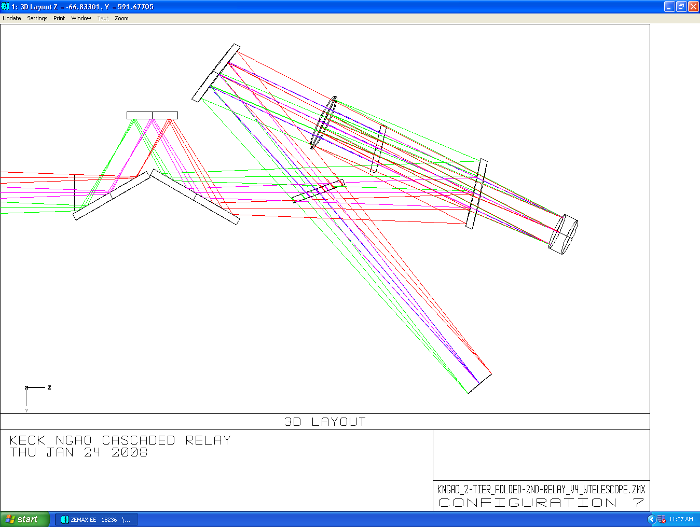

Figure 3 Optical path to LOWFS/Tip-Tilt sensors and dIFS instrument.

Located between the dichroic bank and the OSM for the LOWFS and dIFS is a removable, 45-degree incident angle pick-off mirror to the NGS acquistion camera. The NGS acquisition camera will obtain images of the entire 150 arcsec field and allow acquistion of natural LOWFS stars. It will be used as a coordinate reference to acquire science objects for the dIFS, which will be too dim to allow acquisition with the camera.

There are two removable dichroics located before the LOWFS/dIFS OSMs (the interferometer and narrow field relay dichroics). The LOWFS will need to operate simultaneously with either one of these dichroics in place, or with no dichroics. The OSM or proceeding optics will need to be able to accommodate for the focal plane shift along the optical axis and perpendicular to the tilt axis of the dichroic when the dichroics are inserted or removed. The dIFS will be doing science operations only when all the dichroics are removed, so no compensation is needed for that instrument.

Narrow-field, High Strehl Relay
The narrow-field relay feeds a suite of instruments, including the Visible imager, the NIR imager, the visible dIFS and the natural guide star wavefront sensor. There will also be optics to accommodate a change in f/# to feed the existing OSIRIS instrument with an f/15 beam. Common to all of these instruments is OAP3, providing collimated light and a telescope pupil image to a 64x64 actuator, 25mm tweeter mirror. After the beam leaves the tweeter, it is re-imaged by OAP4, having a focal length three times that of OAP3 to provide an f/46 output beam to the instruments.
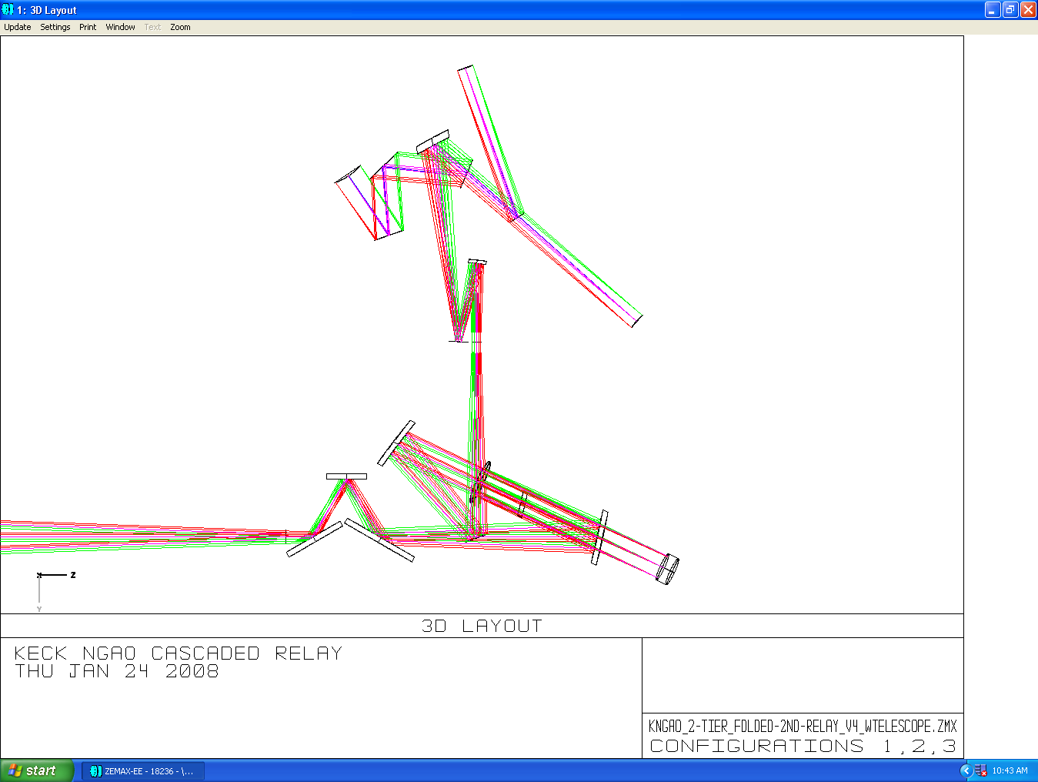
Figure 4 The narrow-field relay optical path.

Natural Guide Star Wavefront Sensor (NGS WFS) and Truth Wavefront Sensor (TWFS)
It was the desire of the design team to allow the NGS WFS and TWFS a selection field of more than the 30 arcseconds provided by the narrow field relay. The NGS WFS and TWFS have thus been designed with the ability to search for natural guide stars throughout a 54 arcsecond field, however this field is not symmetric about the optical axis. The dichroic pick-off immediately following OAP4 feeds both the NGS WFS and TWFS. There are two dichroic options (see dichroic table) depending on whether the visible or IR science instruments are to be used. The dichroic is at an angle of 17 degrees to the incident beam.

A second possibility for the NGS WFS/TWFS dichroic location is in the Visible Imager path (see following section). This position would have the advantage of requiring only one ADC for both the Visible imager and NGS/TWFS sensors (assuming the ADC can operate over the entire .4 - .97μ bandpass). Also, in science cases which require simultaneous imaging with both the NIR camera and the visible camera, the NIR camera will see only one dichroic (the pick-off for the visible imager) instead of two. This design option is not implemented in the current layout because of the desire for low-incidence angles on what might have been the OSIRIS dichroic pick-off, and an uncertainty of the space requirement of the OSIRIS reformatting optics. It has since been decided that OSIRIS will not be fed with a dichroic, but only with a mirror. No simultaneous observations with OSIRIS and the NIR Imager will be possible. This increases the attractiveness of the alternate NGS WFS/TWFS dichroic location, and this possibility will be investigated in the next phase of design.

The field of the natural guide star for both the NGS WFS and TWFS can be acquired using two field steering mirrors (FSMs) located between the dichroic pickoff and the wavefront sensor optics. The second FSM can be rotated to select whether the NGS WFS or TWFS receives the light (there are no configurations in which they are used simultaneously). An ADC will be required in the NGS path to correct atmospheric dispersion.

Visible Imager Path
The visible imager is fed by a dichroic located downstream from the NGS WFS pickoff.
An ADC lies between the reflecting dichroic and the Visible imager to correct atmospheric dispersion at visible wavelengths.

If the dichroic pick-off for the NGS/TWFS is removed from the beam, the focal plane will shift in directions along the optical axis and perpendicular to the tilt axis of the dichroic. The Visible imager must be mounted on a stage that can compensate for this shift.

The focal plane of the imager will be curved (see table blah for optical characteristics of the visible imager).

OSIRIS pickoff

Between the pick-off for the Visible imager and the NIR imager lies space for a pick-off mirror to the OSIRIS instrument. OSIRIS must be preceded by optics which reformats the f/46 beam back to an f/15 beam input. These optics also must adjust for the height difference between the NGAO bench and the OSIRIS optical axis (or a new support structure for OSIRIS must be built).

NIR instrument

The NIR instrument is fed directly by the f/46 2nd relay output. In the beam between OAP4 and the dichroic imager are two removable dichroics. As these dichroics are removed, the focal position of the beam will change, both laterally and along the optical axis. The NIR instrument will therefore need to be mounted on a stage which can compensate for the change in focal position in two directions.

The focal plane of the NIR imager will be curved (see table blah for optical characteristics of the NIR instrument focal plane).

Performance
To determine the performance of the optical system, several sources of optical degradation were analyzed in the wavelength passbands used by the individual instruments. The passbands are a defined in KAON 530.

Field points used were the maximum off-axis defined for each instrument. Wavefront errors and RMS spot radii quoted are the worst-case for the field points analyzed.

Science Instrument dIFS, Wide-field Relay
It is assumed that the wide field dIFS is used in MOAO mode, and that a DM can apply low-order correction optimized for each field position. Corrections were applied via the Zernike Fringe surface, up to Zernike Fringe term #9.

When the dIFS is in use, there will be no dichroic in the converging beam ahead of the instrument. Lateral color and chromatic focal shift are therefore very close to null. Results are shown in Table 1
Table 1 Performance of the dIFS relay.
Instrument | λ bands | F/# | FOV (″) | Field Curvature (mm) | RMS WFE (nm) | Spot Size (μ) at J | Spot size (mili ″) | Airy radius (μ) at J
dIFS | J, H, K | 15 | 150 | 1430 | 8.6 | 1.25 | 1.7 | 19.5

LOWFS/Tip-tilt
The LOWFS/Tip-tilt optical selection mechanisms share a location with the dIFS science instrument. Because the LOWFS/Tip-tilt instruments must be used with the imagers located in the second relay, it will often be the case that the dichroic splitter for the second relay lies between OAP2 and the LOWFS/Tip-tilt focal plane.

This dichroic location introduces several issues. When the dichroic is removed, the focus will change by 34mm along the optical axis toward the dichroic, and 5mm perpendicular to the direction of the axis of tilt of the dichroic. The instrument will have to be able to adjust for this gross movement.

The insertion of the dichroic also leads to both lateral color and chromatic focal shift. Chromatic aberrations cannot be removed with the deformable mirrors located in each NGS beam path.

Table 2 gives aberrations during simultaneous observation of J and H bands
Table 2 Performance of the LOWFS/TT optical relay in simultaneous J and H bands.
Instrument  (mode) | λ (μ) | F/# | FOV ″ | Fld curv.  (mm) | RMS WFE (nm) | RMS Spot Radius (μ) | RMS Spot Radius (mili-″) | Airy radius  (μ) | Lateral color (μ) | Chrom. Focal shift (μ) | Depth of focus*  (mm)
LOWFS/TT | 1.17-1.78 | 15 | 150 | 1320 | 15.6 | 18.6 | 10.7 | 19.5 | 24.4 | 70 | 0.9

Of concern above is the lateral color term when the tip/tilt sensor admits both J and H bands, which is on the same order as the airy radius. This can be seen quite clearly in the spot diagram, Figure 5.
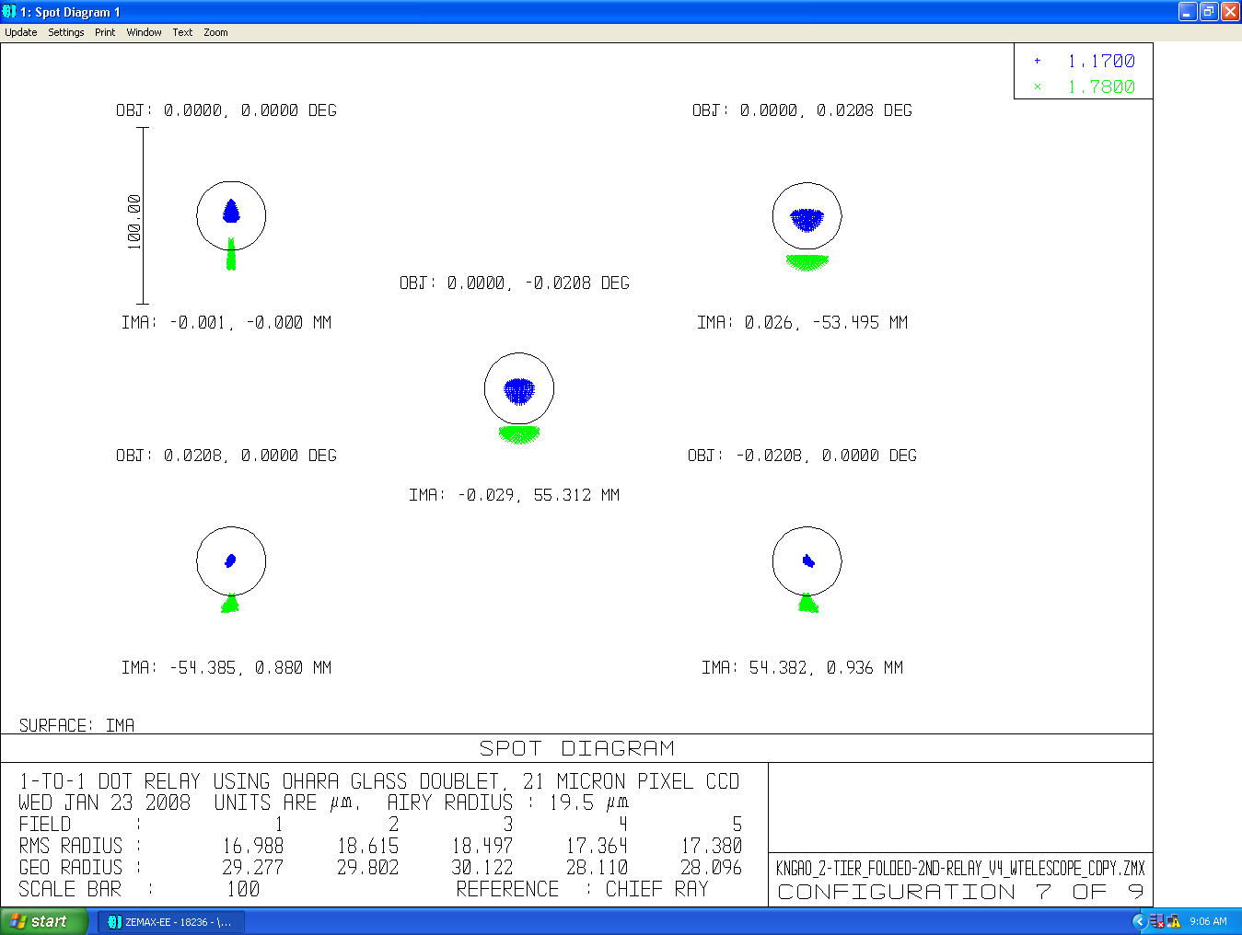

Figure 5: Spot diagram showing clearly the lateral color that results from the insertion of the narrow-field relay pick-fff dichroic.

Science Instruments, Narrow Field Relay
To determine the performance of the optical system of the narrow-field relay, several sources of optical degradation were analyzed in the wavelength passbands used by the individual instruments. The passbands as are defined in KAON 530.

Field points used were the maximum off-axis defined for each instrument. Wavefront errors and RMS spot radii quoted are the worst-case for the field points analyzed.

It is assumed for the narrow field instrument that a DM can apply low-order correction across the entire field. Corrections were applied via the Zernike Fringe surface, up to Zernike Fringe term #9.

Numbers for the NIR imager given in Table 3assume that the NGS/TWFS dichroic is in place. RMS spot radius takes lateral color into account.

Table 3 Performance of the Narrow-field relay instruments.
Instrument  (mode) | λ (μ) | F/# | FOV ″ | Fld curv.  (mm) | RMS WFE (nm) | RMS Spot Radius (μ) | RMS Spot Radius (mili-″) | Airy radius  (μ) | Lateral color (μ) | Chrom. Focal shift (μ) | Depth of focus*  (mm)
NIR im, Y-band | 0.97-1.07 | 46 | 30 | 277 | 15.6 | 17.5 | 7.8 | 55.1 | 4 | 11.8 | 8.4
NIR Im, J-band | 1.17-1.33 | 46 | 30 | 277 | 15.6 | 18.3 | 8.2 | 66.4 | 5.5 | 17 | 10
NIR Im, H-band | 1.49-1.78 | 46 | 30 | 277 | 15.6 | 20.9 | 9.4 | 84.6 | 10.78 | 34 | 13
NIR Im, K-band | 2.03-2.37 | 46 | 30 | 277 | 15.8 | 24 | 10.8 | 115.3 | 17 | 53 | 18
Vis. Im, | 0.7-0.97 | 46 | 30 | 277 | 15.8 | 22.2 | 10.0 | 39.7 | 12.8 | 42 | 6
NGS/TWFS | 0.4-0.7 | 46 | 54 | 277 | 36 | 32.3 | 14.5 | 22.7 | 0 | 0 | 3.5
*Depth of focus defined in Zemax as

Lateral color is well inside the airy radius for all instruments in this f/46 beam, and chromatic focal shift is negligible compared to the depth of focus. Note that the NGS/TWFS encounters only reflective optics, and therefore does not suffer from chromatic aberration. Note, also, that none of the analyses include the effects of the ADC which will be required in each beam.

Of concern is the large RMS WFE for the NGS/TWFS leg. This is due to the large field of 54″ from which to appropriate a natural guide star. The OAPs used in the second relay are optimized, but not matched because of the change in f/# required for the instruments, and therefore their performance degrades with field angle, see Figure 7 and Figure 9. The performance of this instrument for the 30″ field are similar to that for the visible imager (a little better, due to the lack of dichroics in its path).
Figure 6

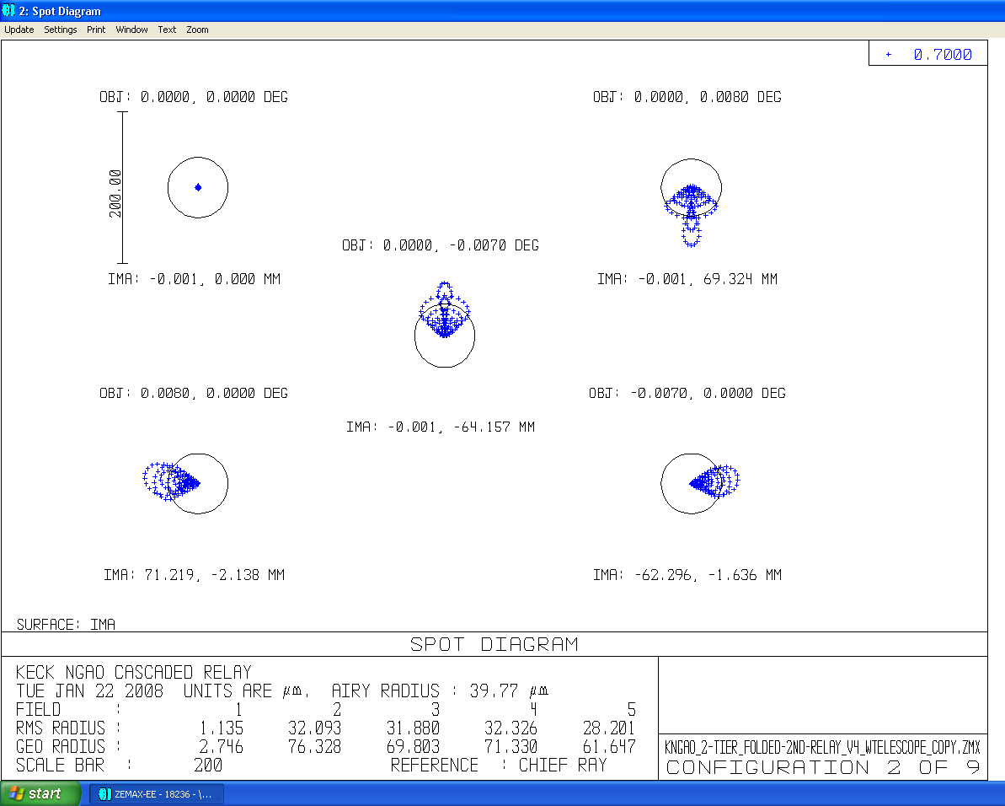
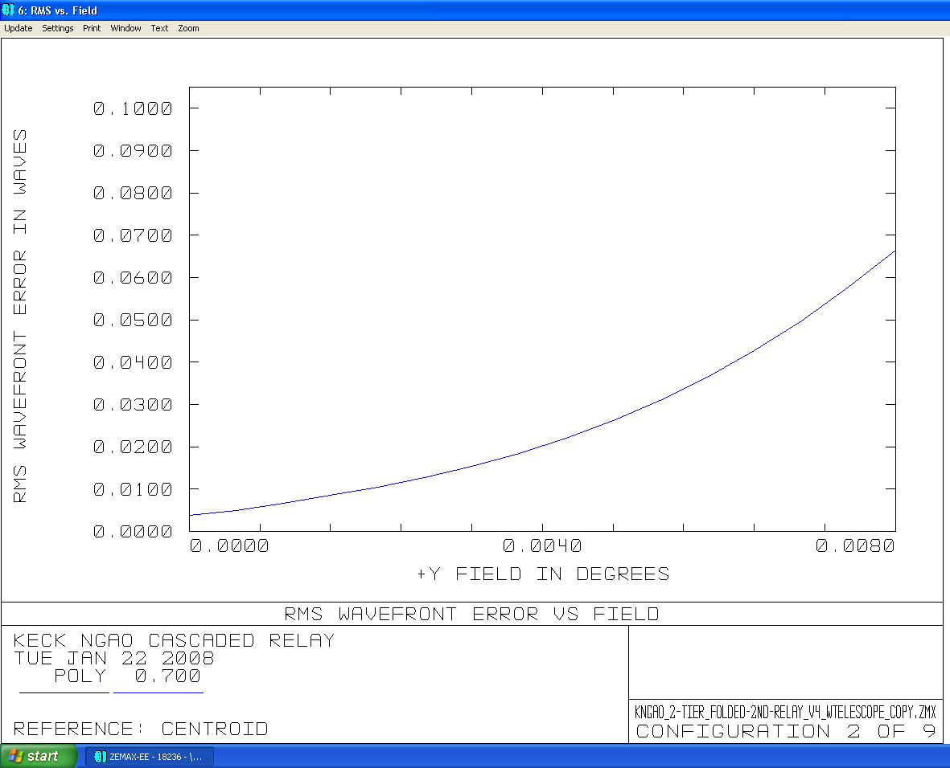

Figure 7 RMS Wavefront Error as a function of field angle in the NGS WFS/TWFS.
Figure 8 Spot size as a function of field angle in the NGS WFS/TWFS

Laser Guide Star Wavefront Sensor

The LGS WFS dichroic pick-off lies in the collimated space between the woofer DM and OAP2. Because the LGS are not at infinite conjugate, the matched OAPs do not have the same advantage as for NGS and science object imaging, so there is not a degradation in imaging performance from utilizing only the first OAP.

The LGS are reimaged using a simple, 1 glass, biconvex lens. The lens chosen need only work at the wavelength of the sodium line (589nm), therefore a high index (1.72) glass was chosen to minimize aberrations (dispersion is not an issue). This lens was optimized for the 90km altitude. A f/15 beam was preserved to provide a 1:1 relay to the LGS WFS.

Table 4 details the performance of the LGSWFS relay.
Table 4 Performance of the LGSWFS optical system with conjugate height.
Conjugate height | FOV, arcsec | Field Curvature (mm) | RMS WFE (μ) | RMS Spot Radius (mili-″)
90km | 174 | 650 | 2.8 | 415
180km | 162.5 | 650 | 3.1 | 440

Of concern are the almost half arcsecond spot sizes of the LGS WFS. This is a significant fraction of the 1.5 arcsecond pixels proposed for the LGS WFS. Any refocusing element optimized for one conjugate height will not be optimum for other zenith angles. These aberrations stem from using OAP1 at finite conjugate. An Alvarez-style corrector plate has been suggested by Brian Bauman as a solution if the WFE is deemed too large.

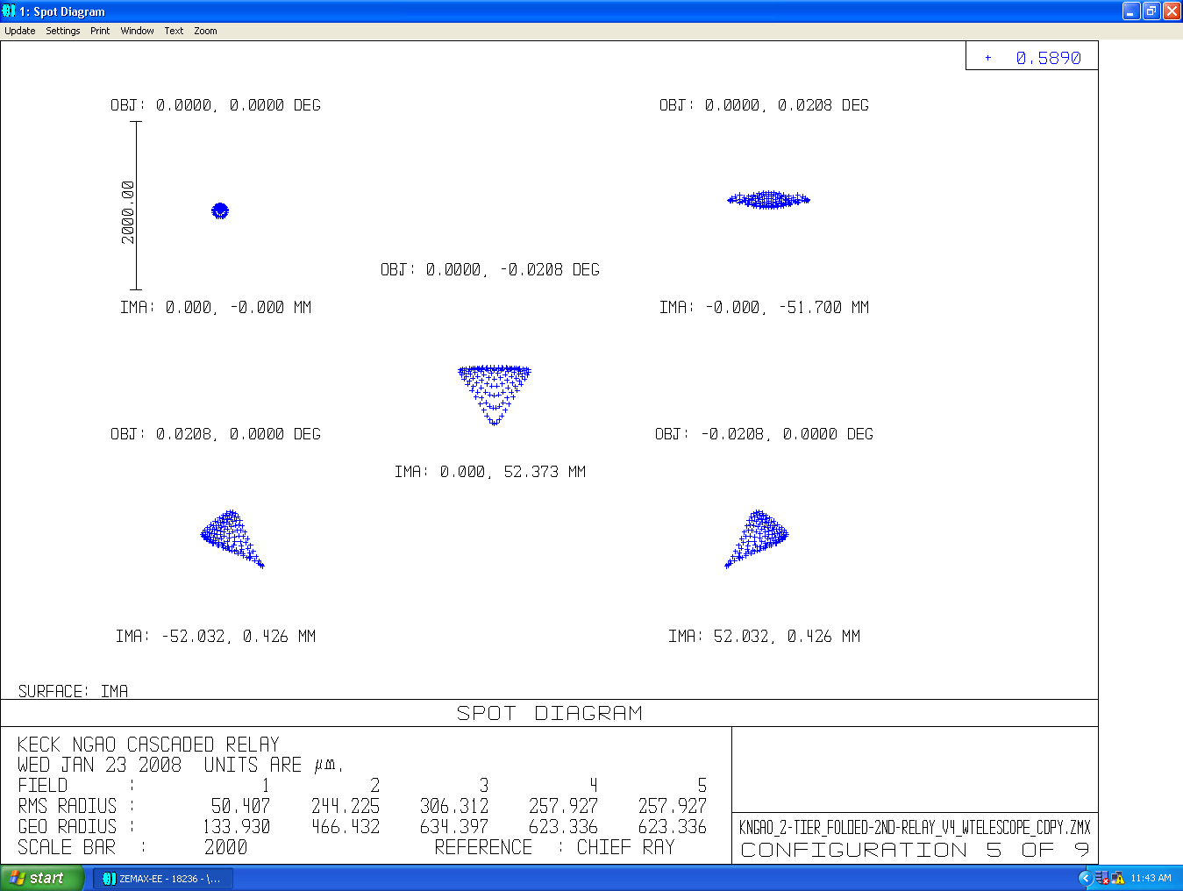

Figure 9 Spots formed at focal plane of LGSWFS relay, 180km conjugate.

Pupil Distortion
Pupil distortion in the NGAO Cascaded relay manifests itself in two different ways. The smaller effect is the degree to which a grid of points on the primary mirror maps to a demagnified, but square grid on the DM. Another consideration is the pupil point spread function (PSF), which depends on the field of view. This effect causes a blurring of the pupil points as they are reimaged on the DM. The latter consideration is the larger effect of the two. Analysis of both effects was done for the pupil planes at the woofer and tweeter DMs.

Table 5 Characteristics of pupil image on deformable mirrors.
 | Diameter (mm) | Field (″) | # actuators | Tilt (meters on sky, peak) | Curvature (mm) | Max Grid Distortion | Pupil PSF, (μ)
DM1, woofer | 100 | 150 | 20x20 | 240 | 5500 | 0.4% | 400
DM2, tweeter | 25 | 30 | 64x64 | 928 | 500 | 0.2% | 38

In the analysis, the telescope primary became the “object”, and field points were defined on the edges of the primary. Observed field was set by adjusting the “stop” size at the Nasmyth focus to accommodate a 150 arcsecond field for DM1 and a 30 arcsecond field for DM2. Results are shown in Table 5 and in the figures on the next pages.

Figure 10 and Figure 11 display grid distortion and the pupil PSFs for the 100mm woofer mirror, respectively. The grid distortion is magnified by 100 in Figure 10. Its effects are negligible in the mapping of pupil to DM, compared to the pupil’s PSFs.

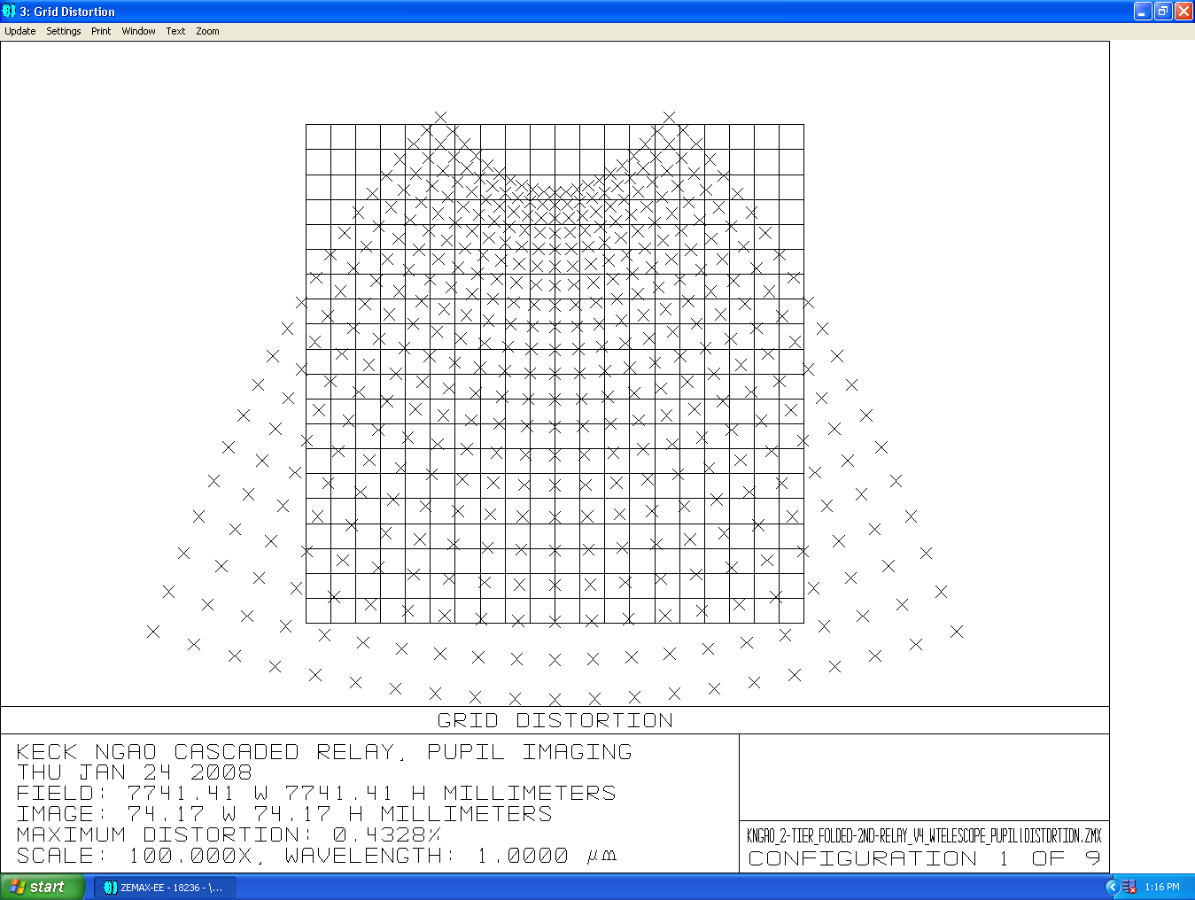
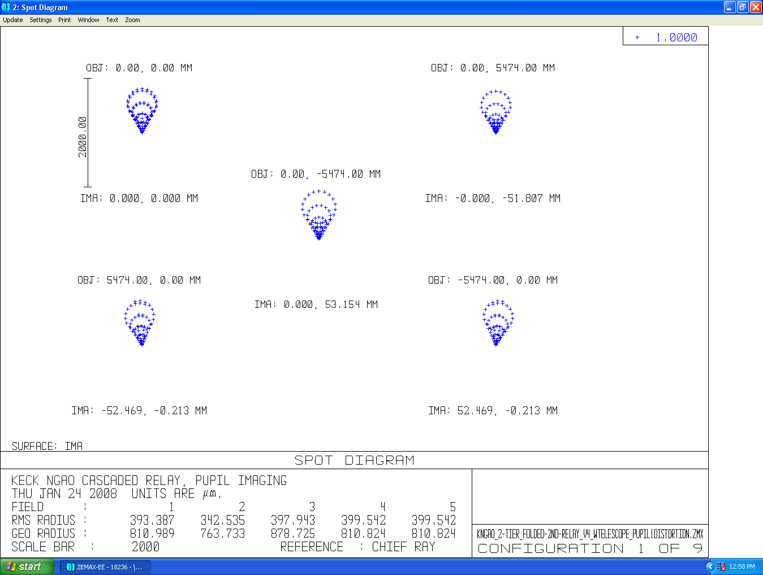

Figure 10 Grid distortion magnficd by a factor of 100 to emphasize shape, DM1.
Figure 11 Pupil (telescope primary) PSFs with position on primary mirror.

For the 100mm woofer DM, located in the first OAP relay, the field curvature and distortion maps for all four directions (+Y,-Y,+X,-X) are shown in Figure 13. The tilt appears surprisingly large because of the nature of imaging with an OAP – almost 25mm over the 100mm pupil. One must realize that this corresponds to 200 meters in the plane of the telescope. The deformable mirror is correcting a plane in the atmosphere that is tilted by 200 meters at the edge of the primary mirror, compared to the center.
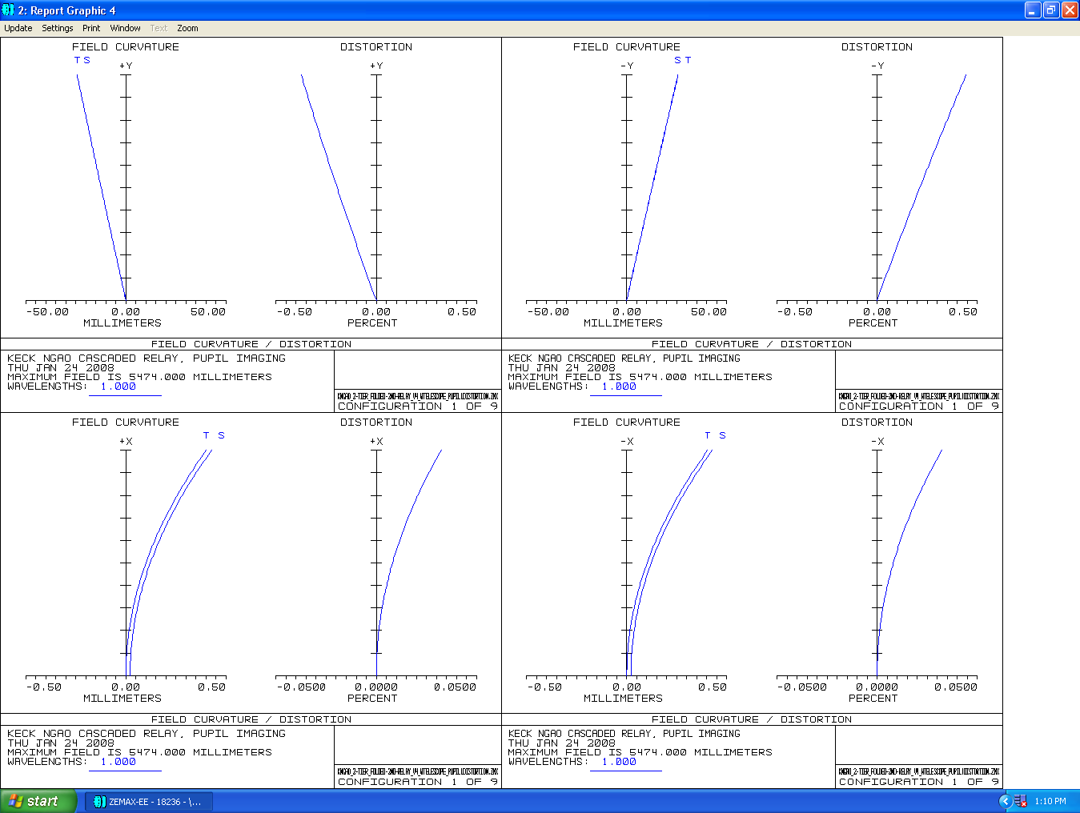
Figure 13 Field curvature and distortion maps in the +Y (top left),-Y (top right), +X (bottom left) and –X (bottom right) directions. Note the large amount of pupil tilt caused by the off-axis parabola. This tilt corresponds to about 240m in the plane of the atmosphere for the 100mm woofer pupil.
Figure 12 Field curvature and distortion plots in the +Y (top left), -Y (top right), +X (bottom left), -X (bottom right). The tilt of the pupil caused by imaging through a single OAP is evident in the Y plots.

The same pupil imaging analysis was performed for DM2, the 25mm tweeter mirror located in the collimated space of the second relay. Results such as those discussed for DM 1 are given in Table 5 and in Figure 16, Figure 14, and Figure 15.
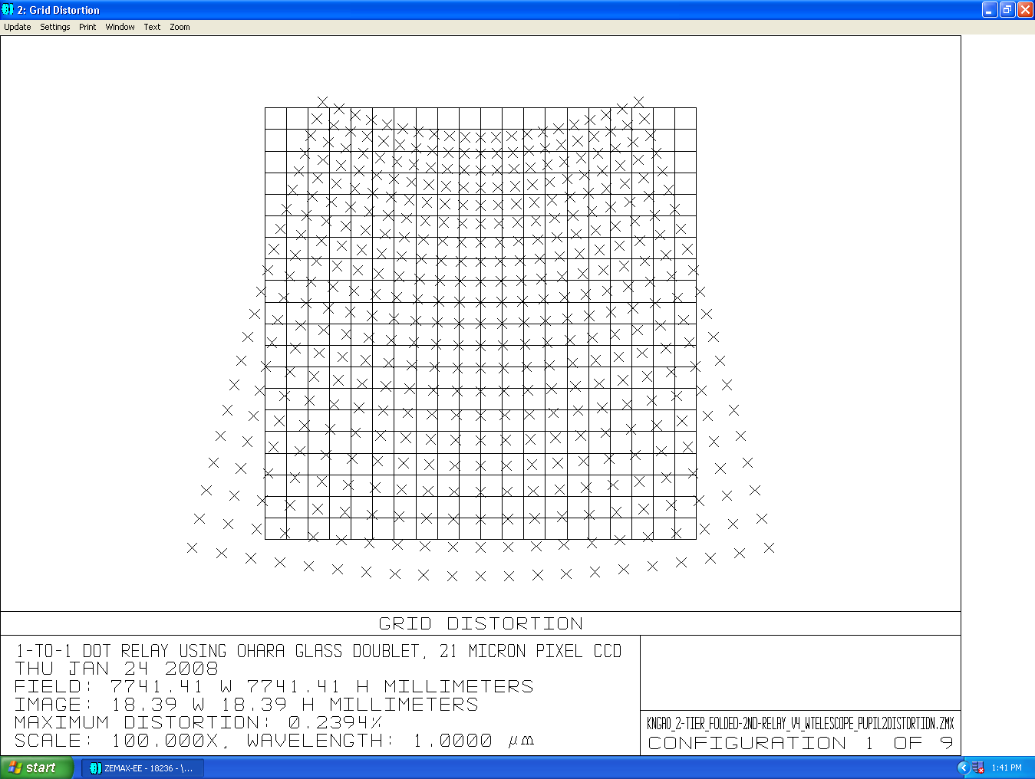
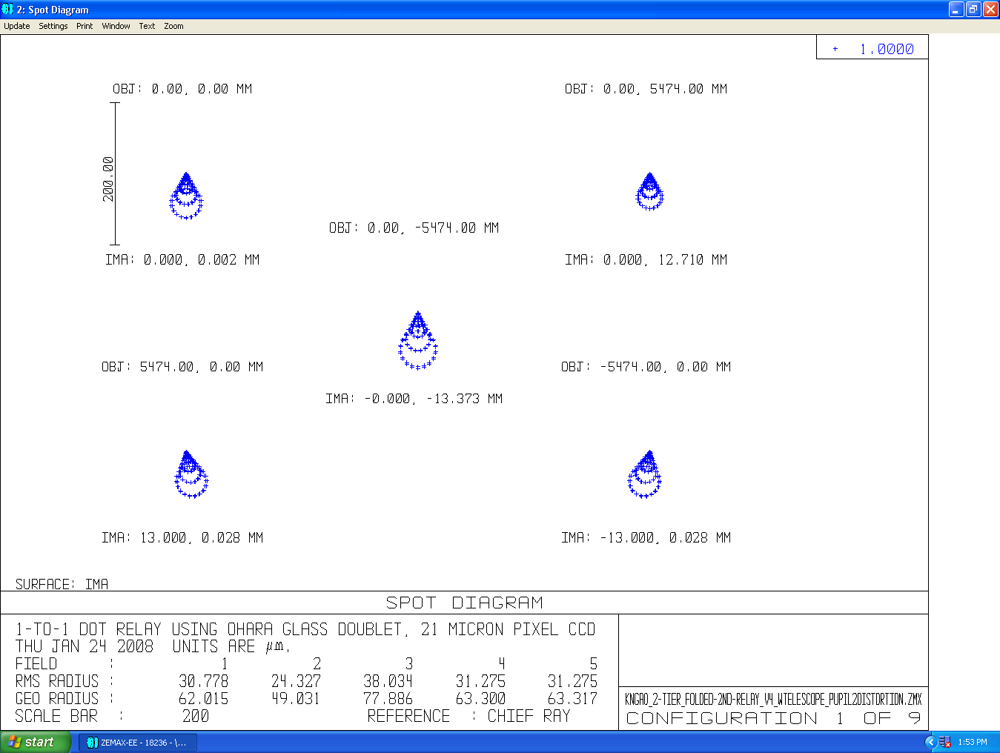
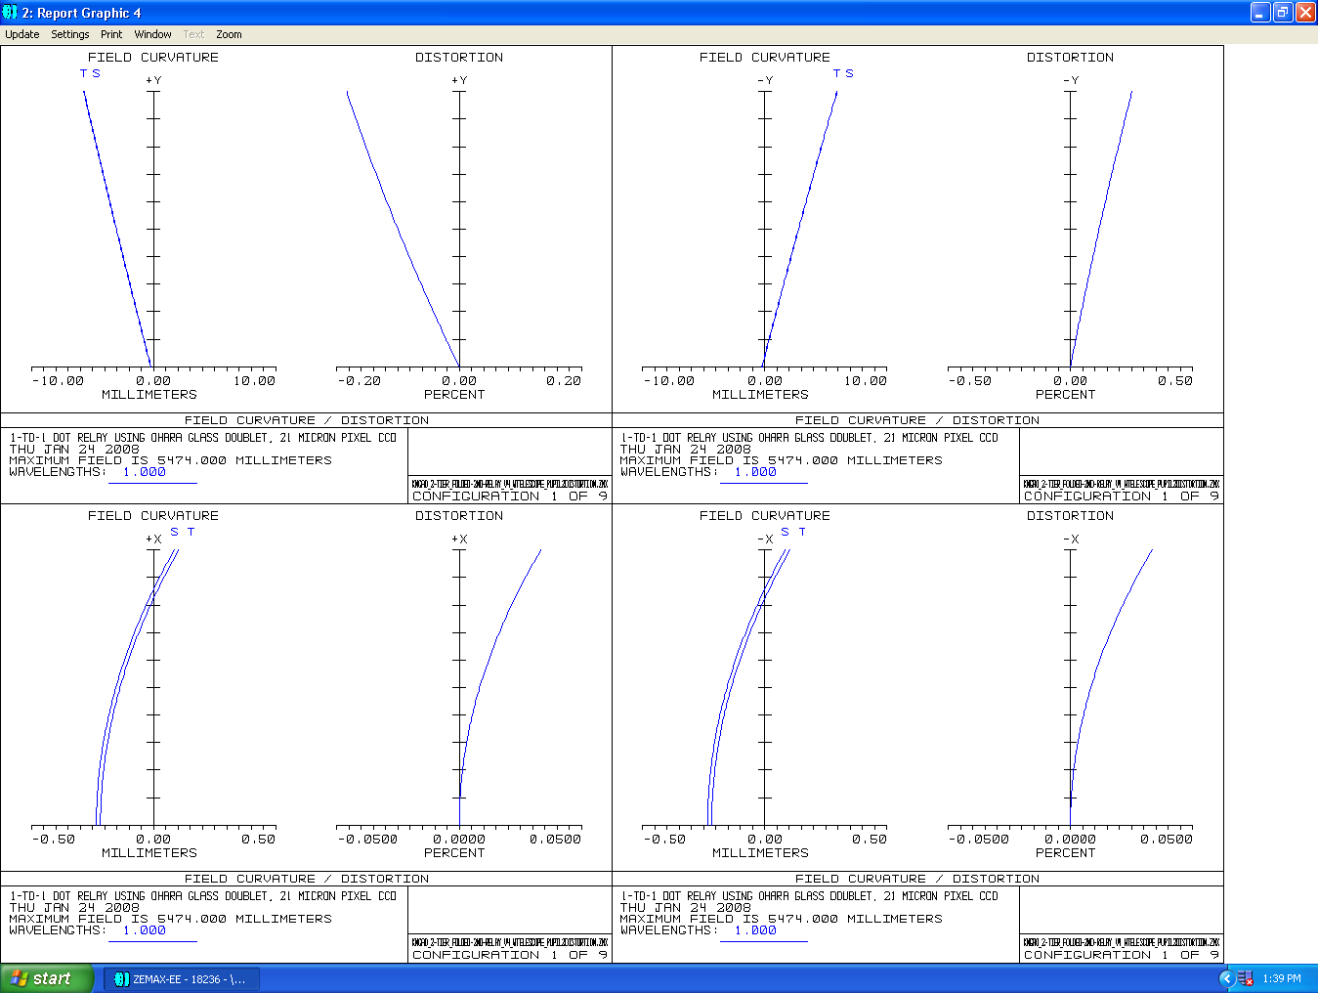
Figure 15 Grid distortion at DM2, multiplied by a factor of 100 to show shape.
Figure 14 Pupil PSFs with position on telescope primary mirror.
Figure 16 Field curvature and distortion plots in the +Y (top left), -Y (top right), +X (bottom left), and –X (bottom right) directions for the 25mm tweeter DM2. Note the tilt in the pupil plane evident in the +Y and –Y plots.

Concerns

Following the analysis of the optical system, the areas of concern include (but are not limited to!) the size of the PSFs for the LGS WFS reimaging optics (and the need for a corrector plate), the effect of the lateral color term on the LOWFS/TT spots when using combined J and H bands, and the degradation of wave front error with field for the NGS WFS.

Remaining Work

Work still to be accomplished is the exact nature of the feed to the interferometer and its effect on the phase of the P and S polarizations of the incoming beam. The reformatting optics for the OSIRIS instrument must also be designed and included in the optical and mechanical layouts.

