

Keck Adaptive Optics Note ___

Keck Next Generation Adaptive Optics
Preliminary Design Report

Authors: P. Wizinowich,
S. Adkins, R. Dekany, D. Gavel, C. Max
on behalf of the NGAO team

April 23, 2010

Keck Adaptive Optics Note 575

Keck Next Generation Adaptive Optics
System Design Report

Table of Contents

Table of Acronyms Used in This Report 3
1. Introduction 4
2. Recommended Reading and Background Information 4
3. Keck Adaptive Optics Background 4
4. Major Milestones Leading up to the Preliminary Design Review 5
5. NGAO Science & Science Requirements 6
6. Preliminary Design 7
6.1 Requirements, Interfaces and Controlled Documents 7
6.2 Design Overview 8
6.3 AO Opto-mechanics 10
6.4 AO Controls 10
6.4.1 AO Control Architecture 11
6.4.2 Real-Time Control 12
6.5 Key Technology Drivers 12
5.1.1 Laser Guide Star Tomography 12
5.1.2 Near-IR Low Order Wavefront Sensing 13
5.1.3 Science Measurement Accuracy 13
6.6 Performance Overview 14
7. Management 17
7.1 Major Milestones Leading up to the Preliminary Design Review 17
7.2 Systems Engineering Management Plan 18
8. Conclusion 20
Appendix A. NGAO Keck Adaptive Optics Notes (KAONs) 21
Appendix B. Science Case Requirements Summary 23

Table of Acronyms Used in This Report

AO Adaptive Optics
COO Caltech Optical Observatories
FRD Functional Requirements Document
IFS Integral Field Spectrograph
KAON Keck Adaptive Optics Note
LGS Laser Guide Star
NGAO Next Generation Adaptive Optics
NGS Natural Guide Star
OOCD Observing Operations Concept Document
PD Preliminary Design
PDM Preliminary Design Manual
PDR Preliminary Design Review
PSF Point Spread Function
SCRD Science Case Requirements Document
SD System Design
SDM System Design Manual
SDR System Design Report (this document)
SEMP Systems Engineering Management Plan
SSC W. M. Keck Observatory Science Steering Committee
UC University of California
UCO University of California Observatories
WFE Wavefront Error
WMKO W. M. Keck Observatory

Introduction
This document provides an overview of the work accomplished during Preliminary Design (PD) phase for the Keck Next Generation Adaptive Optics (NGAO) System. The PD phase is the second design phase for all W. M. Keck Observatory (WMKO) development projects. Successful completion of this phase will allow the project to move into the Detailed Design phase.

Recommended Reading and Background Information
The current document provides a high-level overview. We recommend that the Preliminary Design Phase reviewers also read the following key Keck Adaptive Optics Notes (KAON’s):

- Science Advisory Team Report (KAON )
- Preliminary Design Manual (KAON )
- Preliminary Design Performance Report (KAON 716)
- Programmatic and Technical Risk Evaluation (KAON 720)
- Systems Engineering Management Plan (KAON )

A list of all the NGAO-related KAON’s produced through the system design phase can be found in Appendix A or at http://www.oir.caltech.edu/twiki_oir/bin/view/Keck/NGAO/NewKAONs. This web page is located within a TWiki shared website
(http://www.oir.caltech.edu/twiki_oir/bin/view/Keck/NGAO/WebHome) that was established early in the System Design (SD) phase to serve the functions of management, information exchange, document sharing and document maintenance. The NGAO TWiki site is actively used by the project team, and has been an important factor in uniting researchers from WMKO, UC Observatories (UCO), and Caltech Optical Observatories (COO).

Keck Adaptive Optics Background
Keck I and Keck II are the world’s largest optical and infrared telescopes. Because of their 10-m apertures, they offer the highest potential sensitivity and angular resolution currently available on the ground. Keck deployed the first natural guide star and laser guide star (Error: Reference source not found) AO systems on 8-10 meter diameter telescopes. The Keck 2 and Keck 1 NGS AO systems were commissioned in 1999 and 2001, respectively. Keck 2’s LGS AO capability became operational in 2004. The wavefront control computers and cameras were successfully upgraded on both systems in 2007. Keck 1’s LGS AO capability should be operational in 2011. Four science instruments are used with Keck AO (NIRC2, OSIRIS, NIRSPEC and the Interferometer).

WMKO has a demonstrated track record in scientific leadership in high angular resolution astronomy. The two WMKO AO systems have amassed an impressive series of refereed science publications (259 total including 79 LGS papers as of April 2010). WMKO’s dominance to date in LGS AO science is illustrated in Error: Reference source not found. The importance of achieving the full potential of the Keck telescopes is recognized in the Observatory’s Strategic Plan, which identifies continued leadership in high angular resolution astronomy as a key long-term goal. To maintain leadership WMKO has recognized the need to pursue new AO systems and the science instruments to exploit them. NGAO represents the next major step in maintaining scientific leadership in high angular resolution for the WMKO community.

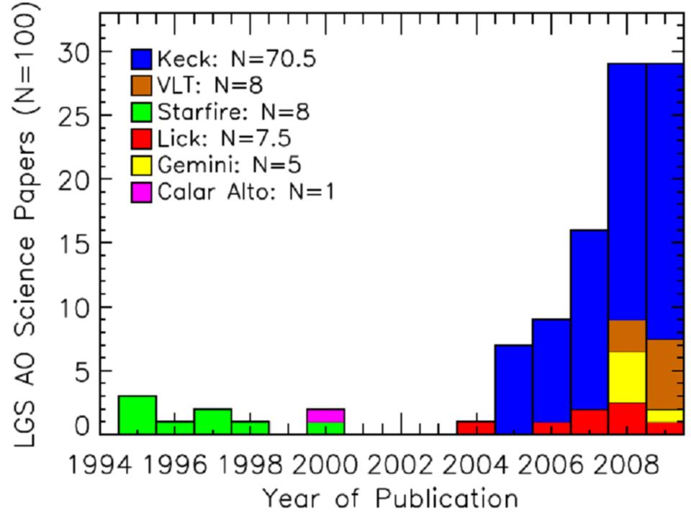
Figure 1. Refereed LGS AO science papers by year and telescope

Major Milestones Leading up to the Preliminary Design Review
The following table lists the major completed project milestones leading up to the Preliminary Design Review (PDR).

Date | Major Completed Milestones | KAONs
Jun 2006 | Proposal presented at WMKO SSC meeting | 399 & 400 (Proposal)
Oct 2006 | Start of System Design after approval of SEMP | 414 (SEMP)
Apr 2008 | System Design Review | 575 (Report), 588 (Panel Report)
Nov 2008 | TMT 1st Light AO Cost Comparison | 625 (Report)
Mar 2009 | Build-to-Cost Review | 648 (Report), 650 (Panel Report)
Apr 2009 | Astro2010 NGAO Activity Submission | 649 (Submission)
Aug 2009 | Laser Launch NSF MRI proposal funded | 707 (Proposal)
Dec 2009 | Laser Preliminary Design Reviews | 706 (Report)

The proposal for NGAO was presented at the June 2006 Keck Science Steering Committee (SSC) meeting. This proposal was approved to proceed through System Design (SD) phase. A Systems Engineering Management Plan (SEMP) was subsequently prepared and approved for the NGAO SD phase which began in October 2006. The System Design Review (SDR) was held in April 2008 and work then began on the Preliminary Design. In response to the SDR panel report the NGAO cost estimate was reviewed in comparison to the TMT 1st light AO system. The result, presented at the November 2008 SSC meeting, largely justified the NGAO cost estimate in comparison to the TMT cost estimate except for a recommendation to hold more contingency for lasers.

In August 2008 the Directors provide the NGAO team with a build-to-cost cap of $60M then-year dollars including the science instruments. This direction required significant rework of the design choices, primarily the removal of deployable near-infrared integral field spectrograph units and their AO design implications. The team successfully completed a build-to-cost review in March 2009.

The NGAO team has had to be aggressive in seeking Federal funding due to the inability to find private funding for NGAO during the PD phase. The PD phase has been completely funded as a result of two TSIP proposals (monthly progress reports were provided to TSIP throughout the PD phase). A white paper to NSF/AURA received $300k in GSMT funds that allowed us to form a U.S. consortium to collaborate with ESO to fund preliminary designs from two laser vendors. The laser PDRs were successfully completed in December 2009. A proposal for a Keck 2 laser center launch telescope that will become part of NGAO was funded by the NSF MRI program in August 2009. Another MRI proposal was submitted in April 2010 for the first NGAO laser and this proposal is supported by collaboration agreements with ESO and TMT. An ATI proposal was submitted in November 2009 for a non-NGAO project, a near-infrared tip-tilt sensor for Keck 1, which will provide risk reduction for NGAO if funded.

In order to ensure that major subsystems were reaching a PDR level and to ensure that the subsystems satisfied their overall requirements the series of mini-reviews shown in the following table were held. In each case a set of documentation was distributed to the reviewers and colleagues prior to the review in order to get pre-review feedback. The reviewers were generally members of the NGAO team but in some cases we added external experts (the name of the review chair is in bold). The reviewer reports were documented as KAONs which were used as part of the input to update the designs and documentation.

NGAO Science and Science Requirements
The science case and science drivers for NGAO have continued to develop through the initial proposal phase, the SD phase and the PD phase.

The NGAO science advisory team has provided a fresh look at the strong science case for NGAO in KAON __.

The NGAO project science team has continued to develop and refine two classes of science cases: “Key Science Drivers” and “Science Drivers”. “Key Science Drivers” are those science cases that place the strongest or most technologically challenging demands on the performance of the NGAO system and its science instruments. These are the science cases that we have used to drive the performance requirements for the AO system and instruments. “Science Drivers” (not “Key”) are included to assure that the NGAO system is sufficiently flexible to deal with the broad range of science that users will demand over the lifetime of the NGAO system. Typically, “Science Drivers” do not strongly push the state of the art of the AO system itself; rather they require specific types of coordination between the AO system, the instruments, and the telescope, or they help define parameters such as the full wavelength range or the required field of view of the instruments. The Science Case Requirements Document (KAON 455) defines and analyzes 5 “Key Science Drivers” and 8 “Science Drivers.” These cases were selected because they represented important astrophysics that would clarify the requirements on the NGAO system from different perspectives.

The “Key Science Drivers” are as follows, in order of distance from Earth:
- Galaxy Assembly and Star Formation History
- Nearby Active Galactic Nuclei
- Precision Astrometry: Measurement of General Relativistic Effects at the Galactic Center
- Imaging and Characterization of Extrasolar Planets around Nearby Stars
- Multiplicity of Minor Planets in our Solar System

The additional “Science Drivers” are as follows:
- Quasar Host Galaxies
- Gravitational Lensing
- Astrometry Science in Sparse Fields
- Resolved Stellar Populations in Crowded Fields
- Debris Disks and Young Stellar Objects
- Size, Shape, and Composition of Minor Planets
- Characteristics of Gas Giant Planets, their Satellites, and Rings
- Characteristics of Ice Giant Planets and their Rings

A first version of the Observing Operations Concept Document (OOCD; KAON 636) was produced during the PD phase. This document defines how the NGAO system will be used to carry out science observations.

Preliminary Design
The NGAO design is summarized in the Preliminary Design Manual (PDM; KAON __). The PDM references a significant number of KAONs where more details can be found. The following sections are only intended to provide a very brief overview of the design.

Requirements, Interfaces and Configuration Control
The requirements are managed within the Contour database purchased from Jama software. This database is under configuration control. The requirements in the database include the science case requirements from the SCRD, the system requirements that include the flowed down science case requirements and additional observatory requirements on the overall NGAO system, the flowed down functional requirements on NGAO subsystems organized by the NGAO product breakdown structure (PBS), and a set of WMKO instrument baseline requirements applicable to all subsystems.

The requirements database and interface control approach (KAON 741) also reference a number of additional documents that are under configuration control:
- The system configuration spreadsheet (KAON 550) which defines the NGAO observing configurations.
- The observing operations concept document (KAON 636) that defines how observations are performed with the NGAO system
- The Master device list (KAON 682) that documents all of the parameters of the devices requiring control.
- Keck drawing 1410-CM0010 that defines the mapping of the Keck primary mirror to each deformable mirror.
- The AO control loops document (KAON 705) that provides a high-level definition of all of the required control loops external to the real-time control systems.
- The power budget (KAON 709) that compiles the power dissipation by device.
- The wavefront error budgets as documented in KAON 716.
- The wavefront error budget tool (KAON 721) used to produce Strehl and ensquared energy predictions.
- The high-contrast error budget tool (KAON 722).
- The performance flowdown requirements spreadsheet (KAON 723) that distributes the error terms between subsystems and components.
- The SolidWorks model (KAON 726) that documents the mechanical design.
- The Zemax optical design (KAON 727) that documents the optical design.

Our adopted approach to configuration control for the requirements and documents is defined in KAON 638.

Design Overview
Key New Science Capabilities
Near Diffraction-Limited in Near-IR (K-Strehl ~80%)
AO correction at Red Wavelengths (0.65-1.0 μm)
Increased Sky Coverage
Improved Angular Resolution, Sensitivity and Contrast
Improved Photometric and Astrometric Accuracy
Imaging and Integral Field Spectroscopy

The NGAO technical approach is shown schematically in Figure 2. The requirement of high Strehl over a narrow field is achieved using laser tomography (to correct for focal anisoplanatism; i.e., the “cone” effect) with an on-axis LGS and three uniformly spaced LGS on a 10" radius (as illustrated in Figure 3), a narrow field relay with a deformable mirror having 64 actuators across the telescope pupil and careful control of all wavefront errors especially tilt errors. High sky coverage is achieved by sharpening the three stars used to provide tip-tilt information with their own LGS AO systems including a movable LGS (shown in Figure 3) and a MEMS DM with 30 actuators across the telescope pupil (i.e., the low order wavefront sensors shown in Figure 2). High sensitivity at thermal wavelengths requires low emissivity which is achieved by cooling the science path optics (e.g., the cooled enclosure in Figure 2).
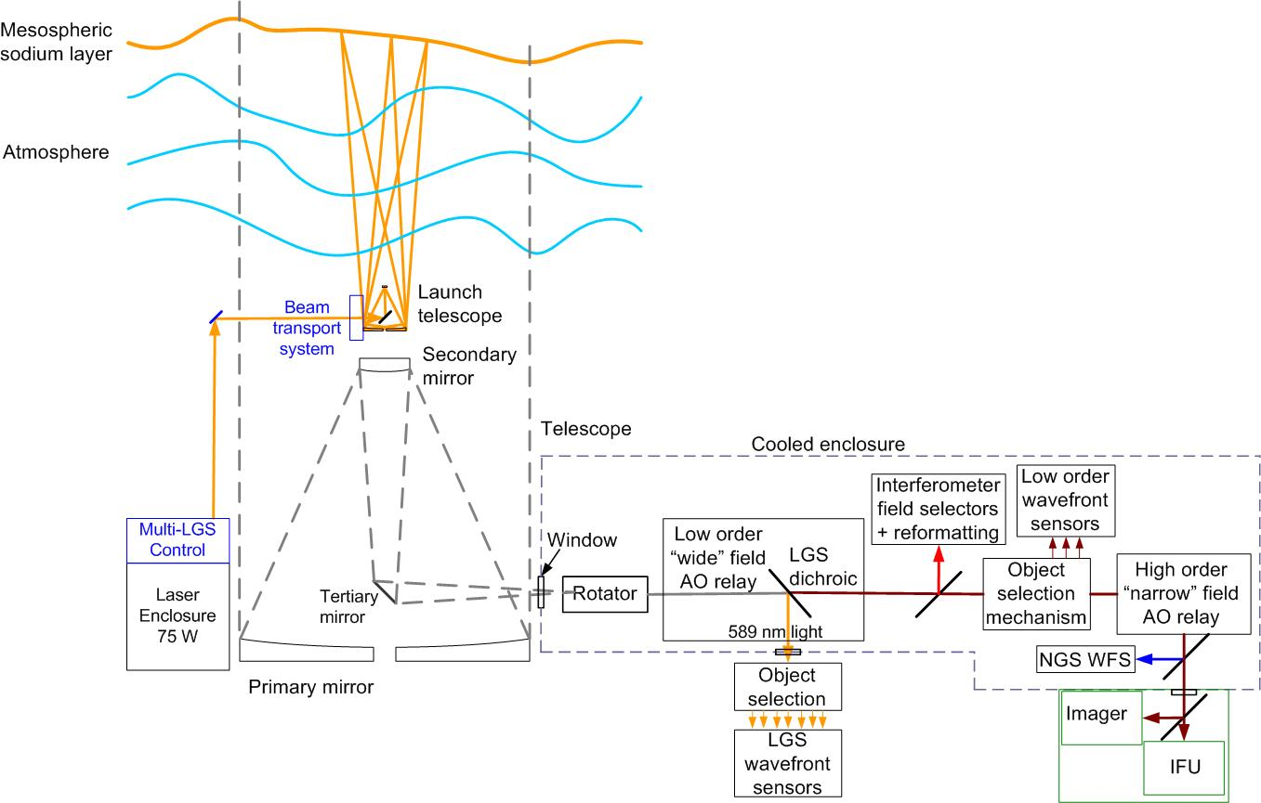
Figure 2 Schematic of the NGAO concept
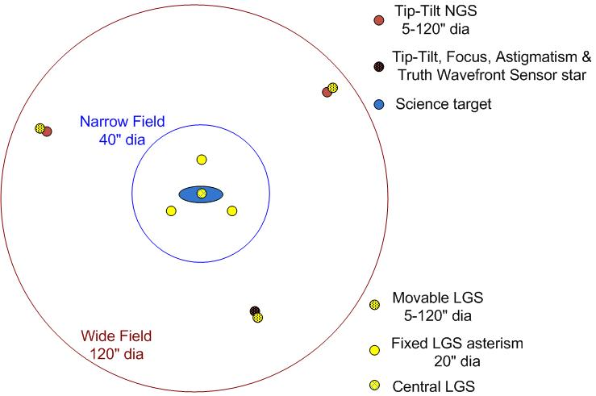
Figure 3 Schematic of the NGAO LGS asterism

AO Opto-mechanics
Optical (Zemax) and mechanical (Solid Works) models of the AO bench have been produced. Figure 4_ provides views of the AO bench from the mechanical model. For comparison, the current Keck AO benches extend 2.4 m from the bulkhead shown in Figure 4.

A key part of the opto-mechanical design will be object selection mechanisms to feed the LOWFS and patrolling LGS wavefront sensors. The two rotary axes pickoff probe arms shown in Figure 5 represent our baseline design for both the multi-wavefront sensor object selection mechanisms.

Figure 4. Elevation and plan views of the AO bench.
Light from the telescope enters from the right along the optical axis.

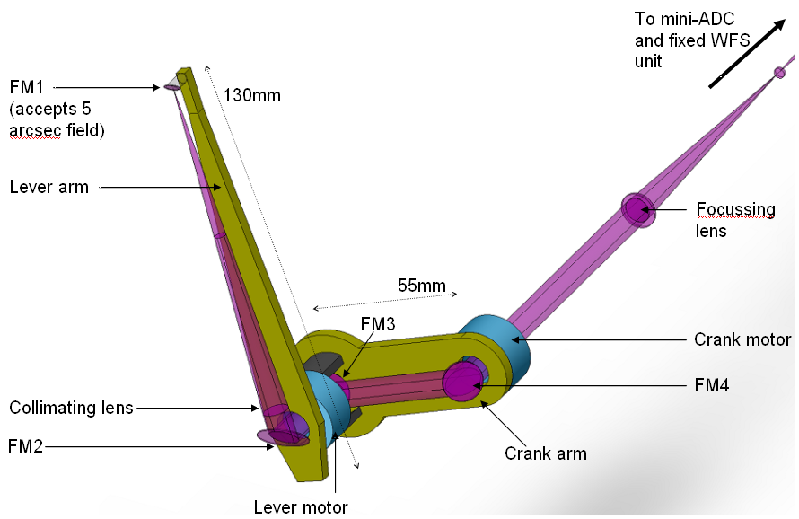
Figure 5. Object selection probe arm.

DAVINCI Science Instrument
The initial NGAO science instrument will provide both imaging and integral field spectroscopy from 0.7 to 2.4 µm. The imager will have a 32" x 32" field of view with 0.008" pixels and a coronagraph. The IFS will offer 0.010", 0.035" and 0.050" spatial sampling scales with fields of view ranging from 0.8"x0.8" to 4"x4". An integral field spectrograph (IFS) is ideally suited to take advantage of the image quality offered by AO because of its ability to provide spatially resolved spectroscopy of diffraction limited images. IFS data can provide information essential for deconvolution of the PSF and offers a comprehensive tool for determining kinematics, mass distributions and velocity dispersions.
The NGAO IFS will be an advanced design based on lessons learned in the development of the first generation of AO-corrected near-IR IFS instruments for large telescopes and an improved understanding of the science requirements gained through observations with the currently available instruments. The IFS will be optimized to take advantage of the lower backgrounds, higher throughput, higher Strehl, and extended wavelength coverage possible with NGAO. The IFS will have higher sensitivity than current near-IR IFS instruments and will provide a 4" x 4" FOV with 0.050" spatial sampling optimized to match the ensquared energy in the NGAO science field. The IFS will also provide spatial sampling matched to the diffraction limit in the K-band with a 2" x 2" FOV, and a fine sampling scale (~0.010") for the short wavelengths.

AO Controls
The AO control system is integrated with the telescope’s overall control system and has its own hierarchy for controlling the operation of the AO system in coordination with the instruments. Lessons learned from prior AO control system development have been taken advantage of in the design of the NGAO system, with particular attention paid to operations planning, efficient observations, and data archiving. In addition, we have developed a feasible approach to address the extremely demanding requirements of the tomography based real-time wavefront control.

AO Control Architecture
The NGAO control architecture is distributed among several subsystems: science instruments, AO system, telescope interface, laser system, data server, atmospheric tools and laser traffic control system. The overall system is operated through the science operations tools box at the topmost layer of control. This toolbox consists of a user interface and operations tools (pre-observing, operation control tools and post-observing tools). Figure 6 and Figure 7 provide schematic overviews of the overall NGAO controls system infrastructure.

Figure 6. A block diagram of the NGAO system viewed abstractly as a distributed controls system.

Figure 7 presents a block diagram of the AO infrastructure where the control systems are represented by a hierarchy. At the top level are the main interfaces to the various subsystems. The science operations tools control the AO facility through a high level sequencer (the multi-system sequencer) as shown at the top of Figure 7. The multi-system sequencer sends parallel commands to each of subsystem sequencer. The sequencing is performed at the lowest possible levels allowing for parallel (time efficient) observing sequences. The middle level of the hierarchy represents the basic control functions for that subsystem. Some users will access the system at this middle level for engineering or troubleshooting purposes, but observing operations will occur via the topmost layer. Shown at the lowest level of the hierarchy are the controlled devices themselves.

Figure 7. A block diagram. Of the NGAO controls infrastructure

Real-Time Control

Laser Guide Star Facility

Performance Overview
A detailed wavefront error budget has been developed for NGAO based on a combination of simulations, anchors to the existing Keck AO system performance and measured atmospheric and sodium conditions. The performance of the NGAO design has been evaluated for each of the key science cases at the wavelengths of most interest to each science case. Figure 8 (bottom left) shows the predicted Strehl ratio for the exoplanet science case at H-band and 10º galactic latitude, as a function of sky coverage. Figure 8 (top right) is a similar plot for the AGN science case at z-band and a galactic latitude of 30º. For this science case the energy in a particular IFS diameter is the performance parameter of interest. The tip-tilt error is shown separately in both of these figures since the impact of increasing tip-tilt error is to increase the diameter of the core of the PSF without decreasing the amount of energy in this core. Overall NGAO is predicted to have excellent sky coverage due to the use of multiple AO-corrected tip-tilt stars.
The performance versus off-axis distance for the Galactic Center science case is shown in Figure 9. The Strehl is the important parameter for reducing source confusion and thereby improving the accuracy of astrometric imaging observations. The ensquared energy is important for the corresponding IFS radial velocity measurements. In this application the IFS will have a maximum size of 2" radius while the science imaging requirement is a radius of 5". If more uniform Strehl performance was required this could be accomplished by optimizing the performance for a different radius at the expense of the on-axis performance.

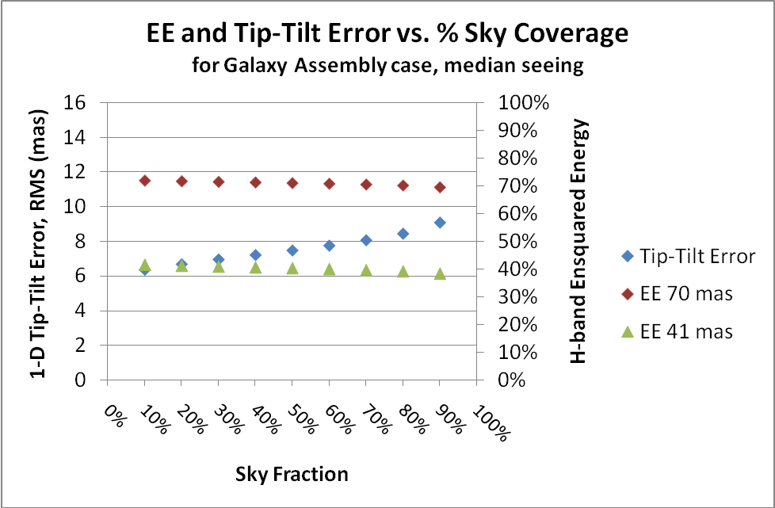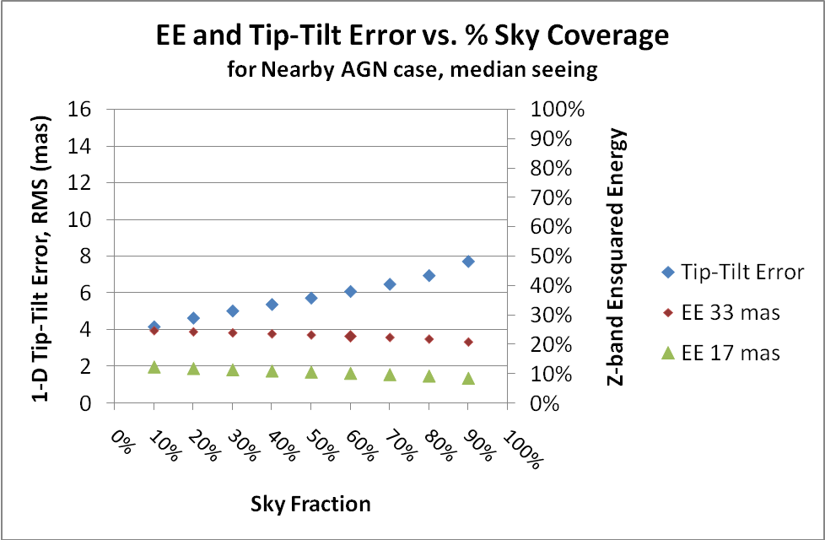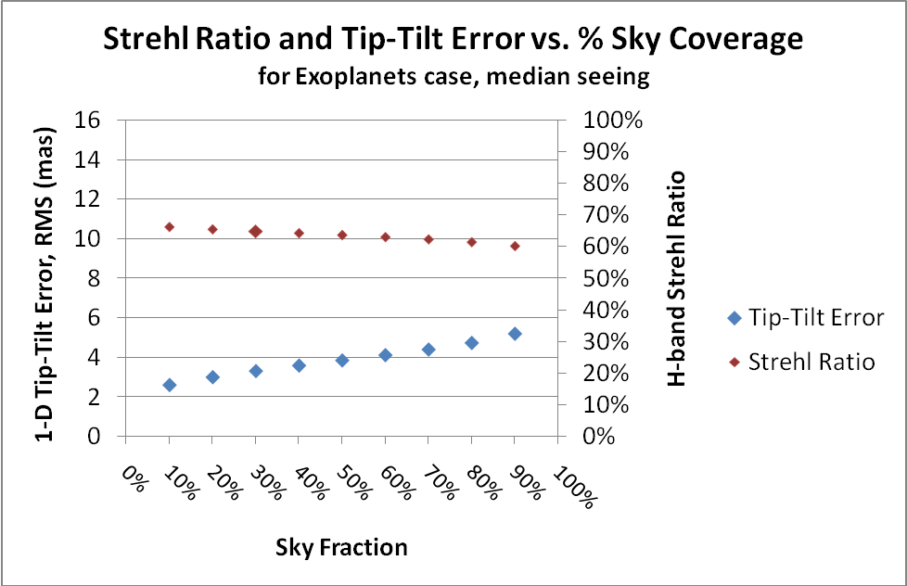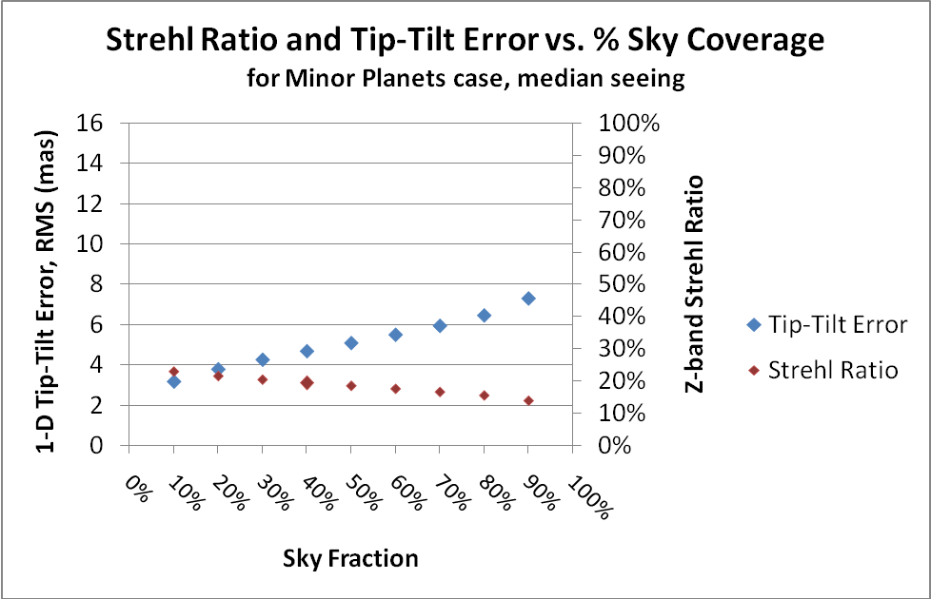
Figure 8 Key performance parameter plots versus sky coverage for four key science cases. The top two plots show ensquared energy (right axis), within the dimension specified in each plot’s legend, for the galaxy assembly in H-band and nearby AGN in z-band science cases. The lower two plots show Strehl ratio (right axis) for the exoplanet in H-band and minor planets in z-band science cases. The rms tip-tilt error is shown versus the left axis in all four plots; the tip-tilt errors are relatively small in comparison to the ensquared energy areas.

Figure 9 NGAO Strehl ratio and ensquared energy (in a 70x70 mas area) for the Galactic Center science. The maximum off-axis distance is 2" for integral field spectroscopy and 5" for imaging of the Galactic Center.
A summary of the predicted NGAO performance for the key science cases is shown in Table 1. The rough comparison between current Keck AO performance and NGAO shown in Figure 10 illustrates the dramatic science improvement that will be provided by NGAO.

Table 1 Predicted performance for the NGAO key science cases

Figure 10 NGAO versus current Keck II NGS and LGS AO performance (for the case when a bright natural guide star is available for NGS AO or for tip-tilt correction with LGS AO).

Risk Assessment
The results of a programmatic and technical risk evaluation and the approaches to mitigating these risks are documented in KAON 720. The changes to the risk matrices between SDR and PDR are presented and discussed. Some funding related programmatic risks identified at the SDR have grown due to the poor economic environment for private fund raising. On the other hand we have made good progress on reducing some of the key technical risks (see the following text block) through simplifications to the NGAO design resulting from the build-to-cost changes and through collaborations.

Key Technology Drivers
Sodium Wavelength Lasers
Laser Guide Star Tomography
Low Order Wavefront Sensing with LGS AO-Corrected Guide Stars
Open Loop AO Correction with MEMS Deformable Mirrors
Improved Science Measurement Accuracy and PSF Knowledge

In order to achieve the required science performance NGAO must offer improved performance in a number of key technology areas that have not yet been demonstrated. The NGAO design process has therefore been one of finding solutions to the reduction of numerous error terms while simultaneously finding ways to minimize risk and cost.

Laser Guide Star Tomography
NGAO will use four LGS beacons (Figure 3) to perform tomography of the atmosphere in a narrow volume around the science field. The primary purpose of tomography is to reduce focal anisoplanatism (i.e., the cone effect); the single largest wavefront error term for the current Keck 2 LGS AO system. Laser tomography has not yet been demonstrated on the sky despite the fact that it is planned as a key part of future AO systems on existing telescopes as well as future extremely large telescopes. We have compared multiple tomography simulation codes, followed the results of NGS tomography demonstrations and performed experiments at the UCSC Laboratory for AO to better quantify the tomography error.
The data from multiple wavefront sensors are combined to determine the wavefront error as a function of altitude and direction. In the NGAO system this information will be used to provide the optimal on-axis correction. This information could alternatively be used to optimize the performance at any given field point within the tomographic volume. We also intend to use the tomographic information in support of providing PSF calibration data versus field position.
Laser tomography requires the availability of high return sodium wavelength lasers. The availability of affordable and reliable commercial sodium wavelength lasers continues to be a major issue for the astronomical community.
Mitigation during PD phase: We collaborated with ESO, GMT, TMT and AURA to fund two companies to develop preliminary designs for commercial lasers. ESO subsequently selected TOPTICA/MPBC to provide four 20W fiber Raman amplifier based lasers. WMKO has signed an agreement with ESO to continue to participate during the final design and pre-production phases for this laser. WMKO with TMT collaboration has submitted a NSF MRI proposal to procure one of the three lasers that will be needed for NGAO. TOPTICA/MPBC produced a demonstrator for the PDR that operated at up to 30W and with a variable gravity vector.

Near-IR Low Order Wavefront Sensing
The NGAO low order wavefront sensors (LOWFS) are a key element in achieving high Strehl with high sky coverage. Two of these LOWFS just provide tip and tilt based on measurements from natural guide stars in the 120" diameter field. A third LOWFS also measures focus and astigmatism. Three tip-tilt measurements are necessary to determine low order modes which the LGS wavefront sensors cannot measure. The use of AO-sharpened tip-tilt stars has not been demonstrated on the sky to date. A number of challenging technologies need to be incorporated into these LOWFS to achieve the required performance. These include:
- Pickoff arms to accurately acquire and track the tip-tilt stars with respect to the science field. Mitigation during PD: our preliminary design meets the requirements.
- MEMS deformable mirrors to open loop sharpen the image of the tip-tilt star based on the wavefront sensor data from the LGS pointed at the tip-tilt star. Mitigation: UCO has demonstrated accurate go-to performance in the lab and on the sky using NGS (Villages experiment).
- Near-infrared low order wavefront sensor cameras. Mitigation: COO has demonstrated the required read noise and we have submitted a joint ATI proposal to field a camera on Keck I.

Science Measurement Accuracy
Astronomers are interested in such key performance issues as sensitivity, spatial resolution, spectral sensitivity, contrast, astrometric accuracy and photometric accuracy. AO developers have traditionally designed and assessed their system performance versus wavefront error (or encircled energy) and transmission/emissivity budgets. In order to move to another realm of science performance the AO developers now need to develop error budgets for, and improved understanding of, the other relevant performance parameters impacting science with AO.
One key parameter is the point spread function (PSF) of the images delivered by the AO system; this needs to be determined in the absence of a PSF star in the science data. The structure of this PSF and its dependence on time and field position strongly impacts the accuracy of astrometric or photometric measurements, the ability to detect faint sources next to bright sources and the ability to characterize the structure of astronomical objects. Improving the stability of the PSF and knowledge of the PSF versus time and field position will directly improve the science achievable with AO.
Mitigation: In the process of developing NGAO we have begun to develop additional error budgets, for such areas as companion sensitivity, astrometry and photometry, in order to determine their impact on the NGAO design. We began the process of implementing PSF characterization tools with the existing Keck AO system, based on existing wavefront sensor data supplemented by atmospheric turbulence monitoring data, as a stepping stone to developing the more complex tools that will need to be implemented with NGAO’s laser tomography system. This effort was stalled for much of the PD but has recently been restarted in collaboration with Gemini and Groningen. PSF characterization tools have not yet been implemented anywhere for LGS AO science or for NGS AO with Shack-Hartmann wavefront sensors.

Systems Engineering Management Plan
A SEMP (KAON __) has been produced for the remainder of the project. The project plan includes a work breakdown structure with task definitions, cost estimates, management plans including risk management, major milestones, and an MS Project plan.

Some key excerpts from the SEMP are summarized here:
- Organization. The project personnel are distributed between Caltech, UCO and WMKO. Key personnel include the project manager, P. Wizinowich (WMKO), who reports to the WMKO directorate, the project scientist, C. Max (UCSC), and the senior management team, R. Dekany (Caltech), D. Gavel (UCSC) and S. Adkins (WMKO), who manage major elements of the NGAO project.
- A Work Breakdown Structure (WBS) and Product Breakdown Structure (PBS) have been defined for the project. The high level WBS is shown in Figure 11. The top level structure reflects the transition from Design (1.0) through Full Scale Development (4.0 to 8.0 and 11.0) to Delivery and Commissioning (9.0 and 10.0). WBS 9.0 includes Science Verification and WBS 10.0 covers the handover to Facility Class Operation. Management (2.0) and Systems Engineering (3.0) are ongoing items through both Full Scale Development and Delivery and Commissioning.
- A high level project milestone schedule is shown in Table 2. The 24-month DD phase is driven by the need to allow time to significantly increase the number of personnel at the start of this phase. Eighteen months between the end of the detailed design and the start of lab I&T will be adequate if long lead procurements can be placed during the detailed design. The laser procurement in particular will likely need to be placed during the preliminary design. The telescope integration and test schedule will need to be carefully coordinated with the observing semester schedule and decision dates in order to minimize the down time for AO (AO will however be available on the Keck I telescope during this period). In this schedule NGAO shared-risk science would begin in semester 15A.
- A very detailed bottoms-up cost estimation process was performed, modeled on the TMT process. This process produced over 300 cost sheets, which include WBS dictionary definitions, deliverables, labor, non-labor, travel and contingency estimates along with their bases of estimation. These costs were also compared to the costs for similarly complex systems. As a result we have a good degree of confidence in the cost estimate for this early in the project. The bottom line estimate is $34.5M plus $7.7M in contingency in FY08 dollars. A summary of this cost estimate by major phase, and cost estimation category, is provided in Table 3.
- We have evaluated and documented the programmatic (KAON 566) and technical (KAON 510) risks to NGAO and our proposed mitigation approaches. Our approach to risk evaluation follows the model used at JPL where risks are ranked according to likelihood and consequence.
- An approach to requirements management using a database management tool has been defined and is in use (as described in KAON 573).
- An approach to integration and test has been defined (KAON 581) and is integrated with our WBS and schedule.
- A preliminary design phase MS project schedule has been produced that is consistent with the cost estimate and with the available Observatory budget. Personnel assignments have been made to each task in the schedule.
- We have not yet dedicated time to the issues of phased implementation approaches or descope options, although we certainly have considerable relevant experience to address these issues.
- A brief summary is provided of how the team performed during the PD phase in terms of deliverables, schedule and budget.

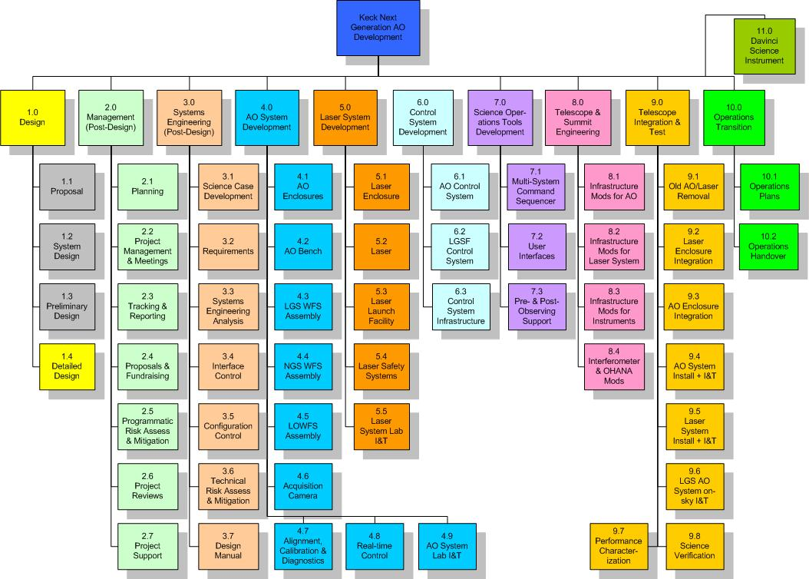
Figure 11. NGAO Work Breakdown Structure (WBS).

Table 2. NGAO Project milestones.

Table 3. NGAO cost estimate by project phase, in FY08 $k.

Conclusion
We believe that we have successfully completed the Preliminary Design phase and that we have established a flexible and robust design approach that meets the scientific and user requirements established for the system, as required for the conclusion of the SD phase. We have also developed a capable and enthusiastic team and a viable technical and management path forward to the realization of a very powerful scientific capability: NGAO for the Keck Observatory. We are looking forward to continuing into the Detailed Design phase and beyond.

Appendix A. NGAO Keck Adaptive Optics Notes (KAONs)

