 Keck Adaptive Optics Note 681

Keck Next Generation Adaptive Optics
Preliminary Design Phase Project Report #15

P. Wizinowich, Sean Adkins and the NGAO Team
August 26, 2009

Narrative

This report is the fifteenth monthly project report for the Preliminary Design (PD) phase in the development of the W. M. Keck Observatory’s (WMKO) Next Generation Adaptive Optics (NGAO) facility. This report covers the PD phase work performed in July 2009.

Summary
Management efforts have been focused on proposal writing. The technical team is making good progress on the requirements, software architecture, opto-mechanical design and real-time control design.

Management Status
The PD phase plan presented at the SDR included work under the following management WBS elements through July. The progress in each of these areas is discussed below.

WBS 1.3.2.1 Planning

WBS 1.3.2.2 Project Management and Meetings

WBS 1.3.2.4 Proposals
Work has continued on an MRI-R² proposal for the implementation of a new Keck II laser which will be submitted by WMKO. TMT has agreed to provide a portion of the cost share for this proposal.

WBS 1.3.2.5 Programmatic Risk Assessment and Mitigation
The second quarterly report to AURA on the laser contracts was submitted at the end of July. The second FASORtronics progress meeting was held on July 1. The revised risk reduction work package proposed by FASORtronics was approved.

Technical Status
The PD phase plan presented at the SDR included work under the following technical WBS elements in July. The progress in each of these areas is discussed below.

WBS 1.3.3.1 Science Case Requirements
This month we have been reviewing the science requirements in the Contour database for the Functional Requirements Document. This review process will continue through the end of next month. We have also been refining science requirements to ensure they reflect the new architecture we adopted at the build to cost review. We have also started working on simulations of galaxy mergers and the effects of resolution and signal to noise on the recovered galaxy morphology. Work will continue next month on all of these tasks.

WBS 1.3.3.2 Requirements
Overall requirements review work has continued with the remaining incomplete items primarily being the RTC, WFS, science operation tools, and vibration sensor requirements.

WBS 1.3.3.3 Systems Engineering Analysis
An initial compilation of the several flowdown budgets into a single Excel spreadsheet was made, but is awaiting final contributions pertaining to the high order and tip/tilt bandwidth (i.e. servo lag) errors. Minor updating (reformatting) of the consolidated workbook has been performed to aid in future requirements traceability.

The high-contrast (HC) error budget was refined and the flowdown analysis of this budget into subsystem requirements has begun. As previously found, the telescope phasing, tip/tilt, and segment errors are more strongly driven by the HC budget than by the Strehl/EE budget. An analysis of the contrast impact of different levels of uncorrectable telescope (and similar) errors is being prepared as a KAON.

Significant progress was made on the analysis of hybrid sodium and Rayleigh laser guide star beacon architectures for NGAO. Using the LAOS modeling tool, performance comparisons of a number of hybrid architectures were made, identifying three intriguing options that meet NGAO tomography error specifications: a system of one sodium beacon and six high altitude Rayleigh beacons, another having one sodium beacon and three high altitude Rayleigh beacons (compromising performance somewhat, but saving cost and complexity), and a final option having 4 high altitude Rayleigh and 6 low altitude Rayleigh beacons. A journal article presenting these results will be prepared.

Good progress has also been made on the addition of the MOAO capabilities to LAOS.

WBS 1.3.3.4 System Architecture
KAON 666 was completed to address how a fixed pupil LGS AO mode will be supported in light of the NGAO build to cost design changes. Three options were proposed along with some assessment of their implications. The recommended option is to use the NGS WFS as the tip/tilt sensor for the LGS AO fixed pupil mode. The feasibility of incorporating this mode into the NGS WFS needs to be evaluated.

KAON 669 was produced to further develop and evaluate the concept of mounting the narrow field deformable mirror on a slow tip/tilt mount. This mount could be used for steering the science field on the science detector without impacting the telescope, LGS WFS or LOWFS pointing. The conclusion of this report is that the science benefits, operational simplicity and reduced LOWFS complexity are significant enough to warrant including this stage in the NGAO baseline design.

We have made excellent progress on the software architecture for the NGAO control system. The architecture design is now complete and we are finishing up the documentation. Portions of the architecture completed this month and documented as KAONs include: class decomposition, command-response pattern, base component definitions, middleware abstraction, naming scheme, common services, user interface architecture, and sequencer architecture.

The device control electronics design and the motion control architecture update 1 are both nearly complete and will be published in August.

WBS 1.3.3.5 External Interface & 1.3.3.6 Internal Interface Control
Drafts of the AO to telescope and AO to Keck interferometer ICDs being prepared for initial review.

WBS 1.3.3.9 Technical Risk Assessment and Mitigation
Good progress continues to be made on preparing for the summit installation of the MASS/DIMM equipment.

WBS 1.3.4.1 AO Enclosure
An initial concept for the enclosure design is complete. Modeling will begin as the AO bench layout is completed.

WBS 1.3.4.2.3 Optical Relays
The AO relay optical design, and the definitions of its interfaces to science instruments, wavefront sensor packages, and acquisition system are complete. There has been continuing progress on developing the mechanical layout of optical components on the Nasmyth platform. As of the end of July:
- The tolerance analysis for the baseline optical design has been completed. Results are in an update to the posted design document (link). The results of the tolerancing have been used to form the static wavefront error budget allocation and are being used to guide the mechanical tolerance requirements for the optical mount designs.
- The mechanical layout and design is continuing this month with full time attention, and with considerable interaction with the CIT and WMKO teams.
- The opto-mechanical group has been working closely with the wavefront sensor and instrument mechanical design teams to work out the interface details. The key issues we have been dealing with are: volume and heat load of the LOWFS; the interface between cold space, LOWFS cryo-dewar, and ambient space; and optical feed to the interferometer (WBS 1.3.4.2.1 and 1.3.4.2.3). Weekly meeting notes are posted on the AO System Design web page.

WBS 1.3.4.2.5 LGS Wavefront Sensor Assembly
Applicable to all of the wavefront sensors, an initial design that is in conformance with the opto-mechanical design requirements has been refined. An initial pick-off optical design has been produced based on the pick-off arm design.

WBS 1.3.4.2.7 Low Order Wavefront Sensor Assembly

WBS 1.3.4.2.8.1 Tip-tilt Vibration Mitigation Analysis
The atmospheric tip/tilt PSD approximation that was used as input to the simulation was found to be in error. It was producing excess power at approximately the rejection bandwidth of the tracking control loop resulting in residuals 10x greater than assumed in the NGAO error budget. Converted to an exact expression for tip/tilt PSD, residuals are now consistent with error budget assumptions. Unfortunately, this has delayed completion of the report into August.

WBS 1.3.4.3 Alignment, Calibration and Diagnostics

WBS 1.3.4.4 Non-real-time Control

WBS 1.3.4.5 Real-Time Control
Progress has been made on refining the RTC design:
- Design of the real-time core processor engine has made considerable progress. We reported last month that the FPGA code for the tomography engine is largely complete. We have been making additional progress on defining the processor engine ancillary functions and architectural layout. This month considerable progress has been made on GPU code that will implement the wavefront sensor processing.
- We have completed the design for the methods of code and parameter loading to the FPGA system and for the method of streaming out diagnostics/telemetry to RAID disk. The external and internal interface definitions are proceeding well.
- We are still carrying the two options for the front-end video processors but with a strong preference for the GPU. Based on final results from the GPU based design and analysis, we plan to make the final go/no go decision this month on the GPU.
- We still continue to have a problem with manpower for FPGA board layout.

WBS 1.3.5 Laser System Design

Laser Enclosure: Document written regarding the installation of Vendor A’s laser on the Keck II telescope. Based on what is currently known for both Vendor A and B’s designs, we should be able to use the existing Keck II laser enclosure on the telescope to support the new laser systems. This will minimize our efforts and costs in developing an enclosure for the lasers.

Laser Launch Facility: An update to the laser generation (asterism) design was presented. The optical design is complete and meets all functional requirements. Initial mechanical designs have been completed in free space within the secondary module. The design is being fitted into the existing K1LGS models.

Three performance issues have arisen for the design. First, the wavefront error is slightly higher than the requirements. This can be alleviated if we go with custom optics. Second, the throughput of the entire launch system is also on the edge. Finally, the total weight of the optical components currently exceeds the 30 kg requirement. This excess is mainly due to the large Newport stages chosen to provide the three point and shoot beams. We will work to select smaller stages to meet the weight requirement.

Models are being generated by an Akamai intern to support the beam transport optics from the lasers to the secondary socket. These models will help in determining the beam path up the telescope. We expect preliminary optical and mechanical models to be completed for this part of the system in August.

WBS 1.3.8.1 Old AO/Laser Removal
The laser removal plan was updated for completeness.

WBS 1.3.9 Operations Transition

Science Instruments
KAON 667 was posted summarizing the baseline capabilities for the NGAO science instruments. A meeting was held on July 6 with the UCLA IR Lab (McLean, Larkin, and Fitzgerald) to begin defining their participation in the NGAO instrument work. A design concept document describing the NGAO instrument has been started with a target of completion by the end of August.

Keck Adaptive Optics Notes
All of the NGAO KAONs can be found at:
http://www.oir.caltech.edu/twiki_oir/bin/view/Keck/NGAO/NewKAONs.

The following KAONs were produced in July:
KAON 666. Fixed Pupil Mode
KAON 667. Science Instrumentation Baseline Capabilities Summary
KAON 669. A Slow Tip-Tilt Mount for the Narrow-Field Deformable Mirror
KAON 670. NGAO Preliminary Design Report #14
KAON 671. Control System SW Architecture: Container Component Model
KAON 672. Control System SW Architecture: Connection Service
KAON 673. Control System SW Architecture: Logging Service
KAON 674. Control System SW Architecture: Sequencer Architecture Design
KAON 675. Control System SW Architecture: Tasks
KAON 676. Control System SW Architecture: Configuration Service
KAON 677. Control System SW Architecture: Alarm Sub-System and Service
KAON 678. Control System SW Architecture: External CA/KTL Interfacing

Schedule and Budget Status

Milestones
All of the milestones through May have been completed. The OCD release milestone has been delayed to August. The requirements PD release milestone has been delayed to Sept.

Table 1: NGAO PD Phase Milestones

Schedule
A high level snapshot of the tracked version of the new schedule through June is shown in Figure 1 with 41% of the total PD phase work complete (versus 37% complete at the end of June 2009).

A tracked version of the Instrument MS Project plan, with a start date of May 1, 2009, is shown in Figure 2 with 3% of the total PD phase work complete (this was not updated for June). This schedule has been revised and shows the tasks planned for completion through the end of September 2009.

Budget
The total NGAO PD phase budget (from the SEMP) is $3030k excluding contingency; the contingency is $449k. A total of $1036k has been spent through July or 34% of the budget excluding contingency (compared to 41% of work completed).

Anticipated Accomplishments in the Next Period
All of the previously anticipated accomplishments through April have been completed and we have chosen not to list them here (see the April report for this list).

The anticipated accomplishments for May along with their status in italics:
- Complete functional requirements release 1. This will be delayed to July.
- Complete observing operations concept document release 1. This will be delayed to August.
- Complete the post build to cost replan and start tracking versus this plan. Complete.

The anticipated accomplishments for June along with their status in italics:
- Hold first NGAO Science Advisory Team meeting. Complete.

The anticipated accomplishments for July are the following:
- Document evaluation of fixed pupil mode design options. Complete.
- Document vibration mitigation work. Delayed to August.
- Complete laser MRI-R2 proposal. Complete. Submitted August 7.

The anticipated accomplishments for August are the following:
- Complete software architecture design review.

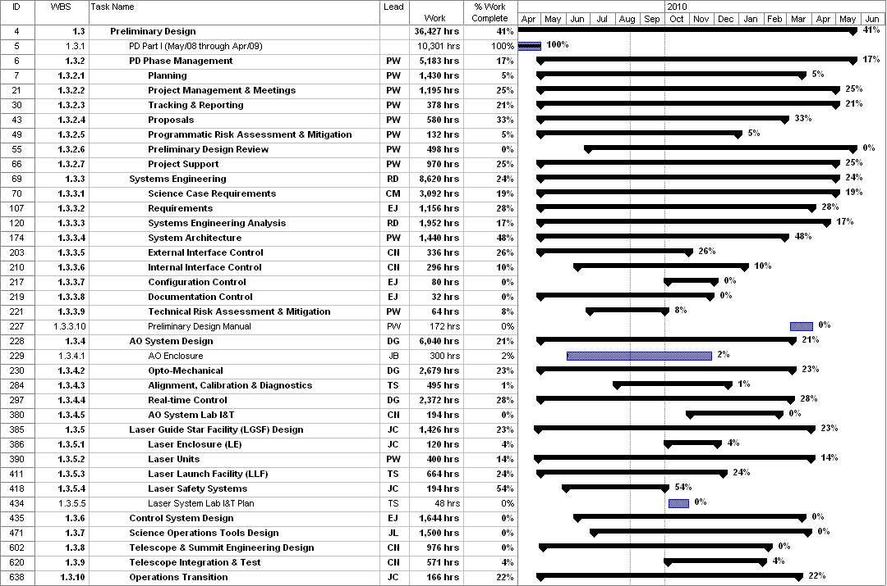
Figure 1: Tracked version of the new PD phase schedule through July 2009

Figure 2: Tracked version of the NGAO Science Instruments schedule through August 2009

Financial Summary

The budget and expenditures to date for year 1 of the NGAO project were provided in KAON 665 (Project Report 13; the year 1 expenditures totaled $729k). The budget, expenditures to date and estimate to completion for year 2 of the NGAO project, which began in May 2009, is shown in Table 2.
Table 2: NGAO PD Phase Expenditure Summary for Year 2 through July 2009

