 Keck Adaptive Optics Note 643

Keck Next Generation Adaptive Optics

Motion Control Architecture Study

Ed Wetherell, Erik Johansson, Jason Chin

Version: 1.5, 2September2009

Introduction
This document describes the results of an architecture study for the motion control subsystem of the Keck Next Generation Adaptive Optics system (NGAO). The complexity of the NGAO system presents us with a number of interesting and challenging motion control problems that must be solved in order to implement the system. The purpose of this document is to explore the motion control requirements for NGAO in more detail and investigate several candidate architectures that can be used for the motion control subsystem. Because we are still early in the design phase, this document is meant to serve as a starting point for architecture discussions with the opto-mechanical design teams. We expect these discussions to begin in earnest following the conclusion of the build-to-cost review in late March 2009.

The document is organized as follows: we begin with a discussion of the requirements for the motion control system. These requirements are based on the NGAO system architecture as defined in the System Design Manual (KAON 511) and amended by KAON 642 (NGAO Design Changes in support of the Build-to-Cost Guidelines). Next we present some device level requirements, mainly to capture information that was collected in the process of writing this document. We then partition the devices into basic categories based on level of precision, type of motion and coordination with other devices. This is followed by a discussion of the locations of the various devices in the NGAO system, as physical groupings may influence the architecture choice. Several candidate architectures are then explored, including their advantages and disadvantages. We continue with a discussion of a number of issues that, while not fundamental to the choice of motion control architecture, are important considerations in the design of the motion control system: servo motor types, servo amplifier types, device multiplexing, communications protocols, cabling, actuator type and limit switches. Finally, we present our recommendations for the NGAO motion control architecture.

Architecture Requirements
We have identified the following requirements for the NGAO motion control architecture. They are categorized as functional, interface, safety, lifetime, environmental, and maintenance. These requirements are based on our current knowledge of the proposed system (Contour requirements, see section 10, FR-471, FR-1834, FR-2149 and FR-2150); experience with the current AO system, Interferometer and telescope motion controls; and standard practices for implementing large motion control systems.

Functional
- The motion control system shall have the ability to position each device according to the following specifications:
  - Payload
  - Range of travel
  - Accuracy and repeatability
  - Maximum move time
- The motion control system shall be able to synchronize the position of multiple devices.
  - Multiple devices within the NGAO system may require synchronous motion with respect to each other. This is referred to as move coordination. An example would be the pickoff arms where both axes must move together in order to keep the desired field on the detector.
  - NGAO devices may be required to be synchronized with external devices/commands at a 40Hz+ update rate. This is referred to as a tracking device. An example would be the image rotator whose position is a function of telescope azimuth and elevation.
  - NGAO devices may also be required to be positioned with respect to absolute time.
  - NGAO devices may require both move coordination and tracking.
- The motion control system shall match the complexity, flexibility, and cost of hardware to the individual device requirements.
  - The tradeoff between standardization of components vs. increased cost and difficulty of configuration should be understood. In the current AO and Interferometer systems all devices use the same controller. In this architecture, simple in/out devices are positioned by a precision controller that is overkill for the device.

Interface
- The motion control system shall accept commands from the high level NGAO control system.
  - This should include the ability to abort a commanded move that is in progress.
- The motion control system shall provide feedback to the NGAO control system in the form of
  - Status and fault reporting
  - High rate (e.g. 40Hz) position feedback to facilitate control of tracking devices whose command may originate outside of the NGAO system.
- The motion control system shall incorporate controllers that support motion programs to perform computations and/or act on inputs. These tasks can be handled at a higher level (as is currently done), but are more efficient when performed in the controller. Given the size of the NGAO system, moving tasks to the controller level will reduce the load on the high level control system and reduce communication overhead.

Safety
- The motion control system shall protect motors, stages and payloads from physical damage.
  - Typical protections include end-of-travel limit switches and hard stops to prevent physical collision; motor over-current detection to protect the motor; soft position limits, velocity and acceleration limits to protect the payload; and encoder failure detection to preserve servo loop integrity.
- A local emergency shutdown (e-stop) system and/or interface to the telescope e-stop may be required to protect personnel.
- Lockout/Tagout and local/remote capabilities are required to protect personnel working on devices that can be remotely controlled.
- Laser safety is handled by Laser Safety System and is outside the scope of this document.

Lifetime
- The motion control system shall not contribute more than TBD minutes of lost time on a night
- The motion control system failures shall not exceed TBD % of total system downtime
  - NGAO System is required to have 95% up-time
    - Mean time between faults > 4 hrs
- The components shall have a 10 year life, 200 nights/yr * 12hrs/night = 2400 hrs/year
  - current AO system components specified at >5yr, 2500 hrs/yr

Environmental
- The components of the motion control system shall operate in the environment present at the W.M. Keck Observatory on the summit of Mauna Kea.
  - All components will operate within specification at an elevation of 13800’ above sea level. This may force de-rating of vendor advertised specifications or add requirements for dedicated environmental controls.
- When required, components will operate within specification in the cooled AO enclosure at a temperature of -15°C. This includes, but is not limited to, stages, motors, encoders and limit switches.
- When required, components will operate within specification in the telescope dome, being exposed to temperatures from -10° to +10° C, wind and dust.
- When required, components will operate within specification in the non-cooled area of the AO enclosure. Temperatures are expected to range from -10° to +10° C.
- The motion control system shall minimize the thermal load on the cooled AO enclosure.
  - The thermal dissipation in the AO enclosure shall be limited to TBD Watts per device, TBD watts total.
- The components of the motion control system located on the AO bench shall not emit light (IR or visible).
  - This requirement is listed to remind us of problems with light contamination from optical encoders in the current AO system.
- The motion control system shall limit generation of Electro Magnetic Interference (EMI).
- The motion control system shall tolerate the presence of Electro Magnetic and Radio Frequency Interference (RFI).
- The components of the motion control system, specifically cooling fans, shall not contribute vibration to the environment.

Maintenance
- The motion control system shall be implemented with a workable and maintainable physical layout.
  - The architecture must consider the requirements for maintenance and troubleshooting the system.
  - The architecture should take into account the possibility of additions to the system.
- In order to reduce maintenance efforts, the motion control system shall provide interchangeable/swappable components where practical.
  - Ideally, a Plug-and-Play or in-system configurable approach will be used which requires no configuration prior to installation in the system.
  - The current AO system requires a controller to be configured via custom (vendor supplied) software before it will work within the control system. Drive amplifiers must be tuned by a technician using an external load.
- The motion control system shall include as much diagnostics as practical.
- In order to facilitate initial setup and ensure long term performance, servo tuning software should be available from the vendor of the motion control hardware

Device Level Requirements
From the architecture requirements listed above, we identify some more detailed requirements for each Degree of Freedom (DOF). These requirements will be useful when selecting hardware to implement the architecture. Although not part of the architecture selection process, we list these items so the thought process is not lost. To avoid confusion, the term DOF is used to refer specifically to a single individual axis (channel) of control. This may be linear or rotational and be one of many axes on a given stage.
- To achieve the positioning requirements, a DOF must be capable of being “homed”
  - This process receives special attention because it is critical to absolute position accuracy and a selected controller must be able to, or be programmed to, home a DOF.
  - “Homing” is the process of precisely initializing the DOF to a known position.
    - It is required to achieve the highest positional accuracy.
    - A sequence of moves is performed to reduce the influence of mechanical uncertainties and insure the location is always able to be determined. This may seem trivial, but after a power-cycle, the location of the DOF may be completely unknown.
    - The precision of homing should be consistent with the required device performance. For maximum repeatability, the preferred method is to combine a home switch and the encoder index mark. For lower precision devices, an end-of-travel limit or hard stop will be sufficient
  - Optionally, a DOF can be moved to a specified offset after the physical reference position has been found. This allows use of protection (limit) switches or hard stops for homing.
  - The final position of the DOF becomes the reference location for the control system and the encoder register(s) are cleared.
  - The homing process would not be required if an absolute encoder system were used. In general, absolute encoders are not practical for several reasons, including cost and the requirement to be placed on the load side of the DOF. Load-side encoding is more challenging as most Commercial Off The Shelf (COTS) stages need to be modified to accept an encoder. Drive-side encoding is straight forward to achieve by coupling an encoder to the motor shaft. Absolute drive-side encoding does not provide sufficient knowledge of the load position to eliminate the need for homing; consider a linear stage where many revolutions of the motor are required to traverse the range of the stage. Note: load side encoding provides more accurate knowledge of the position and should be considered for high precision DOFs.
  - When possible, homing should be performed off of a fixed load position so changing motors (or actuators) does not require recalibration of the stage.
- “Soft” (software programmable) limits should be available to prevent a DOF from hitting the hard limits.
  - Soft limits, as the name implies, allow deceleration and a controlled stop whereas hard limits require a more abrupt stop to prevent a collision.
  - When a soft limit is encountered, the system does not loose knowledge of its position. On the other hand, when a hard limit is encountered, the reported position may no longer be accurate if a load encoder is not present.
  - In some cases, soft limits may need to be updated on the fly based on the position of adjacent devices. For example, multiple object selection mechanisms can physically move to the same location in the field and the keep-out area defined by the arm itself is not constant.
- A number of status, error and fault reporting signals should be present. Some of these are primarily useful for setup or debugging, others are vital for system operation.
  - Current position/velocity
  - Amp enable
  - Motion complete / ‘in position’
  - Real-time limit switch status
  - Latched limit switch status (desirable, not required)
  - Output current / DAC output
  - Real-time following error (difference between actual and commanded position)
  - Maximum following error exceeded (fault)
  - Motor over current error (amp fault)
  - Over-temperature error
  - Communications errors
  - Controller watchdog fault
- The control system should support the option to fit a DOF with a shaft brake. For DOFs that are not tracking and do not have sufficient friction to hold position when the servo is disabled, a shaft brake will prevent position drift.
- Some high precision DOFs may require both drive side (motor) and load side (stage) encoders. A motor is usually fitted with an encoder and is referred to as the drive side encoder. Due to the nature of the mechanical coupling between the drive and the load, the actual position of the stage (load) may have an unpredictable relationship with the position of the motor. By fitting the DOF with two encoders, the position can be controlled more precisely without sacrificing stability of the velocity (motor) control loop.
- In some cases, the load requirements on the motor are significantly different when moving in one direction as opposed to the other. Common examples are moving with or against gravity and moving with or against the force of a spring. Having a controller that includes a compensation factor for this effect is desirable.
- Coordinate systems (non-Cartesian may be required for some DOFs). Currently all of the conversions between a single DOF and the multiple DOFs required to position a device are done at a higher level. Some controllers are capable of creating ‘coordinate systems’ out of a number of channels. This allows tight trajectory control with reduced overhead. Coordinate systems can also help solve transformation problems when reversing moves or handling complex kinematics of multi axis devices.
- Debugging and device characterization benefit from the ability to send open-loop commands to a DOF. This eliminates the servo loop and higher level control.

Device Categories
Because of the large number of devices in the NGAO motion control system, it is helpful to partition them into categories with similar requirements. This allows us to assess a candidate architecture based on its applicability to each category. We looked at the 83 DOFs on the AO bench and the 28 DOFs in the laser system and found six natural groupings. The six categories are described below in order of complexity and difficulty, with 0 being straightforward and 6 being the most demanding.
- Shutters
  - simple in/out devices with very loose positional requirements
  - actuators other than servo motors (e.g., solenoid, pneumatic, etc.) may be considered
  - switches or hard stops, not encoders, used to define the in/out locations
  - knowledge of actual position when moving, although desirable, is not required
- Low precision, non-tracking
  - a dichroic or fold, for example, that is either in the beam or out of the beam
  - moved during configuration, not during an observation
- Medium precision, non tracking
  - aligning a fold (2 axis) or other component
  - moved during configuration, not during an observation
  - possibly combine this category with Type 1 devices
- High precision, non-tracking
  - aligning a lenslet or focusing a unit
  - moved during configuration or acquisition, not during an observation
- Tracking
  - position calculated from and synchronized to external information (telescope az/el, etc)
  - constantly moving during an observation, update rates from 25mS to 100s of seconds
  - various levels of precision required
  - ADC, rotators
- Extremely high precision (non)tracking
  - coordinated motion with other DOF(s)
  - may be constantly moving during an observation, update rates of 1Hz or faster
  - precision may require a piezo (or other) high precision actuator
  - may require slaved course/fine actuators depending on stroke requirement
  - examples include steering mirrors, possibly focus
- Pickoff arms - coordinated high precision (non)tracking
  - most demanding DOF
  - position calculated from and synchronized to external information (telescope az/el, etc)
  - coordinated motion with other DOF(s)
  - spatial position constraints, based on static and dynamic obstacles, to avoid collision
  - may be constantly moving during an observation

The device types are also shown in Figure 1, below. The chart shows the spectrum of devices that are expected in the NGAO project. Table 1, following Figure 1, lists the expected NGAO devices along with details of their motion requirements and categorized control types based on the outline above.

Figure 1: Spectrum of Device Types Required for the NGAO System
Note: Tracking and coordinated-tracking devices may be required to operate in non-tracking mode.

Table 1: Details of the NGAO Movable Devices (Part 1 of 2)
Table 1 (continued): Details of the NGAO Movable Devices (Part 2 of 2)

Location of Devices
The locations of these devices in the NGAO system are shown in Figure 2. There are four primary areas NGAO devices will be located. The devices on the cooled AO bench and those outside of the AO bench (AO Clean Room) will be located on the Left Nasmyth Platform. The devices for the laser(s) and the Beam Transport System (BTS) will be on the elevation ring and the supports on the telescope. The devices to control the asterism and steering of the point-n-shoot beams will be in the secondary socket on the telescope.
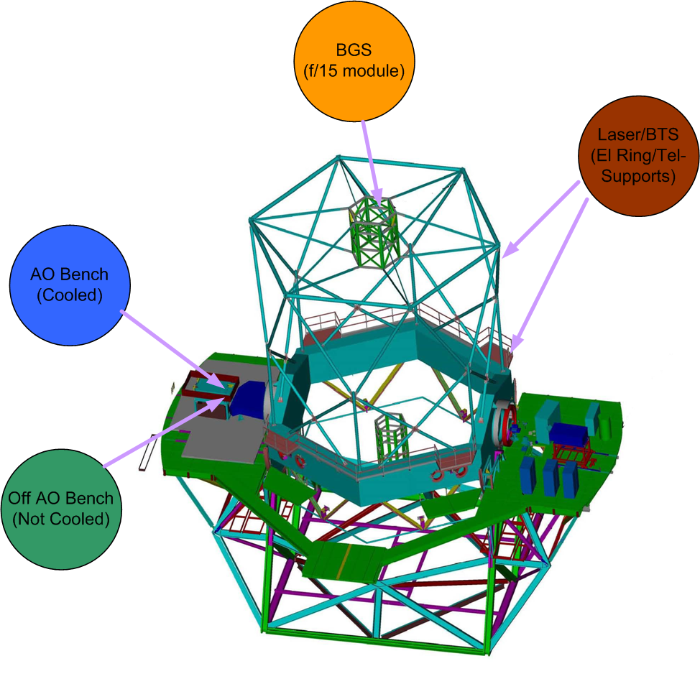
Figure 2: Motion Device Locations

AO Bench Area Devices
On the AO bench and in the AO Clean room, the largest numbers of devices are located in the LGS WFS assembly (31 devices) and the LOWFS (14 devices). These locations are shown in Figure 3 below. The remaining devices on the AO bench are distributed throughout the beam path. The LGS WFS devices, and perhaps some others, will likely not be located on the cooled AO bench. This relaxes the environmental specifications somewhat on these DOFs. This allows a clear distribution of control by function, location and environment. The devices to be controlled in these groups have a number of similarities and consist of device types 3, 5 and 6.

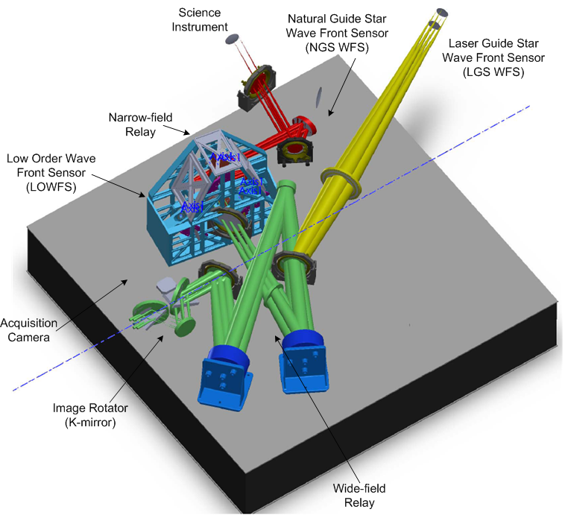
Figure 3: Location of motion control components on/around the AO bench
(Note: This diagram reflects design as of August 2009)

Laser Facility Devices
Figure 4 (which needs to be updated to show the current design) shows the devices in the Laser Facility that will be located on the telescope. The lasers will be delivered from the vendor with their own motion control system. The lasers will be installed in an enclosure(s) located on the front elevation ring of the telescope. The beams from the lasers will travel up the telescope supports to the secondary socket. To keep the beams properly aligned, motion control devices will be required to compensate for flexure in the telescope. Once the beams arrive at the secondary socket, additional motion control devices will be needed to split the three beams into seven, generate the asterism, and steer and rotate the asterism to produce the laser spots on the sky. The use of controllers that are physically close to the devices on the secondary needs to be carefully analyzed due to dissipated power, however there is glycol available for cooling on the secondary.
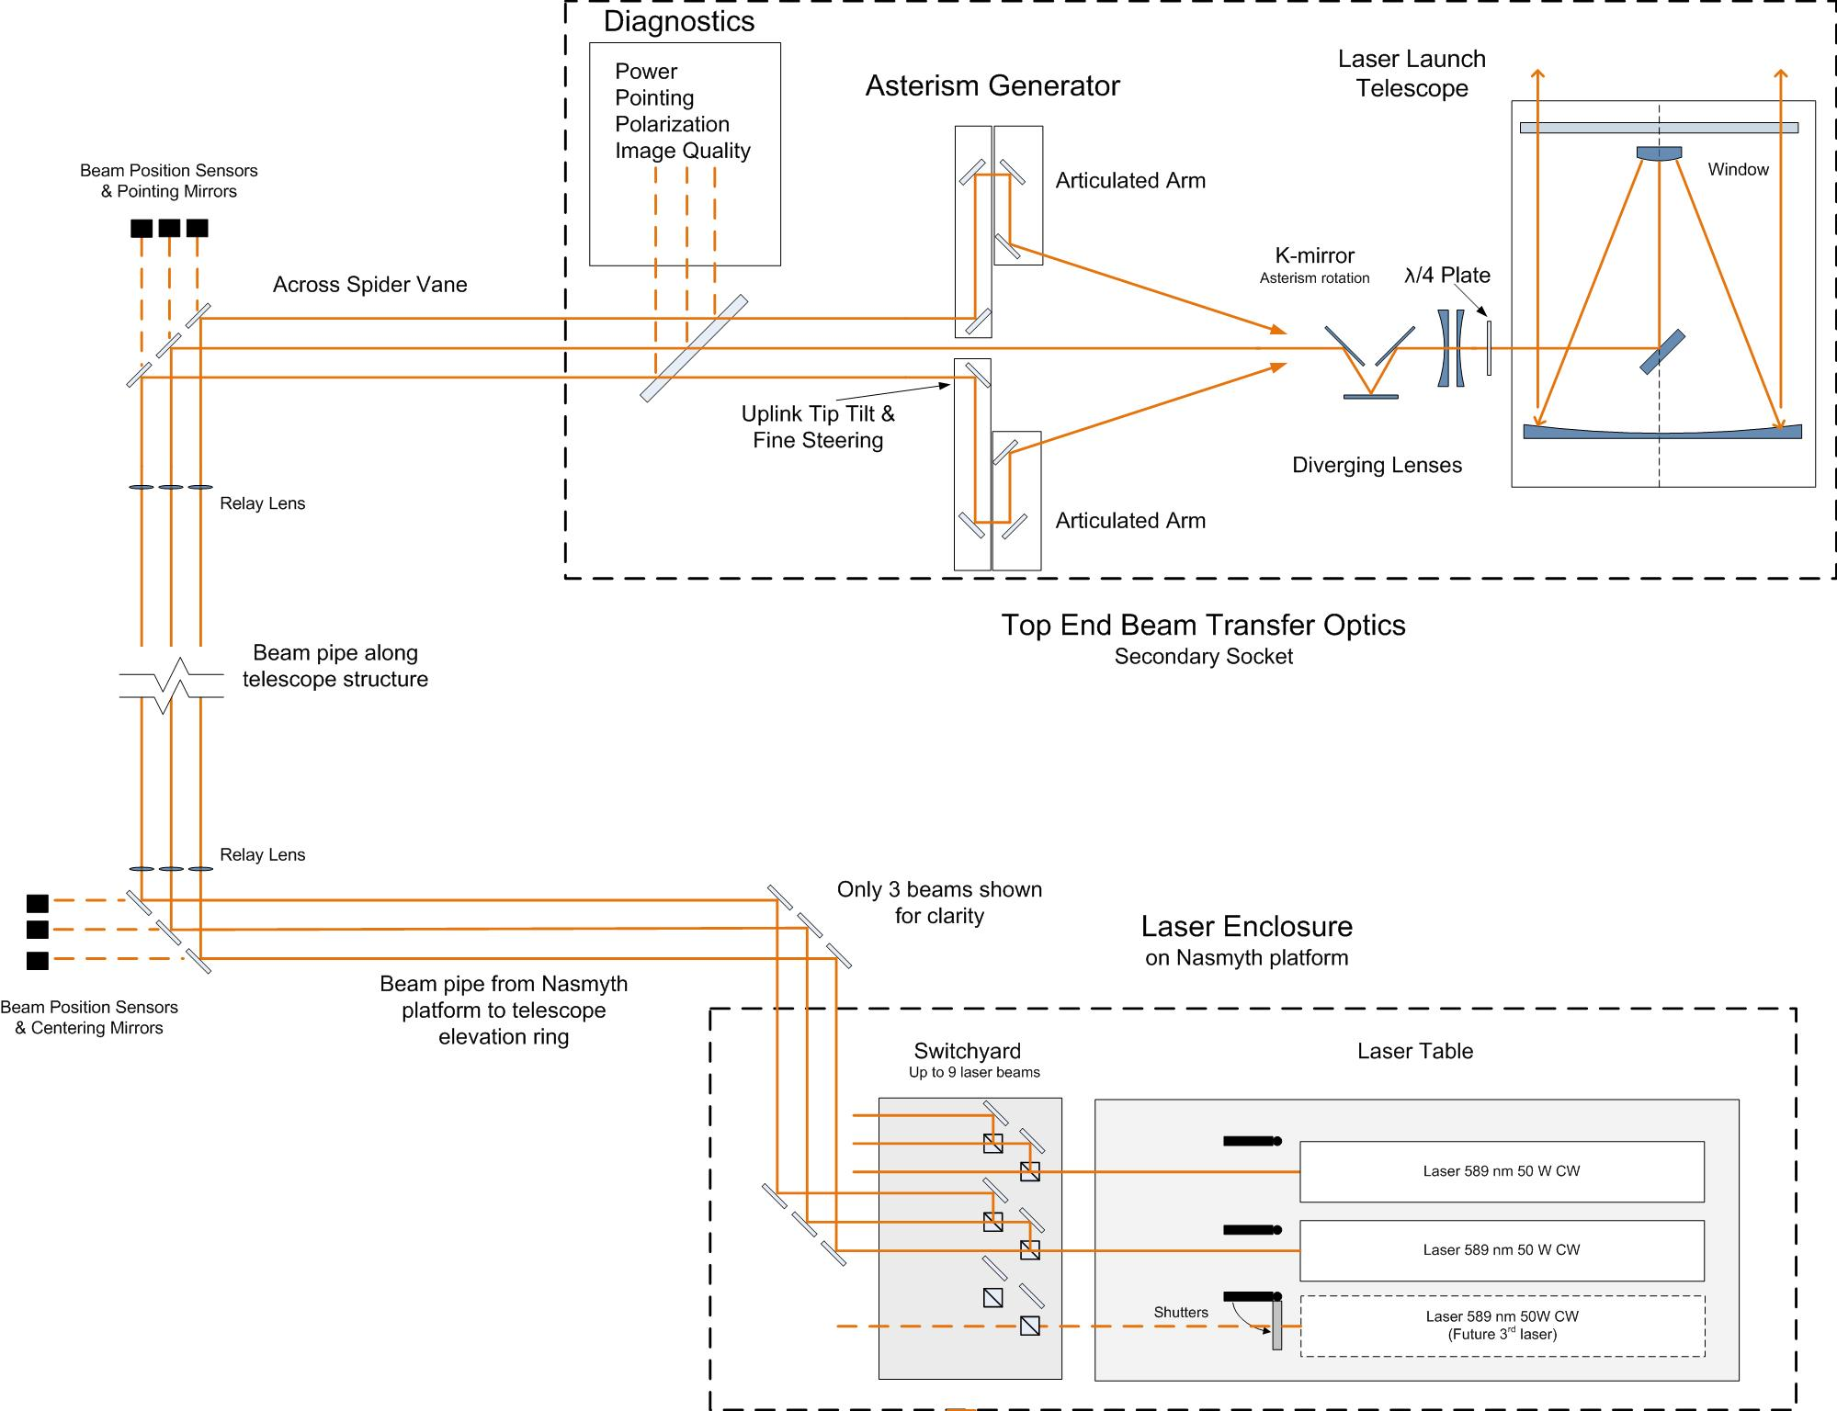

Figure 4: Location of laser system motion control components
(Note: This diagram does not reflect the current design or the Build-to-Cost changes)

Device Breakdown with Location and Type
A more detailed break down of the devices and their control types is shown below in Figure 5. The devices are listed along the vertical axis, roughly corresponding to their position in the AO beam path, with the laser devices at the bottom. The name of each device is shown along with its type of motion in parentheses (x, y, z, θ, Φ). Groups of devices (by function) are denoted by a solid black horizontal line across the chart, with the total number of devices shown in square brackets to the right of the group name (e.g., “Input/Relay 1 [12]”). The control category for each device is shown along the horizontal axis, with type 0 on the left and type 6 on the right. Moreover, the general location of these devices is indicated with a colored diamond. The total number of DOF for a device is shown in square brackets just to the right of the diamond. This is a graphical summary of the information presented in Figure 1 through Figure 4 and Table 1.
Figure 5: Summary of devices, DOF, control type and location.

Possible Architectures
In this section we investigate several candidate architectures for the NGAO motion control system. We begin with a discussion of a centralized architecture and follow with discussions of three distributed architectures. In each section we summarize the key aspects, advantages, disadvantages, and costs. The applicability of these architectures to the device types and overall requirements outlined above is presented in Section 8 at the end of this document.

Centralized Architecture
In a centralized architecture, all of the control components are rack-mounted in a single location. Individual cables flow from the rack to each DOF. This is the primary approach taken throughout the observatory, including the existing AO system and the Interferometer. Components include control CPU(s), motion controllers, drive amplifiers, power supplies and any required I/O for communications, timing and non-motion system control and feedback. Cabled signals include the motor drive signals as well as encoder and limit switch feedback.

Advantages
The benefits of this approach start with familiarity. Many of the systems at Keck are organized in this way and the requirements are understood. By locating all of the electronics in one place, it is easier to remove the generated heat and keep it from interfering with sensitive systems. A central location creates a single starting point for troubleshooting. This architecture allows straightforward synchronization of DOF (on same controller) and there are only small latencies between IO and other controllers within the same VME Crate. There are many vendor/controller options and there is the potential for reusing software if PMACs are chosen as the controller.

Disadvantages
The current (AO) configuration can support 36 DOF in approximately half of a rack. Extrapolating this configuration for NGAO, two racks would be required. It is not clear that all the cabling could be routed to/from a rack with 72 DOF. Also extracting the heat from a 70+ amplifier rack could be problematic. Multiple racks would require several CPUs and many motion controllers adding demands on synchronization.

The wiring on the existing system with 32 channels is quite bulky. Heavy gauge wire is required for long, higher power motor signals. Electrical noise radiation from this wiring as well as noise pickup the on long encoder and switch wiring could be problems. This bulk of cabling will require larger cable trays and a more detailed infrastructure design effort with its associated costs. The long cable runs may dictate the use of more expensive and harder to find linear amplifiers to control noise (see amplifier discussion in section 7.2).

Scalability may be an issue due to physical space constraints in the racks or the location chosen for the electronics.

Cost Estimate
A setup similar to the Interferometer configuration was used as the baseline. The existing AO configuration uses some custom built hardware that is harder to estimate. The assumption is 9 Delta-Tau Turbo PMACs/crate (18 slots) leaving 3 left for a CPU and other peripherals. No estimate was included for cable trays or infrastructure. The component costs are shown in below.

Item | Cost | Number of Channels | Cost / Channel
Equipment Rack | $3000 | 72 | $41.7
VME crate $ | $3500 | 72 | $48.6
CPU | $5000 | 72 | $69.4
Turbo-PMAC | $5000 | 8 | $625.0
Drive chassis, amplifiers and power supplies (Western Servo) | $10000 | 24 | $417.0
Power transformer (Western Servo) | $500 | 24 | $20.8
PMAC to WSD cabling | $100 | 4 | $25.0
Control Rack to DOF stage cabling | $150 | 1 | $150.0
Motor/encoder | $500 | 1 | $500.0
Total |  |  | ~$1900

Table 2: Cost Estimate for Centralized Architecture

Distributed Architectures
The distributed architecture is broken down into three categories: localized motion controller with distributed drive; distributed controller and drive; and “Smart” motors. These approaches all share the benefit of simplifying the cabling. The first two categories generally use a robust industrial communication protocol with deterministic timing. Commonly used physical layers are twisted pair or fiber. Some vendors use a ring type network which may, due to communication speed, impose practical limits on the number of devices that are smaller than the advertised maximums. Selection of a protocol must be done carefully to avoid ending up in a single source situation. “Smart” motors are similar to the distributed controller and drive, but are treated separately because the electronics is packaged with the motor and can only control one DOF.

Local Controller with Distributed Drive
In this configuration the control CPU, I/O and multi-axis motion controller(s) are mounted in a control rack. A low cost cable is routed from the rack to a drive. Multiple drives are then connected to each other with the final drive in the chain connecting back to the control rack to form a ring. The control cable is commonly CAT-5 twisted pair or fiber optic. The drives are distributed and located as close as possible to the DOF they control. A drive consists of a communications controller, feedback interface and amplifier. The drive not only controls power to the servo motor, but it also encodes the feedback signals and transmits them to the servo controller. The power supplies for the drives may be located in the control rack or remotely with the drives. A high speed deterministic protocol is used to communicate output parameters to each drive and feedback information to the controller. Servo bandwidths of several kHz are possible with 16 nodes. Examples include Delta Tau’s TurboPMAC Ultralite or PowerPMAC and Geo MACRO Drives.

Advantages
Controller count can be reduced by using devices a with higher axis count. The wiring is simplified, assuming Ethernet or fiber connections to drives. Depending on the choice of hardware, tighter control is possible if the control signals are all digital, compared with a digital to analog conversion in the controller and possibly an analog to frequency conversion in the amplifier. Given the shorter run of wire from the drive to the motor, the use of Pulse Width Modulated (PWM) drives may be possible. There are many manufacturer options. This configuration is very flexible and scalable. Options exist for precision, high power, etc. Adding existing channels is much less intrusive and requires less rack space.

Disadvantages
The distributed drives represent distributed thermal loads. Managing these loads is a concern. Dissipated heat and operating temperature limits will prevent installing the distributed components in the cooled enclosure without the addition of a specialized cooling system to control the operating temperature and manage the heat generated by these devices. The servo bandwidth may be limited by the choice of communication protocol and physical layer. The servo output data and the feedback data for each DOF all need to fit within the bandwidth of the communications link. Vendors generally support 1 or 2 communication protocols. The choice of protocol requires careful consideration in regard to the available devices in order to ensure the most flexibility and expansion options.

Cost estimate
This number is TBD. We are waiting for information from a prospective vendor.

Distributed Controller and Drive
In this configuration, 4 to 8 channel multi-axis controllers and the associated drive amplifiers are located as close as possible to the devices being controlled. This option is similar to 6.2.1 above, except that each controller is responsible for fewer devices and the controllers, not just the drive amplifiers, are physically distributed throughout the system in close proximity to the devices they control. This is beneficial because the servo control loop bandwidth does not depend on the communication link speed. This also relaxes the specifications on the communication link, possibly allowing use of a non-deterministic protocol. The controller and drive amplifier may be individual components connected by a short cable, or packaged as a single unit. A supervisory CPU with IO would be required, possibly with an industrial communications interface. Examples of this hardware are Delta Tau’s UMAC and Geo PMAC.

Advantages
As with the 6.2.1 solution, wiring is simplified. If individual controllers and drives are chosen, a small amount of wiring will be required to connect the controller to the drive. The short wires between the motor and drive may make the use of PWM amplifiers possible. There are many manufacturer options. As mentioned above, this method has the benefit relaxing the demands on the communication link. The data link communicates high level commands and feedback, but is not part of closing the servo loop. For tracking devices that require a faster update of commanded position, a deterministic communications link may still be required. This is a very flexible and scalable solution. Options exist for precise control, large loads, etc. Adding devices is straightforward and is not limited by the space in a centralized rack.

Disadvantages
As with other distributed approaches, heat sources are distributed. Given the contribution from the controller and drive, this may require cooling. Dissipated heat and operating temperature constraints prevent the distributed components from being installed in the cooled enclosure. Communications latencies will need to be analyzed. This is unlikely to be an issue for GUI commanded devices or devices that do not have high command rate. Communication speed probably would be OK if using a deterministic industrial protocol rather than Ethernet, although the number of nodes may be limited.

Cost Estimate
This number is TBD. We are waiting for information from a prospective vendor.

"Smart" Motors
A smart motor is a combination of a motor, drive amplifier and controller in single compact package with a serial interface. The connections are a serial communications cable and power. It is possible to daisy-chain motors. The number of motors in a chain is likely limited by communication speed and the amount and frequency of information, such as actual position and fault status, requested by the higher level control system. As these are serial devices, a dedicated control CPU may not be required. Optical isolation of the communications signals may be required to prevent ground loops.

Advantages
This approach as has the advantage of simplified wiring. Only communications and power are required. Devices can be daisy-chained together, further reducing the wiring requirement. The motor, amplifier and controller are matched, eliminating the need to carefully select compatible components. If there is a problem, there is only one thing to change. Given the all in one design, better diagnostic data (temperature, supply voltage, actual drive current) is available. In-system programming eliminates need to pre-configure devices before installation.

Disadvantages
For these devices, all power dissipated would be on the bench. For a conventional servo motor, only the motor power is a concern. In the case of the smart motor, the control electronics and the drive amplifier are part of the same package. Communications latencies need to be carefully analyzed. Serial protocols (RS-232/485) are common and their low speed may become a constraint if a larger number of devices are chained together. Communications delays will influence command latency and might present a problem at higher command rates. The amplifier integrated into these devices is a PWM type. PWM amplifiers are known to generate more EMI than a similarly sized linear amplifier (see section 7.2). This is probably not an issue as the amp and motor are physically close so there is minimal wiring to radiate noise. Also, many of these devices are CE marked (Conformite Europeenne) and therefore have been designed to limit the generation of EMI in order to meet the demanding electromagnetic compatibility directive. These devices are slightly larger than a motor/encoder of equivalent power. No 'micrometer replacement' (850G) has been identified, limiting their application to stages that use NEMA frame motors. There are fewer manufacturers of these devices and a limited number of motor sizes available. The smart motor controller will probably have a reduced capability as compared with a dedicated controller.

Vendor Analysis
Animatics is a possible vendor. Their smart motors are currently used in the NIRC2 instrument. They are used for positioning, not tracking and have been very reliable.

The Animatics products are built around NEMA 17, 23 and 34 frame size motors. The SM2340 has similar specifications to the CMC 2130 motor used on Interferometer dichroic stages. Their standard products communicate via RS-232 or RS-485 at 38400 baud, but there are options for DeviceNet or ProfiBus. Each smart motor is configured with a node number to allow each motor to be individually addressed on a network. With a small amount of software, the node number can be configured in-circuit. For RS-232, multiple devices are connected in a ring topology. Commands are passed from node to node along the ring until reaching the recipient. Although a maximum of 120 nodes are possible, the practical limit will probably be significantly smaller and determined by the amount of data and speed of the communications link. These devices have a number of I/O lines that may be used for a dedicated purpose (limit switches, external encoder, shaft brake, etc.) or as general purpose digital I/O or analog input. Motors can be ordered with a shaft brake. To minimize their footprint, these devices use PWM amps, a possible source of EMI. The amplifiers are mounted extremely close (inches) to the motor, effectively eliminating the cabling that would radiate the noise. The devices are CE marked, indicating compliance with strict EMI/RFI emissions and susceptibility requirements. Current products use DB connectors for communications and power. A version (“class9”) with circular connectors will be available in late 2009. These products are rated at 0° to +70°C operating; -20° to +85°C storage with no altitude spec or de-rating. Conversations with the vendor indicate that the products are currently used in applications requiring a -20°C cold start. The vendor also said that there would not be altitude issues with the motor, although de-rating of Animatics power supplies might be required. The controller is low power (<1watt). More details on the thermal issues are presented below. The homing probably is not as precise or easy as with PMAC. Encoder counts are captured by user software installed on the smart motor controller not via a high speed hardware latch. This may add some uncertainty to the position if the device is moving quickly. Example code is available. The vendor said that there is no light leakage from the encoder.

Thermal Analysis
Since these devices are a single package, all of the power dissipated by the controller, drive amplifier and motor is in one location. Any power dissipated by the power supply could be controlled by its location. The suitability of these devices for use inside the cooled enclosure or on the telescope is limited by their power dissipation and operating temperature limits. It is probably not feasible to capture the heat generated by these devices. As mentioned above, discussions with Animatics indicate that the operating temperature is not likely to be an issue. Although their temperature specification is 0° to 70° C, they have existing applications with a -20° C startup. When operating continuously, the case temperature of these motors is directly proportional to load, rising 0.5° C for every 1% of loading.

Power Dissipation
Power dissipation is another issue. There are two aspects to consider: static load where the drive is off and the active or peak load where the motor is moving its load.

Static Load:
The static load is estimated to be 900mW watt per motor. This is based on a 20mA draw at the power supply voltage of 43V or 45mA at 24V. This load will always be present when power is applied to the smart motor. Part of this load is the controller and part is the encoder. This data from the vendor may have been taken with all of the IO ports pulled low. This would be 7mA of current that may not be present in our application. It is not clear if there are any other options to reduce this static load, aside from completely disabling power to the device. Without power, encoder position is not available. As the encoders are not absolute, homing would be required on power-up; therefore this is not a practical solution.

Active or peak load:
Active or peak power is much harder to estimate. This is the sum of the delivered motor power divided by its efficiency, power consumed in the drive (control electronics and switching losses) and the static load of the controller. If a shaft brake is used, that would also need to be factored in.

Animatics was able to provide some data, but they were careful to point out that it may have inaccuracies. Peak efficiencies are at higher motor speeds which are most likely not required in our applications. For a 1000 rpm speed with a load of 60-100% of rated torque, expect efficiencies in the 45-55% range. This equates to a total power of ~100W at 60% load and ~225W at 100% load for a NEMA23, 125 oz-in peak torque, 55 oz-in continuous torque motor (SM2340D). This is a similar size to motors used for linear stages on the current AO bench and interferometer.

Looking at the existing bench, in/out devices (AFM, SOD, etc) are required to complete their move in < 30 seconds. Using a smart motor would dissipate on the order of twice the power used in the existing system. For a single device this is unlikely to be an issue. When the entire bench is initialized, it could be a problem. Ten devices, each with a 100W load = 1kW – not insignificant even though the duration is short. Assuming that the loads could safely handle a higher acceleration, the duration could most likely be decreased without a major increase in power.

A better understanding of the thermal enclosure and the limitations on device power is needed before a final decision can be made. Performing some in-house tests would also help reduce uncertainty.

Cost Estimate
Item | Cost $/DOF
Smart Motor | $1,300
Power Supply | $125
Cabling | $50
Total | $1,475

Table 3: Cost Estimate of Smart Motors

Other Considerations
In this section we discuss of a number of issues that, while not fundamental to the choice of motion control architecture, are still important considerations in the design of the overall motion control system: brushed vs. brushless servo motors, servo amplifier types, device multiplexing, communications protocols, cabling, actuator types and limit switches.

Servo Motor Type

Brushed Servo Motor
Brushed motors are an established, intuitive technology. In the case of the small motors likely to be used in NGAO, they are constructed with permanent magnets on the stator (motor housing) and a series of windings on the rotor. In order to apply current to the rotating windings, brushes are used to contact a split ring (commutator). Each winding is energized through a small angle until the brushes energize the next winding. This is referred to as mechanical commutation. Motor torque is a function of the drive current and speed is a function of voltage.

Advantages
The permanent magnet brushed DC motor is quite cost effective. Controlling these motors is simple; just apply a voltage and the motor moves. Apply a higher voltage the motor moves faster. Reverse the polarity, the motor reverses direction. Only two conductors are required to power the motor.

Disadvantages
Mechanical commutation is the weak link of this motor design. Brushes wear, producing dust and eventually require replacement. The commutator wears and will eventually fail. Brushed motors are less efficient due to friction between the brushes and commutator and inconsistent contact. Heat is generated in the windings that are located on the rotor, making it more difficult to cool the motor. Sparking may occur as the brushes break contact with a coil. All the switching makes these motors electrically noisy. At extremely low speeds, commutation problems can occur.

Brushless Servo Motor
In a brushless motor, the coil and magnet locations are reversed with the magnets on the rotor. Mechanical commutation is replaced by a controller that performs the commutation electrically. Some form of absolute position feedback (optical or Hall-effect transducer) is required in order for the controller to synchronize the commutation angle to the rotor angle.

Advantages
With no moving parts, these motors have a long lifespan and require little maintenance. By eliminating the losses in the commutation system, brushless motors generally have a higher efficiency. This equates to more torque for a given size of motor. No dust is created by wearing brushes. Without the constant mechanical switching, these motors are electrically quiet. Since the coils are (usually) on the exterior of the motor, cooling is easier and more efficient. Linear speed/torque characteristics and lower rotor inertia improve control. The brushless architecture can be used to construct linear motors for precision translation stages. This eliminates mechanical linkage problems (backlash, windup, etc) common to this type of stage.

Disadvantages
The main disadvantage is cost, primarily due to the controller. There is also the additional complexity associated with the controller. At least one, perhaps two or more additional conductors are required to control a brushless motor (depending on winding configuration and type of position feedback). Some motion controller designs allow a high resolution encoder to be used for commutation in addition to providing position feedback to the control loop, eliminating the extra wiring associated with Hall-effect transducers.

Comparison
Aerotech stages are used in a number of places throughout the observatory. The LT1035 brushed servo motor is used on many of these stages. This is a NEMA23 motor with a 1.8 N-m peak torque rating. An attempt was made to compare this motor with similar NEMA23 brushless motors from Aerotech.
The table below summarizes some of the key specifications:

Model | Units | 1035LT | BM75 | BM130 | BMS280
Motor Type |  | Brushed | Brushless | Brushless | Brushless-slotless
Length | mm(in) | 158.2 (6.23) | 132.1 (5.2) | 162.6 (6.4) | 190 (7.48)
Weight (approx) | Kg (lb) | 1.4 (3.1) | 1.1 (2.4) | 1.5 (3.3) | 3.6 (7.9)
Stall Torque (continuous) | N-m(oz-in) | 0.25 (35) | 0.55 (78.3) | 1.00 (141.5) | 1.60 (227)
Peak Torque | N-m(oz-in) | 1.84(260) | 1.4 (196) | 2.5(354) | 6.41 (908)
Rated Speed | Rpm | 6000 | 4000 | 4000 | 3000
Rated Power | W | 129 | 207 | 323 | 381
Bus Voltage (max) | V | 72 | 340 | 340 | 340
Motor Constant | N-m/sqrt(W) | 0.063 | 0.052 | 0.088 | 0.179
Torque Constant | N-m/A | 0.06 | 0.06 | 0.13 | 0.42
BEMF Constant | Vpk/krpm | 6.3 | 6.7 | 16 | 51.1
Rotor Moment of Inertia | Kg-m^2 | 3.8e-5 | 5.2e-6 | 9.2e-6 | 1.96e-5
Poles |  | n/a | 8 | 8 | 14
Connections |  | MS3102A-24 (11 conductors) | Motor: MS3101A-18-10P (4 conductors)  Sensor: MS3101A-20-29P (12-15 conductors)

Table 4: Brushed vs. Brushless Servo Motor

As usual, it is difficult to find an-apples-to apples comparison. What is clear is that the brushless motor has a much higher power rating and a lower moment of inertia. This comes at the price of a (possibly) lower peak torque and an increased conductor count.

Comparison of Cleveland Motion Controls (CMC) NEMA23 servo motors gives a similar picture as the Aerotech comparison above. The brushless motor has a much higher power density and lower inertia. These motors are quite compact at 4.4 inches, including the encoder. List pricing provided by CMC shows the brushless motors are slightly more expensive: T0601T0NCDNFAA (brushless) @ $634 vs. ME2130-198B (brushed) @ $600.

Servo Amplifier
The two main classes of servo amplifiers, those with a linear output and those with a Pulse Width Modulated (PWM) output, are discussed below. This discussion assumes a brushed motor. Amplifiers for a brushless motor will be similar although require the additional commutation circuitry.

Linear Amplifier
Linear amplifiers create a high power analog output that is proportional to the command input. These are analog amplifiers with no high frequency signals. Linear amplifiers are simple devices, containing the power output stage, gain adjustment, bias adjustment and some current limiting components. Some linear amplifiers may contain components to switch in a shunt load to control back-EMF when decelerating a large load. Linear amplifiers are commonly used throughout the observatory.

Advantages
The output signal from these amplifiers is clean and has no fast transitions and therefore produces less noise. The clean analog output may allow more accurate positioning. Performance of linear amplifiers is less dependent on the electrical characteristics of the motor windings.

Disadvantages
Linear amplifiers are not as efficient due to losses, possibly large, in the amplifier output stages. When amplifiers are delivering a small current (i.e. low motor torque or slow speed), the efficiency is quite low due to a large voltage drop across the output drivers. Lower efficiency equates to more heat generated by the amplifier. This results in a physically larger device to be able to handle the heat. A larger power supply may also be required. Linear supplies are getting harder to buy as more and more of the market moves to the PWM type amplifier.

PWM Amplifier
The PWM amplifier digitally ‘encodes’ the output signal by switching the output signal at a fixed frequency and a varying the duty cycle based on the command. A voltage to frequency (duty cycle) conversion is performed in the amplifier. Typical switching frequencies are between 10 kHz and 20 kHz. As described further below, the switching frequency is high enough that the motor only sees the average power, not the individual digital pulses generated by the amplifier. PWM amplifiers also include gain and offset adjustments, configurable current limiting and the ability to shunt generated power under deceleration.

Advantages
PWM amplifiers are more efficient than linear amplifiers. The output stage is either off or on, the entire supply voltage is seen across motor with little drop across amplifier, resulting in less internal loss. Less loss equates to less heat generation, allowing for physically smaller components. Some PWM amplifiers have direct digital input, eliminating the digital to analog to frequency conversion process. This can further reduce costs and provide tighter control. There are many manufacturers of PWM amplifiers that support the motor sizes required for the NGAO system.

Disadvantages
The amplifier output is a digital waveform with sharp edges that create electrical noise. This noise can be managed by using shielded cables and possibly edge filters. Short cable runs are less likely to radiate enough energy to cause problems with other components in the system, especially if they are routed carefully.

The motor torque (for a given frequency and duty cycle) is essentially constant as the power is switched at a high enough frequency that the filter formed by the inductance and resistance of the motor windings deliver a nearly constant current to the motor. This shows that there is a relationship between the drive and the electrical parameters of the motor that is not present in the linear amplifier. There are additional losses in a motor driven by a PWM amplifier that are not present when driven by a linear amp. The switching waveform will result in drive current that has some ripple. This ripple will result in losses in the motor winding. This is less of an issue with higher switching frequencies, but the tradeoff is more EMI. Eddy current losses in the motor also increase proportional to the square of the switching frequency. More care is required when selecting PWM amplifiers for a given motor.

Systems driven with PWM amplifiers may achieve less accurate position control. This is partially due to the digital to analog to frequency encoding and current/torque jitter that results from the switched signal. System performance can be increased by using a pure digital system and carefully matching the drive and motor, but for the ultimate precision, linear amplifiers are still the best choice.

Device Multiplexing
It is possible to multiplex a number of DOF on a single control channel. Given the large number of devices in the system, it is worthwhile to determine if this can be used to reduce the size of the control system. Device multiplexing is well suited for open-loop type actuators (e.g. stepper motors and Picomotors) that don’t have position feedback or loose their current position when unpowered. Unfortunately, these actuators are not applicable for most of the NGAO DOFs. This approach will only be suitable for Type 0-3 non-tracking devices, assuming that multiple devices (on the same multiplexer) were not required to be moved simultaneously.

Advantages
The advantages are reduced cabling and controller channel count. This may result in a cost savings. This approach would possibly reduce load on the power supplies given the smaller amplifier count.

Disadvantages
A custom hardware design is required to perform the multiplexing. This could be a relatively simple box with a number of relays to switch the signals. Nevertheless, it is a design that would require effort. Cabling out of the multiplexer could become a challenge, depending on the number of channels. The more difficult problem is finding a way to maintain current encoder position for the devices (for user feedback) and ensuring that there are no glitches in the position of any DOF when the multiplexer changes channels. Absolute encoders will work, but are expensive. The multiplexer design can include counters to decode the incremental encoders and present a numerical (as opposed to incremental) position to the servo controller. This seems like a good approach, but the homing process needs more thought. Multiplexing only the motors could work as well. This saves drive channels, but not controller channels. When torque is applied to a motor, it generates power. An open circuit motor (generator) requires much less torque to move than one with an electrical load. The multiplexer will probably need to short the motor coils when the motor is de-selected in order to provide holding torque for y-axis DOFs. Another limitation is that only one DOF can be moved at a time, possibly increasing bench initialization time.

Cost Estimate
For an 8 channel multiplexer, the hardware will cost around $1000. This does not include design time.

Communications
For such a large number of devices, the data requirements should be investigated. The current AO and Interferometer systems provide a starting point for analyzing the bandwidth requirements.

There are two methods of communicating with the PMAC VME controllers: VME mailbox and Dual-Port RAM. Motion commands to the PMAC are generally communicated through the ASCII VME mailbox, feedback is through the DP-RAM. For Interferometer pseudo-tracking devices, commands are sent at a rate between 1 and 40Hz, depending on the device. The command size ranges from a minimum of 6 bytes to a maximum of 14 bytes. A typical command might look something like “#8J=150000<cr>”. For each device, feedback information adds up to 20 bytes of data. The PMAC variables are 24bits requiring two 16bit reads for each variable. Requested data includes actual position, commanded position, following error, DAC output and status flags. This information is polled from DP-RAM at 10Hz.

If we just look at the feedback, 20bytes at 10Hz is 1.6 kbit/second; not a big deal for any modern communication channel. A 40Hz worst case command stream would add about 3 kbit/second of data. This data rate does not look to be difficult to accommodate, even with a large number of channels, given a 10 or 100Mbit pipe. However, an RS-232/485 channel will get maxed out pretty quickly.

The bandwidth required for closing the servo loop is another story. Data here is needed at a ~5 kHz rate, although the size of the data is small, probably on the order of 5 bytes: 2 command bytes, 2 feedback bytes and a status byte. This becomes a 200kbit/second data requirement! A loop of only 16 devices would require a 3 Mbit/sec link. This is only an estimate, but it shows the need for a dedicated data link if it is used to close the servo loop.

Communication Options
There are many options for physical layer and protocol. For reference, a few of the common configurations are listed below with a short discussion.

The processor bus, VME, PCI, etc, is used for short distance communication to multiple devices. This is a parallel physical layer. Data is communicated without a ‘protocol’ or error checking. Data may be in the form of ASCII or binary. The processor bus is quite fast and timing is well defined.

A serial port of some sort, RS-232/RS-485, is supported by most devices. RS-232 is generally used for communicating with a single device. The signals are single ended, limiting the length to 15m. RS-485 uses a differential transmitter/receiver and is good for much longer distances (1200m). RS-485 is defined as a two wire, half duplex, multi-point serial channel. Full duplex four wire variants exist as well. Data rates are dependent on the characteristics of the cable, with 100kbit/s being a realistic minimum. The RS-485 physical layer is commonly used with the Modbus or ProfiBus protocol for distributed control systems.

Ethernet is the ubiquitous high-speed network protocol we all know and love. Ethernet actually consists of several layers, making it useful in a network environment with many nodes. On the hardware level, nodes detect the communications carrier and collisions are handled transparently. Each Ethernet device has a globally unique address coded in hardware. Devices can be either full or half duplex. There are several physical layers, but 10BASE-T and 100BASE-T using unshielded twisted pair wire and 8P8C modular (RJ45) connectors are probably the most common. The presence of the underlying protocol, the potential for many hubs/switches/nodes and a variable data load create trouble when trying to use Ethernet as a control protocol. There are a number of places where latencies can be introduced and it is nearly impossible to know the transit time of user level data. Also note that the Ethernet packet (frame), which includes an additional 18 bytes of protocol information, has a minimum and maximum length, so user level data may become fragmented in the communications process. Despite these drawbacks, Ethernet is still widely used given its low cost, ease of installation and generally trouble free operation.

Controller Automation Network (CAN) was designed as a vehicle communication bus. It has been adopted for use as a more general purpose automation protocol. Unlike Ethernet, the CAN bus uses an automatic arbitration scheme allowing higher priority frames to be transmitted without delay. In the case of a collision, the lower priority communication would then be retransmitted. As with all bus architectures, devices need address assignment. The CAN frames are small, ranging from 44bits to 126 bits, depending on the protocol version and the amount of data. Data is limited to 8bytes/frame. The CAN standard does not handle things like flow control, device addressing and transportation of data blocks larger than one frame. This has lead to a number of higher level protocols such as DeviceNet and CANopen. The CAN specification does not completely define the physical layer and therefore a number of variants exist depending on the application. CAN combined with the higher level DeviceNet or CANopen protocols is well suited to handle the requirements of distributed control systems.

Motion and Control Ring Optical (MACRO) is an open source digital interface designed by Delta Tau. The physical layer is a Fiber optic (100Base-FX) or twisted pair (100Base-T) ring. This is primarily used by Delta Tau controllers, but a handful of other vendors look to have products supporting this protocol. 256 nodes (16 masters, 16 nodes per master) are supported. The ring update rate is a function of the number of nodes, ranging from 200 kHz to 3.8 kHz. Although not as wide spread as the various CAN protocols, MACRO was designed specifically for motion control applications, specifically ones with a local master controller and distributed drive amplifiers.

Cabling
Cabling is also an important consideration, as it occupies significant space, can be very heavy, and can limit the layout design of the motion control system.

In the existing AO system, the standard interconnect cable between the OBS rack and the AO bench is 42 feet long and contains 12 twisted pairs of 20 AWG wire with an overall shield, plus a drain (Belden 1058A). The cable OD is 0.56” and weighs approximately 8 pounds (0.194 lbs/foot). The cable is fitted with rugged circular connectors (PT06SE16-99(SR)). The conductors are assigned as follows:
- Motor phases have two parallel conductors (2 pairs)
- Position switches: cw/ccw limit + home – each has dedicated common (3 pairs total)
- Encoder signals (A, B, Z) are all differential (3 pairs total)
- Encoder power and return (one pair)
- Tachometer signal (one pair)
- Spares (2 pairs)
- Shield drain

The Interferometer standard interconnect cable is constructed with 9 individually shielded twisted pairs of 22 AWG wire, each with a drain (Belden 8774) and fitted with DB-25 connectors. The cable OD is 0.417” and weighs 0.118 lbs/foot. Lengths up to 220 feet are currently used. The conductors are assigned as follows:
- Motor phases have two parallel conductors (2 pairs total)
- Position switches: cw/ccw limit + home - single common for all switches (2 pairs total)
- Encoder signals (A, B, Z) are all differential (3 pairs total)
- Encoder power and return (2 pairs)
- Shield drain

This could be reduced to an absolute minimum of eight conductors plus drain if no home switch is used and single ended encoders without index marks are used. Thirteen conductors plus drain is a more realistic minimum count, providing three position switches and three differential encoder signals, as follows:
- Motor phase (2 conductors) - may need 4 or 2 heavier gauge
- Position switches (3 conductors) – return shared with encoder
- Encoder signals (A, B, Z) (6 conductors)
- Encoder power and return (2 conductors) – may need 4 depending on wire gauge and length
- Shield drain

Providing a dedicated common for the position switches would increase the conductor count to 16 or 8pairs. If the same class of cable were chosen, Belden 1057A, the OD would decrease to 0.472” and weigh 0.141 lbs/foot.

Short cable runs from a distributed control system could allow for smaller gauge wire and possibly single ended encoders. A similar 8 pair, 22 AWG cable has minimal size difference and a weight of 0.121 lbs/foot.

Type of Actuator (Stepper vs. Servo)
Based on the analysis conducted for the original K2AO system (reference KAON 105), the use of stepper motors is not being considered to position NGAO devices. The rationale given in the analysis was better tracking performance, reduced vibration, reduced electrical noise and minimal cost difference. We do not have any additional information that would encourage us to revisit this decision.

Limit Switches
End of travel limit switches should be optically isolated in the controller to prevent ground loops. These switches should be fail-safe, i.e., normally closed contacts that open when triggered. Motion controller inputs should support both dry-contact and electrical type switches. Limit switches should be powered by the servo power supply. Detecting encoder failure is difficult. Some controllers provide a level of protection against encoder failure, but this is a challenge if the DOF is not moving. One safeguard that has been used is to couple the limit switch power with encoder power (AO) and/or servo power (Interferometer). This provides protection against an obvious failure mode where the encoder is simply unpowered for whatever reason. Motion in either direction is not allowed if both limits are triggered. This may not help a rotary device where there are no limits, but those are harder to damage in a runaway condition.

Other Actuator Types
In some cases (Laser beam steering, p-n-s laser pointing, DM tip/tilt stage) piezo actuators will be required. Piezo actuators require high voltage drive signals and possibly a more complex drive amplifier. Drive electronics and controllers are usually sold by the actuator manufacturer. Depending on the DOF count and location, a choice between a complete controller (with serial/Ethernet input) or a drive amplifier and general purpose multi-axis controller will need to be made. For a single DOF, it is likely a turnkey controller would be recommended, as compared to 6 DOF might point toward amplifiers and a general purpose controller. The JPL amplifier box used in the Interferometer should be considered as an option as there are a number of spares around. This box takes a 0-10V signal and generates the -10-+150V drive signal for standard piezo devices.

Recommendations
First we present some general recommendations based on the requirements outlined in Section 2 and then follow with a discussion as to how these recommendations apply to the device types defined in Section 4.

Table 5 (below) summarizes the possible architectures and attempts to show whether they meet the requirements presented at the beginning of this document. It is clear that there is not an outright winner. It is not apparent that there is a benefit to standardizing on a single architecture for the entire system. In the past, the device count was small enough that implementing the entire system using the same architecture helped to simplify the design and did not impose a significant cost. For the NGAO system, there are many more devices; therefore the final solution will probably be a combination of architectures to provide the best cost vs. performance solution for each type of device.

Due to the groupings of devices, a distributed architecture looks well suited for use on the NGAO system. The cabling requirements are significant and present a major challenge for implementing, maintaining, and possibly expanding a centralized control system similar to existing Keck designs. There have been significant advances in distributed control over the past 10 years with the development of dedicated deterministic control protocols and robust high speed communication links, making this approach more attractive than before. “Smart” motors offer a considerable advantage by packaging the motion controller and drive amplifier with the servo motor in a package only slightly larger than the motor. Multiplexing devices is most likely not practical (with the exception of type 0 devices), given the challenge of maintaining position feedback and the difficulty of switching channels without moving either the selected or deselected device. Also, the devices that are the best candidates for multiplexing could also be controlled with smart motors.

Table 5: Summary of Architecture Features (Part 1 of 2)
Table 5 (continued): Summary of Architecture Features (Part 2 of 2)

Figure 6 below shows a possible architecture that includes both centralized and distributed components.

Figure 6: Architecture with Centralized and Distributed Controls

Amplifiers should be appropriately sized for the load. We currently use amplifiers that are oversized for many of the stages (5A amplifier to drive a 200mA motor), compromising the precision of the system. PWM amplifiers can most likely be used in a distributed system where the cabling is short and routed carefully. Linear amplifiers may be required if long cable runs are necessary or for devices requiring the highest precision.

Electrical grounding, isolation and shielding will need careful attention. In order to reduce ground loops, actuator frames must be isolated from any of the cabled signals. Shields must not be connected at both ends of a long cable. Limit switches must be optically isolated. Communication signals should incorporate some type of isolation (optical or magnetic) as well.

Care needs to be taken when selecting devices for the cooled AO enclosure or the telescope. Motion stages may need special lubrication. The thermal characteristics of any device on the bench must be carefully understood. Most electronics will be outside the thermal enclosure, but the actuators themselves could present an issue. Distributed components may require forced cooling due to the thin atmosphere. Components should be mechanically isolated to prevent vibration from cooling fans.

Type 0 Devices
The specific controls for these low precision devices will need to be handled on a case by case basis. Their loose positioning requirements allow many types of actuation, including pneumatics. The current design includes three type 0 devices, one of which will certainly be solenoid actuated and controlled by a digital signal. For large devices such as a hatch or cover, a smart motor could be used to drive a rod screw actuator. Given the small device count, the cost of multiplexing cannot be justified.

Type 1 and 2 Devices
The majority of these devices are located on the cold AO bench, with a few more in the laser system. The use of smart motors on the AO bench would be nice to reduce the number of cables penetrating the cold enclosure, although it is not clear if their thermal load would be an issue. At present, no ‘micrometer replacement’ type smart actuator has been identified. This limits their use to linear stages where a motor with a NEMA size mounting frame can be used. This will cover approximately 10 DOF. This count may change once the requirements have stabilized. In cases where a smart motor will not work, either of the distributed architectures would be the next choice. Given the lower precision, linear servo amplifiers should not be required.

Type 3 and 4
These devices are located throughout the system. The use of a distributed architecture will help to reduce implementation costs. The main factors limiting the use of distributed control are heat, time synchronization and the possible requirement for a non-servo motor actuator that would require a dedicated controller. The synchronization issue can most likely be handled with the choice of a time deterministic protocol or with an external timing signal. Power dissipation will prevent the distributed control components from being located within the cooled enclosure, but they can be much closer to the DOF than with a centralized approach. The distributed architecture will reduce cabling costs and complexity, increase maintainability due to the inherent organization of the system, and probably allow the use of lower cost PWM amplifiers. Due to the positioning requirements, multiplexing and smart motors are not suitable options for these devices.

Type 5 Devices
Many of these devices require piezo actuators to achieve the required precision. Either turnkey COTS controllers or a high voltage amplifier in conjunction with an analog output from a real time computer or a general purpose motion controller will be needed. Since closed loop bandwidth is not a concern, and there will probably be other motion control devices in the physical vicinity, it is likely that a general purpose multi-axis controller will be the control source. Some thought may be required to process the strain gauge feedback. The choice of controller will dictate whether a centralized architecture is needed.

Type 6 Devices
These are the most demanding devices to control. Preventing collision of adjacent arms will require additional thought. Proximity detectors located on the tip of the lever arm have been suggested. The motion controller must be able to accept an input from these sensors. Ideally the controller will be able to handle the coordinate system transformation from an (x, y) position in the field to the rotational position of the arm DOFs. The high precision requirements for these motors will probably dictate the use of linear amplifiers. Given there are a number of this type of device, in two distinct locations (LGS WFS and LOWFS), controlling each group from a dedicated servo system (distributed or centralized) is probably a good idea. This will reduce any control latencies and help protect the devices from problems associated with communication dropout or loss of synchronization between controllers. Multiplexing and smart motors are not applicable for these devices.

Device Description Sheet
In order to accurately categorize the motion devices, we are recommending the use of the following table to capture the relevant information for each device. The information in this table will drive the architecture for each device and confirm the groupings identified in the earlier sections of this document.

Device name
Number of DOF per Device
Axis type |  | Linear, rotational, tip/tilt
Range
Accuracy
Repeatability
Runout
Command source |  | GUI, Sequencer, Tel. El, etc
Update rate
Tracking rate |  | Axis speed while tracking
Slew rate |  | Axis speed while slewing
Load weight
Velocity limit
Acceleration limit
Environmental conditions

Table 6: Device Description Sheet

Implications for Software Development
How will the hardware architecture impact software development? The high level distributed communication and control protocol has not yet been selected. To our knowledge, none of the listed architectures apply explicit constraints on the choice of communication protocol. The choice of hardware devices and software protocol should be collaborative so we end up with the most compatible solution with the least integration effort for both hardware and software design teams.

Conclusion
We are confident that the motion control requirements for the NGAO system listed at the beginning of this document can be met using a combination of the identified architectures. To the best of our knowledge, these requirements fit within the specifications of currently available COTS products. We anticipate that at least a portion of the system will incorporate some form of distributed control which will ease the constraints associated with a centralized system.

The following list summarizes the recommendations for the motion control architecture:
- The motion control architecture will be a combination of centralized control for high precision tracking devices and distributed control for devices with less demanding requirements on positioning and control.
- The use of smart motors for distributed control is recommended to minimize controls and infrastructure design; thus overall cost. More analysis of the thermal constraints is required.
- NGAO components such as amplifiers and cabling should be sized according to the device requirements. This will result in reducing the overall footprint of the system as well as the supporting infrastructure such as power and cooling. There are a substantial number of devices which make a “one size fits all” implementation unlikely.
- The selection of hardware should be made in conjunction with the software designers to ensure the lowest overall cost once all aspects of the design are considered.
- The hardware shall support maintenance and troubleshooting. Due to the colder than normal requirements for the AO bench, selected devices should require minimum support.
- Careful considerations must be taken to minimize EMI to and from the devices.
- The use of COTS controllers and packaging will reduce the overall system cost.
- The selection of devices should be done in conjunction with completion of the Device Description Sheet shown in .

The biggest challenges appear to be the (anticipated) heat loading constraints of the AO thermal enclosure and the incomplete specifications (precision, speed, payload, etc) of the individual devices. In order to move forward, we must work closely with the opto-mechanical design teams to consolidate the detailed requirements for each device. We also need detailed information as to how much heat can be introduced into the thermal enclosure, both peak and steady state. We also need to finalize the reliability requirements presented in the section 2.4, Lifetime. Once these are determined, we can proceed with the recommendation of an overall architecture for review.

Requirements
Short Name | ID | Description
AO Motion Control Coordination | FR-471 | AO controls will coordinate the motion control and other tasks needed to perform dithering, offsetting and chopping for science observations.
AO Motion Control | FR-1834 | AO Controls shall provide a motion control function for all opto-mechanical devices requiring remote computer control. The control function shall include basic device control (initialize, standby, start, stop, etc.), configuration control, position control, tracking control for those devices that require it, and support coordinated moves of multiple devices. As of this writing, the opto-mechanical devices requiring motion control are as follows (number of degrees of freedom shown in parentheses):  - Hatch cover (1 DOF)  - Vibration sensor (4 DOF)  - Calibration sources (14 DOF)  - Rotator (1 DOF)  - LGS WFS assembly (31 DOF)  - Interferometer pickoff (1 DOF)  - Acquisition camera pickoff, focus (2 DOF)  - LOWFS assembly (14 DOF)  - Tweeter DM slow tip/tilt (3 DOF)  - NGS WFS (8 DOF)  - NIR imager (3 DOF)  As more information is known about the motion control needs for these devices and subassemblies, individual requirements will be added to address them.
LGS Motion Control | FR-2149 | LGS Controls shall provide a motion control function for all opto-mechanical devices in the LGS facility requiring remote computer control. The control function shall include basic device control (initialize, standby, start, stop, etc.), configuration control, position control, tracking control for those devices that require it, and support coordinated moves of multiple devices. As of this writing, the opto-mechanical devices requiring motion control are as follows (number of degrees of freedom shown in parentheses):  - Laser Shutter (1 DOF)  - Polarization waveplates (3 DOF)  - BTO bottom mirrors (4 DOF)  - BTO top mirrors (4 DOF)  - Shutter (1 DOF)  - Point and shoot beam splitter (2 DOF)  - Star imager pickoff (1 DOF)  - Point and shoot steering (6 DOF)  - Asterism rotator (1 DOF)  - Asterism tip/tilt (2 DOF)  - Fast shutter (1 DOF)  - Beam expander focus (1 DOF)  - LTO cover (1 DOF)  - LTO polarization sensor (1 DOF)  - LTO focus lens (1 DOF)  As more information is known about the motion control needs for these devices and subassemblies, individual requirements will be added to address them.
LGS Motion Control Coordination | FR-2150 | LGS controls will coordinate the LGS facility motion control and other tasks needed to perform dithering, offsetting and chopping for science observations.

Revision History
Date | Version | Author | Description
11mar09 | 1.0 | EW/EMJ/JC | First Release
12mar09 | 1.1 | EW | Break links to worksheet objects, fix minor spelling errors
06Jul09 | 1.2 | EW | Add info on brushless servo motors; update tables/figures of required DOFs
28Aug09 | 1.3 | EW | Required DOF update; additional info in section 8
1Sept09 | 1.4 | EW | Updated figure 3 – reflects bench design as of Aug09
2Sept09 | 1.5 | EW | Add Contour requirements (section 10)

