 Keck Adaptive Optics Note 564

Keck Next Generation Adaptive Optics
Laser Enclosure System Design

Drew Medeiros
January 31, 2008

System Design Cases

  - Case 1

Three cases are presented. Selection is dependent on component size and weight, component tilt restrictions, restrictions on distance between control racks and LASER.

    - Case 1 Design Description

      - Case 1 Design Description for Keck 2

If the LASER Table can be tilted and can meet size and weight restrictions, it would be housed in the existing LASER enclosure on the right-front wall of the Elevation Ring.

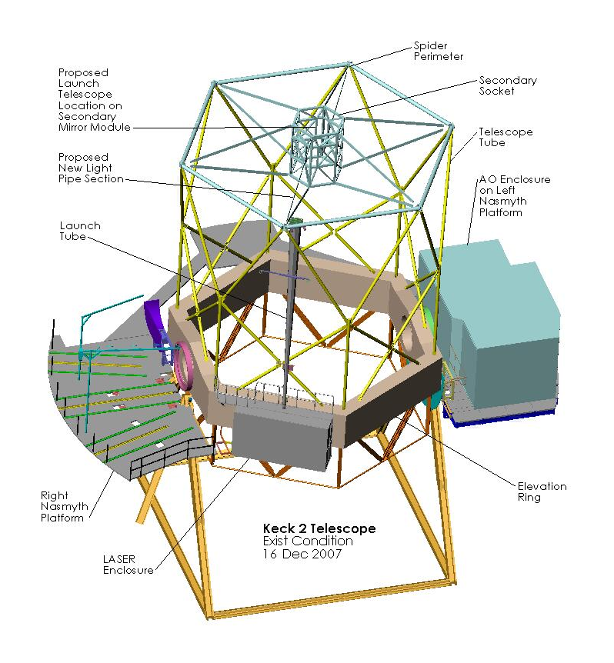

The LASER transport optics and beam path would then be enclosed in a tubing running up the tube to the perimeter of the spider and across to the Launch Telescope on the F-15 Secondary Module. The existing Launch Tube may be able to be utilized for the run up the side of the tube.

The NGAO LASER electronics and power racks would be housed in a new electronics enclosure below the Left Nasmyth Platform.

      - Case 1 Design Description for Keck 1

The design would be the same as on Keck 2 except that a new enclosure will need to be constructed on the Elevation Ring. This will also require stiffening of the Elevation Ring and the addition of an access platform. The NGAO LASER electronics and power racks will be housed in the existing AO Enclosure Electronics vault or the existing Keck 1 LASER Enclosure on the Right Nasmyth Platform.

Case 1 Cost Estimate

TBD (see Case 3 cost estimate for highest cost)

Case 1 Cost Estimate for Keck 2

Case 1 Cost Estimate for Keck 1

  - Case 2

    - Case 2 Design Description

      - Case 2 Design Description for Keck 2

If the LASER Table cannot be tilted, it is proposed that the NGAO LASER Table be housed in the existing AO Enclosure Electronics Vault and a new NGAO Electronics Enclosure be installed under the Left Nasmyth Platform. Because the AO system light path is on axis through the elevation ring, the LASER beam must use an off access path. 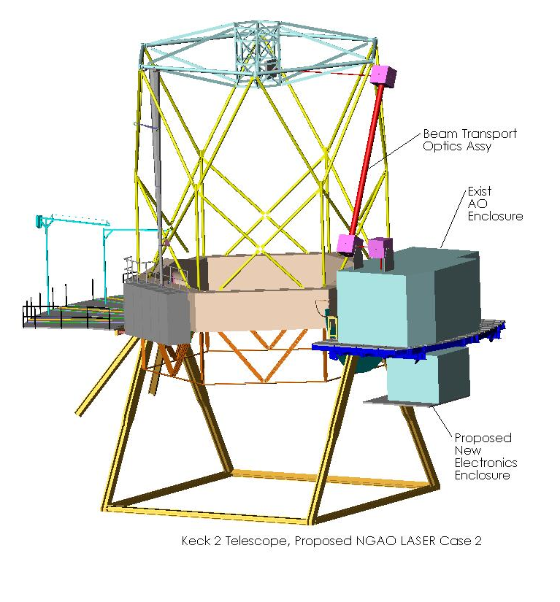

The LASER beam would be directed out through the enclosure roof and folded toward the Elevation Ring to a gimbaled fold mirror located near the edge of the roof, and up to a second gimbaled fold mirror at the outside of the spider perimeter at the top of the tube.

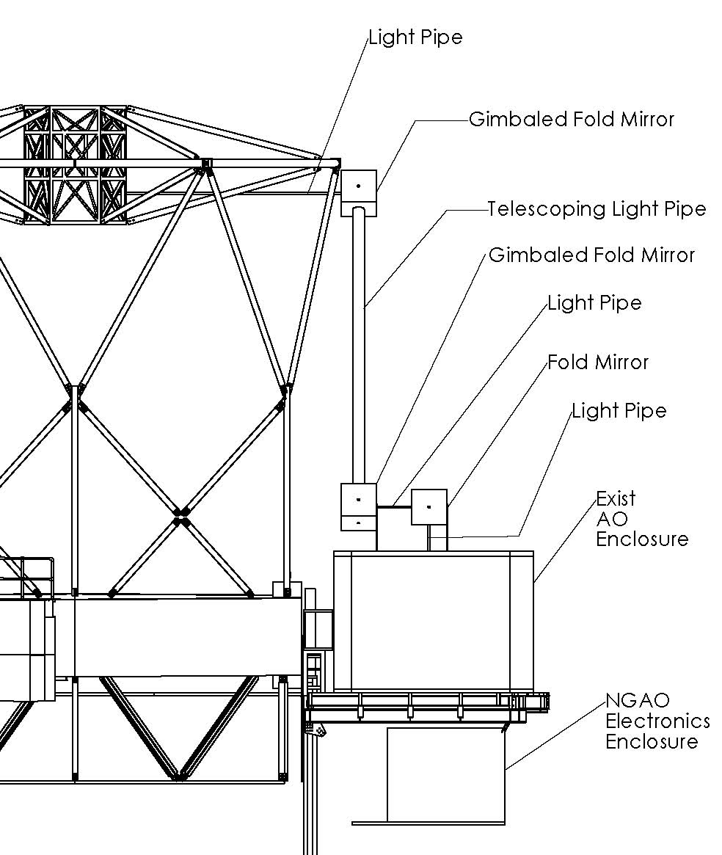

Alignment between the gimbaled fold mirrors would be maintained by software control and/or mechanically by a telescoping connector arm utilizing precision self-aligning linear bearings, to allow for the decrease in distance between the mirrors as the telescope rotates down in elevation. The telescoping light tube between the mirrors would be comprised of two overlapping tubes, one inserted in the other. The light from the upper fold mirror would be directed to the Launch Telescope. A new platform and housing for the electronics and power racks would need to be designed and implemented, either under or behind the left Nasmyth platform.

      - Case 2 Design Description for Keck 1

The design would be the same as on Keck 2

Case 2 Cost Estimate

TBD

Case 2 Cost Estimate for Keck 2
TBD (see Case 3 cost estimate for highest cost)

  - Case 3

    - Case 3 Design Description

      - Case 3 Design Description for Keck 2

If the LASER cannot be installed in the NGAO Enclosure, it is proposed that a new platform and LASER enclosure be constructed between the existing Right Nasmyth and Cassegrain Platforms.

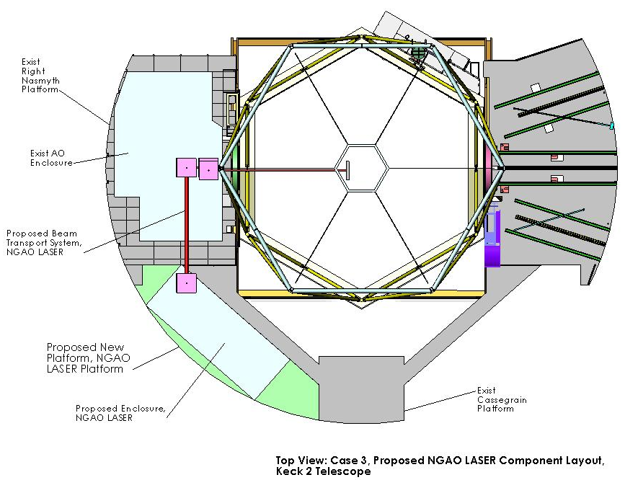

The beam transfer system would be the same as Case 2 except that an extra fold mirror from the top of the new LASER enclosure would be required. A new NGAO electronics vault would be constructed below the Left Nasmyth Platform.
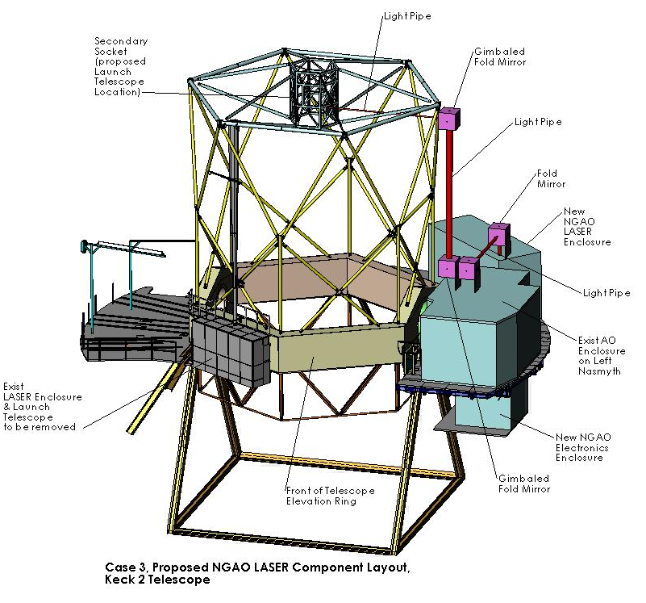

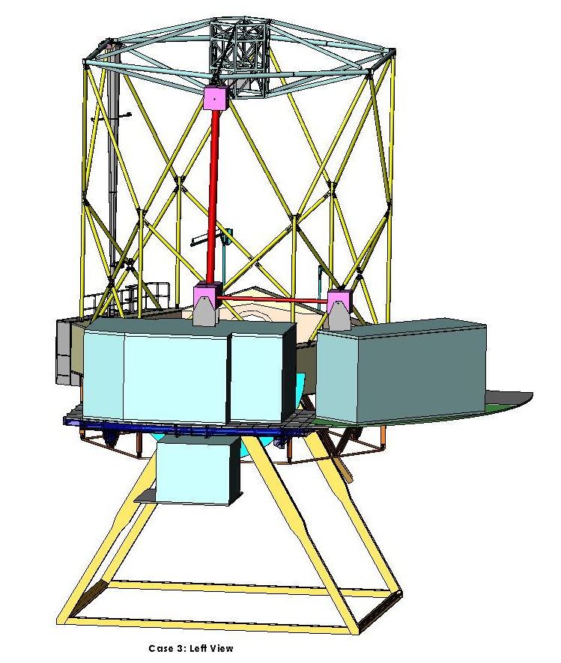
      - Case 3 Design Description for Keck 1

The design would be the same as on Keck 2 except that if the NGAO LASER system fits in the existing Keck 1 LASER enclosure on the Right Nasmyth Platform, it could be installed there.

Case 3 Cost Estimate

The combined cost estimate for case 3 is $461,500 and 7584 work hours.

Case 3 Cost Estimate for Keck 2
Cost Analysis, Sysems Design level, LASER, NGAO
Work Item | $ | Work hrs
Case 3, Keck 2 | $264,000 | 4128
Laser Platform | $104,000 | 1466
design incl. structural engineer | $45,000 | 130
materials & fab (outside shop) | $50,000 | 40
weld testing | $4,000 | 16
construction | $5,000 | 1200
final doc |  | 80
LASER Enclosure | $46,000 | 604
design |  | 140
purchase | $30,000 | 24
construction | $1,000 | 240
install infrastructure | $15,000 | 120
final doc |  | 80
Electronics Platform | $54,000 | 646
design incl. structural engineer | $25,000 | 40
materials & fab (outside shop) | $25,000 | 40
weld testing | $2,000 | 16
construction | $2,000 | 500
final doc |  | 50
Electronics Enclosure | $26,000 | 404
design |  | 60
purchase | $15,000 | 24
construction | $1,000 | 200
install infrastructure | $10,000 | 80
final doc |  | 40
Beam Transport Infrastructure | $34,000 | 608
design | $5,000 | 200
materials & fab (outside shop) | $25,000 | 40
weld testing | $1,000 | 16
construction | $3,000 | 320
final doc |  | 32
Manage |  | 400

Case 3 Cost Estimate for Keck 1
Cost Analysis, Sysems Design level, LASER, NGAO
Work Item | $ | Work hrs
Case 3, Keck 1 | $197,500 | 3456
Laser Platform | $64,000 | 1336
design incl. structural engineer | $5,000 | 40
materials & fab (outside shop) | $50,000 | 40
weld testing | $4,000 | 16
construction | $5,000 | 1200
final doc |  | 40
LASER Enclosure | $46,000 | 416
design |  | 16
purchase | $30,000 | 24
construction | $1,000 | 240
install infrastructure | $15,000 | 120
final doc |  | 16
Electronics Platform | $32,000 | 596
design incl. structural engineer | $3,000 | 24
materials & fab (outside shop) | $25,000 | 40
weld testing | $2,000 | 16
construction | $2,000 | 500
final doc |  | 16
Electronics Enclosure | $26,000 | 336
design |  | 16
purchase | $15,000 | 24
construction | $1,000 | 200
install infrastructure | $10,000 | 80
final doc |  | 16
Beam Transport Infrastructure | $29,500 | 432
design | $500 | 40
materials & fab (outside shop) | $25,000 | 40
weld testing | $1,000 | 16
construction | $3,000 | 320
final doc |  | 16
Manage |  | 340

High Risk Items

If the LASER is mounted on the Elevation Ring (case 1), the telescope will need to be at zenith in order to access it. This will limit access since the telescope must be at other elevations for many essential daily operations, such as Cassegrain and Secondary instrument reconfigurations. Therefore, all equipment mounted on the Elevation Ring must meet higher standards of reliability. Only components of known reliability will be utilized, proven by prior experience with the component and, or testing. These items would include electronics and certain mechanical components. The risk will also be reduced if the LASER is not mounted on the Elevation Ring (cases 2 and 3).

Telescope Loading Restrictions

The right and left Nasmyth Platforms of both telescopes are currently loaded to maximum limit of 20,000 pounds as recommended by the structural engineer, Peter Wrona of Dasse Design, San Francisco.

Keck Telescope Nasmyth Platform Load Estimate Existing as of 4 Dec 2007
Component | lbs
K1 Right Nasmyth | 20000
HIRES Enclosure | 7700 | calculated
HIRES Instrumentation | 5000 | guess????
HIRES Electronics Rack | 500 | assumption
K1 LASER Enclosure (exist) | 4000 | estimated
K1 LASER | 2000 | assumption
K1 LASER Electronic Rack | 800 | assumption
K1 Left Nasmyth | 21000
AO Enclosure | 9681 | calculated
AO Enclosure Stub | 800 | calculated
AO Bench | 2500 | estimated
AO Electronics Racks | 3000 | assumption
Dual Star Module | 3323 | weighed
OSIRIS | 3000 | calculated
K2 Right Nasmyth | 22789
DEIMOS | 19489 | weighed
Cable Boom, DEIMOS | 800 | assumption
NIRSPEC | 2000 | calculated
Cable Boom, NIRSPEC | 500 | assumption
K2 Left Nasmyth | 23104
AO Enclosure | 9681 | calculated
AO Enclosure Stub | 800 | calculated
AO Bench | 2500 | estimated
AO Electronics Racks | 3000 | assumption
Dual Star Module | 3323 | weighed
NIRC2 | 1000 | estimated
Electronics, NIRC2 | 800 | estimated
NIRC2 crane | 2000 | assumption

Based on this table, any weight added to one of the platforms must be compensated for by the removal of existing weight or by structurally modifying the platform. Structural modification could cost upwards of $100,000 and 1400 hours effort.

On Keck 2 all counterweights were removed from the front of the Elevation Ring when the existing LASER system was installed. All new weight added to the Elevation Ring would have to be counterweighted with an equally on the other side of the ring, resulting in 2 pounds added to the ring for each pound of functional component, including equipment, enclosures and platforms, . Adding mass to the Elevation Ring will result in increased structural deformation, rotation inertia and force on the hydrostatic bearings. A study of the Elevation Ring loading was not performed, but will need to be done if it is necessary to add more weight to it.

Inputs and Outputs

TBD

LASER Light

Electrical

Glycol

Pneumatics

Azimuth Cable Wrap Loading
TBD

Personnel Safety

  - The design will meet OSHA, HIOSH and Keck Observatory safety requirements.

  - The design will be developed in consultation with, and overviewed by, the Keck Observatory SHEA Officer. SHEA Officer will review all design reports and Engineering Change Orders.

  - Project Specific Safety Plans will be developed for each of the major construction phases of the project. These plans will be developed in consultation with and reviewed by the SHEA Officer.

  - Applicable Safety Categories

    - Fall Hazard

      - Meet all design codes.
        - Railings
        - Ladders
        - Stairs
        - Landings

      - Meet all construction codes.
      - Fall restraints
      - Fall arrest

    - Electrical
      - Meet local electrical codes.

    - Fire
      - Meet local fire codes and Factory Mutual class 1 rating.

Vibration Isolation (for all sources)
TBD

Suitable Vendors (including vendor provided documentation)
TBD

Preliminary Work Breakdown Structure Inputs
TBD

